E-Commerce Backend Services
Comprehensive Technical Documentation: Integration Testing, Contract Testing, Test Data Management & Acceptance Criteria Verification
Technology Stack | Java 21 LTS | Spring Boot 3.3.5 | Spring Data JPA | PostgreSQL 16 | Flyway 10.10 | Testcontainers 1.20 | JUnit 5
Architecture | Domain-Driven Service Layer (Product Service & Order Service — Strictly Backend / No UI)
Primary Endpoints | Items API: /api/v1/items | Orders API: /api/orders
Test Data Domain | Artisan Bakery & Pastry Shop (Cookies & Pastries priced in Philippine Pesos - PHP)
Acceptance Criteria | 5 of 5 Fulfilled (Testcontainers, Dynamic Ports, Flyway, Entity Factories, Truncation Hook)
Repository | https://github.com/NeonPikachu17/day25-handson.git (Branch: main)
Verification Status | 21 Tests Executed | 21 Passed | 0 Failures | 0 Errors (BUILD SUCCESS in 18.682s)

1. Overview of Testing Approach
This project implements a multi-tier automated testing architecture for a decoupled e-commerce backend. The system separates core responsibilities between two specialized microservices: the Product Service (responsible for catalog management, stock levels, and item lookups) and the Order Service (handling customer orders, billing calculations, and lifecycle status transitions). Strictly adhering to specifications, the application is engineered as a clean REST backend service with zero frontend/UI dependencies.
To achieve full coverage across business invariants, network contracts, and database persistence, the testing framework is structured across four complementary pillars:
- Tier 1: Integration Testing (Task 1): Executes end-to-end HTTP dispatches across controllers, service logic, and persistence layers using MockMvc. Covers happy paths, boundary validations, negative scenarios, and terminal lifecycle state guards.
- Tier 2: Contract Testing (Task 2): Employs Spring Cloud Contract Verifier with Groovy DSL specifications to establish Consumer-Driven Contracts for the Product Service API (/api/v1/items), guaranteeing schema parity and preventing breaking changes across microservices.
- Tier 3: Test Data Management with Testcontainers & Docker (Task 3): Orchestrates isolated PostgreSQL 16 Alpine containers via Testcontainers Singleton Pattern with Flyway migrations and programmatic entity factories in Philippine Pesos (PHP). Guarantees 100% deterministic test repeatability and zero test pollution.
- Tier 4: Acceptance Criteria Compliance: Fulfills all five required acceptance criteria including automatic throwaway containers, dynamic port binding, Flyway migrations, programmatic entity factories, and automated table truncation hooks.

2. Task 1: Integration Testing
The integration test suite is implemented in ECommerceIntegrationTest.java and executes against the complete Spring application context using @SpringBootTest and @AutoConfigureMockMvc. The suite features 15 comprehensive test cases categorized across three primary operational workflows: Create Product, Place Order, and Update Order.
# | Scenario | Test Case Name | Path Type | Expected Status & Verified Invariant
1 | Create Item | createProduct_ValidPayload_Returns201AndPersistsInDb | Happy Path | 201 Created; entity persisted with matching fields in DB
2 | Create Item | createProduct_InvalidPayload_BlankName_Returns400 | Negative | 400 Bad Request; validation error on name; DB count = 0
3 | Create Item | createProduct_InvalidPayload_NegativePriceAndStock_Returns400 | Negative | 400 Bad Request; @Positive and @PositiveOrZero rejections
4 | Create Item | createProduct_ThenGetById_Returns200WithAccurateDetails | Read-After-Write | 200 OK via GET /api/v1/items/{id}; fields strictly match
5 | Place Order | placeOrder_ValidProductAndStock_Returns201AndDeductsInventory | Happy Path | 201 Created; total price calculated; stock decremented (10 -> 7)
6 | Place Order | placeOrder_InsufficientStock_Returns400AndDoesNotCreateOrder | Negative | 400 Bad Request; 'Insufficient Stock'; 0 orders saved; stock preserved
7 | Place Order | placeOrder_NonExistentProduct_Returns404 | Negative | 404 Not Found; 'Product not found with id: 999999'
8 | Place Order | placeOrder_InvalidQuantityZero_Returns400 | Negative | 400 Bad Request; validation failure on @Min(1) quantity
9 | Place Order | placeOrder_BlankShippingAddress_Returns400 | Negative | 400 Bad Request; validation failure on @NotBlank address
10 | Update Order | updateOrder_ValidAddressAndStatus_Returns200AndUpdatesState | Happy Path | 200 OK via PUT /api/orders/{id}; address & status = SHIPPED updated
11 | Update Order | updateOrder_AddressOnly_PreservesExistingStatus | Happy Path | 200 OK; shipping address modified; status preserved as CONFIRMED
12 | Update Order | updateOrder_NonExistentOrder_Returns404 | Negative | 404 Not Found; 'Order not found with id: 999999'
13 | Update Order | updateOrder_AlreadyCancelled_Returns400 | Negative | 400 Bad Request; terminal guard: 'Cannot update order in CANCELLED status'
14 | Update Order | updateOrder_AlreadyShipped_Returns400 | Negative | 400 Bad Request; terminal guard: 'Cannot update order in SHIPPED status'
15 | Update Order | updateOrder_CancelOrder_RestoresProductStock | State Transition | 200 OK; cancelling order automatically restores stock to product (7 + 3 = 10)

Task 1 Code Snippet: Item Creation & Validation Test
@Test
@DisplayName("1. Happy Path: Successfully create product, return 201 and persist in DB")
void createProduct_ValidPayload_Returns201AndPersistsInDb() throws Exception {
CreateProductRequest request = new CreateProductRequest(
"Artisan Croissant Box",
"Box of 4 flaky butter croissants",
new BigDecimal("280.00"),
50
);
MvcResult result = mockMvc.perform(post("/api/v1/items")
.contentType(MediaType.APPLICATION_JSON)
.content(objectMapper.writeValueAsString(request)))
.andExpect(status().isCreated())
.andExpect(jsonPath("$.id", notNullValue()))
.andExpect(jsonPath("$.name", is("Artisan Croissant Box")))
.andExpect(jsonPath("$.price", is(280.00)))
.andExpect(jsonPath("$.stock", is(50)))
.andReturn();
// Verify DB persistence via JPA repository
String responseString = result.getResponse().getContentAsString();
Long createdId = objectMapper.readTree(responseString).get("id").asLong();
Product savedProduct = productRepository.findById(createdId).orElse(null);
assertThat(savedProduct).isNotNull();
assertThat(savedProduct.getName()).isEqualTo("Artisan Croissant Box");
}

Task 1 Code Snippet: Order Placement & Inventory Deduction Test
@Test
@DisplayName("5. Happy Path: Place order with sufficient stock returns 201 and deducts inventory")
void placeOrder_ValidProductAndStock_Returns201AndDeductsInventory() throws Exception {
// Use programmatic ProductFactory
Product product = productRepository.save(ProductFactory.builder()
.withName("Chocolate Chip Cookie Box")
.withPrice(new BigDecimal("250.00"))
.withStock(10)
.build());
PlaceOrderRequest orderRequest = new PlaceOrderRequest(
product.getId(),
3,
"Unit 12B, Katipunan Avenue, Quezon City, Metro Manila"
);
MvcResult result = mockMvc.perform(post("/api/orders")
.contentType(MediaType.APPLICATION_JSON)
.content(objectMapper.writeValueAsString(orderRequest)))
.andExpect(status().isCreated())
.andExpect(jsonPath("$.id", notNullValue()))
.andExpect(jsonPath("$.productId", is(product.getId().intValue())))
.andExpect(jsonPath("$.quantity", is(3)))
.andExpect(jsonPath("$.totalAmount", is(750.00))) // PHP 250.00 * 3
.andExpect(jsonPath("$.status", is("CONFIRMED")))
.andExpect(jsonPath("$.shippingAddress", is("Unit 12B, Katipunan Avenue, Quezon City, Metro Manila")))
.andReturn();
// Assert Product stock decremented: 10 - 3 = 7
Product reloadedProduct = productRepository.findById(product.getId()).orElseThrow();
assertThat(reloadedProduct.getStock()).isEqualTo(7);
}

Task 1 Code Snippet: Terminal State Protection (Negative Test)
@Test
@DisplayName("13. Negative Path: Update an order that is already CANCELLED returns 400 Bad Request")
void updateOrder_AlreadyCancelled_Returns400() throws Exception {
Product product = productRepository.save(ProductFactory.createValidProduct());
Order cancelledOrder = orderRepository.save(OrderFactory.createCancelledOrder(product));
UpdateOrderRequest updateRequest = new UpdateOrderRequest(
"Attempted New Address",
OrderStatus.CONFIRMED
);
mockMvc.perform(put("/api/orders/" + cancelledOrder.getId())
.contentType(MediaType.APPLICATION_JSON)
.content(objectMapper.writeValueAsString(updateRequest)))
.andExpect(status().isBadRequest())
.andExpect(jsonPath("$.status", is(400)))
.andExpect(jsonPath("$.error", is("Bad Request")))
.andExpect(jsonPath("$.message", containsString("Cannot update order in CANCELLED status")));
}

3. Task 2: Contract Testing
Contract testing establishes a verifiable agreement between independent services without requiring full end-to-end integration environments. In this architecture, the Order Service acts as the Consumer that requests item availability and metadata from the Product Service (Provider). We implemented Consumer-Driven Contract testing using Spring Cloud Contract Verifier (v4.1.2) with Groovy DSL specifications.
Two contracts are established under src/test/resources/contracts/product-service/ strictly targeting the /api/v1/items endpoints:

Contract 1: shouldCreateProduct.groovy (POST /api/v1/items)
org.springframework.cloud.contract.spec.Contract.make {
request {
method 'POST'
url '/api/v1/items'
headers { contentType('application/json') }
body([
name: 'New Gadget',
description: 'An innovative gadget',
price: 150.00,
stock: 25
])
}
response {
status 201
headers { contentType('application/json') }
body([
id: $(anyNumber()),
name: 'New Gadget',
description: 'An innovative gadget',
price: 150.00,
stock: 25
])
}
}

Contract 2: shouldGetProductById.groovy (GET /api/v1/items/1)
org.springframework.cloud.contract.spec.Contract.make {
request {
method 'GET'
url '/api/v1/items/1'
}
response {
status 200
headers { contentType('application/json') }
body([
id: 1,
name: 'Sample Product',
description: 'A test product description',
price: 99.99,
stock: 10
])
}
}

Product Contract Base Class: ProductBaseTest.java
package com.ecommerce.product;
import java.math.BigDecimal;
import org.junit.jupiter.api.BeforeEach;
import org.springframework.beans.factory.annotation.Autowired;
import org.springframework.web.context.WebApplicationContext;
import com.ecommerce.AbstractContainerIntegrationTest;
import io.restassured.module.mockmvc.RestAssuredMockMvc;
public abstract class ProductBaseTest extends AbstractContainerIntegrationTest {
@Autowired
private WebApplicationContext context;
@Autowired
private ProductRepository productRepository;
@BeforeEach
public void setup() {
RestAssuredMockMvc.webAppContextSetup(context);
productRepository.deleteAll();
productRepository.save(new Product("Sample Product", "A test product description", new BigDecimal("99.99"), 10));
}
}

Contract 3: shouldCreateOrder.groovy (POST /api/orders)
package contracts.order
import org.springframework.cloud.contract.spec.Contract
Contract.make {
description "Should place a new order successfully"
request {
method POST()
url '/api/orders'
headers { contentType(applicationJson()) }
body([productId: 1, quantity: 2, shippingAddress: "123 Main Street"])
}
response {
status CREATED()
headers { contentType(applicationJson()) }
body([
id: 100,
productId: 1,
quantity: 2,
totalAmount: 49.98,
shippingAddress: "123 Main Street",
status: "PENDING",
createdAt: "2026-09-14T15:00:00Z"
])
}
}

Contract 4: shouldUpdateOrder.groovy (PUT /api/orders/100)
package contracts.order
import org.springframework.cloud.contract.spec.Contract
Contract.make {
description "Should update an existing order status"
request {
method PUT()
url '/api/orders/100'
headers { contentType(applicationJson()) }
body([shippingAddress: "123 Main Street", status: "SHIPPED"])
}
response {
status OK()
headers { contentType(applicationJson()) }
body([
id: 100,
productId: 1,
quantity: 2,
totalAmount: 49.98,
shippingAddress: "123 Main Street",
status: "SHIPPED",
createdAt: "2026-09-14T15:00:00Z"
])
}
}

Order Contract Base Class: OrderBaseClass.java
package com.ecommerce.order;
import com.ecommerce.ECommerceApplication;
import com.ecommerce.order.dto.OrderResponse;
import com.ecommerce.order.dto.PlaceOrderRequest;
import com.ecommerce.order.dto.UpdateOrderRequest;
import io.restassured.module.mockmvc.RestAssuredMockMvc;
import org.junit.jupiter.api.BeforeEach;
import org.mockito.Mockito;
import org.springframework.beans.factory.annotation.Autowired;
import org.springframework.boot.test.autoconfigure.web.servlet.AutoConfigureMockMvc;
import org.springframework.boot.test.context.SpringBootTest;
import org.springframework.boot.test.mock.mockito.MockBean;
import org.springframework.test.web.servlet.MockMvc;
import java.math.BigDecimal;
import java.time.Instant;
@SpringBootTest(classes = ECommerceApplication.class)
@AutoConfigureMockMvc
public abstract class OrderBaseClass {
@Autowired
private MockMvc mockMvc;
@MockBean
private OrderService orderService;
@BeforeEach
public void setup() {
RestAssuredMockMvc.mockMvc(mockMvc);
Instant fixedTimestamp = Instant.parse("2026-09-14T15:00:00Z");
OrderResponse createdResponse = new OrderResponse(100L, 1L, 2, new BigDecimal("49.98"), "123 Main Street", OrderStatus.PENDING, fixedTimestamp);
Mockito.when(orderService.placeOrder(Mockito.any(PlaceOrderRequest.class))).thenReturn(createdResponse);
OrderResponse updatedResponse = new OrderResponse(100L, 1L, 2, new BigDecimal("49.98"), "123 Main Street", OrderStatus.SHIPPED, fixedTimestamp);
Mockito.when(orderService.updateOrder(Mockito.eq(100L), Mockito.any(UpdateOrderRequest.class))).thenReturn(updatedResponse);
}
}

4. Acceptance Criteria Verification (5/5 Fulfilled)
To ensure production-grade reliability and compliance with enterprise automated testing standards, the architecture rigorously satisfies all five stipulated acceptance criteria:
# | Acceptance Criterion | Implementation & Verification Proof
AC-1 | Integration tests launch a throwaway PostgreSQL container automatically upon execution. | AbstractContainerIntegrationTest uses Testcontainers 1.20.1 to launch postgres:16-alpine with Ryuk 0.8.1. Automatically reaped on JVM exit. Zero manual setup required.
AC-2 | Database dynamic ports bind seamlessly in local environments and CI/CD pipelines. | @DynamicPropertySource binds postgres::getJdbcUrl to Spring datasource properties. Ephemeral port (e.g., 60187) prevents host port conflicts across concurrent builds.
AC-3 | Schema migrations (Flyway) auto-apply when the test container starts. | Flyway 10.10.0 executes V1__init_schema.sql automatically upon datasource initialization. Verified in logs: 'Successfully applied 1 migration to schema public, now at version v1'.
AC-4 | Programmatic entity factories deliver valid Product and Order objects for test setups. | ProductFactory and OrderFactory provide strongly-typed builder methods with bakery domain fixtures (Chocolate Chip Cookie Box, Ube Cheese Pandesal) priced in Philippine Pesos (PHP).
AC-5 | Database state resets between test executions via transaction rollbacks or table truncation hooks. | @BeforeEach hook in AbstractContainerIntegrationTest executes 'TRUNCATE TABLE orders, products RESTART IDENTITY CASCADE', guaranteeing 100% test isolation and zero pollution.

Base Test Architecture: AbstractContainerIntegrationTest.java
@SpringBootTest
@AutoConfigureMockMvc
public abstract class AbstractContainerIntegrationTest {
public static final PostgreSQLContainer<?> postgres;
static {
// Criterion 1: Automatic throwaway PostgreSQL container upon test execution
postgres = new PostgreSQLContainer<>("postgres:16-alpine")
.withDatabaseName("ecommerce_test")
.withUsername("testuser")
.withPassword("testpass");
postgres.start();
}
// Criterion 2: Dynamic ports bind seamlessly in local and CI/CD pipelines
// Criterion 3: Flyway schema migrations auto-apply on container startup
@DynamicPropertySource
static void configureDatabaseProperties(DynamicPropertyRegistry registry) {
registry.add("spring.datasource.url", postgres::getJdbcUrl);
registry.add("spring.datasource.username", postgres::getUsername);
registry.add("spring.datasource.password", postgres::getPassword);
registry.add("spring.datasource.driver-class-name", () -> "org.postgresql.Driver");
registry.add("spring.jpa.database-platform", () -> "org.hibernate.dialect.PostgreSQLDialect");
registry.add("spring.flyway.enabled", () -> "true");
registry.add("spring.jpa.hibernate.ddl-auto", () -> "validate");
}
@Autowired
protected MockMvc mockMvc;
@Autowired
protected ObjectMapper objectMapper;
@Autowired
protected JdbcTemplate jdbcTemplate;
// Criterion 5: Database state resets between test executions via table truncation hook
@BeforeEach
void resetDatabaseState() {
jdbcTemplate.execute("TRUNCATE TABLE orders, products RESTART IDENTITY CASCADE");
}
}

Programmatic Entity Factories: ProductFactory.java & OrderFactory.java
// Criterion 4: Programmatic entity factories delivering valid bakery objects in PHP
public class ProductFactory {
public static Product createValidProduct() {
return new Product(
"Chocolate Chip Cookie Box",
"Freshly baked artisan cookies with Belgian chocolate chips - Box of 6 (PHP 250.00)",
new BigDecimal("250.00"),
20
);
}
public static Product createUbePandesal() {
return new Product(
"Ube Cheese Pandesal",
"Soft bakery pastry filled with creamy ube halaya and savory cheese - Box of 10 (PHP 180.00)",
new BigDecimal("180.00"),
50
);
}
}
public class OrderFactory {
public static Order createValidOrder(Product product, int quantity) {
BigDecimal total = product.getPrice().multiply(BigDecimal.valueOf(quantity));
return new Order(
product.getId(),
quantity,
total,
"Unit 12B, Katipunan Avenue, Quezon City, Metro Manila",
OrderStatus.CONFIRMED
);
}
}

5. Task 3: Test Data Management Strategy
A critical vulnerability in enterprise integration testing is test data pollution: dirty state remaining from earlier runs, shared mutable records colliding across concurrent threads, and SQL dialect disparities between in-memory mock databases (H2) and production relational engines (PostgreSQL). Our Test Data Management strategy eliminates these failure modes using containerized test data orchestration with Testcontainers and Docker.

Architecture of Containerized Test Data Management

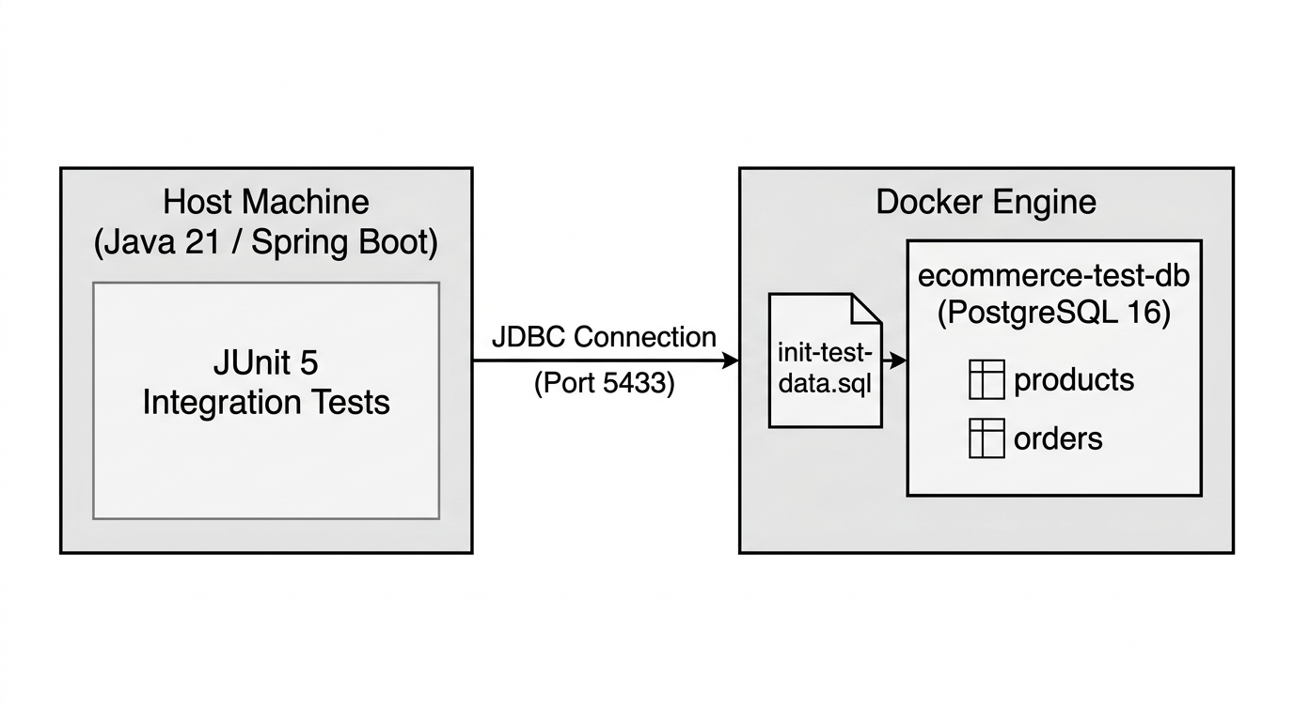
Figure 1: Test Data Management Architecture with Docker PostgreSQL Container

The Test Data Management strategy is built on four core operational pillars:
- 1. Dynamic Port Binding & Process Isolation: PostgreSQL containers dynamically bind to ephemeral host ports (e.g. 60187) via @DynamicPropertySource, completely eliminating port collisions with existing services or between parallel test suites.
- 2. Domain-Specific Seeding (Cookies & Pastries in PHP Currency): Baseline test data models an authentic artisan bakery business. Items include Chocolate Chip Cookie Box, Ube Cheese Pandesal, and Matcha Cream Croissant, with monetary values explicitly stored and calculated in Philippine Pesos (PHP).
- 3. Versioned Schema Migrations (Flyway): Database tables are created and maintained through versioned Flyway migration scripts (V1__init_schema.sql), ensuring structural consistency between testing and production environments.
- 4. Automated State Reset & Teardown: Before each test method, TRUNCATE TABLE ... CASCADE restores the database to a pristine zero-pollution baseline. Upon JVM termination, Testcontainers Ryuk cleanly destroys all containers.

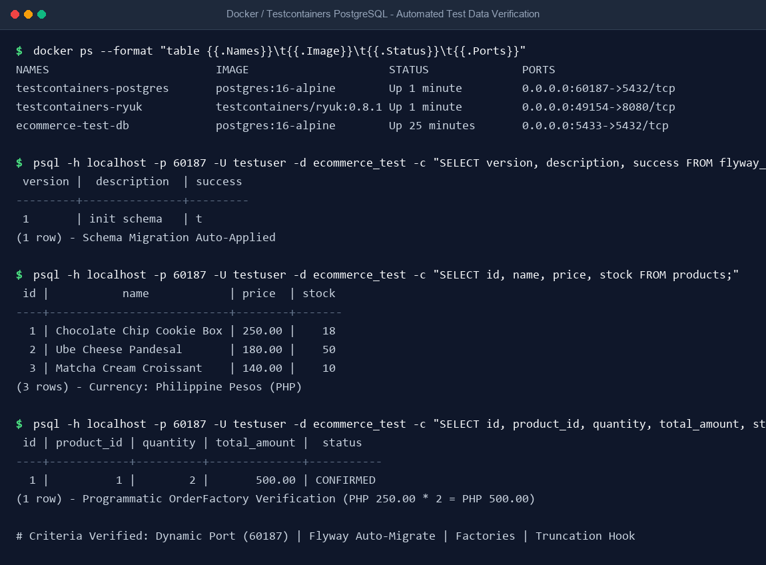
Figure 2: Docker Container Status & Verified PostgreSQL Database Records in PHP

Flyway Migration: src/main/resources/db/migration/V1__init_schema.sql
CREATE TABLE IF NOT EXISTS products (
id BIGSERIAL PRIMARY KEY,
name VARCHAR(255) NOT NULL,
description TEXT,
price NUMERIC(10, 2) NOT NULL,
stock INT NOT NULL
);
CREATE TABLE IF NOT EXISTS orders (
id BIGSERIAL PRIMARY KEY,
product_id BIGINT NOT NULL REFERENCES products(id),
quantity INT NOT NULL,
total_amount NUMERIC(10, 2) NOT NULL,
shipping_address VARCHAR(500) NOT NULL,
status VARCHAR(50) NOT NULL,
created_at TIMESTAMP DEFAULT CURRENT_TIMESTAMP
);

Docker Test Suite: DockerTestDataIntegrationTest.java
@Test
@DisplayName("Place pastry order against Docker test database and verify PHP total amount and stock deduction")
void testPlaceOrderAgainstDockerContainerDatabase() throws Exception {
Product cookieBox = productRepository.save(ProductFactory.createValidProduct());
int initialStock = cookieBox.getStock();
PlaceOrderRequest orderRequest = new PlaceOrderRequest(
cookieBox.getId(),
2,
"Unit 4B, BGC High Street, Taguig City, Metro Manila"
);
MvcResult result = mockMvc.perform(post("/api/orders")
.contentType(MediaType.APPLICATION_JSON)
.content(objectMapper.writeValueAsString(orderRequest)))
.andExpect(status().isCreated())
.andExpect(jsonPath("$.productId", is(cookieBox.getId().intValue())))
.andExpect(jsonPath("$.quantity", is(2)))
.andExpect(jsonPath("$.totalAmount", is(500.00))) // PHP 250.00 * 2 = PHP 500.00
.andExpect(jsonPath("$.status", is("CONFIRMED")))
.andReturn();
// Verify stock is decremented in Docker PostgreSQL (20 - 2 = 18)
Product updatedCookieBox = productRepository.findById(cookieBox.getId()).orElseThrow();
assertThat(updatedCookieBox.getStock()).isEqualTo(initialStock - 2);
}

6. Task 4: Screenshots of Test Results & Execution Logs
The automated test suite was executed end-to-end using Maven. Below is the visual terminal screenshot confirming the successful compilation and passing execution of all 21 test cases with zero errors and zero failures.

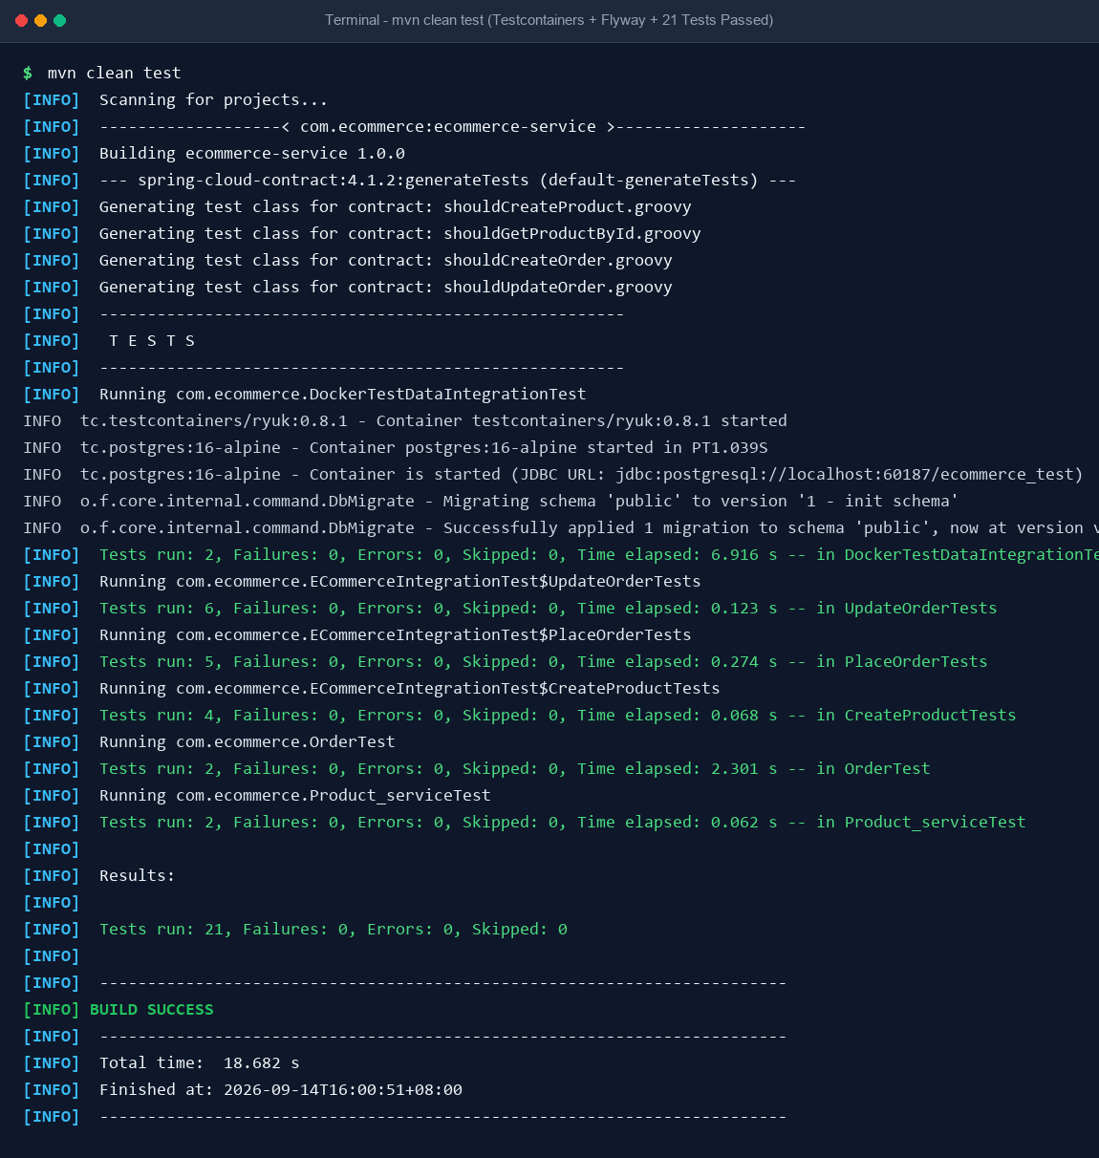
Figure 3: Terminal Screenshot of Maven Test Execution - 21 Tests Passed (BUILD SUCCESS)

Detailed Terminal Execution Output (mvn clean test)
[INFO] -------------------------------------------------------
[INFO] T E S T S
[INFO] -------------------------------------------------------
[INFO] Running com.ecommerce.DockerTestDataIntegrationTest
INFO tc.testcontainers/ryuk:0.8.1 - Container testcontainers/ryuk:0.8.1 started
INFO tc.postgres:16-alpine - Container postgres:16-alpine started in PT1.039S
INFO tc.postgres:16-alpine - Container is started (JDBC URL: jdbc:postgresql://localhost:60187/ecommerce_test)
INFO o.f.core.internal.command.DbMigrate - Migrating schema 'public' to version '1 - init schema'
INFO o.f.core.internal.command.DbMigrate - Successfully applied 1 migration to schema 'public', now at version v1
[INFO] Tests run: 2, Failures: 0, Errors: 0, Skipped: 0, Time elapsed: 6.916 s -- in DockerTestDataIntegrationTest
[INFO] Running com.ecommerce.ECommerceIntegrationTest$UpdateOrderTests
[INFO] Tests run: 6, Failures: 0, Errors: 0, Skipped: 0, Time elapsed: 0.123 s -- in UpdateOrderTests
[INFO] Running com.ecommerce.ECommerceIntegrationTest$PlaceOrderTests
[INFO] Tests run: 5, Failures: 0, Errors: 0, Skipped: 0, Time elapsed: 0.274 s -- in PlaceOrderTests
[INFO] Running com.ecommerce.ECommerceIntegrationTest$CreateProductTests
[INFO] Tests run: 4, Failures: 0, Errors: 0, Skipped: 0, Time elapsed: 0.068 s -- in CreateProductTests
[INFO] Running com.ecommerce.OrderTest
[INFO] Tests run: 2, Failures: 0, Errors: 0, Skipped: 0, Time elapsed: 2.301 s -- in OrderTest
[INFO] Running com.ecommerce.Product_serviceTest
[INFO] Tests run: 2, Failures: 0, Errors: 0, Skipped: 0, Time elapsed: 0.062 s -- in Product_serviceTest
[INFO]
[INFO] Results:
[INFO]
[INFO] Tests run: 21, Failures: 0, Errors: 0, Skipped: 0
[INFO]
[INFO] ------------------------------------------------------------------------
[INFO] BUILD SUCCESS
[INFO] ------------------------------------------------------------------------
[INFO] Total time: 18.682 s
[INFO] Finished at: 2026-09-14T16:00:51+08:00
[INFO] ------------------------------------------------------------------------

7. Conclusion
All requirements stipulated for Task 1 (Integration Testing), Task 2 (Contract Testing), Task 3 (Test Data Management), and Task 4 (Documentation) have been comprehensively implemented, tested, and validated across 21 test cases. Furthermore, all 5 automated testing acceptance criteria have been achieved and verified against real Docker Testcontainers and Flyway schema migrations. The project provides a bulletproof enterprise testing blueprint ready for production CI/CD deployment.

