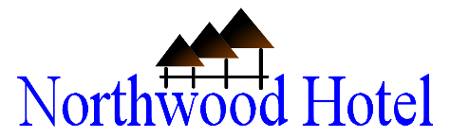

No.21 Quezon Ave., Poblacion, Alaminos City, Pangasinan

Reservation Confirmation

**Dear:**

Thank you for choosing to stay at Northwood Hotel

We are pleased to confirm your accommodation as follows:

|  |  |  |  |
| --- | --- | --- | --- |
| Arrival: |  | ETA: |  |
| Departure: |  | ETD: |  |
| Guest: |  | Guest Type: |  |
| Room Type: |  | | |
| Booking REF: |  | Total: |  |

**HOTEL CHECK IN:** 2.00pm **CHECK OUT:** 12.00nn. Late Check Out till 1:00pm is complementary and subject to availabilityfor booking direct, enquires on arrival.

**CANCELLATION:** will be accepted up to 48hrs prior to arrival date. Should you cancel within 48hrs of arrival, you willforfeit the total cost of accommodation. No Cancellation accepted during a Special Event Period 7 days before arrival.

**BEDDING TYPE REQUESTS:** Please request your preferred bedding configuration before arrival, to arrange contactreservations. We try to honour all requests however bedding configuration is not guaranteed and will be confirmed upon arrival, and subject to availability.

**THE FINE PRINT:**

* To guarantee your reservation a down payment of 50% of the total package amount must be made as soon as the booking is confirmed (within 48 hours of guest confirmation) and full payment must be paid during check-in. Failure to deposit down payment will result in forfeiture of reservation. Failure to make full payment will nullify the booking and consequently bestows on Northwood Hotel the right to disallow the guest to use our facilities.
* Any Valid or Government issues Photo ID is required to check in at the hotel.
* All credit card payments incur a surcharge of 5% additionally to the amount charged.
* The rooms are all strictly non-smoking.

We look forward to welcome you to Northwood Hotel in the near future. Should you need any further information regarding your reservation please email northwoodhotelalaminos@gmail.com or call (075) 636-0910 /+639954086292

|  |  |  |
| --- | --- | --- |
| Thank You |  |  |
| Northwood Hotel bank account numbers: |  |
|  |  |
| Warm Regards, | 368-7-36801187-4 |  |
| Cabrito Manzano Properties Inc. |  |
|  |  |
| **Reservations Team** | Metro Bank |  |
|  |  |