Permafleet Mission Platform
Solution Brief
A live Star Citizen activity relay + an officer-validated mission register for the org. Prepared 13 June 2026 · Status: working prototype, expanding.

Contents
- Executive summary
- 1. What this is
- 2. Where we are now
- 3. What users can do
- 4. The mission register & lifecycle
- 5. The Discord Events hook
- 6. Making a busy feed useful — filters, grouping, metrics
- 7. Future web UI (Discord-role-gated)
- 8. Packaging & distribution (.exe) and virus-scan trust
- 9. Future option — decentralized deployment
- 10. External dependencies & indicative costs
- 11. Roadmap
- 12. Decisions for the product owner
- 13. Honest limitations

Executive summary
This project began as a way to turn a single player’s Star Citizen game log into a Discord feed. Through hands-on testing it has grown into something more useful for an organisation: a live activity relay that each member runs locally, feeding a central mission register that officers use to post missions and fleet actions, members use to take part, and officers validate on completion — all backed by a tamper-evident record.
The single most important thing we learned: the game log cannot prove what happened. The current build does not record kills or ship destruction at all, and a player’s own log is self-reported. So the platform is deliberately built around human (officer) validation as the authority, with the game log providing supporting “evidence” where it exists. This is exactly why it handles out-of-game missions and fleet actions as naturally as in-game ones.
Today the live relay and dashboard work and are tested; the mission register’s engine is built and proven end-to-end; the remaining work is to give it buttons (a web API and a Discord bot) and to host it on a small always-on server. A standout opportunity is to hook into Discord Scheduled Events — officers already create them and members already click “Interested” — so we can capture interest, attendance and activity with almost no new workflow.
Looking further ahead, the architecture keeps the door open to a decentralized (federated) deployment — where members’ own machines share signed updates so there is no single point of failure — without committing to it now. It is an optional resilience upgrade, not a requirement, and most of the value arrives well before it is needed.

1. What this is
Think of it as two halves that work together but are kept separate: a Live Relay on each member’s PC (the only place the game log exists), and a Central Service in the cloud that holds the shared mission register, the activity feed, and the audit trail. Discord is the front door everyone already uses.
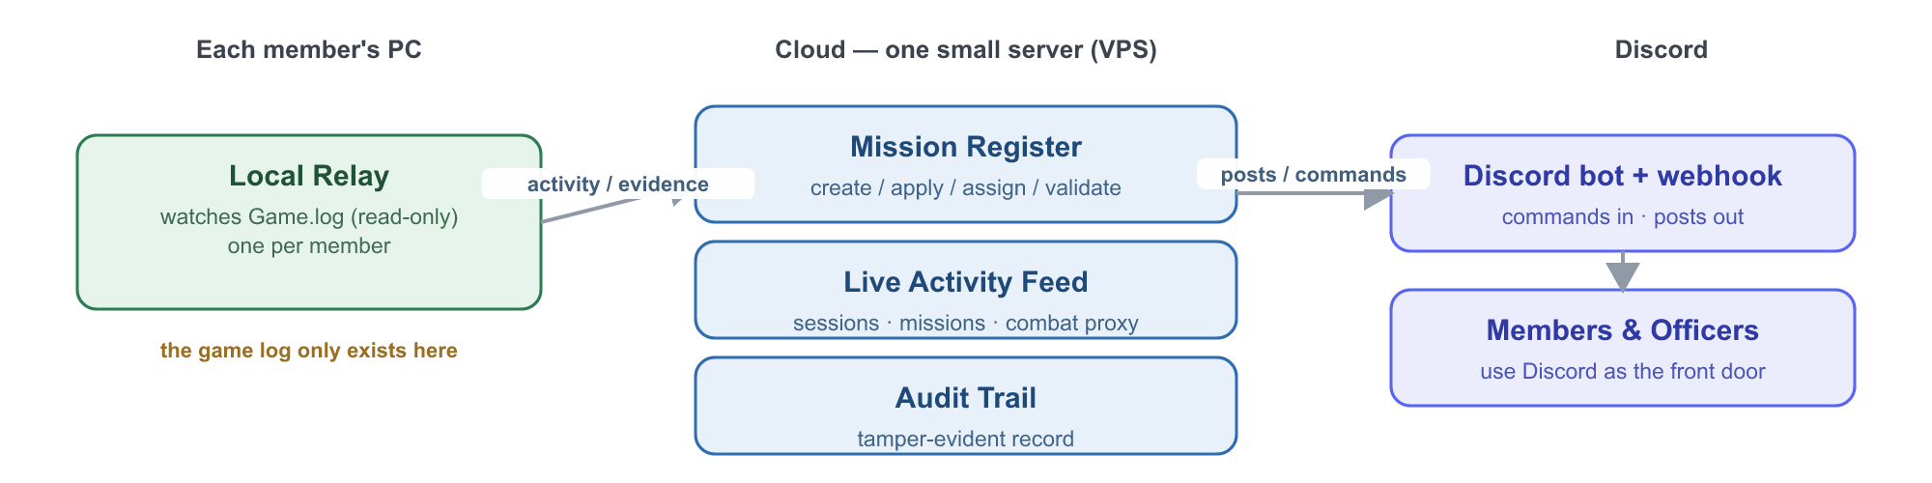
Figure 1 — How the pieces fit together.

2. Where we are now
An honest snapshot of what a user can actually do today versus what is planned:
Capability | Status
Live dashboard — sessions, players, missions, combat-progress, notifications | Built & tested
Auto-detect game install & channel (LIVE / PTU / HOTFIX), survive restarts | Built & tested
Group missions by mission, with objectives nested | Built & tested
Live activity posted to Discord (one-way webhook) | Working once connected
Mission register engine — create / apply / assign / claim / officer-validate + audit | Built (engine), proven end-to-end
Mission register over a web API | Next (M5.2)
Mission register inside Discord (slash commands + Events hook) | Planned (M5.3)
Always-on cloud hosting | Planned (M4)
Detecting individual kills | Not possible (game does not log them)
Decentralized / no-central-server | Optional, later

3. What users can do

Member
- Browse missions and fleet actions (reward, requirements, deadline).
- Apply from Discord; get assigned when an officer accepts.
- Mark a mission complete and (optionally) attach evidence the relay captured.
- See their own participation history.

Officer / administrator
- Post missions and fleet actions — including out-of-game ones the game cannot see.
- Accept or reject applications.
- Validate completions — the core authority step that approves the reward.
- Manage who is an officer via a Discord role.
- See a tamper-evident audit trail of who created, applied to and approved everything.

4. The mission register & lifecycle
Every mission moves through a simple, auditable lifecycle. The officer validation step is the heart of it: because the log cannot prove completion, a human confirms it.
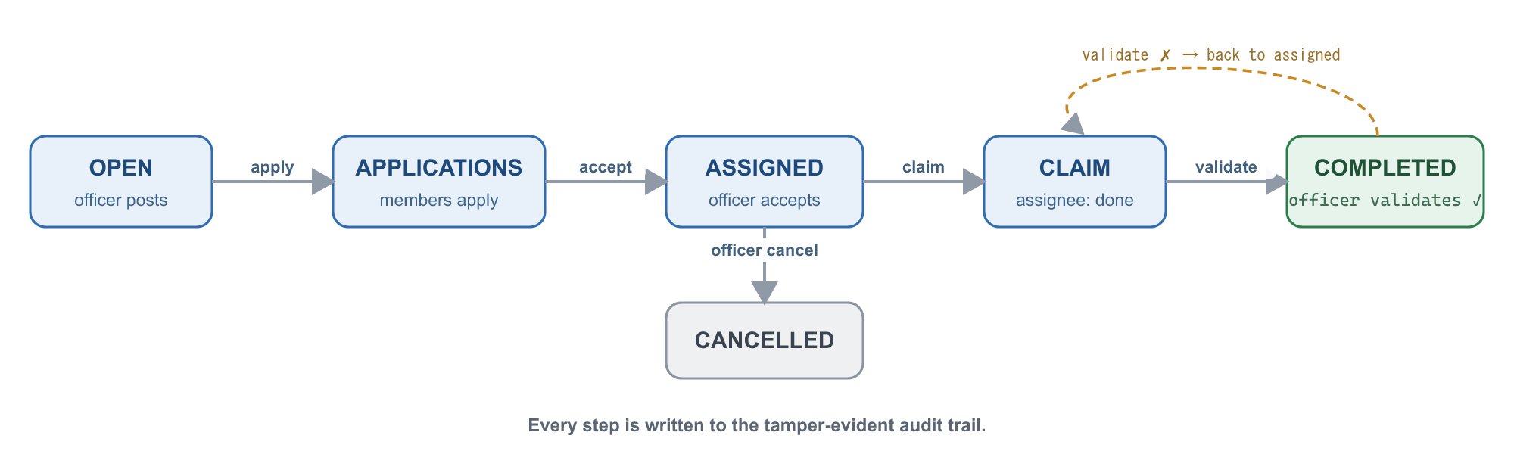
Figure 2 — Mission lifecycle, from posting to officer-validated completion.

5. The Discord Events hook
Officers already create Discord Scheduled Events and members already click “Interested.” We can build on that instead of inventing a new workflow. Discord’s API lets us read the interested list; the relay supplies who actually turned up and what they did during the event window.
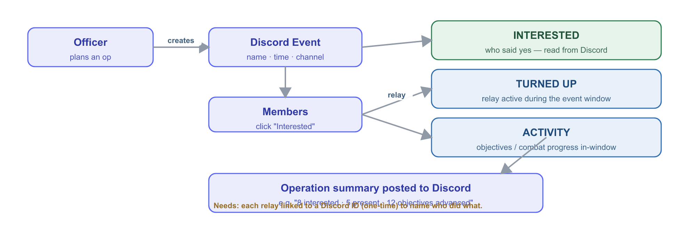
Figure 3 — Using Discord Events to capture interest, attendance and activity.
Why it’s powerful: it turns a workflow officers already use into a participation record — interested vs. turned-up vs. did-stuff — with almost no extra effort. The one prerequisite is a one-time link between each member’s relay and their Discord identity so activity can be attributed to the right person.

6. Making a busy feed useful — filters, grouping, metrics
At fleet scale a raw feed becomes noise. Three levers keep it valuable:

Filter by mission type or operation
In-game mission types (Bounty, Mercenary/Defense, Hauling, Salvage, Investigation, dynamic events such as XenoThreat) can be inferred from the log and mapped to friendly categories. Org “operations” (e.g. “Tactical Strike Group” — a real announced Star Citizen feature) are officer-named labels that in-game activity rolls up under.

Group, don’t spam
- Group by mission (one card per mission, not per line).
- Roll up to operation level (one card per op).
- Edit a single message as it progresses, or use one thread per operation — the biggest noise-killer.
- Optional periodic digest instead of live events.

Metrics — what the log allows
The register is the scoreboard (trustworthy); the log is the colour commentary (engagement, clearly labelled “inferred”). Suggested measures:
Metric | Source | Confidence
Operation participation (distinct members active) | relays | inferred
Active-player-minutes per operation | relays | inferred
Objectives advanced / combat-progress per op | relays | inferred (proxy)
Missions completed per week; completion rate | register | validated
Average time-to-complete / time-to-validate | register | validated
Interest → turn-up conversion; no-show rate | Discord + relays | mixed
Member leaderboard (participation, not kills) | register | validated

7. Future web UI (Discord-role-gated)
Discord remains the primary interface, but a lightweight web front end on the VPS is a natural future addition for officers who want a richer view (a validation queue, metrics dashboards). The key idea: members log in with Discord (no new passwords) and their Discord roles decide what they see — officers get the admin views, members get their own. This is a placeholder for planning; not yet built.
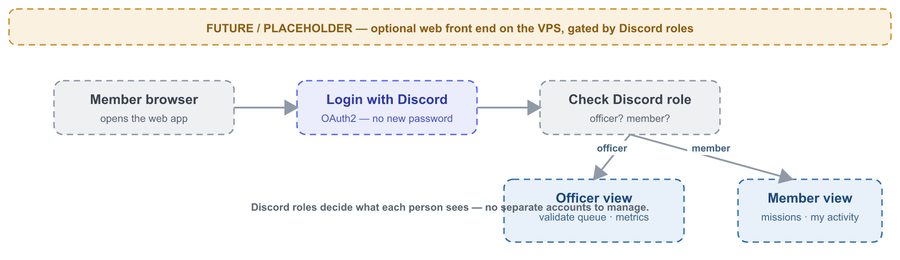
Figure 4 — Placeholder concept: a VPS web front end gated by Discord roles.

8. Packaging & distribution (Windows & Linux) and virus-scan trust
For non-technical members the relay should be a single download that just runs — no Node.js install, no terminal. We need both a Windows and a Linux build: many members play on Windows, a growing number play via Proton/Wine on Linux, and the central service itself runs on a Linux server.
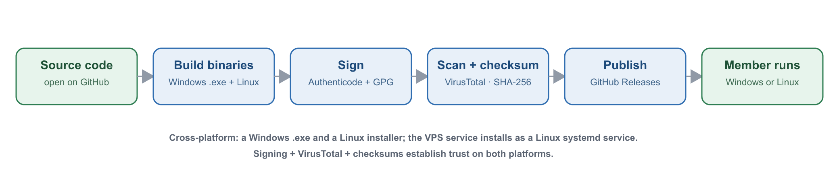
Figure 5 — From source code to a trusted, cross-platform install (Windows & Linux).

Packaging — three targets
Target | What we ship | How it runs
Windows relay | A single .exe (Node.js Single Executable App; alt: pkg/nexe) | Double-click; optional auto-start as a background task
Linux relay | A self-contained binary + install script (tarball; optionally .deb / AppImage) | One-line install; optional auto-start as a systemd user service
Server (VPS) | The central service installed as a Linux systemd service | Runs always-on; survives reboots
- First-run setup writes a tiny config (member’s Discord ID, the server address) on either OS.
- The relay auto-detects the game log: Windows drive paths today; the Linux build adds Proton/Wine prefix detection (e.g. under the Steam/Lutris compat folder).

Virus-scan & trust (important for adoption)
Windows: bundled-Node executables from an unknown publisher commonly trigger SmartScreen warnings and occasional antivirus false positives. Linux: no SmartScreen, but we still want verifiable, signed downloads. The trust stack covers both:
- Signing — Windows: an Authenticode (ideally EV) certificate earns instant SmartScreen reputation — the real fix for “unknown publisher” (~$200–600/yr). Linux: GPG-sign the binaries (and, for a .deb, a GPG-signed apt repo) — free.
- VirusTotal — upload each release (free, ~70 engines) and publish the report link so members can verify, on both platforms.
- GitHub Releases + SHA-256 checksums — members confirm the file is unmodified; the build is auditable because the source is open.
- False-positive submission — if Microsoft Defender (or a Linux AV) flags a release, submit it for review to clear it.
Honest note: false positives are normal for this kind of executable; the combination of signing + VirusTotal + checksums + open source is how we establish trust, not a single silver bullet.

9. Future option — decentralized deployment
The current plan uses one small cloud server the org runs — simple, cheap and a good fit for a trusted organisation. The architecture also keeps the door open to a federated version: members’ own machines exchange signed updates so there is no single point of failure, with the cloud server becoming just one node among several and Discord still the front door.
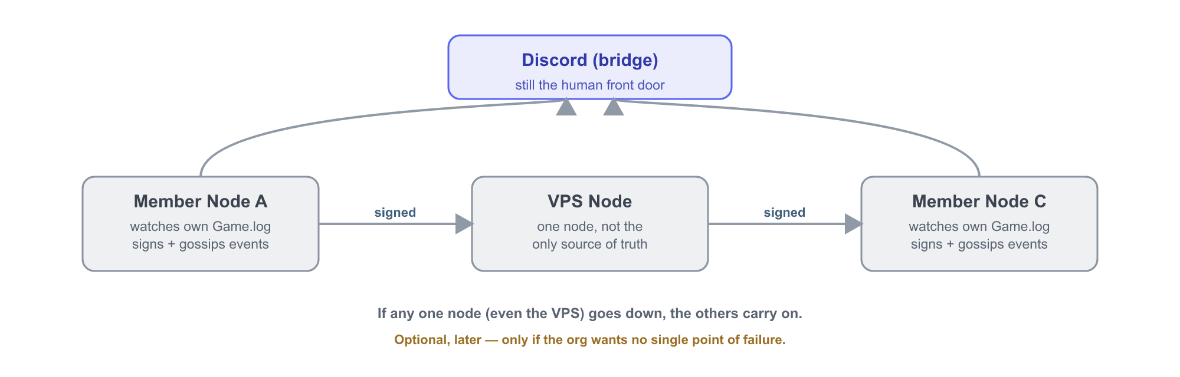
Figure 6 — Optional future: a federated network with no single point of failure.
Recommendation: treat this as an optional resilience upgrade for later. It is genuinely workable (the cryptographic building blocks already exist in the codebase), but it is a sizeable effort and the org — with trusted leadership — does not need it to get the full value. Revisit only if removing reliance on the single server becomes important, or to federate across multiple orgs.

10. External dependencies & indicative costs
Dependency | What it’s for | Cost / effort
Small cloud server (VPS) | Hosts the always-on register & feed | ~$5–10 / month
Discord bot | Two-way commands & the Events hook (a webhook can only post out) | Free; ~30 min setup
Discord server + Officer role | Identity and who-can-validate | Free; your existing server
Each member runs the relay | Reads their local game log (Windows or Linux) | Free; small download
Code-signing certificate | Trusted Windows .exe (no SmartScreen); Linux uses free GPG | ~$200–600 / yr (Windows, optional)
Domain name | Friendly web address (web UI) | ~$10–15 / year (optional)
Deliberately not needed: no blockchain, no cryptocurrency, no paid database, no app-store apps.

11. Roadmap
- M4 — Stand up the cloud server (a home for the register). Needs: hosting choice/budget.
- M5 — Mission register: API (M5.2) then Discord bot + Events hook (M5.3). Needs: create the Discord bot, define the Officer role.
- M6 — Officer roles + signed audit trail (cryptographically signed validations).
- Ongoing — improve what the relay recognises (never blocks the register).
- Later / optional — web UI and/or decentralization.

12. Decisions for the product owner
- Hosting provider and monthly budget.
- Approve creating the Discord bot; choose which role = Officer.
- Live-feed channel: public or private.
- Confirm rewards are informational only (no real money / no blockchain).
- Whether to buy a code-signing certificate for the .exe (improves member trust).

13. Honest limitations
- Individual kills (PvE or PvP) cannot be detected — the game does not log them.
- In-game “activity” is only visible for members who run the relay.
- Activity attribution needs a one-time link between a member’s relay and their Discord ID.
- Cross-player correlation of a shared mission is by type + operation + time window, unless the game exposes a shared id (to be confirmed against a real capture).
- A player’s own log is self-reported — which is exactly why officer validation is the authority.

Prepared by the build team with Claude Code. Source and living technical docs (DESIGN-missions-mvp, DECISIONS, PROGRESS) are in the project repository.

