Question 1

select cri.customer_id, ai.account_type, ai.account_no, bi.bank_name

from customer_reference_info cri join account_info ai

on cri.customer_id=ai.customer_id

join bank_info bi

on ai.ifsc_code=bi.ifsc_code

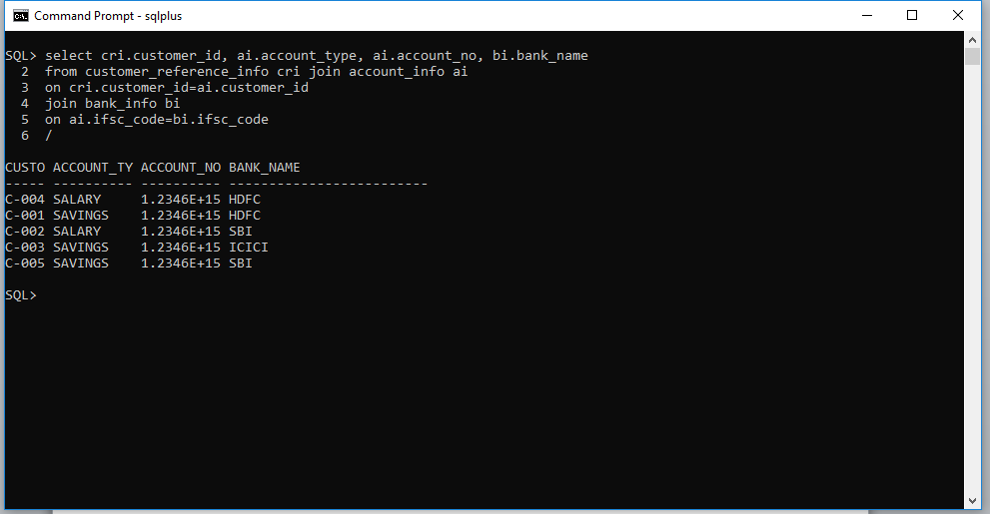

Question 2

select cri.customer_id, ai.account_type, ai.account_no, bi.bank_name, ai.registration_date

from customer_reference_info cri join account_info ai

on cri.customer_id=ai.customer_id

join bank_info bi

on ai.ifsc_code=bi.ifsc_code

where bi.bank_name='HDFC' AND ai.registration_date BETWEEN '12-JAN-2012' AND '04-APR-2012'

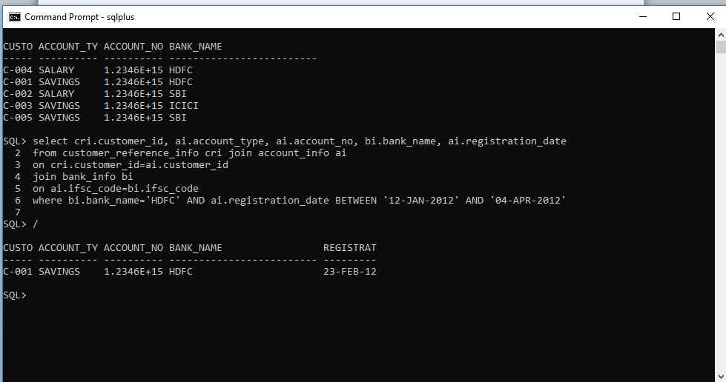

Question 3

select cpi.customer_id, cpi.customer_name, ai.account_type, ai.account_no, bi.bank_name

from customer_personal_info cpi join account_info ai

on cpi.customer_id=ai.customer_id

join bank_info bi

on bi.ifsc_code=ai.ifsc_code

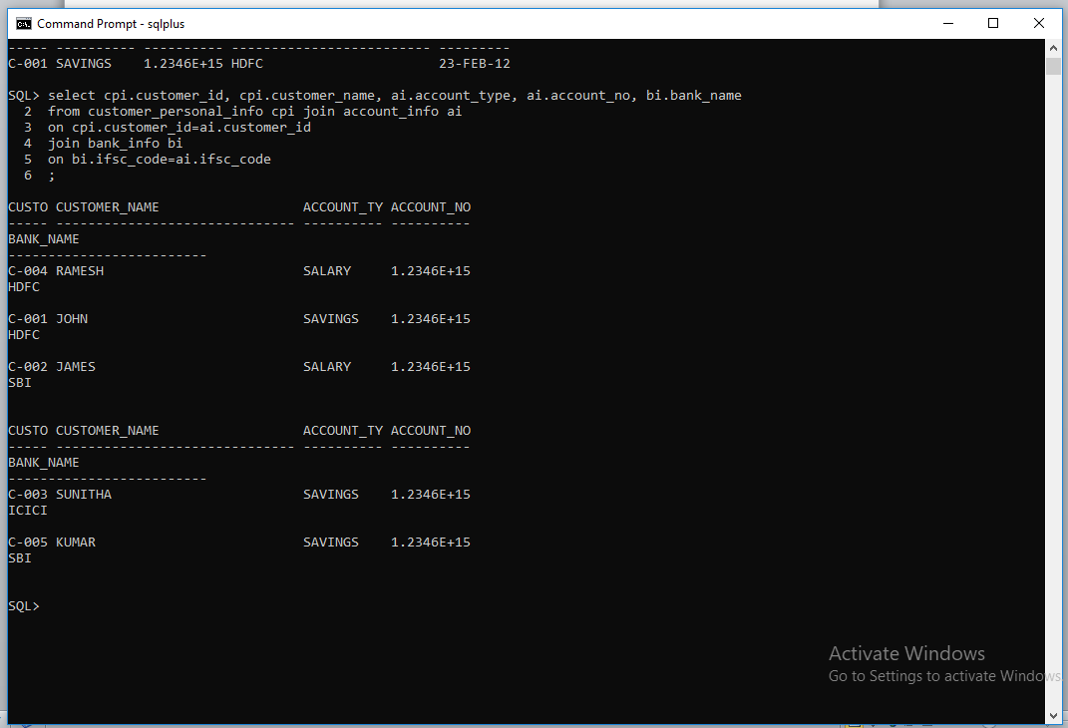

Question 4

select customer_id, customer_name, gender, marital_status, customer_name||'_'|| gender||'_'|| marital_status unique_ref_string from customer_personal_info

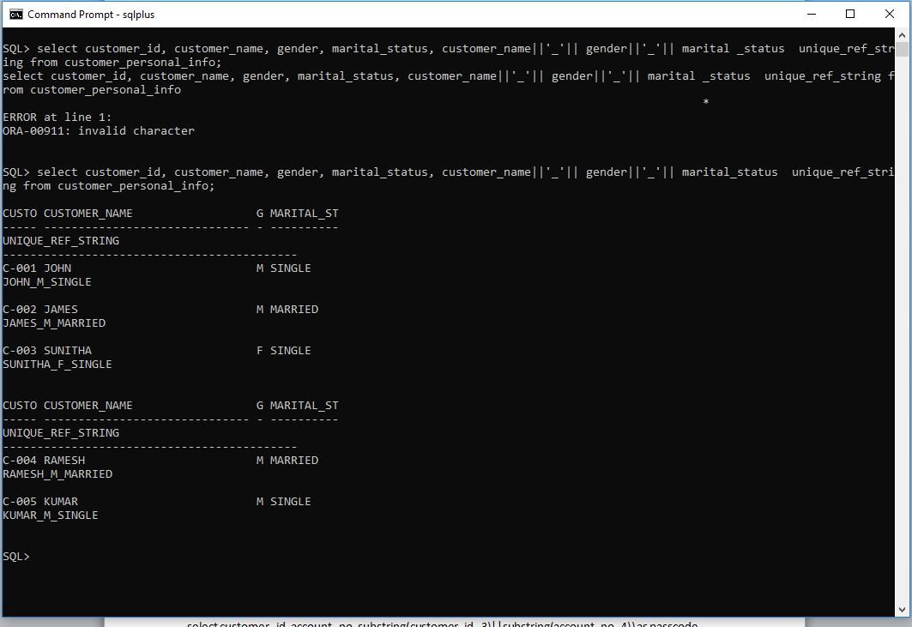

Question 5

select account_no, customer_id, registration_date, initial_deposit

from account_info

where initial_deposit BETWEEN 15000 and 25000

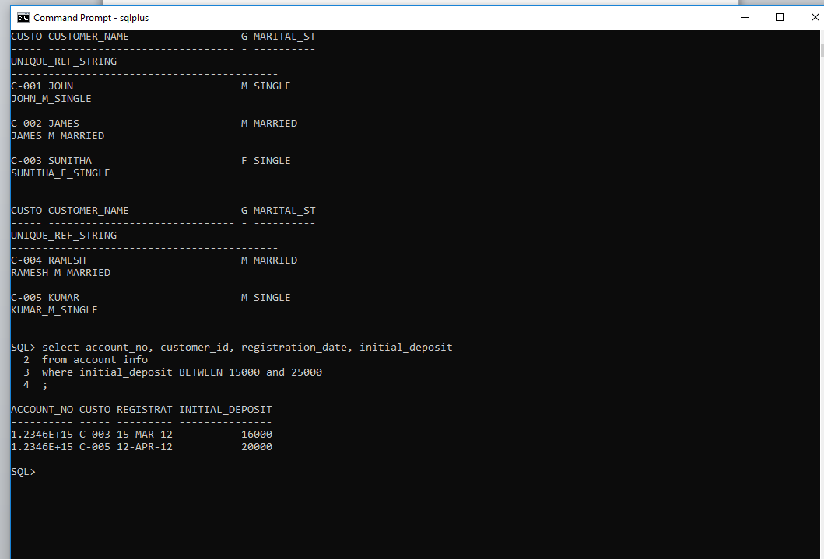

Question 6

select customer_id, customer_name, date_of_birth, guardian_name from customer_personal_info

where customer_name LIKE 'J%'

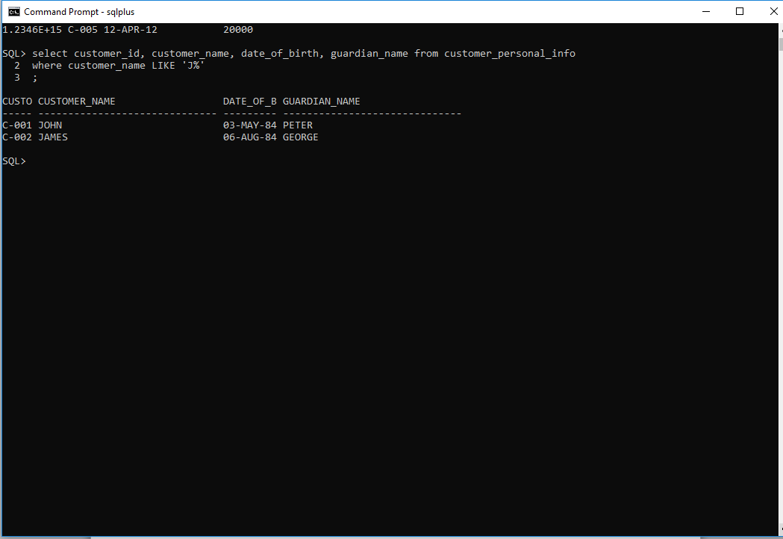

Question 7

select customer_id, account_no, substr(customer_id,-3)||substr(account_no,-4) as passcode

from account_info

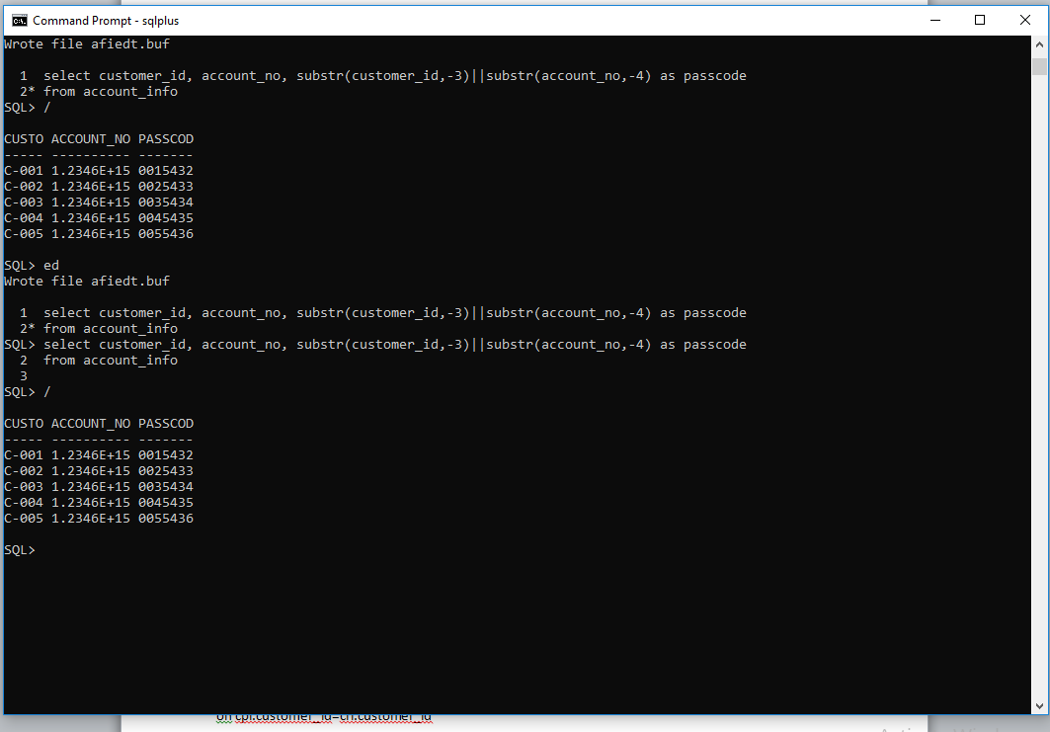

Question 8

select customer_id, customer_name, date_of_birth, marital_status, gender, guardian_name, contact_no, mail_id

from customer_personal_info

where gender='M' and marital_status='MARRIED'

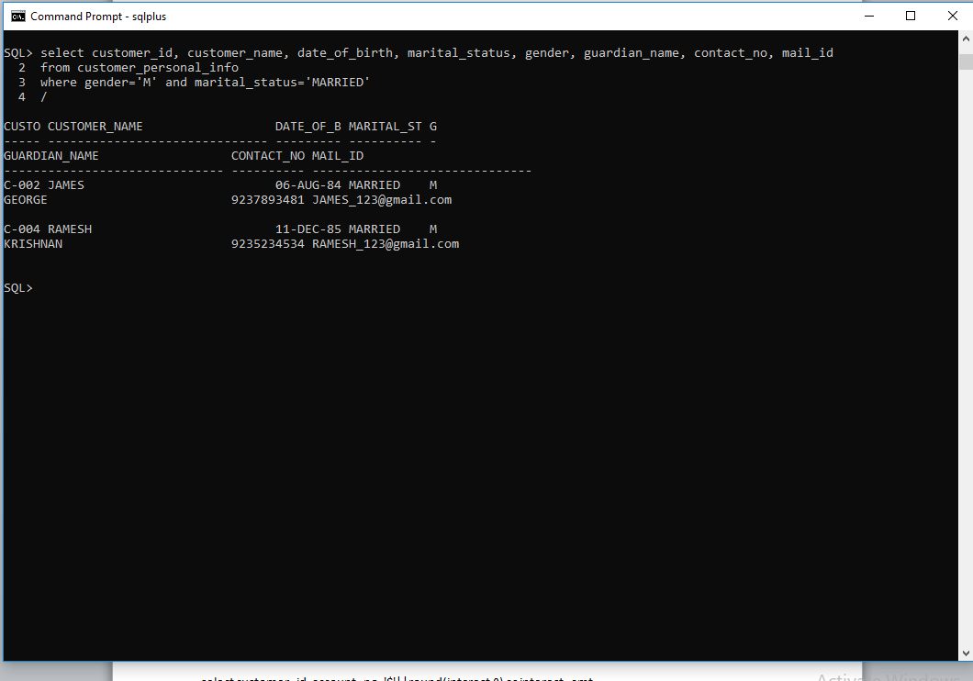

Question 9

select cpi.customer_id, cpi.customer_name, cpi.guardian_name, cri.reference_acc_name as friend

from customer_personal_info cpi join customer_reference_info cri

on cpi.customer_id=cri.customer_id

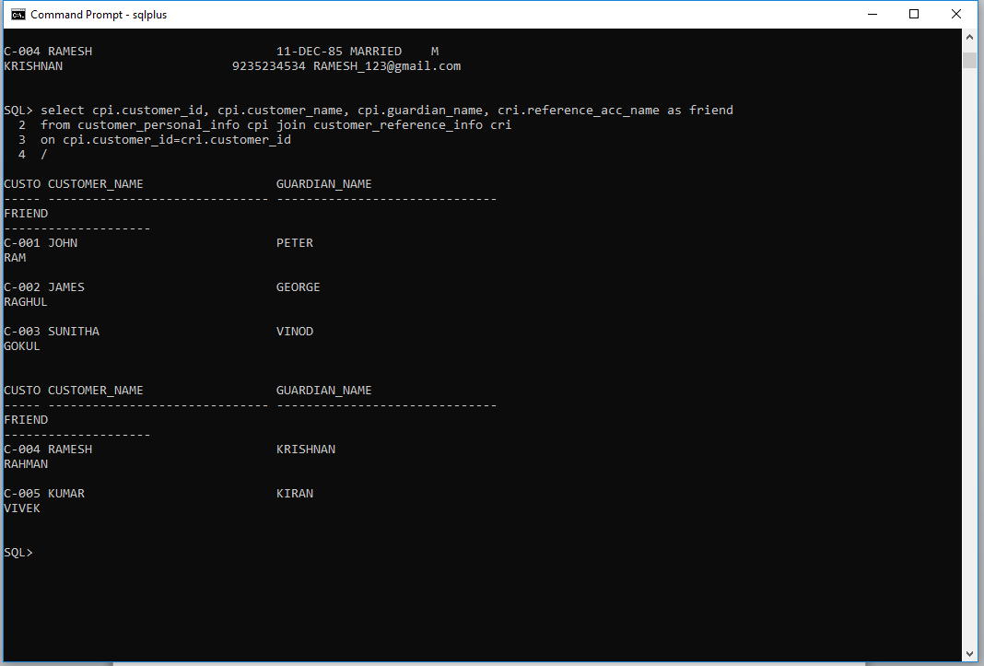

Question 10

select customer_id, account_no, '$'||round(interest,0) as interest_amt

from account_info

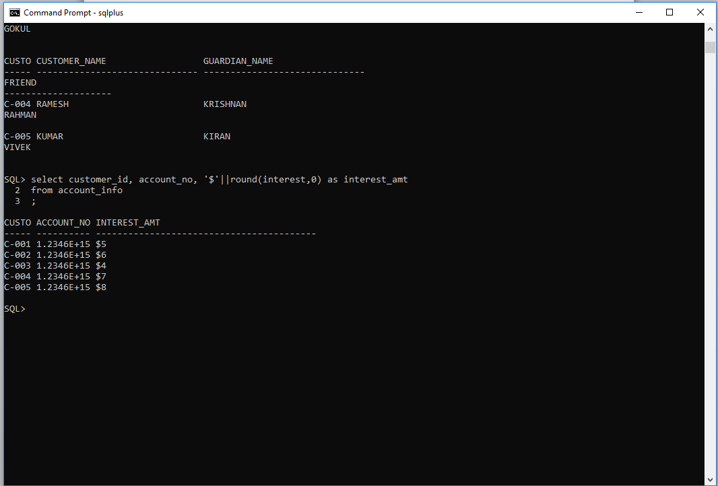

Question 11

select cpi.customer_id, cpi.customer_name, ai.account_no, ai.account_type, ai.activation_date, bi.bank_name

from customer_personal_info cpi join account_info ai

on cpi.customer_id=ai.customer_id

join bank_info bi

on bi.ifsc_code=ai.ifsc_code

where ai.activation_date='10-APR-2012'

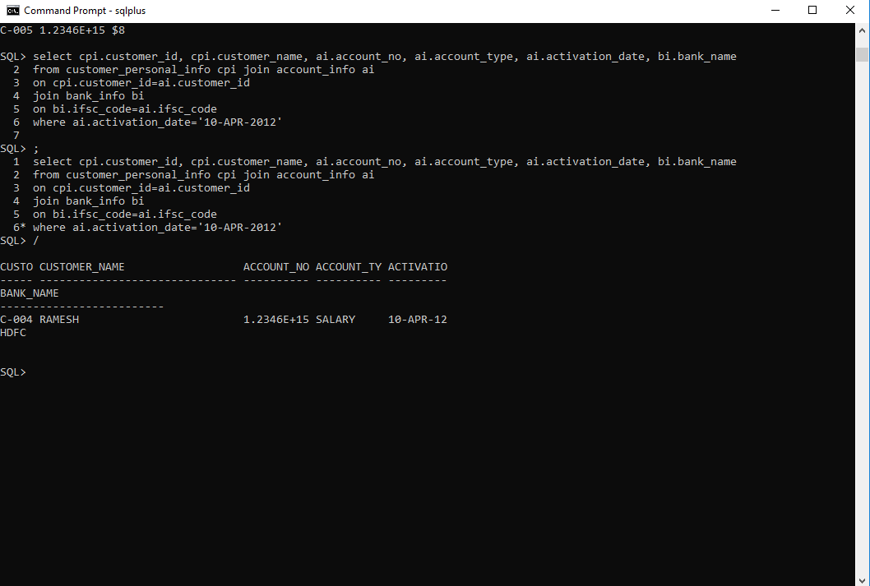

Question 12

select ai.account_no, cpi.customer_id, cpi.customer_name, bi.bank_name, bi.branch_name, bi.ifsc_code, cpi.citizenship, ai.interest, ai.initial_deposit

from customer_personal_info cpi

join account_info ai

on cpi.customer_id=ai.customer_id

join bank_info bi

on bi.ifsc_code=ai.ifsc_code

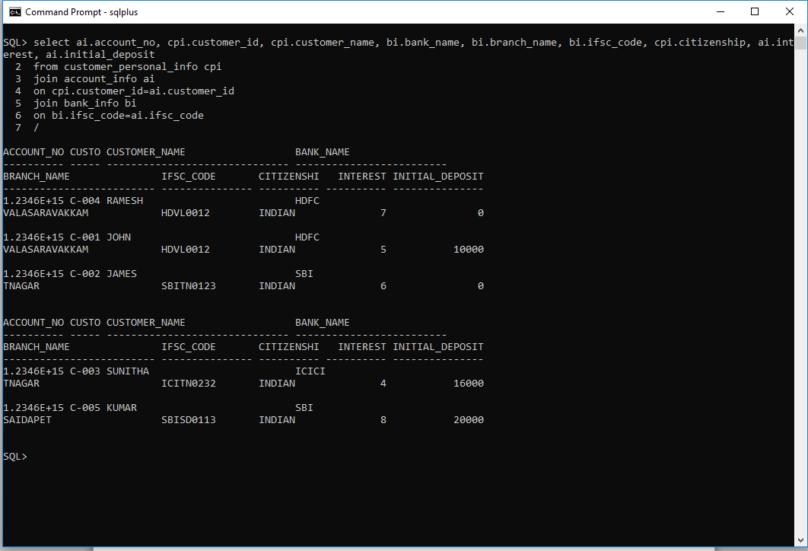

Question 13

select cpi.customer_id, cpi.customer_name, cpi.date_of_birth, cpi.guardian_name, cpi.mail_id, cri.reference_acc_name

from customer_personal_info cpi join customer_reference_info cri

on cpi.customer_id=cri.customer_id

where cpi.identification_doc_type='PASSPORT'

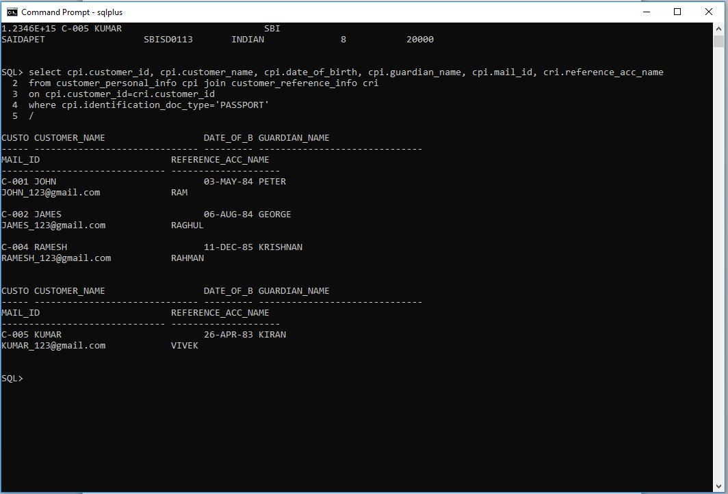

Question 14

select cpi.customer_id, cpi.customer_name, ai.account_no, ai.account_type, ai.initial_deposit, ai.interest

from customer_personal_info cpi join account_info ai

on cpi.customer_id=ai.customer_id

where ai.initial_deposit=(select max(initial_deposit) from account_info)

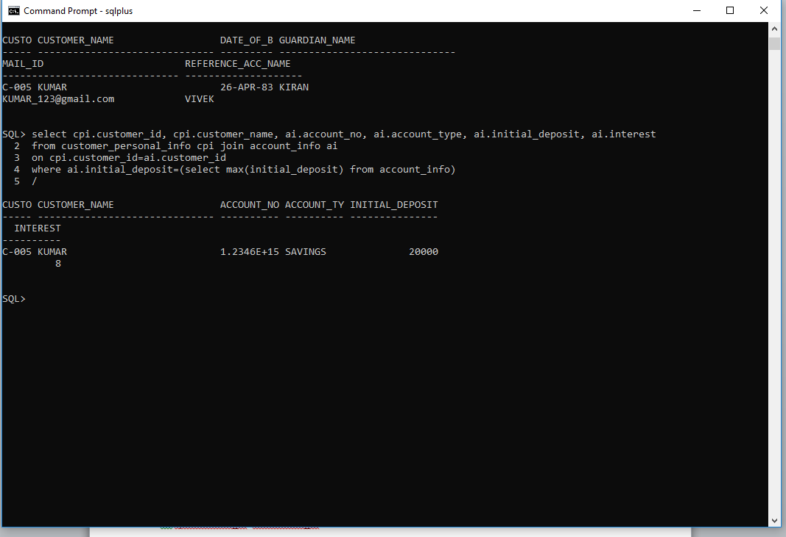

Question 15

select cpi.customer_id, cpi.customer_name, ai.account_no, ai.account_type, ai.interest, bi.bank_name, ai.initial_deposit

from customer_personal_info cpi join account_info ai

on cpi.customer_id=ai.customer_id

join bank_info bi

on ai.ifsc_code=bi.ifsc_code

where ai.interest=(select max(interest) from account_info)

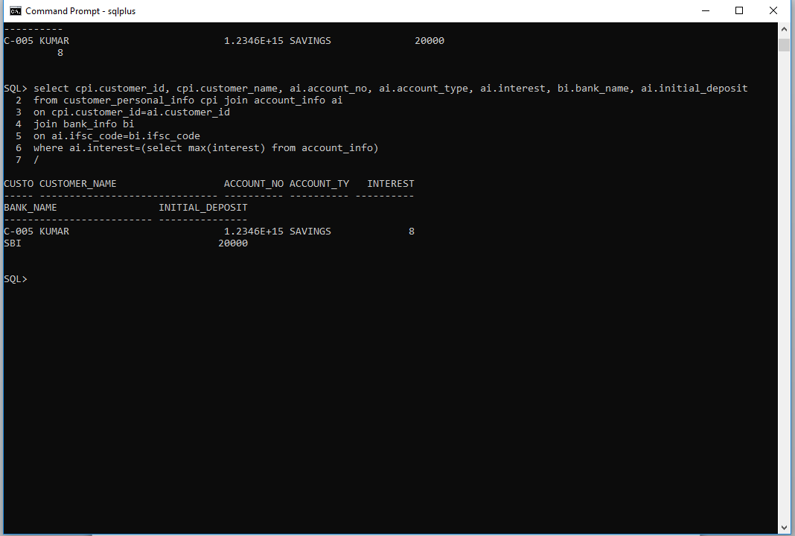

Question 16

select cpi.customer_id, cpi.customer_name, ai.account_no, bi.bank_name, bi.branch_name, cpi.contact_no, cpi.mail_id

from customer_personal_info cpi join account_info ai

on cpi.customer_id=ai.customer_id

join bank_info bi

on bi.ifsc_code=ai.ifsc_code

where cpi.address like '%BANGALORE'

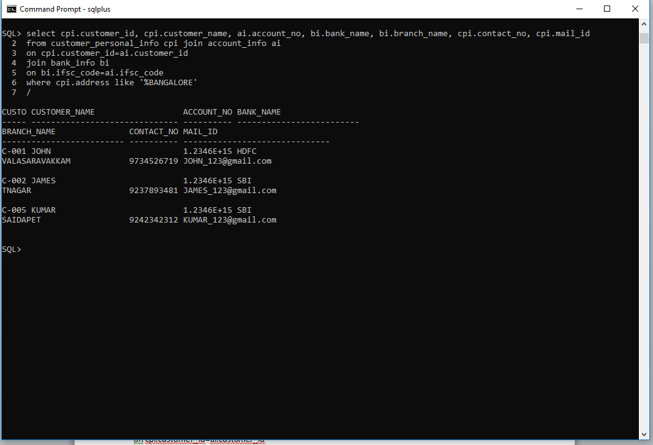

Question 17

select cpi.customer_id, bi.bank_name, bi.branch_name, bi.ifsc_code, ai.registration_date, ai.activation_date

from customer_personal_info cpi join account_info ai

on cpi.customer_id=ai.customer_id

join bank_info bi

on bi.ifsc_code=ai.ifsc_code

where activation_date like '%MAR%'

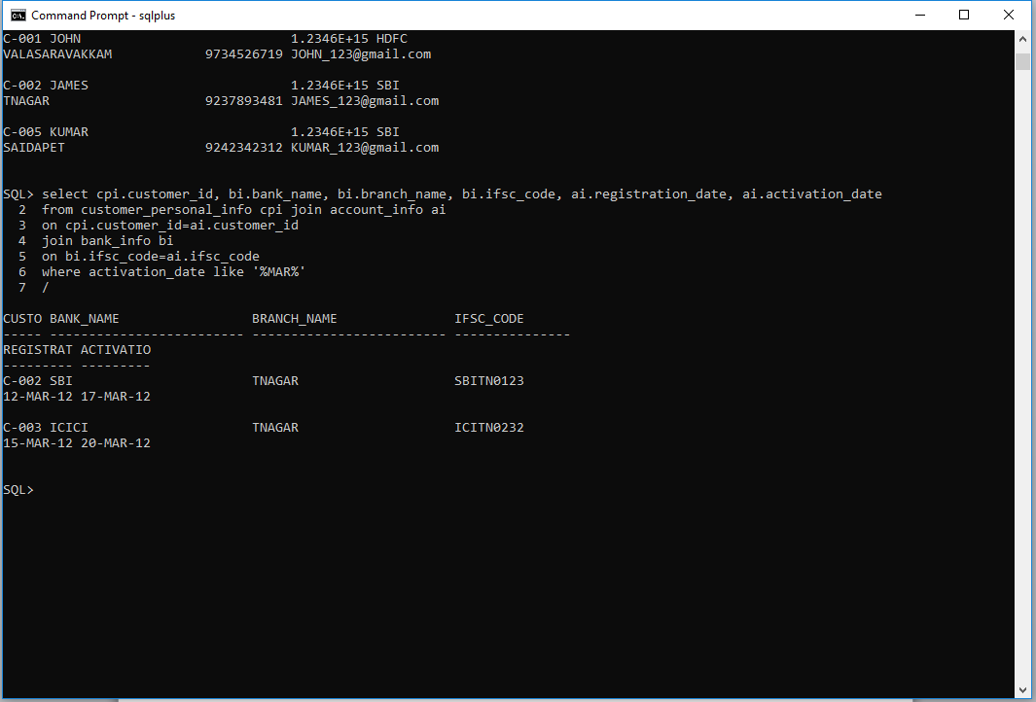

Question 18

select ((interest/100)*initial_deposit) as interest_amt, cpi.customer_id, cpi.customer_name, ai.account_no, ai.account_type, ai.interest, ai.initial_deposit

from customer_personal_info cpi join account_info ai

on cpi.customer_id=ai.customer_id

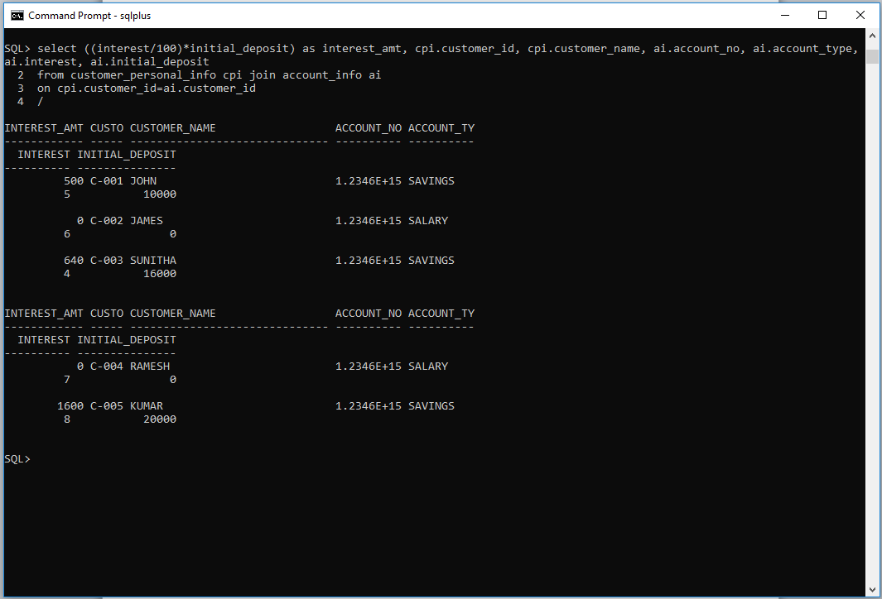

Question 19

select cpi.customer_id, cpi.customer_name, cpi.date_of_birth, cpi.guardian_name, cpi.contact_no, cpi.mail_id, cri.reference_acc_name

from customer_personal_info cpi join customer_reference_info cri

on cpi.customer_id=cri.customer_id

where cri.reference_acc_name='RAGHUL'

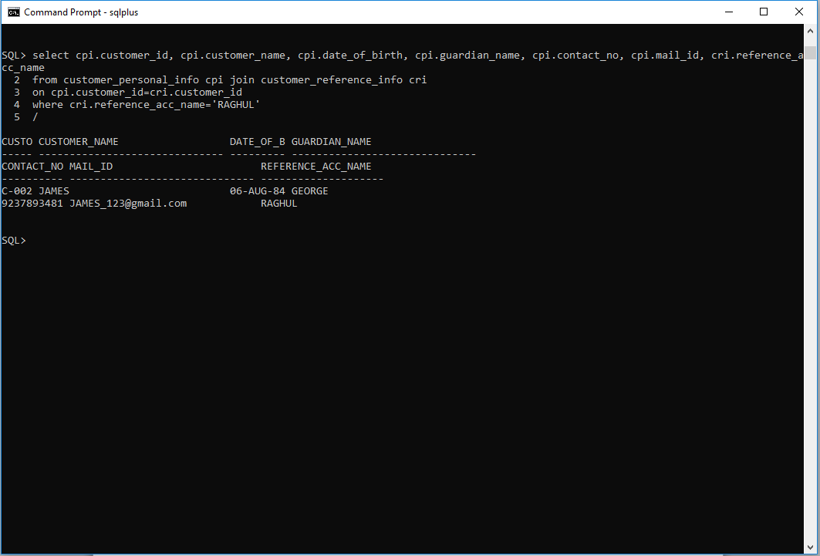

Question 20

select customer_id, customer_name, '+91-'||substr(contact_no,1,3)||'-'||substr(contact_no,4,3)||'-'||substr(contact_no,-4) as contact_isd

from customer_personal_info

order by customer_id desc

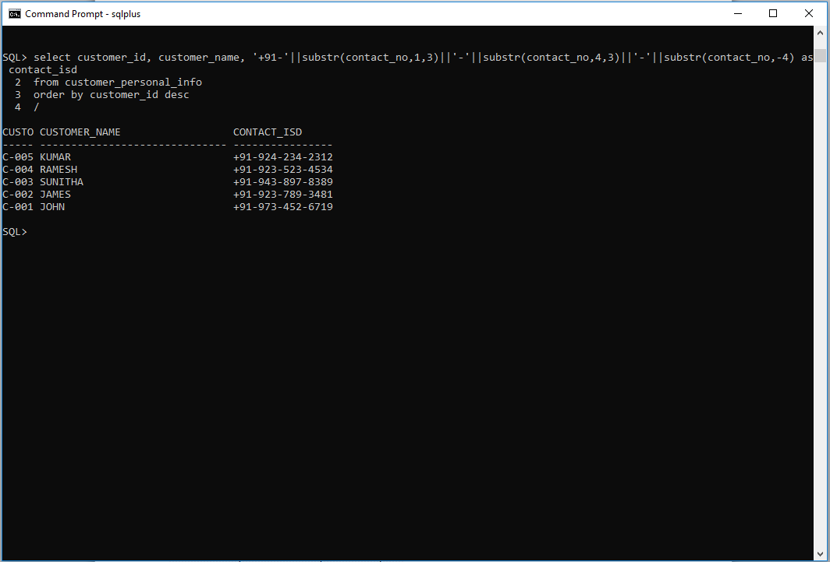

Question 21

select ai.account_no, ai.account_type, cpi.customer_id, cpi.customer_name, cpi.date_of_birth, cpi.guardian_name, cpi.contact_no, cpi.mail_id, cpi.gender,

cri.reference_acc_name, cri.reference_acc_no, ai.registration_date, ai.activation_date, (activation_date-registration_date) as NoofdaysforaActivation,

bi.bank_name, bi.branch_name, ai.initial_deposit

from customer_personal_info cpi join account_info ai

on cpi.customer_id=ai.customer_id

join bank_info bi

on bi.ifsc_code=ai.ifsc_code

join customer_reference_info cri

on cri.customer_id=cpi.customer_id

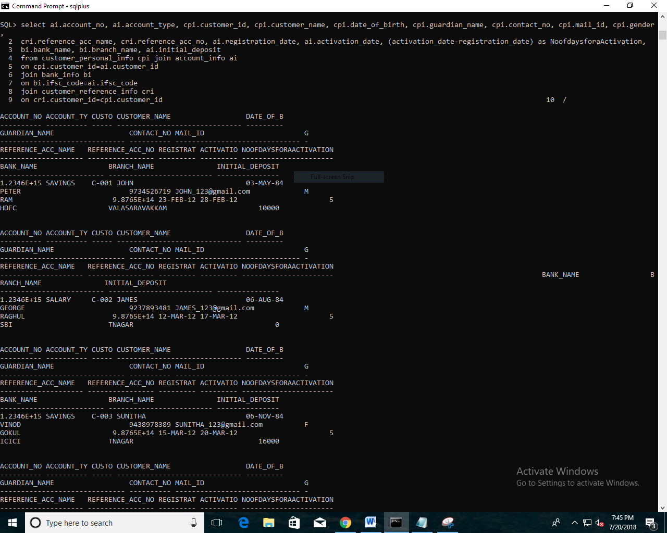

Question 22

select cpi.customer_id, cpi.customer_name, cpi.guardian_name, cpi.identification_doc_type, cri.reference_acc_name, ai.account_type, bi.ifsc_code, bi.bank_name, trunc((initial_deposit+interest),0) as current_balance

from customer_personal_info cpi join account_info ai

on cpi.customer_id=ai.customer_id

join bank_info bi

on bi.ifsc_code=ai.ifsc_code

join customer_reference_info cri

on cri.customer_id=cpi.customer_id

where account_type='SAVINGS'

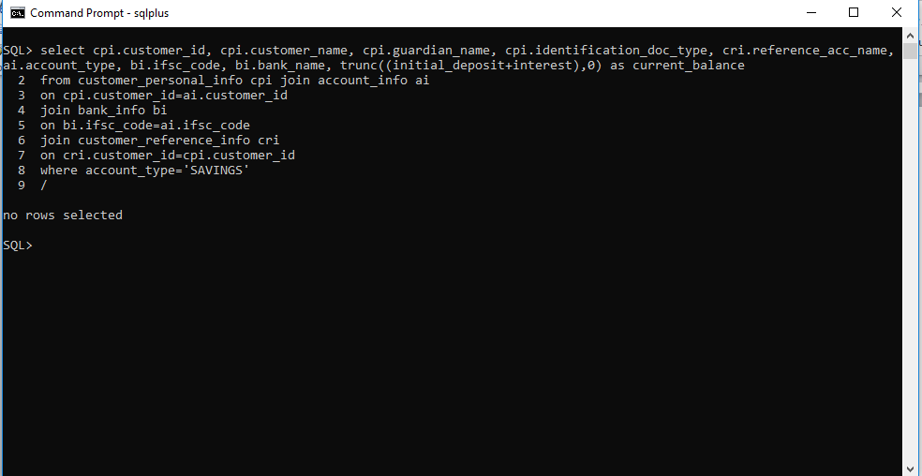

Question 23

select cpi.customer_id, cpi.customer_name, ai.account_no, ai.account_type, ai.interest, ai.initial_deposit,

case

when initial_deposit=20000 then 'high'

when initial_deposit=16000 then 'moderate'

when initial_deposit=10000 then 'average'

when initial_deposit=5000 then 'low'

when initial_deposit=0 then 'very low'

else 'invalid' end deposit_status

from customer_personal_info cpi join account_info ai

on cpi.customer_id=ai.customer_id

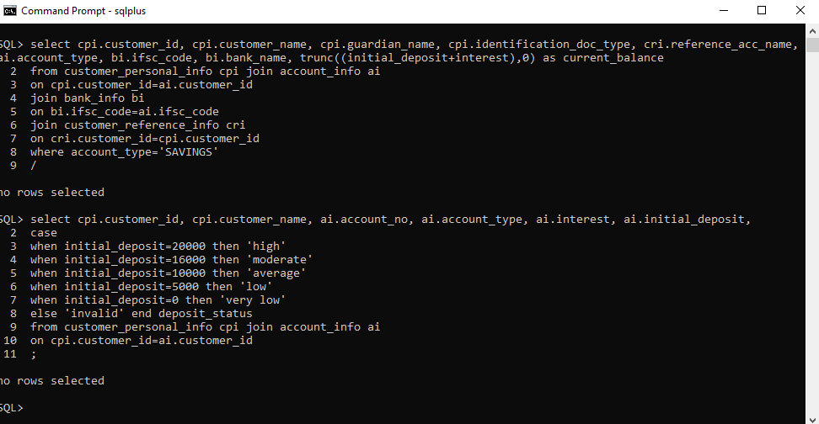

Question 24

select cpi.customer_id, cpi.customer_name, ai.account_no, ai.account_type, bi.bank_name, bi.ifsc_code, ai.initial_deposit,

case

when account_type='savings' then round((interest+(interest*10/100)),2)

else interest end new_interest

from customer_personal_info cpi join account_info ai on

cpi.customer_id=ai.customer_id

join bi_info bi on bi.ifsc_code=ai.ifsc_code

where cpi.customer_name like 'J%'

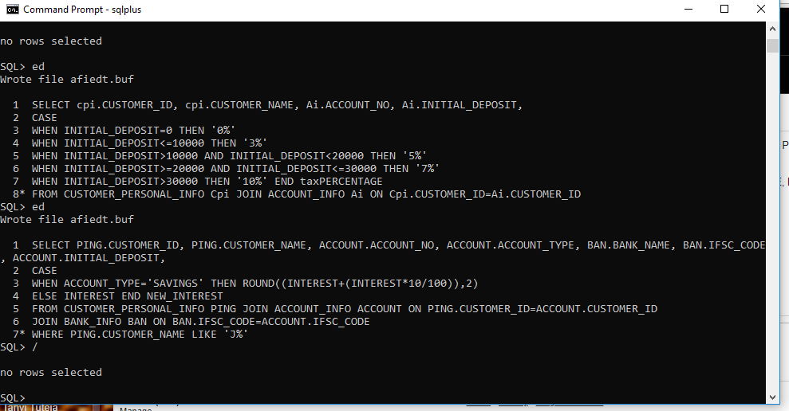

Question 25

select cpi.customer_id, cpi.customer_name, ai.account_no, ai.initial_deposit,

case

when initial_deposit=0 then '0%'

when initial_deposit<=10000 then '3%'

when initial_deposit>10000 and initial_deposit<20000 then '5%'

when initial_deposit>=20000 and initial_deposit<=30000 then '7%'

when initial_deposit>30000 then '10%' end taxpercentage

from customer_personal_info cpi join account_info ai on cpi.customer_id=ai.customer_id

