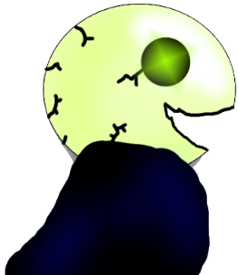

Spooky Run

By Neoteuthis Games

V1.0

**Project Goals**

The goal for this project is to learn the workings of the unity engine and build a fun infinite runner for all ages to be released on PC.

**Summary**

Spooky Run is an action platformer where the world is constantly generating before you where you can collect candy to speed up and collect unholy water to douse flames to collect as many points as possible!

**Gameplay**You start off slowly and quickly gain momentum in this exciting runner as you collect candy and avoid the flames. Once you have some unholy water you can spit it as you run to pass through a flame unharmed and gain extra points. Your goal is to avoid leaving the screen or burning alive while collecting as many points as possible!

**Character**

Meet Marrow, a fun loving denizen of the underworld with a sweet tooth, and a highly flammable robe! He can run, jump, and spit unholy water! With the right item, he might even be able to do a super jump!



**Enemies**

Throughout the adventure, there will be fire sprites up to no good, causing trouble in your neighborhood. One little touch and your cloak will catch fire, so you better spit some water to get rid of these guys! Staying hydrated is important! While on fire, you will be slowed down temporarily and will lose hp (The HP bar will be added in if possible, otherwise, it will just be the slow effect, or simply character death).

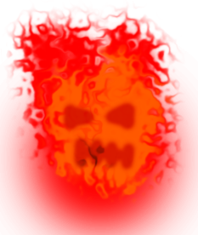

**Obstacles**

The main obstacle in your path is the path itself, or lack thereof. Watch out for walls and holes that may pull you off the screen and into the endless abyss!



**Environment**

The game takes place in Gloomy Hollow, right near the river Bryx. The haunting glow of the afterlife takes away from the absolute blackness. The fire sprites help too in their own way.

**Sound**

Background music that’s both eerie and upbeat mixed with sound effects for collecting items, spitting water, jumping, dying, hitting a fire sprite, defeating a fire sprite

**Controls**

AD is movement, with space and W both being jump, but W allowing for a super jump while you have a spring fungus. Marrow will start to shake when he can’t hold his jump any longer. D lets you spit unholy water at anything in your path as long as you have some in supply.

**Items**

Candy: Run faster and gain more points



Spring Fungus: Do a SUPER JUMP that can even send you through platforms!

Boughtttle: A bottle of unholy water that will give you some ammo against fire sprites.

**Menu**

The main menu will display the current high score as well as give the player the option to start, quit, or go to options.

**Options**

The options menu will allow you to erase all save data or go back to the main menu.

**UI**

The UI will display your score, the high score, as well as your held spring fungus and unholy water.

**Game Over**

Once you leave the screen the game is over. Your score will be recorded if it is the new high score, and you will be prompted to play again or quit.