Project Title:

Group Leader:
Name

Group Members:
List of Names

Submitted to:
Ms. Marisol B. De Guzman
Mr. Louise Vasques

Submission Dates:
Final Documentation - March 4, 2026
Final Defense
March 11, 2026

TABLE OF CONTENTS

2. Introduction
- Background of the System
- Problem Statement
- Project Objectives
- Scope and Limitations

3. Review of Related Concepts
- Object-Oriented Programming Concepts Used
- GUI Framework Overview
- MVC Architecture Overview

Example

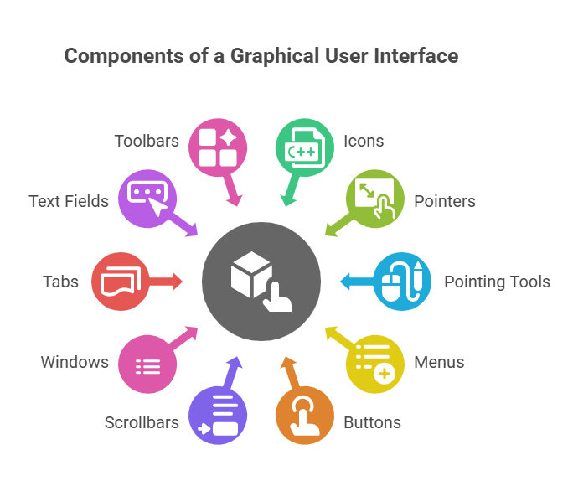

MVC Architecture Overview - EXAMPLE
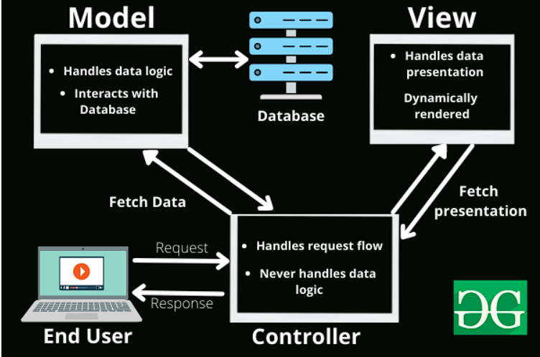

4. System Design
- System Architecture Diagram
- UML Class Diagram
- Description of Classes and Responsibilities

System Design (UML, Architecture)

Example
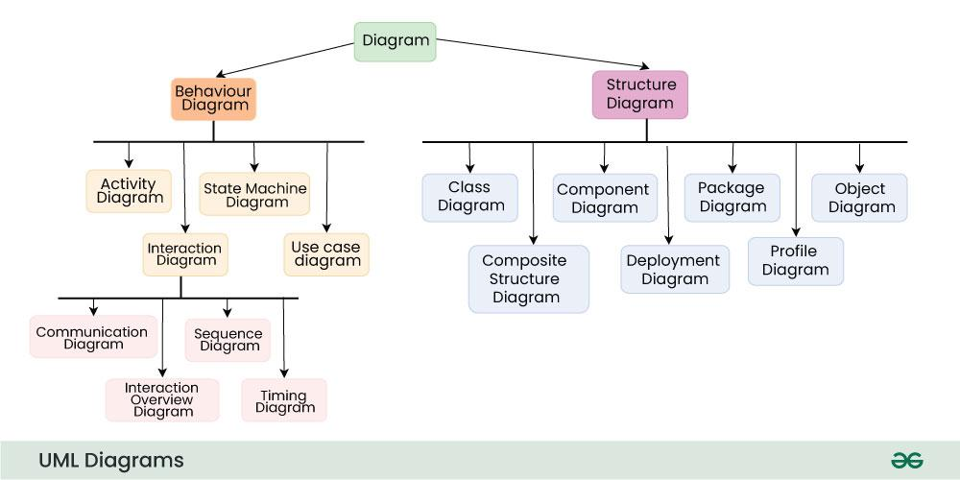

System Implementation
- Programming Language and Tools Used
- Description of Major Modules
- Screenshots of the GUI

DATABASE DESIGN
Requirements Analysis
- Entities needed
- Relationship between entities
EXAMPLE:
Entity: Relationship (1:M)
ER/Diagram
- Visual Diagram
- Explanation of Entities (Paragraph format)
Data Dictionary (per field name)
EXAMPLE:
Field Name | Data Type | Description
student_id | INT | Primary key
name | VARCHAR | Student name

NORMALIZATION
- Explanation of normalization (1 explanation for each normalization)
- Tables for 1NF,2NF and 3NF

DATABASE SCHEMA
- List of tables (normalized)
- Primary key and Foreign Key

Testing and Results
- Test Cases
- Test Results
- Error Handling and Validation

Conclusion & Recommendations
- Summary of the Project
- Lessons Learned
- Possible Improvements

8. References:

Clear Grading Criteria / Rubric
- 15% OOP Implementation
- 15% DATABASE Requirements Analysis
- 10% GUI Design
- 10% Database ER/Diagram
- 20% Code Quality
- 20% Functionality
- 10% Documentation & Presentation

Project Evaluation Criteria (Detailed Grading Rubric)
Criteria | Excellent (90–100%) | Very Good (80–89%) | Satisfactory (70–79%) | Needs Improvement (<70%) | Weight
OOP Implementation/Requirements Analysis | Excellent use of encapsulation, inheritance, polymorphism, abstraction; correct use of interfaces and abstract classes | Minor issues in applying OOP concepts | Basic OOP concepts applied but with design flaws | Poor or incorrect application of OOP concepts | 15%
DATABASE Requirements Analysis | Complete and accurate entities & relationships | Minor missing details | Some unclear relationships | Incorrect or incomplete | 15%
GUI Design & Usability | GUI is intuitive, responsive, and professionally designed | GUI is functional with minor usability issues | GUI works but layout is cluttered or confusing | GUI is incomplete or difficult to use | 10%
Database ER Diagram/  Normalization | Clear, correct, well-labeled  Correct 1NF–3NF with explanation | Minor errors  Minor explanation errors | Some relationship errors  Some normalization errors | Incorrect diagram  Incorrect normalization | 10%
Code Quality & Organization | Clean, well-documented, modular code following standards and MVC | Mostly well-organized code with few inconsistencies | Code is readable but lacks proper structure | Spaghetti code, poor naming, no structure | 20%
System Functionality | All required features work correctly with proper validation and error handling | Most features work with minimal errors | Basic features work but with noticeable bugs | Major features missing or non-functional | 20%
Documentation & Presentation | Complete, clear, and professional documentation; confident demo | Documentation complete with minor issues; good demo | Incomplete documentation or weak explanation | Poor or missing documentation and demo | 10%
Total: 100%

