Project: ConnectEd

Topic: Objectives List

Created by: David Ramirez

Date: 6/26/18

Copyright © 2018 LeapWithAlice,LLC. All rights reserved

\*\*\*\*\*\*\*\*\*\*\*\*\*\*\*\*\*\*\*\*\*\*\*\*\*\*\*\*\*\*\*\*\*\*\*\*\*\*\*\*\*\*\*\*\*\*\*\*\*\*\*\*\*\*\*\*\*\*\*\*\*\*\*\*\*\*\*\*\*\*\*\*\*\*\*\*\*\*\*\*

1. Determine High Level Architecture

* + Completed
  + PaaS with Python and traditional db (noSQL or SQL)

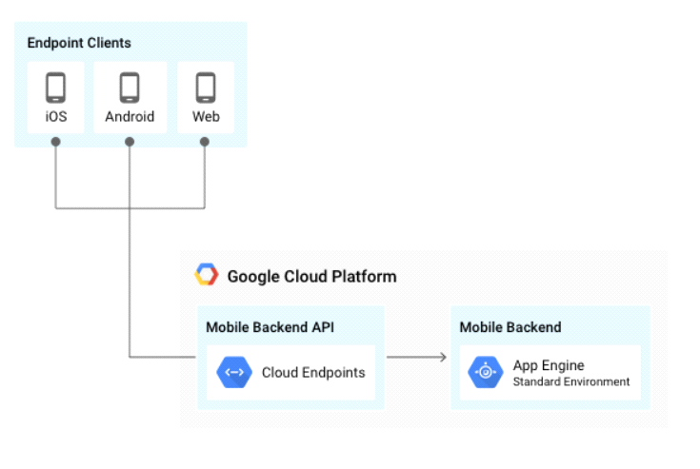

\*Note: this is taken from Google, and was not created by us (but it is accurate)

2. Determine PaaS provider

-Completed

-Google App Engine

3. Determine specific cloud services needed (analytics, security, db etc.)

-in progress

4. Determine architecture of code

5. Design database

6. Create code in python

-perform unit and integration testing concurrenlty with code creation