Project: ConnectEd

Topic: Discussion of using Firebase vs. App Engine for backend solution

Created by: David Ramirez

Date: 6/25/18

Copyright © 2018 LeapWithAlice,LLC. All rights reserved

********************************************************************************

Conclusions (options):

1. Use only firebase

-may increase front end code and computational load

-serverless app

* Recommended for:
* Limiting on-device data storage by storing JSON data in the Firebase Realtime Database and files in Firebase Storage.
* Sending notifications with Firebase Cloud Messaging.
* Automated real-time data synchronization across multiple devices.
* Gracefully handling the offline case.
* Authenticating users through a variety of identity providers.
* Rapid development of a backend service.
* Not recommended for:
* Apps that need a backend service to modify the synchronized data.

2. Use only app engine

-need to find solutions for things firebase would have provided (authentication,

database)

3. Use app engine standard environment with firebase

-more expensive

* Recommended for:
* Firebase apps that need a backend service to modify the synchronized data.
* Backend services that run periodically to process or analyze Firebase data.
* Not recommended for:
* Backend services that call native binaries, write to the file system, or make other system calls.
* Persistent connections to Firebase. App Engine standard environment reclaims socket connections after 2 minutes.

-firebase does a lot of things for you

*note: if using firebase, it essentially replaces our backend and we customize it (no backend language like Python)(can create cloud functions with js)

********************************************************************************

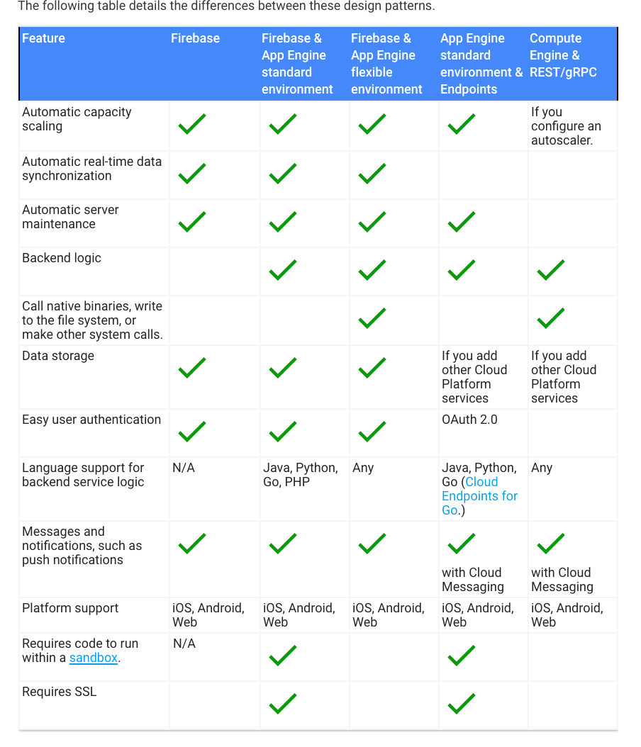

App Engine Architecture

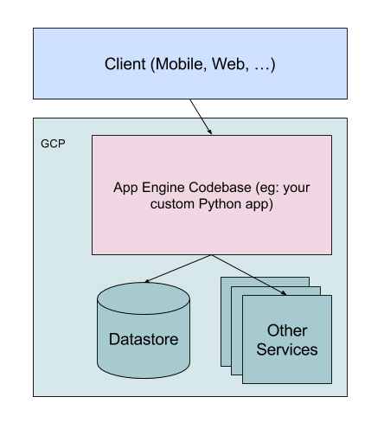

Firebase Architecture

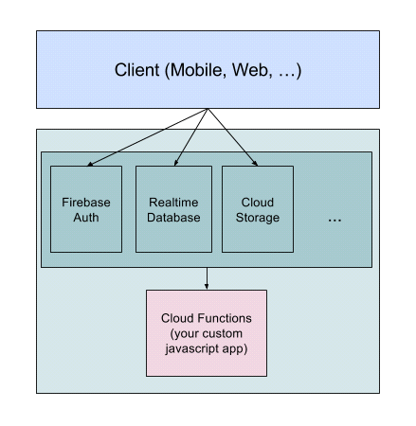

-firebase and app engine are somewhat comparable cloud platforms

********************************************************************************

**-Firebase**

-Backend as a Service (BaaS)

-Clients talk directly to services in Firebase, using special SDKs for web and mobile environments

-js Cloud Functions code triggered by those services based on events occuring in the other

services

-client never calls your code

-cannot build APIs

-better at authentication and change notification (Firebase Authentication and Realtime

Database)

-usually more expensive

**-App Engine**

-Platform as a Service (PaaS)

-must write an API for your clients to call, and then talk to other GCP services on the client's

behalf

********************************************************************************

Sources:

-<https://medium.com/the-infinite-machine/app-engine-vs-firebase-welcome-to-bizzaro-world-24c257ef4908>

<https://cloud.google.com/solutions/mobile/mobile-app-backend-services#design-pattern>