USER MANUAL

Republic of the Philippines
CAVITE STATE UNIVERSITY
CvSU – CCAT Campus
Rosario, Cavite
(046) 437-9507 / (046) 437-6659
cvsurosario@cvsu.edu.ph
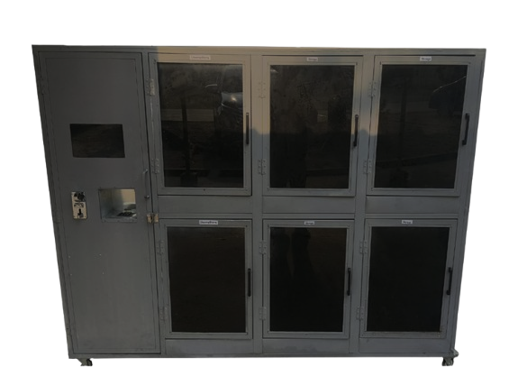
www.cvsu-rosario.edu.ph
Smart Helmet Locker System
Integrated with Cleaning, Drying,
and Administrative Monitoring

PROPONENTS:
CHAELVIN B. BOLANTE | RAPHAEL URIEL DG. ROSARIO
QUOZZAI E. GANABAN | JOHN CARLOS S. BALTAZAR

TABLE OF CONTENTS

Description of the Device 1
Parts of the Device 2
Function of the Parts 4
Principle of Operation 7
How to Use: Drying Mode 8
How to Use: Cleaning Mode 9
How to Use: Storage Mode 10
Administrative Monitoring 11
Maintenance Guidelines 12
Safety Precautions 14
Contact Information 16

DESCRIPTION OF THE DEVICE

The Smart Helmet Locker System is an Arduino/ESP32-based prototype developed by students of Cavite State University – CCAT Campus. It provides a secure, self-service kiosk that addresses critical concerns on helmet hygiene and protection from unpredictable weather conditions.

The system offers three operational modes: Drying, Cleaning, and Storage. Users can access these services through a coin-operated, PIN-secured interface. Active drying is performed by PTC heaters and forced air circulation, UV-C assisted surface cleaning provides surface disinfection, and a secure locker with solenoid locks provides safe storage.

Real-time environmental monitoring, SMS notifications via a GSM module, and an administrative web dashboard allow continuous supervision of the locker status, logs, and alerts.


1
PARTS OF THE DEVICE

The Smart Helmet Locker System consists of the following labeled components. Refer to the diagram photo below for the location of each part.
3

1
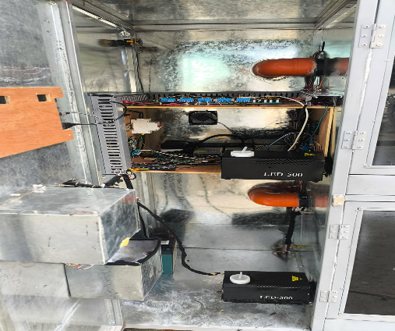
9

19
4
5
2
18

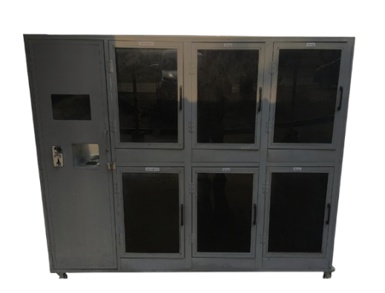
14
16
13
2
1100
15
6
7
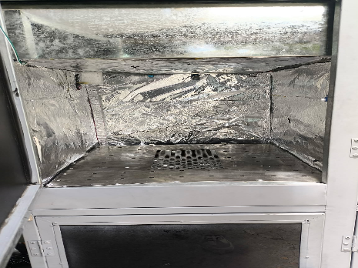

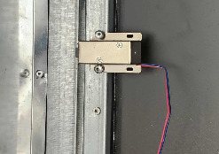
10

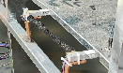

2
12
8
17

No. | Component
1 | Raspberry Pi 4
2 | Raspberry Pi 7" Touchscreen Display
3 | ESP32 Development Board
4 | Arduino UNO
5 | GSM Module
6 | Coin Acceptor
7 | 4x4 Matrix Numeric Keypad
8 | PTC Heater
9 | DC Cooling Fan
10 | UV-C LED Modules
11 | Fog Maker
12 | Solenoid Door Lock
13 | Servo Motor
14 | Micro Switch
15 | DHT11 Temperature & Humidity Sensor
16 | MQ-135 Odor / VOC Sensor
17 | Load Cell
18 | 12V Backup Battery
19 | Circuit Breaker 220V
20 | Glass Panel
3
FUNCTION OF THE PARTS

1. Raspberry Pi 4
Serves as the main Central Processing Unit (CPU) of the system. It manages the graphical user interface (GUI), the administrative dashboard, and all complex operations beyond the capacity of the ESP32.

2. Raspberry Pi 7" Touchscreen
Provides the centralized interface for user interaction — PIN entry, mode selection, and real-time status display. The 7-inch screen supports 5-point capacitive multi-touch input.

3. ESP32 Development Board
Acts as the primary microcontroller for data acquisition from sensors and activation of hardware components. Its dual-core processor and Wi-Fi/Bluetooth capabilities enable real-time IoT communication.

4. Arduino UNO
Serves as the tertiary microcontroller dedicated to controlling the servo motors for locker door opening mechanisms and emergency mechanical overrides.

5. GSM Module (SIM800L)
Enables SMS notifications to users, informing them of locker session progress, completion, and alerts. Also supports data communication for administrative oversight.

6. Coin Acceptor
Accepts coins as payment to activate the selected service (Drying, Cleaning, or Storage), enabling the system to function as a self-service kiosk.
4
7. 4x4 Matrix Numeric Keypad
Allows users to enter their phone numbers and set a secure PIN for authentication. Provides a reliable tactile input method.

8. PTC Heater
Self-regulating positive temperature coefficient heater used for helmet drying and sanitizing. Automatically adjusts power to prevent overheating, ensuring safe thermal management inside the drying/cleaning chambers.

9. DC Cooling Fan
Facilitates forced air circulation inside the drying chambers, removing moisture and regulating temperature. Supports effective ventilation and deodorization.

10. UV-C LED Modules
Emits 275 nm short-wavelength UV-C light to disinfect helmet surfaces inside the cleaning chambers. Targets microorganism genetic material to inhibit reproduction.

11. Fog Maker
Disperses scented disinfectant fog into helmet liners during the cleaning cycle, ensuring thorough coverage of interior padding for enhanced hygiene and freshness.

12. Solenoid Door Lock
Converts electrical signals into mechanical locking/unlocking actions on the six locker doors. Enables secure, automated keyless access and remote locking.

13. Servo Motor
Acts as a secondary mechanical override to open locker doors during emergency scenarios where the solenoid lock fails to respond.

14. Micro Switch / Door Sensor
5
Detects in real-time whether each locker door is open or closed, providing accurate feedback to the control system for safety and security monitoring.

15. DHT11 Sensor
Monitors real-time temperature and humidity levels inside the two specialized (drying/cleaning) lockers to maintain optimal thermal conditions.

16. MQ-135 Odor / VOC Sensor
Detects concentrations of volatile organic compounds (VOCs), ammonia, and CO₂ inside the sanitizing lockers to assess air quality and deodorizing effectiveness.

17. Load Cell / Weight Sensor
Detects the presence of a helmet inside the locker chamber. Triggers automated cleaning, drying, or storage protocols once an object is sensed.

18. 12V Power Supply & Battery Backup
Provides the primary electrical source for all system components. The battery backup ensures continued operation during power interruptions.

19. Circuit Breaker
Protects the 220V electrical system from overcurrent, short circuits, and thermal overloads. Acts as the first line of electrical safety.

20. GI Sheet Enclosure
Durable galvanized iron sheet cabinet housing all internal components, providing structural integrity, UV-C light containment (via epoxy primer lining), and user-friendly access panels.
6
PRINCIPLE OF OPERATION

The Smart Helmet Locker System synchronizes its primary microcontrollers and hardware components to deliver a seamless, intuitive user experience. The user first selects a service mode — Drying, Cleaning, or Storage — then proceeds through payment, authentication, and automated processing.

The overall operational flow is described below. Detailed step-by-step instructions for each mode are provided in the succeeding sections.

General Startup
- Ensure the system is connected to a stable 220V power source.
- Turn on the circuit breaker to power up the entire locker unit.
- Wait for the Raspberry Pi touchscreen to display the main welcome screen.
- Open Smart Helmet Locker System Application.
- Select the desired service mode: Drying, Cleaning, or Storage.

Payment and Authentication
- Insert the required coins into the coin acceptor for the selected service. The system will confirm payment.
- If Drying mode was selected, choose your helmet type: Full-Face, Open-Face, or Modular.
- Enter your mobile phone number using the 4x4 numeric keypad.
- Set a secure 4-digit PIN. This PIN will be saved to the cloud database for retrieval.

Loading and Process Start
- The system will unlock the selected locker door via the solenoid lock.
- Insert your helmet into the open chamber.
- Close the locker door securely. The micro switch sensor will detect door closure, and the weight sensor will confirm helmet presence.
7
- Once both checks pass, a Start button will appear on the screen.
- Upon tapping the button, the system automatically begins the selected process.

HOW TO USE: DRYING MODE

The Drying Mode activates the PTC heaters and DC fans inside the dedicated drying chamber to remove moisture from the helmet. Select this mode when your helmet is wet from rain or perspiration.

Step-by-Step Instructions
8
1 | Turn on the circuit breaker. — Ensure the locker system is powered.
2 | Open Smart Helmet Locker System application.
3 | Select DRYING on the touchscreen. — Tap the Drying icon on the welcome display.
4 | Choose your helmet type. — Select Full-Face, Open-Face, or Modular. Drying duration varies per type.
5 | Insert coins for payment. — The screen will display the required amount. Insert coins until the amount is reached.
6 | Enter your mobile number. — Use the numeric keypad to type your registered phone number.
7 | Set your PIN. — Enter a 4 to 6-digit PIN of your choice. Remember this PIN for helmet retrieval.
8 | Open the locker and insert your helmet. — The assigned locker door will unlock. Place your helmet on the rack inside.
9 | Close and secure the locker door. — Ensure the door is fully closed. The system will verify door closure and helmet presence before starting.
10 | Wait for the drying cycle to complete. — PTC heaters and fans will activate. The screen will display the remaining time. An SMS notification will be sent approximately 2 minutes before completion.
11 | Return to retrieve your helmet. — Go back to the locker and tap Retrieve on the screen.
12 | Verify your identity. — Enter your registered phone number and PIN. If PIN is forgotten, select Send PIN via SMS to receive credentials on your phone.
13 | Collect your helmet. — The locker door will unlock. Take your helmet. Ensure the door is closed after retrieval.

NOTE: If the customer fails to return within the allotted time, an additional session fee will be charged before identity verification and retrieval.

HOW TO USE: CLEANING MODE

The Cleaning Mode activates UV-C LED disinfection and the fog maker to sanitize and deodorize the helmet interior. Select this mode to eliminate bacteria, odors, and moisture buildup from helmet liners.

Step-by-Step Instructions
9
1 | Turn on the circuit breaker. — Ensure the locker system is powered.
2 | Open Smart Helmet Locker System application.
3 | Select CLEANING on the touchscreen. — Tap the Cleaning icon on the welcome display.
4 | Insert coins for payment. — Insert the required coin amount displayed on screen.
5 | Enter your mobile number. — Use the numeric keypad to type your phone number.
6 | Set your PIN. — Enter a 4 to 6-digit PIN for identity verification upon retrieval.
7 | Open the locker and insert your helmet. — Place the helmet fully inside the cleaning chamber.
8 | Close and secure the locker door. — The door sensor and weight sensor will verify correct placement before the cycle starts.
9 | Wait for the cleaning cycle to complete. — UV-C LEDs activate for surface disinfection. The fog maker will dispense disinfectant into the helmet liner. An SMS alert will be sent about 2 minutes before completion.
10 | Return and verify identity. — Enter your phone number and PIN to unlock the door.
11 | Collect your helmet. — Remove helmet and close the door after retrieval.

SAFETY NOTE: The UV-C light is active only when the door is fully closed. The micro switch interlock prevents UV-C activation if the door is ajar.

HOW TO USE: STORAGE MODE

The Storage Mode provides a secure, locked compartment for helmet safekeeping during campus hours. Use this mode when you need to store your helmet safely while attending classes or activities.

Step-by-Step Instructions
10
1
1 | Turn on the circuit breaker. — Ensure the locker system is powered.
2 | Open Smart Helmet Locker System application.
3 | Select STORAGE on the touchscreen. — Tap the Storage icon on the welcome display.
4 | Insert coins for payment. — Insert the required coin amount for the storage session.
5 | Enter your mobile number. — Use the keypad to type your phone number.
6 | Set your PIN. — Enter a 4-digit PIN for secure retrieval.
7 | Open the locker and place your helmet. — The assigned locker will unlock. Place helmet inside.
8 | Close and secure the locker door. — Ensure the door is fully shut. The solenoid lock will engage automatically.
9 | Wait for SMS reminder. — An SMS will be sent 15 minutes before the storage session ends.
10 | Return on time to retrieve your helmet. — Go back before your session expires.
11 | Verify identity. — Enter your phone number and PIN. Use the SMS PIN recovery option if needed.
12 | Collect your helmet. — The door will unlock. Remove your helmet and close the door.

NOTE: Late returns will be charged an additional session fee. Three failed PIN attempts will trigger the SMS PIN recovery option for the user.

ADMINISTRATIVE MONITORING

Authorized personnel can access the web-based Administrative Dashboard to remotely monitor and manage the Smart Helmet Locker System in real time.
11
Admin Login

1 | Open the Administrator Dashboard via the designated web URL or local application.
2 | Enter your administrator Username and Password
3 | You have three (3) login attempts before the system temporarily locks out access.
4 | Upon successful login, the dashboard will display live locker status, session logs, and alerts.

Dashboard Features
- View real-time locker availability (Open / Occupied / Processing)
- Monitor temperature, humidity, and VOC sensor readings per chamber
- Access logs of past sessions (Drying, Cleaning, Storage) with timestamps
- Receive error alerts and maintenance notifications
- Remotely configure settings such as session duration and service rates
- View SMS notification history and delivery status

NOTE: Admin credentials are stored securely in the Firebase cloud database. Contact the system administrator to reset lost credentials.

MAINTENANCE GUIDELINES

DAILY MAINTENANCE

Visual Inspection
- Inspect the machine for visible damage, dents, or debris on the enclosure.
- Verify that the touchscreen displays properly and responds to touch input.
12
- Check that all six locker doors open and close smoothly.
- Ensure the coin acceptor slot is clear and unobstructed.

Basic Cleaning
- Wipe down the exterior surfaces with a dry, soft cloth.
- Remove any dust or particles from the ventilation openings.
- Inspect the fog maker reservoir and refill disinfectant solution if below minimum level.

WEEKLY MAINTENANCE

Clean Fans and Vents
- Gently clean dust from DC fan blades and ventilation grills.
- Ensure no physical obstruction is blocking air circulation inside the chambers.
Check Connections
- Verify that all sensor cables (DHT11, MQ-135, load cells, micro switches) are properly seated.
- Check ESP32, Arduino, and Raspberry Pi connections for loose jumper wires.
- Confirm that solenoid lock wiring is secure and undamaged.
Test Operation
- Run a test cycle for each mode (Drying, Cleaning, Storage) to confirm proper activation.
- Verify that SMS notifications are received correctly during test sessions.
- Confirm that the admin dashboard displays accurate live data.

13

MONTHLY MAINTENANCE

Check Sensors and Heating Elements
- Verify DHT11 and MQ-135 sensor readings against a reference meter for accuracy.
- Inspect PTC heaters for signs of wear, discoloration, or reduced output.
- Check UV-C LED strip brightness and replace if output has degraded (lifespan: 9,000+ hours).
Thorough Cleaning
- Clean the interior walls of the drying and cleaning chambers.
- Wipe UV-C LED panels carefully with a dry cloth (do not use liquid cleaners on LEDs).
- Clean the fog maker nozzle to prevent clogging.
- Inspect the epoxy primer coating inside chambers for cracks or peeling; re-apply if needed.
Battery Backup Check
- Test the 12V and 5V backup batteries by simulating a power interruption.
- Replace batteries if they cannot hold charge for at least one full session.

SAFETY PRECAUTIONS

Read and follow all safety instructions in this manual before operating the Smart Helmet Locker System. Improper use may result in injury, equipment damage, or fire.

READ THIS MANUAL FIRST. Familiarize yourself with all components and functions before first use. Always follow safety instructions.
UNPLUG WHEN NOT IN USE. Disconnect the system from the 220V power outlet during extended periods of non-use to prevent accidental activation.
DO NOT OPEN THE LOCKER DOOR DURING ACTIVE CYCLES. The UV-C light interlock and thermal processes require the door to remain fully closed
14

during operation. Opening the door mid-cycle will trigger an emergency stop.
AVOID INSERTING METALLIC OR NON-HELMET OBJECTS. Only helmet equipment should be placed inside the chambers. Metallic objects can interfere with sensors and heating elements.
CHECK ELECTRICAL CONNECTIONS REGULARLY. Inspect wiring and plugs before use. Do not operate with frayed cords, damaged plugs, or exposed wires.
USE A HEAVY-DUTY OUTLET. Ensure the unit is connected to a grounded 220V outlet rated for the system's power requirements. Do not use extension cords of insufficient gauge.
KEEP CHILDREN AWAY. This system involves high-temperature heating elements and UV-C radiation. Keep children away from the machine at all times. Lock chambers when not supervised.
KEEP A FIRE EXTINGUISHER NEARBY. In the unlikely event of malfunction or fire, have an appropriate fire extinguisher accessible within the vicinity.
USE THE EMERGENCY STOP. In case of unusual sounds, smell of burning, or any system anomaly, press the emergency stop (if equipped) and disconnect power immediately.
DO NOT TAMPER WITH INTERNAL COMPONENTS. Only authorized technicians should access the internal electronics compartment. Unauthorized tampering voids safety compliance.
SCHEDULE EXPERT MAINTENANCE CHECKS. Have a qualified technician inspect the system every three months to ensure continued safe and proper operation.
UV-C SAFETY. Never look directly into the UV-C LED strips when the door is open. The safety interlock prevents UV-C activation with an open door; do not bypass this feature.
15
CONTACT INFORMATION

Proponents' Contact Information

Proponent Name | Contact Number
Chaelvin B. Bolante | 09360658121
Raphael Uriel DG. Rosario | 09995692440
Quozzai E. Ganaban | 09077123974
John Carlos S. Baltazar | 09817921591

"Your safety is our priority. Your helmet is in good hands."

VISION

The premier university in historic Cavite globally recognized for excellence in character development, academics, research, innovation, and sustainable community engagement.
MISSION

Cavite State University shall provide excellent, equitable, and relevant educational opportunities in the arts, sciences and technology through quality instruction and responsive research and development activities. It shall produce professional, skilled, and morally upright individuals for global competitiveness.

QUALITY POLICY

We Commit to the highest standards of education, Value our stakeholders, Strive for continual improvement of our products and services, and Uphold the university's tenets of truth, excellence, and service to produce globally competitive and morally upright individuals.
16

