Query 1

温差

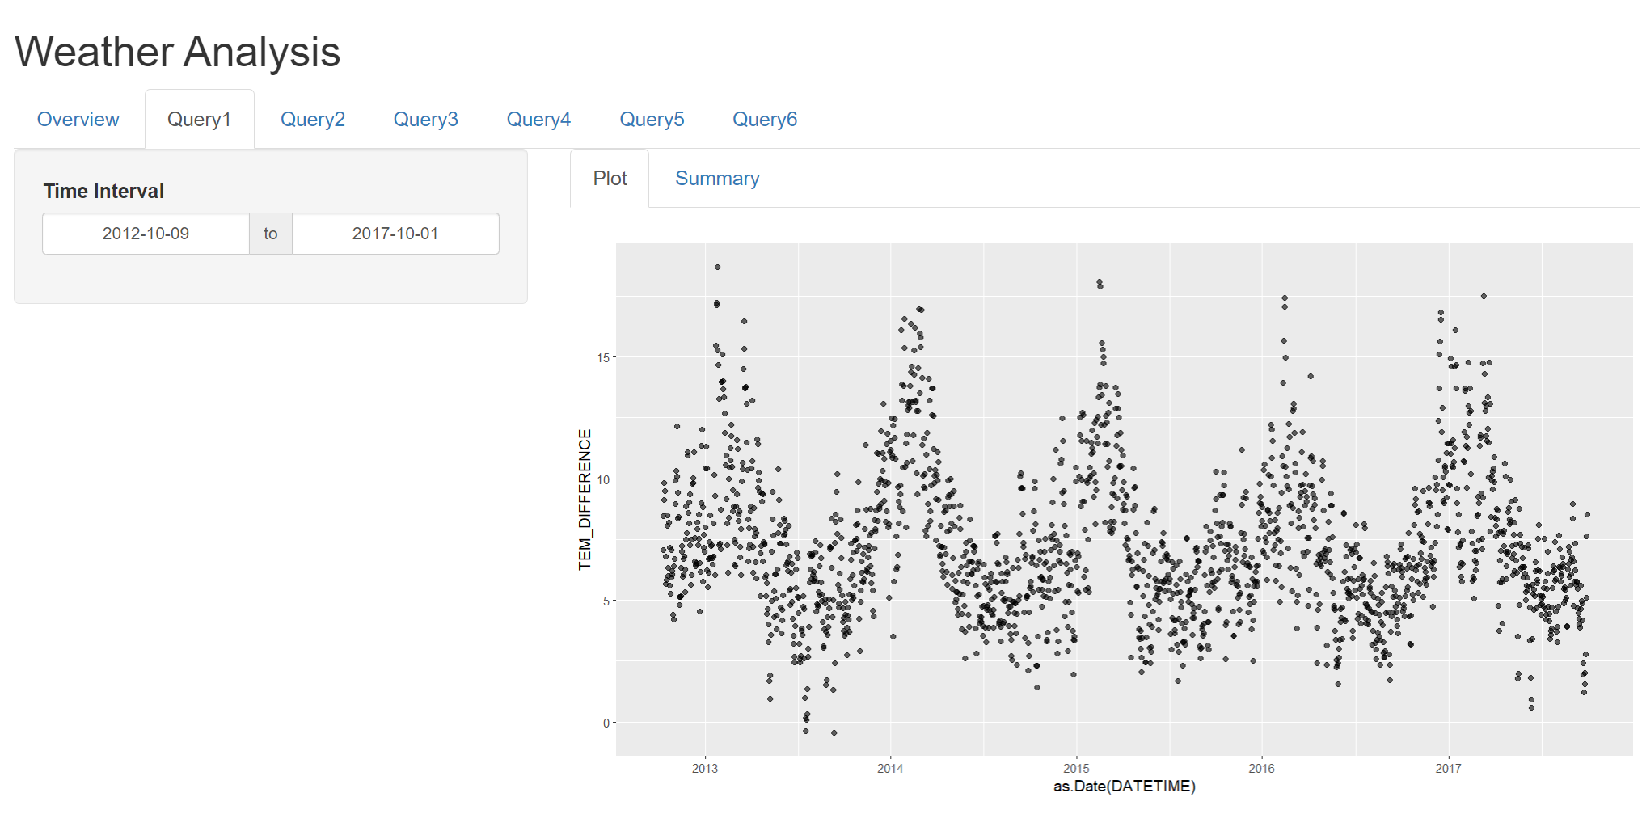

Query 2

Hour Count where Temp > 285

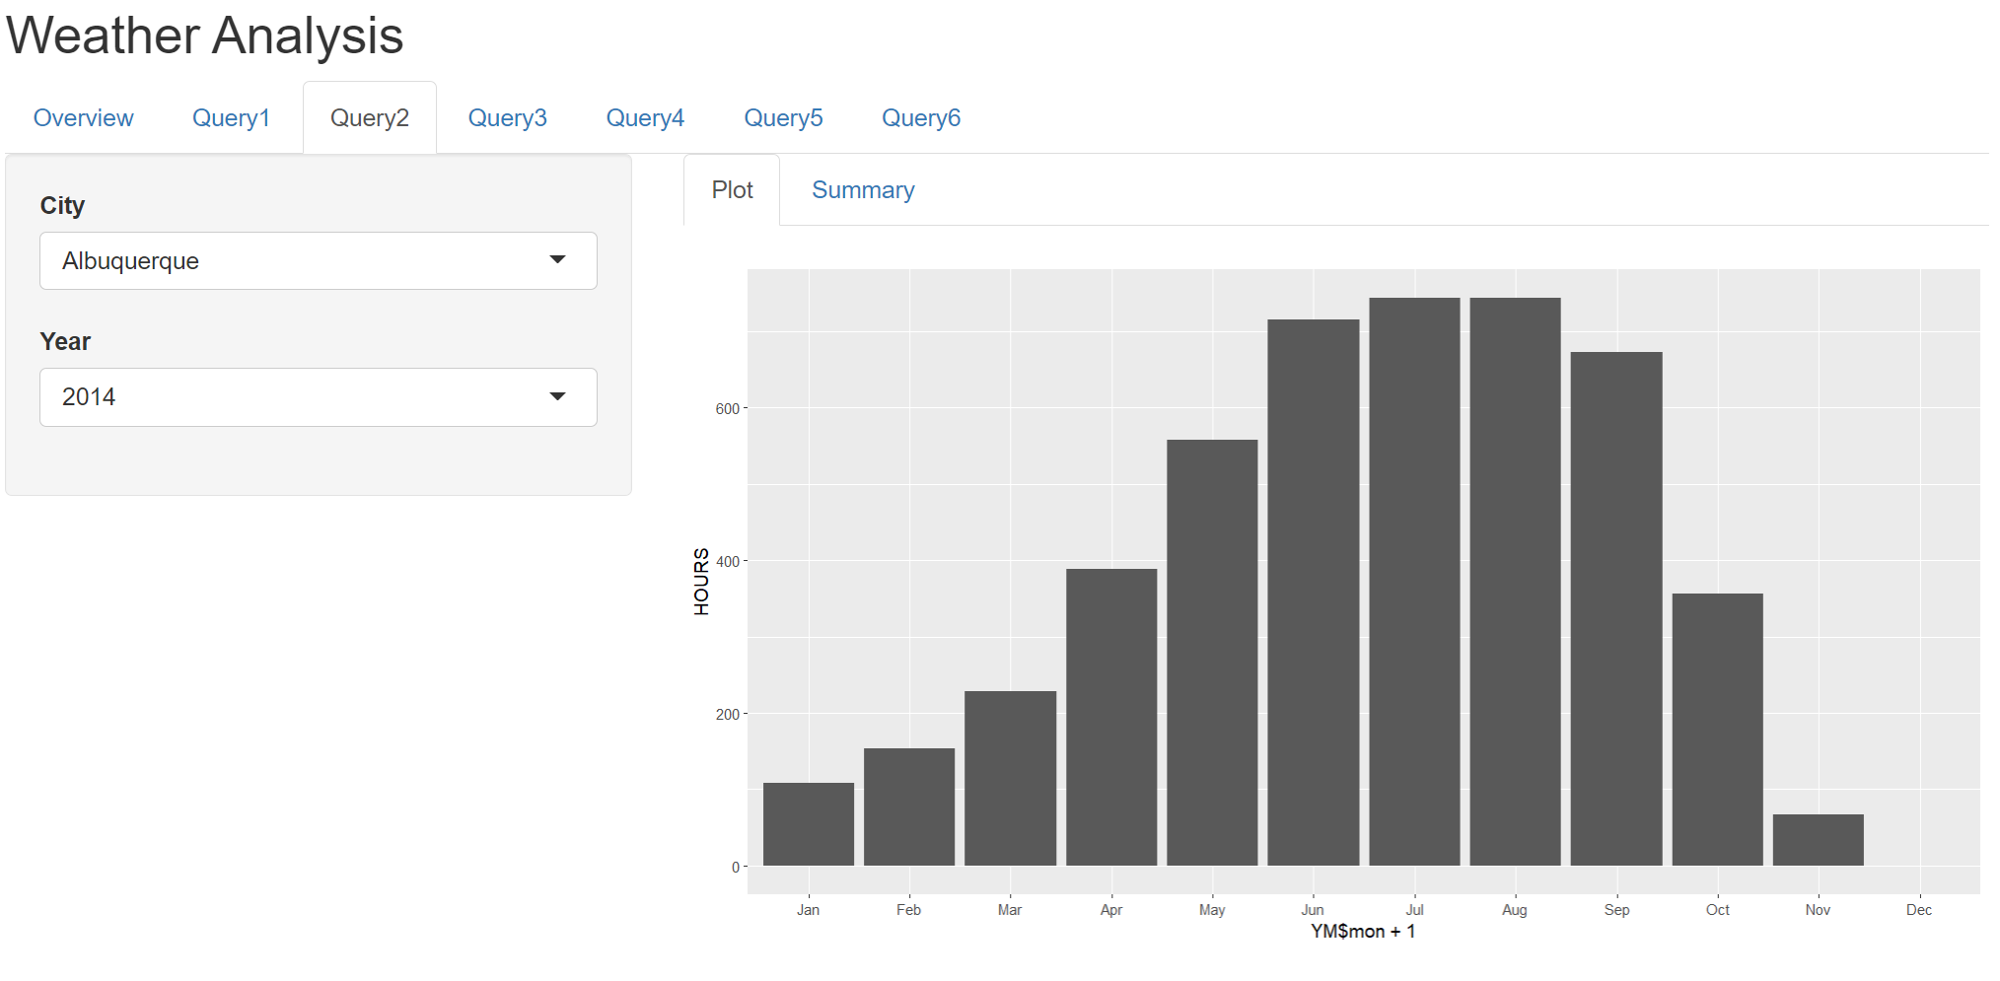

Query 3

Top 5 City, of Temp, Humidity, Pressure

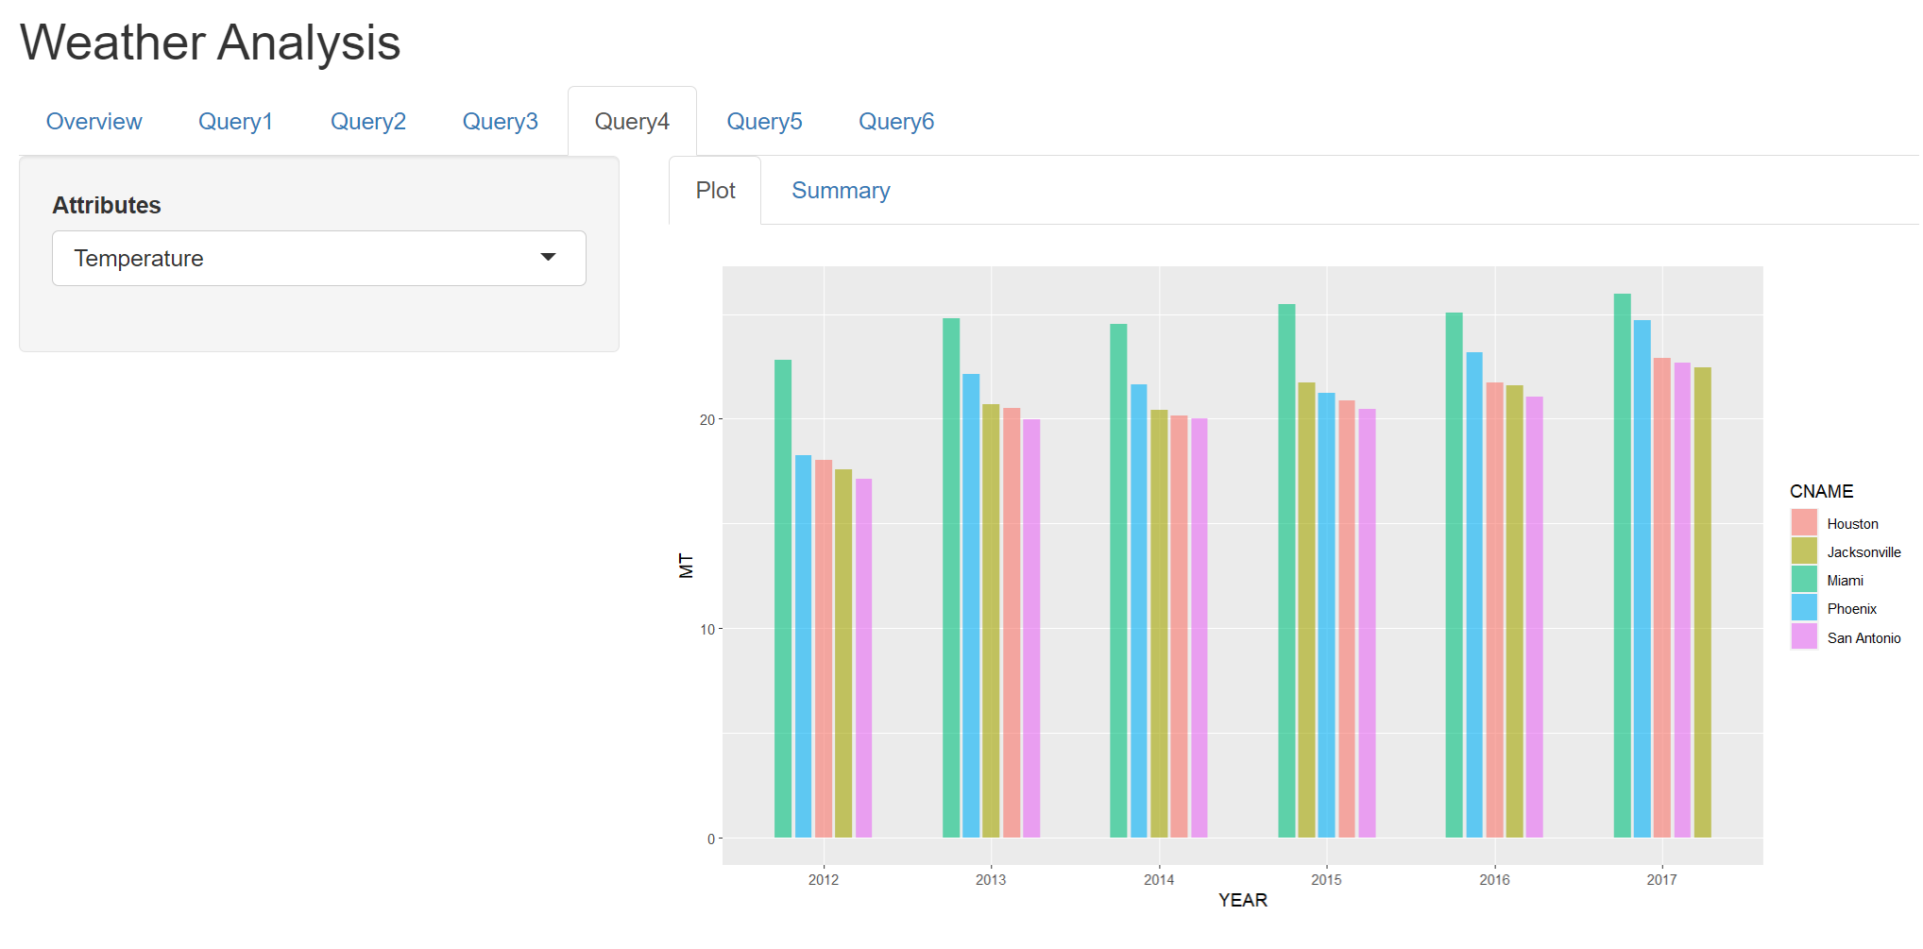

Query 4

Weed Speed of Cities. North Wind or South Wind

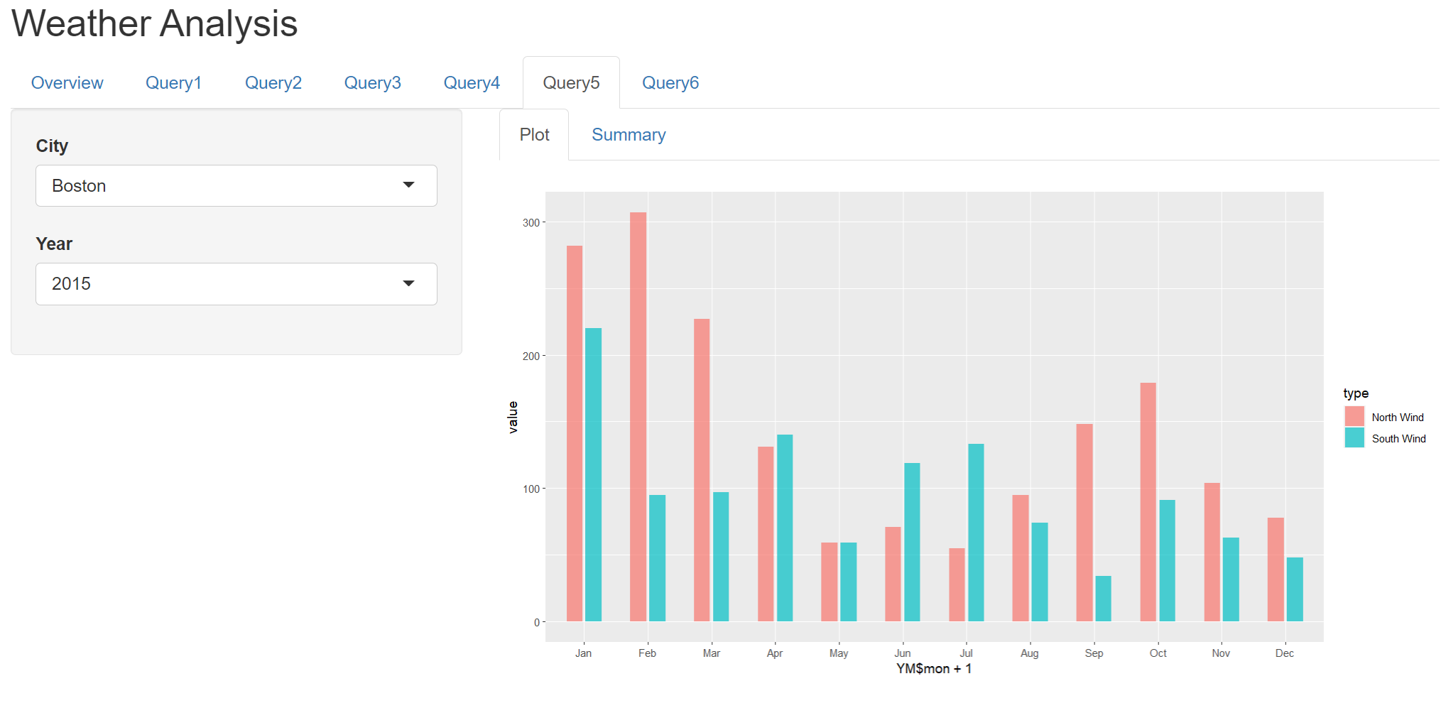

Query 5

Different weather type group by month and cities.

