Atria Institute of Technology



**Department of Information Science and Engineering**

**Big Data Analytics (18CS72)**

**Assignment-1**

**SUBMITTED BY**

Name: TEK NARAYAN CHAUDHARY

USN: 1AT2OIS101

Section: ‘B’

Submission Date: 23-11-2023

**Course Handling Faculty Name:**

Dr. K S Ananda Kumar

Associate Professor

Dept of ISE, Atria IT.

**Table of contents**

|  |  |
| --- | --- |
| **Sl. No** | **Description** |
| 1 | 1. create an **EC2 Linux** instance in AWS Cloud /Any cloud  INSTANCE NAME - **YOUR NAME**  INSTANCE TYPE - t2.micro/any other also.  key pair name- your name  storage - 10 GB  Take the screenshot of instance running status  Mention the private IP address and Public IP address.  (Execute this program/concept and take a screenshot of the output) |
| 2 | Execute the basic Linux commands/ simple program on the instance  (Execute this program and take a screenshot of the output) |
| 3 | Create the **GitHub** Account with your credentials, Same things stored in public repository in Github. Share the assignment in github link. |

**Note:**

1. Minimum 10 Screenshots with proper explanation
2. Minimum no of pages – 10
3. Submit your Assignment soft copy (Word & PDF) to [anandakumar.ks@atria.edu](mailto:anandakumar.ks@atria.edu).

**Subject Line in mail:** Student_Name_USN_BDA_Assignment1

1. Share your assignment Github link in Assignment Document.
2. Submit Assignment on or before **27th Nov 2023.**

**Instance Creation-01**

**Step 1: Create an Oracle Cloud account**

Head over to [Oracle Cloud](https://www.oracle.com/cloud/) and create a new account.

Expect to have to provide a Credit/Debit Card in order to create an account.

Expect to get contacted via email and phone by an Oracle rep.

**Step 2: Add a new VPS instance**

Once signed up, on the getting started page, launch a new VM instance.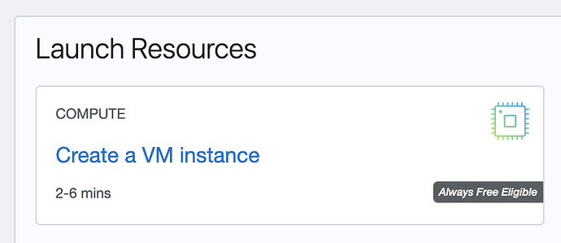

On the Image and shape card, click edit. You'll need to select the Canonical Ubuntu: 20.04 instance.

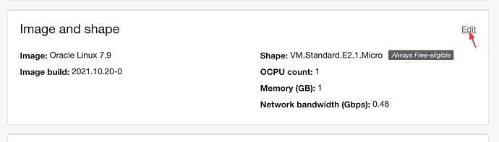



Add your SSH key (you'll need to SSH into the new server in the next steps).



Finally, click on Create. This will provision the server on Oracle's side.

**Step 4 - open port 80 and 443**

Port 80 and 443 will be closed by default. Assuming you plan to add websites to the server, open port 80 and 443 by clicking on Virtual Cloud Network from the server instance details screen.

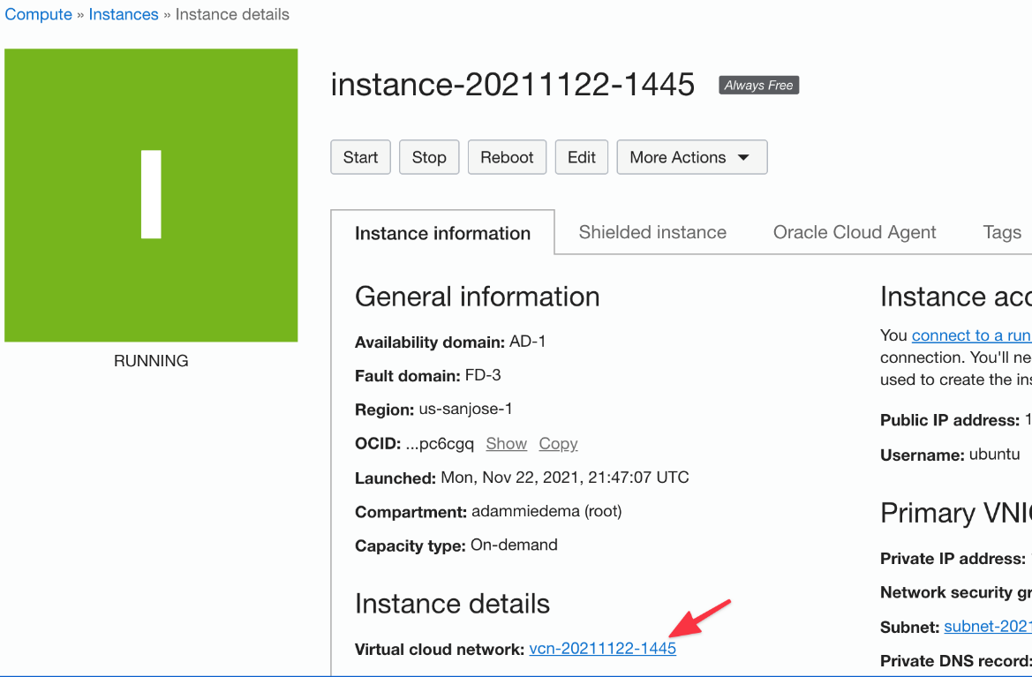

Click Security List on the left menu.

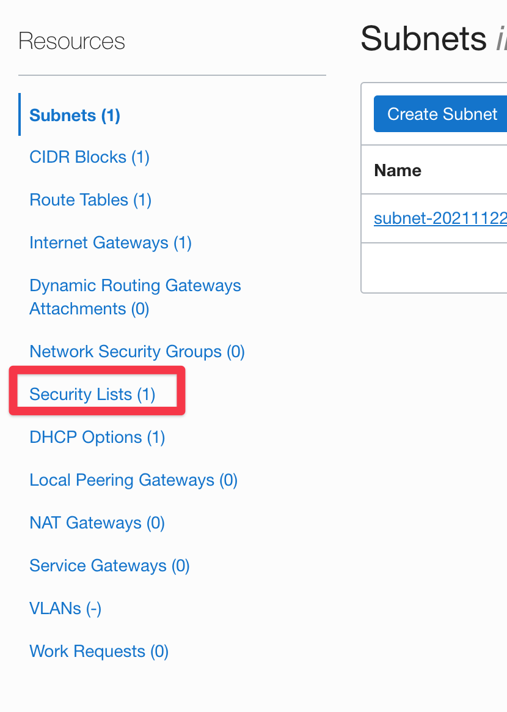

Click on the security list

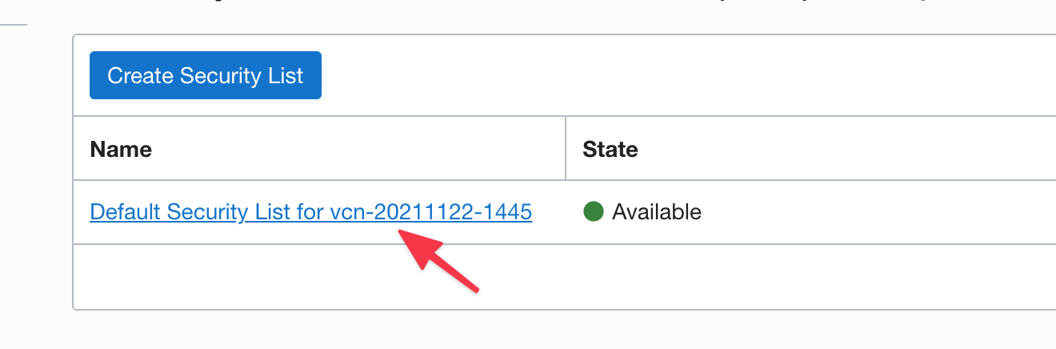

Click Add Ingress Rules

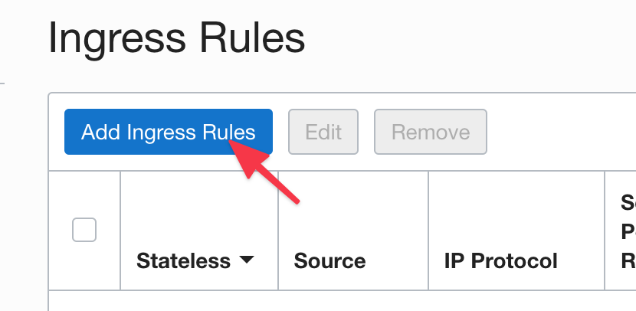

Add the following source and port –

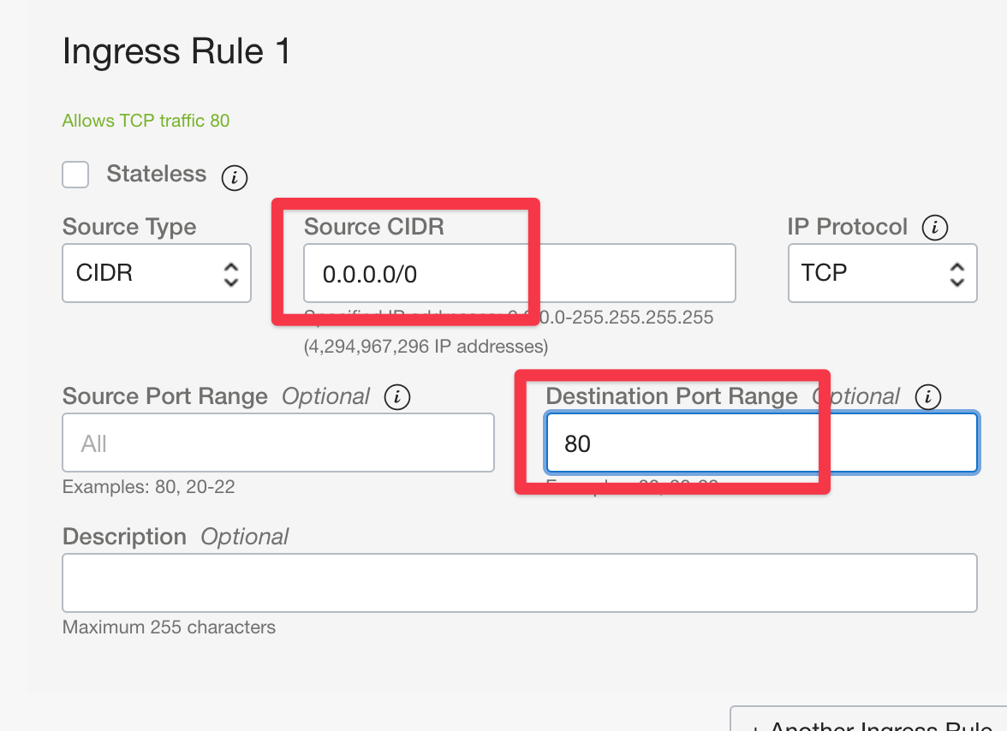

Add the ingress rule for port 80. Do the same process for port 443.

**Step 5: Update Oracle iptables**

On the server terminal via SSH, run the following commands one-by-one:

1. sudo iptables -I INPUT 6 -m state --state NEW -p tcp --dport 443 -j ACCEPT
2. sudo iptables -I INPUT 6 -m state --state NEW -p tcp --dport 80 -j ACCEPT
3. sudo netfilter-persistent save

**VPS Server Details Screenshot:**

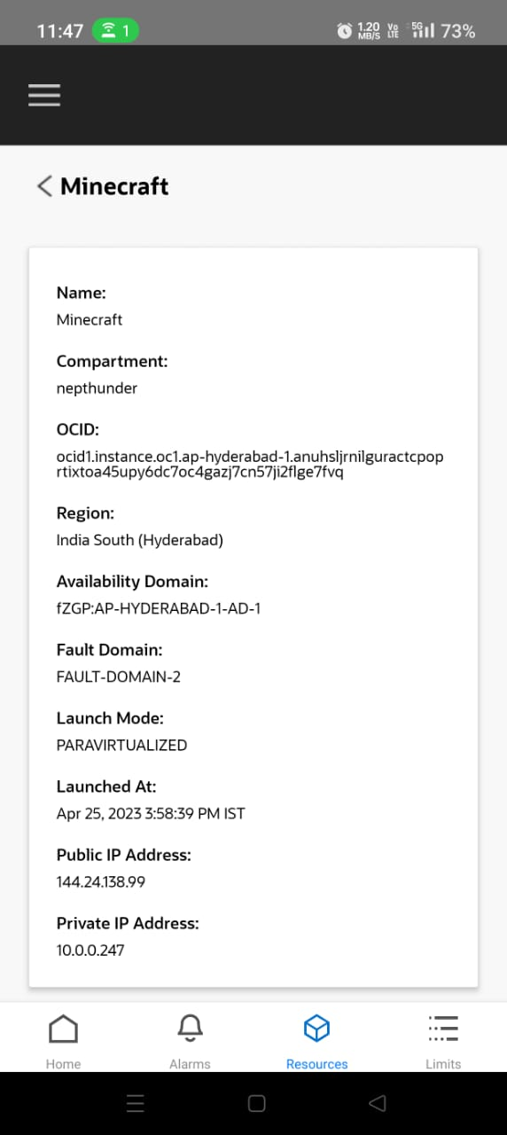

**Running sample Program on Linux Instance**

**Step 1: Login to the server through PuTTY software using ssh key**

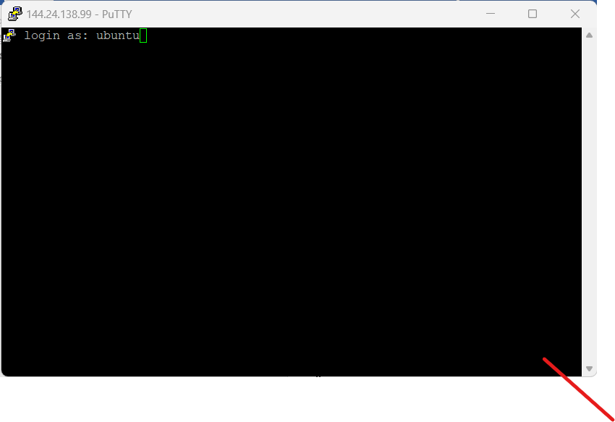

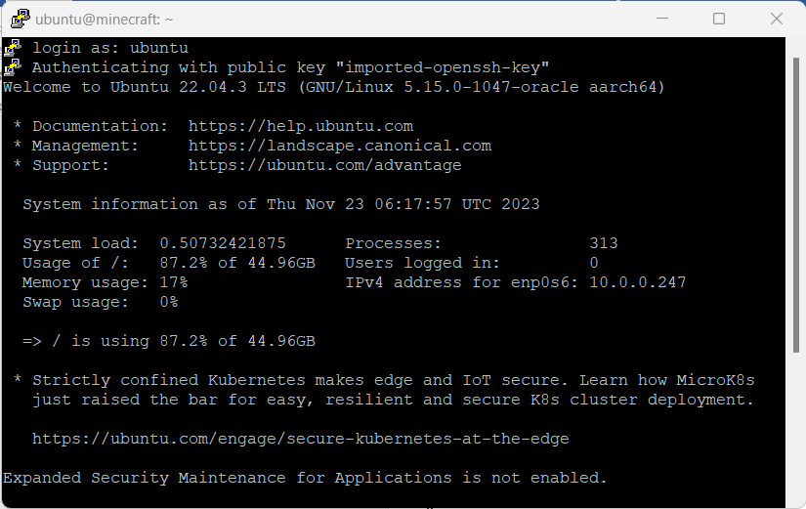

**Step 2: Go to the Minecraft directory**

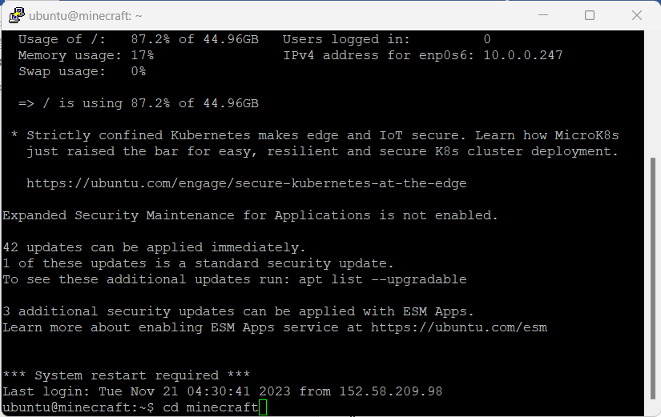

Run ‘ls’ command to list the files inside the Minecraft directory

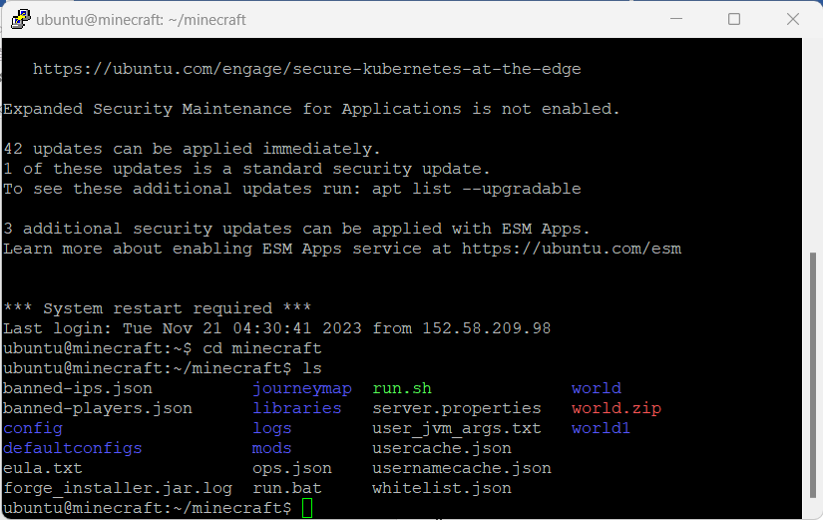

**Step 6: Run ‘./run.sh’ command to initiate the server**

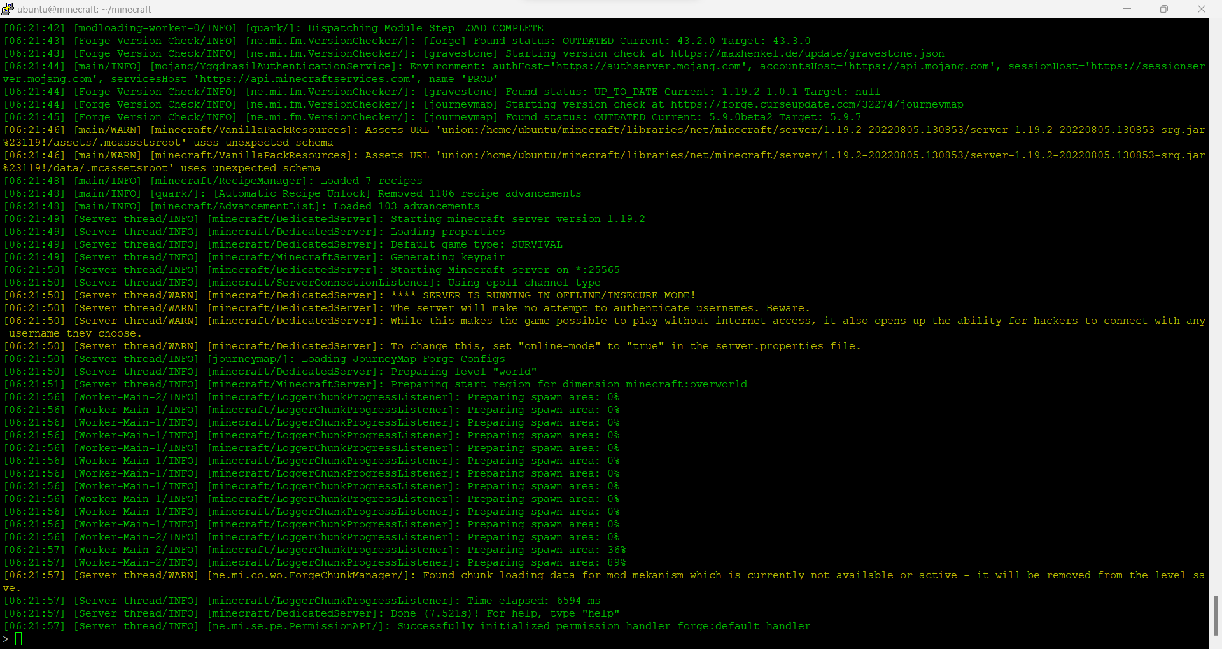

Once, the server is completely initiated, the server is ready to be joined through public ip address.

**GitHub Link.**

The Gaming Server is accessible through ip address: 144.24.138.99. Alternatively, the server is accessible through DNS: ‘suscookies.ddns.net’.

The server is not a vanilla version i.e. it contains mod files which are necessary to have in the mods folder of the Minecraft software to join the gaming server. The mods files can be found in the GitHub repo. from the following link: [NepThunder/ModFiles (github.com)](https://github.com/NepThunder/ModFiles)

Gaming server information:

Minecraft version: Forge 1.19.2

RAM: 24 GB

Storage: 200 GB

Access: Public

Mods: [NepThunder/ModFiles (github.com)](https://github.com/NepThunder/ModFiles)

**Step 1: Open the Minecraft software and go to Multiplayer mode.**

You will be presented with the following screen.

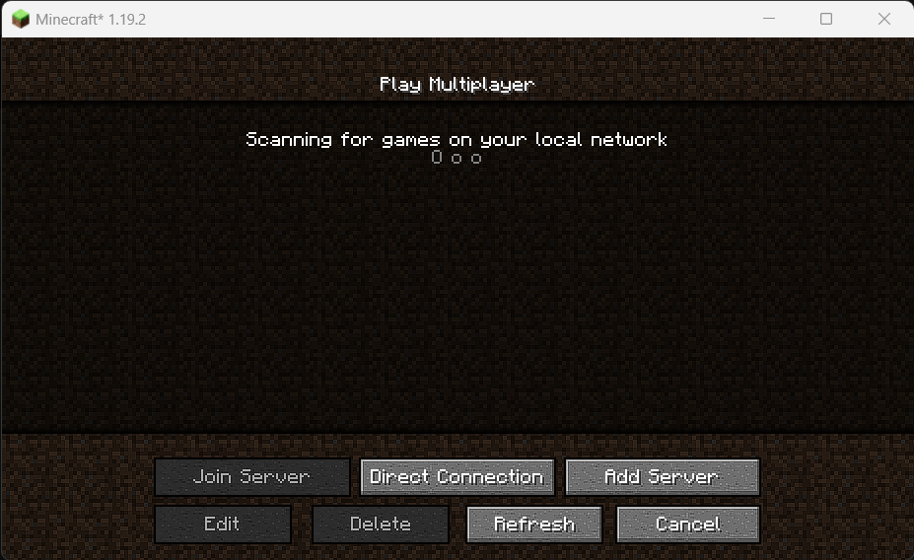

**Step 2: Click on the Add Server Button.**

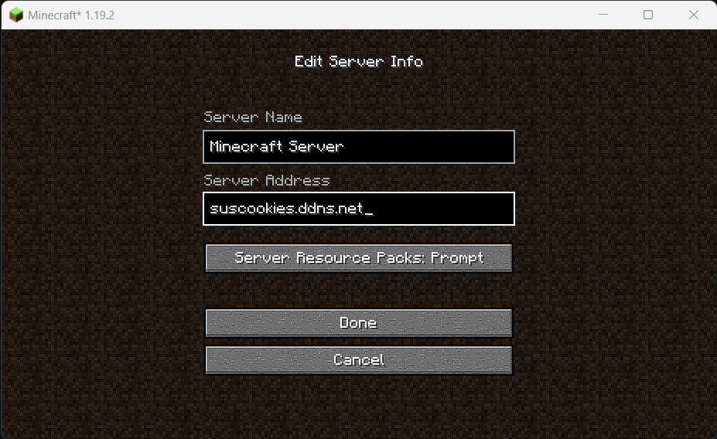

Enter the server ip address or dns: 144.24.138.99 or suscookies.ddns.net

Click on Done.

**Step 3: Double click on the server to join.**

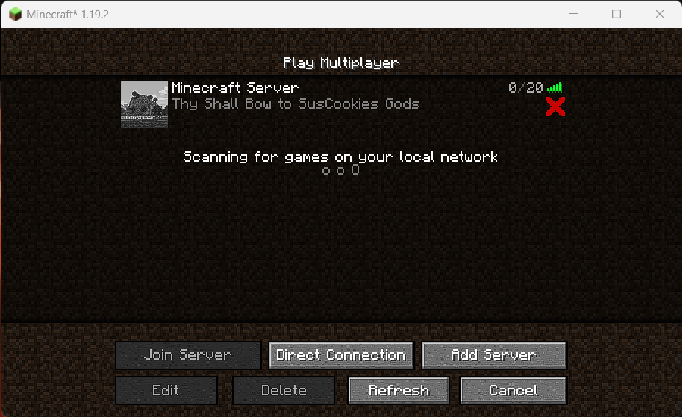

Once joined, you’ll be randomly spawned on the spawn area.   
Note: I was spawned at the last location where I logged out from.

