“FISH DIVERSITY OF RAPTI RIVER, NEPAL”
A Report in Partial Fulfilment of the Requirement of Practice Examination of Biology(bio.301) for Secondary Label Education of NEB.

SUBMITTED TO
Department of Biology
Makawanpur Multiple Campus
Makawanpur, Nepal

SUBMITTED BY
Sujal Chaudhary
Dipendra Kumar Ram
Chandan Kumar Sah
Bishwaraj Mahato
Prashant Chaudhary
Bigyan Pokharel
Amit Gupta
Anish Sapkota
Arnav Kadel
Prakhyat Man Lo
Arif Dewan
Rabi Dong
Umashankar Pandit
Bikash Rajak

DECLARATION
We hereby declare that the project work entitled "Fish Diversity of Rapti River" under the supervision of Mr. Devendra Prasad Dhakal of Makawanpur Multiple Campus is done originally by us and not been submitted for the elsewhere for the award of any degree. All source of information have been specified acknowledge by reference to the authors or institutions.
Sujal Chaudhary
Dipendra Kumar Ram
Chandan Kumar Sah
Bishwaraj Mahato
Prashant Chaudhary
Bigyan Pokharel
Amit Gupta
Anish Sapkota
Arnav Kadel
Prakhyat Man Lo
Arif Dewan
Rabi Dong
Umashankar Pandit
Bikash Rajak

Student's names:

Signatures:

Grade: XI
Section: A
Date: 2082/10/

National Education Board
Makawanpur Multiple Campus
Department of Biology
Nepal

CERTIFICATE OF APPROVAL

This is to certify that report entitled “Fish Diversity of Rapti River”, submitted by the students of class XI for the Zoology pratical of +2 first year, has been accepted as a partial fulfilment of the requirement for the completion of first year +2 certificate Science (Zoology). This is their own work and has not formed the basics for the award of any degree, diploma or any other similar title.
….………………………..
Department of Biology
MMC
Makawanpur
….………………………..
Devendra Prasad Dhakal
Supervisor

ACKNOWLEDGEMENT
Every academic work is completed with the help and cooperation of many people. We sincerely express our gratitude to all those who have directly or indirectly contributed to the successful completion of this report.
We would like to express our sincere thanks to our supervisor, Mr. Devendra Prasad Dhakal, for his valuable guidance, encouragement, and continuous support throughout the preparation of this report. We are also deeply thankful to the local fishermen, whose expertise and assistance in handling the fishing equipment were essential for safely catching our specimens.
Last but not least, We would like to express my sincere thanks to all people who helped.
TABLES OF CONTENTS

1. INTRODUCTION VI
2. OBJECTIVE VII
3. MATERIALS AND METHOD VII
a) Study Area: VII
b) Method: VII
4. OBSERVATION VIII
5. SOME OBSERVERD SPECIMENTS IX
6. Limitation of the study X
7. Discussion X
8. Conclusion XI
9. REFRENCES XI
10. Traditional Angling on the Rapti River XII

- INTRODUCTION
The Rapti River is an important freshwater river of central Nepal that supports a rich diversity of fish species. It is a perennial river originating from the Mahabharat Range and the Churia Hills, flowing from east to west before finally joining the Narayani River at Golaghat (Singh, 2013). Due to its continuous flow and suitable aquatic environment, the Rapti River provides a favorable habitat for various freshwater fish species.
Several studies have been conducted on the fish diversity of the Rapti River. Paudel (2006) studied the fishes of the Rapti River and reported 59 fish species belonging to 8 orders, 18 families, and 36 genera. Other studies by Edds (2007) and Rayamajhi (2017) focused on the Narayani–Rapti River system within the Chitwan National Park area and recorded 91 and 55 fish species, respectively. These studies indicate that the Rapti River is an important river system for freshwater fish diversity in Nepal.
In the present study area, two sampling sites were selected along the Rapti River, covering a total river length of about 5 km. During the monsoon season, the river becomes wide with strong water current and carries a large volume of floodwater. In contrast, during other seasons, the river remains comparatively shallow with mild to moderate water flow. The river water remains clear during the winter season, with algal growth making the riverbed slippery, while it becomes muddy during the rainy season.
The present study aims to observe and document the freshwater fish diversity of the Rapti River. Such studies are important for understanding fish diversity, supporting conservation efforts, and contributing to the collection and preservation of voucher specimens for future taxonomic and biodiversity research.

- OBJECTIVE
The main goal of this study is to explore and document the variety of fish species found in the Rapti River near Hetauda. As a group, we sought to identify different fish by observing their physical features and using scientific references to understand their classification. We also wanted to observe the general environmental conditions of the river to see how they support different types of fish. Furthermore, our study used simple angling methods to catch and release specimens safely within their natural habitat. The main objective of this study is:
- To find the diversity of fish in the study area.

- MATERIALS AND METHOD
In this report various descriptions, terminology and abbreviations are used to describe elements of the data or the source of data used in the analysis. Furthermore, different materials and methods were used and found to be helpful during the preparation of this report.
We selected a 5-Kilometer section of Rapti River in Hetauda as the study area. This river is a perennial body of water situated between latitudes 27.431999 and 27.459464N and longitudes 85.021771 and 85.036894E. Before joining the Narayani River, it flows from east to west from the Mahabharat Range and the Churia Hills. Because of its constant flow, the river offers a suitable habitat for a variety of freshwater fish and is surrounded by natural surroundings.
- Study Area:

Once our field trip was decided, our team traveled to the Rapti River using local transportation under the supervision of our class teacher and the local fisherman. To ensure an eco-friendly study, we relied entirely on the primary method of observation, using only fishing rods and angling to catch the fish specimens without using any mechanical nets. After catching the fish, we carefully examined their external features and used our Biology textbooks along with online platforms and websites to identify their scientific names and characteristics. We also took photographs of the specimens to maintain a visual record for our analysis. By comparing our live observations with these digital and printed references, we were able to complete our report using reliable data while ensuring the fish were handled safely.

- Method:
VII
- OBSERVATION

During the study period many species were recorded. Among them the species which we can identify is listed below in table.

Table 1. Fish species, order, family and local name
S.N. | Order | Family | Species | Local Name
1 | Cyprinidae | Opsarius | tileo | Faketa
2 | Sisoridae | Erethistes | pussilus | Bhoomi
3 | Cyprinidae | Cabdio | morar | Chakale
4 | Cyprinidae | Garra | gotyla | Buduna
5 | Cypriniformes | Nemacheilus | corica | Baghi
6 | Psilorhynchidae | Psilorhynchus | balitora | Patharchatti
7 | Cyprinidae | Labeo | fimbriatus | Boi
8 | Beloniformes | Xenentodon | cancila | Thunge
9 | Cyprinidae | Systomus | sarana | Kande

The order Cypriniformes includes the most common fish in our study area. This group includes the predominant fish species found in the Rapti River, particularly those belonging to the family Cyprinidae. Small carps and loaches made up the majority of the fish collected, while species like Xenentodon cancila (Thunge) were occasionally observed.
- SOME OBSERVERD SPECIMENTS
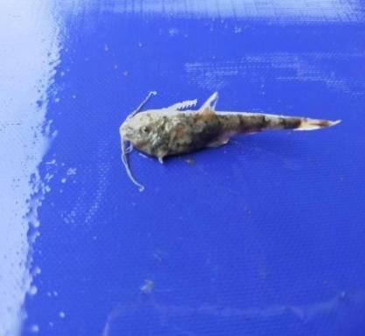
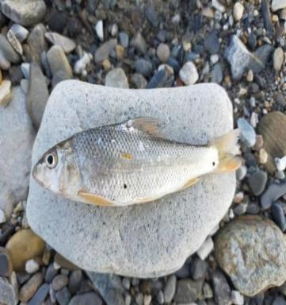
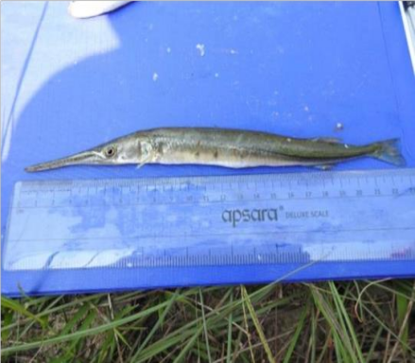
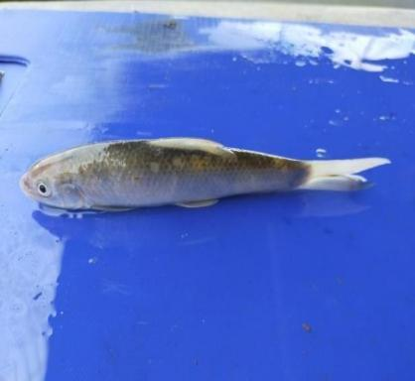
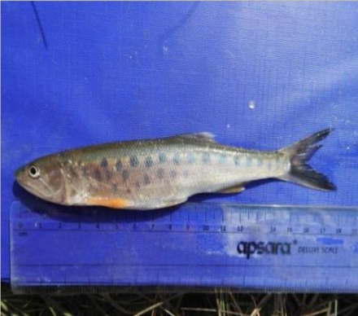
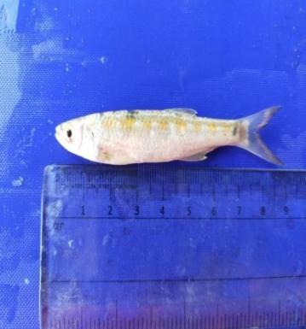
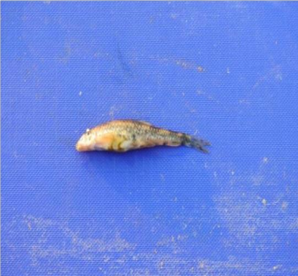
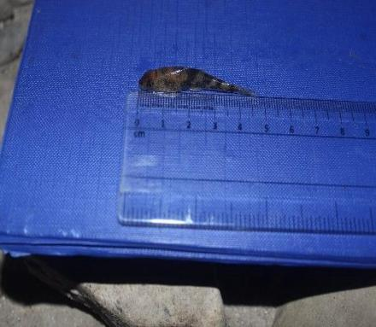
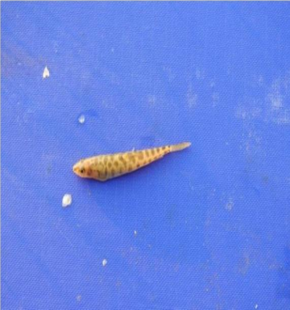
Photoplate I
Systomus sarana

Xenentodon cancila
Labeo fimbriatus
Opsarius tileo
Erethistes pussilus

Cabdio morar
Nemacheilus corica
Garra gotyla
Psilorhynchus balitora

- Limitation of the study
Our field visit to the Rapti River faced several challenges that affected our data collection process. First, the limited availability of professional fishing equipment made it difficult to catch a wider variety of specimens. Second, the cold temperature of the water and the surrounding environment during the study period limited our time spent in the river. Lastly, we observed that the acidic nature of the water may have influenced the presence and activity of certain fish species.

- Discussion
The current fish diversity research carried out in the Rapti River by our group recorded a variety of species that align with the dominant patterns found in previous studies of this region. Our data confirms that Cypriniformes is the most widely found order, with the family Cyprinidae representing a major portion of our collection, including local species like Faketa (Opsarius tileo), Chakale (Cabdio morar), Buduna (Garra gotyla), Boi (Labeo fimbriatus), and Kande (Systomus sarana). We also identified specialized species such as the bottom-dwelling Bhoomi (Erethistes pussilus) from the Sisoridae family, the Patharchatti (Psilorhynchus balitora), and the surface-dwelling Thunge (Xenentodon cancila) belonging to the order Beloniformes. These findings are consistent with past research by experts like Poudel (2006) and Jha (2018), who also noted high diversity within the Cyprinidae family in the Rapti ecosystem. Furthermore, our observations showed that while species like Baghi (Nemacheilus corica) were found across two sampling stations, the overall fish abundance remained closely tied to seasonal changes and environmental factors like water temperature and dissolved oxygen(Sagar Tamang).

- Conclusion
Our field study in the Rapti River successfully identified a total of 19 fish specimens belonging to 4 distinct orders and 6 families, confirming that the order Cypriniformes is the most dominant group in this ecosystem. Our data shows that the family Cyprinidae represents the majority of the diversity, featuring species such as Faketa (Opsarius tileo), Chakale (Cabdio morar), Buduna (Garra gotyla), Boi (Labeo fimbriatus), and Kande (Systomus sarana). Additionally, we recorded specialized species like the bottom-dwelling Bhoomi (Erethistes pussilus) and Baghi (Nemacheilus corica), alongside the surface-dwelling Thunge (Xenentodon cancila) from the order Beloniformes. Although our collection was smaller than some long-term studies, our results align with researchers like Poudel (2006) and Jha (2018) regarding the dominance of cyprinids in the Rapti River. This study demonstrates that even with limited equipment and seasonal challenges, the Rapti River maintains a significant variety of fish species whose presence is closely linked to environmental factors like dissolved oxygen and water temperature.

- REFRENCES
- Singh, G. 2010. Culture fisheries in village ponds: a multi-location study in Haryana, India.
- Gautam, G., Jain, R., Poudel, L. and Shrestha, M. 2016. Fish faunal diversity and species richness of tectonic Lake Rupa in the mid-hill of central Nepal.
- Shrestha, O.H. and Edds, D.R. 2012. Fishes of Nepal: Mapping distributions based on voucher specimens.
- Rayamajhi, A. 2017. Fish assemblage structure of Chitwan National Park, its buffer and adjacent area, central Nepal with notes on macrohabitat.
- Tamang, S. (2018). Survey of Physicochemical Parameters: PH, Dissolved Oxygen, and Water Temperature Variations across Seasonal Changes in the Rapti River (Makawanpur to Chitwan).
- Shrestha, T. K. (2008). Ichthyology of Nepal: A Study of Fishes of the Himalayan Waters. Kathmandu, Nepal: Himalayan Ecosphere.
- Shrestha, J. (1981). Fishes of Nepal. Kathmandu, Nepal: Curriculum Development Centre, Tribhuvan University.
- www.wikipedia.org
- https://gemini.google.com/app
- https://scholar.google.com

- Traditional Angling on the Rapti River

Photoplate II
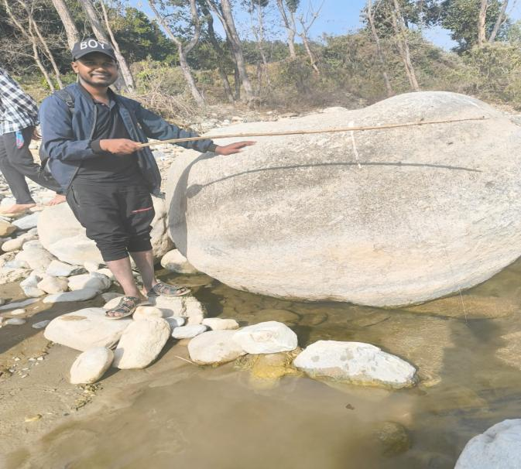
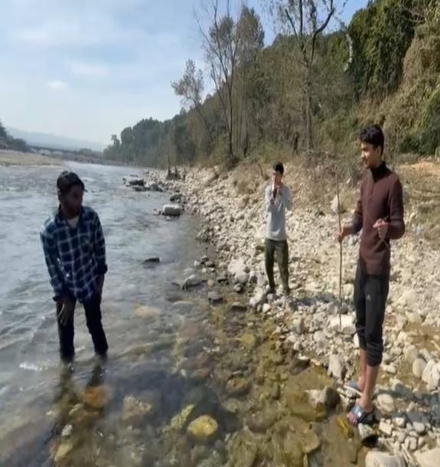
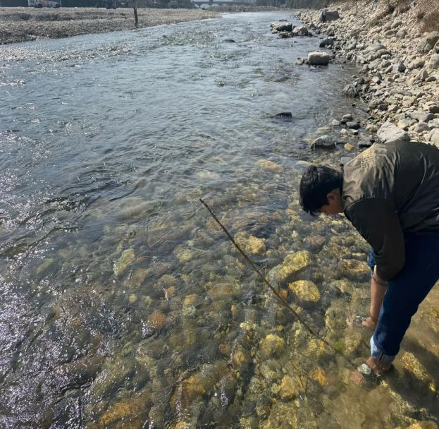
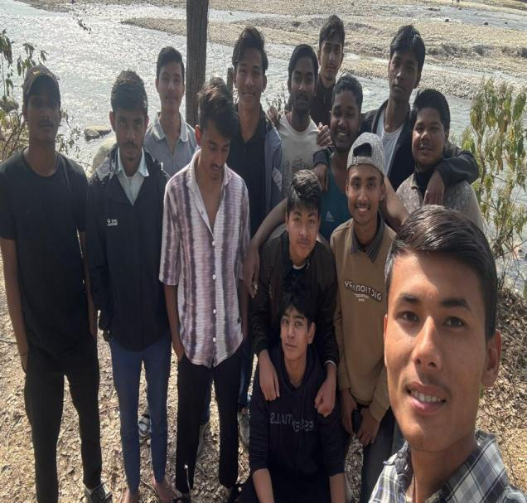
Description of Photoplate II
Photo 1: Traditional Angling for Species Collection
Photo 2: Preparation of Sampling Equipment
Photo 3: The Research Team at the Rapti River Basin
Photo 4: Species Collection
PHOTO 3
PHOTO 4
PHOTO 2
PHOTO 1

