黑色 RARE模型（训练未完成，93.18%的测试集正确率）
蓝色 CRNN模型（encoder+decoder，GitHub已训练好的）

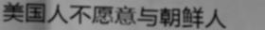
predict_string: 美国人不愿意与朝鲜人 => predict_probability: 0.7122758030891418
predict_string: 美国人不愿意与朝鲜人 => predict_probability: 0.9512082934379578
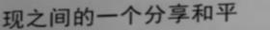
predict_string: 现之间的一个分享和平 => predict_probability: 0.9905706644058228
predict_string: 现之间的一个分享和平 => predict_probability: 0.9693989157676697
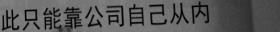
predict_string: 此只能靠公司和己系内 => predict_probability: 0.02648838423192501
predict_string: 此只能靠公司自己从内 => predict_probability: 0.9604918956756592
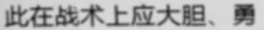
predict_string: 此在战术上应大胆、勇 => predict_probability: 0.7022793292999268
predict_string: 此在战术上应大胆、勇 => predict_probability: 0.4749974310398102
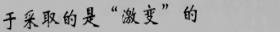
predict_string: 于采取的是“激变”的 => predict_probability: 0.20864160358905792
predict_string: 于采取的是“激变”的 => predict_probability: 0.8600873351097107
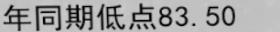
predict_string: 年同期低点83.50 => predict_probability: 0.925869882106781
predict_string: 年同期低点83.50 => predict_probability: 0.9603234529495239
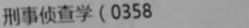
predict_string: 刑事侦查学（0258 => predict_probability: 0.21064405143260956
predict_string: 刑事侦查学（0358 => predict_probability: 0.5212016701698303
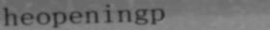
predict_string: beopenthgo => predict_probability: 0.18199212849140167
predict_string: heopeningp => predict_probability: 0.8211488127708435
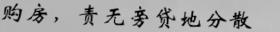
predict_string: 购后，骨无旁贷地分散 => predict_probability: 0.2687998414039612
predict_string: 购房，责无旁贷地分散 => predict_probability: 0.41037827730178833
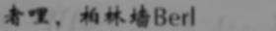
predict_string: 者哩，柏林墙Berl => predict_probability: 0.0637558326125145
predict_string: 者哩，柏林错Behl => predict_probability: 0.05160403996706009
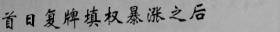
predict_string: 首日发挥模权器际之后 => predict_probability: 0.003339790739119053
predict_string: 首日复牌填权暴涨之后 => predict_probability: 0.3947294056415558
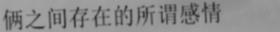
predict_string: 俩之间存在的所谓感情 => predict_probability: 0.8573601841926575
predict_string: 俩之间存在的所谓感情 => predict_probability: 0.2301606684923172
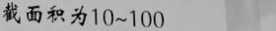
predict_string: 截面积为10-103 => predict_probability: 0.10432742536067963
predict_string: 截面积为10~100 => predict_probability: 0.5793341994285583
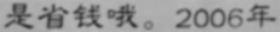
predict_string: 是省钱呢。2006年 => predict_probability: 0.29824450612068176
predict_string: 是省钱喂。2006年 => predict_probability: 0.17451031506061554
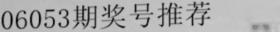
predict_string: 00053期奖号推荐 => predict_probability: 0.5227577686309814
predict_string: 06053期奖号推荐 => predict_probability: 0.8603276014328003
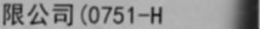
predict_string: 限公司(0751-H => predict_probability: 0.1295630782842636
predict_string: 限公司(0751-H => predict_probability: 0.9064956903457642

predict_string: 造币厂6000000 => predict_probability: 0.4516820013523102
predict_string: 造币厂6000000 => predict_probability: 0.7652470469474792

predict_string: 高校在校生34100 => predict_probability: 0.6115986108779907
predict_string: 高校在校生34100 => predict_probability: 0.9873021841049194
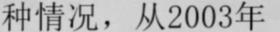
predict_string: 种情况，从2003年 => predict_probability: 0.9470487236976624
predict_string: 种情况，从2003年 => predict_probability: 0.9715602993965149
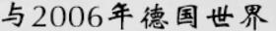
predict_string: 与2006年德国世界 => predict_probability: 0.9981176257133484
predict_string: 与2006年德国世界 => predict_probability: 0.9859565496444702
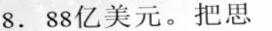
predict_string: 8．88亿美元。把思 => predict_probability: 0.5873456597328186
predict_string: 8．88亿美元。把思 => predict_probability: 0.9727494120597839
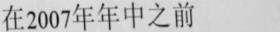
predict_string: 在2007年年中之前 => predict_probability: 0.6221504807472229
predict_string: 在2007年年中之前 => predict_probability: 0.9746188521385193
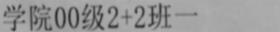
predict_string: 学院HD组过72班一 => predict_probability: 0.02136378362774849
predict_string: 学院00级272班一 => predict_probability: 0.48116979002952576

目前训练出来的模型可较为准确地识别90%左右的文本，但置信度相较github的模型普遍较低，且对于比较模糊或者倾斜的数字的识别不是很准确，真正应用时会影响对电话号码的识别。个人认为整体效果达到了可以上板试验的程度，机械组实验的同时视觉组还会继续尝试训练。

