**Classes list:**

**Neutral:**

- Pyromancer

- Warrior

- Swordsman

- Beast-Warrior

- Berserker

- Druid

- Alchemist

- Lurker / Archer

- Runic Mage

- Spirit tamer

- Mage of Souls

- Enchanter

**Kina’s servant:**

- Skotomancer

- Necromancer

- Soul reaper

- Assassin’s

**Hemera’s servant:**

- Phainomancer

- Paladin

**Mastery list:**

- Light mastery (2 specialization: Heal and Boost)

- ~~Shadow mastery (2 specialization: Illusion and assassinate)~~

- Mental manipulation mastery (2 specialization: Affliction and Manipulation)

- ~~Death mastery (2 specialization: Necrotic and Resurrection)~~

- ~~Spirit mastery~~

- Rune mastery (2 specialization: Boost-Rune and Runic-engineer)

- Soul’s mastery (2 specialization: Transfusion and Absorption)



~~- Flame mastery (2 specialization: Close-range and Long-range)~~

- Alchemist mastery (2 specialization: Offensive Alchemy and Healing Alchemy)

- Enchanting mastery

- Druidic mastery (2 specialization: Heal and Beast communication)

- Lurker’s mastery (2 specialization: Trapper and Archer)

- Close fight mastery (2 specialization: Dexterity fighter and Brute force)

- Berserker mastery

**Some other things:**

AP means armor point.

There are three levels of spell control:

- in training (5% Malus when you use it, and your focus does not give you point on it)

- trained (nothing special)

- Mastered (5% Bonus when you use it, this spell cost nothing if you did un under 15 whiles

rolling)

You can level up the control of a spell if you get a critical success while using it.

There is other way to level up your spell control, you can do training (see with the GM for success chance and cost) or you can find a master that will teach you some spell or help you strengthen your control.

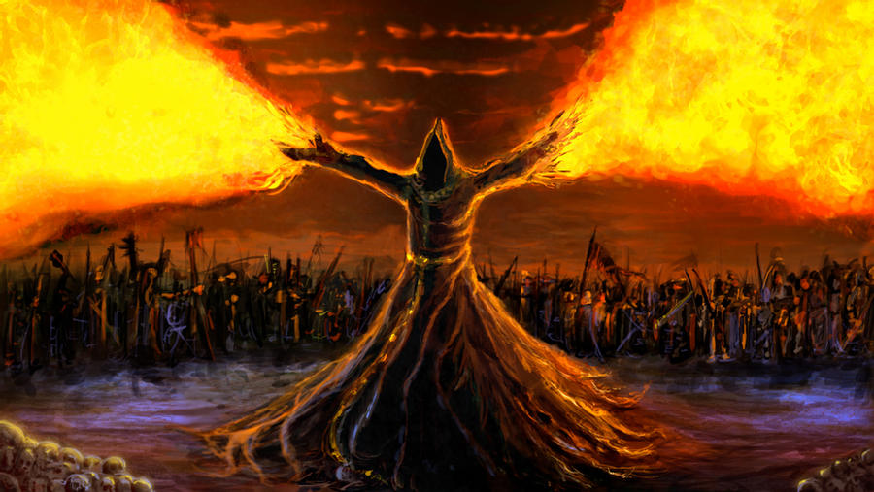**Flame mastery:**

* Saurigien skills:

Draconic breath [Cost X psy] (Create a long fire tongue that came out of the throat of the user, causes fire damage: ($X×\frac{1}{2}×Pyromancer level$) rounded down to the nearest whole number.

* Insider:

Flame manipulation [Passive] (allow the user to create and manipulate small flame)

* Adept:

Light fireball [Cost 3 psy] (launch a small fire ball which causes a D6 of damage)

Flame armor [Cost 2 psy] (create an armor made of flame the protect the user (grant 2 AP))

* Confirmed: (+1 psy)

Protective explosion [Cost 3 psy it cost 1 psy more if you cast in on another person than yourself] (create an explosion that protect the user, can be acquired by critically succeed a Flame armor)

Fireball [Cost 4 psy] (launch a fireball which causes a D6+2 of damage, can be acquired by critically succeed a light Fireball armor)

Flame blade [Cost 2 psy to create and 1 psy/round to maintain] (allow the user to envelope an object with blazing flame (+2fire damage)

Flame propulsion [ Cost 2 psy/round] (allow the user to move two times faster)

* Master: (+2 psy)
* Close range specialization:

Explosion Armor [Cost 3 psy to create and 1 psy/round to maintain] (Fusion of protective explosion and flame armor, it creates flame that surround you (grant 3 Ap) and it explode when someone hit you (causes D4 fire damage))

Plasma blade [Cost 3 psy to create and 2 psy/round to maintain] (Create a blade of plasma that can cut through almost every metal, causes D8 of fire damage or D4 of damage if the opponent in immune to fire)

* Long range specialization:

Great Fireball [Cost 6 psy] (launch a fireball which causes a D8+2 of damage, can be acquired by critically succeed a light Fireball armor)

Fire rain [Cost 8psy] (create a rain of light fireball that cover a circle of 5m diameter, causes D6 of fire damage to all enemy in the perimeter)

* Great Master: (+2 psy)
* Close range specialization:

Bloop

Blap

* Long range specialization:

Blip

Bloup

* Prodigy: (+3 psy and 1 more psy when focus)

Flame manipulation [Passive] (allow the user to create and manipulate small flame)

* God of pyromancer: (Flame spell do not cost psy anymore)

Bless of flame [Passive] (allow the user to create new spell of flame mastery as he wants, he’s also grant with a fire damage immunity)

**Death mastery:**

* Insider:

Energy manipulation [Passive] (allow the user to feal and use the energy stored in the corpses)

Energy absorption [Passive] (allow the user to absorb the energy stored in the corpses, it is a very long process so it cannot be used in fight situation)

* Adept:

Control of small corpses [Cost 3 psy] (Allow the user to control small corpses, smaller than human)

Death imbuement [Cost 2 psy] (Allow the user to imbue some object with dark energy, it can attract some enemy or afraid them if the energy is strong enough)

* Confirmed: (+1 psy)

Corps control [Cost 4 psy] (Allow the user to control corpses, as big as human)

Death touch [Cost 4 psy] (It is a close-range technique where the user releases a big amount of dark energy on a part of his opponent, it causes a D4+1 of damage, this damage cannot be healed by phainomancy)

Numbing blade [Cost 2 psy to create and 1 psy/round to maintain] (allow the user to envelope an object with anesthetic aura (the enemy got -5 to -10 on his roll)

* Master: (+2 psy)
* Necrotic specialization:

Death wave [Cost 5 psy] (release weave of dark energy around you that deal a D6 of damage to everything at less than 3m of you)

Death Blade [Cost 3 psy to create and 2 psy/round to maintain] (Create a blade of dark energy that don’ts cut through almost everything, but every small cut will heavily infect the wound, causes Death infection (deals 2 damage for D6 round))

* Resurrection specialization:

Skeleton minion [Cost 3 psy to create and 2 psy/round to maintain] (Summon a small skeleton from a pocket dimension, it will be the same skeleton every time so you can train it or give him weapon, but that also mean that you will need to heal him. You need to use a corpse to create the skeleton the first time, and it will cost you 10 psy.)

Great Corps control [Cost 5 psy] (Allow the user to control corpses, bigger than human)

* Great Master: (+2 psy)
* Necrotic specialization:

Bloop

Blap

* Resurrection specialization:

Blip

Bloup

* Prodigy: (+3 psy and 1 more psy when focus)

Flame manipulation (allow the user to create and manipulate small flame)

* God of Death: (Death spell do not cost psy anymore)

Bless of Death [Passive] (allow the user to create new spell of Death mastery as he wants, he is also grant with a dark energy damage immunity)

**Shadow mastery:**

* Insider:

Shadow manipulation [Passive] (allow the user to bend the shadow as he will)

* Adept:

Assassinate [Cost 0 psy, can only be used if the target is unaware of the user] (The user dell the max of the damage the weapon he wild, before rolling the damage dice, he rolls one more dice if the skill is mastered)

Shadow cape [Cost 2 psy] (Cover the user with thick shadow, that hide him if his not enlightened)

* Confirmed: (+1 psy)

Shadow nail [Cost 3 psy] (allow the user to launch 3 needle that deals a D4 of damage each, you can distribute those needles up to 3 enemy)

Illusion mask [Cost 3 psy] (Allow the user to steal the figure of someone he saw this day, the illusion vanish at the first physical contact)

Shadow dagger [Cost 1 psy to create and 1 psy/round to maintain] (allow the user to bend the shadow that surround him in a dagger shape who dill a D4 of damage)

* Master: (+2 psy)
* Illusion specialization:

Shadow Clone [Cost 3 psy] (Allow the user to create an ethereal clone of himself, the clone vanish at the first scratch)

Quick disappearance [Cost 3 psy] (Allow the user to disappear in the eyes of his target for 2 turn)

* Assassination’s specialization:

Bloop

Blip

* Great Master: (+2 psy)
* Illusion specialization:

Bloop

Blap

* Assassination’s specialization:

Blip

Bloup

* Prodigy: (+3 psy and 1 more psy when focus)

Bla Blop

* God of Death: (Death spell do not cost psy anymore)

Bless of Shadow [Passive] (allow the user to create new spell of shadow mastery as he wants, he is also grant with a shadow spell immunity)

**Spirit mastery:**

* Insider:

Spirit perception [Passive] (allow the user to see the spirit world and to communicate with their inhabitants)

* Adept: (+1 contract slot)

Spirit invocation [Cost 3psy] (You can invocate spirit bellow the great spirits level, with whom you have a contract)

Minor contract [Cost 5 psy and use 1 contract slot] (Allow to sign contract with minor spirits)

* Confirmed: (+1 psy and 1 contract slot)

Average contract [Cost 7 psy and use 1 contract slot] (Allow to sign contract with spirits that got an average power)

To get this rank you need to have at least 2 contracts with minor spirit.

* Master: (+2 psy and 1 contract slot)

Great contract [Cost 9 psy and use 1 contract slot] (Allow to sign contract with great spirits)

Great invocation [Cost 5 psy] (Allow the user to invocate every type of spirit)

To get this rank you need to have at least 3 contracts with average spirit.

* Great Master: (+2 psy and 1 contract slot)

Group contract [Cost 10 psy and use 1 contract slot] (Allow to sign contract, with a group of spirit, up to 5 average spirit and 10 minor spirit)

Group invocation [Cost 9 psy] (Allow the user to invocate a group of spirit)

To get this rank you need to have at least 3 contracts with Great spirit.

* Spirit Prince: (+3 psy and 2 more contract slot)

Prince authority [Passive] (The user is allowed to rule over the spirit that share the same element as the elemental king with whom he as a contract)

To get this rank you need to have at least 1 contract with an elemental king.

* King of spirit:

Authority of the spirit king [Passive] (The user is allowed to rule over the spirit world he can command every spirit, and he didn’t need to make contract anymore)

To get this rank you need to have a contract with every elemental king.

Useful information:

There are 5 elemental kings: esprit bestial.  
  
The Green king. He rules over nature spirits and can communicate with plants. Legends says that he is an old friend of Phusis.

The Red king. He rules over the fire spirit and, he is a great master of pyromancy. Legends says that he sleeps inside the volcan inside Saurigniens territory.

The Dark king. He rules over darkness spirit, and he is a master of skotomancy and necromancy. Legends says that has been eaten by Kina, so nobody knows where he is.

The Light king. He rules over light spirit, and he is a phainomancy great master. Legends says that he has sign a contract with Hemera.

The beast king. He rules over beast spirit and he can transform in almost every beast form (except legendary like dragon, leviathan, …). Legends says that only Karrion as the means to contact him.

To make a contract with an elemental king you need to defeat him and to get a critical success (you’ve got 3 try) while performing a Great contract.