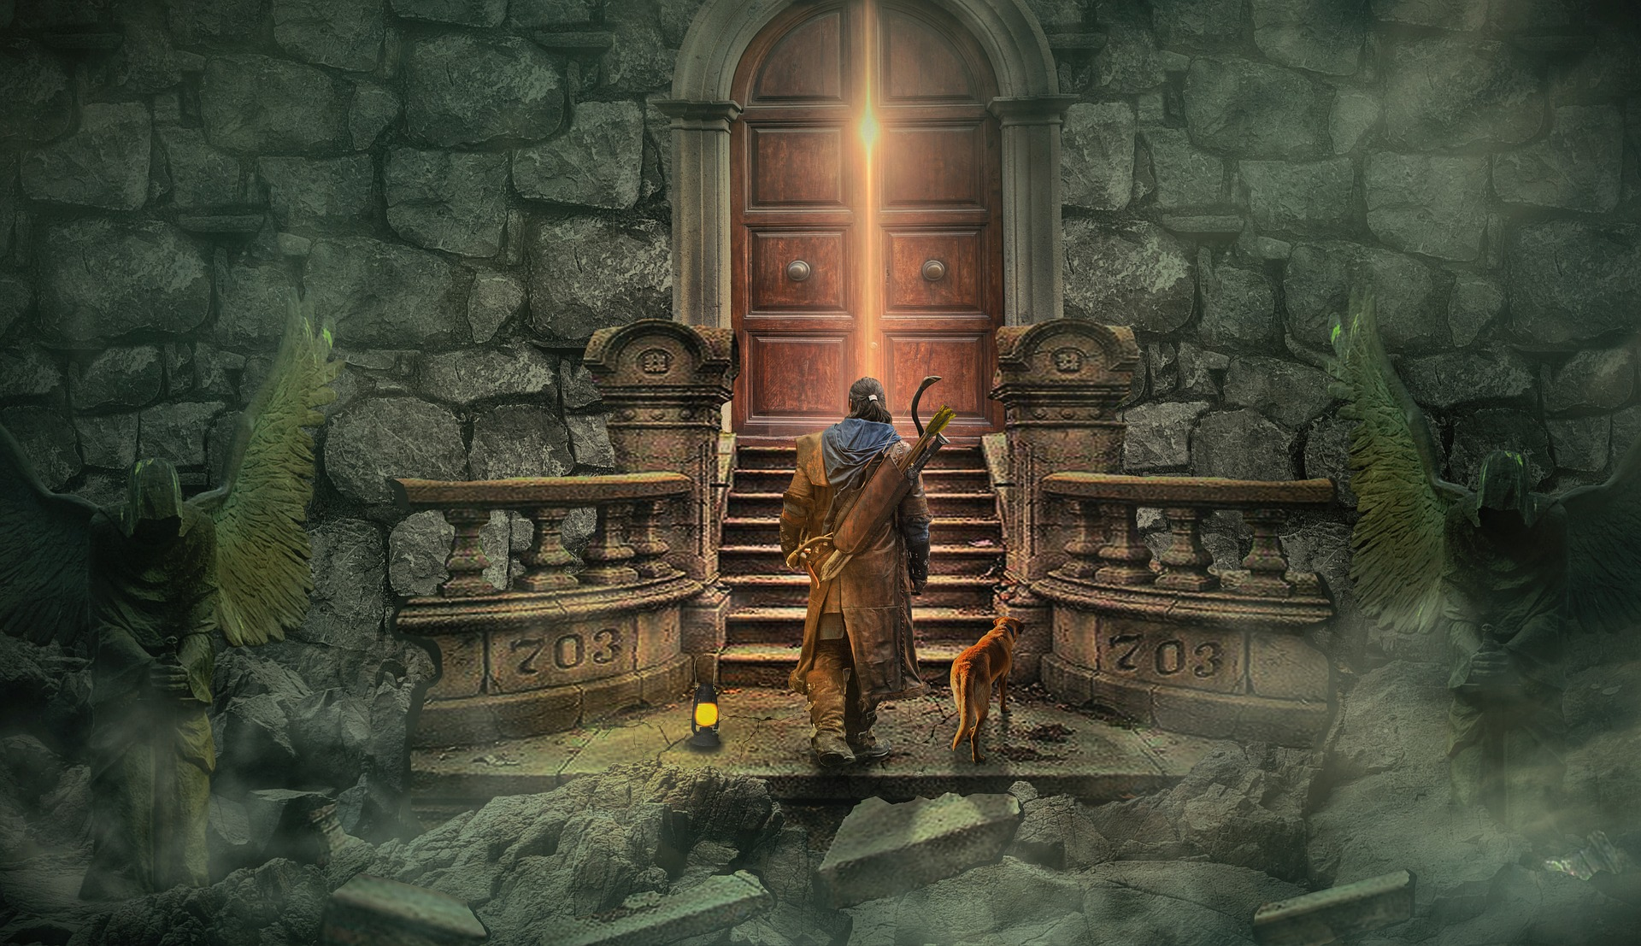Nepheshria

Rules Book

Everything you need to enjoy your own adventure

Introduction 3

The world of Nepheshria…………………………4

Using this book………………………………………..4

How to play……………………………………………..6

Adventures………………………………………………7

Part 1 Characters Creations 6

Part 2 How a round goes 7

Part 3 Training system 8

Since there is no random encounter system or levelup sytem it will be up to the players top create their own new skill or to learn new one whille they encounter pnj or find some scrolls.

N

epheshria is a roleplaying game built with the will to allow even new players that don’t want to read huge rules book, to merge in the story at the first session.

Unlike other well-known Roleplaying game as Dungeons & Dragons or Pathfinder, Nepheshria provide a lot of freedom concerning the course of action. There is nevertheless some dice to roll but it’s up to the DM* to decide what will be the result of your roll.So. It will be up to the DM to decide if you can achieve somethings and what will be your success chance.

However, like every other roleplaying game Nepheshria is about living your own adventure with your friend. To live an adventure, what did I need, you may ask. To live an adventure, you will need two types of players:

- The Adventurer. They are players that incarnate the characters that will live the adventure.

- The DM. It’s the player that will narrate the story and decide on the result of adventurer’s actions.

Since there is no fixed story, the DM can narrate every story he wants. Moreover, the adventurer are not limits to a restricted number of actions as in a book where you are the hero. They can choose not to stick to the DM plots and goes lived their own adventures. (try to at least investigate the main plot even if it’s in an alternative way)

Here is a little example:

The DM might describe a tavern in which you heard rumors about a donjon that nobody ever succeed to explore completely. And the adventurer will decide what they will do.

Will they go asking local people for intel about the dungeon location and what other adventures face in the explored zone.

Or will they ask the DM to describe the quest postpone on the panel at the back of the tavern, because they want to gain money to buy new gears. After that, the DM tell the players if they need to roll to succeed an action.

And then after the rolls, the DM tell the result of the adventurer’s action.

Then the DM determines the results of the adventurers’ actions and narrates what they experience. Sometimes he can like your idea and decide to help you a bit or disadvantage you because killing a PNJ necessary to the plot isn’t really a good idea.

Because the DM need improvise to react to anything the players attempt, Nepheshria is infinitely flexible as every roleplaying game, and each adventure can be exciting and unexpected, even you play the same history to group won’t experiment the same adventure.

Unlike a one-shot, a campaign doesn’t really get an end. Even if you finish the quest you were running you can still embark in a new one with your characters.

The best way to live good experience while playing roleplaying game is to meet with their friends every once in a while to pick up the story where they left off. Making their campaign lasting for months, or event years.

Players will face stronger and stronger foe, they loot legendary artifact instead of the few rusted junk from their beginning, and the most important they will learn new skill from the teaching of NPC* or some scrolls.

Since the purpose of every roleplaying game is to create an exciting story of bold adventurers who confront deadly perils, losing or winning the game wouldn't make sense. So, if an adventurer die the other adventurers can find a way to resurrect him or he can just recreate a character.

The world of Nepheshria

Nepheshria is system of rules, but it comes with his own universe.

This universe as been constructed with the desire to get away from the Tolkien classic. That’s why you won’t encounter the classical elf, Orc, Dwarf. The world of Nepheshria obeys to the law of physics that our world, so do not hesitate to explain how the spells you create work.

The universe will be depicted in more detail in the book of the universe.

How to use this book

This book is divided in three parts.

**Part 1** Characters creation: Here you will discover everything you need to give birth to new character. It includes information on my homemade races, all the classes some are home brew and others are classic, the unique alignment system of Nepheshria. Along this you will find a step-by-step tutorial that will explain you how to create a character and read the characters sheets.

**Part 2** How a round goes: Here you will find all the rules you need to know to play the game as a DM and a player. There will be some examples of a classic round and some tips for the player and the DM.

**Part 3** Training system: This last part is more important for the DM and the players that play campaign. If you only chose to run a one shot* you can skip it since the player characters won’t progress through the adventures. So, you will find an explanation on how you will train your characters and how you will be able to create new spells and artifact.

How to play

A round of a roleplaying game is generally divided in three parts:

1. The player who is the DM describe the place where the players are, if they heard the sound of a minstrel that sung a ballad that sings the praises of the local lord, or if they smell the pestilence of the slurry that have been spread over the field this morning. The DM will also describe all the NPC, and what do they do.

2. Ones the player know where they are, they can decide what do they do with that information. Will they ask the minstrel about the lord, or will they throw slurry at him because they hate the local lord. The option are limitless. Ones they decide what will they characters do, the DM will tell them if they need to do an ability check to succeed an action.

3. The DM Will then describe the action of the player’s characters action. If the minstrel respond to their question or if he sent them away, which lead to an another description, so return to the beginning.

And the session goes on like that by succeeding players action and description of the DM. The player don’t really need to take turn when they are outside combat faze, but when they engage a fight a more structured action can help everyone to figure how thing happened. Since there is no initiative system as in D&D or Pathfinder, so it’s up to the dm to decide how they will do, they can define an order for the players turn at the beginning f the session or the players made a dice roll when they engage a fight.

The true core of roleplaying is your imagination. Your DM can choose to play music, sound affect, or maps with small figures, to help the players get into the game, but all of this is optional.

Everyone can decide to adopt different voice for their players, or even wear costume. This is totally optional, but if you can this might enhance your immersion.

The world of dice

If you are used to TTRPG’s or if you are just passing by you might have notice that we use many special dice. You can fin those dice in tabletop games store or on internet.

We usually use an abbreviation to talk about those dice, these abbreviation work like this:

- d [the number of faces on the dice]

So, the classic dice with six faces will be called d6, and some dice with ten faces will be named d10, d20 for a twenty faces dice and so on. And when you will be in need to roll several dice you add the number of roll you need to perform before the abbreviation.

Like this :

[number of rolls] d [number of faces on dice]

Some peculiar dice can be the combination of two dice or a special utilization of a dice. For example, the d100 is composed by two d10. The first one is for the tens of the digit and the second one gave the ones digit. So, if you roll five and three, the result is 53. And if you roll two zero, the result is 100.

There is some d10 that represent the tens, to make the understanding of what is the tens easier.

And you can simulate a d3 with a d6 if you say that 1 and 2 give 1, 3 and 4 gives 2, and 5 and 6 mean 3. Or you can make a d2 by using the odd and heaven number of a dice.

The D100

Does your characters will manage to strike the plunderer that run toward him, or will his sword drive away the flies?

In cases where the outcome of an action is uncertain, in Nepheshria, we rely on rolls of d100, to determine success or failure. Every character in the game possesses capabilities defined by five ability scores. The abilities are:

- Dexterity: For anything that requires precision and stealth such as lock-picking, infiltration, dodging or handling slashing weapon

- Strength: For anything that requires sheer strength such as weightlifting, stamina or handling blunder weapons.

- Social: For anything that requires communicating to other people, such as negotiation or social interaction.

- Instinct: For anything that requires your innate sensations, such as sensing your environment or manipulating certain magics.

- Intelligence: For anything that requires knowledge, such as identifying things, mythological and historical comprehension or manipulating certain magics.

They typically range from 6 to 95 for most adventurers. These ability scores, and the ability modifiers derived from them, are the basis for almost every d100 roll that a player makes on a character. All ability checks rolls follow these simple steps:

1. Identify the ability to check, usually it’s the DM who decide.

2. Apply circumstantial bonuses and penalties some knowledge, the effect of a spell, an artefact or particular circumstance. Once you’ve done that you, obtain the number you need to roll under.

For example, if need to do a dexterity check you count like this: your dexterity + modifier so it will give you 60 + 15 = 75

3. Then you can roll and compare the result to the number if you roll is lower or equal to your number, the ability check is a success. Otherwise, it’s a failure.

In our case you need to roll a number under or equal to 75

The DM will then decide what will happened in adequation of the result of the roll. The lower the result is the greater the result will be.

Advantage / Disadvantage

Sometimes an ability test is modified by special situations called advantage and disadvantage, usually when you perform an action related to your character's passion or alignment.

Advantage reflects the positive circumstances surrounding a d100 roll, while disadvantage reflects the opposite. When you have either advantage or disadvantage, you roll a second d100 when you make the roll. Use the higher of the two rolls if you have advantage and use the lower roll if you have disadvantage.

For example, if you have disadvantage and roll a 34 and a 56, you use the 56. If you instead have advantage and roll those numbers, you use the 34.

Adventures

Every roleplaying game consists of a group of characters embarking on an adventure that the Dungeon Master presents to them. Each character brings particular capabilities to the adventure in the form of ability scores and skills, class features, racial traits, equipment, and magic items. Every character is different, with various strengths and weaknesses, so the best party of adventurers is one in which the characters complement each other and cover the weaknesses of their companions. The adventurers must cooperate to successfully complete the adventure.

The adventure is the heart of the game, a story with a beginning, a middle, and an end.

An adventure might be created by the Dungeon Master or found in internet, tweaked, and modified to suit the DM’s needs and desires. In either case, an adventure features a fantastic setting, whether it’s an underground dungeon, a crumbling castle, a stretch of wilderness, or a bustling city. It features a rich cast of character: the adventurers created and played by the other players at the table, as well as nonplayer characters (NPCs). Those characters might be patrons, allies, enemies, hirelings, or just background extras in an adventure. Often, one of the NPCs is a villain whose agenda drives much of an adventure’s action.

Over the course of their adventures, the characters are confronted by a variety of creatures, objects, and situations that they must deal with in some way. Sometimes the adventurers and other creatures do their best to kill or capture each other in combat. At other times, the adventurers talk to another creature (or even a magical object) with a goal in mind. And often, the adventurers spend time trying to solve a puzzle, bypass an obstacle, find something hidden, or unravel the current situation. Meanwhile, the adventurers explore the world, making decisions about which way to travel and what they’ll try to do next.

Adventures vary in length and complexity. A short adventure might present only a few challenges, and it might take no more than a single game session to complete, they are generally called one-shot. A long adventure can involve hundreds of combats, interactions, and other challenges, and take dozens of sessions to play through, stretching over weeks or months of real time. Usually, the end of an adventure is marked by the adventurers heading back to civilization to rest and enjoy the spoils of their labors.

But that’s not the end of the story. You can think of an adventure as a single episode of a TV series, made up of multiple exciting scenes. A campaign is the whole series—a string of adventures joined together, with a consistent group of adventurers following the narrative from start to finish.

The Three Pillars of Adventure

Adventurers can try to do anything their players can imagine, but it can be helpful to talk about their activities in three broad categories: exploration, social interaction, and combat.

**Exploration** includes both the adventurers’ movement through the world and their interaction with objects and situations that require their attention. Exploration is the give-and-take of the players describing what they want their characters to do, and the Dungeon Master telling the players what happens as a result. On a large scale, that might involve the characters spending a day crossing a rolling plain or an hour making their way through caverns underground. On the smallest scale, it could mean one character ignite a torch in a dungeon room to see what’s around him.

**Social interaction** features the adventurers talking to someone (or something) else. It might mean demanding that a captured scout reveal the secret entrance to the enemy lair, getting information from a rescued prisoner, pleading for mercy from a thug chieftain, or persuading a talkative magic mirror to show a distant location to the adventurers.

**Combat**, involves characters and other creatures swinging weapons, casting spells, maneuvering for position, and so on—all in an effort to defeat their opponents, whether that means killing every enemy, taking captives, or forcing a rout. Combat is the most structured element of a roleplaying game, with creatures taking turns to make sure that everyone gets a chance to act. Even in the context of a pitched battle, there’s still plenty of opportunity for adventurers to attempt wacky stunts like surfing down a flight of stairs on a shield, to examine the environment (perhaps by pulling a mysterious lever), and to interact with other creatures, including allies, enemies, and neutral parties.

The Wonders of Magic

Few D&D adventures end without something magical happening. Whether helpful or harmful, magic appears frequently in the life of an adventurer, and it is the focus of chapters 10 and 11.

In the worlds o f D u n g e o n s & D r a g o n s , practitioners of magic are rare, set apart from the masses of people by their extraordinary talent. Common folk might see evidence of magic on a regular basis, but it’s usually minor—a fantastic monster, a visibly answered prayer, a w izard walking through the streets with an animated shield guardian as a bodyguard.

For adventurers, though, magic is key to their survival. without the healing magic of clerics and paladins, ;adventurers would quickly succumb to their wounds.

Without the uplifting magical support of bards and clerics, warriors might be overwhelmed by powerful foes. Without the sheer magical power and versatility of wizards and druids, every threat would be magnified tenfold.

Magic is also a favored tool of villains. Many adventures are driven by the machinations of spellcasters who are hellbent on using magic for some ill end. A cult leader seeks to awaken a god who slumbers beneath the sea, a hag kidnaps youths to magically drain them of their vigor, a mad wizard labors to invest an army of ;automatons with a facsimile of life, a dragon begins a mystical ritual to rise up as a god of destruction—these are just a few of the magical threats that adventurers might face. With magic of their own, in the form of spells and magic items, the adventurers might prevail!