Федеральное государственное автономное образовательное учреждение высшего образования «Национальный исследовательский ядерный университет «МИФИ»

Институт интеллектуальных кибернетических систем

Кафедра №42 «Криптология и кибербезопасность»

Отчёт о лабораторной работе №12 (Модуль 5)

по дисциплине "Наука о данных"

Выполнила студентка группы Б17-505:

Худоярова А.М.

Москва – 2020

Оглавление

A. 2

B. 2

C 2

D 3

E 3

Запрос 1. 4

Запрос 2. 4



Report about income from sales by product, client and sales person. Please mind discounts. Also mind that for some combinations of values in these dimensions there are no sales at all, so create two versions of queries with and without zero values.

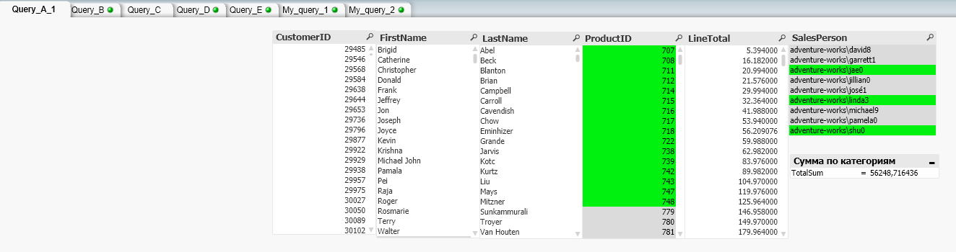



Report about income from sales by product, client and country (region) for billing, shipping and client residency as they can be different. Is it case according our data? But you should generalize in any case. Please mind discounts. You should include in that report only data that supported by sales (so no zero entries except discounted price is zero)

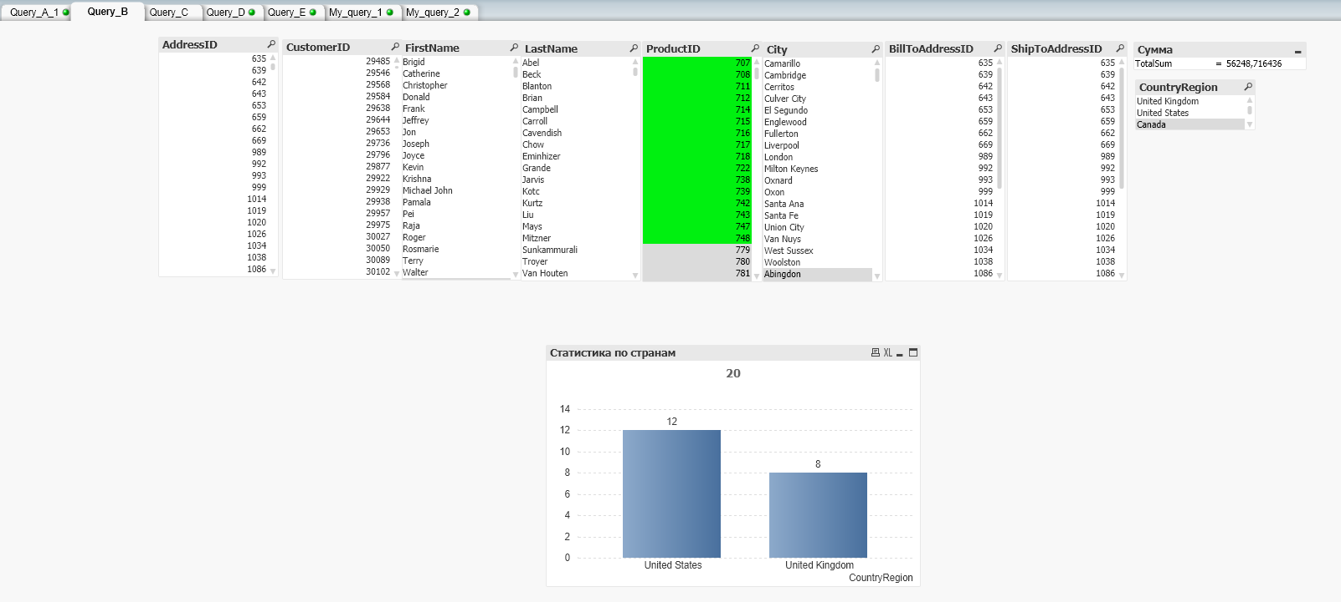

## C

Report about income from sales and provided discounts by location in form of hierarchy city>state/province>country/region. In that report you can rely on unique geographical names, but in general it is not the case. Think about how to solve that task in case that there is a possibility of existence of multiple cities in the same province with the same name. For big cities someone would need more detailed report that can include city districts, solve this task for extra points.

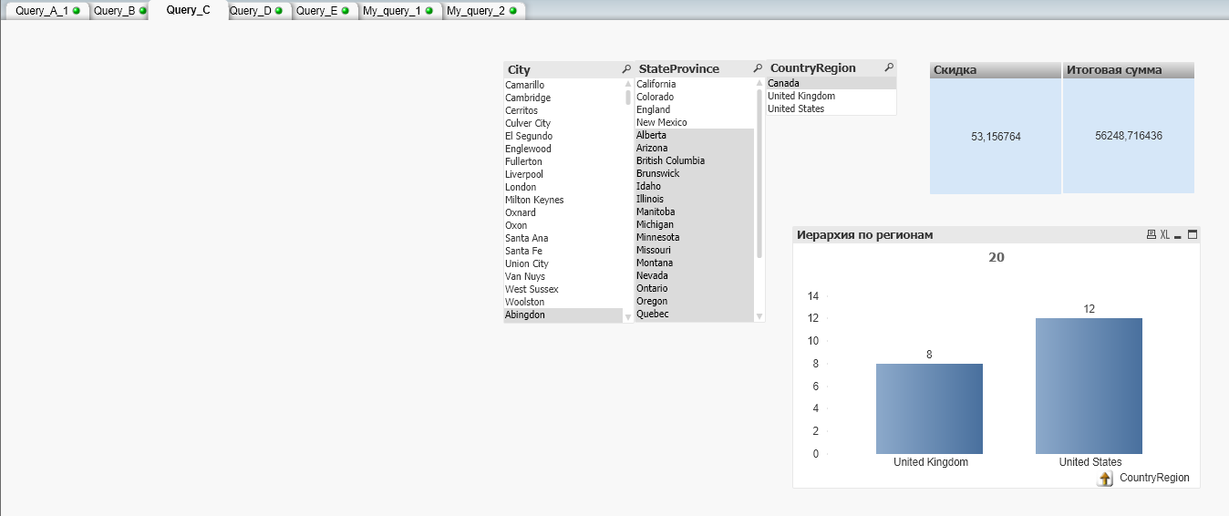

## D

Report about income from sales and provided discounts by product and hierarchy of product categories (high level category-> next level category->...->low level category->product). Please mind that some products can be outside (any) category or be only partially categorized (be not in low level of hierarchy). You can rely on you data to solve to solve this task (especially on that how much subcategories in the current data set), but try to think how to solve this task in general (with arbitrary category tree).

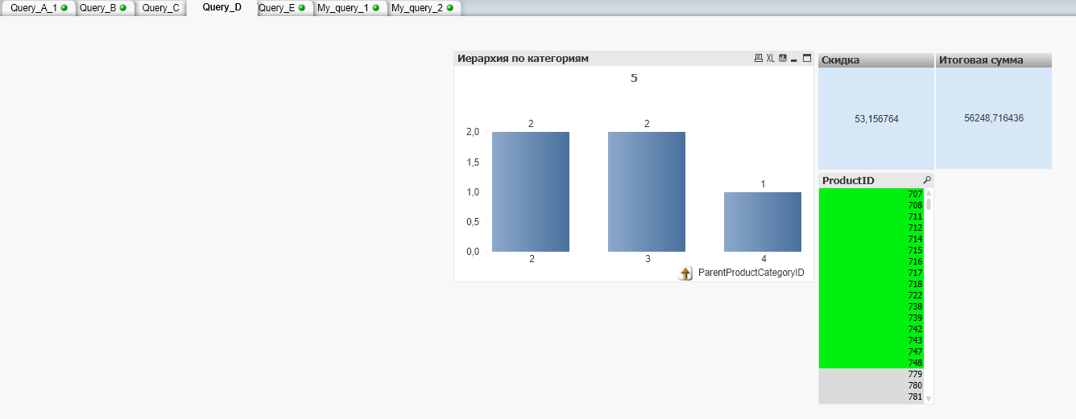

E

Create integral report on number of product sales by product, client, sales person and hierarchy of regions.

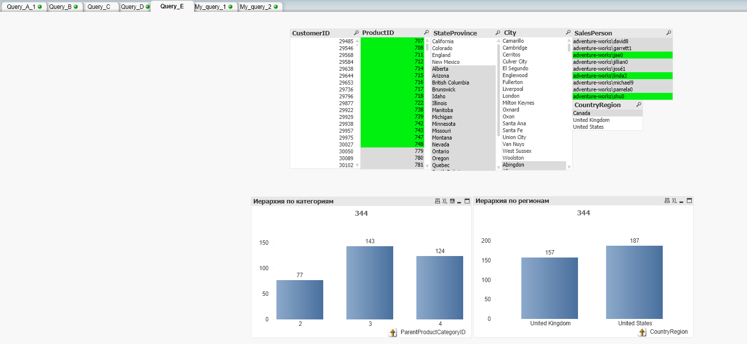

# Запрос 1.

Получение стандартной цены, цены в прайс – листе и наценки

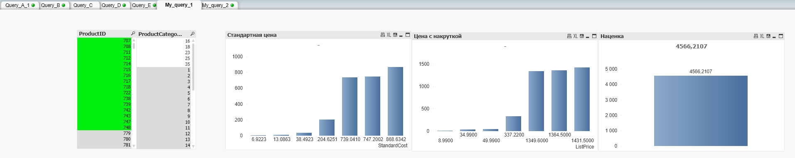

# Запрос 2.

Вывод, сколько продаж по продавцам. Можно использовать для формирования акций.

