System Design Document
Audio Localization system
Names of the group members:
Vladyslav Nepriakhin | 5189969
Aleksey Kapustjonoks | 5267870

Introduction
The audio localization system can detect azimuth and elevation of the sound source (80-200Hz) in the Far- Field. In the far-field the sound travels like a vector using TDOA technique. These techniques are used to calculate the angle of arrival for 2D detection. To achieve this, the system uses a vertical triangle array of three INMP441 omnidirectional MEMS microphones, which are responsible for signal capturing and have bandpass filter with ADC converter. The set up includes one ESP-32, which is responsible for detection algorithms and data processing. In addition, ESP-32 supports two stereo channels, making it possible to connect all three microphones without adding extra hardware. The acquired angle is then streamed via UART interface.

System-level description
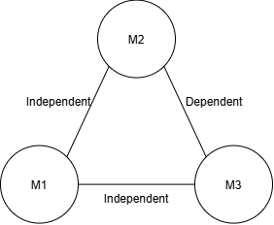
Three INMP441 are arranged in a vertical equilateral triangle, and the source is in front of this triangle facing the microphones. This creates 3 pairs M1<->M2, M1<->M3, M2<->M3, third pair is mathematically dependent on the other two pairs. Therefore, this model provides two angles for two independent pairs. This provides a pointing vector, which indicates where the sound is coming from, but leaves out the third dimension of absolute distance.

The ESP is connected to the Laptop via USB UART and would receive angles to draw vectors.
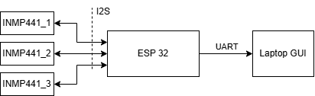
Figure 1: System overview diagram
INMP441 microphones
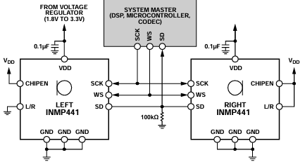
Digital omnidirectional microphones capture raw audio samples that pass through the ADC and then filtered by the bandpass filter to isolate the target frequency spectrum and remove unwanted noise. The pass band of the filter extends to 0.423 × fS and, in that band, has an unnoticeable 0.04 dB of ripple. The high-frequency cutoff of −6 dB occurs at 0.5 × fS. A 48 kHz sampling rate results in a pass band of 20.3 kHz and a half amplitude corner at 24 kHz. The stop-band attenuation of the filter is greater than 60 dB, making it ideal for our application. After samples are transferred to the microcontroller using I2S interface.
Figure 2:INMP441 stereo output
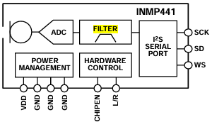
ESP32
Stereo INMP441 microphones are synchronized by the WS signal, so audio captured from two microphones sharing the same clock will be in sync. Synchronized I2S audio frames are continuously captured via Direct Memory Access into the memory buffers without stalling the main execution loop on ESP. After data enters the buffer is then processed by the cross-correlation algorithm to calculate $Δt$ , it aligns buffers and reveals how much difference in samples between microphones. By dividing this sample shift by the $fs$ 48kHz, code converts shifted samples into the $Δt.$ Processing and filtering data at the digital microphone side introduces a group delay, which is 359us from INMP441 datasheet. Because setup uses same microphones, this delay is cancelled automatically.
Figure 3: Hardware functionality

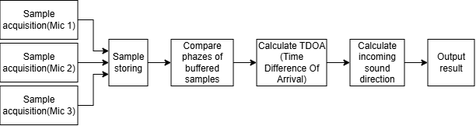
Figure 4: Software system diagram

Detailed Design

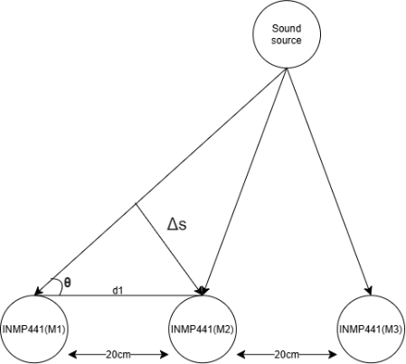
TDOA principle
Figure 5: TDOA model
Assuming we are operating in the far field. Sound waves arrive as flat lines, forming a right-angled triangle where hypotenuse is the known distance between microphones, adjacent is the extra distance that sound needs to travel to second microphone and $θ is the angle of the sound source$. We can calculate adjacent $Δs$, because we know speed of sound $c$ and $Δt$ between microphones à $Δs=Δt×c$ à $Δs=Δt×343m/s$. Knowing two sides of the right-angled triangle we can calculate angle $θ$ using trigonometry rules such as SOHCAHTOA $\cos\left(θ\right)=\frac{Adjecent}{Hypotenuse}$ à
$\cos\left(θ\right)=\frac{Δs}{d_{1}}→ θ=\arccos\left(\frac{Δs}{d_{1}}\right)$ à $arccos(\frac{∆t*c}{d1})$
à where d1 is known distance between microphones.
Critical decisions
Decision | Choice |  | Justification
Microphones | INMP441 |  | Digital I2S output avoids external ADCs and reduces analog noise. A shared SCK/WS clock synchronizes sampling between microphones. L/R channel selection also allows multiple microphones per I2S peripheral.
MCU | ESP32 |  | Provides two I2S peripherals, sufficient RAM/processing capability, and extensive software support.
Number of microphones | 3 |  | Three microphones provide two independent TDOA measurements, sufficient for direction estimation (azimuth/elevation). Range measurement is intentionally excluded to reduce hardware and algorithm complexity.
Array geometry | Equilateral triangle |  | Equal baselines provide comparable TDOA sensitivity in different directions and allow a 3D direction vector to be estimated from the two independent delays.
Sampling rate | 48kHz |  | Maximum available sampling rate minimizes TDOA quantization. One sample represents $T_{s}=\frac{1}{f_{s}}=20.83uS$ corresponding to an acoustic path difference of $∆s=\frac{c}{f_{s}}=7.15mm$.
Frequency band | 80-200Hz |  | The system targets the fundamental-frequency region of adult speech and rejects frequencies outside the band, reducing interference.
Mic spacing | 20cm |  | Spatial aliasing requires $d<\frac{λ_{min}}{2}=\frac{c}{\left(2f_{max}\right)}=\frac{343}{\left(2·200\right)}=0.858 m$. TDOA angular quantization is approximately $Δθ=\sin^{-1}\left(Δs/d\right)$,giving 2.05° at 20 cm. Simulation gives a 2.40° median resolution, equivalent to $3\tan\left(2.40°\right)≈12.6 cm$ lateral uncertainty at 3 m. Larger spacing improves resolution, but 20 cm was chosen as the accuracy/size compromise.
Spacing |  | Best |  | Median | Error @ 3 m | Worst
20 cm |  | 2.36° |  | 2.40° | 12.6 cm | 15.36°
30 cm |  | 1.58° |  | 1.60° | 8.4 cm | 12.53°
40 cm |  | 1.18° |  | 1.20° | 6.3 cm | 10.85°
Non-critical decisions
Decision | Choice | Justification
Output visualization | 3D direction vector | Directly visualizes the calculated azimuth and elevation.
Communication | USB-UART | Simple interface for sending angle data to the laptop; timing impact will be verified experimentally.

