From the Abyss Working Log

Date and version
9 November 2026 | Week 09 | Version 0.4 | Reporting period 3–9 November 2026.

Development progress
From the Abyss, my AI-assisted 2D animation introducing a game world, remains in pre-production and shot testing. The archive includes storyboards for the first three chapters, 49 reference images and five selected existing video tests.

What I did
I checked the proposal, storyboard pages, reference gallery and video files, then published my Fold World Living Studio on GitHub Pages. I added clear entrances to the project, working log and Moon Tides, a related NetArt study using MediaPipe hand tracking to control stars and water ripples. Codex helped with the website, interaction code and documentation.

To do next
Assemble a short rough cut from the existing materials with temporary narration. Check neighbouring shots for visual continuity and pacing, then plan the soundtrack.

Existing problems
The separately generated clips still need continuity checks. Camera interaction may be affected by lighting and hand visibility. The finished animation and soundtrack remain in development.

Possible solutions
Start with a short sequence, record specific mismatches and regenerate only shots that disrupt the story. Keep camera access optional, retain pointer controls and test the interaction under more conditions.
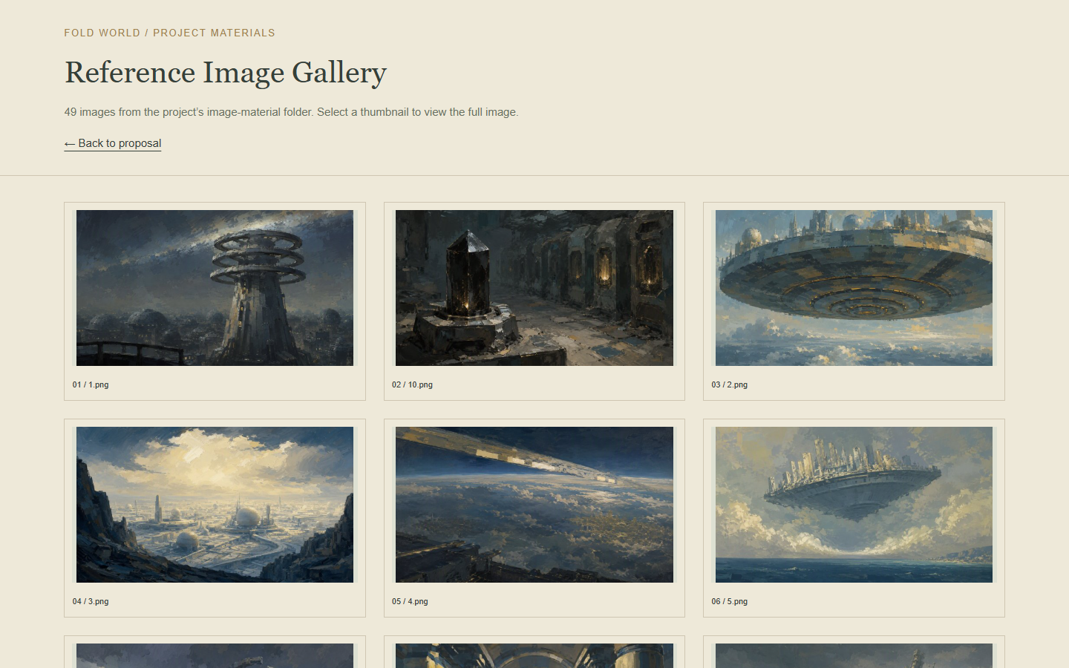
Existing reference images in the online project archive.

