Final Project Working Log
  - From the Abyss

20 October 2026
Over the past week, I focused on developing and organising the pre-production materials for my final project, From the Abyss, an AI-assisted 2D animation based on the background story I wrote for a game. My work centred on translating the written story into visual material, reviewing the available images and video tests, and preparing a presentation that clearly explains the project's direction and production process.
One of the main tasks was developing the storyboards. The complete story contains more than ten chapters, and the adaptation has currently reached the first three chapters. For these chapters, I organised shot descriptions covering the setting, subject, action, camera movement and narration. I also worked on the instructions used to generate reference images and video clips. These instructions help define what each shot should communicate, rather than only describing how it should look. My production workflow follows five stages: story script, storyboard, reference images, video generation, and finally voice-over and editing.
I also organised the existing project materials so that they could be reviewed more easily. This included the complete background story, three storyboard documents and a collection of 49 reference images. I added these materials to an English HTML presentation, with links that allow viewers to open the documents and browse the image gallery. This made the relationship between the written story, the visual references and the generated results easier to follow.
For the video demonstration, I selected five existing clips showing different aspects of the animation: a child moving through a square, a rotating climate tower, a floating city descending into the sea, the deployment of a mechanical structure, and an underground industrial city. Together, these examples demonstrate character movement, mechanical motion, large-scale action and environment design. I reviewed them alongside the relevant storyboard descriptions to consider whether the movement, camera choices and overall atmosphere communicated the intended events. The clips are still production tests and will need further selection and integration before they form a finished sequence.
Another completed task was preparing the project presentation and its Chinese and English speaking scripts. I organised the presentation into six sections covering the central idea, motivation, visual and narrative references, production plan, tools and workflow, and expected challenges. I also revised the reference section to discuss general artistic approaches without requiring the audience to know the details of my story.
Through this work, I identified two main challenges for the next stage: visual continuity and musical continuity. Separately generated shots can vary in character appearance, architecture, colour, lighting and painted texture. I will need to compare neighbouring shots and make adjustments so that the animation feels consistent. The soundtrack will also need a coherent style and smooth transitions between different scenes and moods. My next steps are to refine the selected clips, assemble a rough sequence, and develop the voice-over, music and editing into a more complete animation.

2 November 2026

Current stage and focus
This week, I revisited the story and earlier production notes for From the Abyss and clarified the next stage of development. The project is an AI-assisted 2D animation introducing the background of my game. The existing materials include storyboards for the first three chapters, reference images and several generated video tests. My focus is now on planning how these separate materials can become a coherent sequence with narration and music.

Work completed this week
I organised the outstanding production questions into a clearer review plan. For each selected shot, I will check whether the main action is understandable, whether the camera movement supports that action, and whether the painted appearance remains consistent. The earlier production notes identify cases in which a requested fixed view became a moving or closer camera view. This gives me a specific issue to examine when selecting usable versions.
I also broke visual continuity into more manageable checks: character and architectural details, colour and lighting, movement direction, and framing between neighbouring shots. This helped me define what to compare before deciding that a shot needs to be generated again. For the soundtrack, I clarified the need for a shared musical direction and transition points that follow the development of the scene.

Problems and the role of AI
Visual continuity and musical continuity remain unresolved production tasks. A successful individual clip does not automatically establish a successful transition. My next review will compare the end of one shot with the beginning of the next and consider whether editing, timing or colour adjustments can address the mismatch. I will also leave enough space for narration when planning music levels and transitions.
AI helped me retrieve the earlier project records, organise the remaining tasks and distinguish between generating media and using models to guide behaviour or decisions. I used these discussions to clarify possible experiments and their limits. This week's review established a clearer set of production priorities and a practical plan for the next edit.

Next actions
- Select a short passage from the existing storyboards and list the shots needed for a rough sequence.
- Compare the corresponding reference images and video tests, recording the specific continuity issues in each shot.
- Assemble the selected clips with temporary narration and test the pacing, music transitions and sound levels.
- Revise only the shots that prevent the sequence from communicating clearly, and record the changes in the next dated entry.

9 November 2026
  - Week 09

Date and version
9 November 2026 | Week 09 | Working Log version 0.3. Reporting period: 3–9 November 2026. This entry records the development and documentation session on 9 November.

Development progress
From the Abyss is my AI-assisted 2D animation introducing the background of a game. It remains in pre-production and shot testing. The existing archive contains storyboards for the first three chapters, 49 reference images and five selected video tests. This session focused on making these materials accessible through my Living Studio and recording a clearer plan for the next edit.

What I did
I checked the project proposal, storyboard pages, reference gallery and selected clips in the website archive. I preserved the relationship between the story, visual references and motion tests so that viewers can follow how the animation is developing. I also checked that the reference thumbnails open their full images.
I prepared a standalone web version of my Fold World Living Studio for GitHub Pages. I added direct entrances to the final-project proposal, Creative Coding 2.0 and the working log. I replaced the empty public log template with this dated record and removed local source paths from the published gallery data.
For the related NetArt 02 exercise, I added Moon Tides, a hand-controlled artwork that develops the lunar-water atmosphere and pointer interaction of my earlier website. A pretrained MediaPipe model estimates hand landmarks; hand position guides the visual focus, and pinching and releasing creates a ripple. The work is embedded in the studio and also has its own page. This is an interactive course study alongside the animation project.
I used Codex to help locate earlier records, prepare the website and implement the interaction. The project story and existing media provide the content; the new work in this session is the publication, interaction and documentation. I have not added new animation shots or completed the soundtrack in this entry.
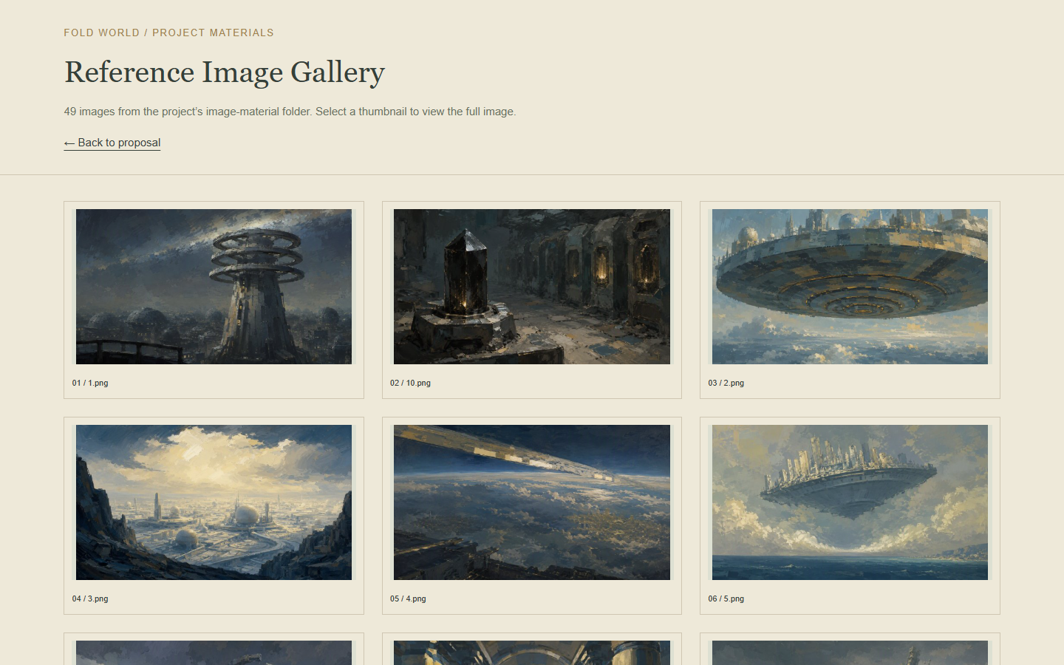
Figure 1 Existing reference images organised in the From the Abyss archive

Week 09 continued

To do next
- Choose one short passage from the existing storyboards and list the shots it needs.
- Assemble the corresponding clips into a rough cut with temporary narration. Compare character details, architecture, movement direction, lighting and framing between neighbouring shots.
- Test music transitions and sound levels after the basic pacing is clear. Record specific problems before regenerating any shot.
- Try the camera interaction under different lighting conditions and on another device, then record where hand tracking becomes unreliable.

Existing problems
The film is still a collection of production materials and separate tests. Visual continuity, narration, pacing and musical continuity need to be judged in an edited sequence. A finished website does not resolve these film-production tasks.
The interactive study depends on camera permission, lighting and hand visibility. Pointer control makes the visual response accessible without a camera, but it does not demonstrate AI tracking. The three-dimensional studio is also more demanding than the individual project pages.

Possible solutions
I will use a short rough cut to identify the most disruptive continuity problems, then revise only the shots that prevent the sequence from communicating clearly. I will keep comparison notes so that each revision has a specific purpose.
For the website, I kept the project pages directly accessible and included the model assets locally. The camera starts only after the viewer chooses it, provides tracking feedback and can be stopped. I will use further camera tests to adjust the interaction rather than treating the first working version as a complete evaluation.
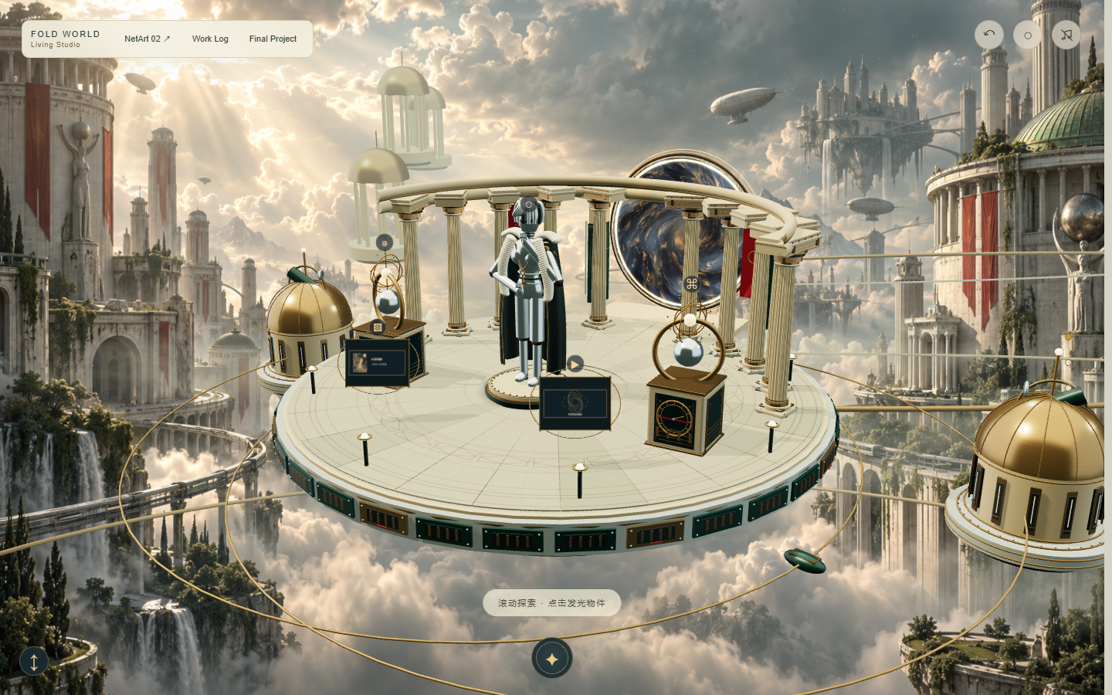
Figure 2 Fold World with entrances to the final project interactive work and working log
Open the public Living Studio
Open this Week 09 record online

