1. **install MySQL with docker**
2. docker run --name mysql -e MYSQL_ROOT_PASSWORD=7654321 -e MYSQL_USER=admin --mount source=my-vol-MySQL,target=/server -d mysql:latest
3. setup mysql(https://blog.csdn.net/hcrw01/article/details/83375943)

switch to Console

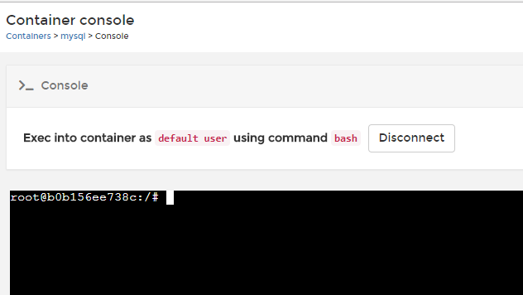

Load to mysql with command: mysql -uroot -p

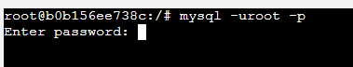

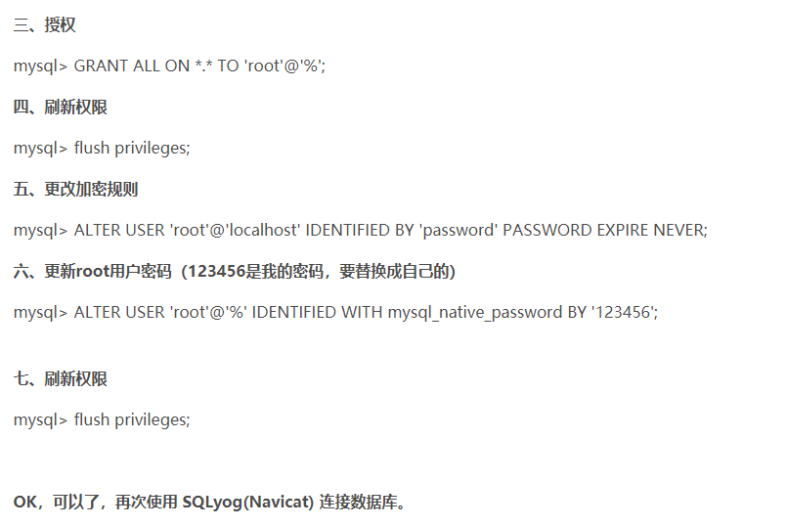

1. **install Redis in VM Linux Ubuntu**

REFERENCES:

1. <https://www.cnblogs.com/zongfa/p/7808807.html>
2. <https://www.cnblogs.com/zhangxue/p/7244167.html>
3. <https://blog.csdn.net/jackliu16/article/details/80920362>
4. Install redis server

sudo apt-get install redis-server

1. Check redis server status

netstat -nlt|grep 6379

1. Connect to redis server in VM

redis-cli

1. Update(I comment all bind ip to let all can connect) bind ip address to make sure Windows host or others IP can connect to VM redis server(A,B,C)

sudo vi /etc/redis/redis.conf

sudo /etc/init.d/redis-server restart

1. Connect to redis server in Windows via VIM

redis-cli.exe -h 192.168.117.128 -p 6379

1. **Redis common command and test**

REFERENCES:

1. <https://www.cnblogs.com/zongfa/p/7808807.html>
2. **SpringBoot connect to Redis**

REFERENCE:

1. <https://www.cnblogs.com/-flq/p/9068605.html>