- Router
A router connects different networks and decides how data should travel between them.
It connects various networks simultaneously.

Switch
A switch connects devices within a single network.
It connects various devices simultaneously.

- Copper Straight-Through cables

06.
Router>enable
Router#conf
Router#configure t
Router#configure terminal
Enter configuration commands, one per line. End with CNTL/Z.
Router(config)#interface g
Router(config)#interface gigabitEthernet 0/0
Router(config-if)#ip a
Router(config-if)#ip address
Router(config-if)#ip address 200.165.10.10 255.255.255.0
Router(config-if)#no shut
Router(config-if)#no shutdown

Router(config-if)#
%LINK-5-CHANGED: Interface GigabitEthernet0/0, changed state to up

%LINEPROTO-5-UPDOWN: Line protocol on Interface GigabitEthernet0/0, changed state to up

Router(config-if)#exit
Router(config)#inter
Router(config)#interface G
Router(config)#interface GigabitEthernet 0/1
Router(config-if)#ip address
Router(config-if)#ip address 200.165.20.10
% Incomplete command.
Router(config-if)#ip address
Router(config-if)#ip address 200.165.20.10 255.255.255.0
Router(config-if)#no shut
Router(config-if)#no shutdown

Router(config-if)#
%LINK-5-CHANGED: Interface GigabitEthernet0/1, changed state to up

%LINEPROTO-5-UPDOWN: Line protocol on Interface GigabitEthernet0/1, changed state to up

Router(config-if)#exit
Router(config)#interface g0/2
Router(config-if)#ip addre
Router(config-if)#ip address 200.165.30.10 255.255.255.0
Router(config-if)#no dh
Router(config-if)#no dh
^
% Invalid input detected at '^' marker.

Router(config-if)#no shu
Router(config-if)#no shutdown

Router(config-if)#
%LINK-5-CHANGED: Interface GigabitEthernet0/2, changed state to up

Router(config-if)#exit
Router(config)#copy ru
Router(config)#^Z
Router#
%SYS-5-CONFIG_I: Configured from console by console

Router#copy ru
Router#copy running-config sta
Router#copy running-config startup-config
Destination filename [startup-config]?
Building configuration...
[OK]
Router#

07.

10.
Ping from PC0 to Laptop2
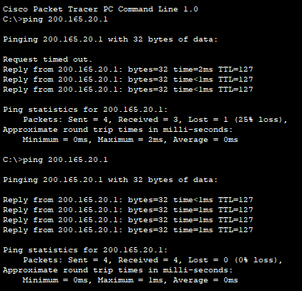

Ping from PC3 to PC1
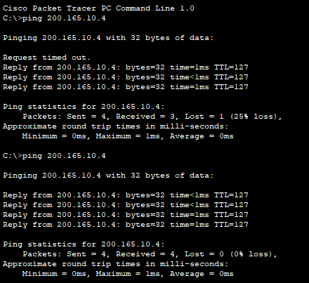

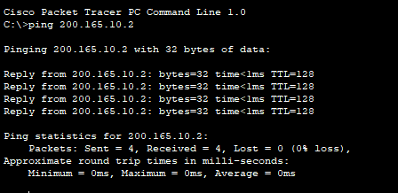
Ping from Laptop0 to Laptop1

11.
a.
Switch>enab
Switch>enable
Switch#conf t
Enter configuration commands, one per line. End with CNTL/Z.
Switch(config)#host
Switch(config)#hostname S0
S0(config)#
b.
S0(config)#^Z
S0#
%SYS-5-CONFIG_I: Configured from console by console

S0#show runn
S0#show running-config
Building configuration...

Current configuration : 1076 bytes
!
version 15.0
no service timestamps log datetime msec
no service timestamps debug datetime msec
no service password-encryption
!
hostname S0
!
!
!
!
!
!
spanning-tree mode pvst
spanning-tree extend system-id
!
interface FastEthernet0/1
!
interface FastEthernet0/2
!
interface FastEthernet0/3
!
interface FastEthernet0/4
!
interface FastEthernet0/5
!
interface FastEthernet0/6
!
interface FastEthernet0/7
!
interface FastEthernet0/8
!
interface FastEthernet0/9
!
interface FastEthernet0/10
!
interface FastEthernet0/11
!
interface FastEthernet0/12
!
interface FastEthernet0/13
!
interface FastEthernet0/14
!
interface FastEthernet0/15
!
interface FastEthernet0/16
!
interface FastEthernet0/17
!
interface FastEthernet0/18
!
interface FastEthernet0/19
!
interface FastEthernet0/20
!
interface FastEthernet0/21
!
interface FastEthernet0/22
!
interface FastEthernet0/23
!
interface FastEthernet0/24
!
interface GigabitEthernet0/1
!
interface GigabitEthernet0/2
!
interface Vlan1
no ip address
shutdown
!
!
!
!
line con 0
!
line vty 0 4
login
line vty 5 15
login
!
!
!
!
end
c.
S0#
S0#conf t
Enter configuration commands, one per line. End with CNTL/Z.
S0(config)#line vty 0 15
S0(config-line)#passw
S0(config-line)#password cisco
S0(config-line)#login
S0(config-line)#exit
d.
S0(config)#line con 0
S0(config-line)#pass
S0(config-line)#password cisco
S0(config-line)#login
S0(config-line)#ex
S0(config-line)#exit
e.
S0(config)#exit
S0#
%SYS-5-CONFIG_I: Configured from console by console

S0#show star
S0#show startup-config
startup-config is not present

f.
S0#copy running-config st
S0#copy running-config startup-config
Destination filename [startup-config]?
Building configuration...
[OK]
g.
S0#show flash:
Directory of flash:/

1 -rw- 4670455 <no date> 2960-lanbasek9-mz.150-2.SE4.bin
2 -rw- 1131 <no date> config.text

64016384 bytes total (59344798 bytes free)
12.

