II)
Given IP address : 130.210.0.0/16
We want 3 host bits borrowed to the network part
Subnet mask : 255.255.224.0/19

Network address: 130.210.0.0
Broadcast address: 130.210.31.255

Network address: 130.210.32.0
Broadcast address: 130.210.63.255

Network address: 130.210.64.0
Broadcast address: 130.210.95.255

Network address: 130.210.96.0
Broadcast address: 130.210.127.255

Network address: 130.210.128.0
Broadcast address: 130.210.159.255

Network address: 130.210.160.0
Broadcast address: 130.210.191.255

III)
Device name | Interface | IP address | Subnet Mask | Default gateway
PC0 |  | 130.210.0.1 | 255.255.224.0 | 130.210.0.254
PC1 |  | 130.210.0.2 | 255.255.224.0 | 130.210.0.254
PC2 |  | 130.210.0.3 | 255.255.224.0 | 130.210.0.254
PC3 |  | 130.210.32.1 | 255.255.224.0 | 130.210.32.254
Laptop0 |  | 130.210.32.2 | 255.255.224.0 | 130.210.32.254
Laptop1 |  | 130.210.64.1 | 255.255.224.0 | 130.210.64.254
Laptop2 |  | 130.210.64.2 | 255.255.224.0 | 130.210.64.254
Router0 | G0/0 | 130.210.160.1 | 255.255.224.0
 | G0/1 | 130.210.96.1 | 255.255.224.0
 | G0/2 | 130.210.254.0 | 255.255.224.0
Router1 | G0/0 | 130.210.160.2 | 255.255.224.0
 | G0/1 | 130.210.128.1 | 255.255.224.0
 | G0/2 | 130.210.32.254 | 255.255.224.0
Router2 | G0/0 | 130.210.128.2 | 255.255.224.0
 | G0/1 | 130.210.96.2 | 255.255.224.0
 | G0/2 | 130.210.64.254 | 255.255.224.0
Switch0 | VLAN1 | 130.210.0.5 | 255.255.224.0 | 130.210.254.0
Switch1 | VLAN1 | 130.210.32.5 | 255.255.224.0 | 130.210.32.254
Switch2 | VLAN1 | 130.210.64.5 | 255.255.224.0 | 130.210.64.254

V)
Router0
Router(config)#ip route 130.210.32.0 255.255.224.0 130.210.160.2
Router(config)#ip route 130.210.64.0 255.255.224.0 130.210.96.2
Router1
Router(config)#ip route 130.210.0.0 255.255.224.0 130.210.160.1
Router(config)#ip route 130.210.0.0 255.255.224.0 130.210.96.1
Router2
Router(config)#ip route 130.210.0.0 255.255.224.0 130.210.96.1
Router(config)#ip route 130.210.32.0 255.255.224.0 130.210.128.1
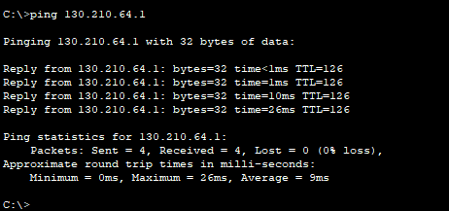
VI)

