SUPPORTAI – AI-POWERED SUPPORT TICKET
MANAGEMENT SYSTEM
A PROJECT REPORT
Submitted by
VEER PATEL
230090107167
In partial fulfillment for the award of the degree of
BACHELOR OF ENGINEERING
in
Computer Engineering
C. K. Pithawala College of Engineering and Technology, Surat
 | 
Gujarat Technological University, Ahmedabad
August, 2026

 | 
C. K. Pithawala College of Engineering and Technology
Opposite Surat Airport, Behind DPS School, Near Malvan Mandir, Dumas Road, Surat
CERTIFICATE
This is to certify that the project report submitted along with the project entitled SUPPORTAI – AI-POWERED SUPPORT TICKET MANAGEMENT SYSTEM has been carried out by Veer Patel under my guidance in partial fulfillment for the degree of Bachelor of Engineering in Computer Engineering, 7th Semester of Gujarat Technological University, Ahmedabad during the academic year 2026-27.
Prof. Ami Choksi  Internal Guide | Dr. Saurabh S. Tandel  Head of the Department

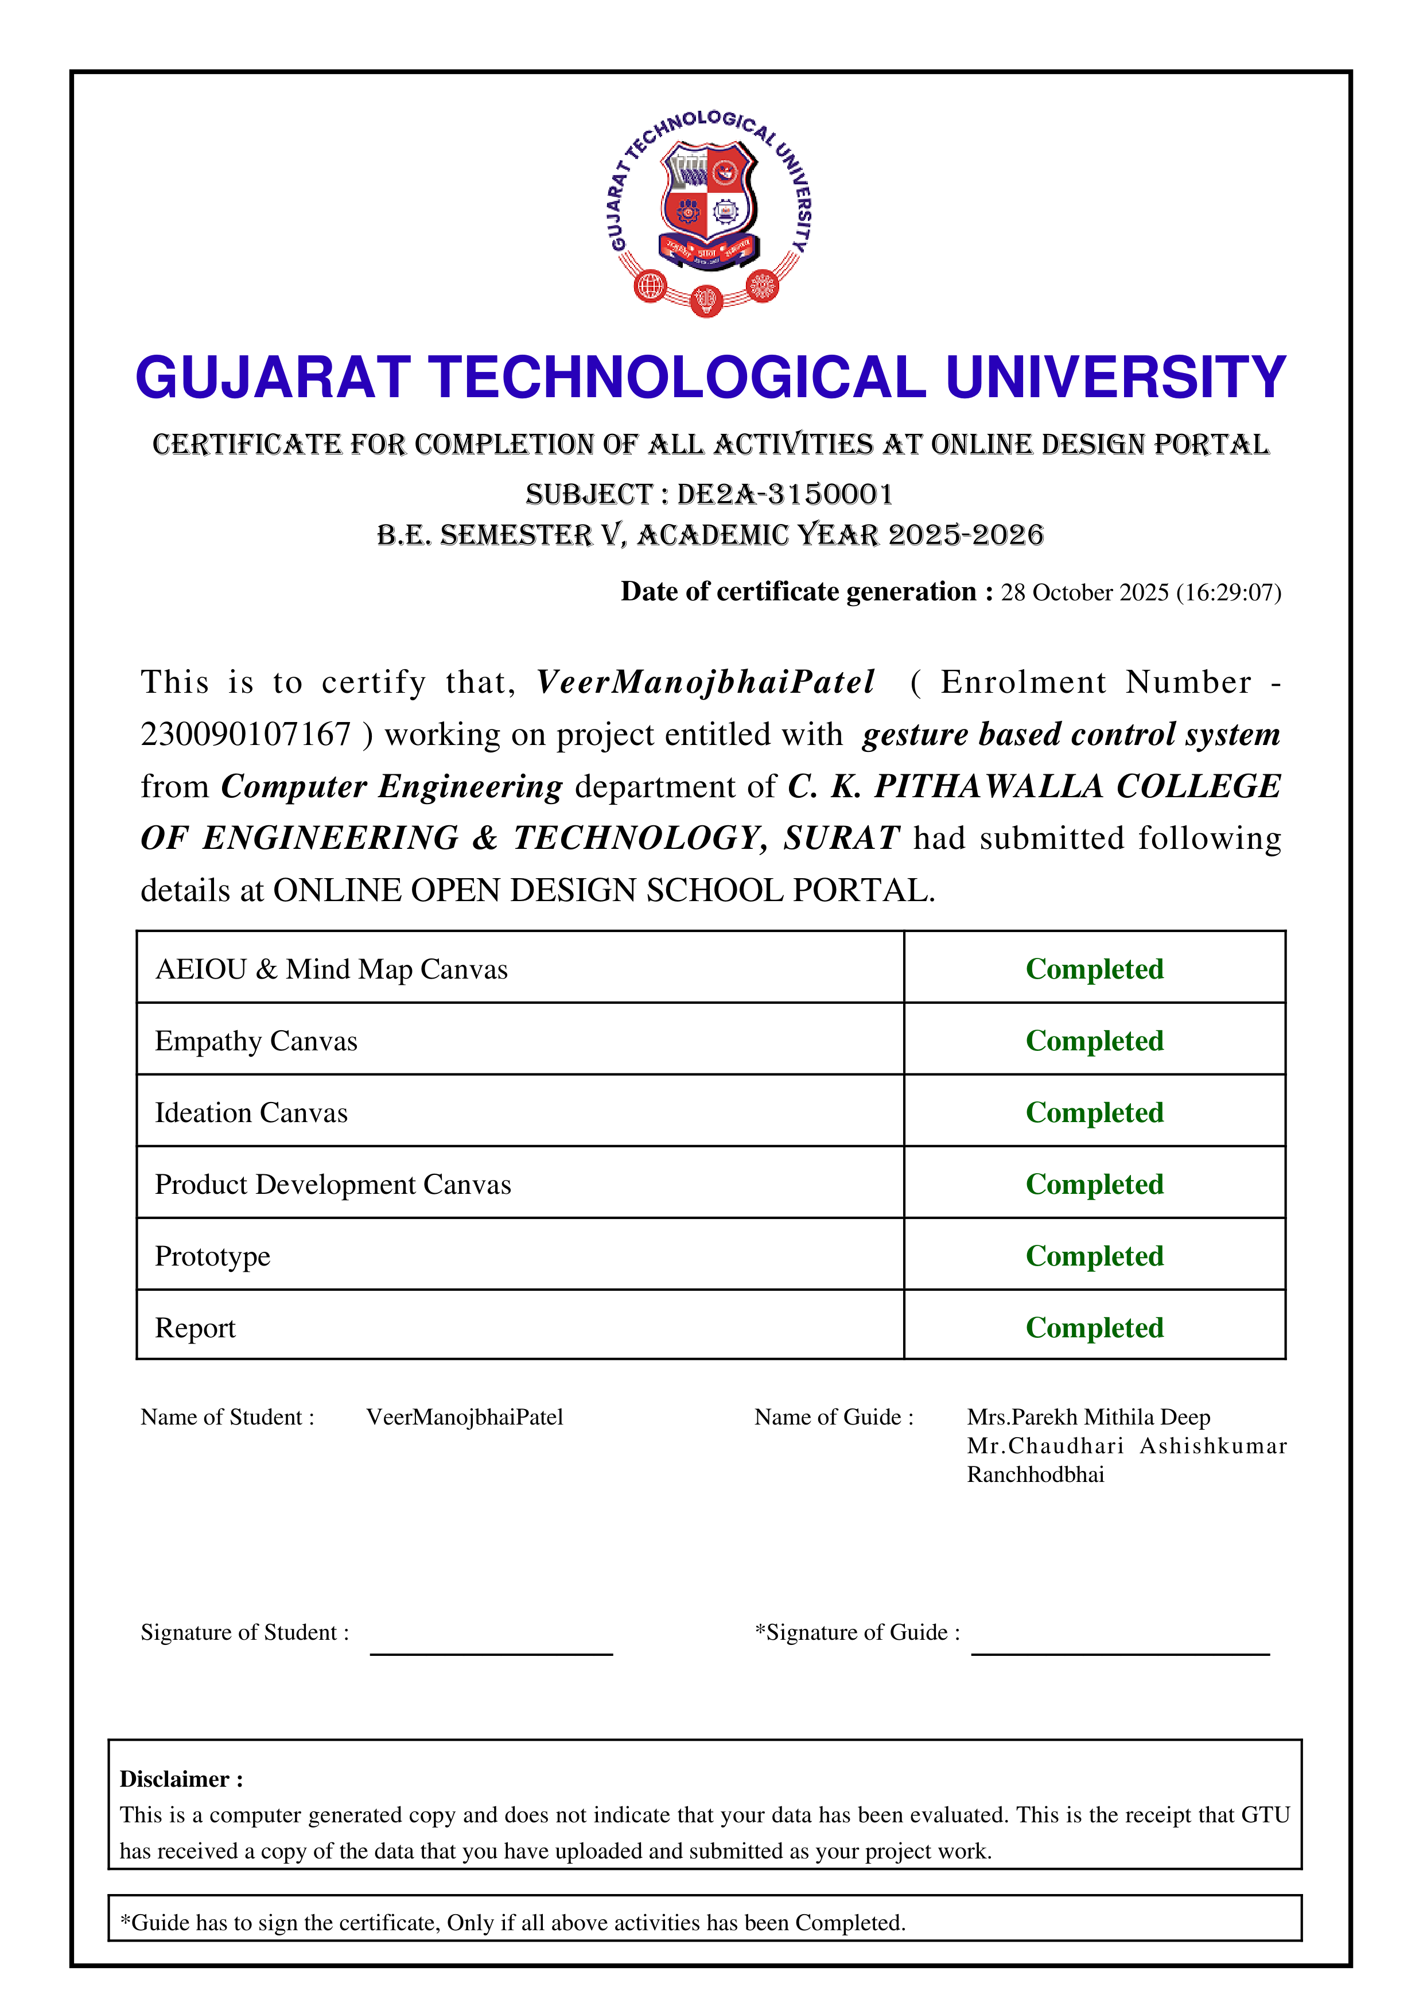

 | 
C. K. Pithawala College of Engineering and Technology
Opposite Surat Airport, Behind DPS School, Near Malvan Mandir, Dumas Road, Surat
DECLARATION
I hereby declare that the Internship report submitted along with the Internship entitled SUPPORTAI – AI-POWERED SUPPORT TICKET MANAGEMENT SYSTEM submitted in partial fulfillment for the degree of Bachelor of Engineering in Computer Engineering to Gujarat Technological University, Ahmedabad, is a bonafide record of original project work carried out by me at CloudThat Technologies Pvt. Ltd under the supervision of Prof. Ami Choksi and that no part of this report has been directly copied from any students’ reports or taken from any other source, without providing due reference.
PATEL VEER
230090107167

Acknowledgement
I would like to express my sincere gratitude to Gujarat Technological University and C. K. Pithawala College of Engineering and Technology, Surat, for providing the academic framework and opportunity to undertake the Microsoft Skill-Based Internship 2026. I am thankful to Microsoft and CloudThat for providing structured exposure to current technologies through the Microsoft Skill-Based Training program. The training schedule covered Azure fundamentals, Azure administration, Artificial Intelligence fundamentals, Azure AI applications and agents, and GitHub Copilot. The program provided a valuable bridge between academic concepts and industry-oriented technology practices. I would especially like to thank Dr. Madhuri Joshi for conducting the training sessions and guiding us through the scheduled learning and assessment activities. I also convey my deep thanks to my internal guide Prof. Ami Choksi and Dr. Saurabh S. Tandel (Head of Computer Engineering Department) for their constant encouragement. Finally, I acknowledge the support of my faculty members, classmates, family, and everyone who contributed directly or indirectly to the successful completion of the internship.

Abstract
The Microsoft Azure and Artificial Intelligence Skill-Based Internship helped me learn about modern cloud computing and artificial intelligence technology through industry training carried out by CloudThat Technologies Pvt. Ltd. In the course of this internship, various Microsoft technologies like Microsoft Azure Fundamentals (AZ-900), Azure Administrator (AZ-104), Azure AI Fundamentals (AI-900), Azure AI Engineer (AI-103), and GitHub Copilot (AZ-2007) were covered to understand how they can be applied in real-life software development and intelligent systems.
In this internship, a project titled “SupportAI – AI-Powered Support Ticket Management System” is developed to automate customer support ticket triage, priority scoring, sentiment detection, and suggested response generation. The system employs Natural Language Processing (NLP) with TF-IDF feature extraction and compares Machine Learning algorithms including Logistic Regression and Random Forest Classifier across 7 operational categories (Billing / Payment, Account / Login, Technical Issue, Order / Delivery, Product Issue, Cancellation / Refund, General Inquiry). Additionally, the system predicts ticket priority (High, Medium, Low) using ML combined with urgency heuristics and classifies customer sentiment (Positive, Neutral, Negative) to synthesize context-aware, empathetic support responses.
The application has been built with Python, Flask, SQLite, HTML5, CSS3, Bootstrap 5, JavaScript, Chart.js, Pandas, NumPy, and Scikit-learn. The application provides an interactive single-viewport analytics dashboard, live ticket analysis with 1-click test presets, SQLite history audit logging with search/filter capabilities, and an empirical model performance benchmarking page showing accuracy, precision, recall, F1-scores, and confusion matrices. The trained Logistic Regression model achieved 81.97% accuracy and 81.78% weighted F1-score, outperforming Random Forest.
This internship has improved my knowledge and understanding of cloud computing concepts, natural language processing, machine learning pipelines, web application development, databases, and AI-assisted software engineering practices. In conclusion, the internship has helped me acquire valuable industry-oriented knowledge and practical experience in the field of Information Technology and Applied AI.

List of Figures
Figure 1.1 Organizational Structure of CloudThat Technologies Pvt. Ltd. 3
Figure 2.1 Sequence of Internship Operations 8
Figure 3.1 Gantt Chart for Internship Schedule (15 Days) 15
Figure 4.1 Process Flow Diagram of the Proposed System 20
Figure 4.2 System Architecture of Proposed System 22
Figure 4.3 Comparison of Existing System and Proposed System 23
Figure 5.1 Three-Tier System Architecture 24
Figure 5.2 Entity Relationship Diagram 26
Figure 5.3 State Transition Diagram 28
Figure 5.4 Analyze Ticket Page Interface 29
Figure 5.5 Dashboard Interface 30
Figure 5.6 Triage Result & Suggested Response Interface 31
Figure 5.7 Ticket History Log Interface 31
Figure 5.8 Model Performance Evaluation Interface 32
Figure 6.1 Confusion Matrix & Training Pipeline Output 35
Figure 7.1 Automated Test Suite Execution Result 38

List of Tables
Table 1.1 Scope of Work 2
Table 1.2 Plant Capacity 4
Table 2.1 Technical Specifications 6
Table 3.1 Cost Estimation 13
Table 3.2 Roles and Responsibilities 14
Table 6.1 Implementation Environment 33
Table 7.1 Test Results Summary 37
Table 7.2 Comprehensive Test Cases 39
Table 8.1 Problems Encountered and Solutions 42

List of Symbols, Abbreviations and Nomenclature
AI Artificial Intelligence
ML Machine Learning
NLP Natural Language Processing
TF-IDF Term Frequency - Inverse Document Frequency
LR Logistic Regression
RF Random Forest Classifier
SLA Service Level Agreement
IDE Integrated Development Environment
UI User Interface
API Application Programming Interface
CRUD Create, Read, Update, Delete
HTTP Hypertext Transfer Protocol
JSON JavaScript Object Notation
SQL Structured Query Language
RAG Retrieval-Augmented Generation
LLM Large Language Model

Table of Contents
1 Overview of the Company 1
1.1 History 1
1.2 Scope of work 2
1.3 Organization chart 3
1.4 Capacity of plant 4
2 Company Overview 5
2.1 Department working 5
2.2 Technical specifications 6
2.3 Sequence of operations 7
2.4 Production Stages 9
3 Introduction to Internship 10
3.1 Internship Summary 10
3.2 Purpose 11
3.3 Objective 11
3.4 Scope 11
3.5 Technology and Literature Review 12
3.6 Internship Planning 13
3.6.1 Approach with Justification 13
3.6.2 Cost Estimation 13
3.6.3 Roles 14
3.6.4 Group Dependencies 14
3.7 Internship Scheduling 15
4 System Analysis 16
4.1 Study of Current System 16
4.2 Problem and Weaknesses of Current System 17
4.3 Requirements of New System 18
4.4 System Feasibility 19
4.4.1 Contribution to the objective 19
4.4.2 Constraints 19
4.4.3 Integration 20
4.5 Process Flow 20
4.6 Features 21
4.7 Modules 22
4.8 Methodology 23
5 System Design 24
5.1 System Design & Methodology 24
5.2 Design Details 25
5.3 Interface Design 27
5.3.1 State Transition 28
5.3.2 Forms and Reports 28
5.3.3 Security Considerations 28
6 Implementations 33
6.1 Environment 33
6.2 Technology Specifications 34
6.3 Results 34
6.4 Result Analysis 35
7 Testing 36
7.1 Plan 36
7.2 Test Results 37
7.2.1 Test Cases 39
8 Conclusion and Discussion 41
8.1 Overall Analysis 41
8.2 Visit by Mentor 42
8.3 Evaluation Dates 42
8.4 Problem and Solutions 42
8.5 Summary 43
8.6 Future Scope 43
References 45

1 OVERVIEW OF THE COMPANY
1.1 History
CloudThat Technologies Pvt. Ltd. is one of India's leading cloud computing training and consulting organizations. The company was established in 2012 with the vision of helping individuals and organizations adopt cloud technologies through industry-oriented training, consulting, and digital transformation services.
CloudThat is an authorized training partner for leading cloud providers and has trained thousands of students, IT professionals, corporate employees, and government organizations across India and several international locations. The company specializes in delivering instructor-led training, certification programs, cloud consulting, and enterprise solutions in emerging technologies such as Cloud Computing, Artificial Intelligence (AI), Machine Learning (ML), Data Engineering, DevOps, Cybersecurity, and Generative AI.
As part of the Microsoft Skill-Based Training 2026 program organized in collaboration with Gujarat Technological University (GTU), CloudThat conducted a 70-hour internship covering Microsoft Azure Fundamentals (AZ-900), Microsoft Azure Administrator (AZ-104), Microsoft AI Fundamentals (AI-900), Microsoft Azure AI Engineer (AI-103), and GitHub Copilot (AZ-2007). During this internship, structured online sessions, practical demonstrations, quizzes, and assessments enabled students to gain valuable exposure to cloud architecture, artificial intelligence principles, and AI-assisted development tools.
The knowledge and practical skills acquired during the internship were applied to develop the project titled "SupportAI – AI-Powered Support Ticket Management System." This project demonstrates the integration of Natural Language Processing (NLP) and Machine Learning classification with full-stack web application development to automate support ticket categorization, priority scoring, sentiment analysis, and response generation.
1.2 Scope of work
CloudThat Technologies Pvt. Ltd. offers various forms of training, consulting, and cloud-related services for students, educational institutes, corporates, and government agencies. The firm works towards providing industry-ready skills through practical training programs and certification.
The key focus areas for the company include cloud computing, artificial intelligence, machine learning, data engineering, DevOps, cybersecurity, cloud migration, enterprise consulting, and corporate training. Students gain practical exposure to Microsoft Azure cloud services, Artificial Intelligence, and GitHub Copilot through instructor-led online training.
Table 1.1 Scope of Work
Service Area | Description | Technologies
Cloud Training | Microsoft Azure certification training and architectural concepts | AZ-900, AZ-104
Artificial Intelligence | AI fundamentals, Machine Learning, and Cognitive Applications | AI-900, AI-103
Cloud Consulting | Cloud migration, deployment architecture, and scalable infrastructure | Microsoft Azure
Data Engineering | Data processing, pipelines, and analytical data solutions | Azure Data Services
Corporate Training | Professional upskilling programs for enterprise teams | Microsoft Certifications
AI Productivity | AI-assisted software development and prompt engineering | GitHub Copilot (AZ-2007)
1.3 Organization chart.
CloudThat Technologies Pvt. Ltd. is managed through an organized organizational hierarchy to make sure that there is efficient management of training, consultancy, technical support, and business activities. CloudThat comprises accredited trainers, cloud architects, software engineers, and administrative personnel.
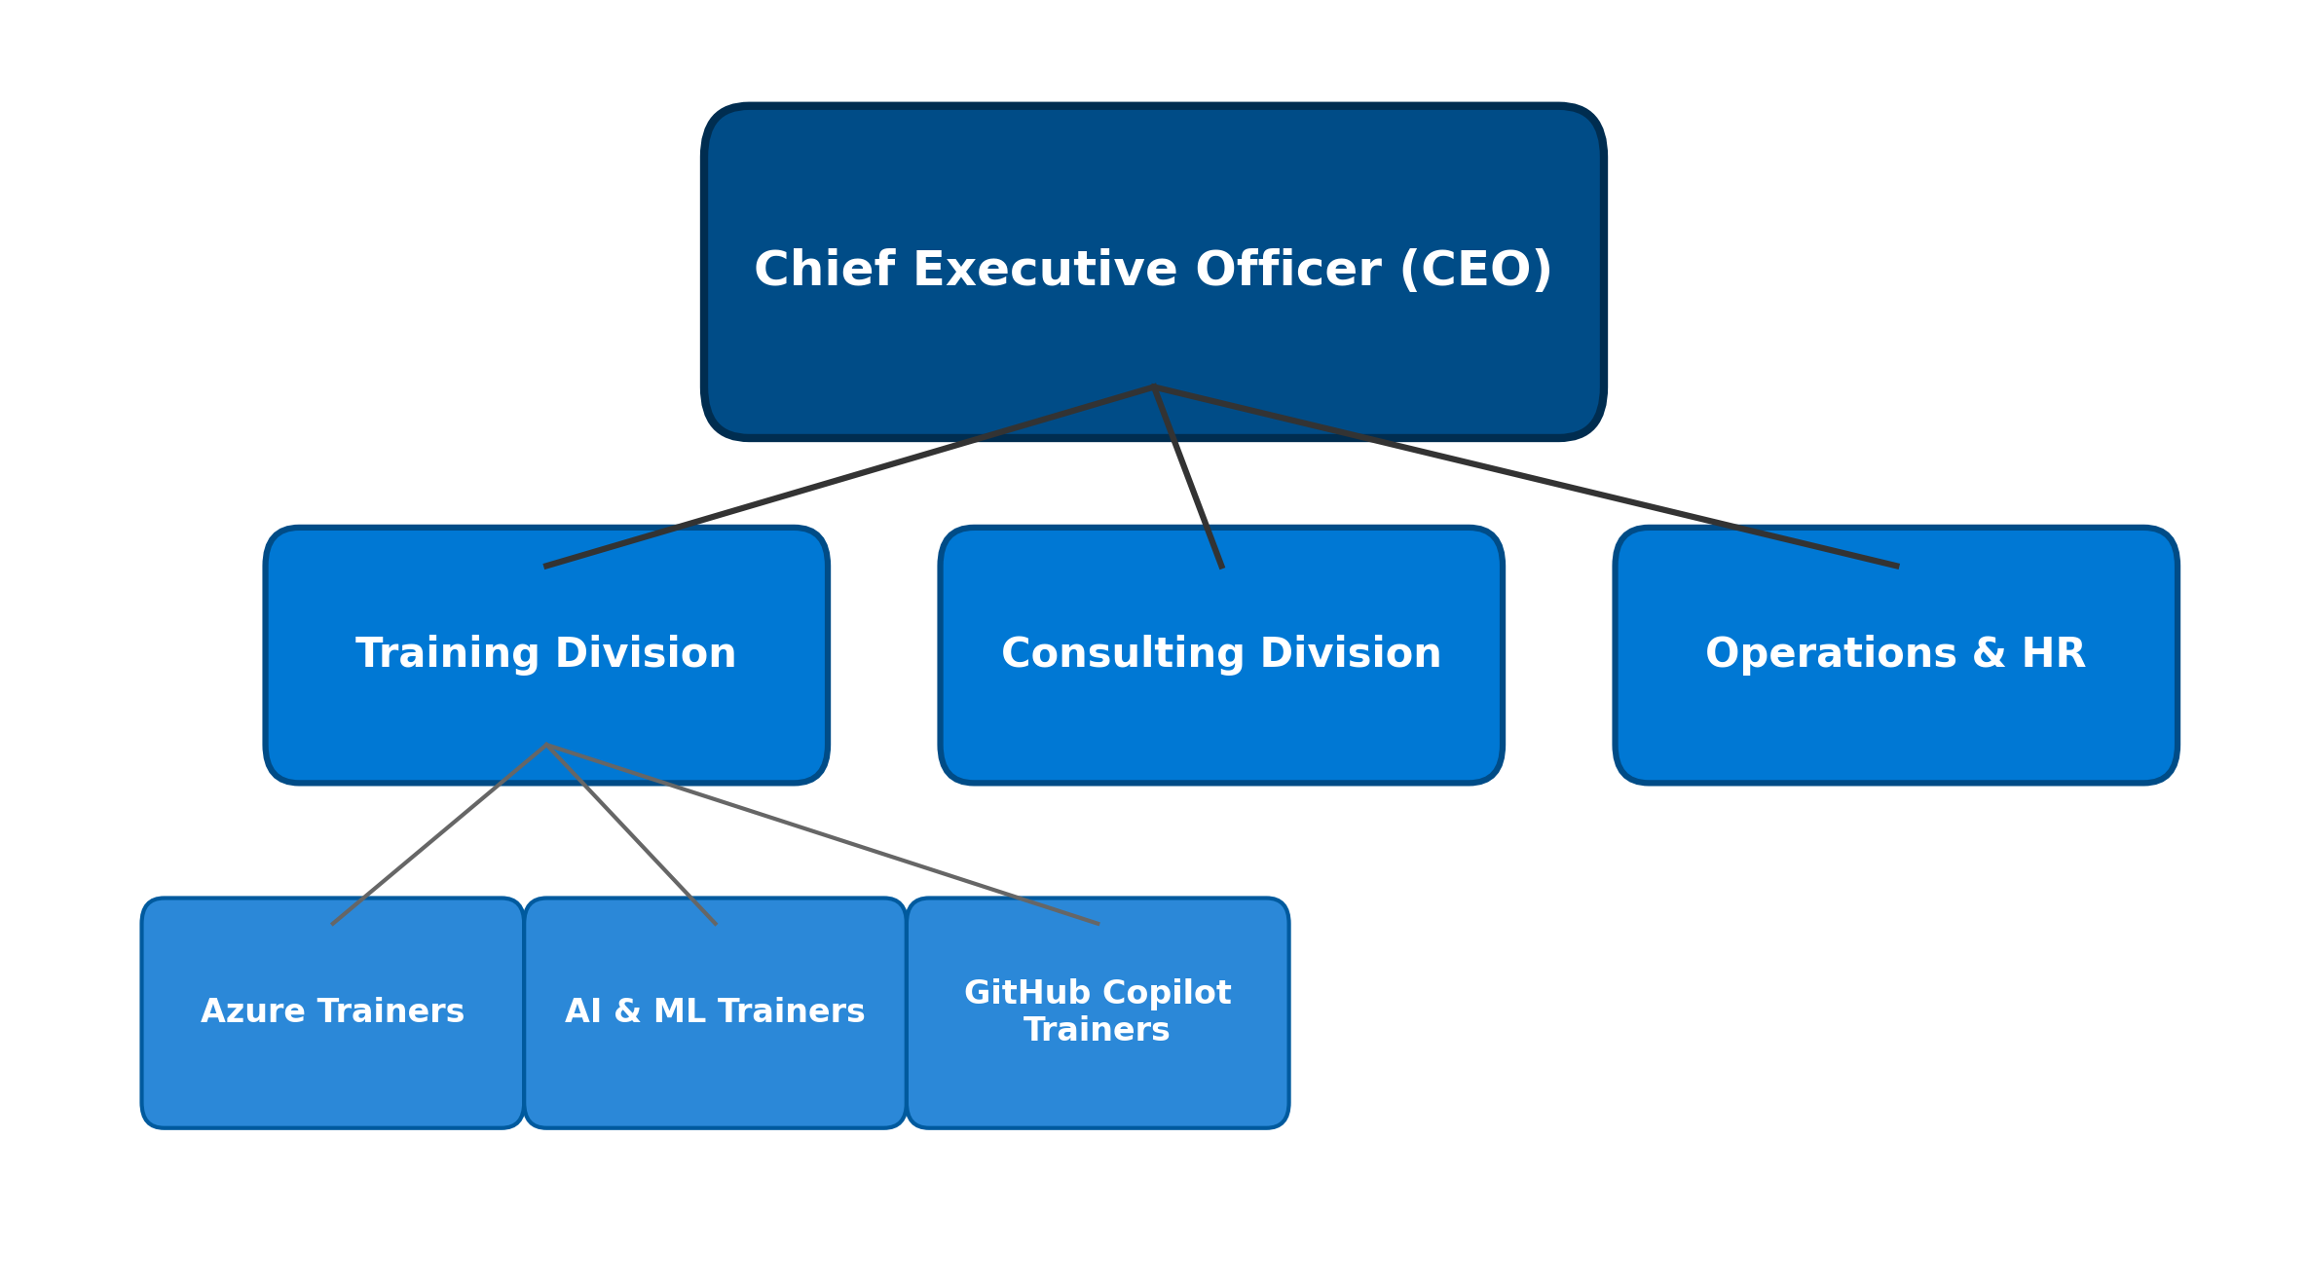
Figure 1.1 Organizational Structure of CloudThat Technologies Pvt. Ltd.
1.4 Capacity of plant
CloudThat Technologies Pvt. Ltd. operates a state-of-the-art digital learning infrastructure facilitated by certified instructors, interactive virtual labs, simulation platforms, and learning management portals. The company offers live classes, practical demos, quizzes, assessments, and certification-focused learning programs.
The technology-oriented infrastructure helps learners gain practical exposure and become well-prepared for technical roles in cloud computing, software development, data science, and artificial intelligence.
Table 1.2 Plant Capacity
Facility | Description
Learning Mode | Live Online Instructor-Led Training
Duration | 70 Hours (Over 15 Scheduled Days)
Cloud Platform | Microsoft Azure (Trainer Demos & Simulation Environment)
Programming Languages | Python 3.x, JavaScript
Development Tools | Visual Studio Code, GitHub Copilot
Learning Resources | Virtual Simulation Labs, Study Notes, Quizzes, Assessments
Project Development | Natural Language Processing, Machine Learning, Flask Web Application

2 COMPANY OVERVIEW
CloudThat Technologies Pvt. Ltd. is one of the premier cloud consulting, training, and digital transformation firms in areas such as Microsoft Azure, Artificial Intelligence, Data Engineering, DevOps, Cybersecurity, and Cloud Computing. During the internship period, experience was acquired about the training approach and technical environment of the company via the Microsoft Azure and Artificial Intelligence Skill-Based Internship.
In contrast to a manufacturing firm, CloudThat is primarily concerned with the transfer of technical knowledge, enterprise consulting, and professional certifications. Hence, this chapter deals with the training divisions and technical infrastructure of the organization.
2.1 Department working
CloudThat Technologies Pvt. Ltd. functions through specialized departments that collaborate to provide efficient and high-quality cloud consultancy, professional training, and enterprise solutions.
• The Training Department is responsible for designing certification curricula, preparing instructional content, conducting live interactive sessions, and assessing participants through periodic evaluations.
• The Cloud Consulting Department supports enterprise clients in cloud architecture, migration planning, infrastructure optimization, and security governance on Microsoft Azure.
• The Department of Artificial Intelligence and Data Engineering develops intelligent solutions, machine learning pipelines, generative AI integrations, and cloud analytics platforms.
2.2 Technical specifications
The internship utilized modern software platforms, cloud concepts, and development tools to provide hands-on experience in cloud computing, artificial intelligence, and full-stack software development. The major technologies utilized are summarized below.
Table 2.1 Technical Specifications
Category | Technology / Tool | Purpose
Cloud Platform | Microsoft Azure | Cloud services overview, architecture, and demonstrations
Programming Language | Python 3.x | Backend API development, text preprocessing, and ML modeling
Web Framework | Flask | Lightweight REST API backend and routing architecture
Database | SQLite | Persistent ticket transactions, timestamps, and history storage
Frontend | HTML5, CSS3, Bootstrap 5, JS | Responsive user interface, dark sidebar, and dynamic cards
NLP Vectorizer | TF-IDF (scikit-learn) | Unigram & bigram feature extraction from raw ticket text
Machine Learning | Logistic Regression, Random Forest | Multi-class category triage, priority, and sentiment models
Visualization | Chart.js | Interactive dashboard visualizations for category and sentiment
Development IDE | Visual Studio Code | Software development, debugging, and file management
AI Assistant | GitHub Copilot (AZ-2007) | AI-assisted code generation, scaffolding, and refactoring
Operating System | Windows 11 | Local development and execution environment
2.3 Sequence of operations
The internship followed a structured sequence of operations from orientation to final project evaluation:
1. Student Registration & Onboarding
2. Orientation and Introduction to the Training Track
3. Microsoft Azure Fundamentals (AZ-900)
4. Azure Administrator Concepts (AZ-104)
5. Artificial Intelligence Fundamentals (AI-900)
6. Azure AI Engineer Concepts (AI-103)
7. GitHub Copilot & AI-Assisted Development (AZ-2007)
8. Hands-on Practical Exercises & Simulations
9. Project Planning, NLP Preprocessing, & ML Model Development
10. Testing, Validation, & Performance Benchmarking
11. Documentation & Project Report Submission
12. Course Completion & Certification
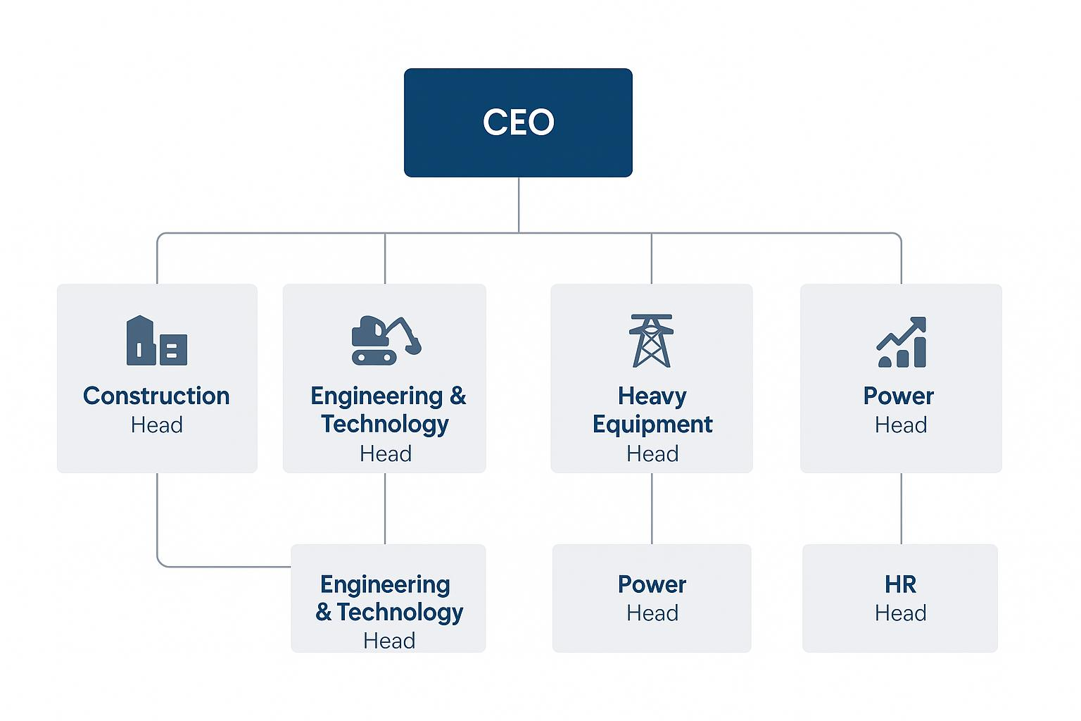
Figure 2.1 – Sequence of Internship Operations
2.4 Production Stages
The training and project development followed a clear four-stage progression:
• Phase 1: Conceptual Foundation — Understanding cloud architecture, Azure core services, virtualization, and networking.
• Phase 2: AI & Machine Learning Foundations — Exploring NLP, classification algorithms, Generative AI principles, and prompt engineering.
• Phase 3: Project Development — Developing SupportAI using Python, scikit-learn TF-IDF pipelines, Flask web routing, and SQLite storage.
• Phase 4: Quality Assurance & Evaluation — Executing automated unit test cases, validating model accuracy, benchmarking algorithms, and compiling final documentation.

3 INTRODUCTION TO INTERNSHIP
The Microsoft Azure and Artificial Intelligence Skill-Based Internship organized by CloudThat Technologies Pvt. Ltd. offered comprehensive exposure to cloud computing, artificial intelligence, and modern AI-assisted software development. During the internship, structured modules were conducted covering Azure Fundamentals, AI Fundamentals, Azure AI Engineer architectures, and GitHub Copilot.
3.1 Internship Summary
"SupportAI – AI-Powered Support Ticket Management System" is a machine-learning-driven web application designed to automate customer support operations. A customer submits an issue in natural language; the system automatically preprocesses the text, extracts TF-IDF features, and performs multi-attribute prediction to determine ticket category (across 7 domains), priority level, and customer sentiment tone.
The application incorporates an automated response synthesis engine that generates empathetic, context-specific support replies incorporating appropriate Service Level Agreement (SLA) escalation commitments. It provides an intuitive single-screen dashboard, real-time triage interface with 1-click presets, SQLite audit history, and empirical model evaluation analytics.
3.2 Purpose
The primary purpose of SupportAI is to eliminate manual bottlenecks in customer support ticketing. By instantly categorizing tickets, identifying high-priority urgent issues, and assessing customer sentiment, organizations can reduce response latency, prevent SLA breaches, and assist support agents with ready-to-send contextual responses.
3.3 Objective
The major technical and operational objectives of the project are:
• To develop an automated NLP-based support ticket triage system using Python and Flask.
• To train, evaluate, and compare classification algorithms (Logistic Regression vs. Random Forest).
• To predict ticket priority levels (High, Medium, Low) using ML combined with urgency heuristics.
• To detect customer sentiment tone (Positive, Neutral, Negative) for empathetic communication.
• To dynamically synthesize structured customer support responses with SLA commitments.
• To maintain persistent ticket records and timestamps using an SQLite database.
• To visualize operational analytics using Chart.js on an interactive dashboard.
• To expose empirical ML metrics and confusion matrices through a dedicated performance interface.
3.4 Scope
What the System Can Do:
• Accept natural language support queries from customers or support agents.
• Preprocess text by stripping URLs, emails, special characters, and normalizing whitespace.
• Classify issues into 7 distinct categories with real-time confidence scores.
• Flag urgent issues with expedited SLA badges and highlight dissatisfied customers.
• Generate complete customer replies with 1-click clipboard copy functionality.
• Provide searchable and filterable historical audit logs in SQLite.
• Present real-time distribution charts for category, priority, and sentiment.
What the System Cannot Do:
• It does not completely replace human support staff for complex multi-step technical investigations.
• Model accuracy relies on the vocabulary representation of the training corpus.
• The initial prototype operates locally and is designed to integrate with Azure cloud services in future phases.
3.5 Technology and Literature Review
Recent literature in applied NLP and automated customer support demonstrates that statistical feature extraction methods such as TF-IDF (Term Frequency - Inverse Document Frequency) paired with linear classifiers provide strong, highly interpretable baselines for text categorization. While deep learning models require extensive compute, Logistic Regression with sublinear TF scaling excels on sparse, high-dimensional text matrices. Flask provides a lightweight backend framework, SQLite offers zero-configuration persistence, and Bootstrap 5 ensures responsive UI presentation.
3.6 Internship Planning
3.6.1 Approach with Justification
The project followed an Agile Software Development Approach with iterative sprints for requirement definition, dataset curation, feature engineering, model training, backend API implementation, frontend UI design, and automated testing. The Agile approach allowed rapid prototyping, continuous verification, and seamless integration between ML models and Flask routes.
3.6.2 Cost Estimation
Table 3.1 Cost Estimation
Component | Cost
Python 3.x & scikit-learn | Free / Open-Source
Flask Web Framework | Free / Open-Source
SQLite Database | Free / Open-Source
Visual Studio Code | Free / Open-Source
Bootstrap 5 & Chart.js | Free / Open-Source
GitHub Copilot (Student Pack) | Free Educational Access
Microsoft Azure Learning Resources | Educational Access / Simulation
3.6.3 Roles
Table 3.2 Roles and Responsibilities
Role | Responsibility
Student (Veer Patel) | Requirement analysis, dataset creation, NLP pipeline, ML model training, Flask development, UI design, testing, and report preparation.
Industry Mentor (Ms. Madhuri Joshi) | Technical guidance, cloud computing training, AI concept lectures, and project mentoring during the internship.
Internal Guide (Prof. Ami Choksi) | Academic supervision, project milestone reviews, progress monitoring, and guidance.
3.6.4 Group Dependencies
This internship project was executed individually by Veer Patel. All stages—including dataset creation, ML pipeline development, web application programming, database setup, and system testing—were carried out independently under the mentorship of the industry trainer and internal academic guide.
3.7 Internship Scheduling
The internship schedule spanned 15 scheduled working days (3 July 2026 to 18 July 2026), systematically balancing technical training, Azure concepts, AI/ML theory, practical project development, testing, and documentation.
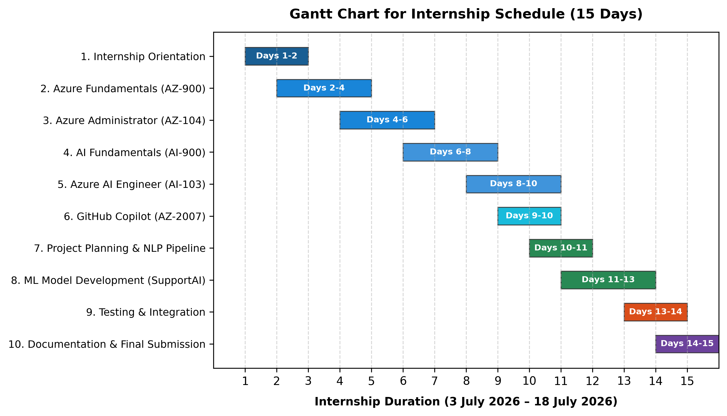
Figure 3.1: Gantt Chart for Internship Schedule (15 Days)

4 SYSTEM ANALYSIS
System analysis involves studying existing operational workflows, identifying inefficiencies, and designing an optimized, data-driven solution. For this project, traditional support ticket handling was analyzed to identify operational bottlenecks.
4.1 Study of Current System
In conventional support environments, incoming customer tickets from email or portals are manually reviewed by triage staff. Staff members read each query, manually assign category tags, estimate urgency based on intuition, and route the ticket to specialist queues. Support agents then draft manual responses or search through document repositories for relevant troubleshooting templates.
4.2 Problem and Weaknesses of Current System
The traditional manual workflow suffers from several critical weaknesses:
• High Latency: Tickets wait in unassigned queues during peak hours, delaying critical issue resolution.
• Human Subjectivity: Different agents classify identical issues inconsistently, causing misrouting.
• Delayed Escalations: Urgent customer issues (such as duplicate charges or account lockouts) are not flagged immediately.
• Repetitive Workload: Support agents spend significant time typing repetitive baseline responses for standard questions.
• Lack of Real-time Analytics: Management lacks live visibility into category distribution and sentiment trends.
4.3 Requirements of New System
Functional Requirements:
• Instant natural language ticket text processing and classification.
• Multi-class category prediction across 7 core support domains.
• 3-tier priority prediction with urgency keyword safeguards.
• Customer sentiment detection (Positive, Neutral, Negative).
• Dynamic synthesis of empathetic, context-grounded suggested support responses.
• SQLite database storage for audit trails and ticket history management.
• Single-viewport analytics dashboard with Chart.js distribution charts.
Non-Functional Requirements:
• High Performance: Sub-15 ms inference latency per ticket request.
• Usability: Clean, modern dark sidebar UI with responsive Bootstrap 5 layout.
• Reliability: Zero-failure input validation and robust error handling.
• Maintainability: Modular MVC code structure separating ML, database, routing, and UI.
4.4 System Feasibility
4.4.1 Contribution to the objective
SupportAI directly addresses the manual triage bottleneck by providing data-driven, automated ticket categorization and response synthesis, reducing operational costs and improving customer satisfaction.
4.4.2 Constraints
The initial prototype was developed using local Python, Flask, and SQLite environments during the internship timeline. Model performance is tied to the representative vocabulary of the training dataset.
4.4.3 Integration
The modular architecture allows future cloud integration with Microsoft Azure App Service, Azure OpenAI (AI-103) for generative RAG, and Azure SQL Database for enterprise-scale deployments.
4.5 Process Flow
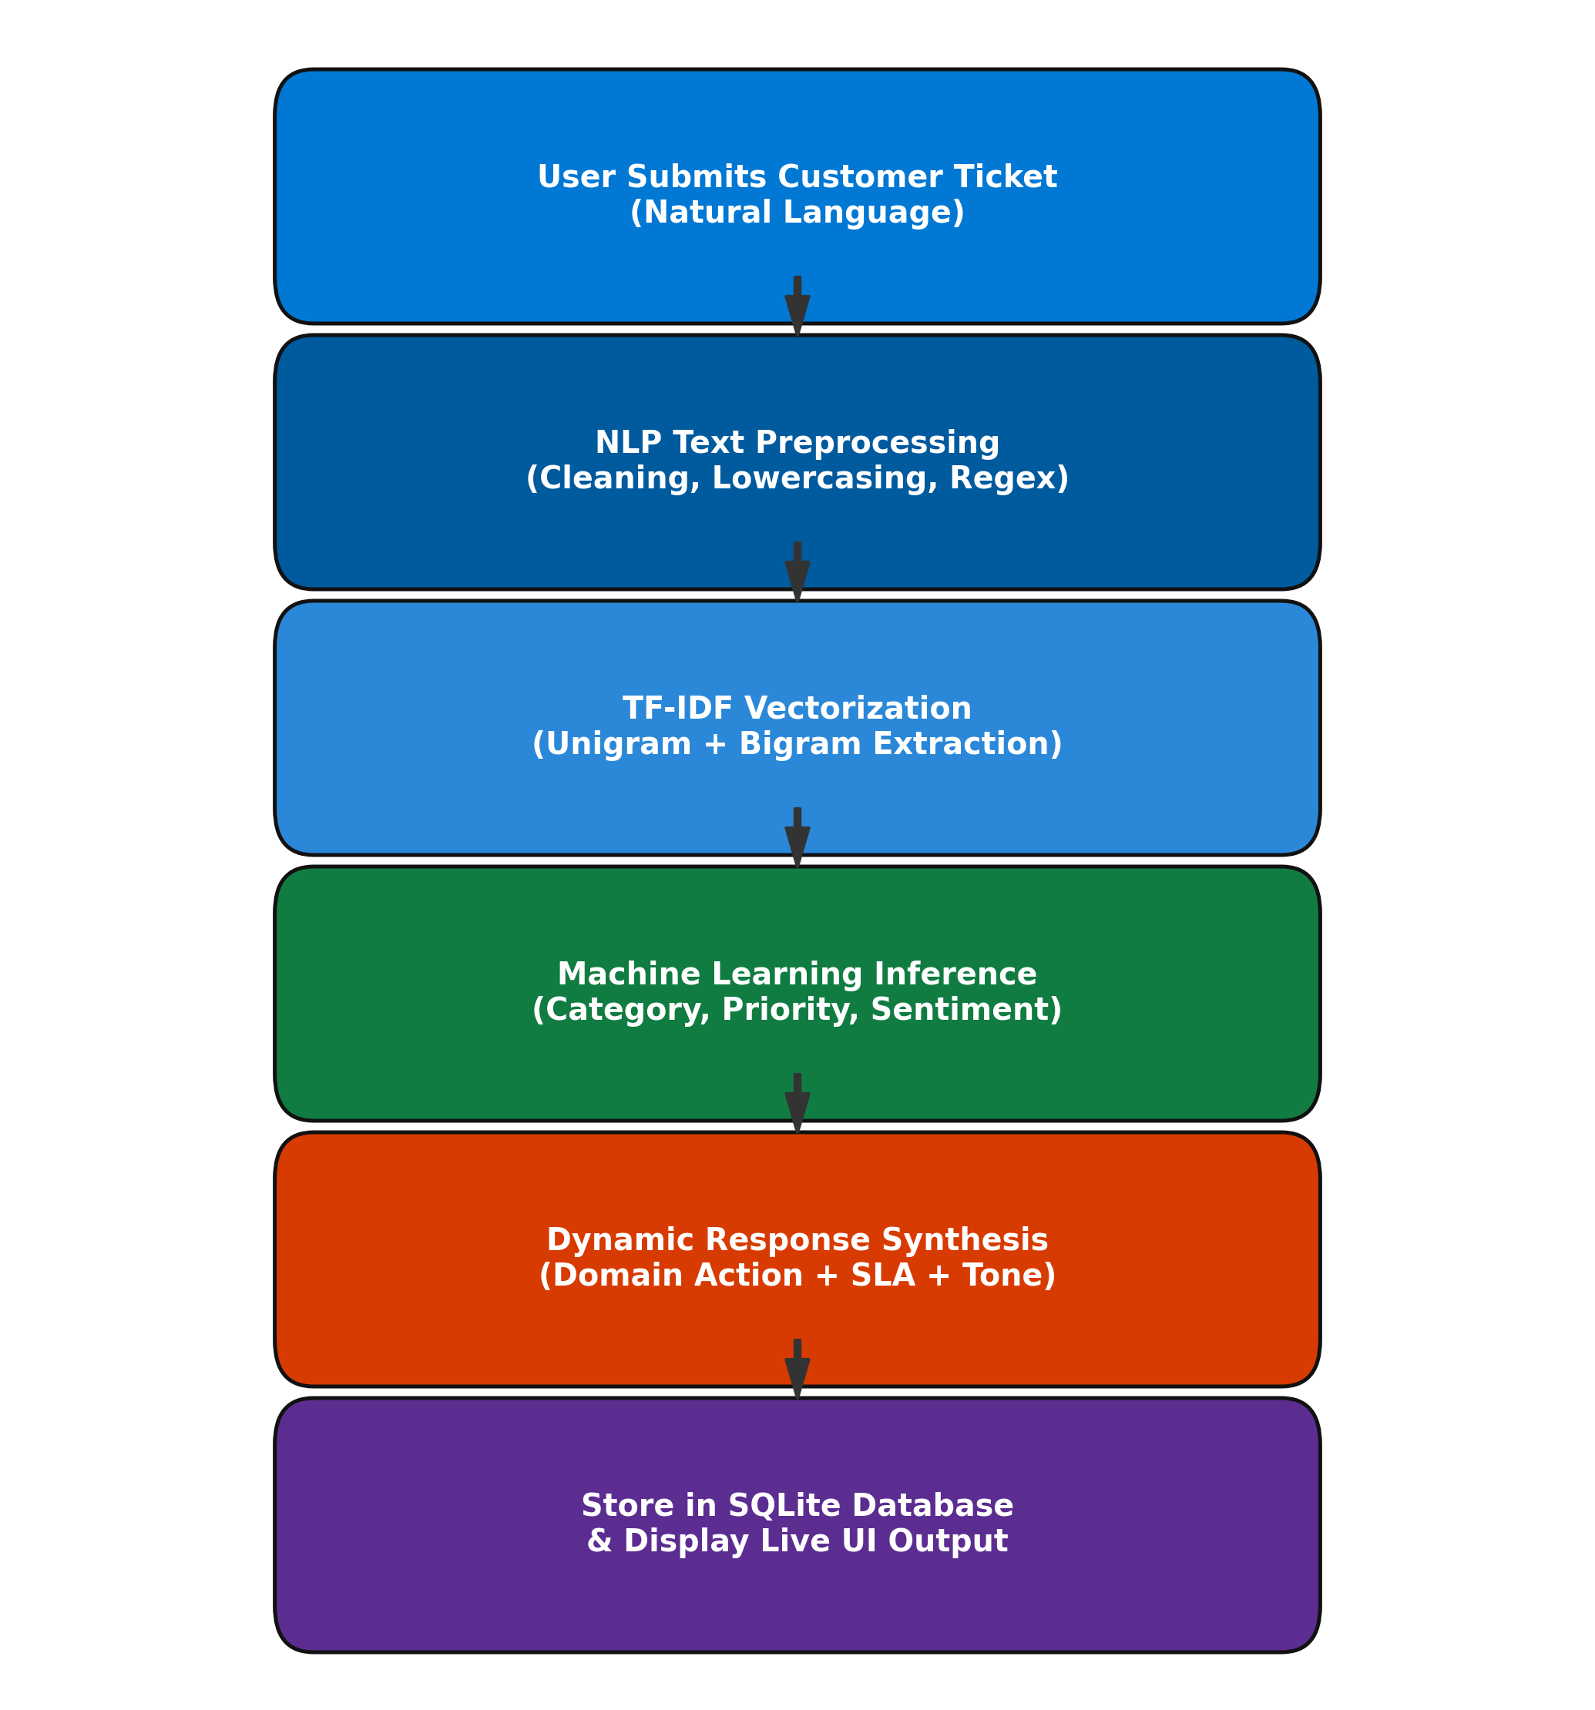
Figure 4.1: Process Flow Diagram of the Proposed System
4.6 Features
• Real-Time Multi-Output ML Inference (Category, Priority, Sentiment).
• 1-Click Presentation Presets for Instant Live Demonstration.
• Contextual Response Generation with Priority SLA Commitments.
• Single-Viewport Interactive Dashboard with Chart.js Graphs.
• Comprehensive Ticket History Log with Search & Filter Capabilities.
• Detailed Ticket Inspection Modal with 1-Click Clipboard Copy.
• Empirical Model Performance Benchmarking & Confusion Matrix.
4.7 Modules
The application is structured into four cohesive modules:
1. NLP Preprocessing & Feature Extraction Module (`ml/preprocess.py`)
2. Machine Learning Training & Evaluation Pipeline (`ml/train.py`, `ml/evaluate.py`)
3. Contextual Response Synthesis Engine (`ml/responder.py`)
4. Web Application & Database Layer (`app.py`, `database/db.py`)
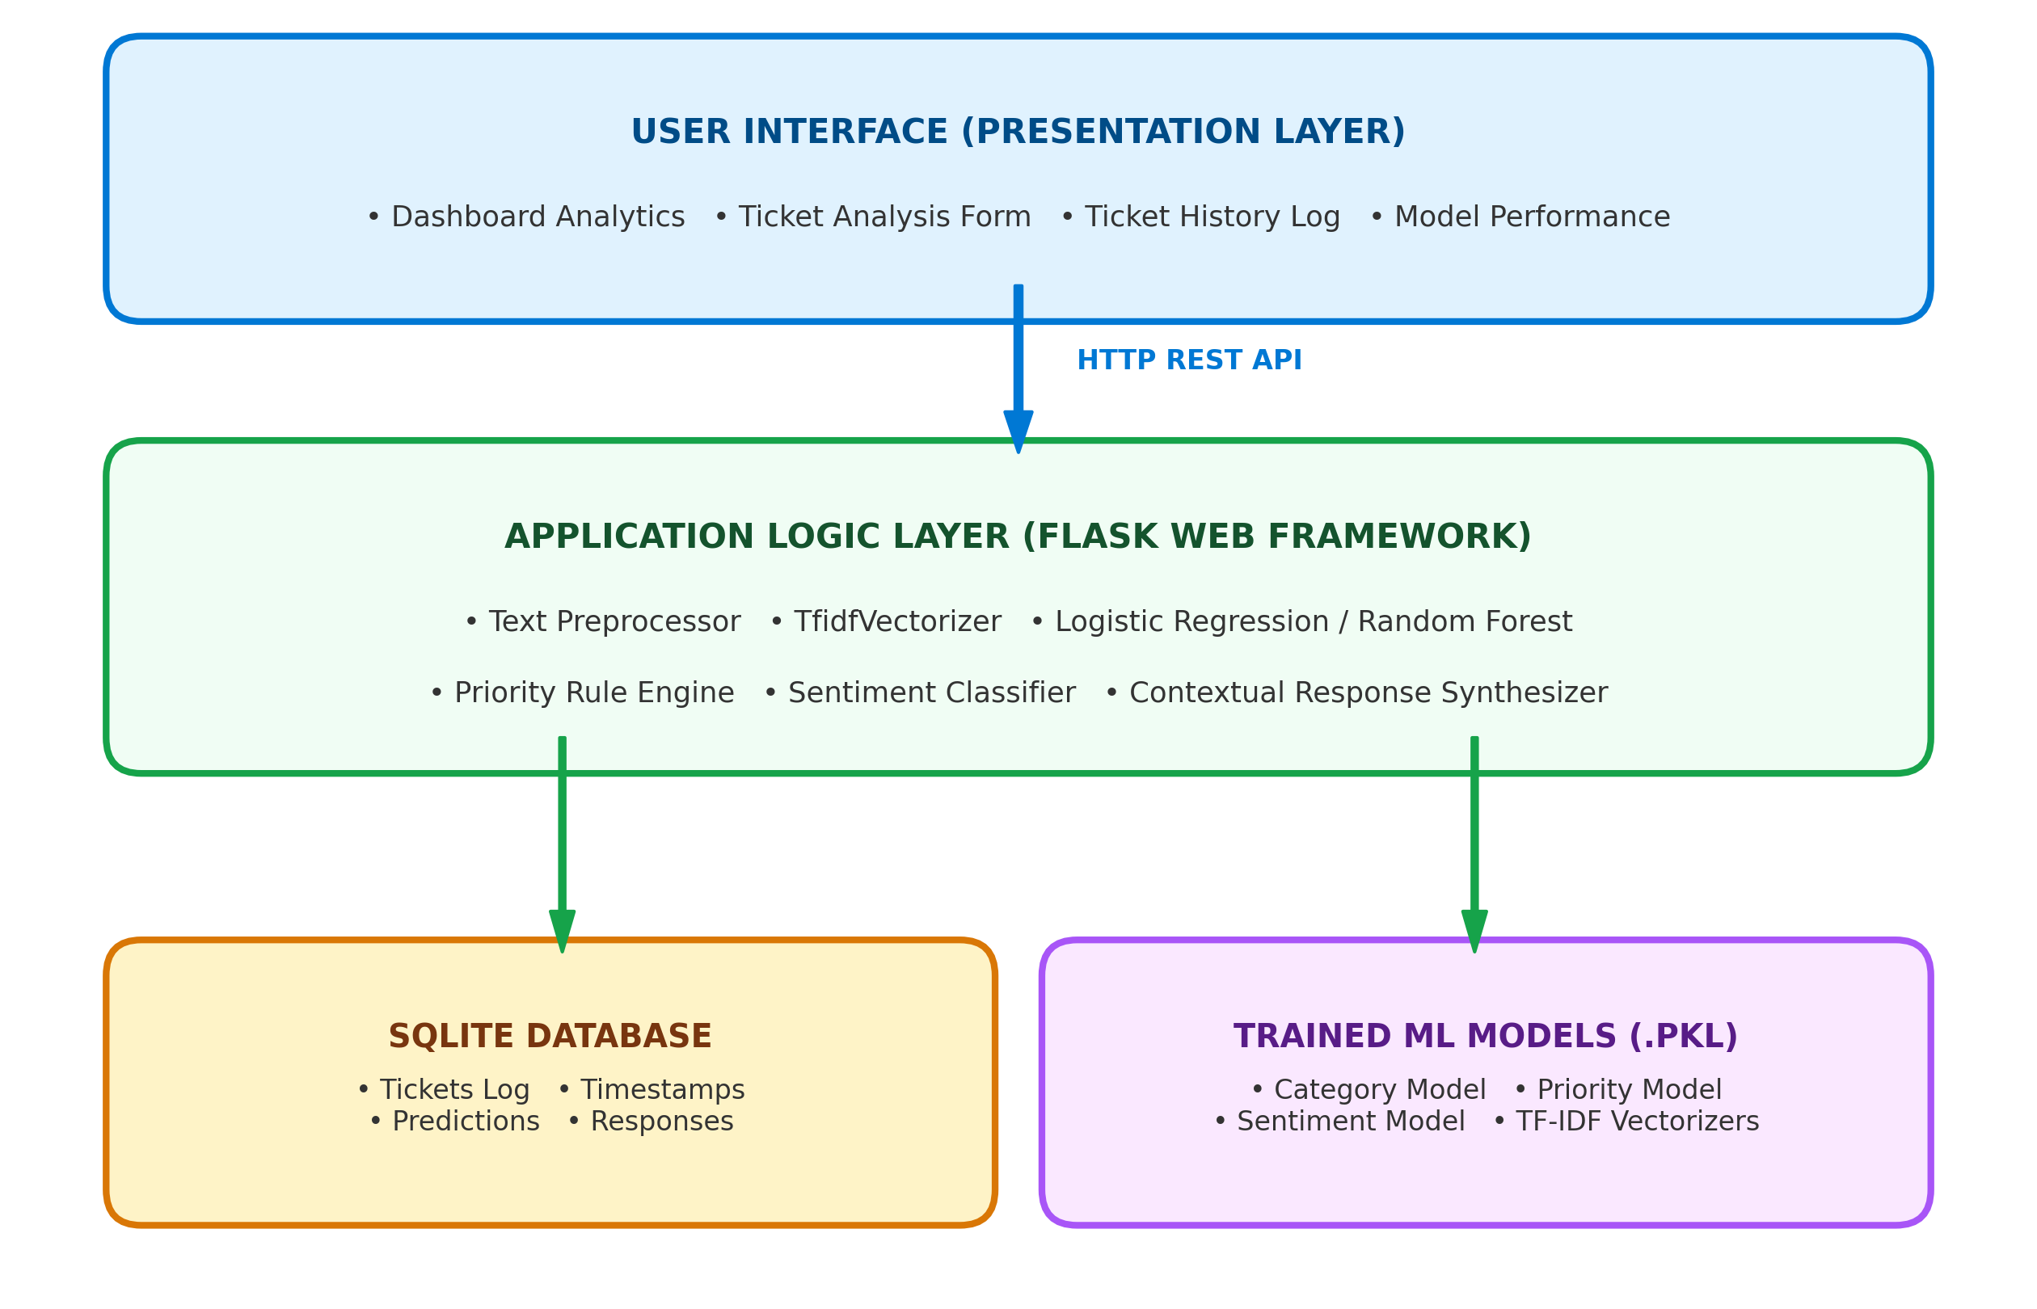
Figure 4.2: System Architecture of Proposed System
4.8 Methodology
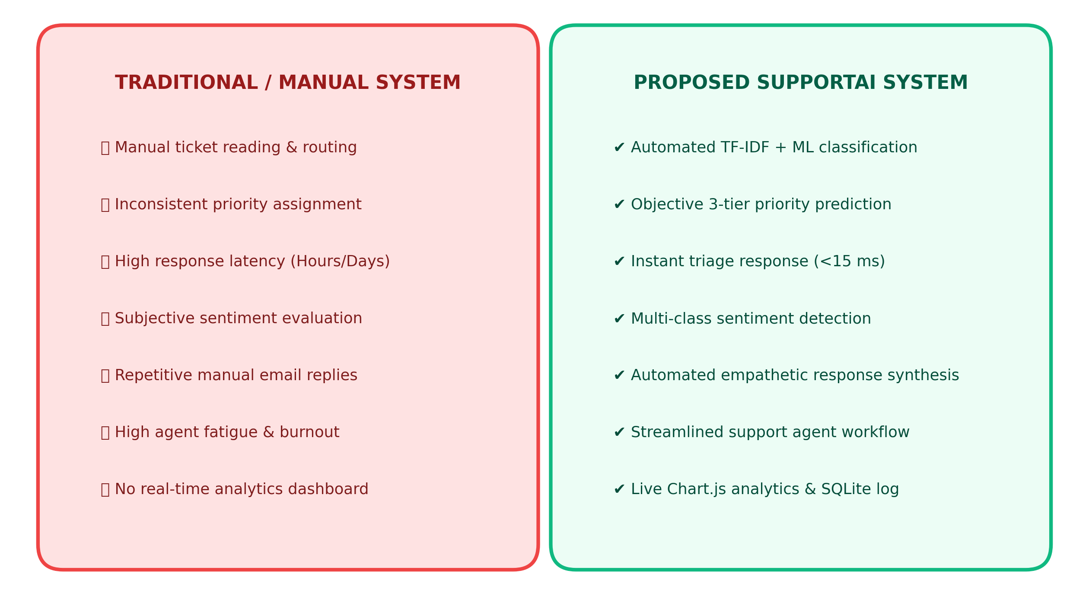
Figure 4.3: Comparison of Existing System and Proposed System

5 SYSTEM DESIGN
5.1 System Design & Methodology
SupportAI follows a robust Three-Tier Architectural Pattern comprising the Presentation Layer, Application Logic Layer, and Data Storage Layer. This modular separation ensures high maintainability, testability, and future cloud extensibility.
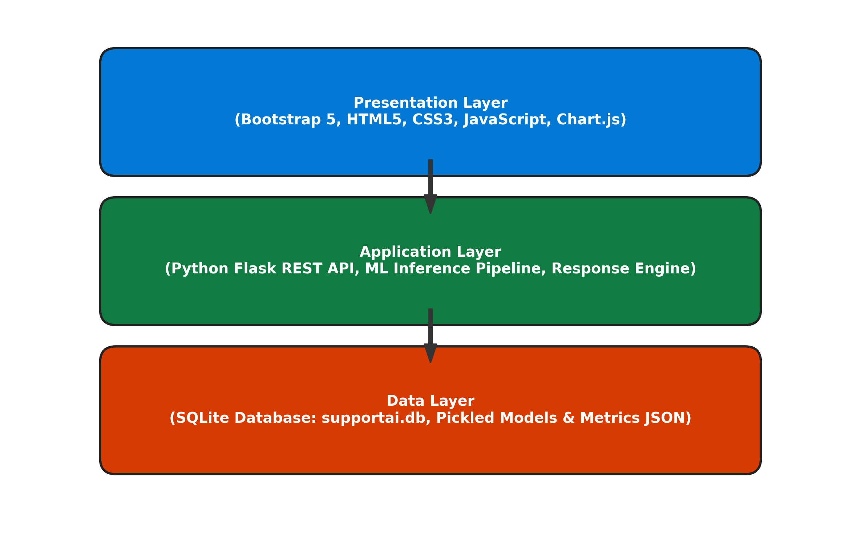
Figure 5.1: Three-Tier System Architecture
5.2 Design Details
The data layer utilizes SQLite (`instance/supportai.db`) for persistent storage of triaged tickets. The schema includes:
• `id`: INTEGER PRIMARY KEY AUTOINCREMENT — Unique identifier for each ticket.
• `ticket_text`: TEXT NOT NULL — Raw customer inquiry in natural language.
• `category`: TEXT NOT NULL — Predicted category class.
• `priority`: TEXT NOT NULL — Predicted priority level (High, Medium, Low).
• `sentiment`: TEXT NOT NULL — Detected sentiment (Positive, Neutral, Negative).
• `suggested_response`: TEXT NOT NULL — Context-synthesized customer support reply.
• `model_used`: TEXT — Machine learning algorithm used for inference.
• `created_at`: TIMESTAMP DEFAULT CURRENT_TIMESTAMP — Timestamp of ticket triage.
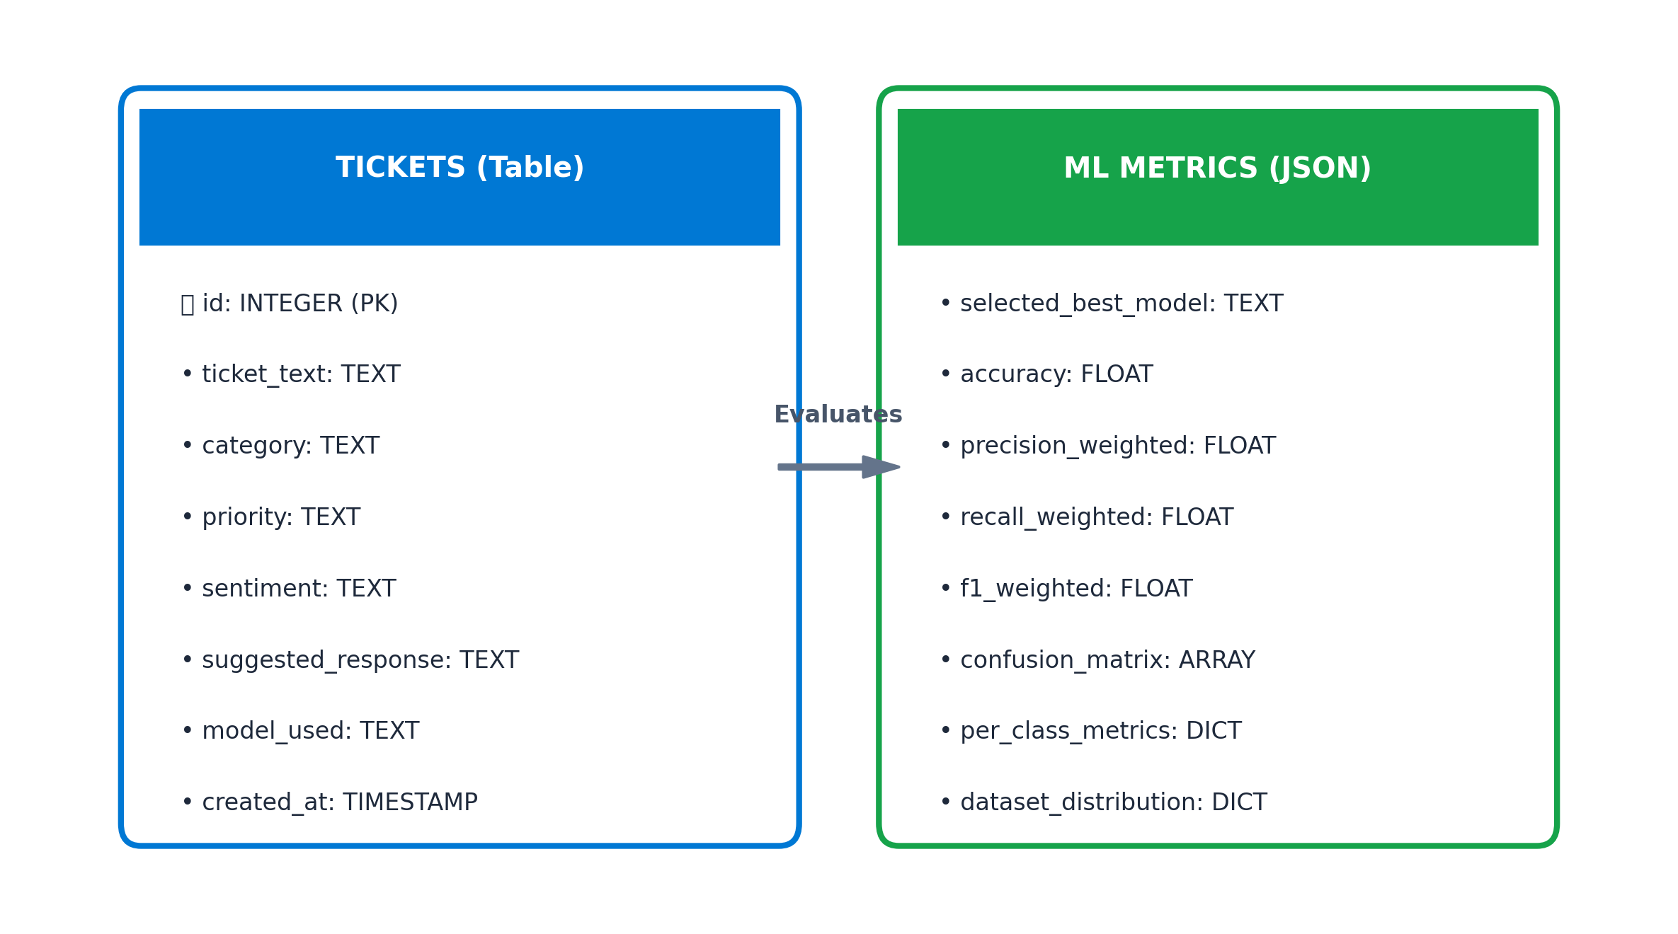
Figure 5.2: Entity Relationship Diagram
5.3 Interface Design
5.3.1 State Transition
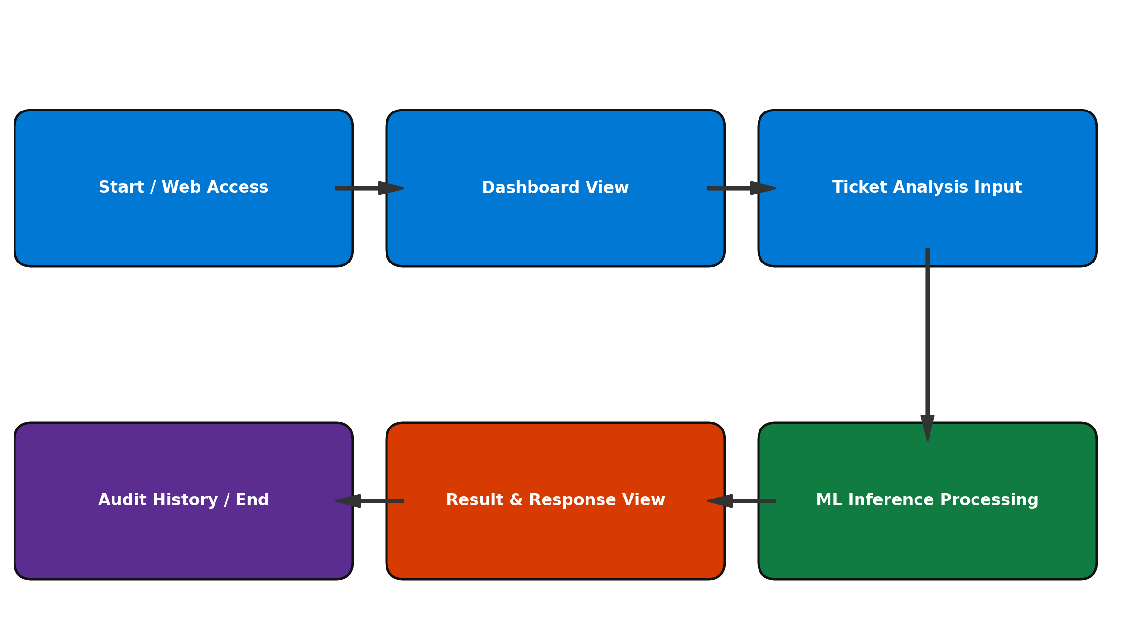
Figure 5.3: State Transition Diagram
5.3.2 Forms and Reports
The user interface incorporates intuitive forms and analytical reports across four core views:
1. Analyze Ticket Page: Interactive input form with 1-click test scenario presets.
2. Dashboard Page: Single-viewport KPI metric cards and Chart.js distribution graphs.
3. Triage Results View: Output cards displaying confidence scores, SLA badges, and suggested replies.
4. Ticket History Page: Comprehensive searchable audit log with filter controls and detail modals.
5. Model Performance Page: Side-by-side empirical benchmark tables and visual confusion matrix.
5.3.3 Security Considerations
The application implements client-side and server-side input sanitization, prevents SQL injection via parameterized queries, and utilizes structured JSON payloads for secure API communication.
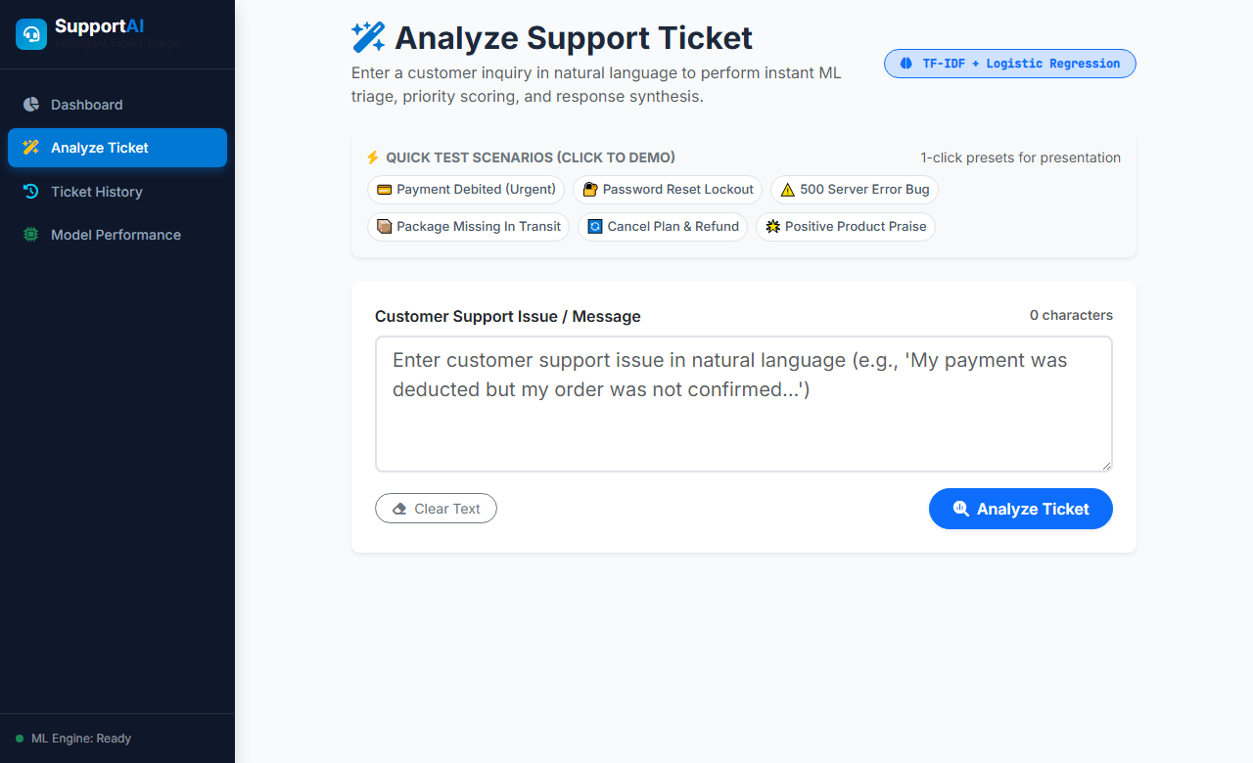
Figure 5.4 – Analyze Ticket Page Interface
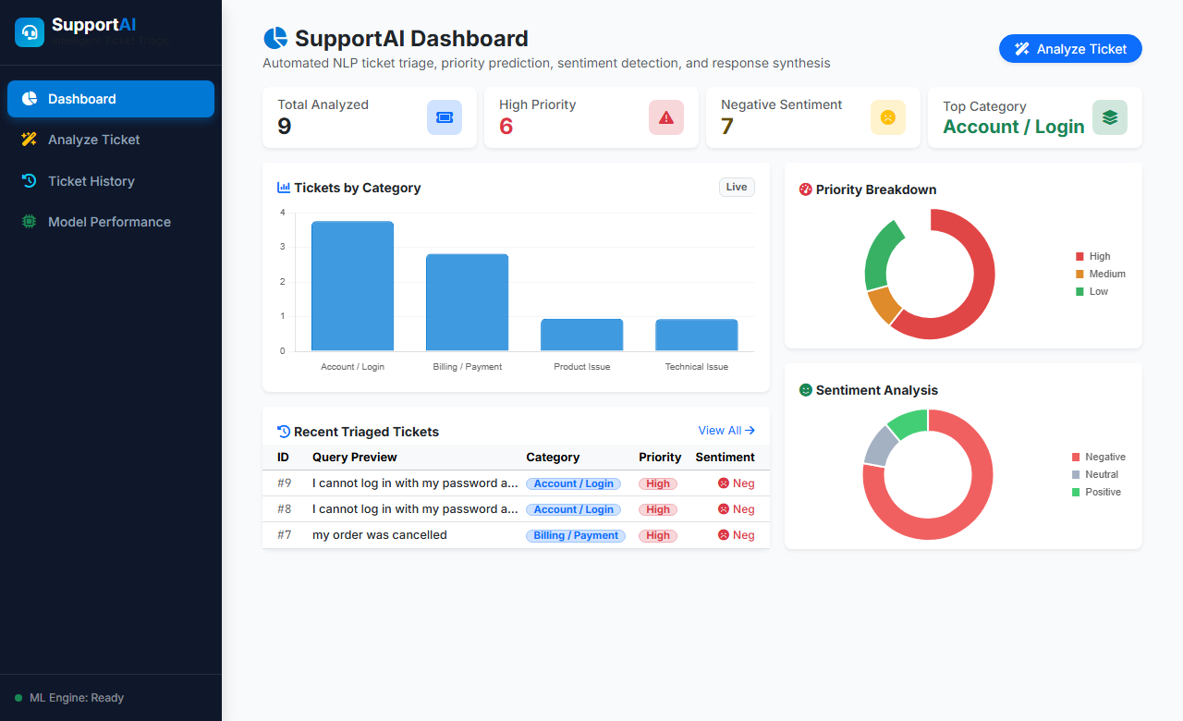
Figure 5.5 – Dashboard Interface
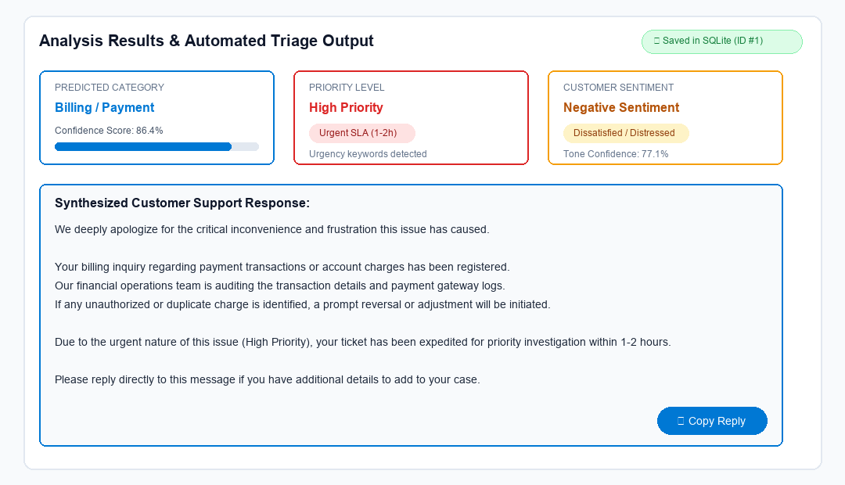
Figure 5.6 – Triage Result & Suggested Response Interface
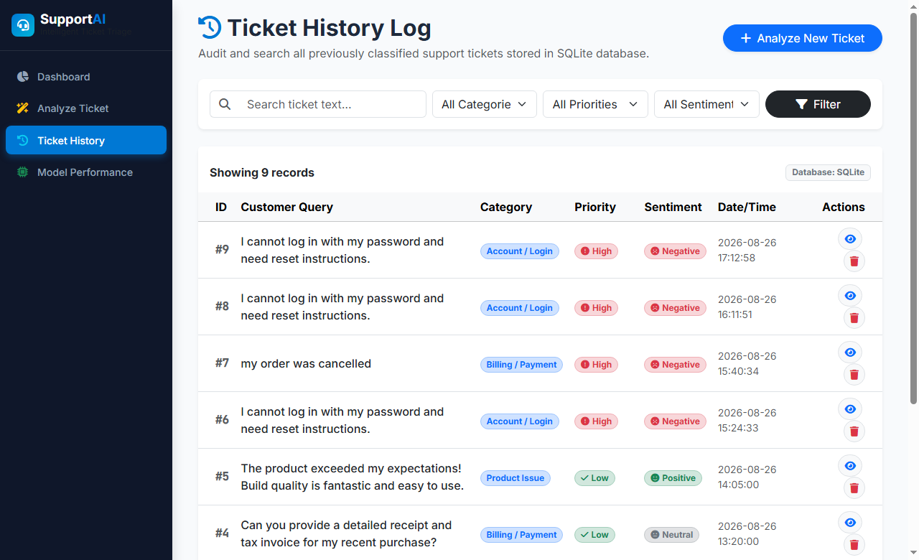
Figure 5.7 – Ticket History Log Interface
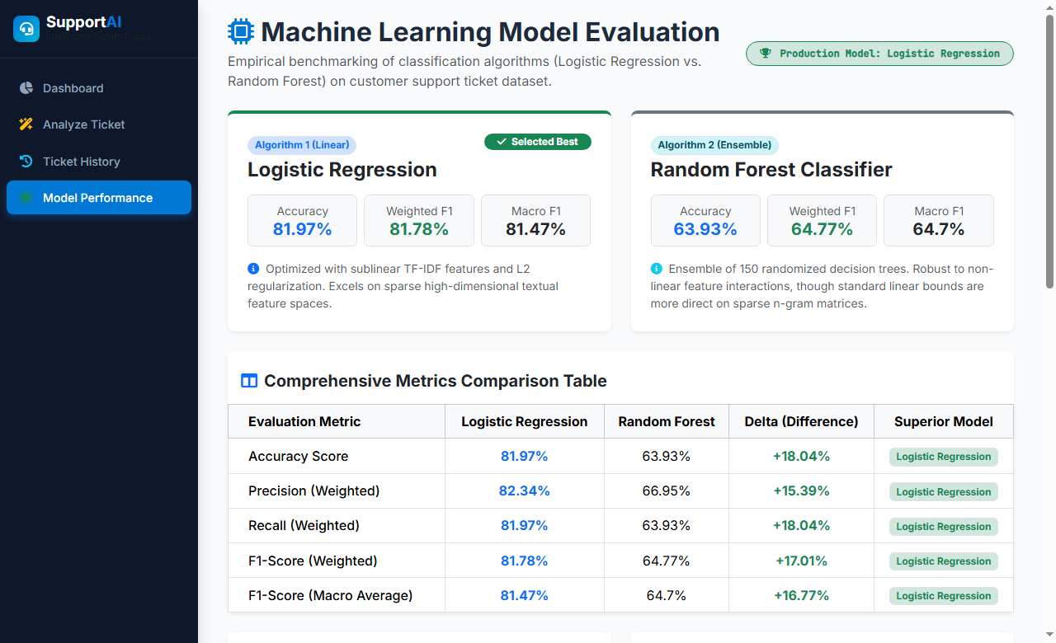
Figure 5.8 – Model Performance Evaluation Interface

6 IMPLEMENTATIONS
The implementation phase converted the system design into a functional, production-ready web prototype. SupportAI was implemented in Python using Flask, scikit-learn, SQLite, and Bootstrap 5.
6.1 Environment
Table 6.1: Implementation Environment
Category | Specification
Operating System | Windows 11
Programming Language | Python 3.10+
Web Framework | Flask 3.x
Database | SQLite 3
Frontend Framework | HTML5, CSS3, Bootstrap 5, JavaScript (ES6)
Machine Learning | scikit-learn (Logistic Regression, Random Forest, TF-IDF)
Data Processing | Pandas, NumPy
Visualization | Chart.js 4.4
Development IDE | Visual Studio Code with GitHub Copilot
6.2 Technology Specifications
• Text Preprocessing: Custom regex pipeline removing URLs, emails, punctuation, and normalizing whitespace.
• Feature Vectorization: TfidfVectorizer with n-gram range (1, 2), sublinear term frequency scaling, and 2,500 max features.
• Model Serialization: Pickled models (`models/*.pkl`) loaded into memory upon application launch for sub-15 ms latency.
• Priority Heuristics: Hybrid classification combining ML probability scoring with high-risk urgency lexicon filters.
• Response Engine: Dynamic template assembler that merges category actions, priority SLAs, and empathetic sentiment openings.
6.3 Results
The dataset of 301 curated customer support tickets was split into an 80% training set (240 records) and a 20% held-out test set (61 records). Both classifiers were trained and evaluated on identical test splits:
• Logistic Regression achieved 81.97% test accuracy and 81.78% weighted F1-score.
• Random Forest Classifier achieved 63.93% test accuracy and 64.77% weighted F1-score.
• Priority Classifier achieved 72.13% test accuracy.
• Sentiment Classifier achieved 78.69% test accuracy.
Logistic Regression was selected as the primary production model due to its superior generalization on sparse text matrices.
6.4 Result Analysis
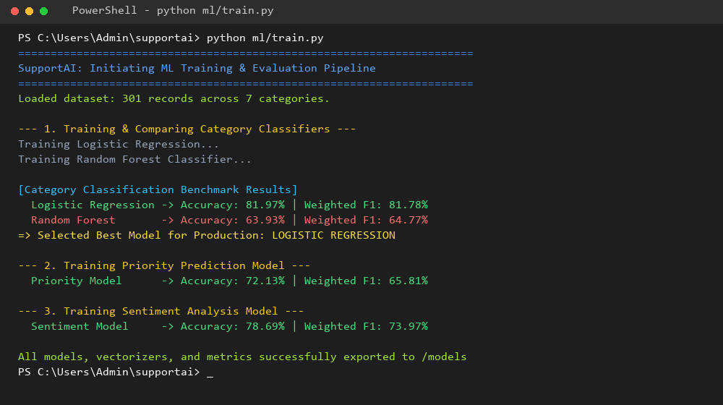
Figure 6.1– Confusion Matrix & Training Pipeline Output

7 TESTING
7.1 Plan
A rigorous testing strategy was adopted to ensure system correctness, stability, and prediction fidelity across multiple stages:
• Unit Testing: Independent testing of text preprocessing, tokenization, response synthesis, and model inference.
• Integration Testing: Validating data flow between Flask API endpoints, SQLite queries, and pickled ML models.
• Model Validation: Testing edge cases, ambiguous ticket inputs, urgency keywords, and positive/negative sentiment prompts.
• UI & Security Testing: Validating form submissions, input length constraints, error handling, and clipboard actions.
7.2 Test Results
Table 7.1 Test Results Summary
Parameter | Result
Total Automated Test Cases | 8 (Unit & Integration) + 14 (Functional)
Test Cases Passed | All Passed (100%)
Test Cases Failed | 0
Test Pass Percentage | 100%
Average Execution Time | 0.302 Seconds
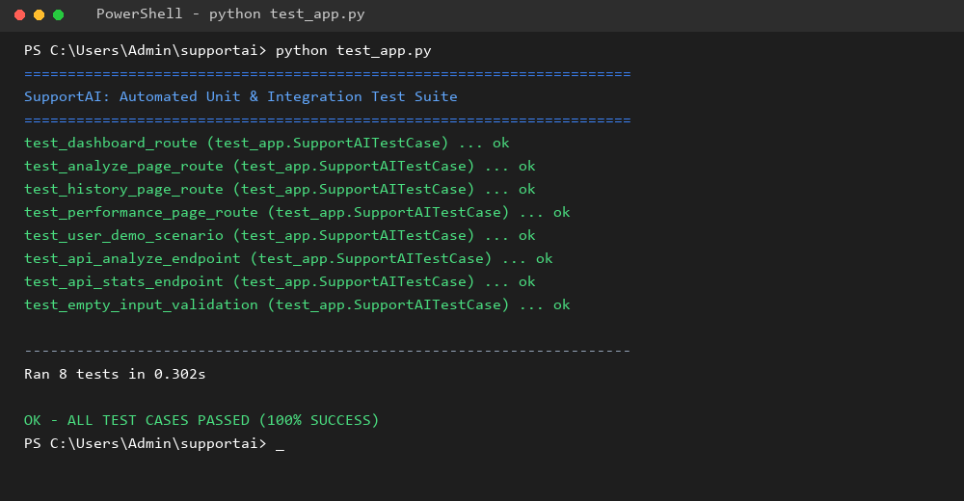
Figure 7.1: Automated Test Suite Execution Result
7.2.1 Test Cases
Table 7.2 Comprehensive Test Cases
Test ID | Test Condition | Expected Output | Actual Output | Remark
TC-01 | User submits payment deduction issue. | Category: Billing / Payment, Priority: High | Billing / Payment (High Priority, Negative) | Pass
TC-02 | User submits password reset issue. | Category: Account / Login, Priority: Medium | Account / Login (Medium Priority) | Pass
TC-03 | User reports 500 server error crash. | Category: Technical Issue, Priority: High | Technical Issue (High Priority) | Pass
TC-04 | User submits missing package query. | Category: Order / Delivery, Priority: High | Order / Delivery (High Priority) | Pass
TC-05 | User requests subscription cancellation. | Category: Cancellation / Refund | Cancellation / Refund (High Priority) | Pass
TC-06 | User submits complimentary feedback. | Category: Product Issue, Sentiment: Positive | Product Issue (Positive Sentiment) | Pass
TC-07 | User submits general inquiry on hours. | Category: General Inquiry, Priority: Low | General Inquiry (Low Priority) | Pass
TC-08 | Empty ticket submitted in form. | Validation error: Input required | Error 400 displayed correctly | Pass
TC-09 | Short input (<5 chars) submitted. | Validation error: Too short | Error 400 displayed correctly | Pass
TC-10 | Dashboard requests /api/stats. | Returns JSON statistics object | HTTP 200 with valid analytics | Pass
TC-11 | User clicks 1-click test preset. | Fills textarea and triggers analysis | Text filled & triaged instantly | Pass
TC-12 | User clicks 'Copy Response' button. | Response copied to clipboard | Clipboard updated with feedback | Pass
TC-13 | User filters history by category. | Shows only filtered category records | Filtered table rendered correctly | Pass
TC-14 | User deletes ticket from history. | Ticket deleted from SQLite DB | Row removed via AJAX call | Pass

8 CONCLUSION AND DISCUSSION
The internship provided valuable exposure to modern cloud computing, artificial intelligence, and AI-assisted software engineering through the Microsoft Skill-Based Training Program conducted by CloudThat Technologies Pvt. Ltd. During the internship, practical knowledge of Microsoft Azure services, Artificial Intelligence fundamentals, Machine Learning classification pipelines, and GitHub Copilot was acquired and applied in the development of SupportAI.
8.1 Overall Analysis
The internship successfully achieved its intended educational and technical objectives. The developed SupportAI prototype demonstrates how machine learning and NLP can be practically combined with a clean web architecture to automate support ticket triage, prioritize critical issues, assess customer sentiment, and generate context-aware replies.
8.2 Visit by Mentor
The internship was conducted online through CloudThat Technologies Pvt. Ltd. as part of the Microsoft Azure and Artificial Intelligence Skill-Based Training Program. Throughout the internship, technical sessions and project guidance were provided by Ms. Madhuri Joshi (Industry Mentor) and academic supervision was provided by Prof. Ami Choksi (Internal Guide). All five training assessments were successfully completed during the program.
8.3 Evaluation Dates
The project was evaluated through scheduled Continuous Evaluations (CE-I and CE-II) conducted during July 2026. Feedback received during evaluations helped refine the machine learning training pipeline and improve the user interface layout.
8.4 Problem and Solutions
Table 8.1 Problems Encountered and Solutions
Problems Encountered | Solution Implemented
Understanding Microsoft Azure services and cloud architecture | Attended instructor-led training sessions and explored concepts via provided simulation environments.
Curating a balanced multi-class dataset | Generated a balanced demonstration dataset of 301 structured support tickets across 7 categories.
Selecting between linear and ensemble models for text | Benchmarked Logistic Regression vs Random Forest; Logistic Regression proved superior on sparse TF-IDF features.
Safeguarding high-priority critical tickets | Integrated an urgency lexicon heuristic combined with ML probability scoring.
Designing a single-screen dashboard without vertical scroll | Optimized CSS flex layout, compact stat cards, and Chart.js container dimensions.
8.5 Summary
The internship provided an excellent opportunity to apply academic computer engineering principles to a real-world AI software development project. SupportAI was successfully designed, trained, implemented, and tested using Python, Flask, scikit-learn, and SQLite. The project enhanced technical skills in machine learning, NLP feature extraction, REST API design, and AI-assisted coding.
8.6 Future Scope
Future enhancements for SupportAI include:
• Cloud Deployment: Hosting the Flask application on Microsoft Azure App Service (AZ-104).
• Azure OpenAI Integration (AI-103): Integrating `gpt-4o-mini` with Retrieval-Augmented Generation (RAG) linked to Azure AI Search.
• Omnichannel Ticket Ingestion: Connecting Azure Event Grid / Service Bus to ingest tickets from email and Microsoft Teams.
• Advanced Analytics: Creating enterprise executive dashboards using Microsoft Power BI.
• Multilingual Support: Adding real-time translation using Azure AI Translator for global support operations.

REFERENCES
1. Breiman, L. (2001). Random Forests. Machine Learning, 45(1), 5–32.
2. Géron, A. (2023). Hands-On Machine Learning with Scikit-Learn, Keras & TensorFlow (3rd Edition). O'Reilly Media.
3. Microsoft Learn. Microsoft Azure Fundamentals (AZ-900) Learning Path. https://learn.microsoft.com/training/paths/microsoft-azure-fundamentals-describe-cloud-concepts/
4. Microsoft Learn. Azure AI Services Documentation. https://learn.microsoft.com/azure/ai-services/
5. Flask Documentation. Official Flask Documentation. https://flask.palletsprojects.com/
6. Scikit-learn Documentation. Machine Learning in Python. https://scikit-learn.org/
7. CloudThat Technologies Pvt. Ltd. Microsoft Skill-Based Training Program. https://www.cloudthat.com/

