BOCHABERI SAMANTHA
AUTONOMOUS GUIDED ROBOT
2024
LINUX LEARNING CENTER

DEDICATION
This project wouldn't be possible without the facilitation of my parents who provided the funding. My teacher, Ibrahim who imparted knowledge in robotics,IoT,python and the Linux os. I would also like to thank the director of the institution for facilitating the classes. Last but not least I would like to thank God for enabling me to finish my training.

Table of Contents
DEDICATION 2
PROPOSAL 4
FEASIBILITY 4
LITERATURE REVIEW 4
Detailed information on autonomous robots 4
1. Wired 4
2. Guide tape 4
3.Laser target navigation 5
4.Vision guidance 5
5.Geo-guidance 5
Applications of guided tape AVG: 5
PROJECT MATERIALS 7
Robot Chassis 8
DC TT motors 8
IR Infrared Sensor Module 9
HY- SRF05 Ultrasonic Ranging Sensor 9
L298N Dual H-Bridge Motor Driver 10
Micro Servo 9g TS180 Servo motor 10
LCD 20X4Yellow Backlight with IIC 10
18650 Lithium Battery Charger 11
9V Li-ion Ni-MH Rechargable Battery 11
LM2596 DC-DC Step-Down Converter 11
4 Channel I2C Logic Level Converter 12
Digital LCR Multimeter 12
Multimeter Design 13
Display 13
Components 13
Button Panel 13
Dial 13
Input Jacks 13
Multimeter Uses 13
Checking The Voltage Of Batteries 13
Examining Power Outlets 13
Testing A Fuse 13
Locating A Bad Switch Or Wire 13
Raspberry pi 13
Manual 14
Project execution 14

PROPOSAL
Project name – Autonomous guided robot using raspberry pi
Project actuator – Bochaberi Samantha
School – Linux Learning Center, Hurlingam
Summary – This is a raspberry pi based robot that has obstacle avoidance capability, and line following capability. It can be controlled by A,W,S,D keys, Blynk and connect bot remotely. This is a school project meant to test student comprehension in sensors and python.
Project Duration -01/07/2024 – 05/07/2024

FEASIBILITY
Time feasibility – this project is estimated to last a week
Financial feasibility – This project is averagely expensive approximately 28,000 k sh. It is economically feasible.
Technical feasibility – the equipment required for the project is readily available in shops country wide eg Pixel Electric, Nerokas.
Legal Feasibility – This project is based in open source software hence no licenses required for personal and educational use

LITERATURE REVIEW

Detailed information on autonomous robots
An automated guided vehicle(AGV), is a portable robot that follows along marked long lines or wires on the floor, or uses radio waves, vision cameras, magnets, or lasers for navigation. They are most often used in industrial applications to transport heavy materials around a large industrial buildings, such as a factories or warehouses.
Types of AVG according to navigation:

1. Wired
A slot is cut in to the floor and a wire is placed approximately 1inch below the surface. This slot is cut along the path the AGV is to follow. This wire is used to transmit a radio signal. A sensor is installed on the bottom of the AGV close to the ground. The sensor detects the relative position of the radio signal being transmitted from the wire. This information is used to regulate the steering circuit, making the AGV follow the wire.

2. Guide tape
sometimes tape can be used for the guide path. The tapes can be one of two styles: magnetic or colored. The AGV is fitted with the appropriate guide sensor to follow the path of the tape. One major advantage of tape over wired guidance is that it can be easily removed and relocated if the course needs to change. Colored tape is initially less expensive, but lacks the advantage of being embedded in high traffic areas where the tape may become damaged or dirty. A flexible magnetic bar can also be embedded in the floor like wire but works under the same provision as magnetic tape and so remains unpowered or passive. Another advantage of magnetic guide tape is the dual polarity. Small pieces of magnetic tape may be placed to change states of the AGC based on polarity and sequence of the tags.

3.Laser target navigation
Laser target navigation is accomplished by affixing reflective tape to permanent objects such as poles, walls, or machines. On a rotating turret, the AGV holds a laser transmitter and receiver. The same sensor receives and transmits laser energy. Any reflectors that are in line of sight and within range are automatically measured for angle and (sometimes)

4.Vision guidance
They work by employing cameras to capture features along the path, which the AGV can replay and navigate using the captured features. Dr. Hans Moravec of Carnegie Mellon University created and first worked on the Evidence Grid technology, which is an application of probabilistic volumetric sensing, which is used by vision-guided AGVs. In order to account for the unpredictability of sensor performance and environmental factors, the Evidence Grid technology uses probabilities of occupancy for each point in space. Specially created stereo cameras serve as the principal navigational sensors. The vision-guided AGV creates a 3D map using 360-degree photographs to follow a predetermined path without human intervention or the inclusion of unique elements, landmarks, or positioning technologies.

5.Geo-guidance
To determine its location, a geoguided AGV identifies its surroundings. The forklift uses Geoguidance technology to locate columns, racks, and walls in the warehouse without the use of any infrastructure. It can position itself in real time and plan its course using these fixed references. There are no restrictions on the number of pick-up or drop-off places that can be traveled. Routes can be changed indefinitely

My project is based on the guided tape AVG.

Applications of guided tape AVG:
1. Transporting raw materials including paper, steel, rubber, metal, and plastic is a
common task for AGVs. This includes delivering supplies directly to production lines as
well as moving materials from receiving to the warehouse.

2. Work-in-Process Movement: Work-in-Process Movement refers to the repetitive
movement of materials during the manufacturing process and is one of the earliest uses
of automated guided vehicles. AGVs can be utilized to transfer materials between
processes or from the warehouse to production/processing lines.

3. Pallet handling is a particularly common application for AGVs since pallets are frequently moved repetitively in manufacturing and distribution operations. The palletizer, stretch wrapping, warehousing, storage, and outgoing shipment ports may all be reached by AGVs.

4. Handling of finished goods - The last movement of materials before they are delivered
to clients involves moving finished goods from manufacture to storage or shipping.
Because the items are finished and vulnerable to harm from rough handling, these
movements frequently call for the gentlest material handling. AGVs are a great choice
for this type of application because they work with precisely regulated navigation,
acceleration, and deceleration, which minimizes the possibility of damage.

5. Trailer loading is a relatively new use for automated guided vehicles that is rapidly
gaining in popularity. Without the use of specific dock equipment, AGVs are utilized to
transfer and load pallets of finished items into regular over-the-road trailers. Pallets can
be delivered into the trailer using the predetermined loading pattern by AGVs after
being picked up from conveyors, racks, or staging lanes. Natural Targeting is a
navigational technique used by some Automatic Trailer Loading AGVs to observe the
walls of the trailer. These ATL AGVs can be either fully autonomous or powered by a
hybrid engine.

6. Roll handling - AGVs are used to move rolls in a variety of factories, including paper
mills, converters, printers, newspapers, steel and plastics companies. Rolls of paper can
be stored and stacked on the ground, in racking, and even automatically loaded into
printing presses by AGVs.

7. Container handling -In some port container terminals, sea containers are moved using
AGVs. Reduced labor expenses and more consistent (less variable) performance are the
key advantages. The first AGVs used hydraulic or electric drives and were powered by
fuel. However, more AGV use battery power and automated battery switch, which cuts
refueling costs and reduces emissions, but are more expensive to buy and have a limited
range.

PROJECT MATERIALS
- Robot Chassis + 4 DC TT motors
- IR Infrared Sensor Module
- HY- SRF05 Ultrasonic Ranging Sensor
- L298N Dual H-Bridge Motor Driver
- Micro Servo 9g TS180 Servo motor
- LCD 20X4Yellow Backlight with IIC
- 18650 Lithium Battery Charger
- 9V Li-ion Ni-MH Rechargable Battery
- LM2596 DC-DC Step-Down Converter
- 4 Channel I2C Logic Level Converter
- Round Pin (Header Connector)
- Soldering Iron Gun
- Soldering Wire 100g Spool
- Ultrasonic Holder
- Lithium Ion Battery – 3.7V 600mAh
- Digital LCR Multimeter
- Raspberry pi 5

Robot Chassis
This chassis will be used to mount the projects components

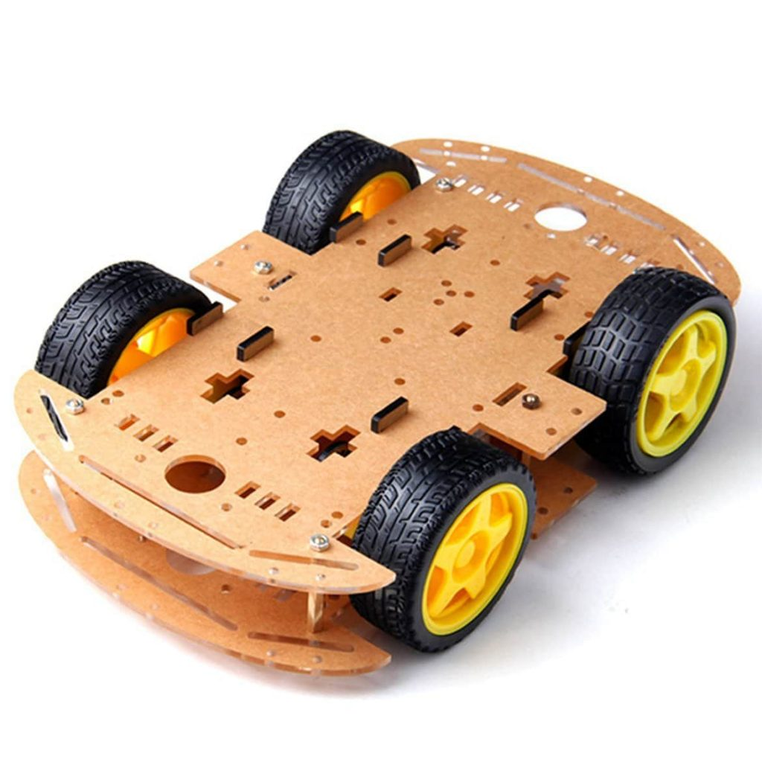

DC TT motors
- Rated Voltage: 3~6V
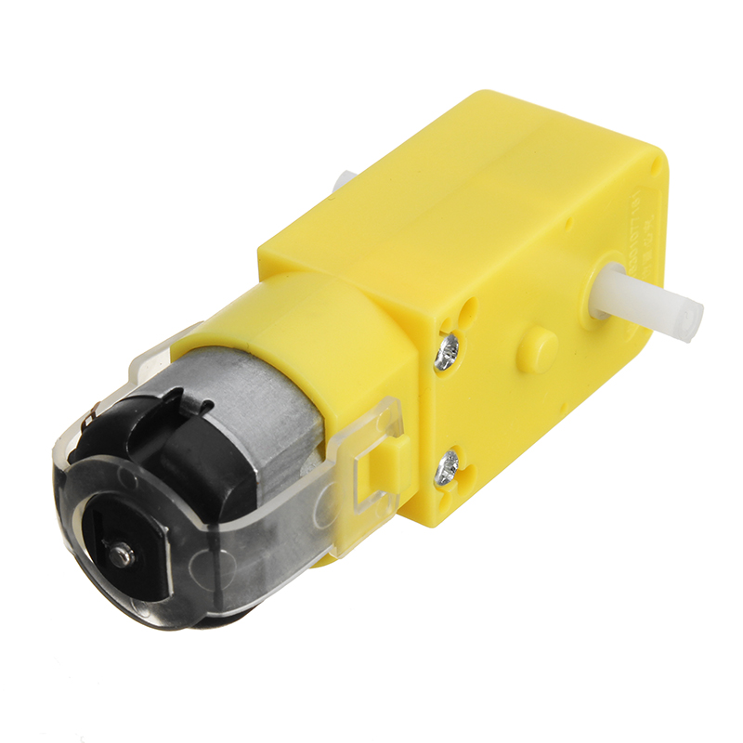
- Continuous No-Load Current: 150mA +/- 10%
- Min. Operating Speed (3V): 90+/- 10% RPM
- Min. Operating Speed (6V): 200+/- 10% RPM
- Stall Torque (3V): 0.4kg.cm
- Stall Torque (6V): 0.8kg.cm
- Gear Ratio: 1:48
- Body Dimensions: 70 x 22 x 18mm
- Wires Length: 200mm & 28 AWG
- Weight: 30.6g
working principal -A DC motor is an electrical motor that uses direct current (DC) to produce mechanical force. A simple DC motor has a stationary set of magnets in the stator and an armature with one or more windings of insulated wire wrapped around a soft iron core that concentrates the magnetic field. The windings usually have multiple turns around the core, and in large motors there can be several parallel current paths. The ends of the wire winding are connected to a commutator. The commutator allows each armature coil to be energized in turn and connects the rotating coils with the external power supply through brushes. (Brush-less DC motors have electronics that switch the DC current to each coil on and off and have no brushes.)
The total amount of current sent to the coil, the coil's size, and what it is wrapped around decide the strength of the electromagnetic field created.

IR Infrared Sensor Module
The IR sensor or infrared sensor is one kind of electronic component, used to detect specific characteristics in its surroundings through emitting or detecting IR radiation. These sensors can also be used to detect or measure the heat of a target and its motion. In many electronic devices, the IR sensor circuit is a very essential module. This kind of sensor is similar to human’s visionary senses to detect obstacles.
An infrared sensor includes two parts namely the emitter & the receiver (transmitter & receiver), so this is jointly called an optocoupler or a photo-coupler .The photodiode used in this is very sensitive to the infrared light generated through an infrared LED. The resistance of photodiode & output voltage can be changed in proportion to the infrared light obtained. This is the fundamental IR sensor working principle.
The type of incident that occurred is the direct otherwise indirect type where indirect type, the arrangement of an infrared LED can be done ahead of a photodiode without obstacle. In indirect type, both the diodes are arranged side by side through a solid object ahead of the sensor. The generated light from the infrared LED strikes the solid surface & returns back toward the photodiode.
IR sensors use three basic Physics laws like Planck’s Radiation, Stephan Boltzmann & Wein’s Displacement.
- Planck’s Radiation Law defines that the temperature of any object is not equivalent to Zero
- Stephan Boltzmann Law defines that the whole energy which is generated at all wavelengths through a black body is associated with the total temperature.
- Wein’s Displacement Law defines that the temperature of different objects emits spectra that are maximum at various wavelengths and inversely proportional with temperature.
The main specifications and features of the IR sensor module include the following.
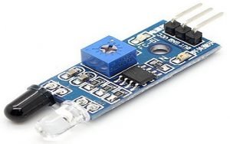
- The operating voltage is 5VDC
- I/O pins – 3.3V & 5V
- Mounting hole
- The range is up to 20 centimeters
- The supply current is 20mA
- The range of sensing is adjustable
- Fixed ambient light sensor

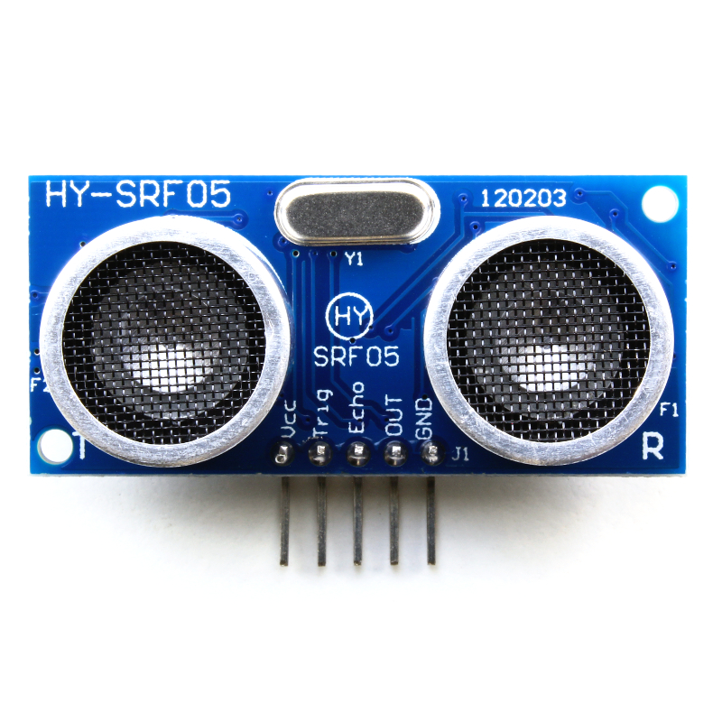
HY- SRF05 Ultrasonic Ranging Sensor
Supply voltage: 4.5V to 5.5V
Supply current: 10 to 40mA
Trigger pin format: 10 uS digital pulse
Sound frequency: 40 KHz
Echo pin output: 0V-VCC
Echo pin format: digital
working principle -Using I/O trigger for at least 10us high level signal,the module automatically sends eight 40KHz and detect whether there is a pulse signal back. If the signal back, through high level, time of high output IO duration is the time for sending ultrasonic signal to its return. Test distance = high level time x velocity of sound (340m/s) / 2

L298N Dual H-Bridge Motor Driver
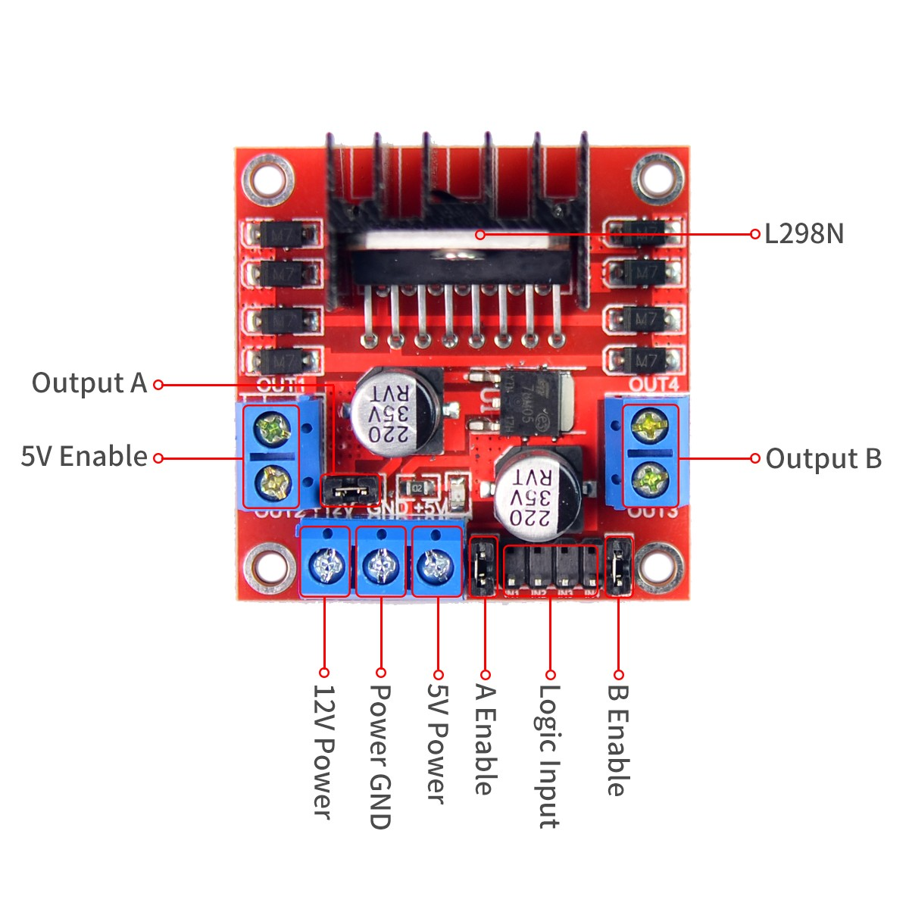
The L298N is a dual H-Bridge motor driver which allows speed and direction control of two DC motors at the same time. The module can drive DC motors that have voltages between 5 and 35V, with a peak current up to 2A.The module has two screw terminal blocks for the motor A and B, and another screw terminal block for the Ground pin, the VCC for motor and a 5V pin which can either be an input or output.

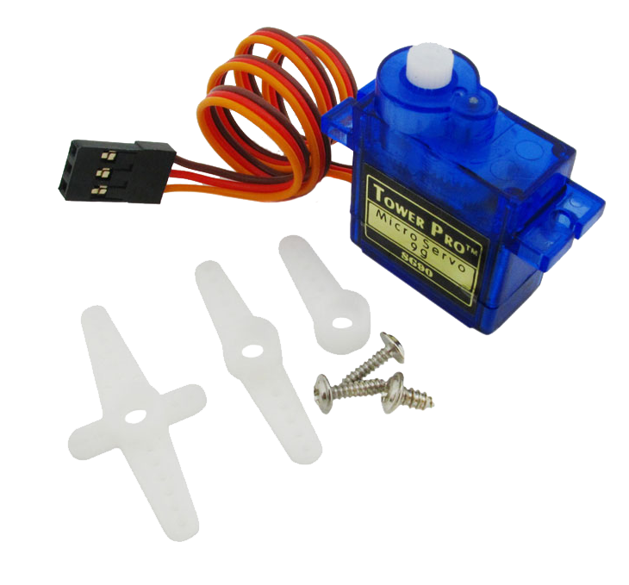
Micro Servo 9g TS180 Servo motor
Specifications
• Stall torque: 1.8kg/cm (4.8V); 2.2kg/cm (6.6V)
• Operating speed: 0.10sec/60degree (4.8V); 0.08sec/60degree (6.0V)
• Operating voltage: 4.8V~ 6.6V
• Temperature range: 0 _ 55 °C °C
• Dead band width: 1us
• servo arms &screws included
It is normally used in
• actuators in many robots like Biped Robot, Hexapod, robotic arm etc.
• steering system in RC toys
• Robots where position control is required without feedback
• Less weight hence used in multi DOF robots like humanoid robot

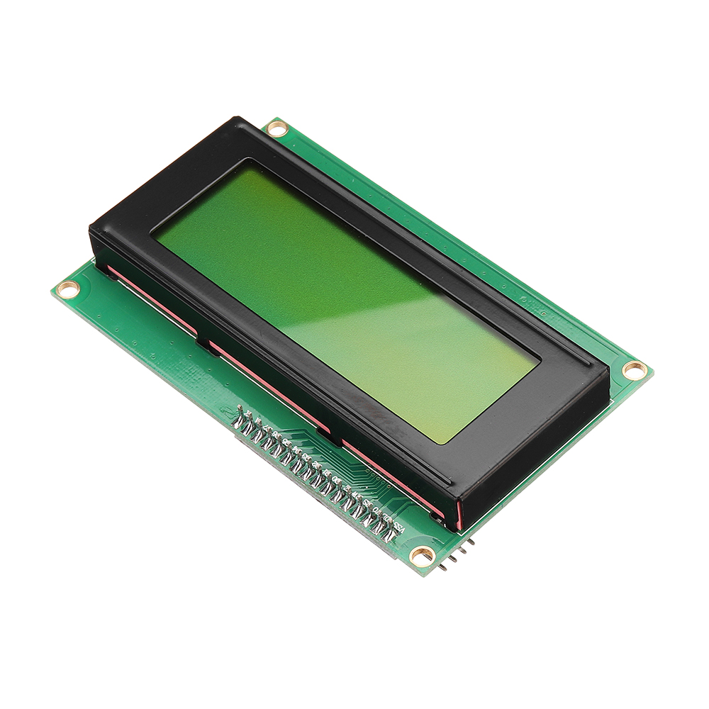
LCD 20X4Yellow Backlight with IIC
LCD (Liquid Crystal Display) is typically used in embedded systems to display text and numbers for the end user as an output device. The 20×4 alphanumeric display is based on the Hitachi HD44780 driver IC. Which is the small black circular chip on the back of the LCD module itself. This is the controller that controls the LCD unit and we communicate with using Arduino or raspberry pi to send commands and text messages.The LCD module consists of 20×4 character cells (4 rows x 20 columns), each cell of which is 5×8 dots. Controlling all of these individual dots is a tedious task therefore its use together with IIC.
The I2C IO expander IC (PCF8574) is commonly used as a cheap solution to implement an I2C LCD interface that replaces the classic parallel connection to the LCDs (at least 6 pins) with an easy-to-use I2C bus (only 2 pins). Using it saves a lot of GPIO pins that would have been consumed to create a generic LCD parallel communication.
Image of I2C LCD Module (PCF8574 IO Expander)
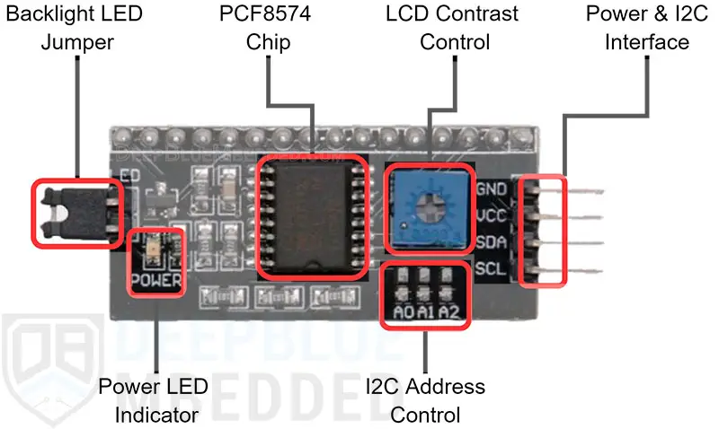

18650 Lithium Battery Charger
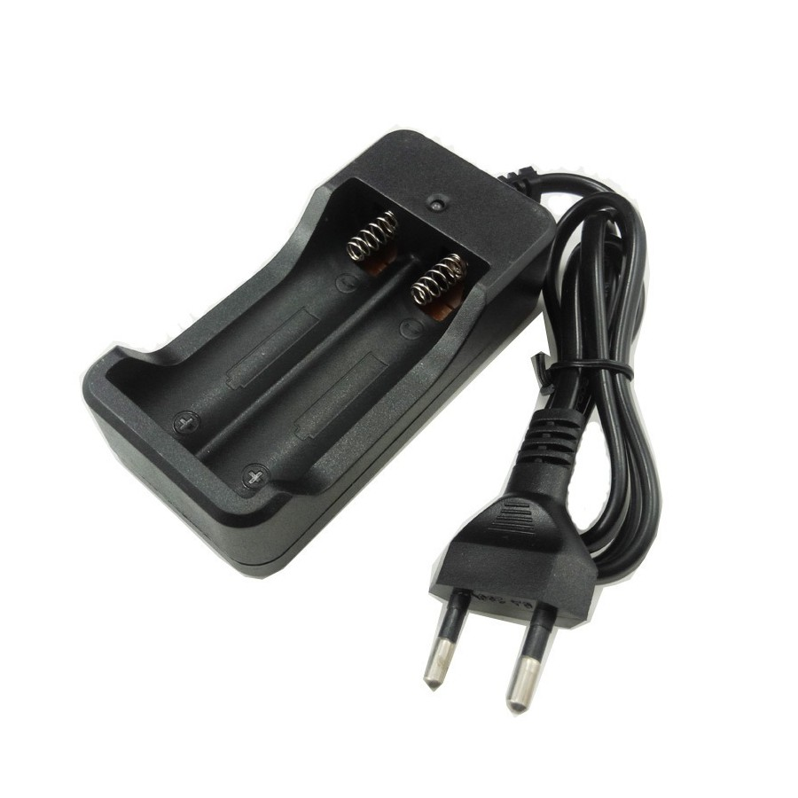

9V Li-ion Ni-MH Rechargable Battery



Voltage: | 9 Volt (8.4)
Capacity: | 200 mAh
Type: | NiMH
Battery Size: | 9 Volt

LM2596 DC-DC Step-Down Converter
The LM2596 series of regulators are monolithic integrated circuits that provide all the active functions for a step-down (buck) switching regulator, capable of driving a 3-A load with excellent line and load regulation. These devices are available in fixed output voltages of 3.3 V, 5 V, 12 V, and an adjustable output version. Requiring a minimum number of external components, these regulators are simple to use and include internal frequency compensation, and a fixed frequency oscillator. The LM2596 series operates at a switching frequency of 150 kHz, thus allowing smaller sized filter components than what can be required with lower frequency switching regulators. Available in a standard 5-pin TO-220 package with several different lead bend options, and a 5-pin TO-263 surface mount package.
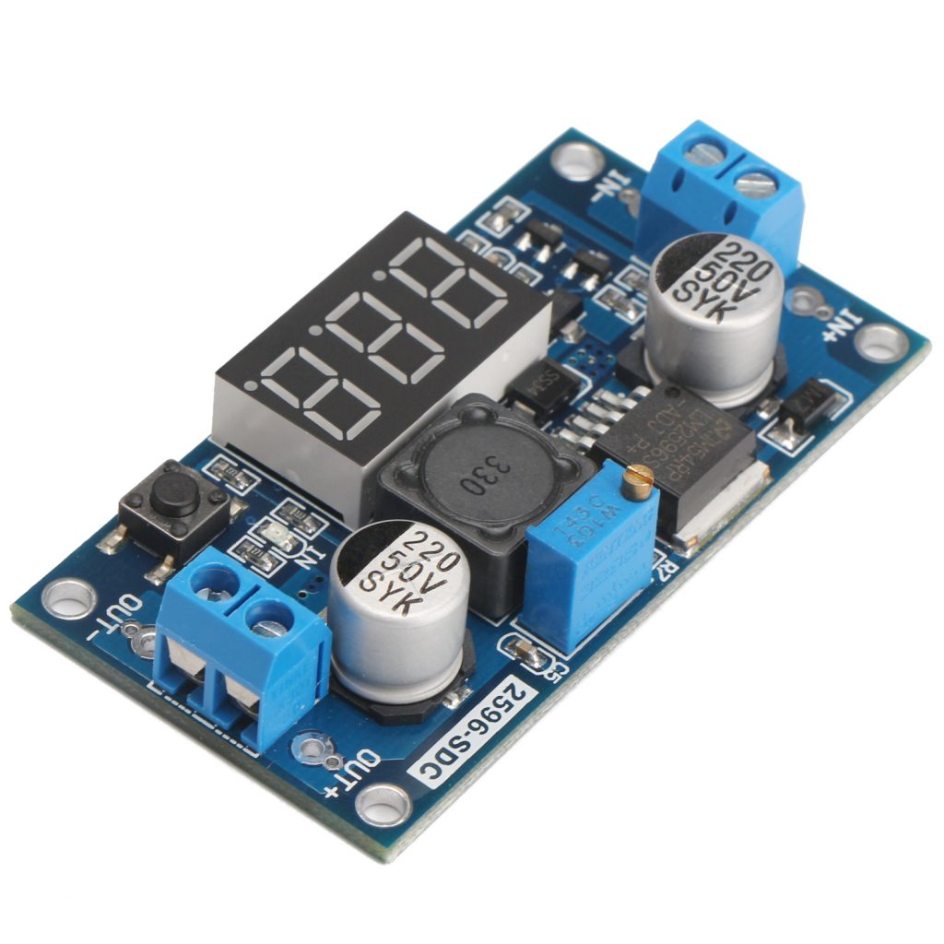
Applications :Appliances,Grid infrastructure ,EPOS ,Home theater

4 Channel I2C Logic Level Converter
If you want to connect a 3.3V I2C or SPI Sensor to a 5V device like Arduino with support for two-way communication, then the solution is to use an External Level Shifter or a Logic Level Converter.
The Logic Level Converter presented here supports bidirectional level shifting by using one MOSFET per bus line and it also protects the low voltage side from spikes at the high voltage side.Consider the following circuit consisting of an N-Channel MOSFET with internal Drain – Substrate Diode (it is important to have one). Let us divide the circuit into two parts the left side or the low voltage side and the right side or the high voltage side.Each side has different supply voltages and also different logic levels. The bus in the low voltage side is pulled HIGH to 3.3V and also the device power supply on this side is 3.3V.The right-side bus is pulled HIGH to 5V and the device power supply voltage is 5V. The Gate of the MOSFET must be connected to low voltage power supply i.e., 3.3V in this case. The Source and Drain of the MOSFET are connected to low voltage bus and high voltage bus respectively.
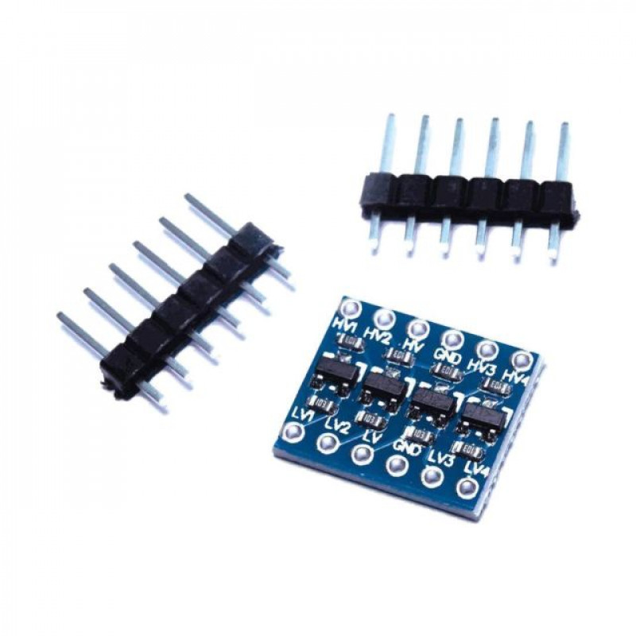
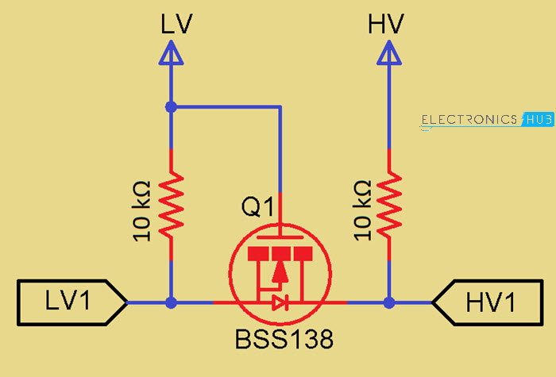

Digital LCR Multimeter
A multimeter can also measure these components, but it is able to perform a wider range of measurements such as voltage, current, and even temperature.

Multimeter Design

Display
A multimeter typically has a digital or analog display. It can measure voltage, current, and resistance.

Components
A multimeter has different probes and ports for measuring various electrical properties. It can also measure continuity, dwell, and diode testing.

Button Panel
A multimeter has a button panel with buttons to switch between the different measurement modes and settings.

Dial
Some multimeters also have a dial to switch between measurement ranges.

Input Jacks
A multimeter has input jacks for the different probes to connect to. Also, a multimeter can measure AC and DC properties.

Multimeter Uses

Checking The Voltage Of Batteries
A multimeter may check for voltage, current, and resistance in a circuit. However, it is not as accurate as an LCR meter when measuring the latter two properties.

Examining Power Outlets
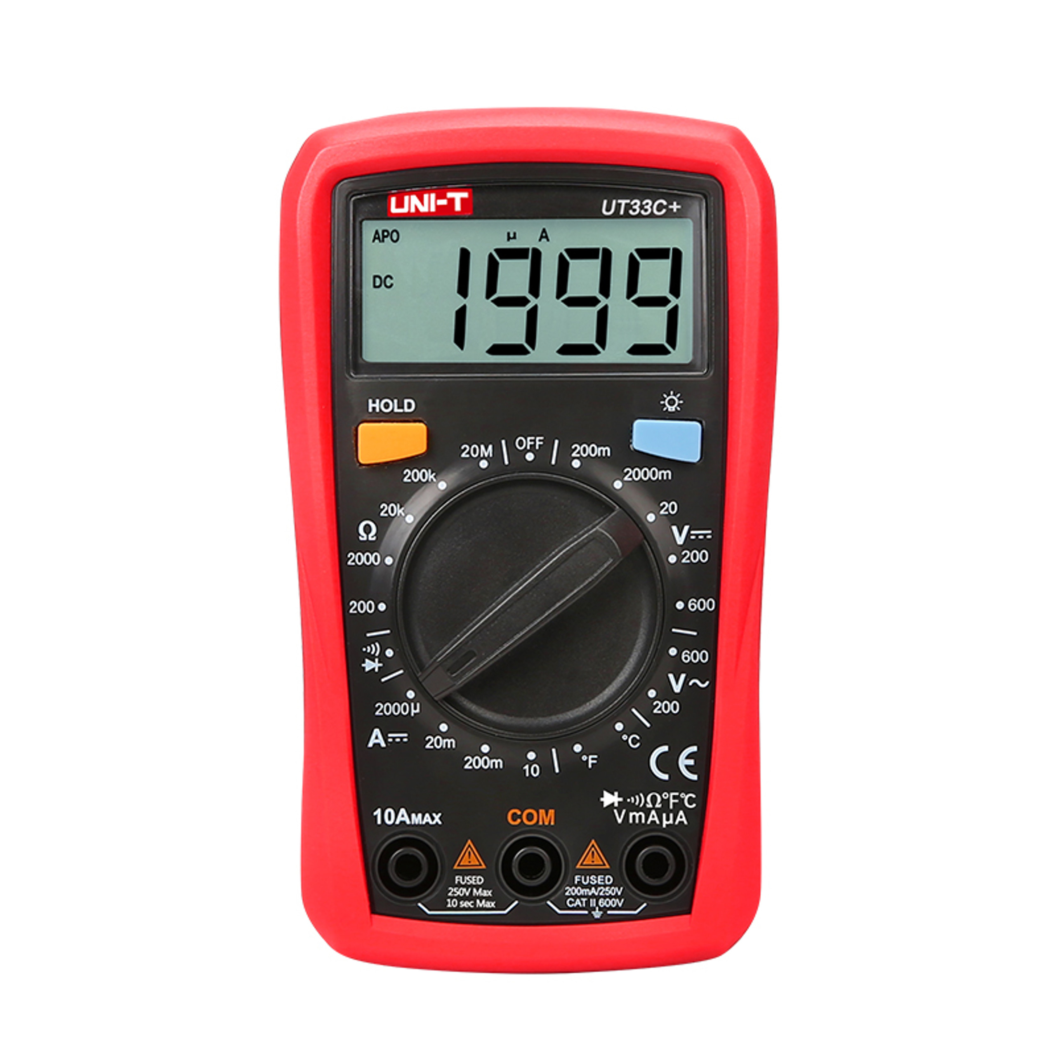
A multimeter may also be used to check for proper function in power outlets, by measuring the voltage and current flow.

Testing A Fuse
A multimeter can also test a fuse to see if it is functioning properly.

Locating A Bad Switch Or Wire
A multimeter can also be used to locate a faulty switch or wire in a circuit.

Raspberry pi
Key features include:
- 2.4GHz quad-core 64-bit Arm Cortex-A76 CPU
- VideoCore VII GPU, supporting OpenGL ES 3.1, Vulkan 1.2
- Dual 4Kp60 HDMI® display output
- 4Kp60 HEVC decoder
- Dual-band 802.11ac Wi-Fi®
- Bluetooth 5.0 / Bluetooth Low Energy (BLE)
- High-speed microSD card interface with SDR104 mode support
- 2 × USB 3.0 ports, supporting simultaneous 5Gbps operation
- 2 × USB 2.0 ports
- Gigabit Ethernet, with PoE+ support (requires separate PoE+ HAT, coming soon)
- 2 × 4-lane MIPI camera/display transceivers
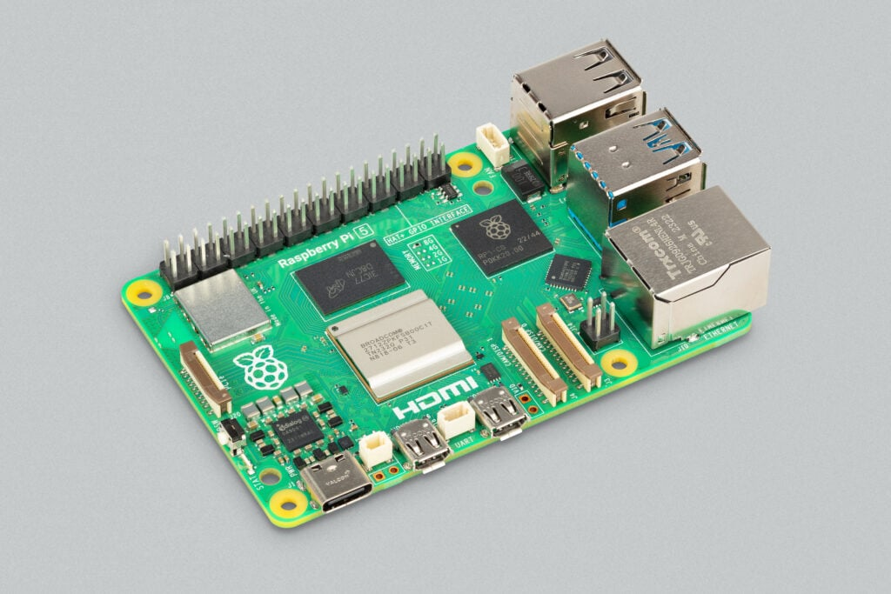
- PCIe 2.0 x1 interface for fast peripherals
- Raspberry Pi standard 40-pin GPIO header
- Real-time clock
- Power button

Manual

Project execution
This project was done in 3 stages:
Documentation – detailed information which includes the manual on how to use
hardware assembly – putting together components
software design – python was used in programming the sensors

