**Instruction Manual for the NGA XRF Mapping GUI**

Damon Conover1,2

John Delaney1,2 ([j-delaney@nga.gov](mailto:j-delaney@nga.gov))

1 National Gallery of Art, Scientific Research Department, Washington, DC

2 The George Washington University, School of Engineering & Applied Science, Washington, DC

Introduction

X-ray fluorescence (XRF) spectroscopy is a non-invasive point-based analytical method that can be utilized to identify the elements that make up an object. An x-ray source is used to bombard a sample with x-ray photons, dislodging electrons from the inner shells of the atoms. The resulting vacancies are filled by electrons from outer shells. This movement of electrons from shells with different binding energies corresponds to the release of x-ray photons as fluorescence. The energies of the x-rays (named Kα, Kβ, Lα, Lβ, Mα, and Mβ according to the shell where the original vacancy occurred) are characteristic of specific elements.

An XRF imaging spectroscopy scanner can be used to visualize the spatial distribution of elements. At the National Gallery of Art (NGA), in Washington, D.C., an XRF scanner has been constructed to obtain two-dimensional element maps of works of art. A novel feature of the NGA scanner is that the x-ray source and detector are stationary while the artwork is moved by a custom two-axis computer-controlled easel. The NGA scanner consists of a high-precision, two-axis, computer-controlled easel (SmartDrive), a rhodium x-ray source (XOS), and a silicon drift detector (Vortex-60EX, Hitachi High Technologies Science America, Inc.).

The spatial distribution of x-ray fluorescence at a given energy can often provide a way to visualize a map of an element’s distribution in an artwork. Analyzing a single energy, however, does not guarantee an accurate element map. While each element does have a unique set of x-ray energies, elements can have overlap at a single energy. Fitting the spectra using a sum of Gaussian functions, centered at the characteristic energies of the fluorescence peaks of each element, is used here to identify the contribution from each element and produce accurate element maps.

Installation

1. Install the MATLAB Compiler Runtime (MCR) Installer on your computer. The version of the MCR Installer will depend on your operating system (Windows, Mac) and the version of MATLAB used to compile the executable file.
2. Copy the XRFMapping executable, xrf_table.csv, and XRFMapping.txt files to your hard drive (If using a Mac, install, rather than copy, XRFMapping to the Applications folder and verify that XRFMapping.txt has both read and write permissions).



Operation

1. Execute the XRFMapping executable file. The associated window shown above will appear.
2. To select the XRF image cube to process, click the *Select file info* button and browse to the desired cube.
3. In the *Energy range (KeV)* fields, enter the range you wish to analyze. All peaks outside of this range will be ignored.
4. In the *Mapping region* fields, enter the horizontal and vertical pixel ranges you wish to analyze. When analyzing registered cubes there are often pixels at the border where no XRF information was collected. Use these fields to limit the spatial range that will be analyzed. If a range is set to*1* to *end* the full spatial range will be analyzed.
5. The *# of cores to use* field will be automatically be populated with the number of cores of your computer. If you wish to use less than the maximum number of cores, change this field accordingly.
6. In the *Element selection* field, select the elements that may be found in the artwork. Maps will be produced for each element selected. If there is not a radio button associated with the element, type its symbol name in the field provided. For multiple elements separate them with commas. The default values are read from the XRFMapping.txt file. The elements selected will be written to the TXT file and will become the default for the next time the executable is run.
7. The calibration coefficients that related the XRF detector channel number to energy (KeV) are read from the XRFMapping.txt file and shown in the bottom right of the GUI. If you wish to generate new coefficients, click the *Update coefficients* checkbox. When the Run button is pressed an automatic calibration procedure will be initiated. When it has completed, the new coefficients will be shown in the GUI and will replace the defaults stored in the TXT file. Additionally, the r2 associated with the linear fit to the calibration data will be shown in the GUI.
8. Press the *Run* button to initiate the mapping procedure. The status will change from *Idle* to *Running*. Upon completion of the mapping procedure, images will be written to disk in the same directory that contains the XRF image cube. There will be uncompressed TIF files showing 1) the sum of the counts under each peak and 2) the sum of counts under all peaks for a given element. There will also be 1) compressed PNG files showing the same information as the TIF files with scale bars and 2) compressed pairs of PNG files showing the element maps and their associated confidences. Finally, the fit spectra (with the offset removed) are output in the form of a cube the same size as the original cube.

Results

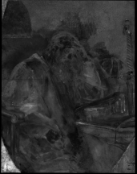

Fe Kα map

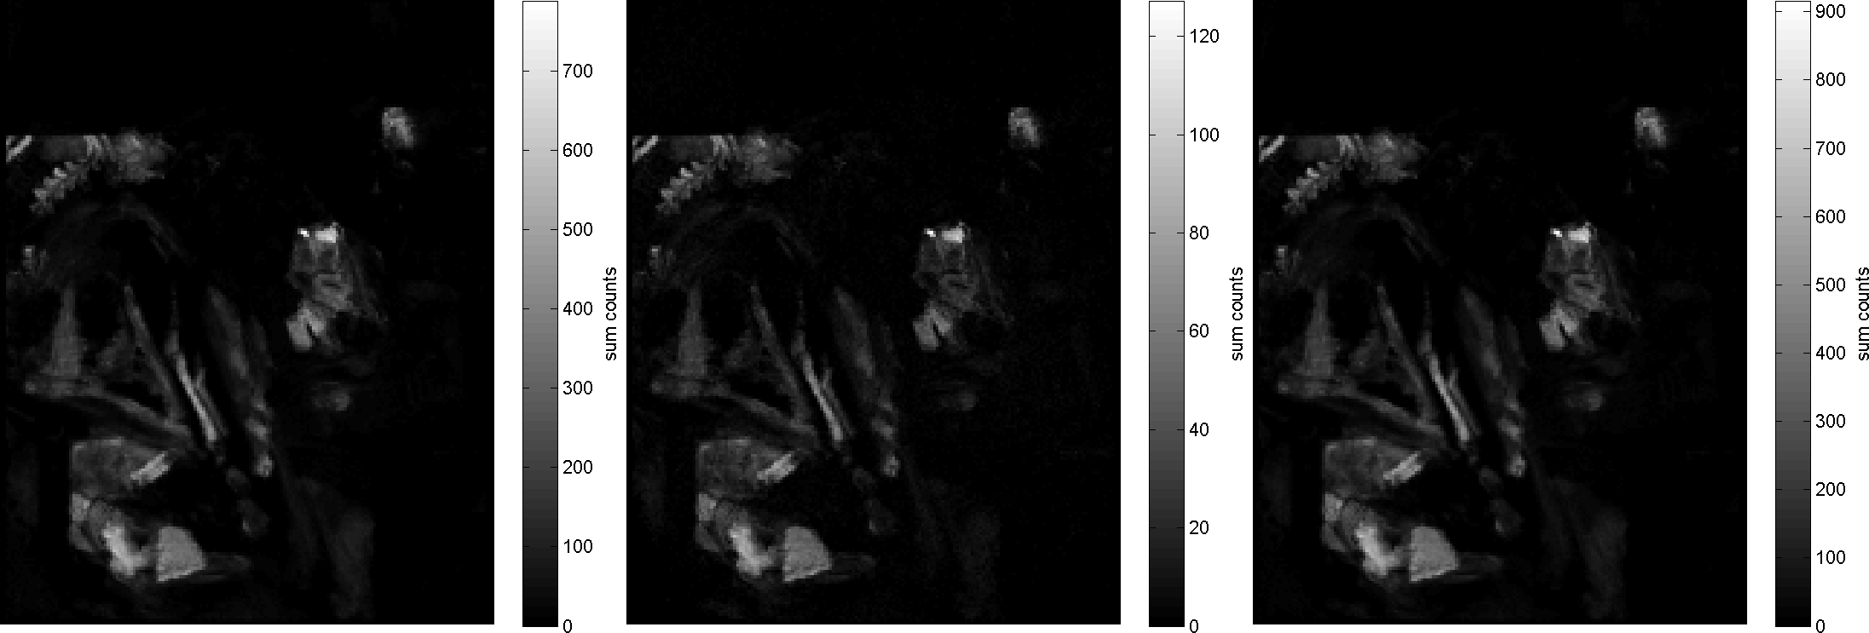

**Co maps: (left) Kα, (center) Kβ, (right) Kα + Kβ**

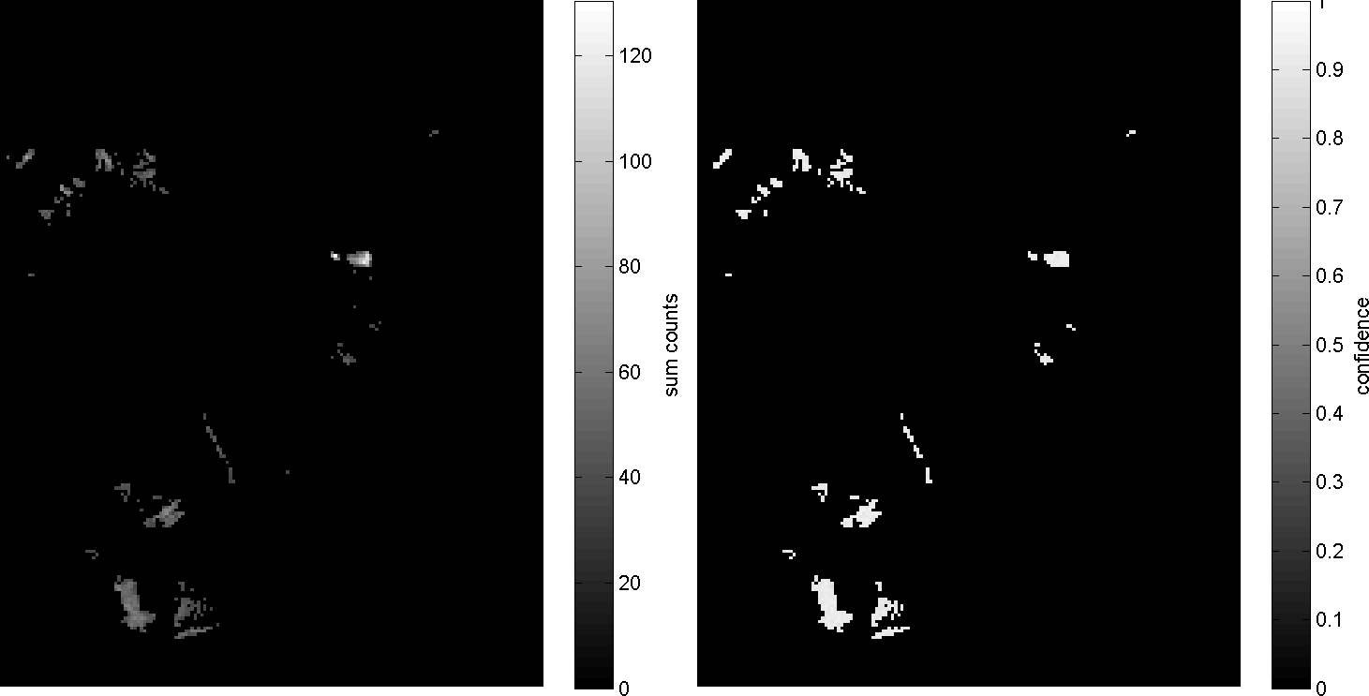

**(left) As map, (right) As confidence**

Revision history:

2015 - 06 - 30: The document was created. (Damon Conover)