PHY 505

Homework Assignment 2

John Nord

4/9/2017

**Abstract:**

In this assignment, we set out to study the accuracy of the Gutenberg-Richter Law for earthquake linear trends, and compare the data gathered by the NEIC to the data downloaded from the NCEDC ANSS catalog. Our results show that including all earthquake data provides a loose fit using the Gutenberg-Richter Law, but when excluding all earthquakes with magnitude less than M = 3.0, our data sets both show strong fits to the M > 3.0 best-fit line. In addition, we set out to analyze global CO2 concentrations and their overarching trends in an effort to lightly evaluate the future of our planet and species. Finally, we compare the previously mentioned CO2 trend to a NASA global temperature dataset to see what the correlations are, if any.

**Contents:**

1. Problem 1 ……………………………………………………………………………………………….. 1
2. Problem 2 ……………………………………………………………………………………………….. 3
3. Problem 3 ……………………………………………………………………………………………….. 4
4. References ………………………………………………………………………………………………. 6

**Problem 1:**

The NEIC Global dataset contains incredible amounts of information. So much so, it turns out, that the information begins to detract from the accuracy of our models and best-fit lines. So, when initially looking at the Gutenberg Richter fit of our earthquake data using our quake.cpp program, we get an approximate slope b of:

Earthquake data: Gutenberg-Richter Law

reading data file: california_earthquakes_2010_to_2013.csv

stored 141055 events in histogram

wrote events to file: histogram.dat

a = 5.3869

b = -0.799356

log_10(N) error bar = 0.26734

Now, according to a study published by Kanamori and Brodsky[1], the slope of the Gutenberg-Richter law should be approximately -1, so our data needs to be appended. It turns out when plotting our histogram using cpp_plot.py the issue stems from data on quakes of magnitude M < 3.0, so after a simple fix to our quake.cpp to limit the included data to those of only magnitude 3.0 or greater gives us the following results:

Earthquake data: Gutenberg-Richter Law

reading data file: california_earthquakes_2010_to_2013.csv

stored 16471 events in histogram

wrote events to file: histogram.dat

a = 5.95747

b = -0.904

log_10(N) error bar = 0.225093

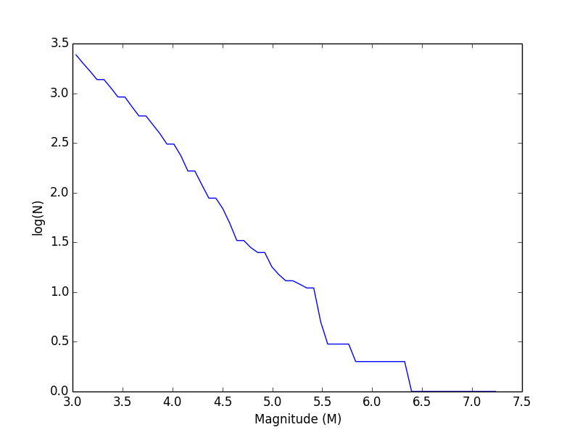

Fig.1, NEIC California earthquake data, M > 3.0

As we see here, our best-fit line now has a slope of b = -0.904; much closer to the value we were expecting, and within our anticipated error to call this an acceptable result.

**Problem 2:**

For years the NOAA have been monitoring the current levels of CO2 in the atmosphere and comparing this data to tens of thousands of years worth of previous CO2 levels found through ice core analysis. The results show a cycle of increasing and decreasing levels over large timescales, but a clear increase in recent history at alarming rates. Using data collected at Mauna Loa since 1958, the NOAA have produced a dataset that we can plot to see the CO2 concentration trend in recent history, and compare this to macroscopic trends dating much further back. Plotting the measured CO2 levels by month and year collected, we come up with the following trend:

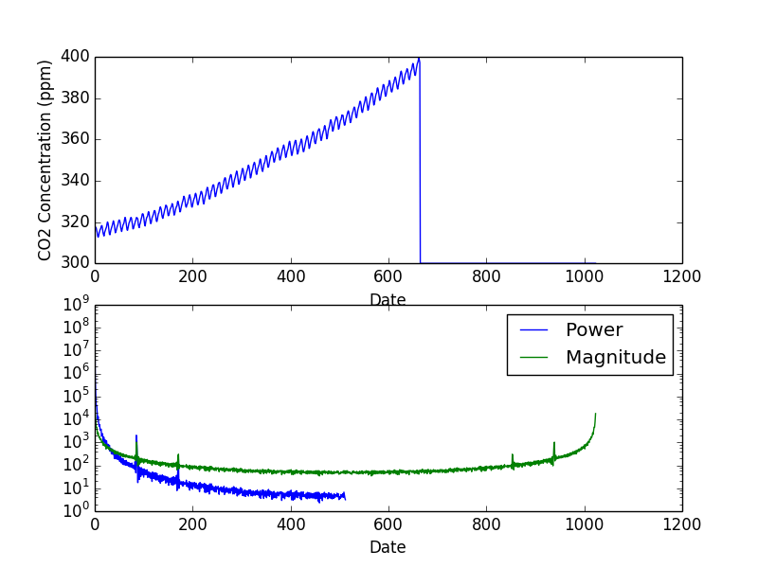

Fig.2, CO2 concentration change over time

Immediately, there is an observed pattern of oscillating increases and decreases in CO2 levels from what could be considered a rolling average at the time, but overall there is a very distinct increasing trend to this plot. In order to further flush out this macroscopic trend, we can instead plot the average value corrected for seasonal fluctuations as follows:

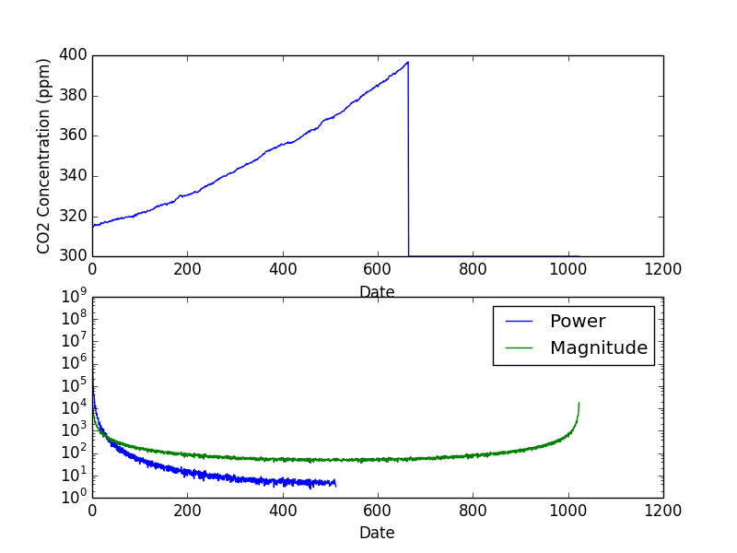

Fig.3, CO2 concentration over time corrected for seasonal fluctuation

As you can see, the data now contains much less noise and a much clearer trend is apparent. Not only is the average concentration of atmospheric CO2 increasing, but it is increasing at an accelerating rate over time.

**Problem 3:**

For comparison’s sake, we also searched online for another earthquake event dataset, and after finding several sites that have been taken down or are no longer accessible we were able to attain data from the Northern California Earthquake Data Center (ANSS Composite Catalog)[3]. Taking all recorded earthquakes of magnitude 3.0 or greater from 1992 until the present time gave us 158,849 events, and when fit to a Gutenberg-Richter Law gives us a slope of b = -0.9097 making it an acceptable dataset and fit as follows:

Earthquake data: Gutenberg-Richter Law

reading data file: anss_earthquake_catalog.csv

stored 158849 events in histogram

wrote events to file: histogram2.dat

a = 7.29887

b = -0.909723

log_10(N) error bar = 0.243706

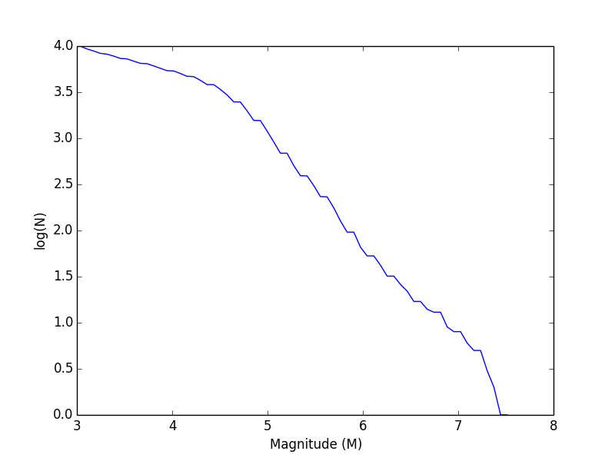

Fig.4, ANSS California earthquake data, M > 3.0

When comparing these results to the previously examined NEIC dataset, we see a very strong correlation between the two. When fit to the Gutenberg-Richter Law, they both have slopes very nearly b = -1 as intended. Visually, we do see some slight deviations at the very lowest and highest magnitudes recorded in the ANSS dataset with a much more linear trend in the middle magnitudes. This is in contrast to the NEIC dataset, which had a very linear form until roughly magnitude 5.5 when the data becomes more scattered. The exact cause of these slight deviations is unknown, but the overall trend for each fit as intended.

Global temperature has been measured as well by NASA, and if we graph the deviation from average temperature over the past 136 years we get the following plot:

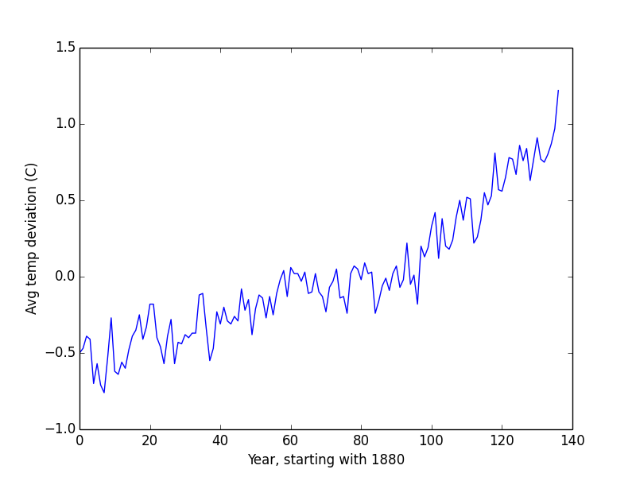

Fig.5, Global deviation from average temperature by year

If we compare this graph to Fig.2, we see the tail end of Fig.5 (signifying the overlapping years with the CO2 data) matches up alarmingly well. From here, we can safely assume that the increasing level of CO2 is related to the increasing deviation from average temperature.

**References:**

[1]: The Physics of Earthquakes, Physics Today 54, 6, 34 (2001); doi: <http://dx.doi.org/10.1063/1.1387590>

[2]: PHY 410-505 Webpage, <http://www.physics.buffalo.edu/phy410-505>

[3]: NCEDC, ANSS Composite Catalog, <http://www.quake.geo.berkeley.edu/anss/catalog-search.html>

[4]: NASA Goddard Institute for Space Studies, GISTEMP, <https://data.giss.nasa.gov/gistemp/>

**Github Code:**