# IT 230 Coding Activity Submission Template

Submit your work on the coding activities for Modules One, Two, Three, Four, and Six in this document. In addition to this document, you should submit a ZIP file containing all your Visual Studio project files and source code that can be run in Visual Studio on a different computer.

For each coding activity, complete the following steps:

* Download and rename this document to meet the file naming conventions requested in the assignment instructions.
* Fill in the required information below by replacing the bracketed text with the relevant information.
* Submit this document and your ZIP file for grading and feedback. Your ZIP file should follow the same naming conventions.

Document your work in the coding activity by completing each of the following items:

1. Provide a screenshot of the output that resulted from running your program successfully in Visual Studio. See the coding assignment instructions for an example of what should be included in the screenshot. Your screenshot must include the following elements:
   1. Your last name as the first printed text on the screen
   2. 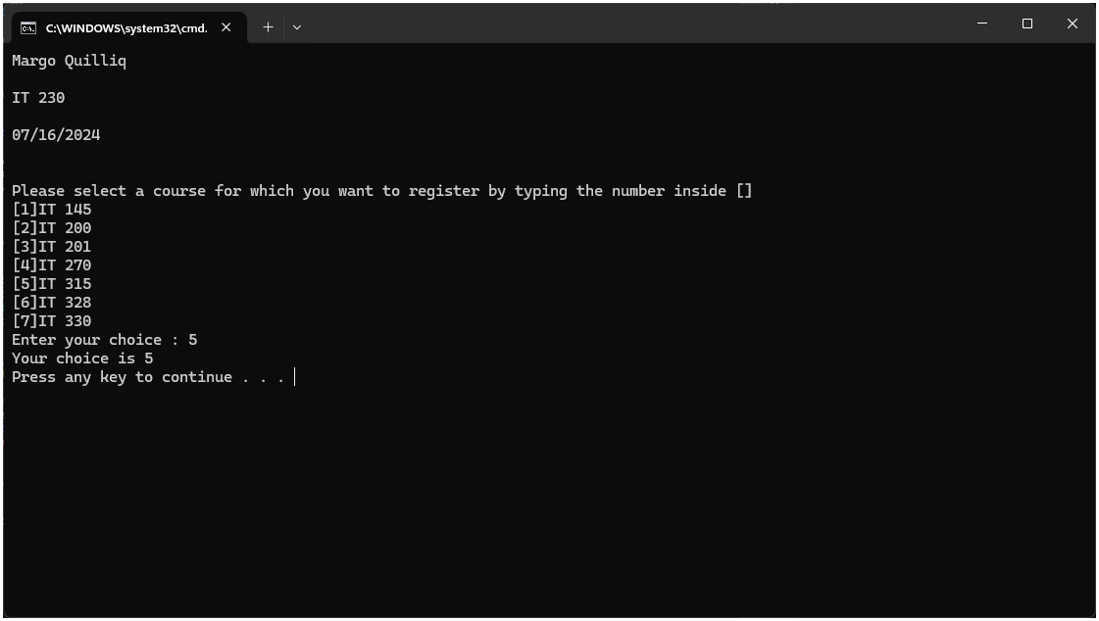Verification that the program is fully functioning and data results are accurate for the given problem
2. Copy and paste the source code text you wrote for this assignment from the *.cs file into the space below. Only providing the *.cs files or a screenshot does not meet the requirements for this part of the assignment. Code should be logically organized. It should also follow proper syntax and conventions noted in the Coding Activity Guidelines and Rubric.

using System;

using System.Collections.Generic;

using System.Linq;

using System.Text;

using System.Threading.Tasks;

namespace DebugFixMethods

{

class Program

{

static void Main(string[] args)

{

(new Program()).run();

}

void run()

{

int choice = 0;

WritePrompt();

choice = ReadChoice();

WriteChoice(choice);

}

void WritePrompt()

{

Console.WriteLine("Margo Quilliq\n\nIT 230\n\n07/16/2024\n\n");

Console.WriteLine("Please select a course for which you want to register by typing the number inside []");

Console.WriteLine("[1]IT 145\n[2]IT 200\n[3]IT 201\n[4]IT 270\n[5]IT 315\n[6]IT 328\n[7]IT 330");

Console.Write("Enter your choice : ");

}

int ReadChoice()

{

string s = "";

s = Console.ReadLine();

int choice = int.Parse(s);

return choice;

}

void WriteChoice(int choice)

{

Console.WriteLine("Your choice is {0}", choice);

}

}

}

1. Show that you understand the task by explaining the design of your program in the space below. Include the process and steps you took to write your code. Explain how you arrived at the solution to the problem and completed the activity.
2. I changed the name of the function on line 27 from "void Writeprompt()" to "void WritePrompt()"
   * The reason behind why I needed to change the capitalization of this function name is because on line 21 it had “WritePrompt” spelled with a capital P and for the function to work it needs to be matching/fluid throughout.
3. I added the “int” data type to line 41, which made it “void WriteChoice(int choice)” instead of “void WriteChoice(choice)”
   * The reason behind why I needed to add the int data type, is because beforehand there wasn’t any data type and there needs to be one there to make the code function properly.
4. I uncapitalized the c in choice on line 43 which made it “Console.WriteLine("Your choice is {0}", choice);” instead of “Console.WriteLine("Your choice is {0}", Choice);”
   * The reason behind why I needed to change the capitalization of “Choice” is because in line 41 as you can see in the parentheses… “choice” is not capitalized and for the code to function properly these spellings need to match exactly.
5. I converted string to int using parse. To do this I added in “int choice = int.Parse(s);” underneath the readline function.
   * The reason behind why I needed to convert string to int, was because the rest of the code relied on the return type being int, not string. So I needed to convert string to int for the code to run properly.
6. I changed the “s” in line 39 to “choice”.
   * The reason behind why I needed to change the “s” in line 39 to “choice” is because the variable needs to come from the return type.
7. Reflect on your learning experience and what you learned from completing the activity.

Throughout this learning experience I struggled a lot, and I do mean… A Lot. I had to get some help from multiple tutors through SNHU to find someone who could explain it in a way that I could understand. However, I finally found someone who could explain it in the right way for me and I learned so much. I was confused about pretty much everything in this assignment and the tutor went through it step by step for me, to help me understand definitions of certain things and the order in which code is supposed to be, etc…