**Original Output**

[Base Output, Showing All of The Options You Can Choose From]

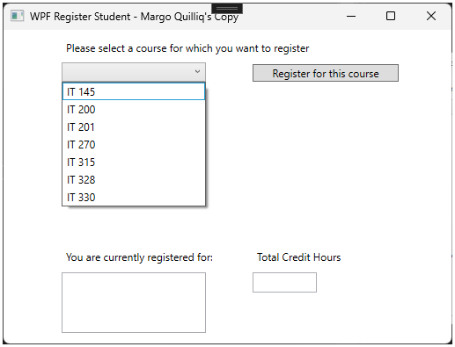

**Can Register For Courses**

[Shows the ability to choose three courses]

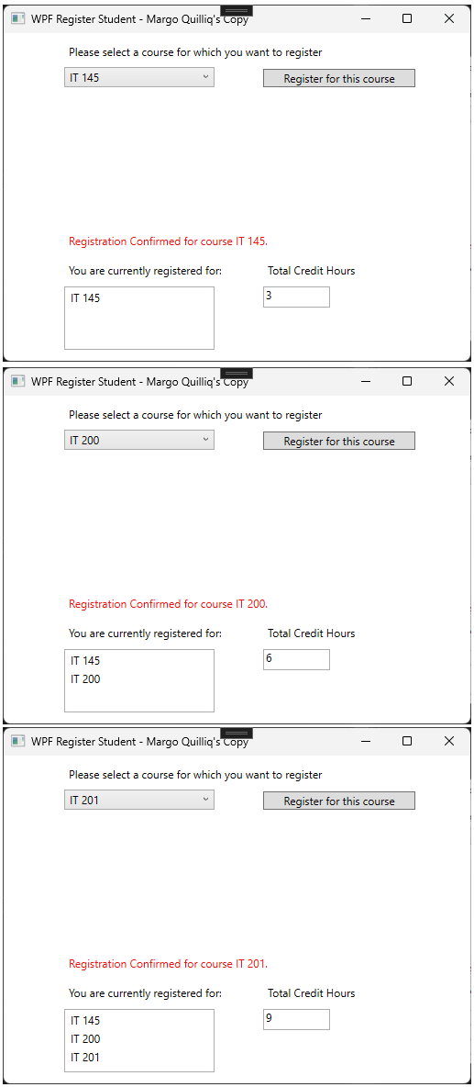

**Cannot Register for Same Course**

[Shows error when trying to register for the same course]

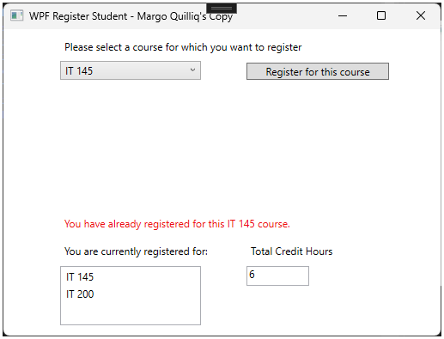

**Cannot Go Over Nine Credit Hours**

**Pasted Code**

using System;

using System.Collections.Generic;

using System.Linq;

using System.Text;

using System.Threading.Tasks;

using System.Windows;

using System.Windows.Controls;

using System.Windows.Data;

using System.Windows.Documents;

using System.Windows.Input;

using System.Windows.Media;

using System.Windows.Media.Imaging;

using System.Windows.Navigation;

using System.Windows.Shapes;

namespace WPFRegisterStudent

{

/// <summary>

/// Interaction logic for MainWindow.xaml

/// </summary>

public partial class MainWindow : Window

{

Course choice;

private int creditHours = 0; //varaible for to track creditHours. Private because the others parameters are private.

public MainWindow()

{

InitializeComponent();

}

private void Window_Loaded(object sender, RoutedEventArgs e)

{

Course course1 = new Course("IT 145");

Course course2 = new Course("IT 200");

Course course3 = new Course("IT 201");

Course course4 = new Course("IT 270");

Course course5 = new Course("IT 315");

Course course6 = new Course("IT 328");

Course course7 = new Course("IT 330");

this.comboBox.Items.Add(course1);

this.comboBox.Items.Add(course2);

this.comboBox.Items.Add(course3);

this.comboBox.Items.Add(course4);

this.comboBox.Items.Add(course5);

this.comboBox.Items.Add(course6);

this.comboBox.Items.Add(course7);

this.textBox.Text = "";

}

private void button_Click(object sender, RoutedEventArgs e)

{

choice = (Course)(this.comboBox.SelectedItem);

// TO DO - Create code to validate user selection (the choice object)

// and to display an error or a registation confirmation message accordinlgy

// Also update the total credit hours textbox if registration is confirmed for a selected course

if (listBox.Items.Contains(choice)) //If statement for the listbox which is where the course show at

{

label3.Content = "You have already registered for this " + choice + " course."; //If the listbox contains choice then it tell you it's already registered.

}

else if (creditHours < 9) //Boolean Expression for creditHourse < 9. Thought it was <= at first but didn't work correctly.

{

listBox.Items.Add(choice); //listBox is the the name of the box where the courses will appear.

creditHours += 3; //Adding 3.

textBox.Text = Convert.ToString(creditHours); //Converting to string.textBox is the name of the box that show credit hours.

label3.Content = "Registration Confirmed for course " + choice + "."; //Output the confirmed what course is registered.

}

else //else statement. When nothing fits above else is this.

{

label3.Content = "You can not register for more than 9 credit hours."; //When over 9 credit it with outputs this since above is < 9.

}

//Note to self: Remember to close window after done. If you Try to build when window of the debugging open it gie errors below.

}

}

}