# IT 230 Coding Activity Submission Template

Submit your work on the coding activities for Modules One, Two, Three, Four, and Six in this document. In addition to this document, you should submit a ZIP file containing all your Visual Studio project files and source code that can be run in Visual Studio on a different computer.

For each coding activity, complete the following steps:

* Download and rename this document to meet the file naming conventions requested in the assignment instructions.
* Fill in the required information below by replacing the bracketed text with the relevant information.
* Submit this document and your ZIP file for grading and feedback. Your ZIP file should follow the same naming conventions.

Document your work in the coding activity by completing each of the following items:

1. Provide a screenshot of the output that resulted from running your program successfully in Visual Studio. See the coding assignment instructions for an example of what should be included in the screenshot. Your screenshot must include the following elements:
   1. Your last name as the first printed text on the screen
   2. Verification that the program is fully functioning and data results are accurate for the given problem

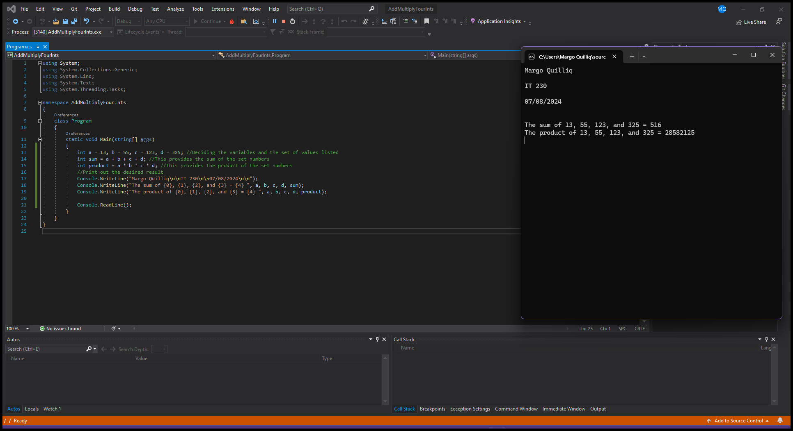

1. Copy and paste the source code text you wrote for this assignment from the *.cs file into the space below. Only providing the *.cs files or a screenshot does not meet the requirements for this part of the assignment. Code should be logically organized. It should also follow proper syntax and conventions noted in the Coding Activity Guidelines and Rubric.

using System;

using System.Collections.Generic;

using System.Linq;

using System.Text;

using System.Threading.Tasks;

namespace AddMultiplyFourInts

{

class Program

{

static void Main(string[] args)

{

int a = 13, b = 55, c = 123, d = 325; //Deciding the variables and the set of values listed

int sum = a + b + c + d; //This provides the sum of the set numbers

int product = a * b * c * d; //This provides the product of the set numbers

//Print out the desired result

Console.WriteLine("Margo Quilliq\n\nIT 230\n\n07/08/2024\n\n");

Console.WriteLine("The sum of {0}, {1}, {2}, and {3} = {4} ", a, b, c, d, sum);

Console.WriteLine("The product of {0}, {1}, {2}, and {3} = {4} ", a, b, c, d, product);

Console.ReadLine();

}

}

}

1. Show that you understand the task by explaining the design of your program in the space below. Include the process and steps you took to write your code. Explain how you arrived at the solution to the problem and completed the activity.

In this assignment the goal was to create a program that could successfully run and show the sum and product of specific numbers. To complete this assignment I first gave all four of the original numbers a value of the alphabet. Next, I wrote code to demonstrate what each value would be doing with one another to create the sum and product of the numbers. Then, I used the Console.WriteLine function to execute the code. Lastly, I added the Console.ReadLine() function to make the finished product of the code show up in a command prompt after it had run.

1. Reflect on your learning experience and what you learned from completing the activity.

With this assignment in particular, I learned a lot about how to one assign values to things and how to use those values later. However, I also learned how to add and multiply with code. Which is something I didn’t really think too much into before this assignment. I’m glad to have had the opportunity to learn this material, Thank you!