QSPI Flash Controller
Specification

Overview
The QSPI Flash Controller is configured through an APB register interface. These registers allow software to configure flash commands, addresses, transfer modes, dummy cycles, data length, and monitor controller status.

1 Micro-architecture:

1.1 Overview:
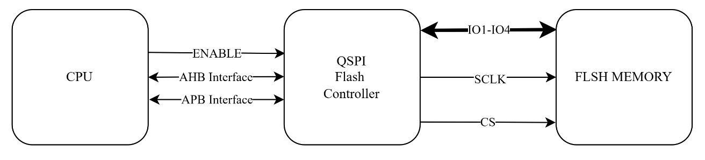

1.2 APB:
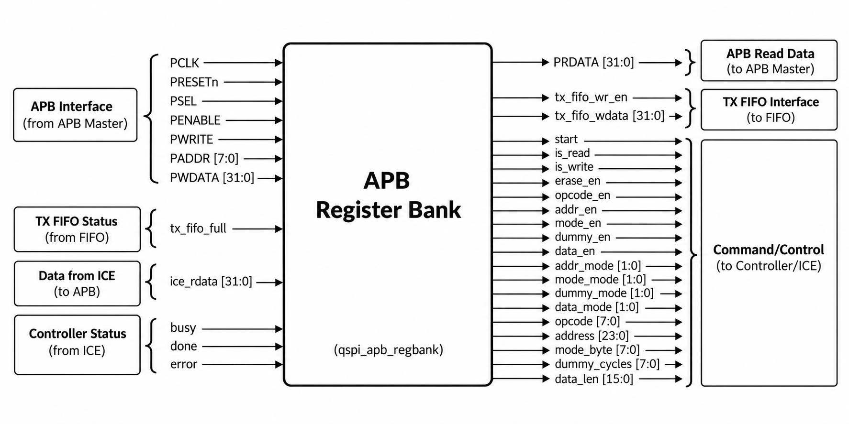

1.2.1 Indirect Command Engine Path
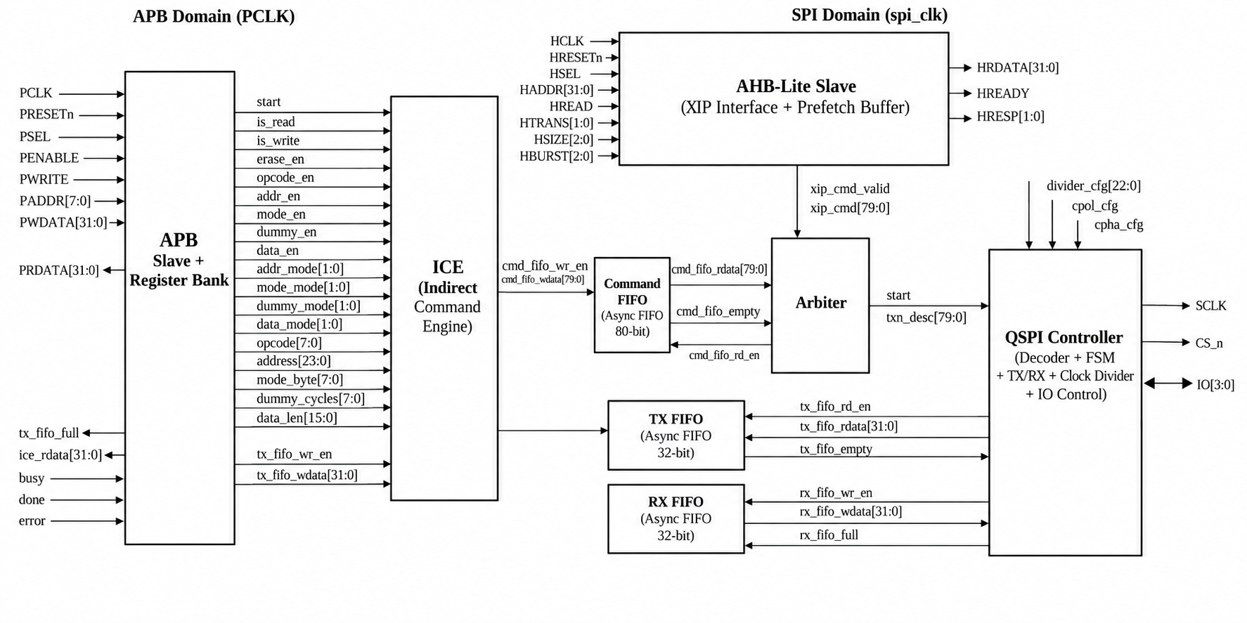

1.3 SPI Controller:

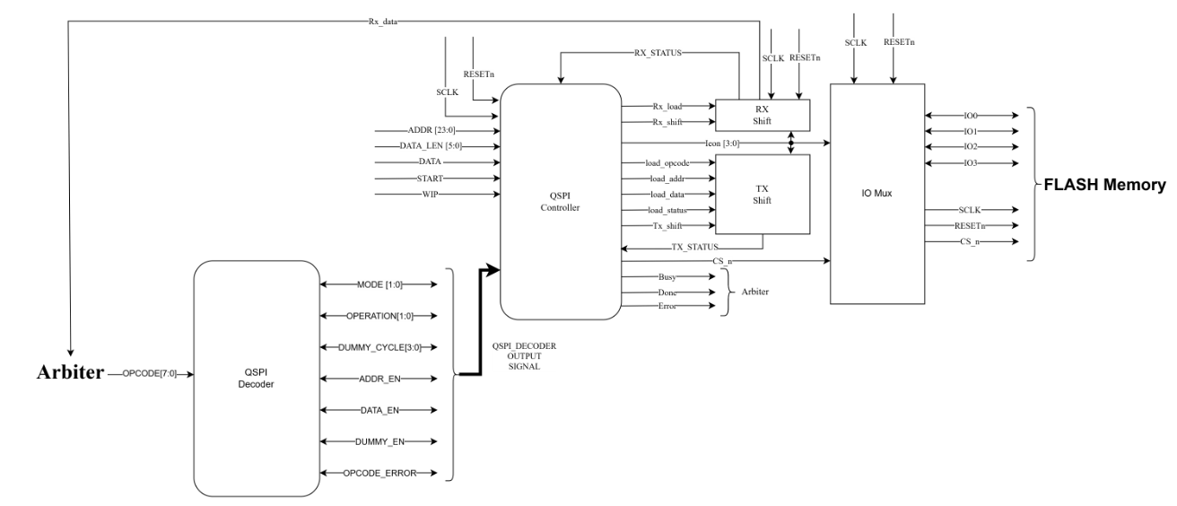

1.3.1 FSM:
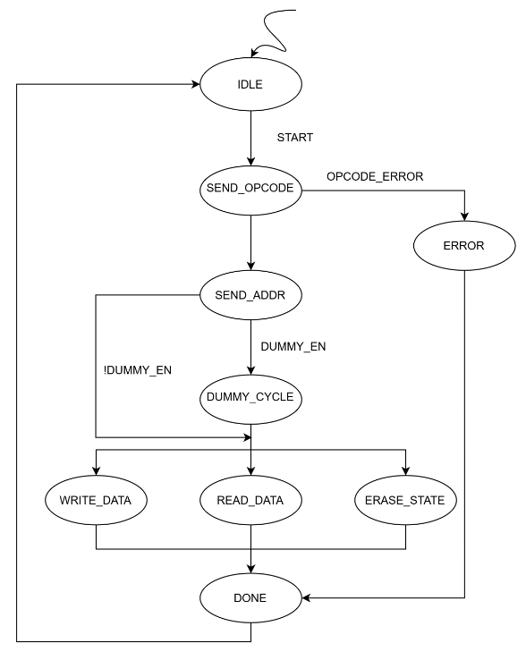

2 Register Map
Offset | Register Name | Width | Access | Description | Reset Value
0x00 | CTRL | 4 bits | RW | Transaction control register | 0x0
0x04 | OPCODE | 8 bits | RW | Flash command opcode | 0x00
0x08 | ADDRESS | 24 bits | RW | Flash memory address | 0x000000
0x0C | MODEBYTE | 16 bits | RW | Optional mode/alternate bytes | 0x0000
0x10 | DUMMY | 15 bits | RW | Number of dummy cycles | 0x0000
0x14 | DATALEN | 6 bits | RW | Data transfer length | 0x00
0x18 | MODECFG | 2 bits | RW | Transfer mode configuration | 0x0
0x1C | TXDATA | 32 bits | WO | Transmit data register (TX FIFO write) | 0x00000000
0x20 | RXDATA | 32 bits | RO | Receive data register | 0x00000000
0x24 | STATUS | 3 bits | RO | Controller status flags | 0x0

2.1 CTRL Register (0x00)
Controls the type of flash operation and initiates transactions.
Bit | Field | Description
[0] | START | Starts a flash transaction
[1] | IS_READ | Enables read operation
[2] | IS_WRITE | Enables write/program operation
[3] | ERASE_EN | Enables erase operation

2.2 OPCODE Register (0x04)
Stores the flash command opcode to be transmitted during the command phase.
Bits | Field | Description
[7:0] | OPCODE | Flash command opcode

2.2.1 Supported Opcodes
Opcode | Command
0x06 | Write Enable (WREN)
0x05 | Read Status Register (RDSR)
0x9F | Read JEDEC ID (RDID)
0x02 | Page Program (PP)
0x20 | Sector Erase (SE)
0x0B | Fast Read
0xEB | Quad I/O Read

2.3 ADDRESS Register (0x08)
Stores the target flash address.
Bits | Field | Description
[23:0] | ADDRESS | Flash memory address

2.4 MODEBYTE Register (0x0C)
Stores optional mode or alternate bytes used by certain flash commands.
Bits | Field | Description
[15:0] | MODEBYTE | Mode/alternate byte value

2.5 DUMMY Register (0x10)
Defines the number of dummy clock cycles inserted before data transfer begins.
Bits | Field | Description
[14:0] | DUMMY_CYCLES | Dummy cycle count
Range
0 to 32767 cycles

2.6 DATALEN Register (0x14)
Specifies the amount of data transferred during the data phase.
Bits | Field | Description
[5:0] | DATA_LEN | Number of bytes to transfer
Range
0 to 63 bytes

2.7 MODECFG Register (0x18)
Selects the transfer width used during communication with the flash.
Bits | Field | Description
[1:0] | MODE | Transfer mode selection

2.7.1 Encoding
Value | Mode
2'b00 | Single SPI (1-bit)
2'b01 | Dual SPI (2-bit)
2'b10 | Quad SPI (4-bit)
2'b11 | Reserved

2.8 TXDATA Register (0x1C)
Write-only register used to push data into the transmit FIFO.
Bits | Description
[31:0] | Data written to TX FIFO

2.9 RXDATA Register (0x20)
Read-only register used to retrieve received data.
Bits | Description
[31:0] | Data received from flash

2.10 STATUS Register (0x24)
Provides the current status of the controller.
Bit | Field | Description
[0] | BUSY | Controller is executing a transaction
[1] | DONE | Transaction completed successfully
[2] | ERROR | Transaction terminated with an error

2.10.1 Status Values
ERROR | DONE | BUSY | Meaning
0 | 0 | 0 | Idle
0 | 0 | 1 | Transaction in progress
0 | 1 | 0 | Transaction completed
1 | X | X | Error detected

5. Design Operation

5.2 Command Flow
The controller supports a programmable transaction sequence:
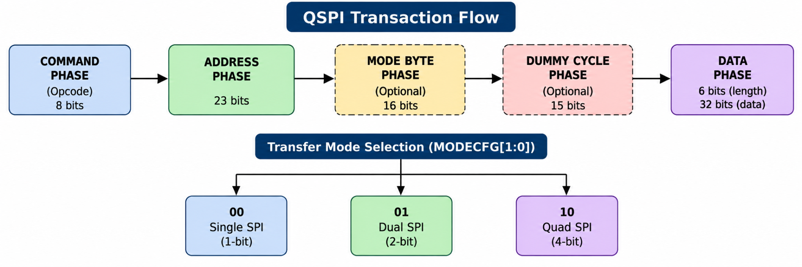

- SPI Mode
- Dual SPI Mode
- Quad SPI Mode
This configuration is selected through the MODECFG register.

6.3 APB Register Bank
The APB Register Bank stores all transaction configuration parameters.
Software programs:
Register | Function
CTRL_REG | Start transaction and operation type
OPCODE_REG | Flash command opcode
ADDR_REG | Flash address
MODEBYTE_REG | Optional mode byte
DUMMY_REG | Dummy cycle count
DATALEN_REG | Data transfer length
MODECFG_REG | Phase width configuration
TXDATA_REG | Write data
STATUS_REG | Controller status
When start is asserted, the register contents are forwarded to the Indirect Command Engine.

6.4 Indirect Command Engine (ICE)
The ICE collects all programmed transaction parameters and creates a complete command descriptor.
The descriptor includes:
Opcode
Address
Mode Byte
Dummy Cycles
Data Length
Read/Write Information
Phase Enables
Transfer Width Configuration
The descriptor is written into the Command FIFO for execution.

6.5 Command FIFO
The Command FIFO stores pending flash transactions.
Functions:
- Decouples APB programming from command execution
- Buffers command requests
- Preserves transaction ordering
The QSPI Decoder reads commands from the FIFO whenever the QSPI Controller becomes available.

6.7 QSPI Controller
The QSPI Controller performs the actual flash protocol execution.
The controller consists of:
QSPI Decoder
QSPI FSM
TX Shift Engine
RX Shift Engine
Clock Divider
IO Control Logic
The controller interprets the transaction descriptor and generates the required QSPI signaling.

6.9 Transfer Width Configuration
Each transaction phase supports programmable bus widths.
Mode Value | Transfer Width
2'b00 | Single SPI (1-bit)
2'b01 | Dual SPI (2-bit)
2'b10 | Quad SPI (4-bit)
2'b11 | Reserved
The following phases are independently configurable:
- Address Phase
- Mode Byte Phase
- Dummy Cycle Phase
- Data Phase

6.10 Data Transfers

Read Operations
For read transactions:
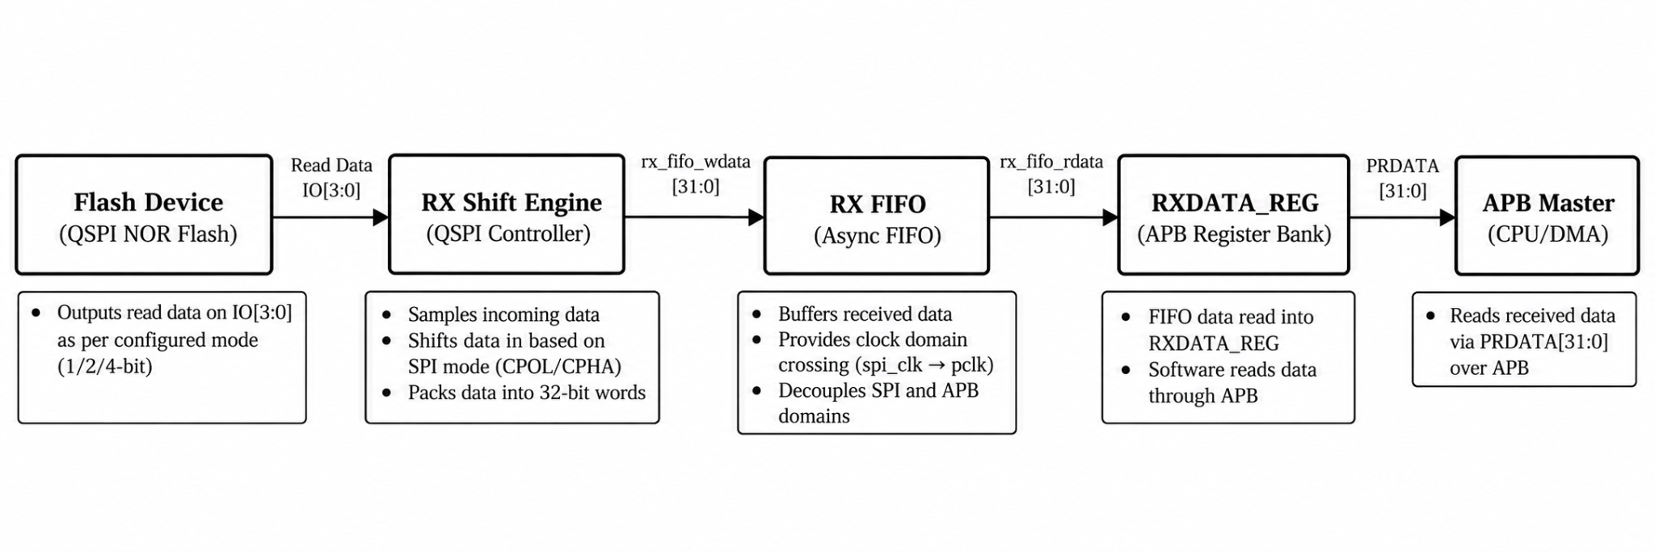
Received data is made available through the APB interface.

Write Operations
For write transactions:
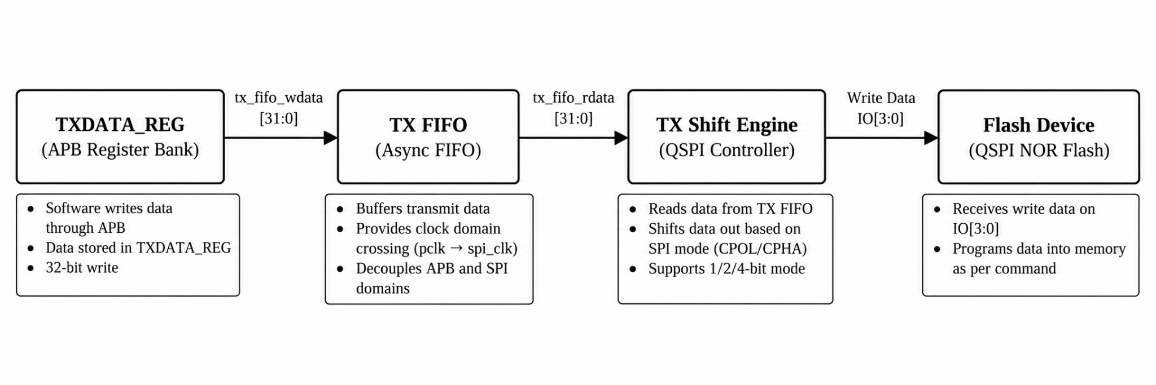
Data is transmitted to the flash device during the Data Phase.

6.11 Status Reporting
Transaction status is reported through STATUS_REG.
Bit | Signal | Description
[0] | busy | Controller executing a transaction
[1] | done | Transaction completed
[2] | error | Transaction error detected

6.12 Reset Behavior
All modules use an active-low asynchronous reset (PRESETn / RESETn).
Upon reset:
- Controller returns to Idle state
- All configuration registers are cleared
- FIFO interfaces are reset
- Status flags are cleared
- Pending transactions are discarded

