**<Title of Document- RisciiDocTemplate>**

**Project RISCII**

*<”Quoted, italicized brief of document- template for RISCII documents”>*

**Rev <Letter- A>**

**<Date of last revision release- 12-JUN-2024>**

**Purpose 1**

**Section Header 1**

Sub-section Header 1

Lowest Header 2

**Revision History 2**

# Purpose

This section (concisely) describes the purpose of the document. It should effectively explain why the document was created and why it has the sections described in the table of contents.

Document head, revision history, and footers are already formatted and just need the red text to be replaced with their actual values (and re-colored black). The Table of contents is also formatted as needed.

In general, paragraphs and section headers should be separated by 12 pt spaces and left justified. Captions underneath pictures and tables are an exception to this rule.

# Section Header

Section headers are 16 pt, bold, and underlined

## Sub-section Header

Sub-section headers are 14 pt and underlined

### Lowest Header

The lowest header (besides captions) is simply 12 pt and underlined.

Regular text is 12 pt.

| **Bold** | **Underlined** | **12 pt** | **Col/Row Names** |
| --- | --- | --- | --- |
| 12 pt | for | table | entries |

* Table comments are 12 pt, single point lists and center justified

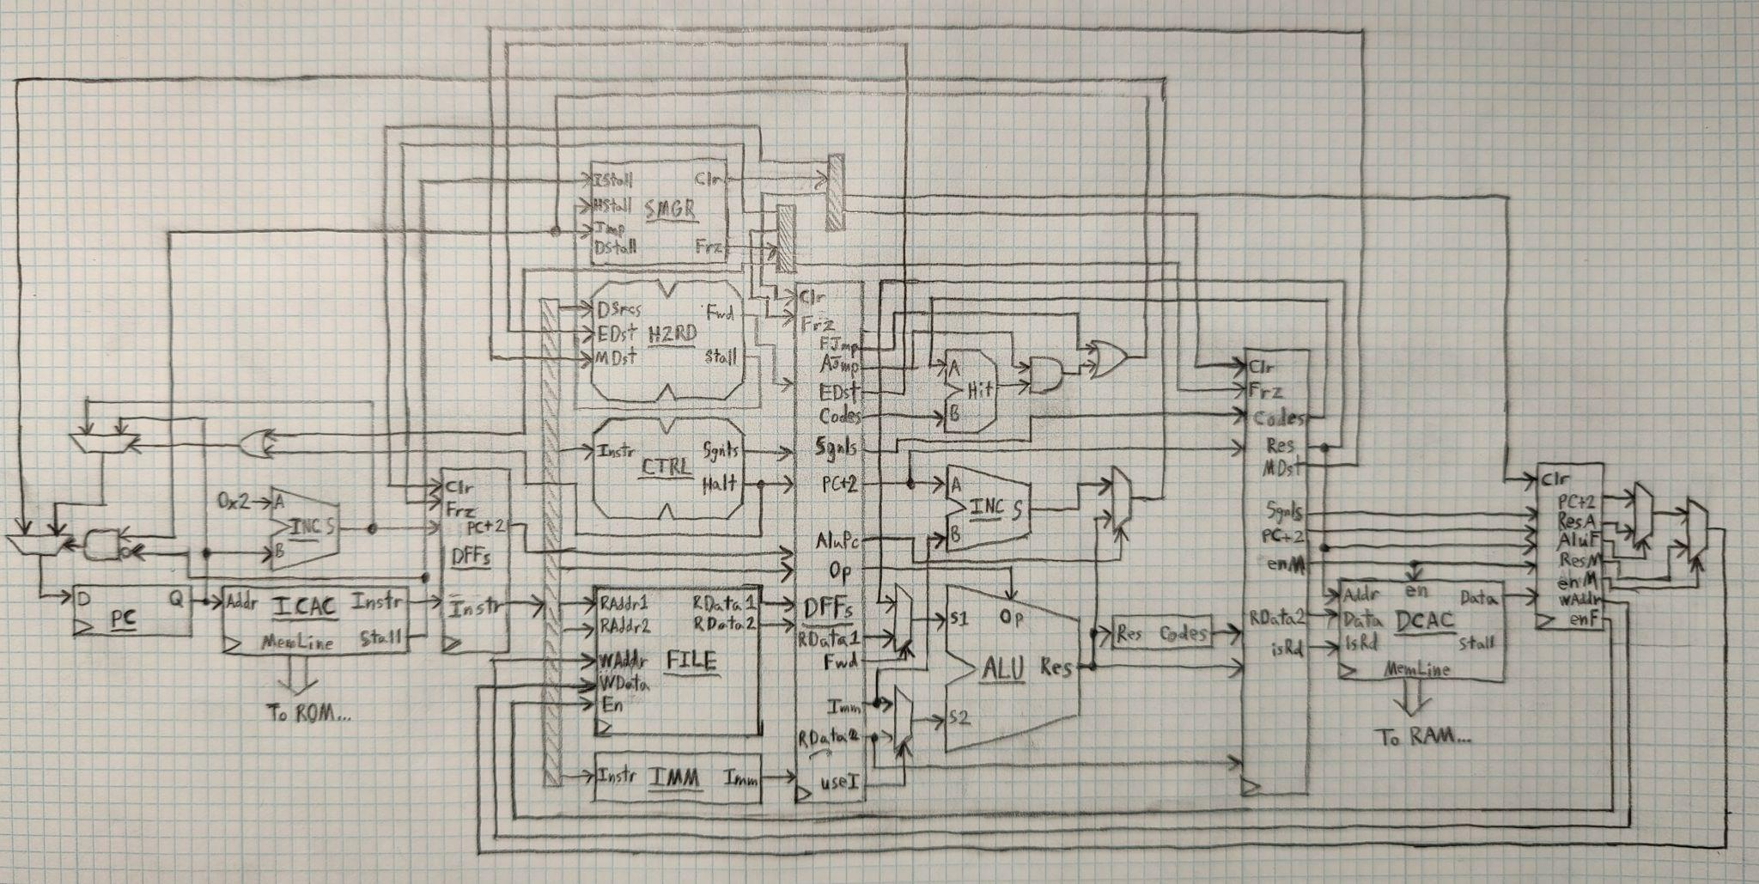

* Image comments are 12 pt, single point lists and center justified

# Revision History

| **Rev** | **Date** | **Description of Changes** | **Initials** |
| --- | --- | --- | --- |
| A | 12-JUN-2024 | Initial draft of template | J.E. |
|  |  |  |  |
|  |  |  |  |