**<Title of Document- RisciiDocTemplate>**

**Serial Checker (<File Designation- SC0000>)**

*<”Quoted, italicized brief of document- template for RISCII documents”>*

**Rev <Letter- B>**

**<Date of last revision release- 23-JUN-2024>**

**Purpose 1**

**Abbreviations 1**

**References 2**

**Section Header 2**

Sub-section Header 2

Lowest Header 2

- Table 1: Table #, 12 pt, single point list, center justified (and a “heading”) 2

- Image 1: Image #, 12 pt, single point list, center justified (and a “heading”) 3

**Revision History 3**

# Purpose

This section (concisely) describes the purpose of the document. It should effectively explain why the document was created and why it has the sections described in the table of contents.

Document head, revision history, abbreviation/references sections, and footers are already formatted and just need the red text to be replaced with their actual values (and re-colored black). The Table of contents is also formatted as needed, but must be manually updated (there’s often a button for that).

In general, paragraphs and section headers should be separated by 12 pt spaces and left justified. Captions underneath pictures and tables are an exception to this rule.

# Abbreviations

| **Abbreviation** | **Description** |
| --- | --- |
| **This (uncaptioned) table is for abbreviations and aliases found in the document** | **It acts as a common place to describe common terms in the document without explaining them every time** |
| **For no entries, keep table with one entry row with “-” as both values** |  |

# References

| **Name** | **Document Number** |
| --- | --- |
| **This (uncaptioned) table is for referencing other documents (or possibly media)** | **It acts as a common place to “link” to other documents by their designation number** |
| **For no entries, keep table with one entry row with “-” as both values** |  |

# Section Header

Section headers are 16 pt, bold, and underlined

## Sub-section Header

Sub-section headers are 14 pt and underlined

### Lowest Header

The lowest header (besides captions) is simply 12 pt and underlined.

Regular text is 12 pt.

| **Bold** | **Underlined** | **12 pt** | **Col/Row Names** |
| --- | --- | --- | --- |
| 12 pt | for | table | entries |

#### Table 1: Table #, 12 pt, single point list, center justified (and a “heading”)

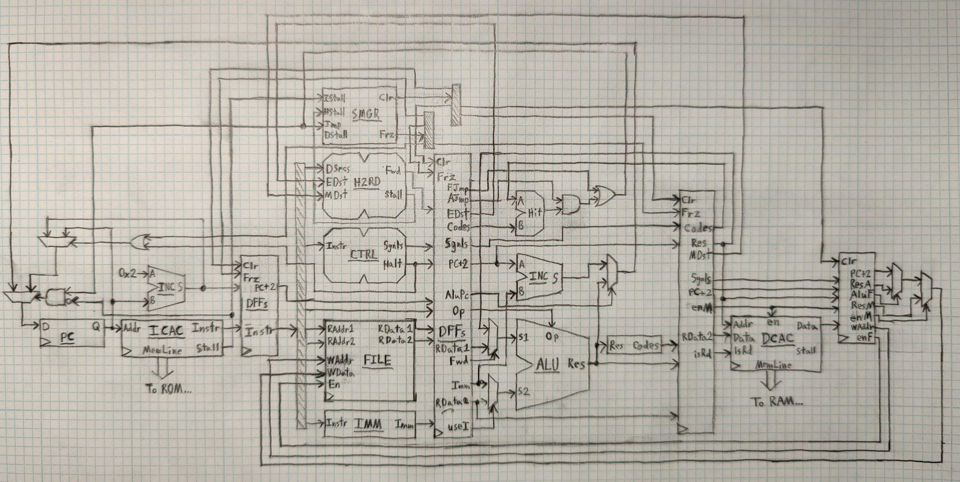

#### Image 1: Image #, 12 pt, single point list, center justified (and a “heading”)

# Revision History

| **Rev** | **Date** | **Description of Changes** | **Initials** |
| --- | --- | --- | --- |
| A | 12-JUN-2024 | Initial draft of template | J.E. |
| B | 23-JUN-2024 | Altered some headings, added common sections | J.E. |
|  |  |  |  |