Digital Business Analysis of AstraZeneca

(Name)
(Course)
(Institution)
(Date)

Introduction
A company's "digital business activities" are those that use digital technology and techniques to boost internal processes, deepen relationships with customers, and stimulate creative thinking. Leading pharmaceuticals corporation such as AstraZeneca relies heavily on digital business activities such research and development, patient involvement, and data analysis. The purpose of this research is to give a thorough evaluation of AstraZeneca's digital business operations, including an assessment of their relevance to and effect on the company's bottom line. The paper will focus on the internal factors that determine AstraZeneca's digital strategy, including strategic direction, organizational structure, and controls. The potential and challenges in the digital world will be better understood by an examination of the external environment, which includes consumer behaviors, economic circumstances, and demographic changes. Focusing on developments in R&D and digital patient involvement, the study will also examine the pros and cons of AstraZeneca's digital business operations. The ultimate goal of this research is to shed light on AstraZeneca's digital initiatives, highlighting how they have contributed to the company's expansion, new developments, and better patient outcomes.
Brief over view of Astra Zeneca and its Relevant business
The AstraZeneca Plc group is a holding corporation that operates in the pharmaceutical industry. Oncology, cardiovascular, renal, metabolic, and respiratory therapies all benefit from its pipeline products. The company's headquarters are in Cambridge, United Kingdom, and it was established on June 17, 1992 (Forbes, 2018).
The main objective of AstraZeneca, an international, innovation-driven, biopharmaceutical company, is the discovery, development, and commercialization of prescription drugs in six therapeutic areas: cardiovascular, gastrointestinal, infectious disease, neuroscience, oncology, and respiratory disease and inflammation (Forbes, 2018). When it comes to bettering healthcare, AstraZeneca collaborates with others to pool resources and expertise. The annual R&D expenditure for the firm is about $4 billion (Forbes, 2018). Its research and development division employs over 11,300 people across 14 primary R&D centers in 8 countries, while its supply and manufacturing division employs around 9,600 people across 16 nations (Forbes, 2018).
There are more than 57,200 individuals working for AstraZeneca (46% in Europe, 31% in the Americas, and 23%), and the company operates in more than 100 countries, with a rising presence in developing markets which include China, Brazil, Mexico, and Russia (Forbes, 2018). In 1999, two European pharmaceutical firms merged to form the current Astra Zeneca: the Swedish pharmaceutical and medical equipment manufacturer Astra AB and the British bioscience firm Zeneca PLC, which specialized in pharmaceuticals, agricultural, special-purpose chemicals, and disease-specific medical treatments (Gate, 2021). The company's revenues were $15.8 billion and its profit from operations was $4 billion a year after the merger (Gate, 2021).
In 1913, more than 400 Swedish physicians and pharmacists took the decision to form Astra AB and became its first stockholders. In 1914, Astra released two successful products: the cardiac medicine Digitotal and the dietary supplement Glukofos (Gate, 2021). With the addition of Hjalmar Andersson Tesch, a pharmacist, as president of Astra in 1915, the company's product portfolio expanded to include a wide range of pharmaceuticals. Wartime import restrictions led to increased demand for Astra's goods, prompting the corporation to invest in additional production facilities. At the close of World War I, Astra was showing impressive financial gains (Gate, 2021). By 1995, Zeneca had reached its maximum output. Pharmaceutical, agrochemical, and specialized product sales accounted for £4.8 billion of the company's total revenues, while operating profit rose to £894 million (Gate, 2021). In terms of global sales of anticancer treatments, the business placed second, and it was also among the top six agro-chemical companies. Zeneca has grown to have locations in over 25 countries, with product sales in over 100 (Gate, 2021).
Both Astra and Zeneca's share prices jumped the day after the merger was announced, with Astra's increasing by 13% and Zeneca's by 7.5%. AstraZeneca PLC, the resulting corporation, would rank third among pharmaceutical companies. On April 6, 1999, 80 days after it was announced, the US$37 billion merger was finalized, and shares of the combined business began trading on the London, Stockholm, and New York stock markets (Gate, 2021). Tom McKillop, previously CEO of Zeneca, and Percy Barnevik, formerly of Astra, served as CEO and Chairman, respectively, of AstraZeneca. The two businesses looked complementary to one another in many respects. They were both sizable enough (worth over US$30 billion) to participate in the merger on an even playing field (Gate, 2021). Announcing the merger in June of 1999, McKillop said, "This merger is really equal since we are combining two firms which have enormous regard for one other, we are starting a whole new business” (Gate 2021). One of the first things AstraZeneca did as a "new firm" was to split off the agricultural and chemical businesses Zeneca had brought to the merger in order to simplify operations and concentrate only on the medicines sector. In 2000, the firm combined its agrochemical division with that of rival pharmaceutical firm Novartis (Gate, 2021).
Key internal and external drivers of the digital business activities of AstraZeneca
Internal Drivers of the AstraZeneca’s Digital Activities
The McKinsey 7s model is used by AstraZeneca PLC to improve performance and develop effective change management procedures on a regular basis. AstraZeneca PLC utilizes the model's seven components as a guide for maintaining and enhancing its products' performance over time.
Strategy
All of AstraZeneca PLC's staff and customers are aware of and supportive of the company's established objectives and overall business plan. As a result, the company is better able to monitor progress, plan for the future, and develop strategies that mesh with its digital vision (AstraZenca, 2021). The formulation and dissemination of the business' digital strategy also increases the openness of AstraZeneca PLC's operations and better coordinates the company's efforts.
As a company, AstraZeneca PLC relies on its strategic direction to help influence the actions of its employees, partners, and other stakeholders in pursuit of the company's objectives (McLaughlin, 2022). In keeping with the company's digital strategy, SMART objectives with both short- and long-term time frames are developed. The business strategy guides workers in making choices about their actions and how they might contribute to the company's overall growth.
A key component of AstraZeneca PLC's approach is the incorporation of ongoing research on customer preferences, market dynamics, and purchasing habits. To stay viable and relevant to its intended consumer groups, as well as to detect gaps in demand in the marketplace for consumers, this is a key aspect of AstraZeneca PLC's strategic orientation. When a corporation identifies a gap in the market, it uses product launches and promotional initiatives to deliberately fill that gap, giving it an advantage over competitors. For example, AstraZeneca is using AI to help its researchers learn more about illnesses, find promising new drug targets, and create innovative treatments (McLaughlin, 2022). Machine Learning and Ledger Orchestration for Drug development (MELLODDY) was created in June 2019 by AstraZeneca and 16 other organizations as a research partnership to use ML to speed up the drug development process (Global Data, 2022).
Figure 1: Funding and capital Investment in AI-driven drug discovery
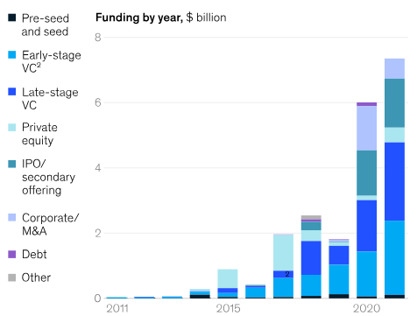
Source: (McKinsey & Company, 2022)
Structure
AstraZeneca PLC is a proactive and learning company with a flatter organizational structure. Staff members have a greater sense of safety and confidence, as well as more access to information, when there are fewer layers of administration between them and more access to top management and leadership (Garter, 2022). AstraZeneca PLC is able to make decisions more quickly because to the flattening of the company's structure, and its workers are more invested in the company as a result.
AstraZeneca PLC has excellent interdepartmental collaboration. When a company's many units need to collaborate on a job or project that calls for a wide range of skills, they often create cross-departmental teams. All interdepartmental communication and cooperation is efficient and well-organized. To facilitate efficient workflow and the timely completion of assigned tasks and the company's overall objectives, AstraZeneca PLC has a formal procedure for starting and tracking cross-departmental collaboration (Garter, 2022).
Each of AstraZeneca PLC's clearly delineated systems is equipped with its own set of controls, including a unique set of tools and procedures for measuring output and progress toward objectives (Garter, 2022). Different divisions' controls and safeguards are tailored to the specifics of their work and duties. Furthermore, each division creates its own set of controls for assessing team members' performance and coordinating their efforts across divisions.
External Environment
There is a close relationship between consumer habits and economic conditions. AstraZeneca PLC has exciting prospects for expansion when consumers have more discretionary income and are ready to spend greater amounts on items and amenities to improve their standard of living. This is because it is easier to introduce novel goods and services to these clients, and the likelihood of revenue growth also remains higher. However, since affluent customers have higher expectations, it is crucial for AstraZeneca PLC to study their consumption/spending habits and preferences in depth through modern digital technologies (Friddie Murphy, 2021). AstraZeneca PLC would benefit greatly from knowing whether or not consumers are motivated primarily by practical or hedonic considerations when making purchases.
AstraZeneca PLC benefits from favorable demographic trends when it focuses on the youth market by increasing its product offerings and advertising campaigns. AstraZeneca PLC also look at the host country's perspective on immigration; a friendly stance towards people from all walks of life is an indication that a variety of management methods should be prioritized (Friddie Murphy, 2021).

Main strengths and weakness of the digital business activities of AstraZeneca
The pharmaceutical giant AstraZeneca has been using digital business strategies to boost creativity, streamline processes, and better serve customers. In this report, we will analyze AstraZeneca's digital business operations, highlighting both the company's successes and prospects for future growth.
Strengths
Research and Development (R&D) Advancements
To improve its research and development (R&D) procedures, the pharmaceutical firm AstraZeneca has adopted digital technology. The use of these digital resources has helped the firm produce new medicines more quickly. Machine learning techniques and big data analysis are two technologies that AstraZeneca has used.
AstraZeneca's move toward digitalization is greatly aided by machine learning techniques. These algorithms are meant to be able to pick up on trends and improve their performance without any human intervention (Weatherall, 2021). AstraZeneca is able to examine and comprehend massive volumes of biological data more quickly with the use of machine learning (Weatherall, 2021). Evidence like this may be found in medical journals, genetic databases, and clinical studies. By using artificial intelligence algorithms, AstraZeneca is able to mine the biological data for previously unseen patterns and insights. These algorithms can spot links and patterns that may otherwise go unnoticed by human researchers. Algorithms can process and analyze this data to find links between genetic markers, illness outcomes, and responses to therapy.
Figure 2: Various fields Used by AstraZeneca in Drug discovery by using Machine Learning
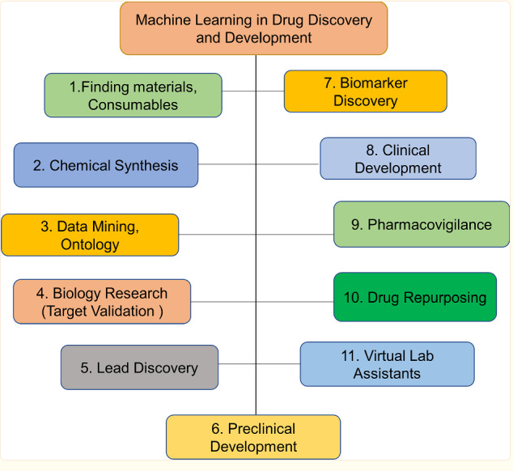
Source: (Weatherall, 2021)
Digital Patient Engagement
Strong digital platforms built by AstraZeneca act as a nerve center for patient interaction. Patients have access to a wealth of health-related resources, tools, and data via these digital platforms, which may be accessed through websites, mobile applications, and other digital channels (AstraZeneca, 2022). The ultimate aim is to provide patients with an intuitive and all-encompassing digital environment where they can easily get the help they need.
AstraZeneca places a strong emphasis on patient education as part of its digital patient engagement programs. Patients now have easy access to extensive learning resources made possible by digital platforms and apps (AstraZeneca, 2022). These materials are designed to help people learn more about their medical issues, available treatments, and how to take better care of themselves. Videos, engaging modules, infographics, and textual materials are just some of the media that may be used to disseminate information about different illnesses and drugs. AstraZeneca gives its customers agency over their health by providing them with credible and user-friendly educational tools.
Disease management assistance is also available on AstraZeneca's online platforms. Patients are offered with digital tools to aid in the management of their health, such as prescription reminder applications, symptom monitors, and managing their lifestyles modules (Ahmed, 2022). Patients may record their progress, keep tabs on their symptoms, and get tailored advice on how to best manage their ailments with the help of these apps. Patients are urged to take charge of their health and wellbeing by actively participating in their treatment and making use of these resources.
Weaknesses
Data Privacy and Security Risks
AstraZeneca must put security and confidentiality of information at the forefront as it increasingly uses digital technology and accumulates massive amounts of patient data. Protecting sensitive information is essential to avoiding legal trouble and losing patients' confidence. Let's go deep into AstraZeneca's data privacy and security concerns, as well as the steps company has put in place to address them (Kansteiner, 2022).
Unauthorized use of patient information is a major concern. This may happen for a variety of reasons, including fraudsters trying to get into AstraZeneca's digital infrastructure and workers getting their hands on confidential information without authorization (Kansteiner, 2022). Personal and medical information about patients is vulnerable to theft, abuse, and disclosure if it falls into the wrong hands.
To guarantee that only appropriate individuals have access to patient information, AstraZeneca uses many layers of security and authentication. Multi-factor authentication, role-based access restrictions, and strict password regulations all fall under this category (Kansteiner, 2022). Unauthorized intrusions may be prevented by the diligent auditing and monitoring of access records. Employee training programs also stress the significance of security and confidentiality of information and educate workers on the best ways to protect confidential data.
Main opportunities and threat faced by AstraZeneca in its digital business activities
AstraZeneca PLC confronts a changing environment full of possibilities and risks as it expands its digital business operations. The purpose of this study is to investigate the most significant development possibilities and risk factors that the organization faces in its digital activities.
Opportunities
Enhanced Digital Analytics
AstraZeneca uses cutting-edge technology like artificial intelligence (AI) and better data analysis to glean actionable knowledge from a wide variety of data sets (Tech Informed, 2021). AstraZeneca is able to better understand the efficacy and safety of its therapies through applying analytics to data from clinical trials, real-world settings, and patient feedback. AstraZeneca use data analytics to discover novel treatment targets by mining massive information derived from genetics, proteomics, and other areas of biology (Tech Informed, 2021). This provides a clearer picture of how illnesses work, which may lead to the identification of new therapeutic avenues. AstraZeneca's ability to create medicines that get at the causes of illnesses will be greatly aided if these targets can be identified.
AstraZeneca is able to streamline its drug discovery procedures because to data analytics. The firm is able to enhance trial design, patient selection, and therapy effectiveness by evaluating massive datasets from preclinical and clinical research. These discoveries have the potential to improve the quality of clinical trials, shorten the time it takes to create new drugs, and raise their success rates.
Telemedicine and remote Patient Monitoring
AstraZeneca can track the efficacy and safety of its drugs after they have been released to the market thanks to telemedicine and remote patient monitoring. The organization can remotely monitor patients' health results, adverse events, and drug adherence to spot any possible safety problems and act swiftly to resolve them (Duran, 2021). This foresight guarantees patient safety and permits prompt action in the face of unexpected problems.
Patients are able to take a more proactive role in their treatment via the use of telemedicine and remote patient monitoring. These technologies provide patients a feeling of control over their healthcare by allowing them to communicate with medical personnel and keep tabs on their health from a distance. When patients understand their conditions and treatment options, they are more likely to take an active role in their care and see positive results.
Patients and healthcare systems may save money thanks to telemedicine and remote patient monitoring. These innovations may help cut healthcare costs and travel time by decreasing the frequency of in-person appointments and hospital stays (Duran, 2021). Additionally, difficulties and healthcare expenses related with avoidable crises or hospital readmissions may be avoided with proactive surveillance and early management.

Threats
Cyber Security
AstraZeneca must address the cybersecurity risks connected with the growing use of digital technology and the collection of personally identifiable information about patients. Vulnerabilities in the healthcare sector's digital infrastructure are a tempting target for cybercriminals (He et al., 2020). Constant cyberattacks pose a serious risk to AstraZeneca's operations and might have devastating results for the corporation.
Sensitive patient information may be accessed, stolen, or exposed if there is a breach in cybersecurity. PII, medical records, and intellectual property all fall under this category. Reputational harm, loss of patient confidence, regulatory fines, and legal ramifications are all possible outcomes of a data breach of this kind. AstraZeneca has to take strong precautions to secure patient data, such encryption, access limits, and data anonymization.
When it comes to developing new medicines, AstraZeneca spends a lot of money on R&D. Drug formulas, research data, and clinical trial findings are just few examples of the confidential information that might be compromised in an online attack on proprietary information. AstraZeneca's edge over rivals and the ability to make new discoveries might be harmed by the leak of this information (Duran, 2021). Protecting intellectual property requires stringent security precautions like as segmentation of networks, detection of intrusions, and staff education and training to recognize and detect phishing attempts.

Figure 3: AstraZeneca’s R&D Spend
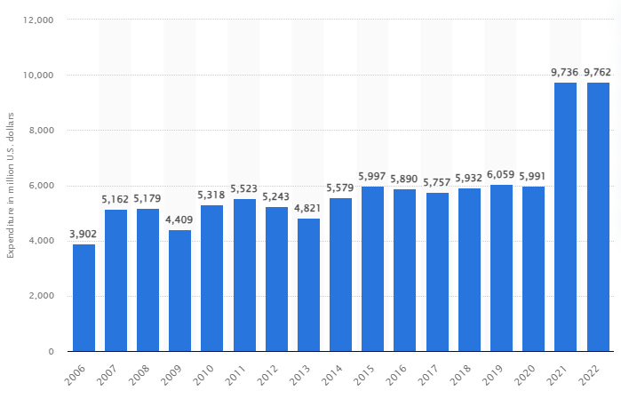
Source: (Mikulic, 2023)
Conclusion
AstraZeneca is a leading pharmaceutical firm with a long and illustrious history and an international footprint. The primary focus of the corporation is the research, development, and marketing of pharmaceuticals for therapeutic use. AstraZeneca spend over $9 billion the last two years on R&D, demonstrating the company's dedication to innovation via its monetary commitment to the field (Mikulic, 2023). The corporation places a premium on teamwork, sharing its resources and knowledge with competitors to improve patient care.
Improving the effectiveness and safety of AstraZeneca's treatments and expediting the drug development processes are both possible with the use of better digital analytics. Opportunities for proactive patient involvement and cost reductions are made possible through telemedicine and remote patient monitoring.
AstraZeneca is well-positioned for development and innovation because to its digital business operations, which, nevertheless, need vigilant data security and privacy safeguards. AstraZeneca can maintain its prominence in the pharmaceutical sector and the betterment of global healthcare by making optimal use of digital technology and meeting the accompanying difficulties.

References
Ahmed, E. (2022). AstraZeneca pours millions into a digital health startup, but it could lag behind pharma peers. Insider Intelligence. https://www.insiderintelligence.com/content/astrazeneca-pours-millions-digital-health-startup-lags-behind-pharma-peers-digital-health
AstraZenca. (2021). Thinking differently: how AstraZeneca finds value in the competitive oncology sector through industry-leading dealmaking. Www.nature.com, 1(1). https://www.nature.com/articles/d43747-022-00153-y
AstraZeneca. (2022). AstraZeneca announces sale of its AMAZE disease management platform to Huma. AstraZeneca Websites. https://www.astrazeneca-us.com/media/press-releases/2022/astrazeneca-announces-sale-of-its-amazetm-disease-management-platform-to-huma-032322.html
Duran, C. (2021). Digital health: Transforming how we develop medicines. Www.astrazeneca.com. https://www.astrazeneca.com/r-d/digital-health-revolutionising-healthcare-for-patients.html
Forbes. (2018). AstraZeneca | Company Overview & News. Forbes. https://www.forbes.com/companies/astrazeneca/?sh=3cce7d526866
Friddie Murphy. (2021). PESTEL Analysis Of AstraZeneca PLC. EssayPandas. https://www.essaypandas.com/essay/AstraZeneca-PLC-3774-Pestel-Analysis
Garter. (2022). AstraZeneca Drives Sustainable Growth Through Innovation. Gartner. https://www.gartner.com/en/information-technology/customer-success-stories/driving-growth-through-innovation
Gate, S. (2021). AstraZeneca PLC - Company Profile, Information, Business Description, History, Background Information on AstraZeneca PLC. Www.referenceforbusiness.com. https://www.referenceforbusiness.com/history2/77/AstraZeneca-PLC.html
Global Data. (2022). ShieldSquare Captcha. Www.globaldata.com. https://www.globaldata.com/store/report/astrazeneca-plc-enterprise-tech-analysis/
He, Y., Aliyu, A., Evans, M., & Luo, C. (2020). Healthcare Cyber Security Challenges and Solutions Under the Climate of COVID19: A Scoping Review (Preprint). Journal of Medical Internet Research, 23(4). ncbi. https://doi.org/10.2196/21747
Kansteiner, F. (2022, November 4). Big Pharma cyber flub: AstraZeneca blames “user error” for patient data exposure. Fierce Pharma. https://www.fiercepharma.com/pharma/astrazeneca-credits-user-error-patient-data-exposure
McKinsey & Company. (2022). AI in biopharma research: A time to focus and scale | McKinsey. Www.mckinsey.com. https://www.mckinsey.com/industries/life-sciences/our-insights/ai-in-biopharma-research-a-time-to-focus-and-scale
McLaughlin, K. (2022, April 13). Coronavirus’ Business impact: Evolving Perspective | McKinsey. Www.mckinsey.com; McKinsey & Company. https://www.mckinsey.com/capabilities/risk-and-resilience/our-insights/covid-19-implications-for-business
Mikulic, M. (2023, March 6). AstraZeneca R&D expenditure 2006-2019. Statista. https://www.statista.com/statistics/266556/expenditure-on-research-and-development-of-astrazeneca-since-2006/
Tech Informed. (2021). AI can save the world, says AstraZeneca’s Analytics chief, so long as you have clean data. – TechInformed. Techinformed.com. https://techinformed.com/ai-can-save-the-world-says-astra-zenecas-analytics-chief-so-long-as-you-have-clean-data/
Weatherall, J. (2021). Data Science & Artificial Intelligence: Unlocking new science insights. Www.astrazeneca.com. https://www.astrazeneca.com/r-d/data-science-and-ai.html

