The behavioural cognition and physiological responses during subjects performing virtual reality cycling exercise

Abstract
High-immersive virtual reality (VR) environments can increase enjoyment and frequency of exercise participation. As VR can also be used to manipulate sensory feedback it is possible that specialist environments can modulate exercise performance and ratings of perceived exertion (RPE) and breathlessness. We aimed to (i) assess whether cycling in a ‘congruent’ VR environment (where perceived/virtual exercise intensity and actual pedaling resistance are matched) enhances exercise performance and reduces RPE and breathlessness, and (ii) to assess whether cycling in an ‘incongruent’ VR environment can further manipulate these perceptions. Following familiarisation, 6 healthy (3 male, 27 ± 5.3 years) participants repeated a series of four cycling exercise trials on a gradient adjustable ergometer under two conditions: within VR (VR condition; comprising of a custom-made VR environment in a head mounted display). Within VR, the hill gradient experienced was either congruent or incongruent with the pedalling resistance. Participants could choose their power output/RPM throughout. During congruent trials participants chose to perform at a higher power output in the VR condition (+11W±14, p<0.05) with no difference in RPE or breathlessness. There was also a significant interaction in VR condition and congruence vs incongruence for RPE and breathlessness. Specifically, when the experienced hill gradient was steeper than pedalling resistance RPE and breathlessness was greater, and when experienced hill gradient was less steep than pedalling resistance RPE and breathlessness was lower. In conclusion, we have shown that congruent VR cycling environments can modulate exercise performance. Furthermore, the novel application of incongruent VR cycling exercise manipulated exercise perceptions in either direction. This technique has potential applications in exercise training or rehabilitation modalities.

Table of Contents
Chapter 1: Introduction 5
1.1 Background Information 5
1.2 Problem Statement 7
1.3 Objectives 9
1.3.1 General Objective 9
1.3.2 Specific Objectives 9
1.4 Research questions 9
1.5 Significance 10
1.5.1 Enhancing Exercise Adherence 10
1.5.2 Optimizing Rehabilitation Protocols 10
1.5.3 Informing Clinical Interventions 10
1.6 Scope of the study 10
1.7 Limitations 11
Chapter 2: Literature Review 12
2.1 Virtual Reality and Exercise 12
2.1.1 Definition of Virtual Reality and its Components in Exercise Settings 12
2.1.3 Previous Research on the Effects of VR on Exercise Performance and Adherence 13
2.2 Behaviour Cognition During Virtual Reality Cycling 14
2.2.1 Overview of Cognitive Processes Involved in Exercise 14
2.2.2 Influence of VR on Cognitive Engagement during Cycling Exercise 14
2.2.3 Studies Examining How Cognitive Processes are Affected by VR in the Context of Cycling 15
2.3 Physiological Response During Virtual Reality Cycling 15
2.3.1 Explanation of Physiological Responses during Exercise 15
2.3.2 Effects of VR on Physiological Responses during Cycling Exercise 16
2.3.3 Research Findings on the Impact of VR on Physiological Parameters 17
2.4 Integration of Behavioural Cognition and Physiological Response 17
2.4.1 Discussion on the Interplay between Cognitive Processes and Physiological Responses during VR Cycling 17
2.4.2 Studies Investigating the Correlation between Cognitive Engagement and Physiological Outcomes 18
2.4.3 Implications of the Relationship between Cognition and Physiology for Exercise Performance and Enjoyment 18
2.5 Individual Difference and Consideration 19
2.5.1 Exploration of Individual Factors Affecting Behavioral and Physiological Responses to VR Cycling 19
2.5.2 Discussion on the Need for Personalized Approaches in VR Exercise Interventions 20
Chapter 3: Methodology 21
3.1 Hypothesis 21
3.1.1 Hypothesis one 21
3.1.2 Hypothesis 2 21
3.1.3 Hypothesis 3 21
3.2 Data Collection Methods and Ethical Approval 22
3.3 Materials used 22
3.4 Steps Followed 24
3.4.1 Visit 1 – Familiarisation and Peak V̇O2 assessment 24
3.5 Physiological and psychological measures 25
3.6 Data analysis 26
Chapter 4: Results 28
4.1 Participant Characteristics 28
4.2 Congruent Trials 28
Chapter 5 39
5. Discussions 39
Appendixes 51

Chapter 1: Introduction

1.1 Background Information
The positive benefits of engaging in physical activity (PA) on a person's wellbeing have been extensively studied over the last several decades (Chou et al., 2012). World Health Organization (WHO) reports that over 25% of adults as well as 80% of teenagers globally are not physically active. This is in spite of the well acknowledged advantages of PA involvement (World Health Organization, 2022). Adults and students alike may shy away from PA-related activities at the end of a long day because they associate exercise (i.e., planned, controlled, and repeated PA) with boredom and difficulty. People would rather be entertained while sitting still (i.e., engaging in sedentary behavior) with pastimes like playing video games. Therefore, pique their interest and enhance their PA behavior via the integration of video games and physical activity (e.g., virtual reality (VR)-integrated workouts).
In recent years, virtual reality (VR) exercise has emerged as a novel strategy for encouraging physical activity (PA) and healthy lifestyle choices (Ahn & Fox, 2017). Virtual reality (VR) exercise has been shown to improve the psychological effects of exercise and boost long-term exercise adherence (Qian et al., 2020). Virtual reality (VR) is a kind of interactive media in which viewers are immersed in a computer-generated world and encouraged to engage with it by manipulating virtual objects using a variety of senses (including sight, sound, touch, and smell) (Bae, 2023). Virtual reality may be either fully immersive or somewhat immersive, or it can be interactive. When compared to non-immersive VR, which uses an interface like a flat screen TV/computer screen and necessitate the use of a connecting keyboard, controller, and/or joystick, it is clear that immersive VR is the superior technology for simulating a fully virtual reality for users. The primary focus of interactive virtual reality (VR) is on the capacity of users to engage with virtual things using gear (such as gloves or digital glasses) that simulate the experience of handling actual goods, such as lifting up an apple (Vieira et al., 2014).
Interest from kinesiology and public health researchers has been drawn to the growth of VR technology and its application during PA via incorporation with conventional exercise apparatus and rehabilitation procedures. Virtual reality (VR) has the potential to make physical therapy more exciting for patients by increasing the difficulty of routine exercises and providing more immediate feedback via the use of immersive environments (Vieira et al., 2014). The benefits of virtual reality exercise for health and wellness, mental health, and rehabilitation have been studied in previous studies. Stroke patients, for instance, may see improvements in lower limb function after engaging in virtual reality (Vieira et al., 2014). Patients recovering from a stroke, adults with Parkinson's disorder (PD), and children with cerebral palsy (CP) have all benefited greatly from virtual reality (VR) exercise (Juras et al., 2019). There is also substantial evidence that virtual reality (VR) may be useful in psychotherapy (Valmaggia et al., 2016). Virtual reality (VR) exercise, for instance, has been shown to alleviate emotional distress (Valmaggia et al., 2016). Virtual reality (VR) technology has been extensively employed in the field of disease rehabilitation because to its proven efficacy in assisting patients in regaining motor abilities they may have lost due to accident or sickness. This is why it's common practice to discuss the positive effects of virtual reality exercise in terms of both physiological and therapeutic results.
One study has already shown that VR exercise may help stroke patients improve their balance (Li et al., 2015). Another evaluation found that VR helped improve motor control, functionality, cognitive ability, and balance in those with Parkinson's disease (Juras et al., 2019). Studies included in the aforementioned literature review focused on very particular demographics and conditions, such as stroke and Parkinson's disease. However, the elderly, who may gain enhanced balance and other physical skills via VR exercise, are among the vulnerable demographics who stand to gain the most. However, there is a lack of systematic studies focusing on the use of virtual reality exercise as an intervention for this group.

1.2 Problem Statement
Patients who have ongoing cardiovascular complications, such as heart failure, or chronic obstructive pulmonary disease (COPD), often suffer from serious exercise aversion and a poor standard of life as a result of exaggerated impressions of breathlessness and intense physical activity throughout exercises (Johnson et al., 2017). Exercise avoidance, which leads to physical degeneration and, in turn, exercise intolerance and inactivity, may cause a 'disease cycle' (Polkey & Moxham, 2011). Exercise may be quite stressful for these people, which may explain why physical therapy is commonly advised but seldom followed through on (Keating et al., 2011).
Current thought is that the brain's processing of sensory data and past expectations contributes to the amplification of effort and breathlessness throughout exercises, in addition to the underlying pathology (Bruce et al., 2019). If this concept is correct, it might pave the way for innovative treatments like the use of virtual reality, or VR, which can alter sensory input to aid in recovery.
Due to the ability to increase exercise participation and adherence, the incorporation of VR technology within PA has received considerable interest (Qian et al., 2020). Because people with heart failure and COPD often feel more out of breath and uncomfortable during exercise, this breakthrough technology has the potential to combat exercise resistance and sedentary behavior among those with chronic cardiovascular conditions (Taylor et al., 2021). Although PA has been shown to improve health and quality of life in several ways, a large percentage of people worldwide still don't get enough of it (World Health Organization, 2020). The notion of integrating virtual reality (VR) with fitness regimens has developed to combat this tendency and encourage people to participate in PA (Qian et al., 2020).
The psychological advantages of exercise and long-term exercise adherence may both be fostered by using virtual reality (Seo et al., 2023). Virtual reality (VR) provides comprehensive and interactive environments that may make workout more engaging; yet, its potential to attenuate exercise aversion and enhance physiological reactions in certain groups, especially those with cardiovascular diseases, is an understudied topic (Hamid Bouraghi et al., 2023). The advantages of VR exercise across varied statistics, such as seniors and those with chronic cardiovascular diseases, have not been well explored due to the current emphasis on specific groups like stroke victims and persons with Parkinson's disease (Marileen Kouijzer et al., 2023).
The primary issue is the lack of research on the effects of virtual reality (VR) incorporated cycling exercise on people with persistent cardiovascular problems, especially with regards to their behavioral cognitive and physiological reactions during these types of activities (Zeng et al., 2021). Exercise prevention, physical decline, and inactivity are common problems for people with chronic heart disease conditions; however, by recognizing how VR modifies sensory input and impacts perceptions of effort and feeling short of breath, new methods could be established to modify physical activity encounters and potentially break this cycle.
This study aims to fill this knowledge gap by conducting a comprehensive analysis of previous research on the topic of virtual reality (VR) and its potential to transform exercise circumstances, enhance psychological reactions, and encourage long-term exercise adherence in people with chronic cardiovascular conditions. This study aims to shed light on the potential of virtual reality (VR) to help people with chronic cardiovascular diseases overcome exercise resistance and improve their quality of life by analyzing the emotional cognition and physiological reactions of participants who participated in VR cycling exercise.

1.3 Objectives

1.3.1 General Objective
Improve exercise participation and adherence in people with cardiovascular disease by conducting a thorough investigation of the impact of virtual reality (VR)-integrated cycling activity on their physiological reactions, mental involvement, and subjective experiences.

1.3.2 Specific Objectives
- To investigate the influence of virtual reality (VR) cycling exercise on cognitive processes, including attention, perception, and decision-making, among participants.
- To examine the physiological responses, including heart rate, oxygen consumption, and perceived exertion, of subjects engaged in virtual reality cycling exercise.
- To explore the interplay between cognitive engagement and physiological responses during virtual reality cycling exercise and how these factors mutually influence each other.

1.4 Research questions
- How does a virtual reality (VR) cycling exercise compare to regular riding in terms of effects on attention, perceived effort, and decision making?
- How do participants who participate in virtual reality cycling exercise differ from those who engage in traditional cycling in terms of their heart rate, oxygen consumption, and perceived exertion?
- To what extent does the mental effort put into a virtual reality cycling workout affect physiological reactions, and how do these two aspects interact to shape the exercise experience as a whole?

1.5 Significance
The findings of this research have important effects on exercise science and for the treatment of people with chronic coronary artery disease. People with chronic cardiovascular diseases may find that exercising with the use of virtual reality (VR) technology is a game-changer for their motivation to get moving. The study's results will provide light on the following aspects of the effects of virtual reality (VR)-integrated bicycle exercise on this population:

1.5.1 Enhancing Exercise Adherence
The results of this research may support the use of VR-enhanced cycling exercise to increase exercise adherence in those with chronic coronary artery disease. This may have far-reaching consequences for encouraging regular exercise and bettering health indicators related to the cardiovascular system.

1.5.2 Optimizing Rehabilitation Protocols
Comparison of physiological reactions to traditional exercise and cycling with VR integration may help in the design of individualized rehabilitation programs. Individuals who have persistent coronary artery disease may benefit from more individualized regimens that take into account their specific symptoms and conditions.

1.5.3 Informing Clinical Interventions
In order to better develop therapeutic therapies that address exercise dislike, it is important to understand how felt effort and breathlessness change between VR-integrated riding and regular cycling. This information might help medical practitioners design more tolerable and motivating exercise plans for their patients.

1.6 Scope of the study
The purpose of this research is to examine how cycling exercise combined with VR affects those who have been identified with chronic coronary artery disease (CAD). The research aims to give a holistic knowledge of the effect of VR technology on exercise participation and reactions within this particular demographic, therefore it will include both physiological and psychological factors.

1.7 Limitations
Exercise perception mechanisms have been the subject of much discussion and research (Halperin & Emanuel, 2019). All models involve present sensory data as input to regulate exercise performance (Thiel et al., 2018). Virtual worlds and 'incongruent' virtual reality are two examples of how this sensory data might be modified. In this sense, "incongruent" describes a setting in which the perceived difficulty of riding and the actual resistance to pedalling are at odds with one another. The pedalling resistance will be less than, or more than, what is predicted by the steepness (gradient) of the virtual reality cycling course. The notion is supported by a small body of research. Breathing reactions during exercise appear to be influenced by learning or prior experiences of exercise, and changes in visual information have been shown to impact feelings of breathlessness in cycling exercise to name a few examples (Finnegan et al., 2023).

Chapter 2: Literature Review

2.1 Virtual Reality and Exercise
As a game-changing technology, virtual reality (VR) has novel possibilities for boosting many facets of the human experience, including physical activity. Virtual reality (VR) in the context of physical activity is a term for an online setting that is both interactive as well as immersive, simulating real-world settings and involving users through visual, audio, and occasionally tactile sensations (Qian et al., 2020). New opportunities to improve workout experiences and health outcomes have emerged thanks to the introduction of virtual reality (VR) technology into exercise environments.

2.1.1 Definition of Virtual Reality and its Components in Exercise Settings
The term "virtual reality" refers to a kind of interactive simulation that blends visual and auditory elements created by a computer with tactile input to create a fully immersive experience. The use of an HMD (head-mounted display) or similar immersive technologies to transfer people into virtual surroundings is a common component of VR in fitness settings (Saldana et al., 2020). People are able to participate in activities that would be difficult to find in the real world because to the great variety of virtual surroundings available, from peaceful nature settings to competitive sports venues.
Key components of VR in exercise settings include:

2.1.1.1 Head-Mounted Display (HMD)
In order to fully immerse the user in the virtual world, this gadget is placed on the head and produces both visual and aural inputs (Zeng et al., 2017). By following the user's head, it gives them the impression that they are really there in the virtual environment.

2.1.1.2 Hand Controllers
These portable gadgets allow users to communicate with virtual items and features, heightening their feeling of immersion and involvement (Zeng et al., 2017).

2.1.1.3 Haptic Feedback:
Tactile feedback devices, which vibrate or apply pressure, are used in certain VR systems to more realistically recreate the feeling of communicating with a virtual world (Zeng et al., 2017).

2.1.2 Benefits of Using VR in Exercise
There are several ways in which using virtual reality (VR) technology while exercise may boost motivation, interest, and enjoyment.

2.1.2.1 Enhanced Motivation
Regular workout programmers might lose their appeal and effectiveness if they become too regular and boring. Virtual reality (VR) is innovative because it takes users to exciting and new places. Having something new to look forward to throughout an exercise might help people stay motivated (Hamad & Jia, 2022).

2.1.2.2 Increased Engagement
Virtual reality's high degree of involvement makes for a more interesting and immersive workout. Users may experience a feeling of fun thanks to the ability to explore virtual environments, compete in competitions, and interact with virtual things.

2.1.2.3 Immersive Distraction
By keeping the user's mind off the effort required to complete an exercise routine, virtual reality (VR) technology may make working out more tolerable. With their attention diverted in this way, people may be able to work out for extended periods of time without tiring.

2.1.3 Previous Research on the Effects of VR on Exercise Performance and Adherence
The effects of virtual reality (VR) on performance during exercise and commitment have been the subject of a large number of research in recent years. Positive findings have been found in favour of employing virtual reality (VR) technology to improve workout experiences.
There is evidence to suggest that those who exercise using VR have a more positive experience and are more likely to stick with the programme than those that exercise using more conventional methods. Participants who rode in a simulated setting reported higher levels of satisfaction and perceived effort compared to people who cycled without VR, according to a research by Rojo et al., (2023). Mouatt et al., (2020) found that those who used virtual reality cycling were more committed to their exercise routines and were more immersed in their sessions.
Virtual reality (VR) has also been proved to improve physical performance. Sauchelli & Brunstrom, (2022) found that those who used VR while cycling were more likely to enhance their cardiovascular health and physical tolerance than those who did not use VR.

2.2 Behaviour Cognition During Virtual Reality Cycling

2.2.1 Overview of Cognitive Processes Involved in Exercise
Exercise is not solely a physical endeavour; it is intricately linked with cognitive processes that influence how individuals perceive, engage with, and adapt to their surroundings. Key cognitive processes involved in exercise include attention, perception, and decision-making. Attention allocation determines where individuals focus their mental resources, perception shapes their interpretation of sensory information, and decision-making guides their choices during physical activity.

2.2.2 Influence of VR on Cognitive Engagement during Cycling Exercise
The mental procedures that affect how people take in, respond to, and adjust to their environments are inextricably intertwined with the physical activity of exercise. Focus, awareness, and choice are essential cognitive processes in physical activity. During physical exercise, one's attention allocation, one's perception, and one's decision-making are all influenced by one's ability to allocate mental assets (Tripathi et al., 2022).

2.2.3 Studies Examining How Cognitive Processes are Affected by VR in the Context of Cycling

2.2.3.1 Attention Allocation and Distraction
The effect of virtual reality (VR) on focus during bicycle training has been studied. Liu & Gao, (2021) looked at how virtual reality affected focus when riding in place. When compared to a non-VR control group, they discovered that VR cyclists paid more attention to the in-game world. Virtual reality's ability to immerse users in a world of moving images and sound while exercise might help people forget about the aches and pains they're experiencing.

2.2.3.2 Perception of Effort and Time Perception
Exercise adherence may be affected by one's subjective assessment of the time and effort required for a certain workout. The effects of virtual reality (VR) on cyclists' perceptions of effort and time were studied by Høeg et al., (2023). Compared to conventional riding, participants reported less felt exertion and a different perception of time passing when engaged in virtual reality cycling. This indicates that the subjective experience of exercise may be improved due to the mental distortions induced by virtual reality.

2.2.3.3 Decision-Making and Strategy Adaptation
Virtual reality presents a fluid environment, necessitating a shift in decision-making approaches. Høeg et al., (2023) investigated the impact of virtual reality on cyclists' judgement. Players competed against one another in a virtual reality cycling game that required them to use strategic thinking to come out on top. The results of the research showed that people engaging in VR-based exercise needed to be cognitively flexible in order to adapt their decision-making techniques to the unique set of circumstances presented by the virtual world.

2.3 Physiological Response During Virtual Reality Cycling

2.3.1 Explanation of Physiological Responses during Exercise
The complex processes that occur inside the body in order to maintain and satisfy the increasing demands of exercising are known as the "physiological responses" to exercise. Vital signs, oxygen intake, and rate of perceived effort are all important measures of physical fitness. Collectively, these measures reveal how the body responds to increasing stress from exercise (Ruegsegger & Booth, 2018).
One of the most basic measures of cardiovascular stress when exercising is heart rate. The heart rate increases to provide the working muscles with enough oxygen and nutrients as the intensity of the exercise rises.

2.3.1.1 Oxygen Consumption
Maximum oxygen consumption (VO2 max) is a measure of the body's efficiency in converting oxygen into usable energy. Understanding one's physical fitness and endurance capability may be gained through this test.

2.3.1.2 Perceived Exertion
A person's sense of exertion is an arbitrary measure of the effort they are putting forth during a physical activity. It is a factor that determines tolerance for exercise and is affected by both physiological and psychological variables.

2.3.2 Effects of VR on Physiological Responses during Cycling Exercise
Virtual reality (VR) adds a dynamic element to cycling training, which might affect physiological reactions. Physiological responses to exercise may be altered by the virtual reality medium.
Virtual reality (VR) has the ability to cause alterations in people's physiological reactions by shifting the way their attention is directed. When using a virtual reality bike, users may focus less on their physical exertion and more on the immersive experience. It's possible that switching your focus can affect your heart rate, oxygen intake, and how hard you feel like you're working.

2.3.3 Research Findings on the Impact of VR on Physiological Parameters

2.3.3.1 Heart Rate Variability and Autonomic Nervous System Modulation
Variations in the times between heartbeats are reflected in heart rate variability (HRV). It's a measure of how well the circulatory system is being controlled by your autonomic nervous system. Alfonso & Capdevila, (2022) looked at how VR affected cyclists' heart rate variability. They discovered that those who cycled in virtual reality had different HRV patterns, which may indicate a shift in the nervous system's autonomic function. This demonstrates that bodily reactions to exercise may be modified by the cognitive engagement provided by VR.

2.3.3.2 Oxygen Consumption and Energy Expenditure
The effect of virtual reality on breathing and metabolism has received a lot of attention. The effects of virtual reality on cyclists' oxygen consumption were studied by Ahmed et al., (2020). According to their findings, virtual reality cycling increased participants' oxygen consumption compared to conventional riding. This indicates that the mental challenge posed by VR may boost energy expenditure during physical activity.

2.3.3.3 Perceived Exertion and Fatigue Levels
The degree of effort that a person feels depends on their own unique combination of physiological and psychological variables. Finnegan et al. (2023) investigated how virtual reality (VR) affects how hard you work when riding. They discovered that people felt less tired when riding in virtual reality than while cycling in the real world. Virtual reality (VR) is so engrossing because it takes your mind off of your body, so you don't notice how hard you're working or how tired you are.

2.4 Integration of Behavioural Cognition and Physiological Response

2.4.1 Discussion on the Interplay between Cognitive Processes and Physiological Responses during VR Cycling
There is a complicated and entangled interaction between the mental and physical processes at play during VR riding. Attention, perception, and making choices are all examples of cognitive activities that have the potential to greatly impact physiological responses including respiration, heart rate, and perceived effort (Finnegan et al. 2023). A person's cognitive involvement with the virtual world as they cycle in VR may alter their sense of effort and, in turn, the physiological response of their body to the physical challenge.

2.4.2 Studies Investigating the Correlation between Cognitive Engagement and Physiological Outcomes
Recent research has investigated the link between mental effort and tangible health benefits from virtual reality riding. Li et al., (2021) investigated how participants' focus changed as they cycled through virtual reality. According to the results, individuals who paid more attention to the virtual world had different patterns of heart rate variability than those who paid less attention. This further substantiates the link between active thought and the regulation of the autonomic nervous system.
Li et al., (2021) also looked at the impact of thought processes on oxygen use when riding in VR. Oxygen intake rates were found to be greater among research participants who reported feeling more present and immersed in the virtual world. This association between mental absorption and elevated physiological demands provides new insight into the complex relationship between thought and physical exertion.

2.4.3 Implications of the Relationship between Cognition and Physiology for Exercise Performance and Enjoyment
Important effects on training efficiency and pleasure in the context of virtual reality cycling arise from the link between mental processes and responses from the body. Exercise treatments have the ability to improve both physiological results and participant experiences via the deliberate manipulation of cognitive involvement.
Cognitive participation has been shown to increase exercise consistency. Rojo et al., (2023) found that those whose brains were actively engaged during virtual reality cycling were more likely to keep up with their training routines. The monotony of regular workout regimens may be lessened thanks to virtual reality (VR) surroundings, which are both immersive and fascinating.
Additionally, cognition-physiological response connections may direct the development of individualised exercise therapies. Exercise drive and achievement might be improved by customising virtual reality experiences to each person's unique cognitive profile. People who thrive in competitive environments, for example, can reap the benefits of cognitively engaging virtual reality (VR) cycling programmes that provide them with competitive challenges.

2.5 Individual Difference and Consideration

2.5.1 Exploration of Individual Factors Affecting Behavioral and Physiological Responses to VR Cycling
Although virtual reality (VR) cycling may provide interesting and unique situations, not everyone has the same reaction to it. A person's physiological and behavioural reactions to virtual reality cycling may be influenced by a number of variables.

2.5.1.1 Age, Fitness Level, and Prior VR Experience
Two major factors that influence how people interact with virtual reality cycling are age and fitness level. The cognitive and physiological reactions of older individuals to virtual reality cycling were shown to differ from those of young people in a research by Yang et al., (2019). Additionally, those with greater fitness levels may often endure more strenuous exercise and may undergo unique physiological changes as a result. A person's level of cognitive involvement and physiological reactions are both impacted by their level of pre-existing VR experience.

2.5.1.2 Personality Traits and Cognitive Styles
How people approach and enjoy virtual reality cycling depends on their personalities and their ways of thinking. People who are more extroverted may appreciate competitive VR cycling settings, while those who are more introverted may favour quieter, more reflective ones (Houston, 2019). Decision-making processes used during VR cycling may be influenced by cognitive approaches, such as analytical vs intuitive thinking, which in turn may alter the way the body reacts.

2.5.2 Discussion on the Need for Personalized Approaches in VR Exercise Interventions
There is a pressing need for individualised strategies in VR exercise therapies due to the wide variety of variables impacting responses in VR cycling.
Customization increases motivation to work out regularly. Dwivedi, (2022) highlighted the importance of tailoring virtual reality cycling experiences to an individual's interests and fitness levels in order to increase adherence compared to standard treatments. Individual differences in age, fitness level, and familiarity with VR may inform the design of training programmes that are more likely to keep people coming back for more.
Furthermore, personalised methods provide the best physiological results. Stewart et al. (2022) found that compared to participants in traditional therapies, those who participated in VR exercise programmes tailored to their personality attributes improved their cardiovascular fitness more. This indicates that the physiological adaptations caused by exercise may be amplified by matching participant psychological characteristics with individualised VR experiences.
Interventions tailored to the individual enhance pleasure as well. Cummings et al. (2022) found that people had a better time in virtual reality (VR) cycling settings that matched their personality and cognitive preferences. This highlights the importance of intrinsic motivation, or personal resonance, in determining long-term success in an exercise programme.

Chapter 3: Methodology

3.1 Hypothesis
From the Research questions the following hypothesis can be formed.

3.1.1 Hypothesis one
Null Hypothesis (H0): Virtual reality (VR) cycling training had no discernible effect on cognitive abilities including attention, sense of exertion, and decision making when compared to conventional bike training.
Alternative Hypothesis (Ha): When compared to conventional riding, engaging in a VR cycling workout has a profound effect on the attentional concentration, perceived effort, and decision-making abilities of its participants.

3.1.2 Hypothesis 2
Null Hypothesis (H0): Heart rate, utilization of oxygen, and ratings of perceived effort did not vary significantly between those who participated in a virtual cycling training and those who engaged in traditional cycling.
Alternative Hypothesis (Ha): Changes in heart rate, utilization of oxygen, and perceived effort are only some of the particular physiological responses that are significantly different between those who participate in a virtual cycling training and those who engage in traditional cycling.

3.1.3 Hypothesis 3
Null Hypothesis (H0): Cognitive load during VR cycling exercise has no appreciable effect on physiological responses, and neither does it combine with other physiological elements to alter the workout experience.
Alternative Hypothesis (Ha): Participants' cognitive load has a large effect on their physiological reactions during VR cycling physical activity, and there is a connection between mental and physiological elements that affects the workout experience as a whole.

3.2 Data Collection Methods and Ethical Approval
In this study, we have recruited six healthy adult participants (3 females). The study was granted approval by the Ethics Committee of King’s college London (Ref: LRS/DP-21/22-26409). Study inclusion criteria were adults aged 18-65 years without any history metabolic, respiratory, or cardiovascular disease (e.g., hypertension, asthma and diabetes). Exclusion criteria were significant deviation from study protocols or condition/injury that would impair exercise capacity. Notably, such confirmation of these exclusion criteria was double checked during participating the experiment of each subject. Here, the written informed consent was obtained from all participants before enrolment and all procedures were conducted in accordance with the Declaration of Helsinki. Participants were informed that they would perform some cycling exercise in a virtual reality environment and encounter a series of scenario such as flat sections and hill climbs.
Participants visited the laboratory only once and, after familiarizing themselves with the equipment and apparatus, were randomly tested on 3 different Trails (T1 Mild, T2 Moderate T3 Hard). participants were familiarised to all procedures and underwent a maximal incremental cycling exercise task to assess peak oxygen consumption (V̇O₂peak). During visit 2 and 3, Participants performed 4 sessions of extreme cycling in a VR environment. Participants were asked to refrain from eating and consuming caffeine for 4 h after each trial, and to refrain from strenuous exercise or alcohol consumption for 12 h. All participants performed all trials in the VR condition in randomized order.

3.3 Materials used
Each subject performed the VR task wore the VR headset (Vive Pro, HTC, Taiwan) and used the custom-made simulated VR program (Figure 1, right) written in Unity-3D (Finnegan et al., 2023). During the process of using an automated cycle ergometer (Wahoo-Kickr Climb Integrated Cycling system, Wahoo, Atlanta, US) for cycling (Figure 1, left), ventilatory and metabolic variables measured using an automated metabolic cart system (Metalyzer 3B, Cortex, Leipzig, Germany) which was calibrated prior to each study per manufacturer instructions. The ramp (Watts/min) of the incremental exercise task was determined from standard prediction equations so that predicted maximum power output (Wmax) was achieved within 8-12 minutes (Costa et al., 2015). The incline (up/down tilt) of the Wahoo cycle ergometer was automatically adjusted by the VR software to match the gradient of the hill/flat. The use of Wahoo cycle ergometers has been validated previously (Finnegan et al., 2023). In addition, a fan (Wahoo-Kickr headwind, Wahoo, Atlanta, US) which automatically adjusted its air flow to match estimated cycling speed was used.
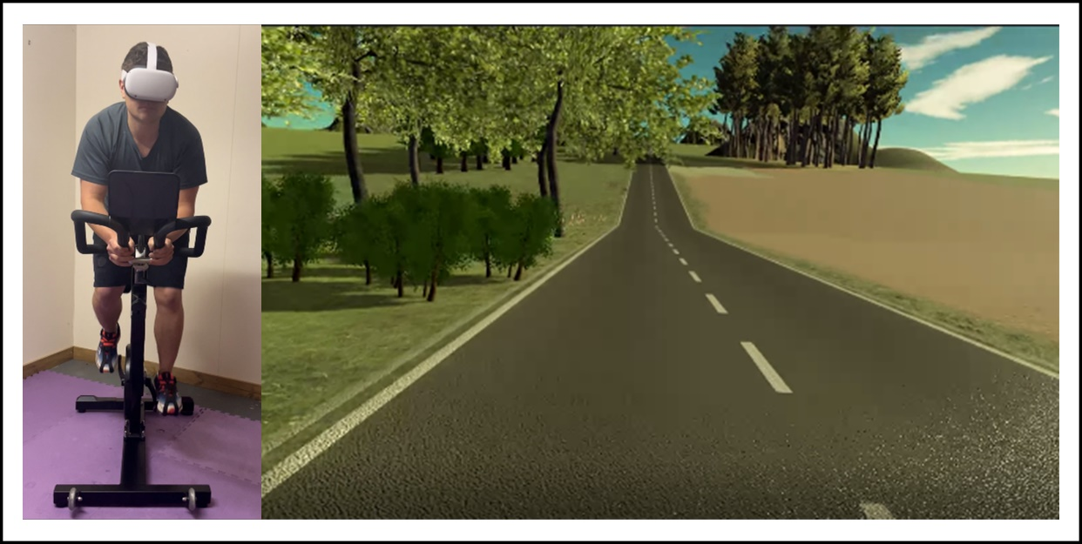
Figure 1. First person view of the VR cycling environment when approaching the hill from the first flat section.

3.4 Steps Followed

3.4.1 Visit 1 – Familiarisation and Peak V̇O2 assessment
Once the subject decided to take part to the study, would be invited to the physiology laboratory on one occasion, and presented the equipment needed in the experiment, would be adjusted for each subject to fitness and let subjects to be familiarized to all procedures and equipment, including the bike and VR headset (Figure 1). Then the practice run with 100 meters flat (visual grade i.e., incline as the baseline of 0% in the VR environment, as seen in Figure 1) and 500 meters hill (incline as 7%) would be filled subjects in at first. This practice procedure aimed to not only adjust the appropriate (manageable and comfortable) gear settings to each subject who had been maintaining the revolutions per minute (RPM) of 60 both in the section of flat and hill, also double checked the motion sickness.
One more familiarisation run would be given then, with 100 meters flats and 150 meters hills with three gradients each i.e., mild (1% gradient), moderate (4% gradient) and hard (7% gradient). Subject would be asked maintaining RPM at 60 to cycle through a course with such different gradient repeated twice and intermediated flat (Figure 2). The gearing on the bike would be automatically changed while simulating inclines and declines by changing pedalling resistance and by tilting up or down. Familiarisation was to create a leaning effect i.e., sat expectation for the next and familiarised them with the RPE scale. And more importantly, RPE would be collected and breathless data while on the first flat and then each of the hills. As the official experiment, subjects would then be asked to pedal through 3 different VR environments (as Trial 1, 2 and 3) with a short break (15 minute) in between (Figure 3). Each trial contained a single flat and hill (either mild, moderate or hard) with 750 meters and a random order. Notably, the moderate hill is congruent that the incline (VR gradient/bike gradient) matches pedalling resistance and on the contrary to the hard and mild conditions, which were incongruent i.e., pedalling resistance would not change with the variation of incline and remains consistent with the moderate hill. The same instruction still was maintaining the RPM throughout.
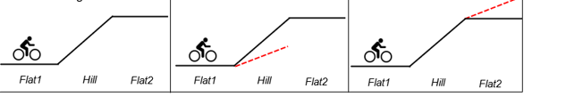Figure 1 : Schematic diagram of familiarization run
The black lines represent the visual gradient and, when not accompanied by a broken red line, the pedalling resistance is matched to the visual gradient during that stage for the trial (Flat1, Hill and/or Flat2). Therefore, Trial 1 and 2 are entirely ‘congruent’. The broken red line represents a stage of the trial where the pedalling resistance does not match the visual grade. In trial 3, the pedalling resistance during the Hill was adjusted to be lower than the visual grade,

3.5 Physiological and psychological measures
During the three trials, heart rate (HR), respiratory rate (RR) were recorded continuously with an ECG and respiratory belt respectively (Equivital EQ02, Cambridge, UK) using LabChart version 8 (AD instruments, Oxford UK). Immediately before each trial, heart rate and respiratory rate was collected for 1 minute while participants rested on the bike. Measurements of distance, watts, and cadence (RPM) were recorded each second using the Wahoo fitness app. Overall ratings of perceived exertion (RPE), as well as sensations of breathlessness, were measured using a CR10 Borg scale (Borg, 1982) during the final 30 seconds of each stage of each trial. Participants were familiar with the measure before testing and then verbalised their ratings when prompted. The scale could not be used visually given the VR headset.
The 8-item Physical Activity Enjoyment Scale (PACES) (Kendzierski & DeCarlo, 1991; Mullen et al., 2011) was also completed. Following the trial 1 in the VR condition, the presence questionnaire (Witmer et al., 2005; Witmer & Singer, 1998) was completed by all participants to evaluate their presence in the virtual environment.

3.6 Data analysis
Mean HR and RR were recorded during the final 30 seconds of each stage of the trials. HR and RR is presented as change (Δ) from baseline (recorded during the rest period immediately before the start of each trial). A repeated measures two-way ANOVA, and where appropriate multiple comparison post hoc analysis with Bonferroni correction, was used to examine differences in ΔHR, ΔRR, power output, RPM, RPE and breathlessness between trial stages and between condition. Before ANOVA, if Mauchly's test of sphericity was violated, degrees of freedom were adjusted in accordance to the Greenhouse-Geisser test. A student’s paired t-test was used to examine differences between the data recorded by PACES, Sim-TLX and CALM in the VR condition (within the same trial).
Both ‘congruent’ trials (1 and 2) are identical, but when presenting ‘congruent’ data we have analysed data from trial 2 alone. This is to remove any variability encountered in the first trial the participant performed. When performing the analysis, it was noticed that incorrect resistances were applied during some stages of the incongruent trials of 4 participants due to an error in the software. These participants have been removed from the incongruent analysis. Data are expressed as mean ± SD (unless otherwise stated) and statistical significance was taken as (P<0.05). Statistical analysis was conducted using a standard statistical package (SPSS, Chicago, IL, USA) and figures produced through GraphPad (Prism). A sample size calculation was performed using G*Power (3.1.9.7) based upon pilot data collected. Average power output was +10W (±14W) greater in the VR condition.

Chapter 4: Results

4.1 Participant Characteristics
In total, 6 participants (3 females) were recruited for this pilot study. The basic demographic characteristics was shown in Table 1 including ratio of gender, mean and standard deviation of age, height and weight. Notably, all participants were capable to cycle and kept the cycling habit with a few hours per week.
 | N
Gender (Female) | 6 (3)
 | Mean (±Std)
Age (years) | 27 (±5.3)
Height (cm) | 167.8 (±9.516)
Weight (kg) | 64.6 (±12.474)
Averaged hours cycling per week | 1.2 (±1.304)
Table 1. Participant characteristics (mean ± standard deviation)

4.2 Trials
As the figure 4 shown, the mean power is presented output, RPM, HR and RR during each stage of three trials during the VR task. Through visual inspection, each participant was directly observed to unsure they quite followed the instruction of the task. Because the power output of the condition with Hill 1 and 2 were plateaued and gradually higher than the Flat and Rest. Similar as the RPM, since the participants were instructed to maintain RPM at 60, then the conditions of Flat, Hill 1 and 2 were basically all same. Interestingly, no matter HR or RR both showed a gradual upward trend.
Additionally, the power output, RPM, and HR trends under the incongruent condition were actually very similar to those under the congruent condition. The only difference is that the RPM may show slightly more divergence. The most important finding in this study, in fact, was the discovery that the upward trends of trial 1 and trial 2 and 3 under the Hill condition were not the same. Specifically, trial 1 showed a slower increase in RR with increasing visual slope compared to the other trials.
Figure 3. Mean (±SD) power output, RPM, HR and RR during the final 30 seconds of each trial stage both in congruent and incongruent conditions.

Mean (±SD) power output, RPM, ΔHR and ΔRR during the final 30 seconds of each trial stage (Flat1, Hill, Flat2) in the VR condition. † = significant main effect of trial stage (p<0.05). ‡ = significant main effect of condition (VR condition; p<0.05).

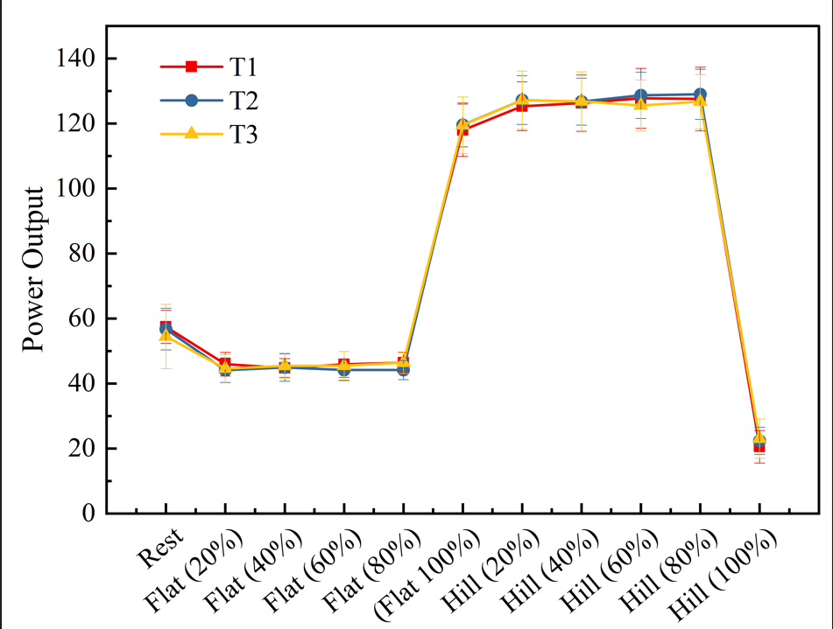
Figure 4: Mean (±SD) ratings of perceived exertion (RPE), Breathlessness during the final 30 seconds of each trial stage (Flat1, Hill, Flat2) in the VR condition.
Figure 5 (A-C) presents mean ratings of perceived exertion (RPE) and breathlessness during each stage of the congruent trial in VR condition. There was a significant main effect (Trial stage at VR condition) or interaction effect for any of these variables.
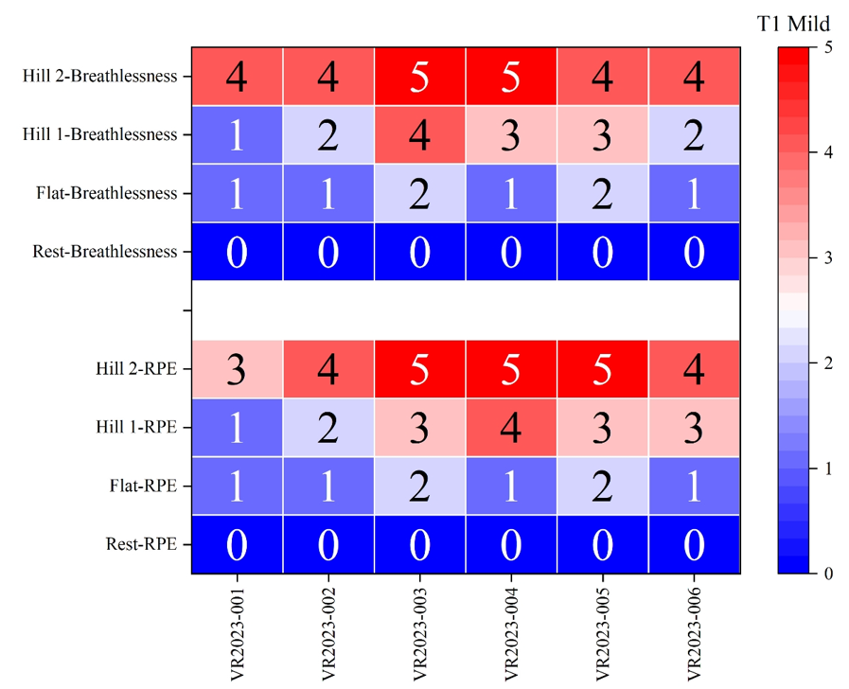
Figure 5. Mean (±SD) values from each category of the Physical activity enjoyment scale (PACES). * = significant difference between condition (T1 mild vs T2 Moderate vs T3 hard; p<0.05)
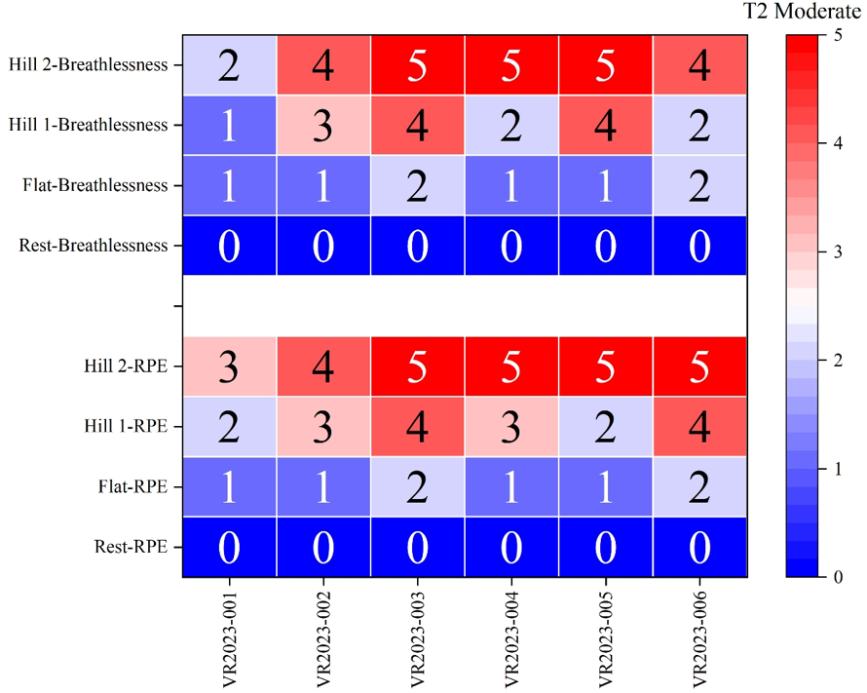

Figure 6. Mean (±SD) values from each category of the Physical activity enjoyment scale (PACES)

. 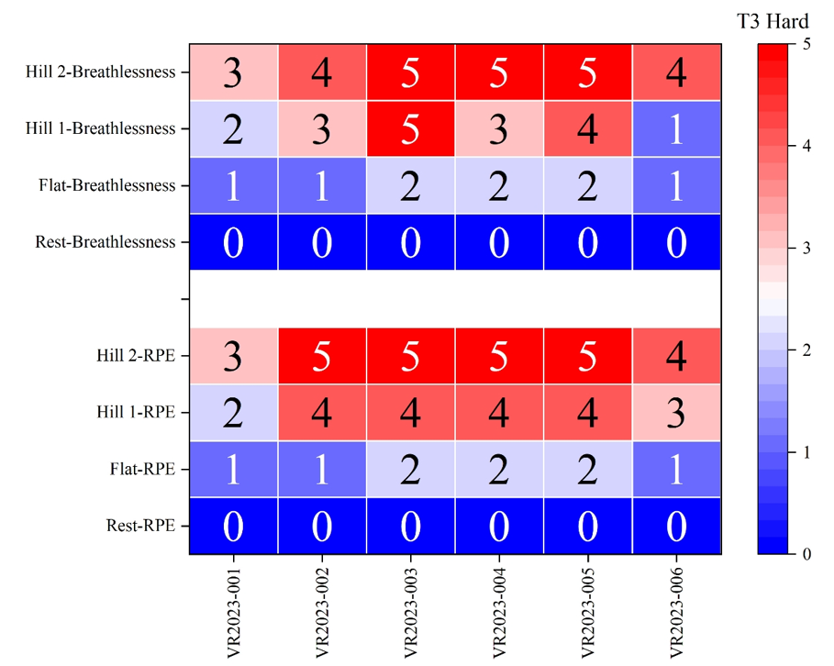
Figure 7. Mean (±SD) values from each category of the Physical activity enjoyment scale (PACES).
The Sim-TLX records perceived workload of the task in regard to its specific demands (i.e. mental, physical, temporal, frustration, complexity, stress, distraction, strain, control and performance). In the congruent trial, the only significant difference between the T1 mild, T2 Moderate and T3 hard conditions was ‘Hill 1-RPE’, which was higher in the T3 hard than T2 moderate and T1 mild condition (an average of 3.5) in comparison to the T1 mild nd T2 moderate condition (with an average of 2.7 and 3; p<0.05). Therefore, there exists enough evidence to reject the null hypothesis and make the conclusion that participants' cognitive load has a large effect on their physiological reactions during VR cycling physical activity, and there is a connection between mental and physiological elements that affects the workout experience as a whole.
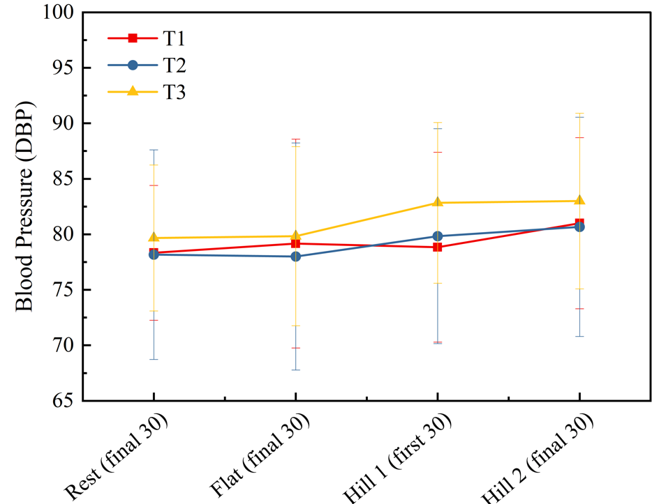
Figure 8: Average Blood pressure of the three trials
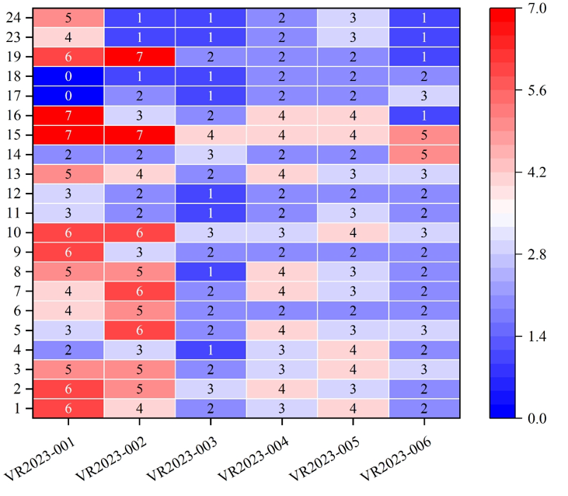
Figure 9: Presence Questions
As shown in figure 8 there was no significant difference in the blood pressure betweenT1, T2 and T3 conditions. Only T3 proved to be highly immersive with the blood pressure rising higher than the normal levels to an average of 82.5. Figure 9 presents mean values for each category of the physical activity enjoyment scale (PACES) recorded for the congruent trial in all three congruent trials. Enjoyment was significantly higher across all categories (p<0.05) where the average value across categories was 4.12 ±0.3. Therefore, there do not exists enough evidence to reject the null hypothesis and thus a conclusion can be made that virtual reality (VR) cycling training had a discernible effect on cognitive abilities including attention, sense of exertion, and decision making when compared to conventional bike training.
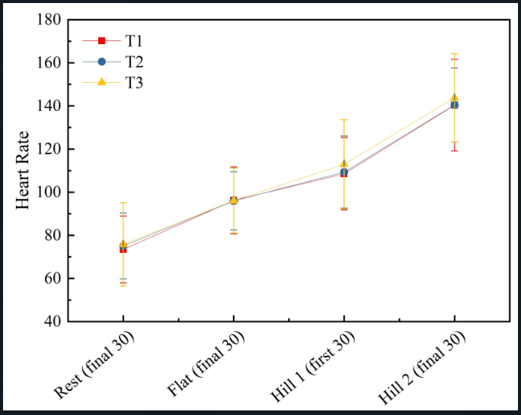
Figure 10: Mean heart rate comparison of all participants on each incongruent stage
Figure 10 (A-D) presents the heart rate as per the mean power output, RPM, ΔHR and ΔRR during each incongruent trial stage in VR condition. This shows that the heart rate tends to increase with each burst of power output per each incongruent stage. It can be observed that the heart rate of people who participated in traditional bicycle training did not vary much with those who participated in the VR training. Thus, there exist no evidence to disregard the null hypothesis that the heart rate, utilization of oxygen, and ratings of perceived effort did not vary significantly between those who participated in a virtual cycling training and those who engaged in traditional cycling.
Figure 11 (A-C) presents mean ratings of perceived exertion (RPE) and breathlessness during each incongruent trial stage. There was no significant main effect for RPE and breathlessness. There was a significant interaction effect for RPE (F(1,9) = 5.8, p<0.05) and for breathlessness (F(1,9) = 5.6, p<0.05) .
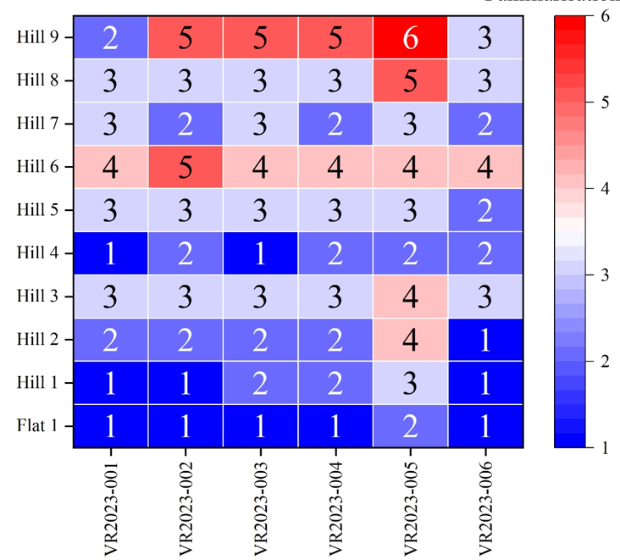
Figure 11: Familiarization RPE

Chapter 5

5. Discussions
Clinical populations have shown promise for the use of VR in physical activity (PA) and health promotion, with increased motor abilities and rehabilitative results. However, there is a dearth of research examining the efficacy of virtual reality (VR) exercise systems in boosting PA and health in healthy populations. This research is the first of its kind to examine the physiological and psychological effects of using a commercially accessible virtual reality workout equipment upon. For various key end measures, a difference between the three exercise sessions was statistically significant, with effect sizes ranging from moderate to large. The results showed that it was possible to increase people's confidence in their ability to complete PA and their enthusiasm for the activity by utilizing a virtual reality exercise bike. Participants who engaged in VR-based riding exercise reported lower RPE levels compared to those who engaged in conventional stationary biking exercise, despite both groups exhibiting comparable patterns in blood pressure change.
An increase in pleasure has been shown to boost physical activity (PA) engagement. Higher levels of self-efficacy for PA have also been reported to improve PA engagement, suggesting a positive feedback loop between the two (Oliveira et al., 2018). Therefore, while developing exercise programs to encourage PA, researchers should take into account factors like pleasure and self-efficacy (McAuley & Blissmer, 2000). Fortunately, virtual reality (VR)-based systems have been shown to raise both patients' interest in and sense of control over physical activity (PA). However, the majority of these research efforts have only employed VR equipment produced by researchers, and there has been very little exploration of VR exercise systems and equipment now on the market. Participating in VRbased biking, as opposed to traditional static biking exercise, increased participants' PA pleasure and self-efficacy.
This research used a readily accessible VR physical activity system and equipment (the VirZoom VR exercise bike). These results are consistent with those from clinical trials, and they are also interesting since the VR system and gear used in the study were not designed by researchers but rather are commercially accessible to any consumer concerned with their health. The results are significant because they show that a commercially accessible VR system and gear has the ability to produce long-term changes in PA behavior by reaching a larger audience and promoting improvements in critical psychological factors.
Investigating a body of research regarding the possibility of using this type of VR equipment for promoting health requires proof that the novel VR-based biking equipment induces a similar physiological reaction contrasted to conventional stationary cycling exercise, as raised BP during physical activity is crucial to good health (Ahmadi & Ramazani, 2020). Since the strength of the pedaling force in both sessions of exercise was set to encourage moderately intense PA, it is not unexpected that there was no statistically significant difference in blood pressure variations between the two workout modalities.
RPE was still dramatically reduced during the VR-based cycling activity, though. The VirZoom VR training bike's special features may explain this important result. VirZoom VR fitness bike and VirZoom Playground Game have been the first publicly sold VR cycle and game intended to demand pedaling to engage in fully immersive virtual reality gameplay5 —games developed with the pleasure of the user as the desired consequence. The VirZoom Arcade Game included a number of challenging and entertaining games for the user to choose from.

This pilot study only used two of the more taxing games, but it's encouraging that the VirZoom VR exercise bike's the need of pedaling throughout playing generated equivalent BP fluctuations from pre- to post-exercise compared to conventional stationary exercise biking, despite subjects recognizing lower RPE. Since none of the participants had ever used a virtual reality exercise bike or played the VirZoom Arcade Game before, the lower RPE values seen during VR games may be attributed to the fun participants were having. In particular, virtual reality experiences like these may encourage physical activity. It's important to keep in mind that factors like the desire to wear the helmet might influence results like satisfaction. Additionally, the RPE ratings may be affected by other psychological aspects, such as familiarity with and liking for the workout modality. Implications for promoting PA among those who see it as overly demanding stem from the aforementioned result (Almarcha et al., 2022).
Although limitations exist, the present research provides the first documented assessment into the efficacy of a Virtual Reality (VR) fitness machine that is now on the market college students' health, the research is not conclusive. First, the sample size is low reduces the study's statistical power and limitations how far its results may be applied. In particular, to guarantee that the strength of the the reliability of the results was not compromised by the research. The effect size of the research was evaluated using Cohen's d. Second, it's possible that the participants didn't understand RPE scale in its intended context (Arney et al., 2019).

References
Ahmadi, M. S., & Ramazani, A. (2020). Relationship between hope and psychological well-being among male and female students of Farhangian University of Zanjan province. Independent Journal of Management & Production, 11(6), 2077. https://doi.org/10.14807/ijmp.v11i6.1122
Ahmed, S., Safdar, M., Morton, C., Soave, N., Patel, R., Castillo, K., Lalande, S., Jimenez, L., Mateika, J. H., & Wessells, R. (2020). Effect of virtual reality-simulated exercise on sympathovagal balance. PLOS ONE, 15(7), e0235792. https://doi.org/10.1371/journal.pone.0235792
Ahn, S. J. (Grace), & Fox, J. (2017). Immersive Virtual Environments, Avatars, and Agents for Health. Oxford Research Encyclopedia of Communication, 1(1). https://doi.org/10.1093/acrefore/9780190228613.013.325
Alfonso, C., & Capdevila, L. (2022). Heart rate variability, mood and performance: a pilot study on the interrelation of these variables in amateur road cyclists. PeerJ, 10(1), e13094. https://doi.org/10.7717/peerj.13094
Almarcha, M., González, I., Balagué, N., & Javierre, C. (2022). Prescribing or co-designing exercise in healthy adults? Effects on mental health and interoceptive awareness. ProQuest, 1(1). https://doi.org/10.3389/fnbeh.2022.944193
Arney, B. E., Glover, R., Fusco, A., Cortis, C., de Koning, J. J., van Erp, T., Jaime, S., Mikat, R. P., Porcari, J. P., & Foster, C. (2019). Comparison of RPE (Rating of Perceived Exertion) Scales for Session RPE. International Journal of Sports Physiology and Performance, 14(7), 994–996. https://doi.org/10.1123/ijspp.2018-0637
Bae, M.-H. (2023). The Effect of a Virtual Reality-Based Physical Education Program on Physical Fitness among Elementary School Students. Iranian Journal of Public Health, 1(1). https://doi.org/10.18502/ijph.v52i2.11890
Bruce, R. M., Jolley, C., & White, M. J. (2019). Control of exercise hyperpnoea: Contributions from thin‐fibre skeletal muscle afferents. Experimental Physiology, 104(11), 1605–1621. https://doi.org/10.1113/ep087649
Chou, C.-H., Hwang, C.-L., & Wu, Y.-T. (2012). Effect of Exercise on Physical Function, Daily Living Activities, and Quality of Life in the Frail Older Adults: A Meta-Analysis. Archives of Physical Medicine and Rehabilitation, 93(2), 237–244. https://doi.org/10.1016/j.apmr.2011.08.042
Costa, D. C., de Santi, G. L., Crescêncio, J. C., Seabra, L. P., Carvalho, E. E. V., Papa, V., Marques, F., Gallo, L., & Schmidt, A. (2015). Use of the Wasserman equation in optimization of the duration of the power ramp in a cardiopulmonary exercise test: a study of Brazilian men. Brazilian Journal of Medical and Biological Research, 48(12), 1136–1144. https://doi.org/10.1590/1414-431X20154692
Cummings, J. J., Cahill, T. J., Wertz, E., & Zhong, Q. (2022). Psychological predictors of consumer-level virtual reality technology adoption and usage. Virtual Reality, 1(1). https://doi.org/10.1007/s10055-022-00736-1
Dwivedi, Y. K. (2022). Metaverse beyond the hype: Multidisciplinary perspectives on emerging challenges, opportunities, and agenda for research, practice and policy. International Journal of Information Management, 66(66), 102542. Sciencedirect. https://doi.org/10.1016/j.ijinfomgt.2022.102542
Finnegan, S. L., Dearlove, D. J., Morris, P., Freeman, D., Sergeant, M., Taylor, S., & Pattinson, K. T. S. (2023). Breathlessness in a virtual world: An experimental paradigm testing how discrepancy between VR visual gradients and pedal resistance during stationary cycling affects breathlessness perception. PloS One, 18(4), e0270721. https://doi.org/10.1371/journal.pone.0270721
Halperin, I., & Emanuel, A. (2019). Rating of Perceived Effort: Methodological Concerns and Future Directions. Sports Medicine, 1(1). https://doi.org/10.1007/s40279-019-01229-z
Hamad, A., & Jia, B. (2022). How Virtual Reality Technology Has Changed Our Lives: An Overview of the Current and Potential Applications and Limitations. International Journal of Environmental Research and Public Health, 19(18), 11278. https://doi.org/10.3390/ijerph191811278
Hamid Bouraghi, Mohammadpour, A., Taleb Khodaveisi, Marjan Ghazisaeedi, Saeedi, S., & Sahar Familgarosian. (2023). Virtual Reality and Cardiac Diseases: A Systematic Review of Applications and Effects. Journal of Healthcare Engineering, 2023(1), 1–20. https://doi.org/10.1155/2023/8171057
Høeg, E. R., Andersen, N. B., Malmkjær, N., Vaaben, A. H., & Uth, J. (2023). Hospitalized older adults’ experiences of virtual reality-based group exercise therapy with cycle ergometers: An early feasibility study. Computers in Human Behavior Reports, 11(1), 100301. https://doi.org/10.1016/j.chbr.2023.100301
Houston, E. (2019, July 4). Introvert vs Extrovert: A Look at the Spectrum and Psychology. PositivePsychology.com. https://positivepsychology.com/introversion-extroversion-spectrum/
Jedziniak, W., Rokita, A., Zwierko, M., & Popowczak, M. (2023). Effects of in-situ stroboscopic training on visual, visuomotor and reactive agility in youth volleyball players. PeerJ, 11(1), e15213–e15213. https://doi.org/10.7717/peerj.15213
Johnson, M. J., Yorke, J., Hansen-Flaschen, J., Lansing, R., Ekström, M., Similowski, T., & Currow, D. C. (2017). Towards an expert consensus to delineate a clinical syndrome of chronic breathlessness. European Respiratory Journal, 49(5), 1602277. https://doi.org/10.1183/13993003.02277-2016
Juras, G., Brachman, A., Michalska, J., Kamieniarz, A., Pawłowski, M., Hadamus, A., Białoszewski, D., Błaszczyk, J., & Słomka, K. J. (2019). Standards of Virtual Reality Application in Balance Training Programs in Clinical Practice: A Systematic Review. Games for Health Journal, 8(2), 101–111. https://doi.org/10.1089/g4h.2018.0034
Keating, A., Lee, A., & Holland, A. E. (2011). What prevents people with chronic obstructive pulmonary disease from attending pulmonary rehabilitation? A systematic review. Chronic Respiratory Disease, 8(2), 89–99. https://doi.org/10.1177/1479972310393756
Li, H., Zhang, X., Wang, H., Yang, Z., Liu, H., Cao, Y., & Zhang, G. (2021). Access to Nature via Virtual Reality: A Mini-Review. Frontiers in Psychology, 12(1). https://doi.org/10.3389/fpsyg.2021.725288
Li, Z., Han, X.-G., Sheng, J., & Ma, S.-J. (2015). Virtual reality for improving balance in patients after stroke: A systematic review and meta-analysis. Clinical Rehabilitation, 30(5), 432–440. https://doi.org/10.1177/0269215515593611
Liu, W., & Gao, Z. (2021). Effects of Virtual Reality Exercise on Promoting Physical Activity and Health among College Students: A 4-week Randomized Controlled Trial A Dissertation SUBMITTED TO THE FACULTY OF UNIVERSITY OF MINNESOTA BY IN PARTIAL FULFILLMENT OF THE REQUIREMENTS FOR THE DEGREE OF DOCTOR OF PHILOSOPHY. https://conservancy.umn.edu/bitstream/handle/11299/224576/Liu_umn_0130E_22589.pdf?sequence=1
Marileen Kouijzer, Kip, H., Yvonne, & Kelders, S. M. (2023). Implementation of virtual reality in healthcare: a scoping review on the implementation process of virtual reality in various healthcare settings. 1, 4(1). https://doi.org/10.1186/s43058-023-00442-2
McAuley, E., & Blissmer, B. (2000). Self-efficacy determinants and consequences of physical activity. Exercise and Sport Sciences Reviews, 28(2), 85–88. https://pubmed.ncbi.nlm.nih.gov/10902091/
Mouatt, B., Smith, A. E., Mellow, M. L., Parfitt, G., Smith, R. T., & Stanton, T. R. (2020). The Use of Virtual Reality to Influence Motivation, Affect, Enjoyment, and Engagement During Exercise: A Scoping Review. Frontiers in Virtual Reality, 1(1). https://doi.org/10.3389/frvir.2020.564664
Oliveira, B. R. R., Santos, T. M., Kilpatrick, M., Pires, F. O., & Deslandes, A. C. (2018). Affective and enjoyment responses in high intensity interval training and continuous training: A systematic review and meta-analysis. PLOS ONE, 13(6), e0197124. https://doi.org/10.1371/journal.pone.0197124
Polkey, M. I., Moxham, J., & Green, M. (2011). The case against inspiratory muscle training in COPD. European Respiratory Journal, 37(2), 236–237. https://doi.org/10.1183/09031936.00095510
Qian, J., McDonough, D. J., & Gao, Z. (2020). The Effectiveness of Virtual Reality Exercise on Individual’s Physiological, Psychological and Rehabilitative Outcomes: A Systematic Review. International Journal of Environmental Research and Public Health, 17(11), 4133. https://doi.org/10.3390/ijerph17114133
Rojo, A., Castrillo, A., López, C., Perea, L., Alnajjar, F., Moreno, J. C., & Raya, R. (2023). PedaleoVR: Usability study of a virtual reality application for cycling exercise in patients with lower limb disorders and elderly people. PLOS ONE, 18(2), e0280743. https://doi.org/10.1371/journal.pone.0280743
Ruegsegger, G. N., & Booth, F. W. (2018). Health Benefits of Exercise. Cold Spring Harbor Perspectives in Medicine, 8(7). https://doi.org/10.1101/cshperspect.a029694
Saldana, D., Neureither, M., Schmiesing, A., Jahng, E., Kysh, L., Roll, S. C., & Liew, S.-L. (2020). Applications of Head-Mounted Displays for Virtual Reality in Adult Physical Rehabilitation: A Scoping Review. American Journal of Occupational Therapy, 74(5), 7405205060p1. https://doi.org/10.5014/ajot.2020.041442
Sauchelli, S., & Brunstrom, J. M. (2022). Virtual reality exergaming improves affect during physical activity and reduces subsequent food consumption in inactive adults. Appetite, 175(1), 106058. https://doi.org/10.1016/j.appet.2022.106058
Seo, E.-Y., Kim, Y.-S., Lee, Y.-J., & Hur, M.-H. (2023). Virtual Reality Exercise Program Effects on Body Mass Index, Depression, Exercise Fun and Exercise Immersion in Overweight Middle-Aged Women: A Randomized Controlled Trial. International Journal of Environmental Research and Public Health, 20(2), 900. https://doi.org/10.3390/ijerph20020900
Smith, R. W., Housh, T. J., Arnett, J. E., Anders, J. P. V., Neltner, T. J., Ortega, D. G., Schmidt, R. J., & Johnson, G. O. (2023). The Effects of Anchor Schemes on Performance Fatigability, Neuromuscular Responses and the Perceived Sensations That Contributed to Task Termination. Journal of Functional Morphology and Kinesiology, 8(2), 49. https://doi.org/10.3390/jfmk8020049
Stewart, T. H., Villaneuva, K., Hahn, A., Ortiz-Delatorre, J., Wolf, C., Nguyen, R., Bolter, N. D., Kern, M., & Bagley, J. R. (2022). Actual vs. perceived exertion during active virtual reality game exercise. Frontiers in Rehabilitation Sciences, 3(1). https://doi.org/10.3389/fresc.2022.887740
Sutton, J., & Austin, Z. (2019). Qualitative Research: Data Collection, Analysis, and Management. The Canadian Journal of Hospital Pharmacy, 68(3), 226–231. NCBI. https://doi.org/10.4212/cjhp.v68i3.1456
Taylor, J. L., Bonikowske, A. R., & Olson, T. P. (2021). Optimizing Outcomes in Cardiac Rehabilitation: The Importance of Exercise Intensity. Frontiers in Cardiovascular Medicine, 8(1). https://doi.org/10.3389/fcvm.2021.734278
Thiel, C., Pfeifer, K., & Sudeck, G. (2018). Pacing and perceived exertion in endurance performance in exercise therapy and health sports. German Journal of Exercise and Sport Research, 48(1), 136–144. https://doi.org/10.1007/s12662-017-0489-5
Tripathi, A., Dalal, P., Kar, S., Narayan, C., & Matkar, A. (2022). Mental capacity including testamentary capacity. Indian Journal of Psychiatry, 64(7), 25. https://doi.org/10.4103/indianjpsychiatry.indianjpsychiatry_696_21
Valmaggia, L. R., Latif, L., Kempton, M. J., & Rus-Calafell, M. (2016). Virtual reality in the psychological treatment for mental health problems: An systematic review of recent evidence. Psychiatry Research, 236(1), 189–195. https://doi.org/10.1016/j.psychres.2016.01.015
Vieira, G. D. P., Araujo, D. F. G. H. de, Leite, M. A. A., Orsini, M., & Correa, C. L. (2014). Realidade virtual na reabilitação física de pacientes com doença de Parkinson. Journal of Human Growth and Development, 24(1), 31. https://doi.org/10.7322/jhgd.72046
World Health Organization. (2020, November 26). Physical activity. Www.who.int. https://www.who.int/news-room/fact-sheets/detail/physical-activity#:~:text=living%20with%20disability%3A-
World Health Organization. (2022, October 5). Physical Activity. World Health Organization; World Health Organization. https://www.who.int/news-room/fact-sheets/detail/physical-activity
Yang, V. W., Stradford, J., Tsang, I., Ravichandran, R., Pa, J., & Sakhare, A. (2019). Cycling and Spatial Navigation in an Enriched, Immersive 3D Virtual Park Environment: A Feasibility Study in Younger and Older Adults. 1, 11(1). https://doi.org/10.3389/fnagi.2019.00218
Zeng, N., Liu, W., Pope, Z. C., McDonough, D. J., & Gao, Z. (2021). Acute Effects of Virtual Reality Exercise Biking on College Students’ Physical Responses. Research Quarterly for Exercise and Sport, 1(1), 1–7. https://doi.org/10.1080/02701367.2021.1891188
Zeng, N., Pope, Z., & Gao, Z. (2017). Acute Effect of Virtual Reality Exercise Bike Games on College Students’ Physiological and Psychological Outcomes. Cyberpsychology, Behavior, and Social Networking, 20(7), 453–457. https://doi.org/10.1089/cyber.2017.0042

Appendixes
Appendix 1
Figure 1: RPE Scale
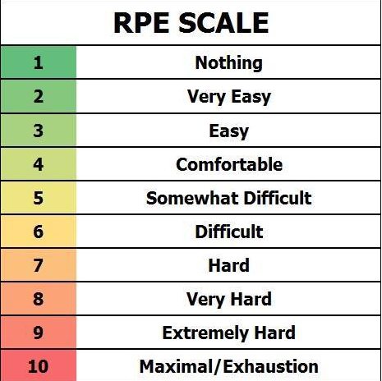

Figure 2: Familiarization Breathlessness
