Title: -
PowerBuilder Programming Language

Overview

Introduction:
The PowerBuilder programming language has a rich history that dates back to 1991 when it was introduced by PowerSoft Corporation. During its early years, PowerBuilder garnered attention for its innovative approach to developing database-driven business applications. The key figures behind its development included Bruce Scott and a team of dedicated programmers. As the years progressed, PowerBuilder went through several significant updates and enhancements, adapting to the changing needs of the software development industry.

Developing History:
2. Developing History:
2.1 Early Years (1991-1995):
PowerBuilder was initially released in 1991 by PowerSoft Corporation, a company founded by Richard A. Pick and Dean A. Power. It was developed as a graphical application development tool that aimed to simplify the process of building database-driven business applications. The early versions of PowerBuilder provided developers with a visual development environment and a powerful event-driven programming model. This combination allowed developers to create user interfaces and define application logic more efficiently compared to traditional programming languages.

2.2 Acquisition by Sybase (1995):
In 1995, Sybase, a prominent software company specializing in data management and enterprise software, acquired PowerSoft Corporation. The acquisition was a strategic move by Sybase to expand its product portfolio and strengthen its position in the enterprise application development market. Under Sybase's ownership, PowerBuilder received significant investments in research and development, resulting in updates and enhancements to the language. Sybase's resources and expertise helped propel PowerBuilder to greater heights, making it a popular choice for developing client-server applications.

2.3 Evolution and Updates:
Following the acquisition by Sybase, PowerBuilder underwent several major releases, each introducing new features and improvements. PowerBuilder 6, released in 1996, brought enhanced capabilities such as support for component-based development, enabling developers to create reusable code modules and increase development efficiency. PowerBuilder 7, released in 1998, introduced a more advanced version of the DataWindow technology, known as DataWindow.NET, which allowed for web-based application development. Subsequent releases continued to refine and expand PowerBuilder's features, including support for mobile application development, web services integration, and improved support for distributed computing environments.

Domain and Category:
3.1 Business Application Development:
PowerBuilder found its domain in the realm of business application development. It became widely known for its ability to streamline the development of database-driven applications, particularly those related to enterprise resource planning (ERP), customer relationship management (CRM), and financial systems. PowerBuilder's visual development environment, data access capabilities, and robust event-driven programming model made it well-suited for developing business applications that interacted with large databases.

3.2 Client-Server Architecture:
PowerBuilder's category as a programming language lies within the client-server architecture. It was designed to facilitate the development of applications that follow the client-server model, where a client application interacts with a centralized server to access and manipulate data. PowerBuilder excelled in this domain, providing developers with tools and features specifically tailored for building client-server applications. Its integration with popular databases and support for distributed computing environments made it a preferred choice for developing scalable and efficient client-server applications.

Goals, Concerns, Success, and Contribution:
4.1 Goals of PowerBuilder:
PowerBuilder's primary goals were to simplify the development process, accelerate application development, and improve developer productivity. It aimed to provide a visual and intuitive environment for designing user interfaces, integrating with databases, and implementing business logic. PowerBuilder strived to make it easier for developers to build robust and scalable applications without sacrificing performance or flexibility.

4.2 Concerns and Challenges:
As technology evolved and new paradigms emerged, PowerBuilder faced concerns and challenges. One of the major challenges was the shift towards web and mobile application development, which required support for web technologies, responsive design, and cross-platform compatibility. PowerBuilder initially struggled to adapt to these trends, as its core strengths were rooted in client-server architecture and desktop applications. Additionally, the availability of skilled PowerBuilder developers became limited over time, as new generations of programmers focused on more modern languages and frameworks.

4.3 Success and Contribution:
PowerBuilder achieved significant success and made notable contributions to the software development industry. During its prime years, it played a pivotal role in advancing client-server application development and simplifying the creation of database-driven business applications. PowerBuilder's visual development environment, coupled with its DataWindow technology, offered developers unprecedented productivity and efficiency. Its contributions include accelerating the development process, empowering developers to build powerful applications, and enabling businesses to streamline their operations through robust software solutions.

Special Features:
PowerBuilder introduced several features and capabilities that set it apart from other programming languages:
- Visual Development Environment: PowerBuilder's visual IDE allowed developers to design user interfaces by simply dragging and dropping controls onto design surfaces. This visual approach reduced the need for manual coding and enabled rapid prototyping and application design.
- DataWindow Technology: One of PowerBuilder's flagship features, the DataWindow technology, provided a versatile and efficient way to interact with databases. It offered a unified interface for querying, retrieving, updating, and displaying data from various database sources.
- Component-Based Development: PowerBuilder supported a component-based development approach, allowing developers to create reusable code components that could be shared across applications. This feature enhanced code reusability, maintainability, and development efficiency.
- Database Integration: PowerBuilder seamlessly integrated with popular database management systems, such as Oracle, Microsoft SQL Server, and IBM DB2.

This tight integration simplified database operations and enabled developers to work with data more effectively.

PowerBuilder's capabilities in these areas contributed to its success and made it a preferred choice for developers working on business applications.

Overview of the Programming Language:
PowerBuilder is a high-level programming language that combines visual design tools, a powerful event-driven programming model, and seamless integration with databases. The language is primarily used for developing business applications with a focus on client-server architecture. PowerBuilder provides a comprehensive development environment that includes an integrated development environment (IDE), a visual design tool, a powerful scripting language called PowerScript, and a rich set of libraries and frameworks.

PowerBuilder applications are built using objects, such as windows, controls, data windows, and user-defined objects. These objects serve as the building blocks of the application's user interface and functionality. PowerBuilder's visual design tool allows developers to visually create
and arrange these objects, defining their properties and behavior.

PowerScript, the scripting language used in PowerBuilder, is derived from procedural programming languages like C and Pascal. It offers a rich set of language constructs and commands to define application logic, handle user interactions, and interact with databases. PowerScript supports features such as conditional statements, loops, variable declarations, functions, and event handlers.

One of PowerBuilder's key features is the DataWindow technology. The DataWindow provides a powerful and flexible interface for interacting with databases. It simplifies database operations by providing a unified interface for querying, retrieving, updating, and displaying data. Developers can easily define the structure of the DataWindow and bind it to a database table or query, allowing for seamless data access and manipulation. The DataWindow also offers advanced features such as data validation, sorting, filtering, and grouping.

PowerBuilder applications can be deployed on various operating systems, including Windows. The compiled application can be distributed to end-users as an executable file or installed on client machines. PowerBuilder applications are typically deployed in client-server environments, where the client application communicates with a centralized server to access data and perform business logic.

Example:
Here are some examples of PowerBuilder code along with explanations for each code snippet:
- Create a window with a button and an event handler:
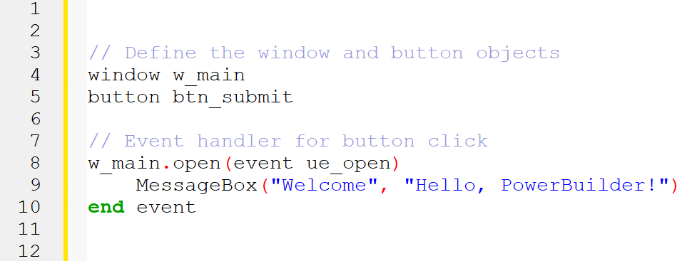

- A specific method executed when a button is clicked:
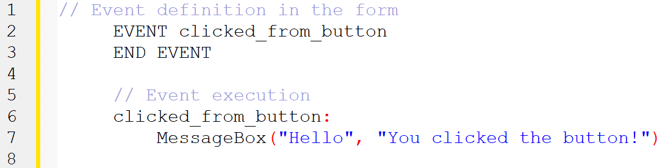

- Event for form load:
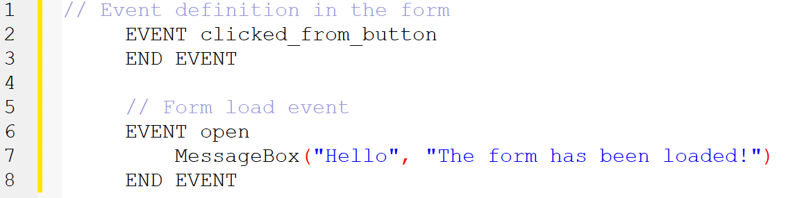

- GUI Examples: Creating a new window:
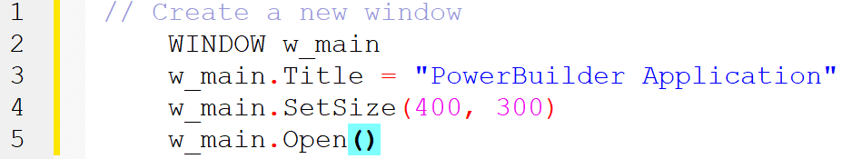

- Adding a button to the window:
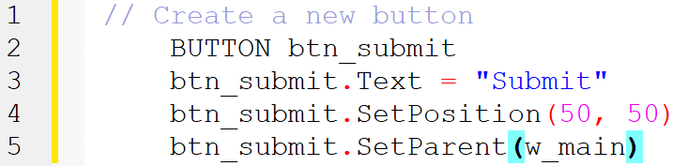

- Database Examples: Simple query to retrieve data from a table:
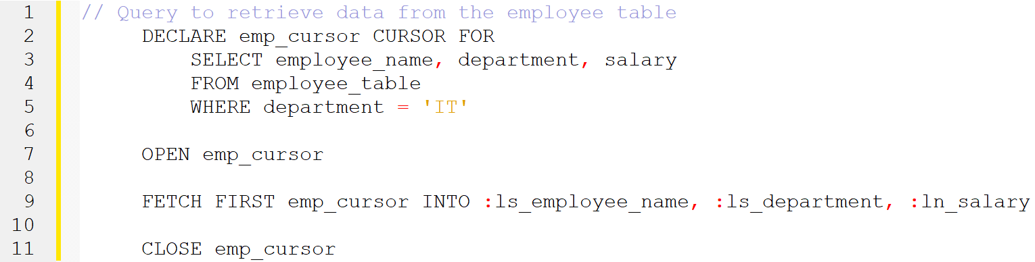

- Adding a new record to a table:
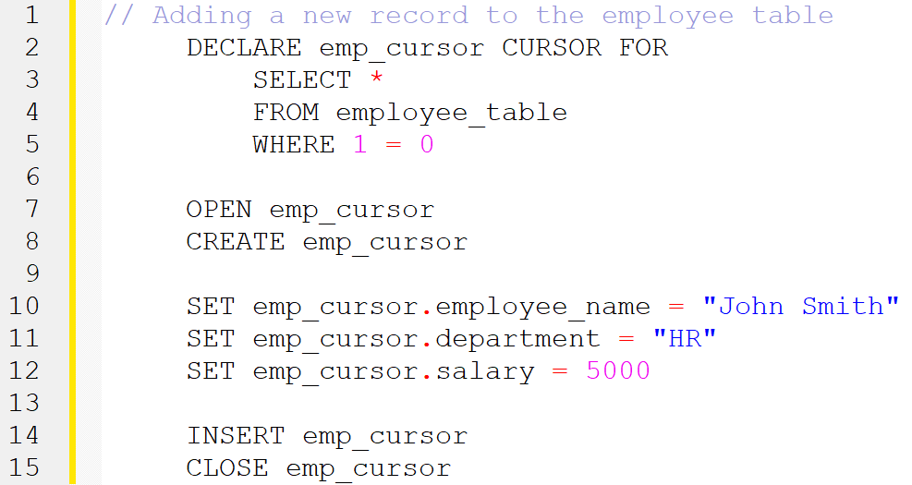

- Control Flow Examples: If-Else statement:
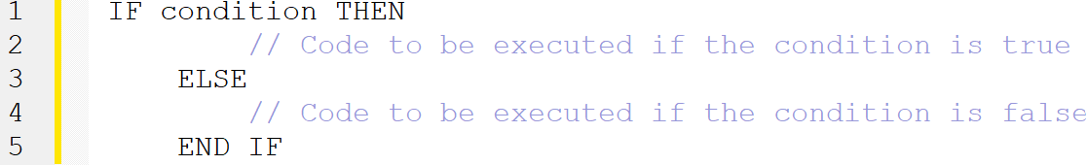

- For loop:
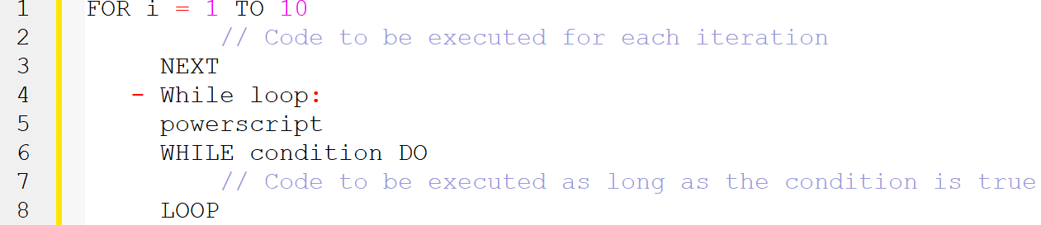

- Error Handling Examples: Try-Catch block:
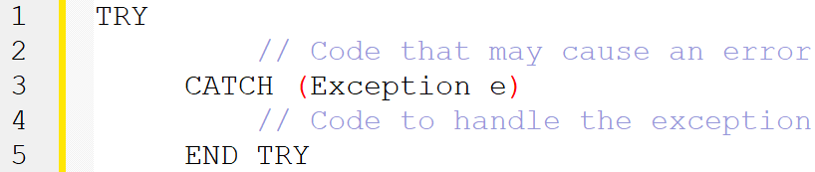

- Error event handler:
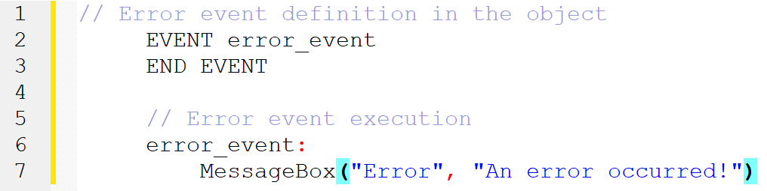

- DataWindow Examples: Retrieving data from a DataWindow control:

- Modifying data in a DataWindow control:
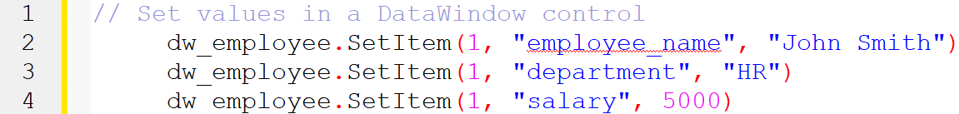

- Saving data from a DataWindow control to the database:

Comments and Evaluation:
PowerBuilder has enjoyed significant popularity and success in the past, particularly in the era of client-server applications. Its visual development environment, ease of use, and robust database integration made it a preferred choice for building business applications. The DataWindow technology, in particular, was highly praised for its power and versatility in simplifying data access and manipulation.

However, PowerBuilder faced challenges in adapting to new technology trends, such as web and mobile application development. The language's focus on client-server architecture and desktop applications limited its ability to keep up with the demand for modern web and mobile experiences. This led to a decline in its popularity in recent years.

Nevertheless, PowerBuilder still has a dedicated community of developers who appreciate its strengths and continue to maintain and enhance existing applications
built with the language. Efforts are being made to modernize PowerBuilder and extend its capabilities to support web and mobile development. The PowerBuilder community remains active, providing support, knowledge-sharing, and third-party tools to support the ecosystem.

Industry Applications:
- Discuss real-world examples of PowerBuilder applications deployed in various industries such as finance, healthcare, manufacturing, and government sectors. Highlight the specific challenges addressed by PowerBuilder and the benefits achieved through its usage.

Impact on Software Development:
- Explore the influence of PowerBuilder on the software development landscape. Discuss its impact on the evolution of client-server architecture, database integration, and visual development environments. Analyze how PowerBuilder influenced subsequent programming languages and frameworks.

Community and Support:
- Discuss the active community surrounding PowerBuilder, including user groups, forums, and conferences. Highlight the support available for PowerBuilder developers, including online resources, documentation, and third-party tools. Provide insights into the collaboration and knowledge-sharing within the PowerBuilder community.

Case Studies and Success Stories:
- Present detailed case studies showcasing successful PowerBuilder projects. Describe the specific business requirements, challenges faced, and how PowerBuilder was utilized to deliver effective solutions. Include testimonials from clients or project stakeholders.

Comparison with Other Programming Languages:
PowerBuilder and Java are both popular programming languages used for software development, but they have distinct differences in terms of their history, syntax, development environments, and areas of application. Here's a comparison between PowerBuilder and Java:

1. History and Background:
- PowerBuilder: PowerBuilder is a proprietary, object-oriented, fourth-generation programming language (4GL) developed by Sybase (now SAP). It gained popularity in the 1990s for building client-server applications.
- Java: Java is a general-purpose, object-oriented programming language developed by Sun Microsystems (acquired by Oracle). It was released in 1995 and designed to be platform-independent, running on any device with a Java Virtual Machine (JVM).

2. Syntax and Structure:
- PowerBuilder: PowerBuilder uses a syntax similar to Basic or Pascal, with a focus on drag-and-drop GUI development. It utilizes a visual development environment and offers a rapid application development (RAD) approach.
- Java: Java has a C/C++-like syntax, providing a more traditional programming style. It emphasizes structured programming and supports both object-oriented and procedural programming paradigms.

3. Development Environment:
- PowerBuilder: PowerBuilder has its integrated development environment (IDE) called PowerBuilder Developer. It provides a visual design interface for building user interfaces and allows developers to create database-driven applications with its data window concept.
- Java: Java offers a range of IDEs, such as Eclipse, IntelliJ IDEA, and NetBeans, that provide advanced code editing, debugging, and project management tools. It also supports various frameworks and libraries for different types of development.

4. Platform and Portability:
- PowerBuilder: PowerBuilder applications primarily target the Windows platform, although it has limited support for other platforms through third-party solutions.
- Java: Java was designed with platform independence in mind. Java programs run on the JVM, which is available for multiple operating systems, making Java highly portable.

5. Application Domains:
- PowerBuilder: PowerBuilder was initially focused on developing desktop client-server applications and data-driven enterprise systems. It has strong support for database integration and is often used in industries like finance, manufacturing, and government.
- Java: Java has a broad range of applications. It is widely used in web development (Java EE, Spring framework), mobile app development (Android), enterprise software, big data processing (Hadoop), scientific computing, and more.

6. Community and Resources:
- PowerBuilder: PowerBuilder has a smaller and more specialized community compared to Java. It may be more challenging to find extensive online resources, tutorials, and community support.
- Java: Java has a vast and active developer community. There is an abundance of resources, libraries, frameworks, and open-source projects available, making it easier to find help, documentation, and code samples.

In summary, PowerBuilder is a 4GL language focused on client-server applications with a visual development approach, primarily targeting Windows. On the other hand, Java is a general-purpose language with a C/C++-like syntax, emphasizing

portability, and offering extensive application domains and community support. The choice between PowerBuilder and Java depends on the specific project requirements, platform needs, and the developer's familiarity with the languages and associated ecosystems.

Modernizing PowerBuilder:
- Discuss the efforts and initiatives to modernize PowerBuilder and keep it relevant in the current technology landscape. Explore the introduction of web and mobile development capabilities, the adoption of new frameworks and libraries, and the integration of modern UI/UX design principles.

Conclusion:
PowerBuilder has a significant development history, starting from its inception in the early 1990s. It has found its domain in business application development, with a focus on client-server architecture. PowerBuilder's goals have been to simplify and accelerate the development process, and it has made notable contributions to the industry through its visual development environment, powerful event-driven model, and data access capabilities. While it faced challenges in adapting to emerging technology trends, PowerBuilder continues to have a loyal user base and ongoing efforts to modernize the language and support current development needs.

References

"History of PowerBuilder" - PowerBuilder Wiki: - (https://powerbuilder.fandom.com/wiki/History_of_PowerBuilder)

"PowerBuilder - A Brief Overview" – Code Project: - (https://www.codeproject.com/Articles/142727/PowerBuilder-A-Brief-Overview)

"PowerBuilder" – Wikipedia: - (https://en.wikipedia.org/wiki/PowerBuilder)
- Introduction to PowerBuilder: - https://docs.appeon.com/pb2019/getting_started/ch01.html
- PowerBuilder Classic: - https://www.appeon.com/products/powerbuilder-classic
- PowerBuilder.NET Overview: - https://docs.appeon.com/pb2019/pb_net_overview/index.html

Team
Name | Id
Alaa Hussein Ibrahim | 42210367
Nermeen Kamal-Eldin Ahmed | 42110428

