How to run the code:
The code passes through several stages in order to run.
Important functions:
1.Extract the features
function [categories,annotations,tocluster] = BagOfFeatures(install,testnum,catnum,bound)
This extracts the features from the specified number of categories using the SIFT feature detector and SIFT feature descriptor. The version of SIFT used here is vl_sift. In order for vl_sift to run you must set the install = 1, in the first run and install =0 in subsequent runs, as installing several times can cause memory problems.
The Sift features here are invariant to scale and rotation, and slight deformations I saw that as the best option rather than using a dense sift given the slight variations in image sizes. I used a bounding box mainl to decrease the computation time. The sift features are generated via the sift points in using the traditional way, the sift features f, contain the coordinates of the centroid, as well as orientation and scale. However this will not be used. We will used the resulting sift descriptor. That is build automatically by the function to be rotation and scale invariant, D.

The sift runs using the following code:
[F,D] = vl_sift(single(testimage2));
The image has to be grayscale and in single format. The outputs are the keypoints represented by F and the descriptors represented by D. Only the descriptors will be used in the subsequent sections.

The testnum in this case is actually the training number of the training images you will include. The training images are not selected at random, and the algorithm takes the first testnum images to extract the Sift features from.
The catnum gives you the freedom of choosing the first catnum categories. This allows you to test the function on smaller number of categories as the 101 category takes time to calculate.
The option bound allows you to use the annotations to extract test images using bounding box, or not. You have to send bound = 1 to use this. If this is used bound must be set to 1 in all the subsequent images. The results so far are conducted on bound =1
The function outputs the categories used, the category of annotations used, the siftfeatures in tocluster
e.g. [categories5,annotations5,tocluster5] = BagofFeatures(1,1,5,1);
The above installs vl_sift, extract only one training image from each category, only extracts images from 5 categories and using a bounding box before calculating the sift features.
e.g.2 [categories101,annotations101,tocluster101] = BagofFeatures(0,3,101,0);
The above doesn't vl_sift, extract three training image per category, only extracts images from all 101 categories and does not use a bounding box to extract the features.

Step 2: kmeans clustering.
Originally I made my own kmeans clustering program kmeans_n which takes the first k elements from the sift features, to_cluster above, as well as the number of clusters required,k, it outputs the centroid means of the k clusters. It does this by first assigning the points to the first k points, finding the average of the assigned points, calculating new k means, and reassigng the points. The calculation of means and assigning the points is repeated until convergence.
As an alternative I used a function called fkmeans. Due to different implementation you have to inser the sift features transposed inside the function. And then tranpose the output.
A brief on k-means clustering:
The BatckKmeans is a variant of the Kmeansalgorithm. It uses mini-batches to reduce the computation time, while still attempting to optimise the same objective function. Mini-batches are subsets of the input data, randomly sampled in each training iteration. These mini-batches drastically reduce the amount of computation required to converge to a local solution. In contrast to other algorithms that reduce the convergence time of k-means, mini-batch k-means produces results that are generally only slightly worse than the standard algorithm.
Steps:
The algorithm iterates between two major steps, similar to vanilla k-means. In the first step, samples are drawn randomly from the dataset, to form a mini-batch. These are then assigned to the nearest centroid. In the second step, the centroids are updated. In contrast to k-means, this is done on a per-sample basis. For each sample in the mini-batch, the assigned centroid is updated by taking the streaming average of the sample and all previous samples assigned to that centroid. This has the effect of decreasing the rate of change for a centroid over time. These steps are performed until convergence or a predetermined number of iterations is reached.
MiniBatchKMeans converges faster than KMeans, but the quality of the results is reduced. In practice this difference in quality can be quite small, as shown in the example and cited reference.
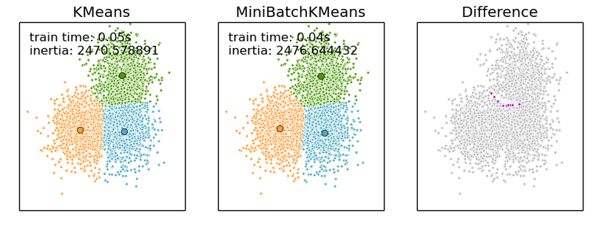
To get the kmeans do the following.
[a3,b404_100_5,c3]=fkmeans(double(tocluster101_5)',404); Where tocluster101_5 represents the sift features generate for 101 categories with 5 training images for categories, and 404 represents the number of k clusters that we want to generate. I chose this number as I assume there could be 4 clusters per class. And we have 100 classes. The output is k_centroids, specifically 404 clusters, generated from our original sift points that are 10k in number or more depending on the number of training images.
2-Build the Bag of Features for the training set.
Using the clusters generated in the previous step. For all test images used in the previous step, (e.g. if you used 1 image per class when building the initial sift features, you need to use those again, and if you use 3 you need to use the same three). Check the distance of the features from the centroids generated by k-means. For each feature assign that feature to the nearest centroid by incrementing a histogram of clusters by 1. Map each picture in k-dimensional space and create a bag of features by incrementing that way, till you get a histogram for each picture. For each n pictures lying in the same category, sum their histograms, and take an average of the histograms for better results. The results in the experiment use the annotation to take the bounding box around the object being detected.
---------
Although the implementation of matlab works just fine due to the high dimensionality data we opted for a solution that can be resilient to high dimensionality data.
function s = buildBagofFeatures(categories,annotations,centroids,install,testnum,bound)
The output is a struct containing the average bag of feature in a bag variable vs. the category name. The testnum here is actually the number of training images, used for building the bag of features. It has to match the number of images used in the feature extraction step. The centroids are taken from the key mean step.
e.g.
s101_5 = buildBagofFeatures(categories101_5,annotations101_5,b404_100_5',0,5,1);
The above algorithm takes the categories and annotation from the feature selection step, the clusters b404_100_5 from the feature step, doesn't install vl_sift, trains 5 images per class and uses a bounding box.
Here when building the bag of features, as before we take the first k images in the dataset to be our training images.
3-Build a bag of features for the testing set.
Repeat the same step that you did for the training images for the testing images. Just make sure the testing and training images don't overlap. We take the first k images after the ones taken for training to be our testing images. Thus if we have one training image we start taking images from image 2, and if we have 5 training images we start taking images from image 6 and so forth. This is done in order to implement the overall detection rate. The features per category here are not averaged. A bounding box is used to select the images, as the same treatment was used for the training set.
function s = testBagofFeatures(categories,annotations,centroids,install,testnum,trainnum,bound)
The only difference between build and test bag of features is the fact that this function is for the testing set. The testnum here represents the number of testing images which is fixed at 10 while the trainnum consists of the number of training images used to build the clusters, and the bag of words for training. In the scope of this experiment we will vary it between 1, 5 and 15 and plot that accordingly.
e.g. s101test_5=testBagofFeatures(categories101_5,annotations101_5,b404_100_5',0,10,5,1)
The above function gets the bag of features for 10 testing images, using clusters generated using 101 images, and 5 trainig features per images.
The above two features use a function called sqDistance which measures the euclidean distance between each feature and each cluster centroid. To speed up the below function vectorization is used.
function D = sqDistance(X, Y)
4. Calculate the detection rate
function [rrate,positives,errors ] = compareBags( strain,stest )
In order to compare the accuracies of the bag we compare the training set average bag value to each bag in the testing set using nearest neighbour algorithm. The nearest neighbour algorithm is calculated using the following functoin.
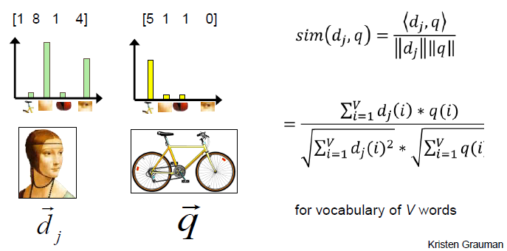
The above function is similarity function and doesn't measure the distance between two objects therefore the higher the number the higher the similarity. And the higher the match.
In order to generate a match we compare each test image to all the categories and take the highest scoring category. If both categories match we have a match and we increment a counter of true positives, otherwise we increment a counter of mismatches. The detection rate is calculated by dividing the total correct matches / correct matches + failures to match.
The similarity function used is the nearest neighbor, and is computed using the following function:
nearestn.m it takes two vectors and finds the similarity between them. In this case two bags.
Steps 1,2, 3 and 4 are repeated for training images 1, 5, and 15, but with fixed number of testing images which is 10.

e.g compareBags(s101,s101test);
Will compare 101 categories for bags generated using 1 training image s101, and bags generated using 10 testing images that are not part of the training set. S101 and s101test are outputs of buildBagofFeatures and testBagofFeatures respectively.
In the actual function the first input parameter is strain while the last input parameter is stest. Those are
the bag of features for the training set and the testing set respectively.
The function outputs rrate which is the recognition rate, positives which are successful detections, as well as errors which are unsuccessful detections.
5.Explanation of the retrieval function
The last function which is the similarity function takes in an input image and also optionally its annotation since the entire data was generating using a bounding box. It also takes the bag of features generated using training, as well as the corresponding cluster of images. The image's bag of features is first calculated with the help of Euclidean distance from the k-mean centroids, calculated from previous steps. After the bag of features is calculated compare the image bag of features to the bag of features of all categories of the training set. Select the 5 best matching features and display them along with their similarity score which uses nearest neighbor function. The test image should not be including in the training set or else you'll get an optimistic score of 100%.
The install function installs vl_sift if needed if it is set to 1, the categories has the categories that were selected by far, this will stay constant when we move from feature selection to building bag of features and so forth, the centroids has the k-means calculated for the features generated in the first step, the strain function is the bag of words generated using the training set, the image path and annotation path are of the testing image we are about to test, and the maxcounter, allows you to vary how many closest n results you want the classifier to output.
We an can vary the centroids, and strain to represent bag of features trained with a higher number of images and note the results respectively.
function [cat,score] = similarity2(install,categories,centroids,strain,imagepath,annotpath,bound,maxcounter)
The overall pipeline or architecture of the project is as follows: (please see image below)

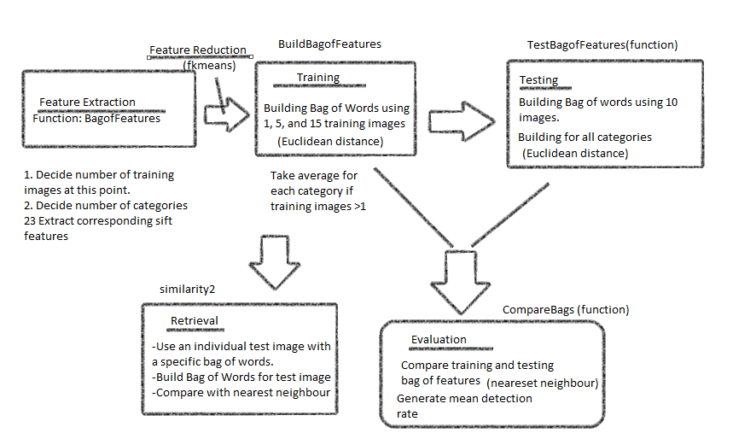

(a)Sample Results of similarity2 function.
The function retrieves the best five categories that fit the object.
When using all 101 categories and training the bag of features with one image. We inserted the image
imagepath = '101_ObjectCategories\accordion\image_0001.jpg';
annotpath = 'Annotations\accordion\annotation_0001.mat';
The image was also trained with image_0001 in the accordion dataset which resulted in the following result.

The image is:

'The image is_accordion by:'

100

'The image is_anchor by:'

49.9801

'The image is_saxophone by:'

36.2616

'The image is_octopus by:'

33.2073

'The image is_chandelier by:'

32.9810
However this result is optimistic as the testing is done with the same image as the training set.
~~~~~~~~~~~~~~~~~~~~~~~~~`
On choosing a random image33 from the accordian class.
The image was misrecognized probably because we only trained the bag of features with one class only.

'The image is_llama by:'

36.3287

'The image is_stegosaurus by:'

34.9076

'The image is_platypus by:'

34.8002

'The image is_umbrella by:'

33.4871

'The image is_windsor_chair by:'

33.0227

>> similarity2(0,categories101,b404_100',s101,'','',1);
--------------------------------------------------------------------------------
Using image 2 and its corresponding annotation we get the following result.

'The image is_accordion by:'

55.8491

'The image is_bass by:'

42.4893

'The image is_chandelier by:'

40.5525

'The image is_kangaroo by:'

38.3256

'The image is_trilobite by:'

37.7127

--------------------------------------------------------------------------------
The results show above that the recognition rate is very low when using one training image to generate the results. Additional results of image retrieval using 1 class are shown at the end of this document.
Using 15 training images, the using the corresponding bag of words for image retrieval generated the following results:
similarity2(0,categories101_15,b404_100_15',s101_15,'','',1,10);

imagepath = '101_ObjectCategories\accordion\image_0015.jpg';
annotpath = 'Annotations\accordion\annotation_0015.mat';

'The image is_accordion by:'

62.7779

'The image is_menorah by:'

57.4682

'The image is_trilobite by:'

46.5579

'The image is_gramophone by:'

43.8218

'The image is_nautilus by:'

43.4209

'The image is_stapler by:'

43.3662

'The image is_barrel by:'

43.2942

'The image is_windsor_chair by:'

42.3514

'The image is_laptop by:'

42.0601

'The image is_electric_guitar by:'

41.0647
~~~~~~~~~~~~~~~~~~~~``
Using image 16 yielded in the accordion category generated the following result.
Image 16 wasn't used for testing.
'The image is_lobster by:'

44.0441

'The image is_barrel by:'

43.3261

'The image is_ewer by:'

42.6186

'The image is_buddha by:'

42.3784

'The image is_mandolin by:'

41.7903

'The image is_panda by:'

41.6477

'The image is_elephant by:'

41.4344

'The image is_electric_guitar by:'

41.3609

'The image is_binocular by:'

41.1589

'The image is_sea_horse by:'

41.1062
We can conclude from this that increasing the number of training images only increases the chances of finding images that have been seen before. But doesn't correctly classify images that have not been trained using the training set. The mean recognition rate is also 18.9% which for the testing images that are mutually exclusive from the classes which can explain why the items are not being recognized.
To confirm this we repeat the results with a few more images from the face class.
---------------------------------------------------------------------------------------------------------
The results attained when running similarity2 using a bag of features trained with 15 images, and selecting image 5 which was used for training.
'The image is_Faces by:'

68.8165

'The image is_Faces_easy by:'

63.9618

'The image is_schooner by:'

54.4861

'The image is_crocodile_head by:'

53.6367

'The image is_crocodile by:'

53.5354
The results attained when running similarity2 using a bag of features trained with 15 images, and selecting image 16 which was not used for training.
'The image is_lamp by:'

61.8754

'The image is_Faces by:'

59.2371

'The image is_Faces_easy by:'

57.2543

'The image is_ketch by:'

57.1521

'The image is_pyramid by:'

56.0503
The results attained when running similarity2 using a bag of features trained with 1 images, and selecting image 16 which was not used for training.
'The image is_emu by:'

48.3671

'The image is_Faces by:'

45.3439

'The image is_umbrella by:'

41.6223

'The image is_flamingo_head by:'

41.0845

'The image is_hedgehog by:'

40.7663
-----------------------------------------
The results attained when running similarity2 using a bag of features trained with 1 images, and selecting image 2 which was not used for training.
'The image is_Faces_easy by:'

45.5270

'The image is_Faces by:'

41.3025

'The image is_gramophone by:'

37.5096

'The image is_rhino by:'

36.3488

'The image is_flamingo_head by:'

36.0493
------------------------------------------------------
The results attained when running similarity2 using a bag of features trained with 1 images, and selecting image 1 which was used for training.
'The image is_Faces by:'

100.0000

'The image is_Faces_easy by:'

87.6197

'The image is_umbrella by:'

43.3826

'The image is_emu by:'

41.5821

'The image is_mandolin by:'

39.2358
The results above show that some classes have better recognition rate than others. Thus a face is still recognizable even when only one feature is used in training as opposed to an accordian, when using all 101 features.
-------------------------------------------------------------------------------------
(b) Results of running the compareBags which calculates the mean recognition rate.
Note- The mean recognition rate was calculated using 10 testing images for all features, and thus summing up the means of each class would give the same result as summing up the total detected categories divided by the total number of images.
Using 101 clusters but only 1 training image as well as 404 clusters, 10 testing images.
The recognition rate was 8.5%
Snapshot of the result.
positives =

86

errors =

924

rrate =

0.0851
Using 101 clusters, 5 training image as well as 404 clusters, and 10 testing images.
The recognition rate was 12.3%
Snapshot of the result
positives =

124

errors =

886

rrate =

0.1228
Using 101 clusters, 15 training image as well as 404 clusters, and 10 testing images.
The recognition rate was 18.9%
positives =

191

errors =

819

rrate =

0.1891

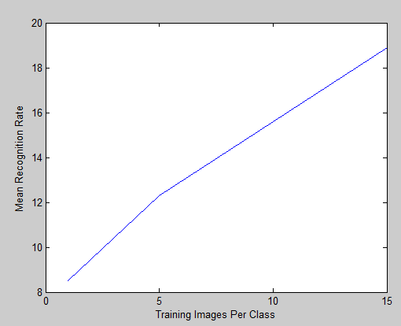
The graph below summarizes the results attained.
(Please scroll downwards)

The results below show the comparison of the above results with the other classifiers for caltech 101 dataset. The accuracy of the technique is very low at 1 and 5 images for the training but starts to be comparable with the baseline SSD as well as the FeiFei,Pergus and Perona datsets when using 15
training images, to train the classifier and build a bag of Words, and nearest neighbour classifier.

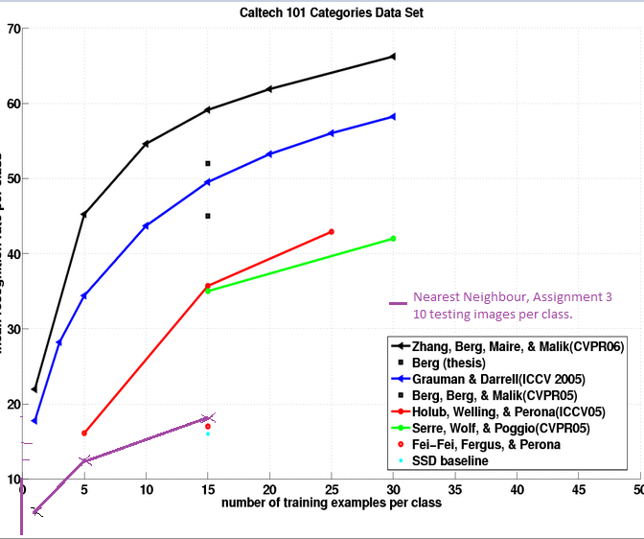
Additional results attained using 1 training image and the similarity function for detecting an accordion.
'The image is_trilobite by:'

64.2837

'The image is_accordion by:'

46.7277

'The image is_scorpion by:'

42.8582

'The image is_menorah by:'

42.0982

'The image is_stapler by:'

42.0262

----------------------------------------------

'The image is_kangaroo by:'

36.3850

'The image is_panda by:'

34.2025

'The image is_chandelier by:'

33.8295

'The image is_gramophone by:'

33.4709

'The image is_rooster by:'

33.1726
------------------------

'The image is_kangaroo by:'

36.3850

'The image is_panda by:'

34.2025

'The image is_chandelier by:'

33.8295

'The image is_gramophone by:'

33.4709

'The image is_rooster by:'

33.1726

'The image is_llama by:'

33.1153

'The image is_lobster by:'

32.7968

'The image is_cougar_body by:'

32.5119

'The image is_wild_cat by:'

31.9193

'The image is_pizza by:'

31.5374

-------------------------------------------

'The image is_euphonium by:'

41.6920

'The image is_windsor_chair by:'

40.5539

'The image is_trilobite by:'

37.4652

'The image is_scorpion by:'

36.7130

'The image is_stapler by:'

35.4442

'The image is_wheelchair by:'

34.8189

'The image is_wild_cat by:'

32.7424

'The image is_accordion by:'

30.4993

'The image is_menorah by:'

29.9217

'The image is_kangaroo by:'

29.1284

