For features 1 and 2:
For features 1 and 2, the overall testing accuracy is:
96.6667

The corresponding testing accuracy for class setosa is:
93.3333

The corresponding testing accuracy class versicolor is:
100
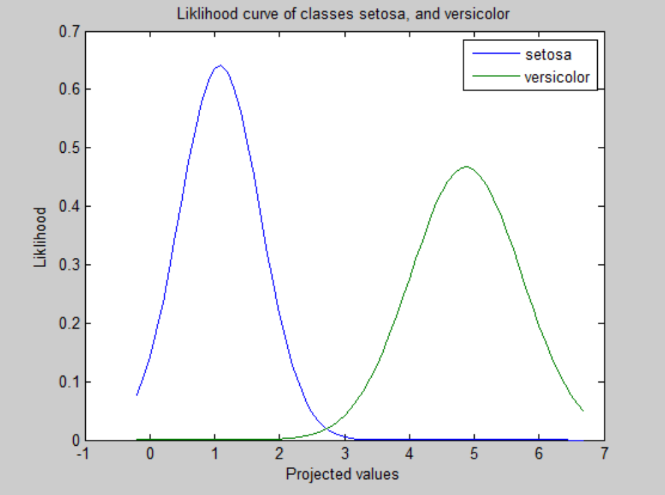
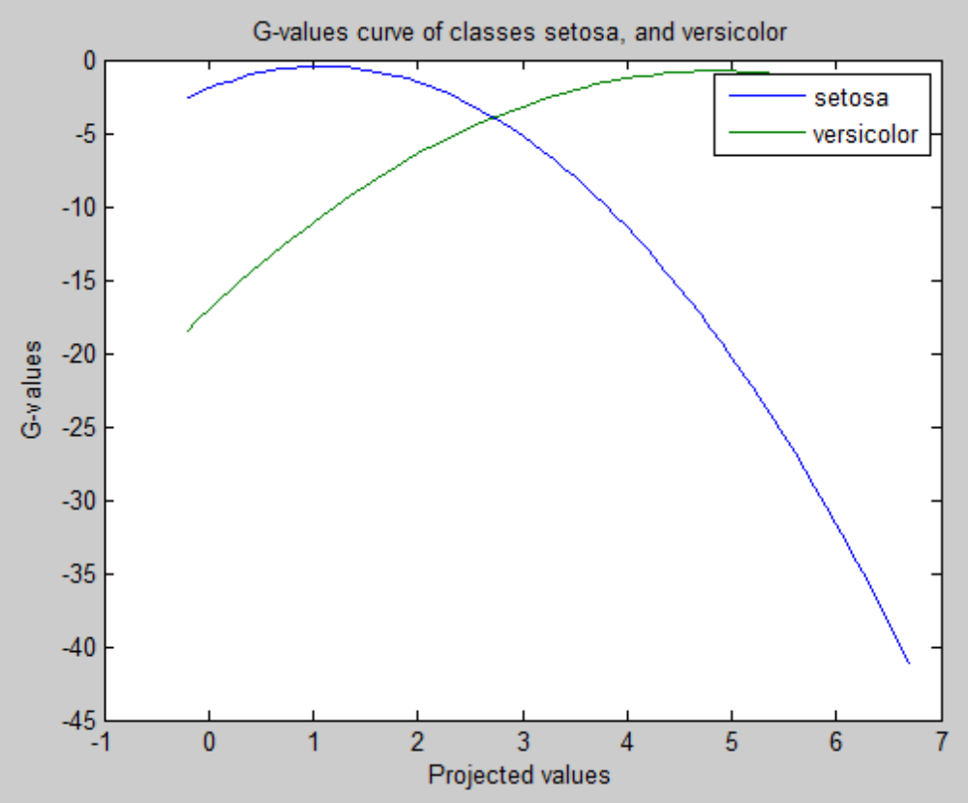
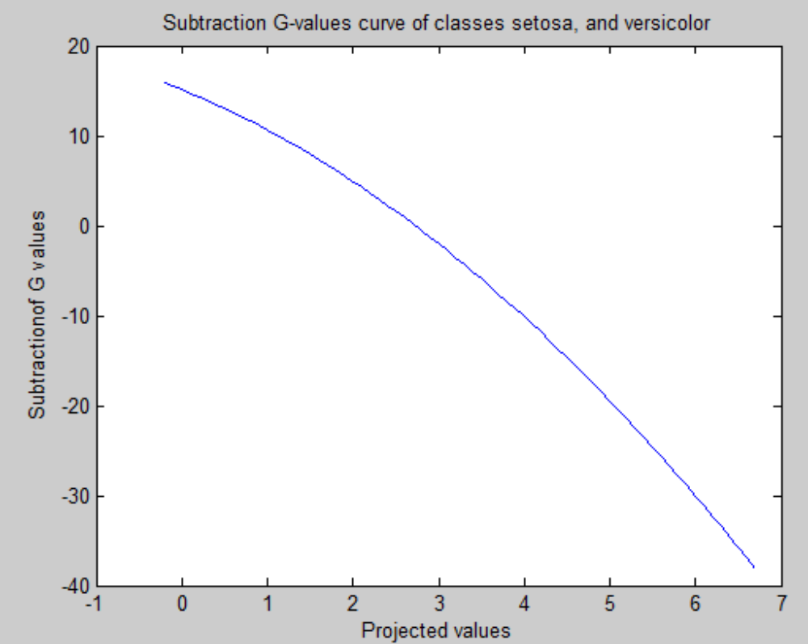
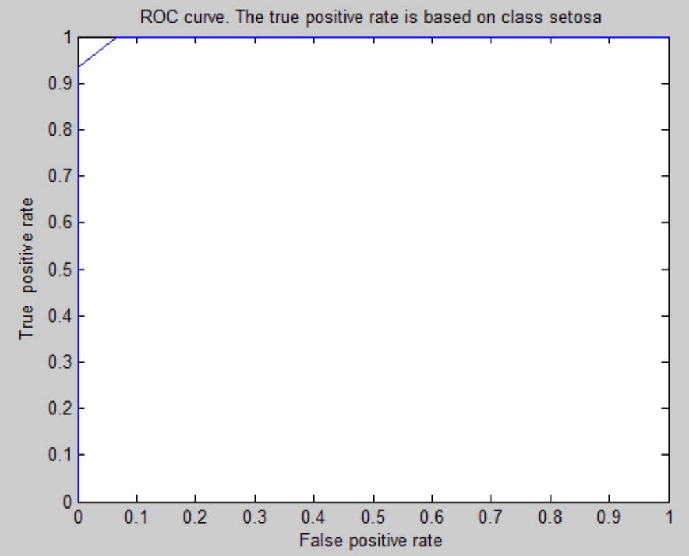

For features 1 and 3:
For features 1 and 3, the overall testing accuracy is:
100

The corresponding testing accuracy for class setosa is:
100

The corresponding testing accuracy class versicolor is:
100
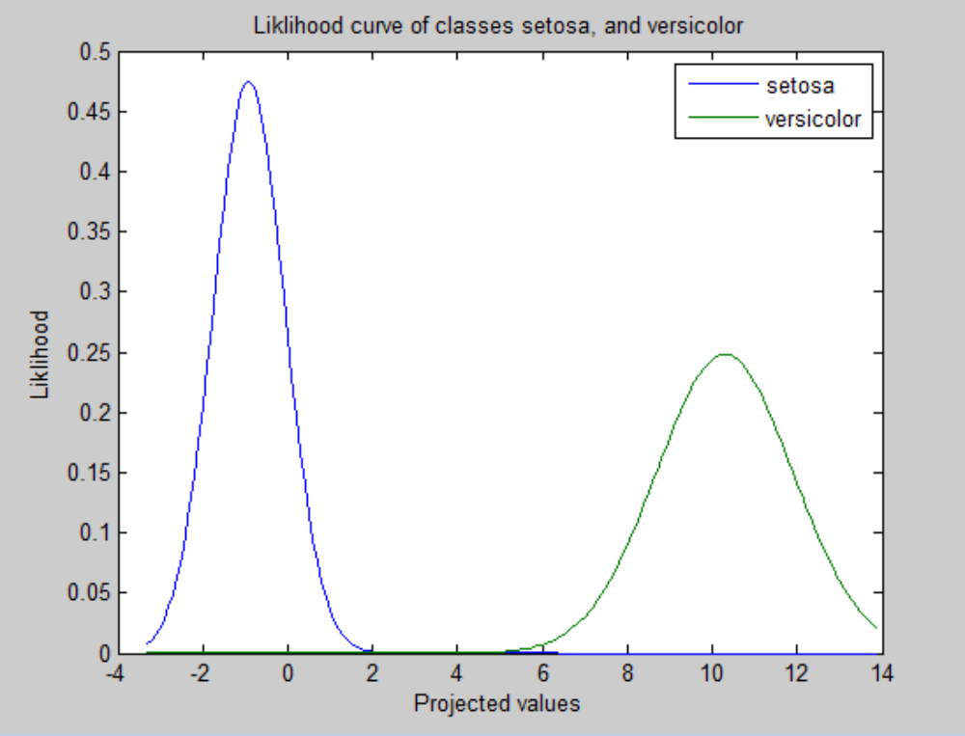
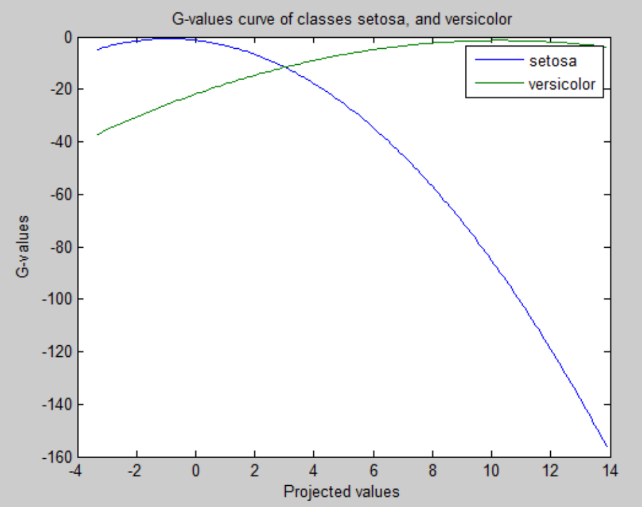
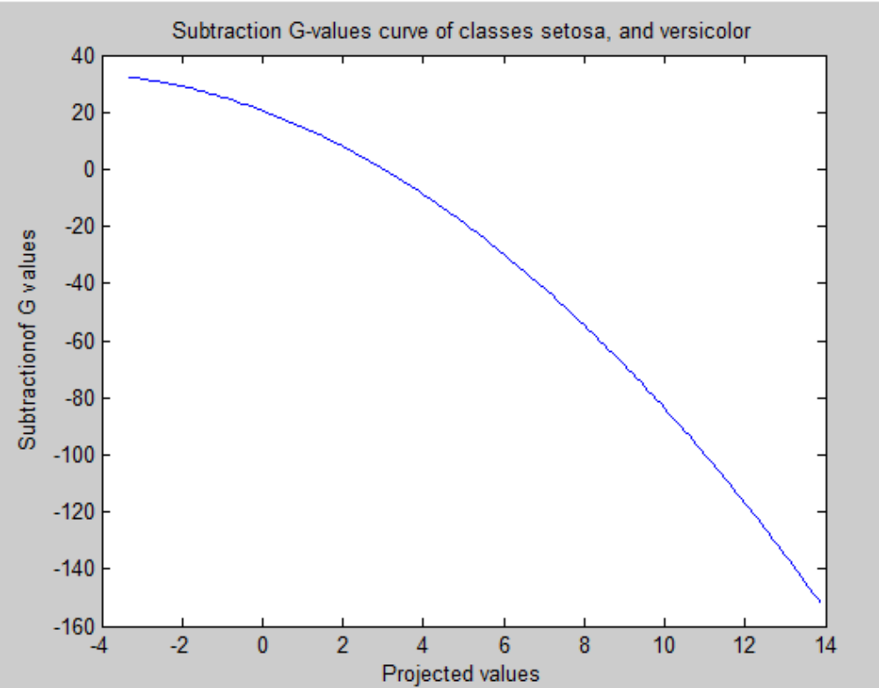
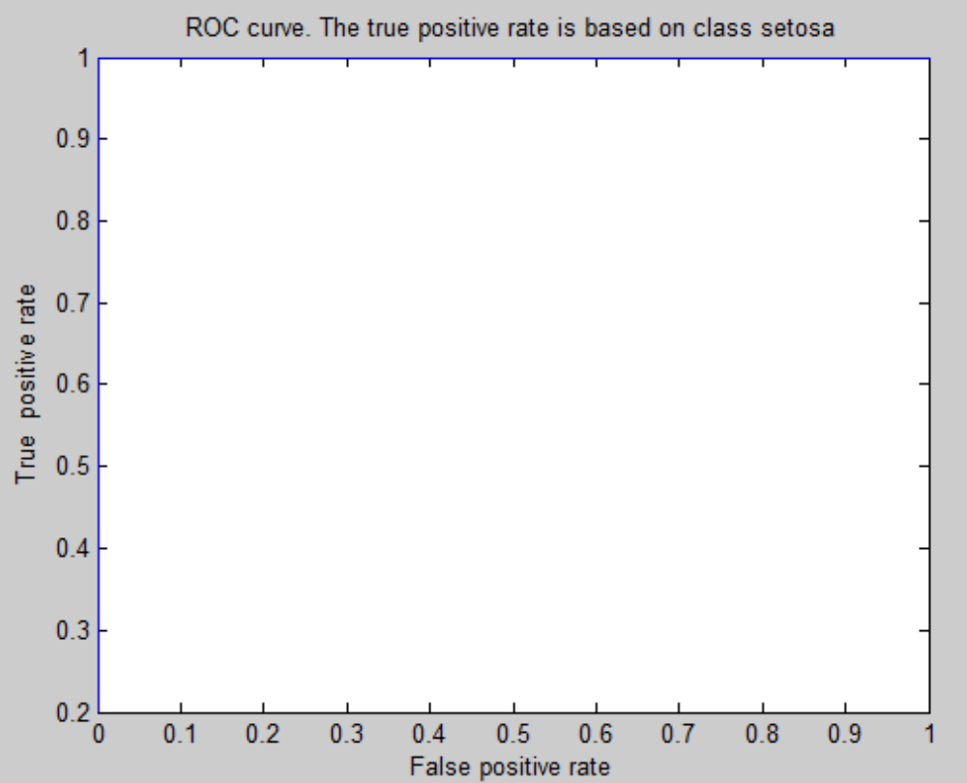

For features 2 and 3:
For features 2 and 3, the overall testing accuracy is:
100

The corresponding testing accuracy for class setosa is:
100

The corresponding testing accuracy class versicolor is:
100
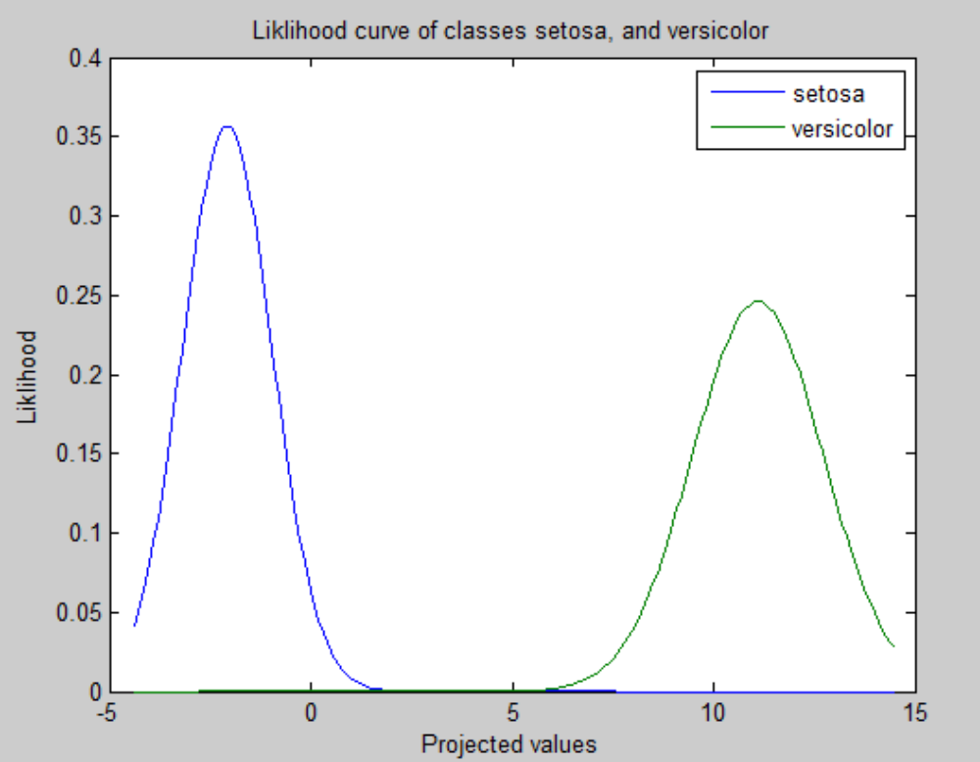
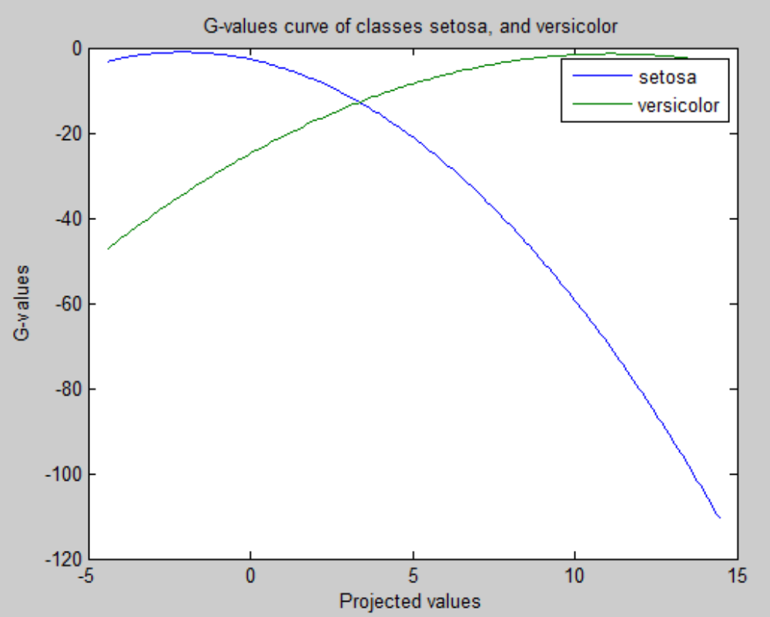
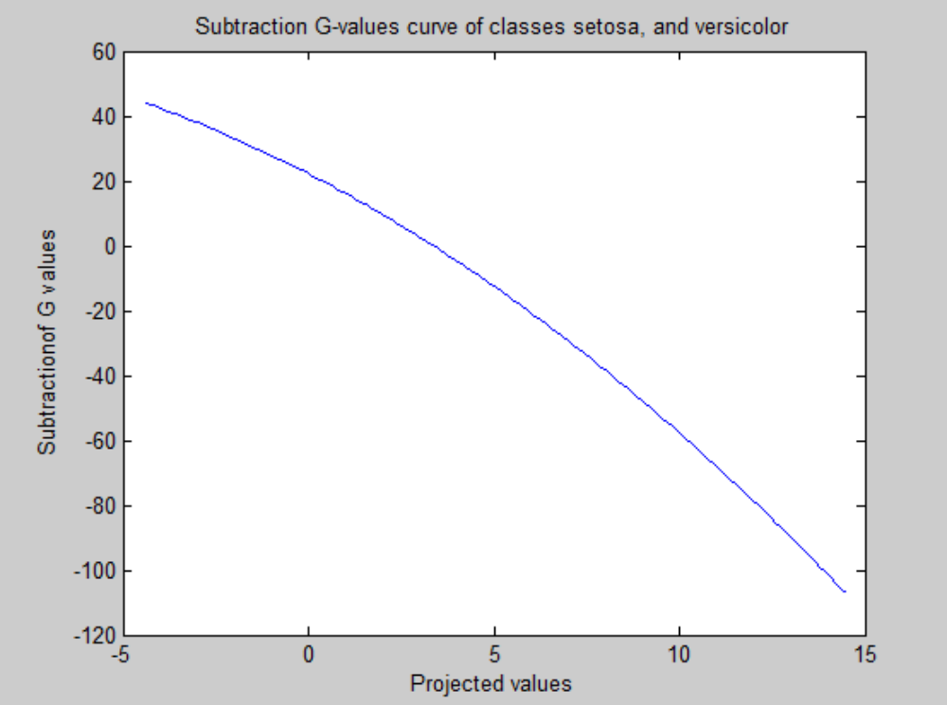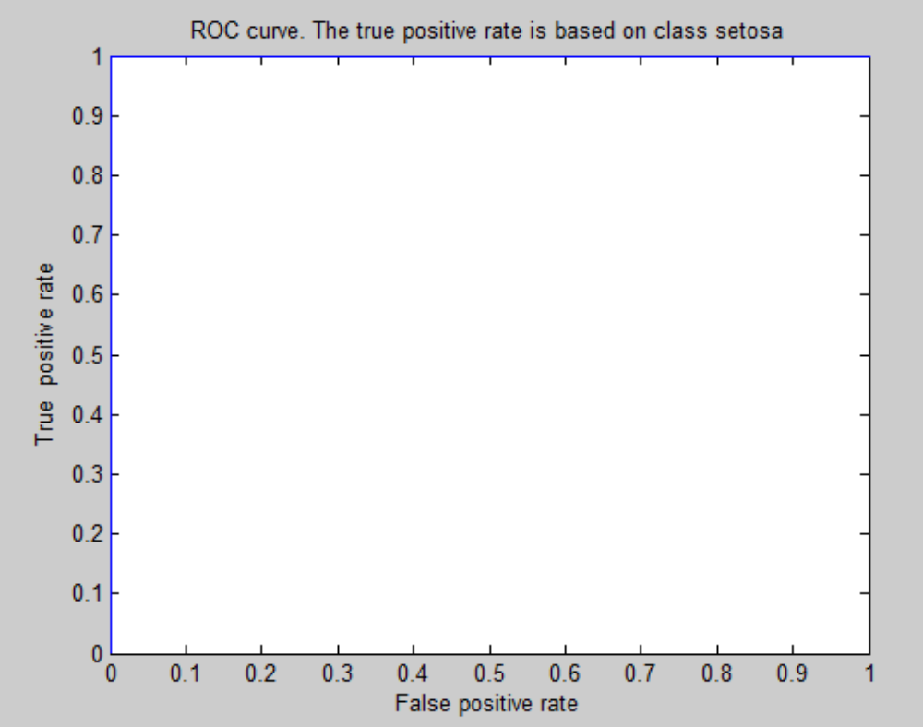

Features 1 and 4
For features 1 and 4, the overall testing accuracy is:
96.6667

The corresponding testing accuracy for class setosa is:
93.3333

The corresponding testing accuracy class versicolor is:
100
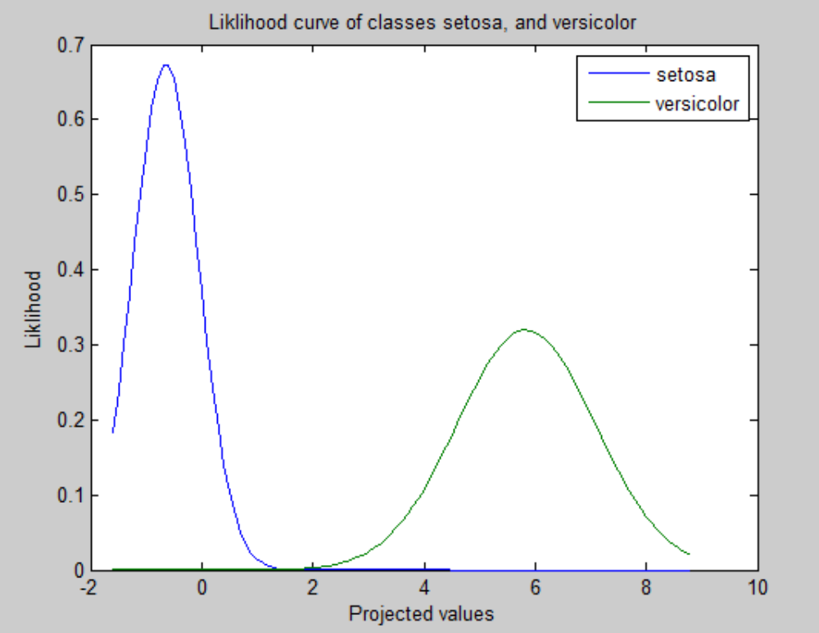
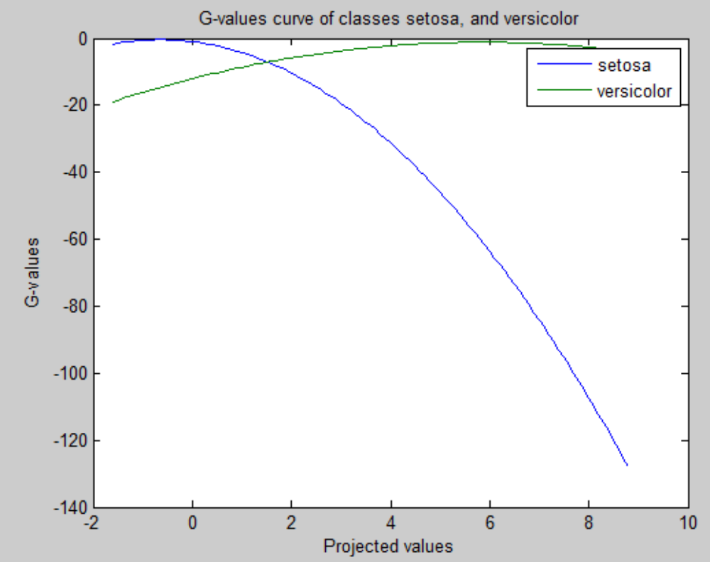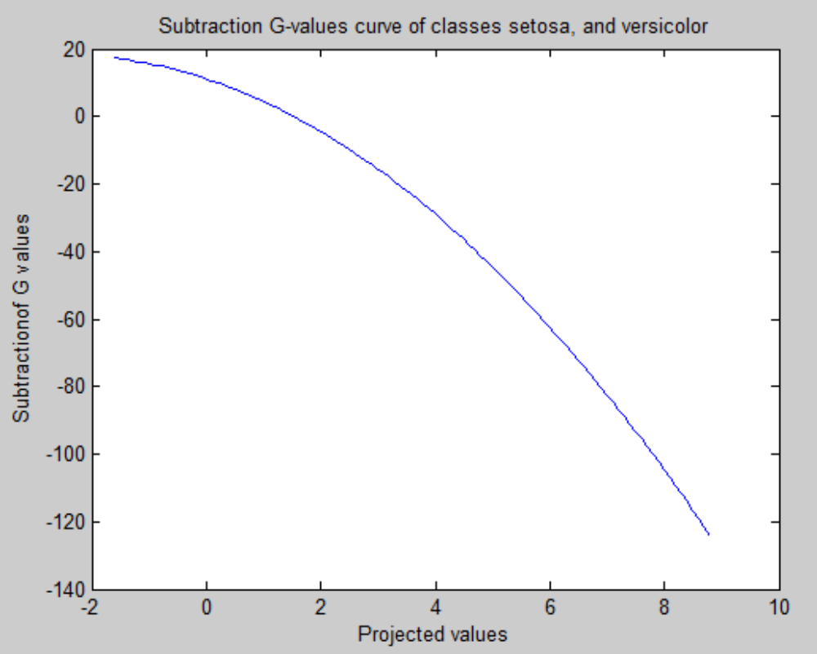
Features 2 and 4
For features 2 and 4, the overall testing accuracy is:
100

The corresponding testing accuracy for class setosa is:
100

The corresponding testing accuracy class versicolor is:
100
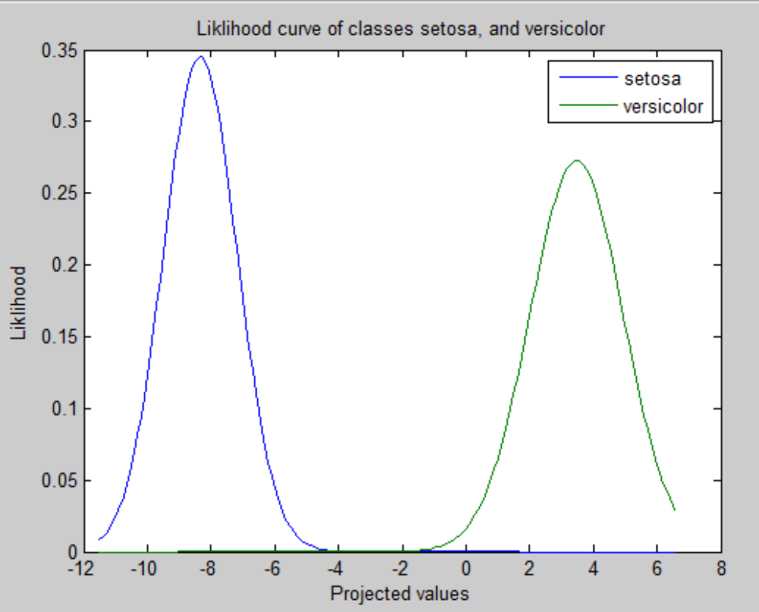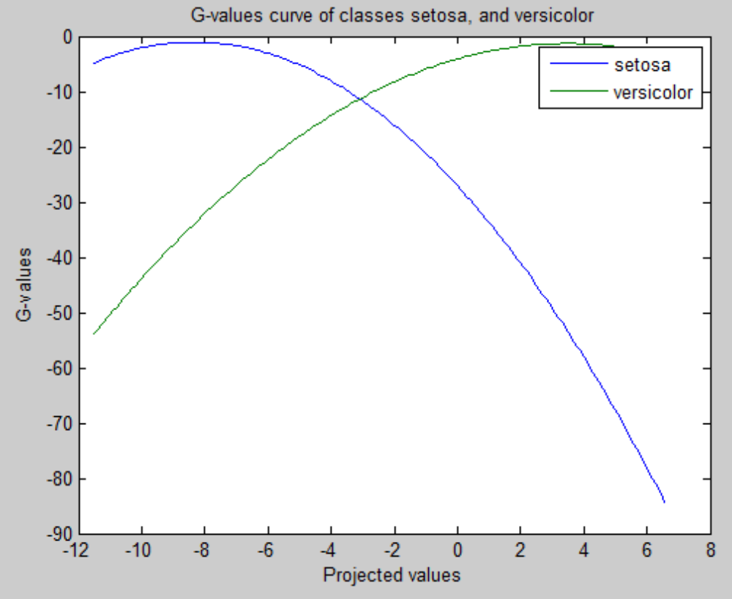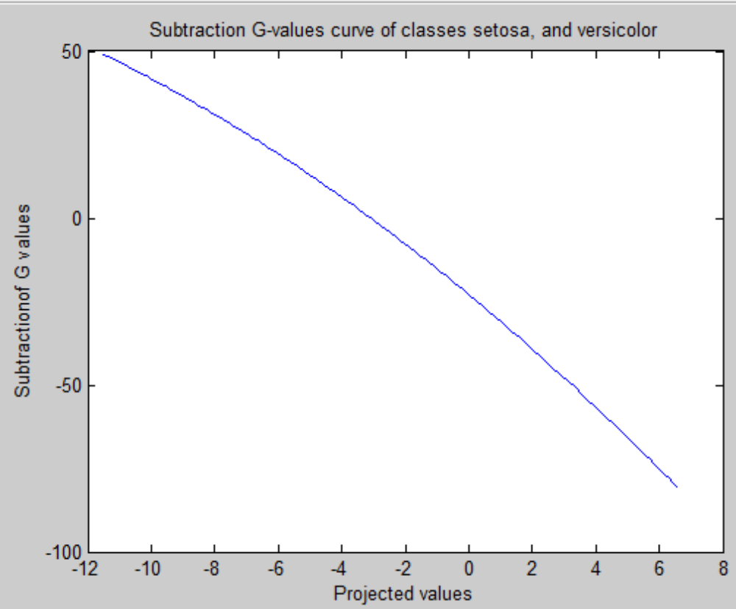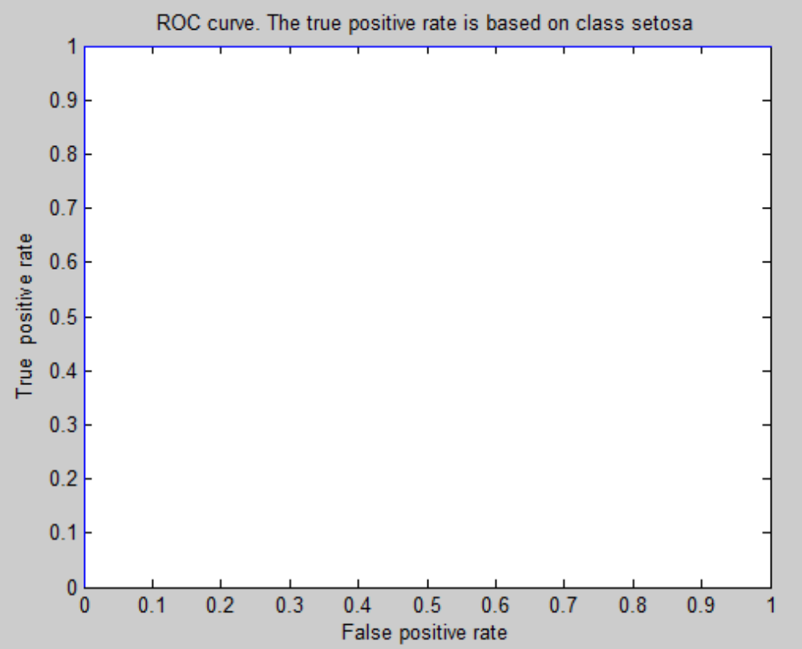

Features 3 and 4
For features 3 and 4, the overall testing accuracy is:
100

The corresponding testing accuracy for class setosa is:
100

The corresponding testing accuracy class versicolor is:
100
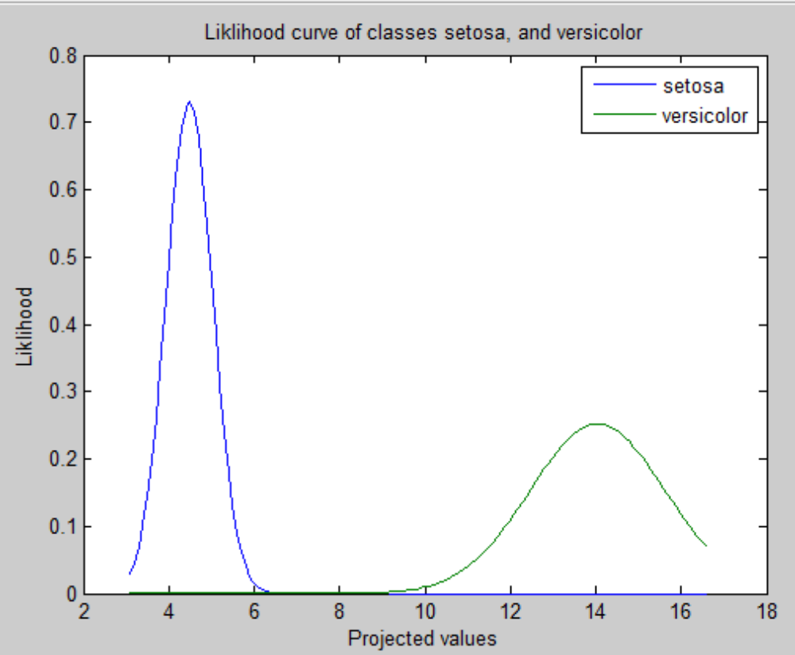
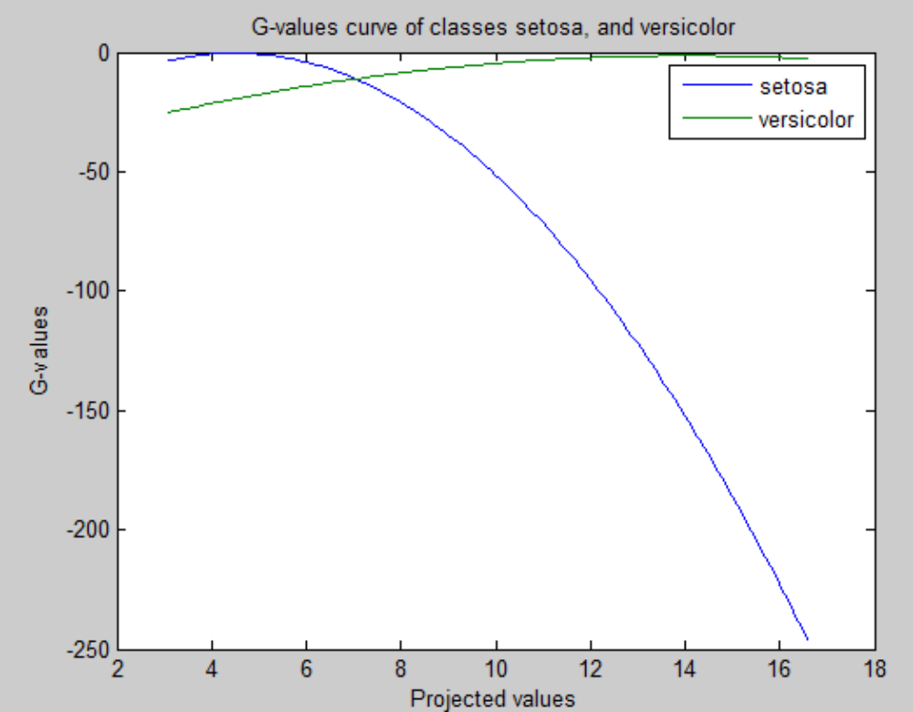
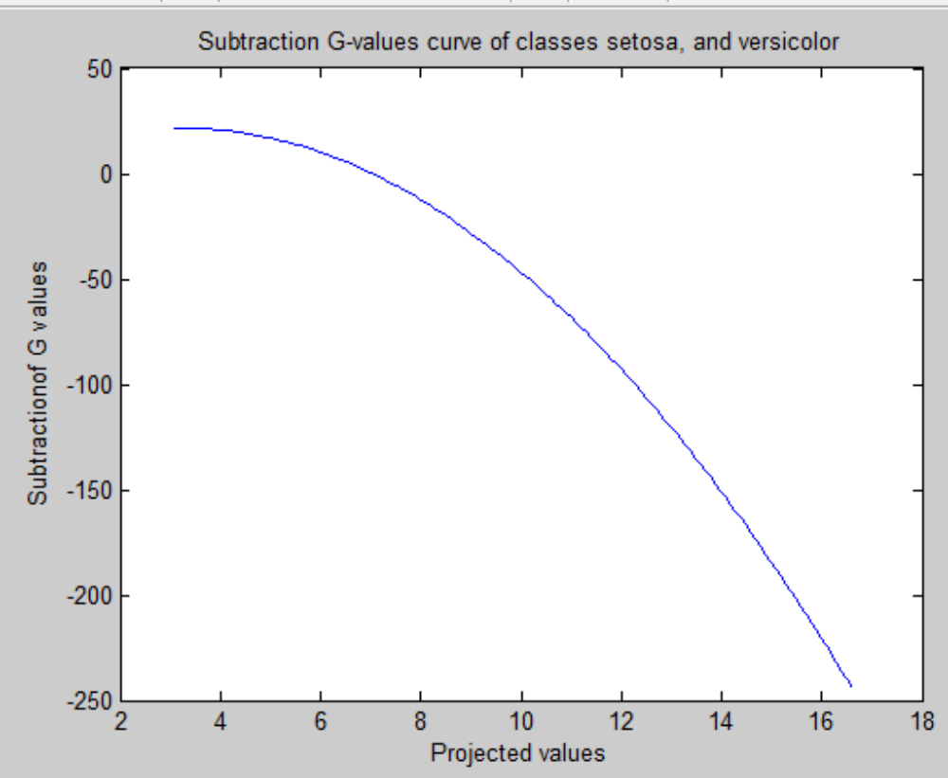
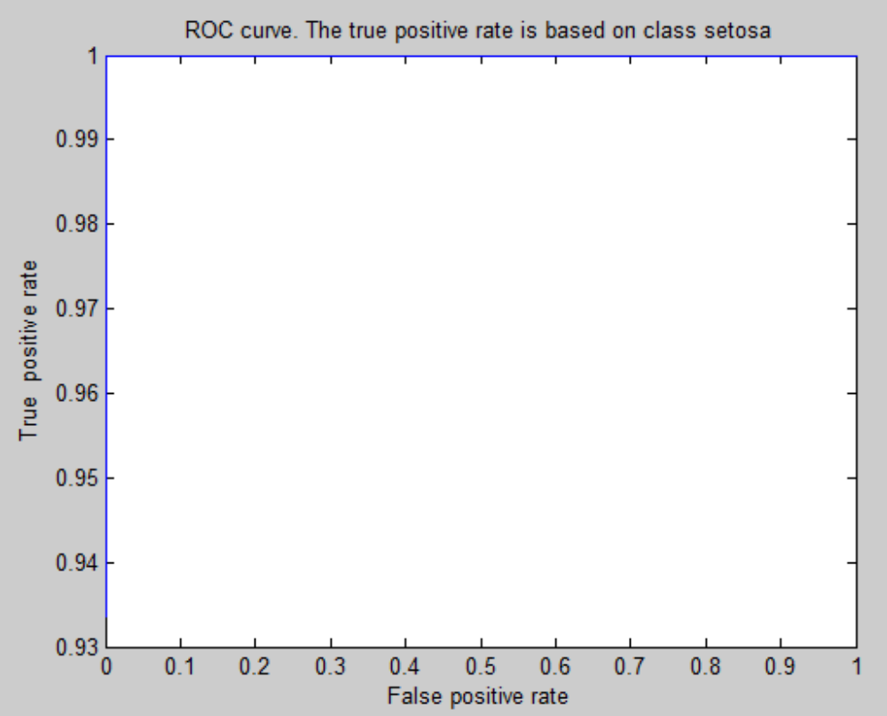
Features 1,2 and 3
For features 1,2 and 3, the overall testing accuracy is:
100

The corresponding testing accuracy for class setosa is:
100

The corresponding testing accuracy class versicolor is:
100
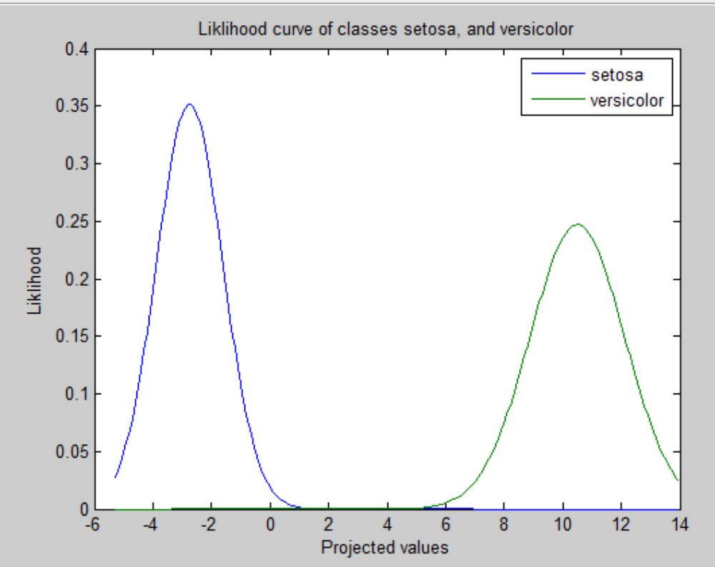

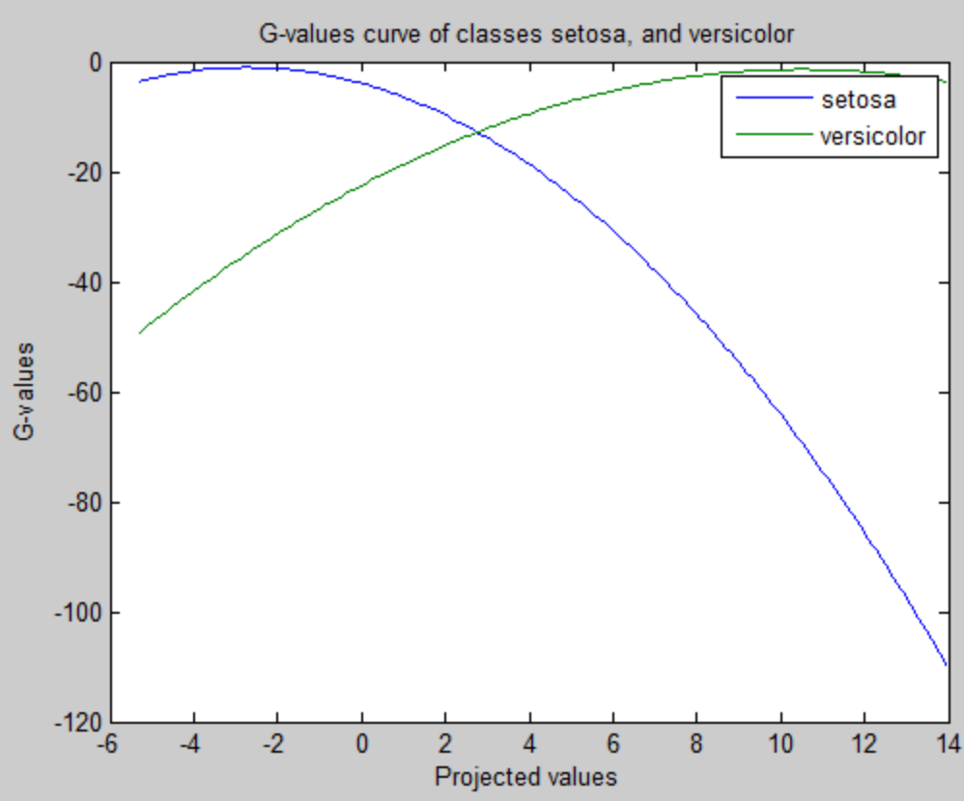
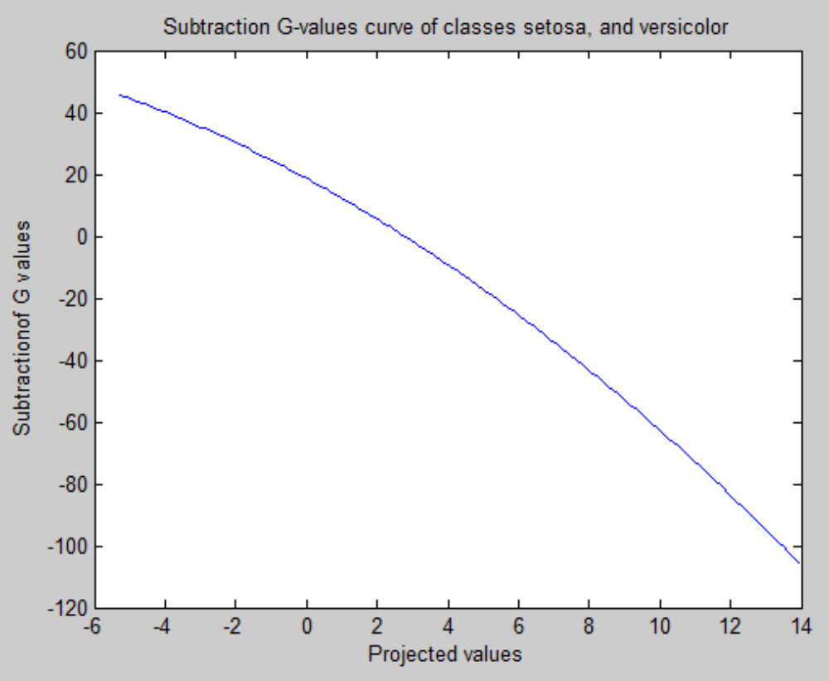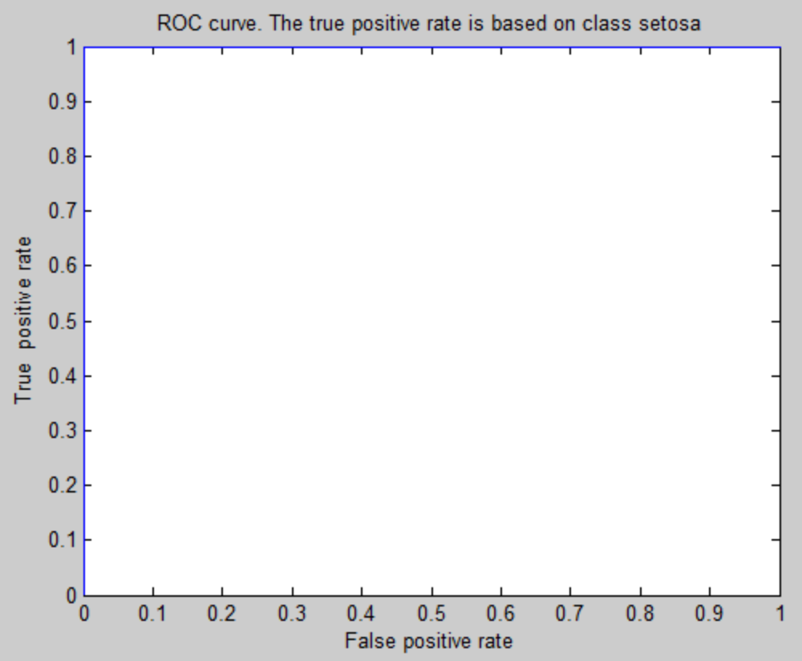
Features 1,2 and 4
For features 1,2 and 4, the overall testing accuracy is:
100

The corresponding testing accuracy for class setosa is:
100

The corresponding testing accuracy class versicolor is:
100
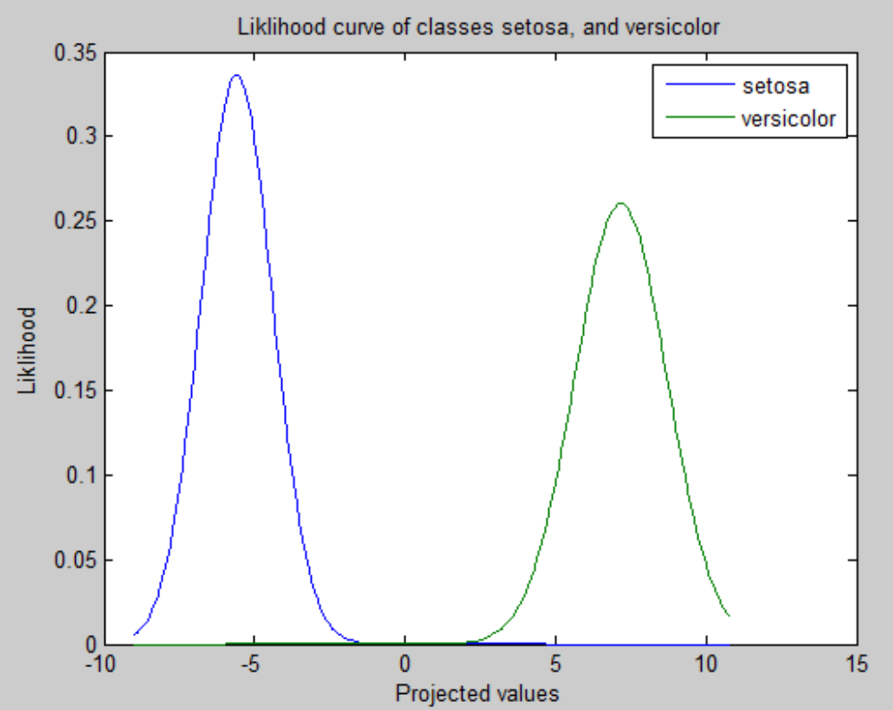
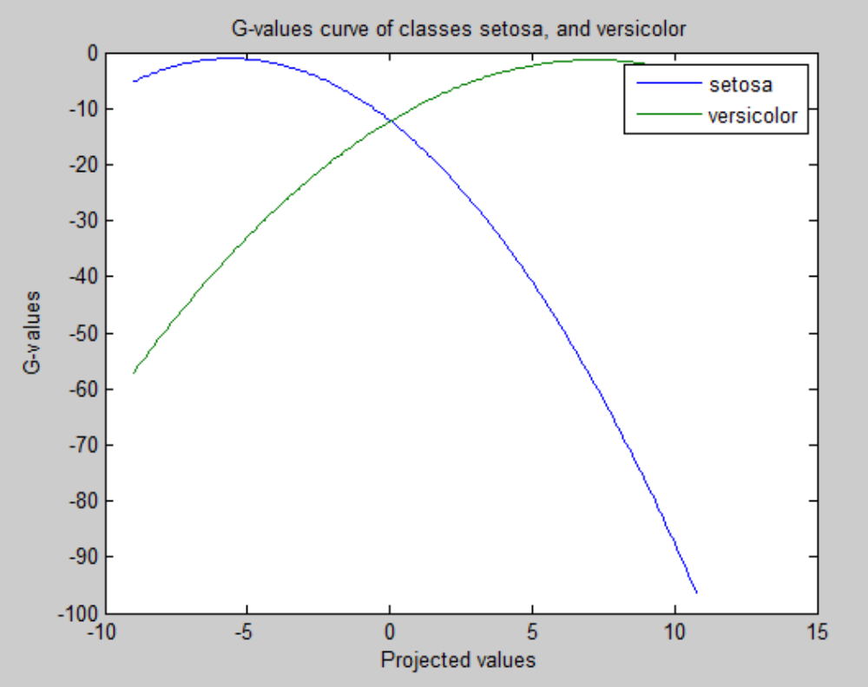
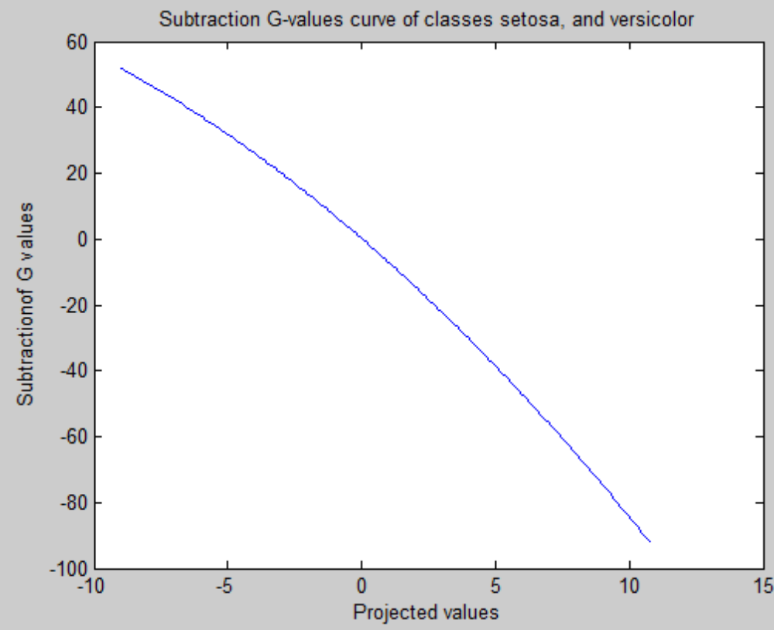
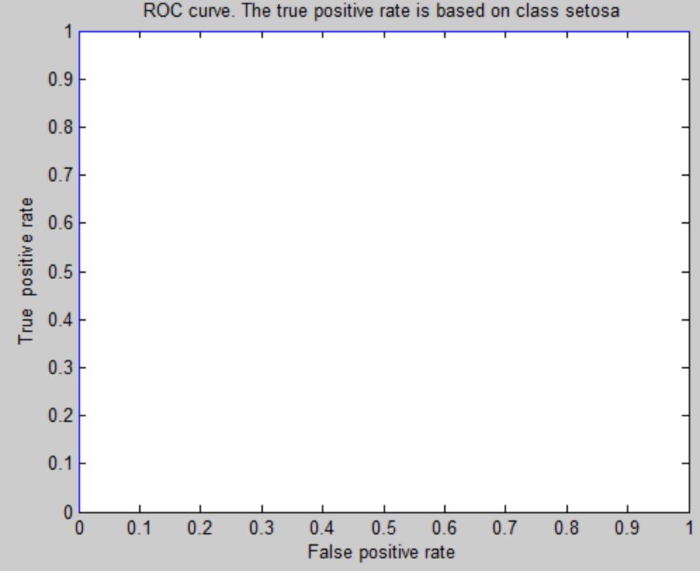
Features 1, 3, and 4
For features 1,3 and 4, the overall testing accuracy is:
100

The corresponding testing accuracy for class setosa is:
100

The corresponding testing accuracy class versicolor is:
100
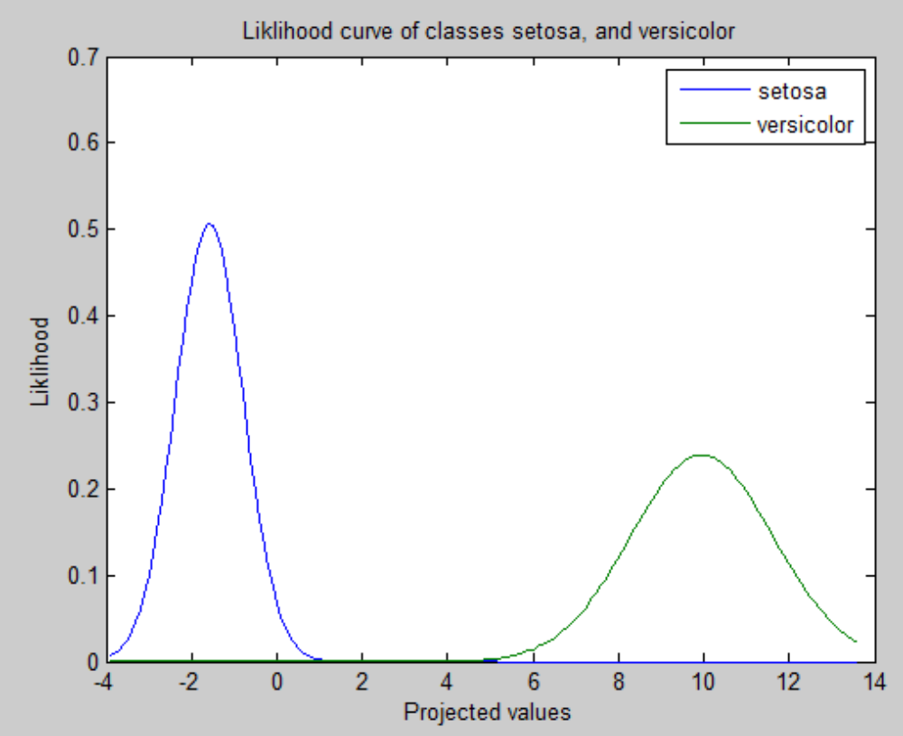
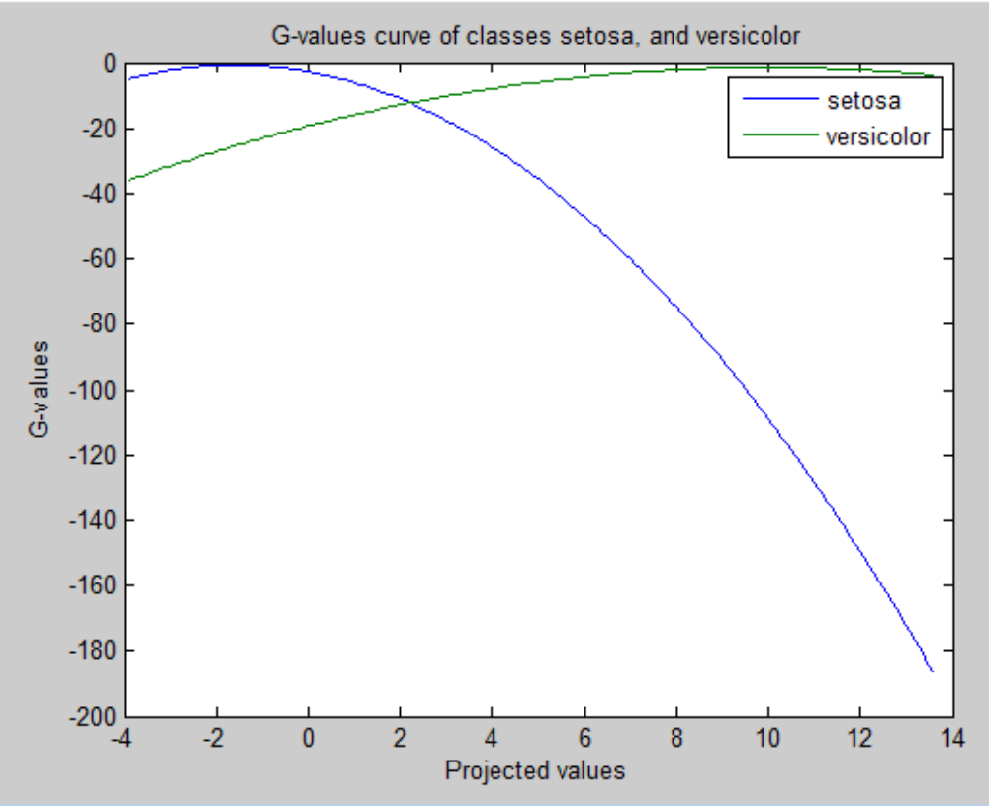
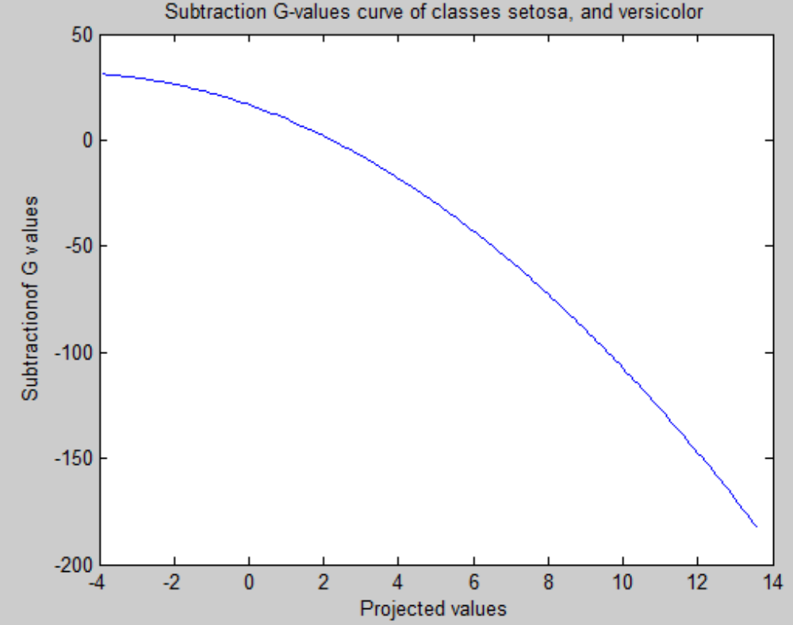
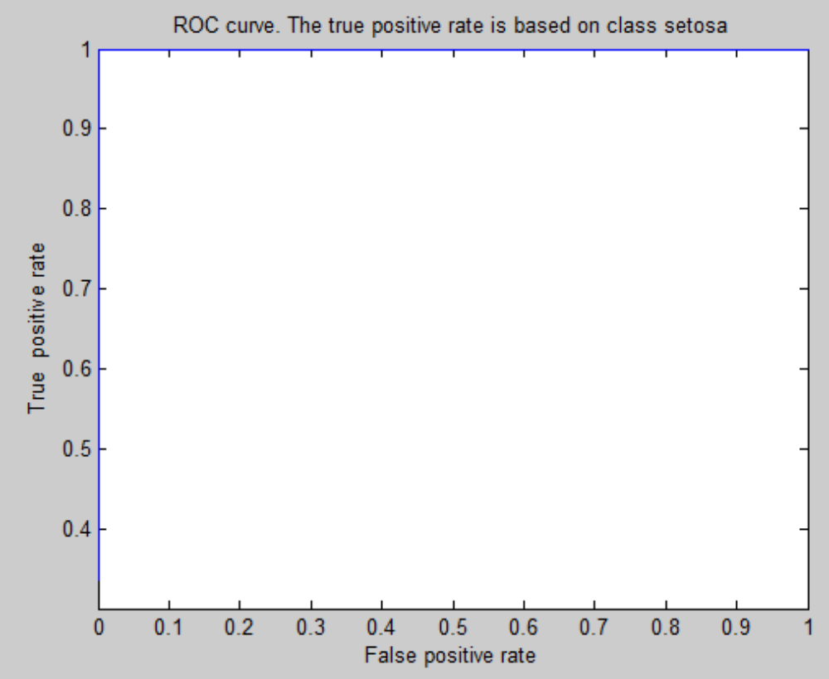
For Features 2, 3 and 4
For features 2,3 and 4, the overall testing accuracy is:
100

The corresponding testing accuracy for class setosa is:
100
The corresponding testing accuracy class versicolor is:
100
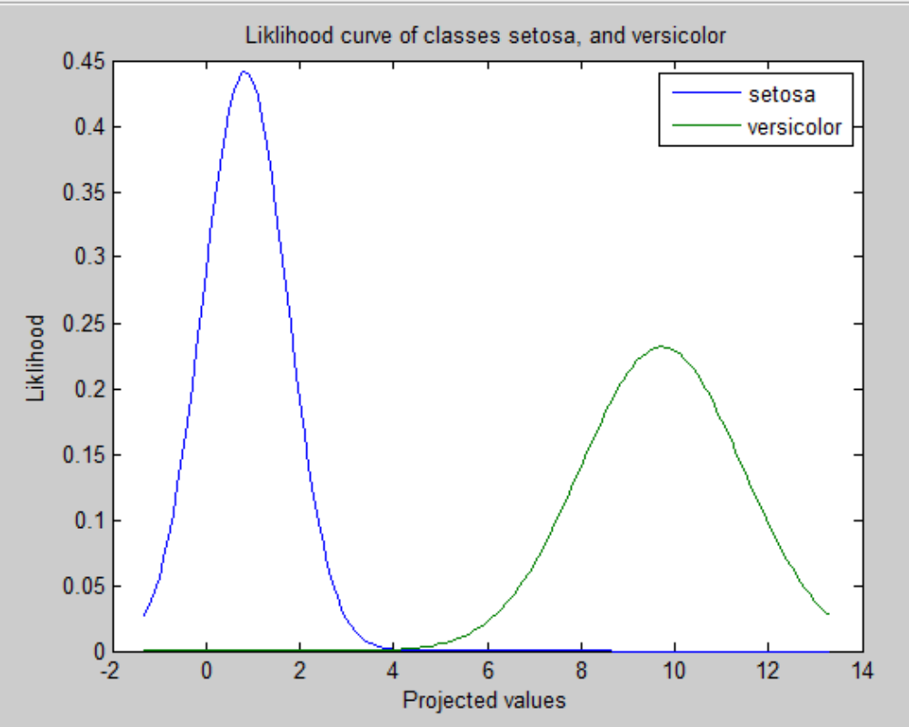
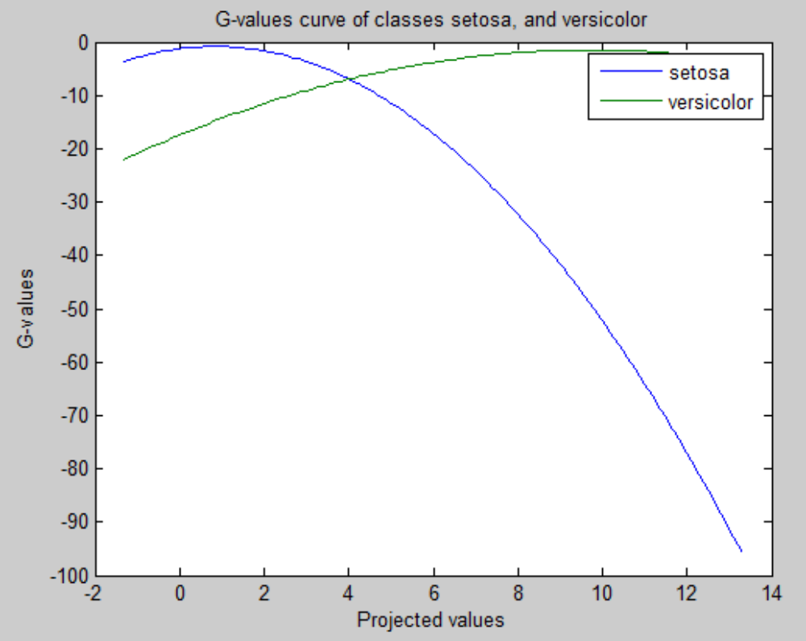
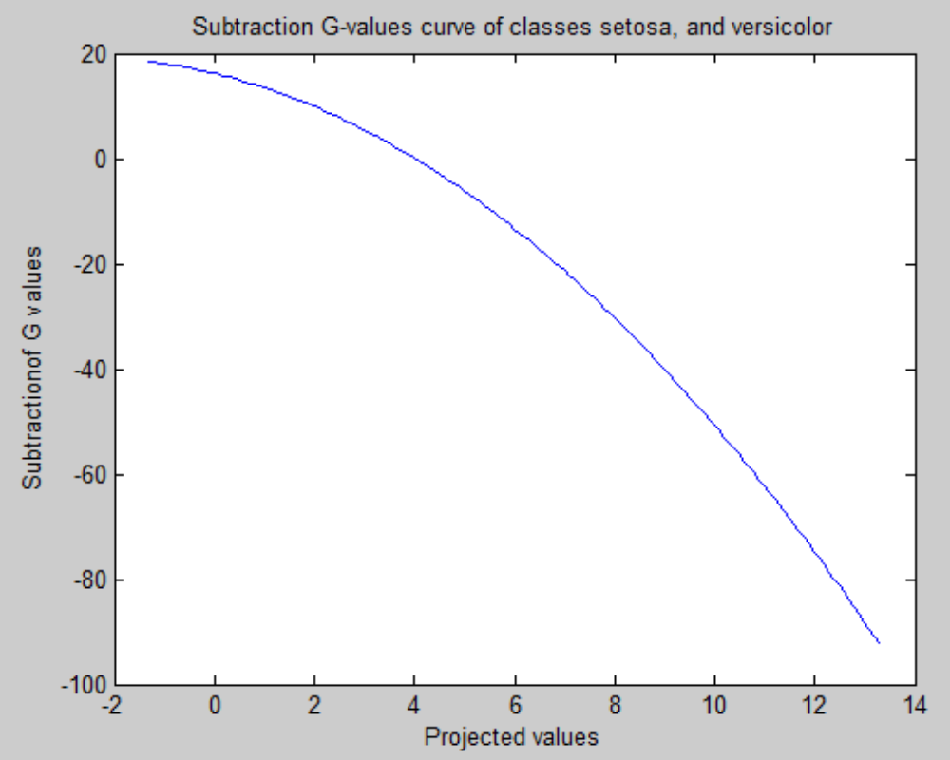
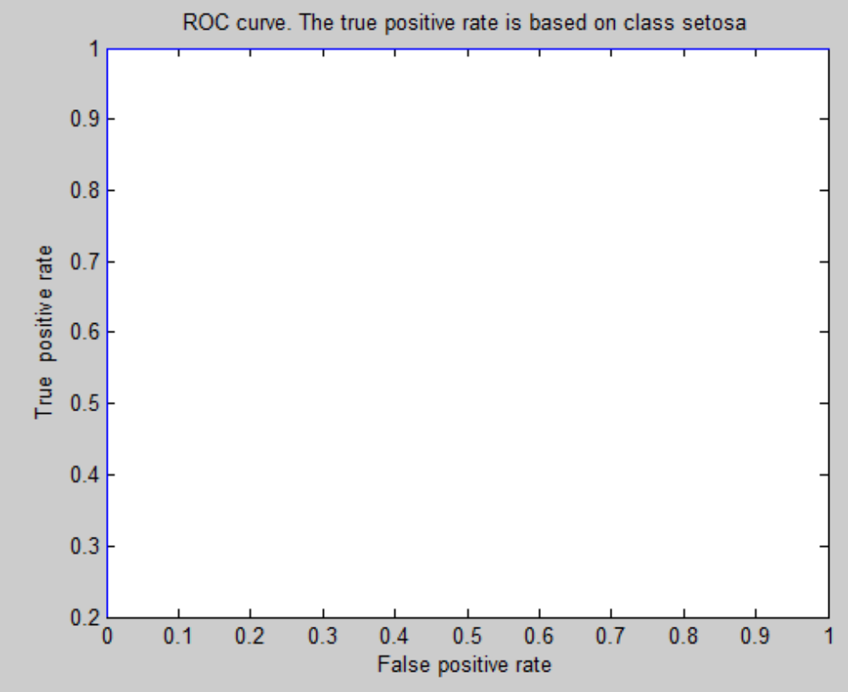
For features 1,2,3, and 4
For features 1,2,3 and 4, the overall testing accuracy is:
100

The corresponding testing accuracy for class setosa is:
100

The corresponding testing accuracy class versicolor is:
100
