The American University in Cairo Department of Computer Science and Engineering CSCE 5930/585 – Selected Topics: Pattern Analysis Dr. Mohamed Moustafa Assignment 3 [10%] Spring 2015 Implement a support vector machine classifier and compare it with any classifier you have developed in Assignment 1 or 2. Make sure to use the same data partitions (training vs. testing) when you do the comparison.
(i)
Comparison of the linear SVM with the the FDA. We will compare the best ROC and worst ROC cursves from the linear SVM classifier and the FDA. The data compared will be the iris dataset. The classification at hand is that of the setosa dataset with respect to the versicolor dataset
The worst performance in the linear classifier in the non-kernel SVM was achieved by feature 2 with an overall classification accuracy of 70% and an accuracy of 93.3% and 50% on classes setosa and versicolor respectively.
The resulting plotted curve was
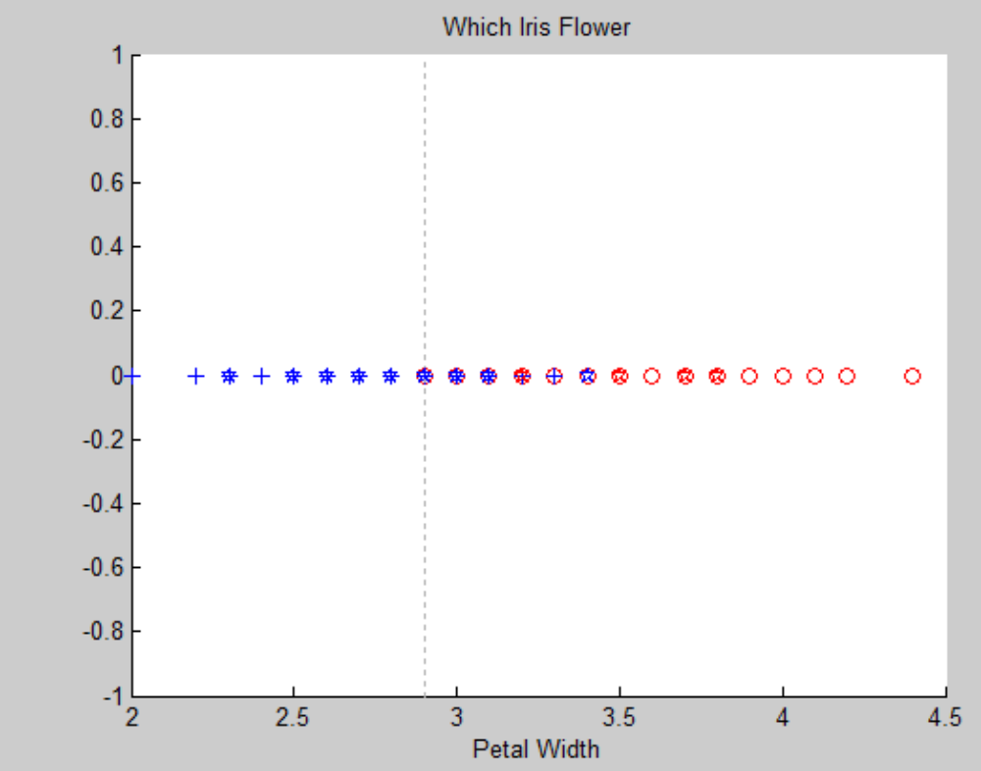
And it's corresponding ROC curve was
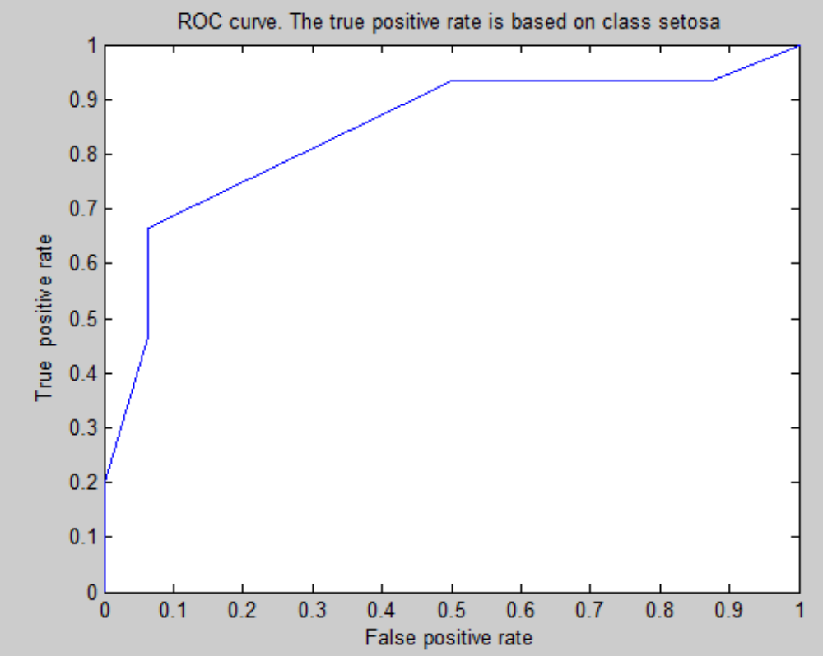

The worst performance in the FDA classifier starting at two features was achieved by features 1 and 2 which overlapped slightly despite the projection with an overall testing accuracy of 96.7. The corresponding testing accuracy for class setosa was 93.3333. And the corresponding testing accuracy class versicolor was 100
The corresponding curve plots after the FDA seperated the data and classified the data as a Gaussian was as follows:
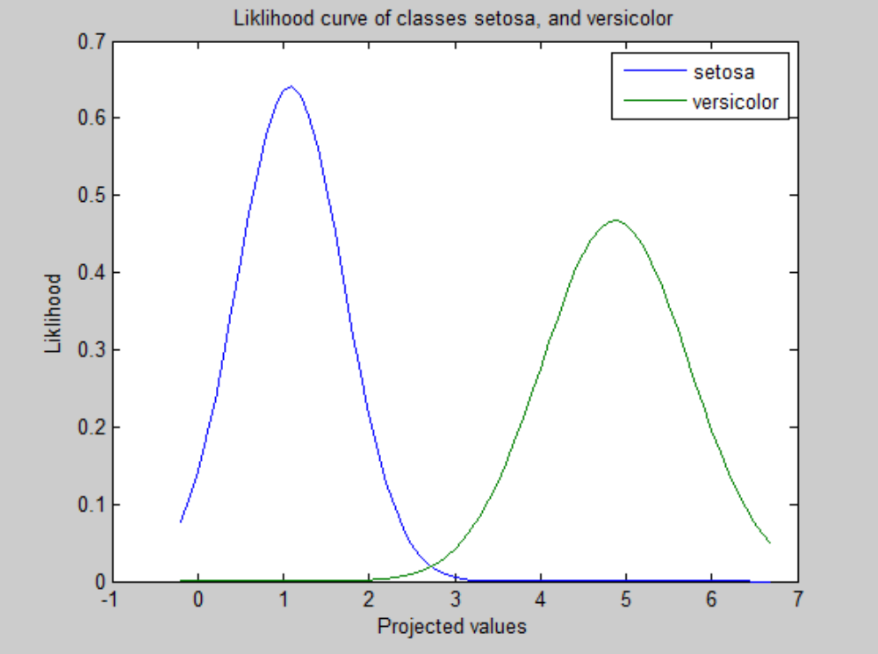
And the resulting ROC curve was:
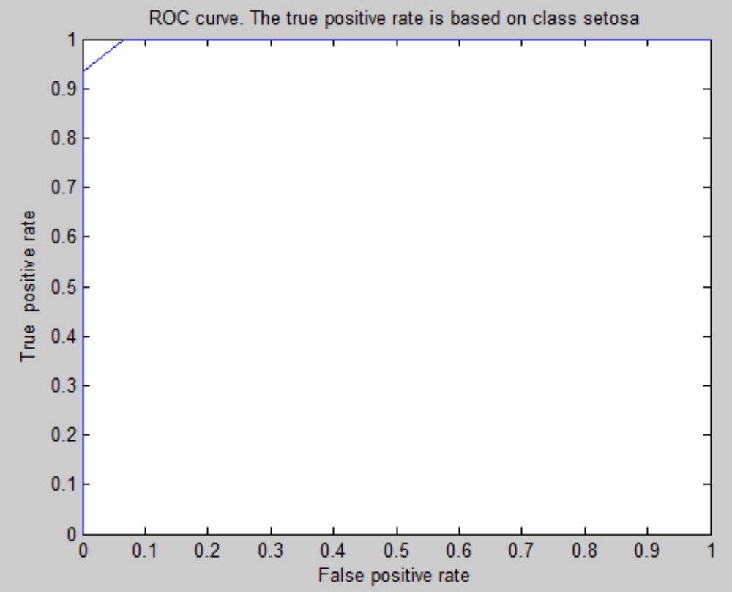

The best performance achieved by the SVM was on features 2 and 3 we chose this in specific despite of many features achieving 100% accuracy on both overall accuracy and class accuracy on the two feature level to compare it to the best classification performance of the FDA. FDA had the best performance on the same classifier with the same accuracy.
For the support vector machine the plots and ROC curves were as follows:
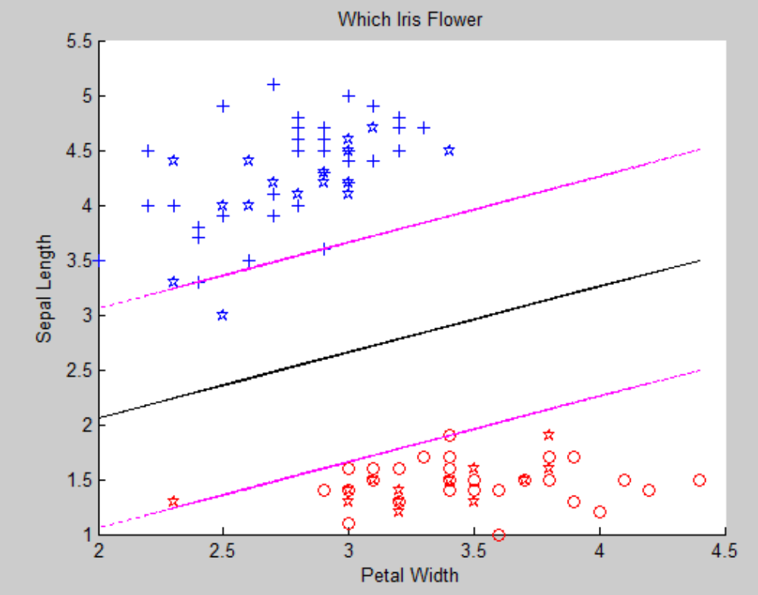
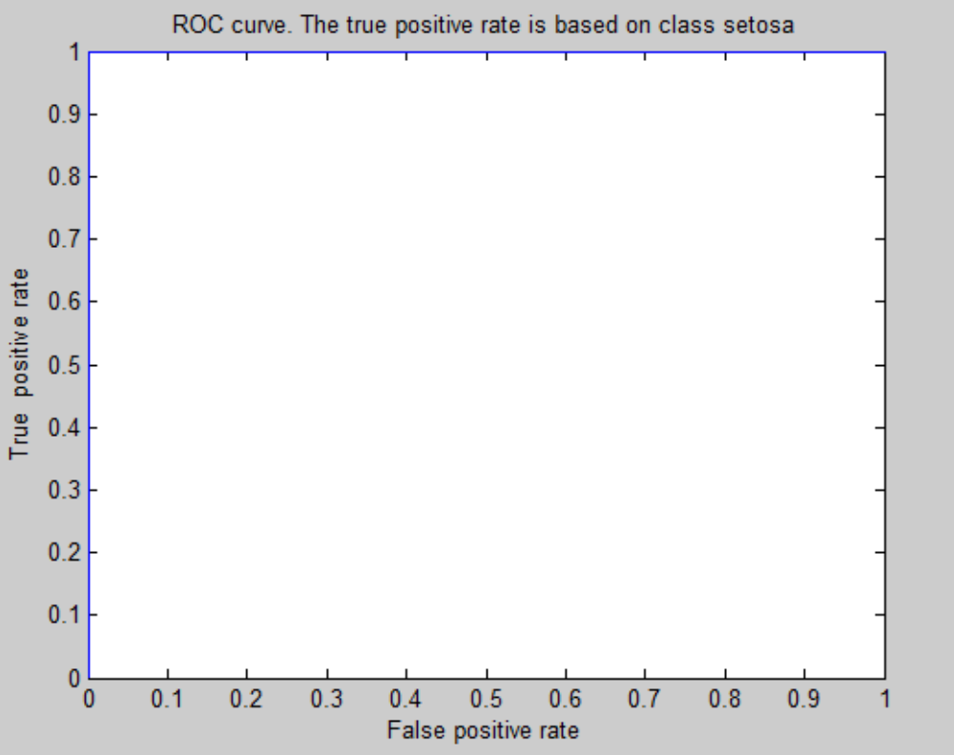
For the FDA the plots were as follows:
Plot for the graph after maximization with FDA and plotting
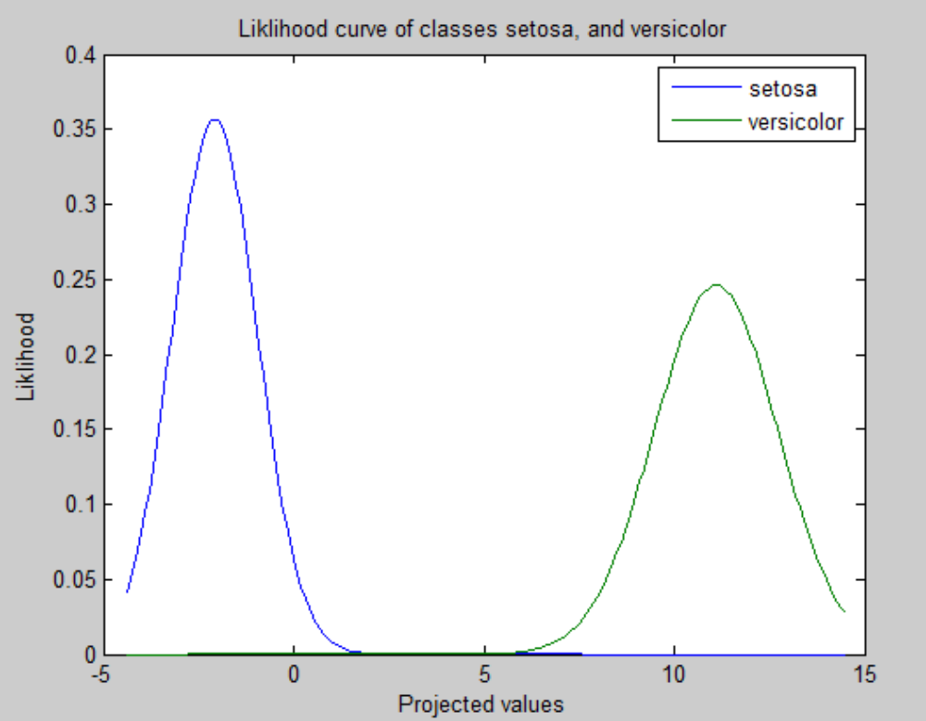
Plot of the corresponding ROC curve for features 2 and 3.
Without the use of a Kernel using FDA followed by classification with Gaussian achieves better results as its worse classifier is well separated compared to the worst classifier in the SVM but to be fair the FDA can only classify features starting from two classes only, as it is a data reduction method.

Comparing the plot of accuracies vs increasing features to further prove that the SVM produces the following curve of number of features vs. accuracy:

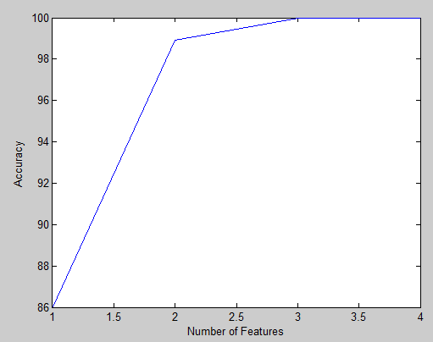
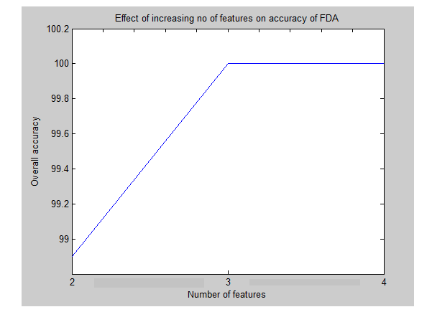
While the FDA produces the following curve:

However using the kernel, which will later be discussed in detail. The worst classification accuracy and corresponding ROC curve achieved for the one feature class was 83.8%, with class Setosa's accuracy and class Versicolor's accuracy being at 80% and 87.5% respectively which is a vast improvement. And the worst possible classification accuracy at the two feature level was 100% achieved by features 1 and 2 which were not clearly separable by the Gaussian before, achieved at 2.7 degree of the polynomial. The corresponding ROC curves are shown below
The ROC curve for polynomial kernel of value 0.1 for feature 2:
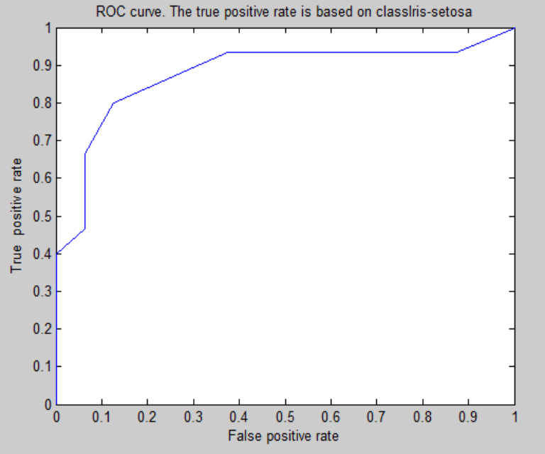

The ROC curve for the polynomial kernel of value 2.7 for features 1 and 2
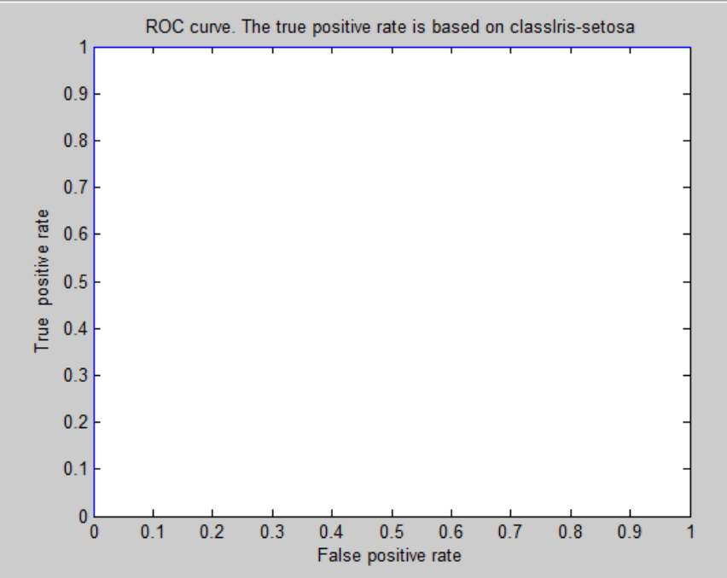
This shows that when using a polynomial kernel the SVM can be a more powerful classifier than the FDA combined with a gaussian classifier. However care has to be taken to choose the appropriate degree for the polynomial at each feature as the optimal value differs per feature as shown in the table below in the third section.
Additionally the accuracy of the classifier per features improved further as shown below:
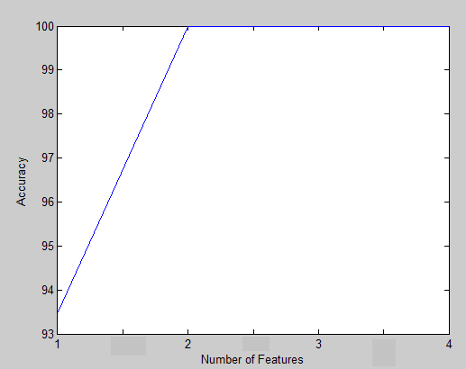

a) Source code of your programs/scripts (using your preferred language).
To run the code you need to run the following scripts.
svm_p(s,v,f,a,k,curve,d,n) runs the classifier
To run the linear SVM use:
svm_p('setosa.txt', 'versicolor.txt',2 ,'w',0,'x',0,0); for setosa as class 1
svm_p('virginica.txt', 'versicolor.txt',2 ,'w',0,'x',0,1); for virginica as class 1
svm_p('virginica.txt', 'versicolor.txt',2 ,'w',0,'ROC',0,1); for the ROC curve
The two here states that you will use feature 2 to classify
To run polynomial use
svm_p('setosa.txt', 'versicolor.txt',12 ,'a',1,'x',0.5,0); %to run a polynomial kernel of degree 0.5, for features 1 and 2
svm_p('setosa.txt', 'versicolor.txt',12 ,'a',2,'x',0.5,0); % to run a radial basis kernel of sigma 0.5, for features 1 and 2
traintestsvm(w,x,b,k,cst,cvt,f,c,alphar,X,Y,d,n )
is part of svm_p and trains and tests the classifier as well as draws ROC curves.

b) Document containing: 1. Explanation of your classifier and of your data.
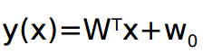
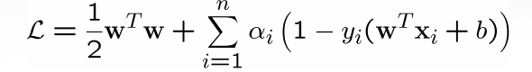
The data: As before the iris dataset is used but this time all three classes are tested as binary classifiers.
Class setosa is tested against versicolor. They are linearly separable. Class virginica is tested against versicolor. They are not linearly separable. With each first a linear classifier is used as stated above. Then the kernels to see the effect on classification accuracy, and if setosa vs. versicolor can be improved while virginica vs versicolor can be made linearly seperable.
The linear SVM
The classifier works by finding the boundary between two classes using the hyperplane
This is done using the constraints
Where the first parameter maximizes the margin between the classes while the second parameter ensures that the least error is achieved, taking into account the correct classification of each points using these constraints the best hyperplane will be chosen that will divide the data exactly in the middle while increasing the margins of the data at the same time. Instead of poorly seperating between the two points with a random boundary.

This is achieved in matlab as follows. Quadprog Matlab usually defines its constraints in the form of
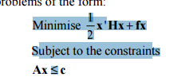
for the function:
The encoding is done as follows:

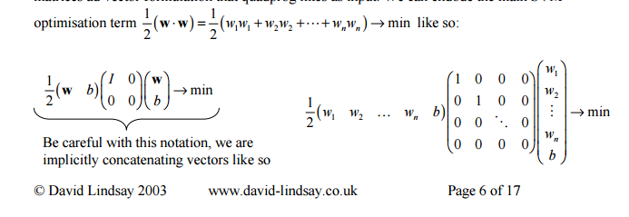
where H = the identity array with zero at the end to avoid minimizing the b.
f = 0

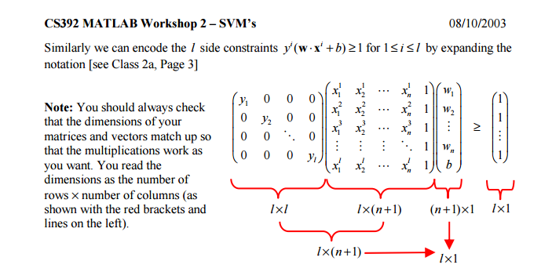

A = diagonal y values but the sign is flipped to make it less than. And the array of ones is the c value but again the sign is flipped to flip the equality sign and make it minimum.
The function above outputs w of dimension of b + w which is directly substituted in the
funciton g =wTx + b giving a discriminant value. If the value is above zero the class is setosa otherwise versicolor for the first dataset. And virginica otherwise versicolor for the second dataset.
~~~~~
To implement the non-linear kernal. The minimization condition stated above in the lagrangian was diffrentiated to give:
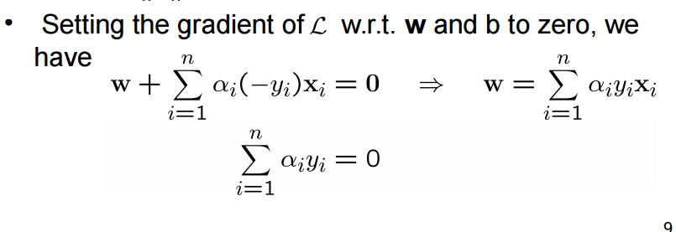
Substituting that back in the lagrangian term we get:

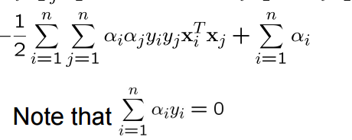

Sometimes kernels are applied to data to make them linearly seperabale. e.g. XOR applying and and function to get x3 and linearly seperating that (to x1 and x2). The kernel trick is you only have to replace each dot product of x with the dot product of the kernel. Instead the equation above becomes.

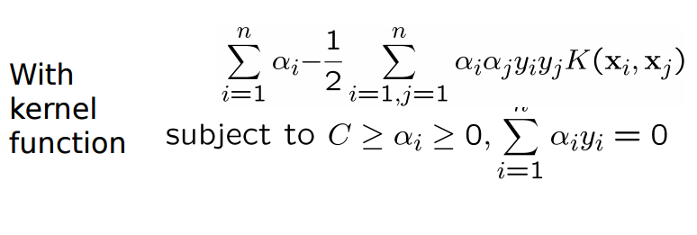
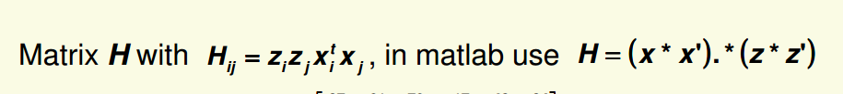
We get the alpha that will best classify the data using the quadratic programming as follows in Matlab
Using the previous constraint format as mentioned before. The z*z' are the class coordinates, and the x*x' are the points, only we replace them with K(xi,xj) to achieve the kernel trick.

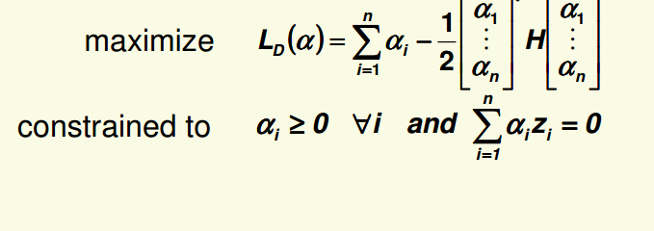
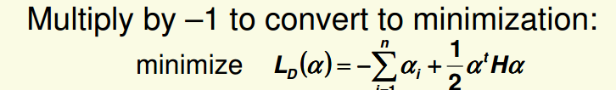

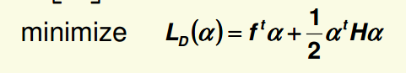
f is a vertical array of -1's with same dimensions as the training dataset.
To achieve the other constraints. Set

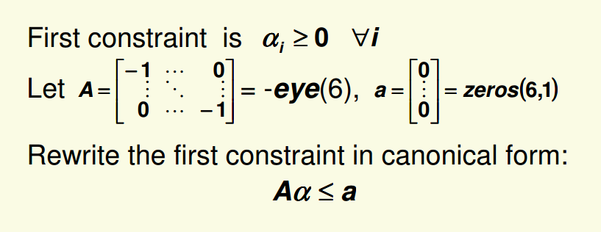
But with the same dimensions at the training dataset.

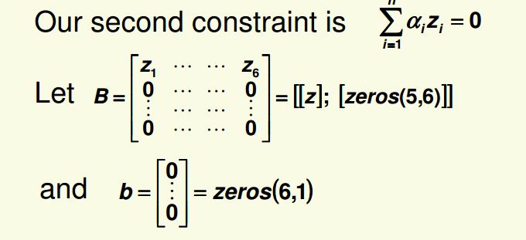
Using the same dimensions as the training dataset.
Finally set upper bound and lower bound = 1000 and zero respectively.
Call quadprog as follows and the resulting alphas will be used to apply the kernel trick directly to the di
srimination function..
The new discrimination function being

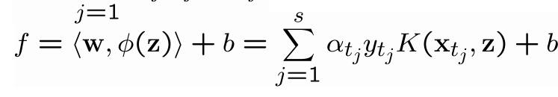
To calculate the b set f = 1 or -1 and to the corresponding x and alpha (which are support vectors), and calculate the b. You can do this with one point and take an average. After this use f to decide the class fi the function > 0 decide the first class, otherwise the second.

2. Plot the ROC curves for your classifiers.

The ROC curves are all shown in two attached docx documents labelled setosa and virginica.

3. Plot your accuracy results in a graph, where x-axis is the number of features and y-axis is the classification accuracy. What number of features and kernel type gave you the best accuracy? Notes: You can use external tools and libraries to solve the quadratic programming step in building the SVM.
The effect of increasing the features on the accuracy of the SVM without applying a kernel, on the classificatoin accuracy of class setosa vs. versicolor, when using the linear separator, which is trying to maximize w.^2/2 and with the constraint that y(wx+b) >1
 | f1 | f2 | f3 | f4 | F1&  f2 | F1 &  f3 | F1 &  f4 | F2 &  f3 | F2 &  f4 | F3 &  f4 | F1,f2 & f3 | F1,  f2  &f4 | F1,f3,f4 | F2,  f3,f4 | F1,f2,f3  ,f4
Overall  Testing  Accuracy | 74.1 | 70 | 100 | 100 | 96.7 | 100 | 100 | 100 | 96.7 | 100 | 100 | 100 | 100 | 100 | 100
Testing  Accuracy setosa | 46.6 | 93.3 | 100 | 100 | 93.3 | 100 | 100 | 100 | 93.3 | 100 | 100 | 100 | 100 | 100 | 100
Testing  Accuracy versicolor | 100 | 50 | 100 | 100 | 100 | 100 | 100 | 100 | 100 | 100 | 100 | 100 | 100 | 100 | 100
Without a kernel for the SVM and the setosa vs. versicolor iris dataset.
The overall accuracy of using one feature is: 86%
The overall accuracy of using two features is: 98.9%
The overall accuracy of using three features is: 100%
The overall accuracy of using four features is: 100%

Curve for using svm without the kernel and the corresponding accuracy with increasing number of features.
The effect of increasing the features on the accuracy of the SVM after applying a kernel.
The kernels will be tried on f1, f2, using dual features f2 and f3, as well as f2 and f4 only as those are the features that need improvement. Theoretically the kernel should improve the performance. The f in f2 stands for feature. The kernel being applied is the quadratic function and radial bases functions respectively the degree of the polynomial and sigma of the radial basis function
 | Using polynomial kernel |  |  |  | Using the radial basis kernel
 | F1 | f2 | F1&  f2 | F2 &  f4 | F1 | F2 | F1&  f2 | F2 &  f4
Overall  Testing  Accuracy | 90.3 | 83.8 | 100 | 100 | 83.8 | 64.5 | 80.6 | 93.5
Testing  Accuracy setosa | 93.3 | 80 | 100 | 100 | 93.3 | 73.3 | 80 | 93.3
Testing  Accuracy versicolor | 87.5 | 87.5 | 100 | 100 | 75 | 56.3 | 81.3 | 93.8
Degree or Sigma used  that gave optimal results. | 2 | 0.1 | 2.7 | 2 | 0.5 | 0.3 | 0.7 | 0.7
For class setosa vs. versicolor
Using the polynomial kernel only at the appropriate or optimal degrees
The overall accuracy of using 1 feature is: 93.5%
The overall accuracy of using 2 features is: 100%
The overall accuracy of using 3 features is: 100%
The overall accuracy of using 4 features is: 100%

Curve for using the SVM with a polynomial kernel where each kernel degree is maximized per feature to achieve the best results.

The effect of increasing the features on the accuracy of the SVM without applying a kernel, on the classificatoin accuracy of class virginica vs. versicolor, when using the linear separator, which is trying to maximize w.^2/2 and with the constraint that y(wx+b) >1

 | f1 | f2 | f3 | f4 | F1&  f2 | F1 &  f3 | F1 &  f4 | F2 &  f3 | F2 &  f4 | F3 &  f4 | F1,f2 & f3 | F1,  f2  &f4 | F1,f3,f4 | F2,  f3,f4 | F1,f2,f3  ,f4
Overall  Testing  Accuracy | 50 | 50 | 87.5 | 93.75 | 56.3 | 78.1 | 96.9 | 83.4 | 87.5 | 96.9 | 78.1 | 96.9 | 96.9 | 100 | 96.9
Testing  Accuracy virginica | 100 | 100 | 100 | 93.75 | 81.3 | 62.5 | 93.8 | 75 | 93.3 | 93.8 | 62.5 | 93.8 | 93.8 | 100 | 93.8
Testing  Accuracy versicolor | 0 | 0 | 75 | 93.75 | 31.3 | 93.8 | 100 | 100 | 100 | 100 | 93.8 | 100 | 100 | 100 | 100
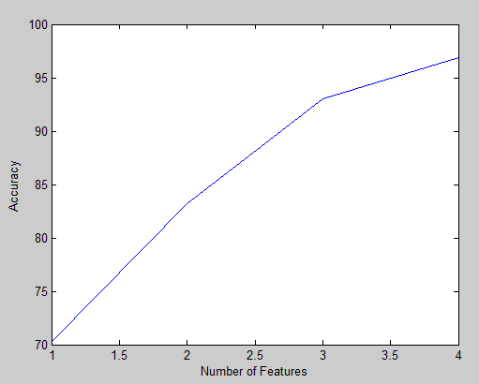
Overall accuracy of 1 feature: 70.3
Overall accuracy of 2 feature : 83.2
Overall accuracy of 3 feature : 93
Overall accuracy of 4 feature : 96.9

The effect of using a polynomial kernel on the accuracy of the SVM on the classification accuracy of class virginica vs. versicolor, when using the linear separator, which is trying to maximize w.^2/2 and with the constraint that y(wx+b) >1

Polynomial kernel | f1 | f2 | f3 | f4 | F1&  f2 | F1 &  f3 | F1 &  f4 | F2 &  f3 | F2 &  f4 | F3 &  f4 | F1,f2 & f3 | F1,  f2  &f4 | F1,f3,f4 | F2,  f3,f4 | F1,f2,f3  ,f4
Overall  Testing  Accuracy | 78.13 | 65.63 | 96.9 | 96.9 | 78.13 | 96.9 | 96.9 | 96.9 | 96.9 | 100 | 93.8 | 96.9 | 100 | 100 | 100
Testing  Accuracy virginica | 68.75 | 81.25 | 93.8 | 93.8 | 62.5 | 93.8 | 93.8 | 93.8 | 93.8 | 100 | 87.5 | 93.8 | 100 | 100 | 100
Testing  Accuracy versicolor | 87.5 | 50 | 100 | 100 | 93.75 | 100 | 100 | 100 | 100 | 100 | 100 | 100 | 100 | 100 | 100
Degree of kernel used | 0.1 | 0.1 | 0.1 | 0.1 | 0.1 | 1.8 | 0.1 | 0.1 | 0.1 | 2 | 0.1 | 0.1 | 0.1 | 0.1 | 0.1
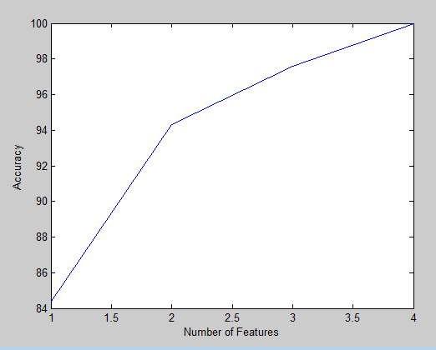
Overall accuracy of 1 feature: 84.4
Overall accuracy of 2 feature : 94.3
Overall accuracy of 3 feature : 97.6
Overall accuracy of 4 feature : 100
The effect of using a radial basis kernel on the accuracy of the SVM on the classification accuracy of class virginica vs. versicolor, when using the linear separator, which is trying to maximize w.^2/2 and with the constraint that y(wx+b) >1. As can be shown it doesn't perform very well

Radial  Basis kernel | f1 | f2 | f3 | f4 | F1&  f2 | F1 &  f3 | F1 &  f4 | F2 &  f3 | F2 &  f4 | F3 &  f4 | F1,f2 & f3 | F1,  f2  &f4 | F1,f3,f4 | F2,  f3,f4 | F1,f2,f3  ,f4
Overall  Testing  Accuracy | 78.13 | 65.63 | 15.63 | 59.4 | 62.5 | 31.25 | 68.75 | 31.25 | 65.63 | 34.38 | 40.63 | 65.6250 | 43.75 | 37.5 | 46.88
Testing  Accuracy virginica | 68.75 | 81.25 | 18.75 | 100 | 100 | 56.25 | 62.5 | 62.5 | 62.5 | 56.25 | 37.5 | 62.5 | 50 | 56.25 | 56.25
Testing  Accuracy versicolor | 87.5 | 50 | 12.5 | 18.8 | 25 | 100 | 75 | 0 | 68.75 | 12.5 | 43.75 | 68.75 | 37.5 | 18.75 | 37.5
Degree of kernel used | 0.1 | 0.2 | 1 | 0.1 | 0.15 | 1 | 1.5 | 2 | 1.5 | 1.5 | 1.55 | 0.7 | 1.5 | 2 | 1.5
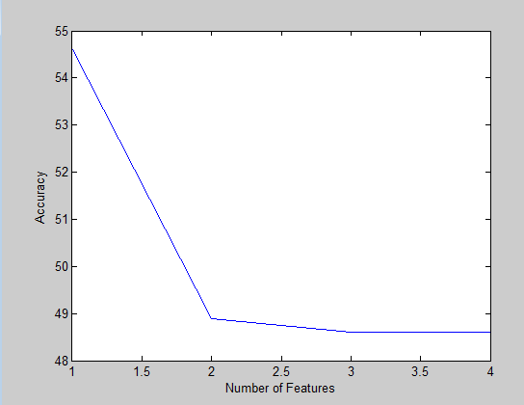
Overall accuracy of 1 feature: 54.6
Overall accuracy of 2 feature : 48.9
Overall accuracy of 3 feature : 46.8
Overall accuracy of 4 feature : 46.8
The best classifier is that of the polynomial with optimized degree. The worst is radial basis even when optimized as the performance decreases. It is not suitable for this dataset at least with C = 1000.

We consider the worst accuracy to be a situation where one class is classified and the other is not recognized at all therefore an example of the worst accuracy is feature 2 without using the kernel. concerning virginica vs. versicolor, while an example of the worst classification is using features 3 and 4 at degree 2 of the polynomial kernel. Although there are worst performances when using the radial basis function, as it is not suitable for seperating this specific problem set. Please refer to the .docx documents.

