Select one of the following two problems:
I've selected the FDA problem
1- Implement a classifier based on FDA and compare it with the Baysian-Gaussian classifier you
developed in Assignment 1-b). Show the effect of multiple input features on the final accuracy of
both classifiers.
Because the FDA's main goal is reduce multiple features to that of a linear classifier, we will only compare the FDA to the Baysian Gaussian Classifier. We will do so by comparing the accuracies as well as ROC curves of the best features from both the Baysian and the Gaussian Classifier for multiple features.
The following assumption is made with the Gaussian classifier, when increasing the number of features, the amount of time taken to train and test the classifier increases drastically. This is due to the g-matrix used for boundary calculation increasing from 1 dimensions to 2, 3, and 4 dimensions. Thus we will only compare the FDA with the best classifier from Gaussian using 2 features, not more, as both the accuracy and the speed of the classfier as high.
In the FDA, most classifiers output 100% accuracy as well as a perfect ROC curve due to the maximum seperation of data. Using the same logic for FDA, although the data ultimately collapses to one dimension calculating the projection of 2 features onto one dimension values is slightly faster than 3 and 4 features. Thus we'll select our best classifier from the projections of the two features.
I selected the FDA classifier which combines feature 2 and 3 since the seperation between the two points is vast as shown by the gaussian, g-values, and g-decision bounday curves before.
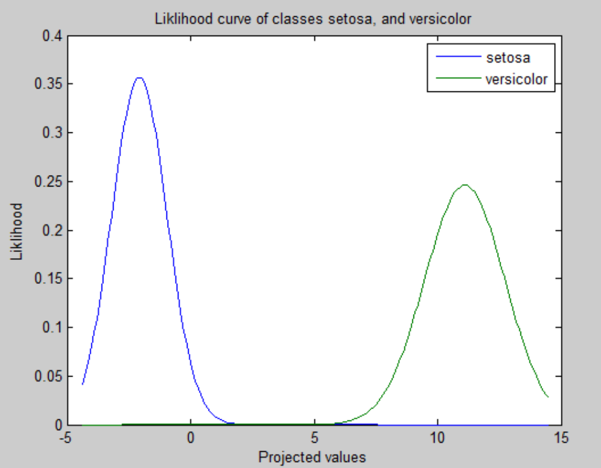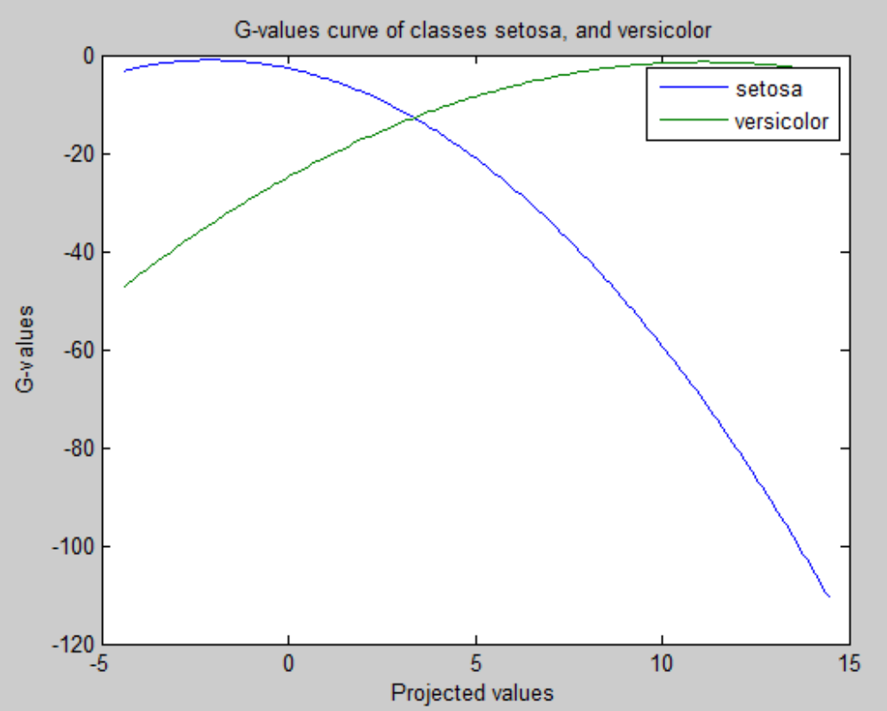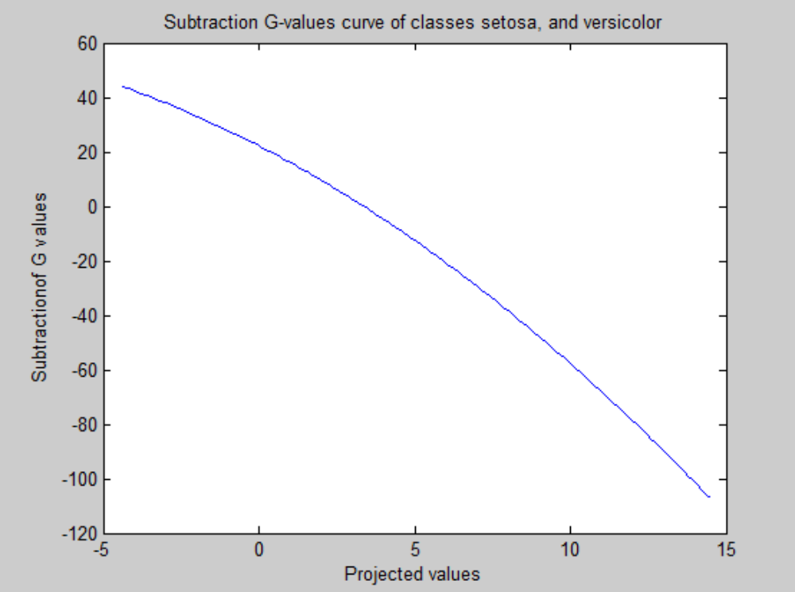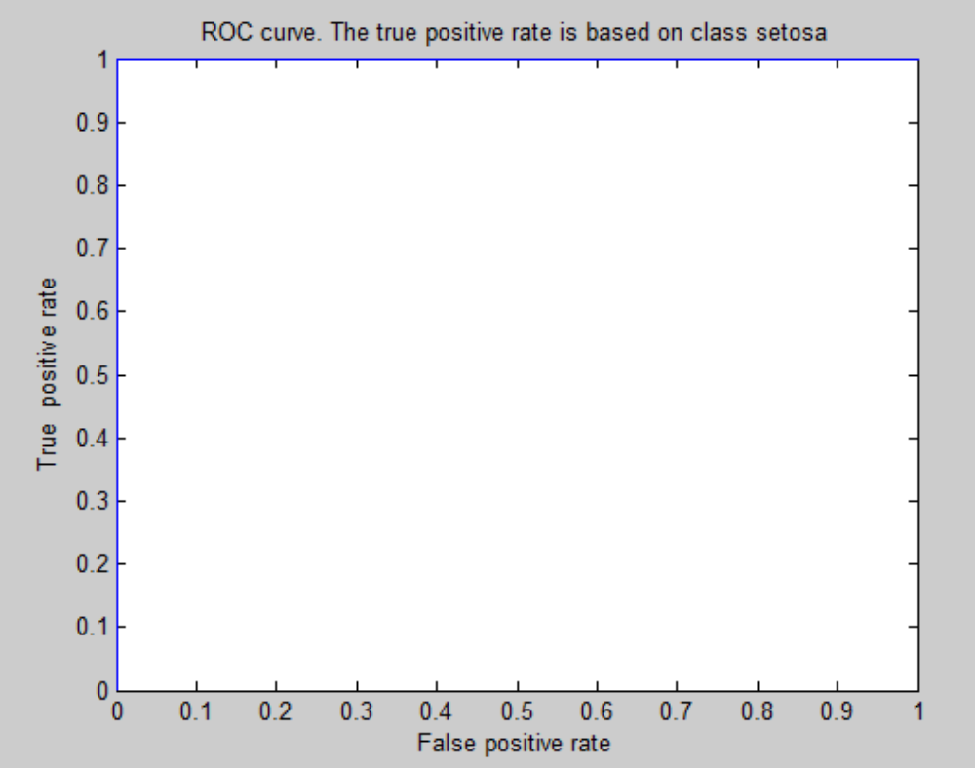
For features 2 and 3, petal width and sepal lenght the overall testing accuracy was 100%, while the corresponding testing accuracy for both class setosa and versicolor were 100%. As can be seen the classification is very accurate as well as fast.
In the case of the Gaussian classifier, the two features the showed the best seperability where also features 2 and 3 as can be shown by their corresponding gaussian curves, g-value curves, as well as ROC curve, and the boundary planes respectively. The ROC curve is also ideal with the curve pushed against the to and the right side of the curve showing perfect classification. As can be seen from the final accuracy table, the overall accuracy of sing features 2 and 3, as well as the accuracy on class setosa and versicolor respectively is 100%. The difference is in the execution time of the training the classifier as the boundary equations and Gaussian boundary functions are expensive to calculate.
Gaussian Plot for Features 2 and 3 for setosa and versicolor respectively
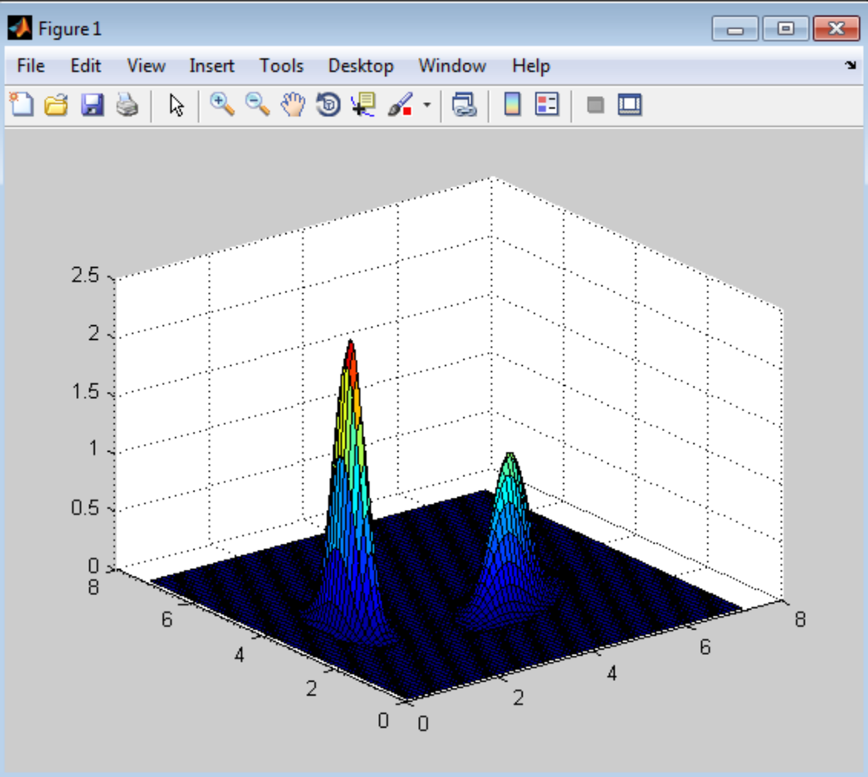

G-plots (boundary) curves for both setosa and versicolor.
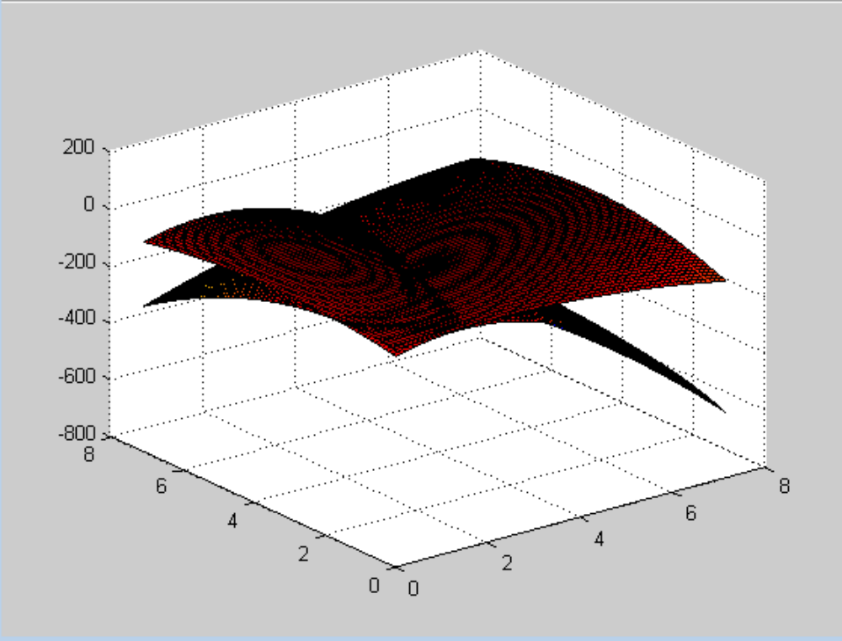
The diagram below shows the corresponding ROC curve the curve shows perfect classification.
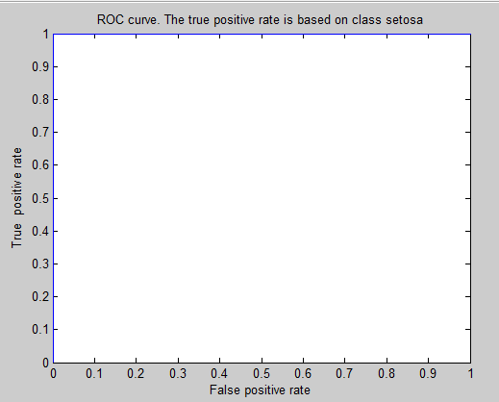
Both classifiers have identical ROC curves but one is faster than the other, since less values for g which is the boundary function are calculated for FDA which is in one dimension as compared to the Gaussian which is in two dimensions.

Table showing the effect of increasing features on the accuracy of classification of the Bayesian
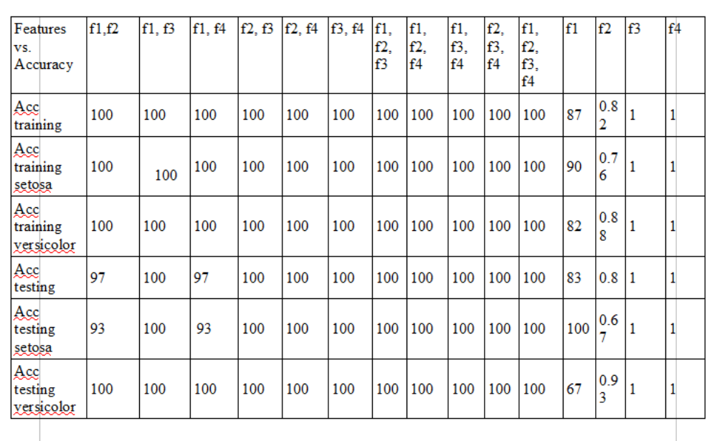
b) Taking only the testing set to calculate the final accuracy. The final accuracy is calculated by taking all the true results, over the total number of points tested. Using the accuracy from the document
ROC-gaussian-gvalues-Assignment2
The table below shows the effect of accuracy with increasing features for FDA
Features vs  Accuracy (%) | F1,  f2 | F1,  f3 | F1,  f4 | F2,  f3 | F2,  f4 | F3,  f4 | F1,  f2,  f3 | F1,  f2,  f4 | F1,  f3,  f4 | F2,  f3,  f4 | F1,f2,  f3,f4
Accuracy  testing | 96.7 | 100 | 96.7 | 100 | 100 | 100 | 100 | 100 | 100 | 100 | 100
Accuracy  testing  setosa | 93.3 | 100 | 93.3 | 100 | 100 | 100 | 100 | 100 | 100 | 100 | 100
Accuracy  testing versicolor | 100 | 100 | 100 | 100 | 100 | 100 | 100 | 100 | 100 | 100 | 100
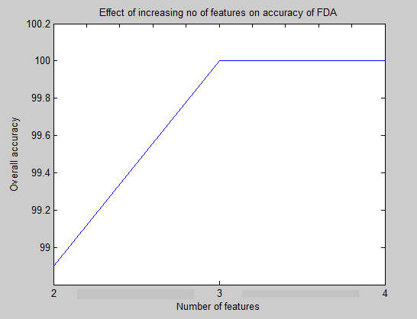
Overall accuracy of using 2 features =(100*4) + (96.7 *2) / 6 =98.9%
Overall accuracy of using 3 features = (100 *4)/4 = 100%
Overall accuracy of using 4 features = 100%
The above image shows the effect of varying the number of features on the performance of the FDA
Using the table previously shown previously for the Gaussian when comparing classifiers for the Gaussian, the overall accuracy of increasing features for Gaussian is:
The values were derived from the testing set:
Overall accuracy of 1 feature = 91
Overall accuracy of 2 features = 98
Overall accuracy of 3 features = 100
Overall accuracy of 4 features = 100
The corresponding curve is for the Gaussian classifier, and shows the effect increasing the number of features on accuracy
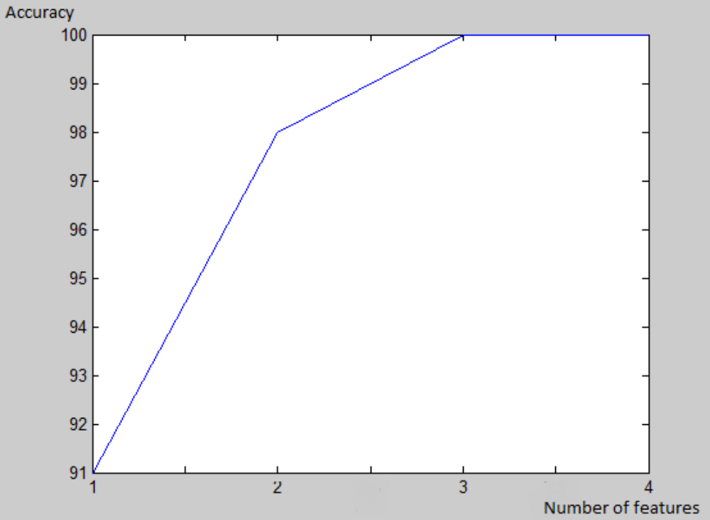
~~~~~
Explanation of the code.
a)The code fda3 runs a linear discriminant analysis on the iris dataset.
The iris dataset is composed of four features, petal length, petal width, sepal length, and sepal width respectively, representing features 1,2,3 and 4 respectively.
The fda code runs as a binary classifier and thus the features are reduced to c-1 classes which is 1 feature only.
The excpected values/means and the scatter matrices (covariance without dividing by the number of classes) is calculated for combinations of two features, three features and four features. The combinations of features used are feature 1 and 2, features 2 and 3,
%13 features 1 and 3, features 1 and 3, features 2 and 4,features 3 and 4, features 1,2 and 3, features 1,2 and 4, features 1,3 and 4, features 2,3 and 4 and features 1,2,3 and 4 respectively.
The FDA projects the dataset on the direction which separates the two datasets. Due to the special case where we are classifying two classes classes are being classified, the w term due to the Rayleigh quoetient, and the eigen system is w = Sw-1(m1 -m2)
After calculating means and scatter matrices, for each feature combination. We sum the scatter matrices for a particular matrix combination. Find it's inverse, then subtract the means for a particular marix combination. We then find w using w=Sw-1(m1-m2)

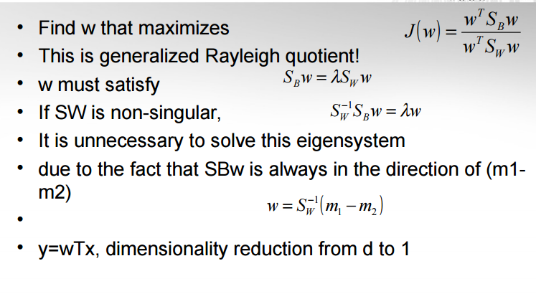
The w should have the same dimensionality as the features. We then multiply the transpose of w assuming w is a column vector, this will give us the new projected point in the direction of greatest seperability.
After seperating the data the Guassian Bayes classifier was used to classify the data, gaussian curves, g-plot (boundary curves) were drawn using the training set, and ROC curves generated using the testing set.
The ROC curves were drawn by finding the minimum value and maximum value of the boundary functions after being subtracted from each other the true positive and true negative rates were then measured by incrementing g value multiple times using the equation
g1x – g2x > threshold where the true positive rate, and false positive rate is calculated for all points whilethe threshold is being varied starting from the min value to the max value in increments of 30
Then a graph of true positive rate vs false rate is plotted.
This was done for all combination of features of FDA, the final results can be seen in the supporting document labelled ROC curves. It was done only for the best feature for the Gaussian.
Other supporting functions include traintest.m which basically trains and tests the results of FDA using the gaussian classifier
The values produced by the FDA were two small so were multiplied by 10 then rounded to the nearest decimal using the round2 function in order to have values that are more comprehensible.
Last but not least the function multixVisual was enhanced to allow for drawing of ROC curves.
b) please see the supporting document containing the plots in the ROC-GAUSSIAN-GVALUES-ASSIGNMENT2 document. This contains the plots for FDA
c) Please see the initial section of this document for thorough comparison of both classifier as well as the plots. The no of features giving the highest accuracies are 3 features and 4 features respectively. Thus to be safe one can stick to 3 features with the iris dataset with FDA as no matter the features 100% accuracy is attained.
How to run the code:
To run the code for the FDA type fda3('setosa.txt','versicolor2.txt',14,'ROC');
where the first two variables are the datasets, the 14 represents the combination of features in this case features 1 and 4 please check documentation for how to type the remaining features and
'ROC' represents the graph you want drawn, please check documentation for other curves.
To run the code for the Baysean ROC curve
Please run
multixVisual('setosa.txt','versicolor2.txt',23,'r');
where the first two variables are the datasets, the 23 represents the combination of features in this case features 2 and 3 please check documentation for how to type the remaining features and
'r' represents the graph you want drawn, please check documentation for other curves.

