Login:

You can create an account with email and you will receive an email for confirmation.

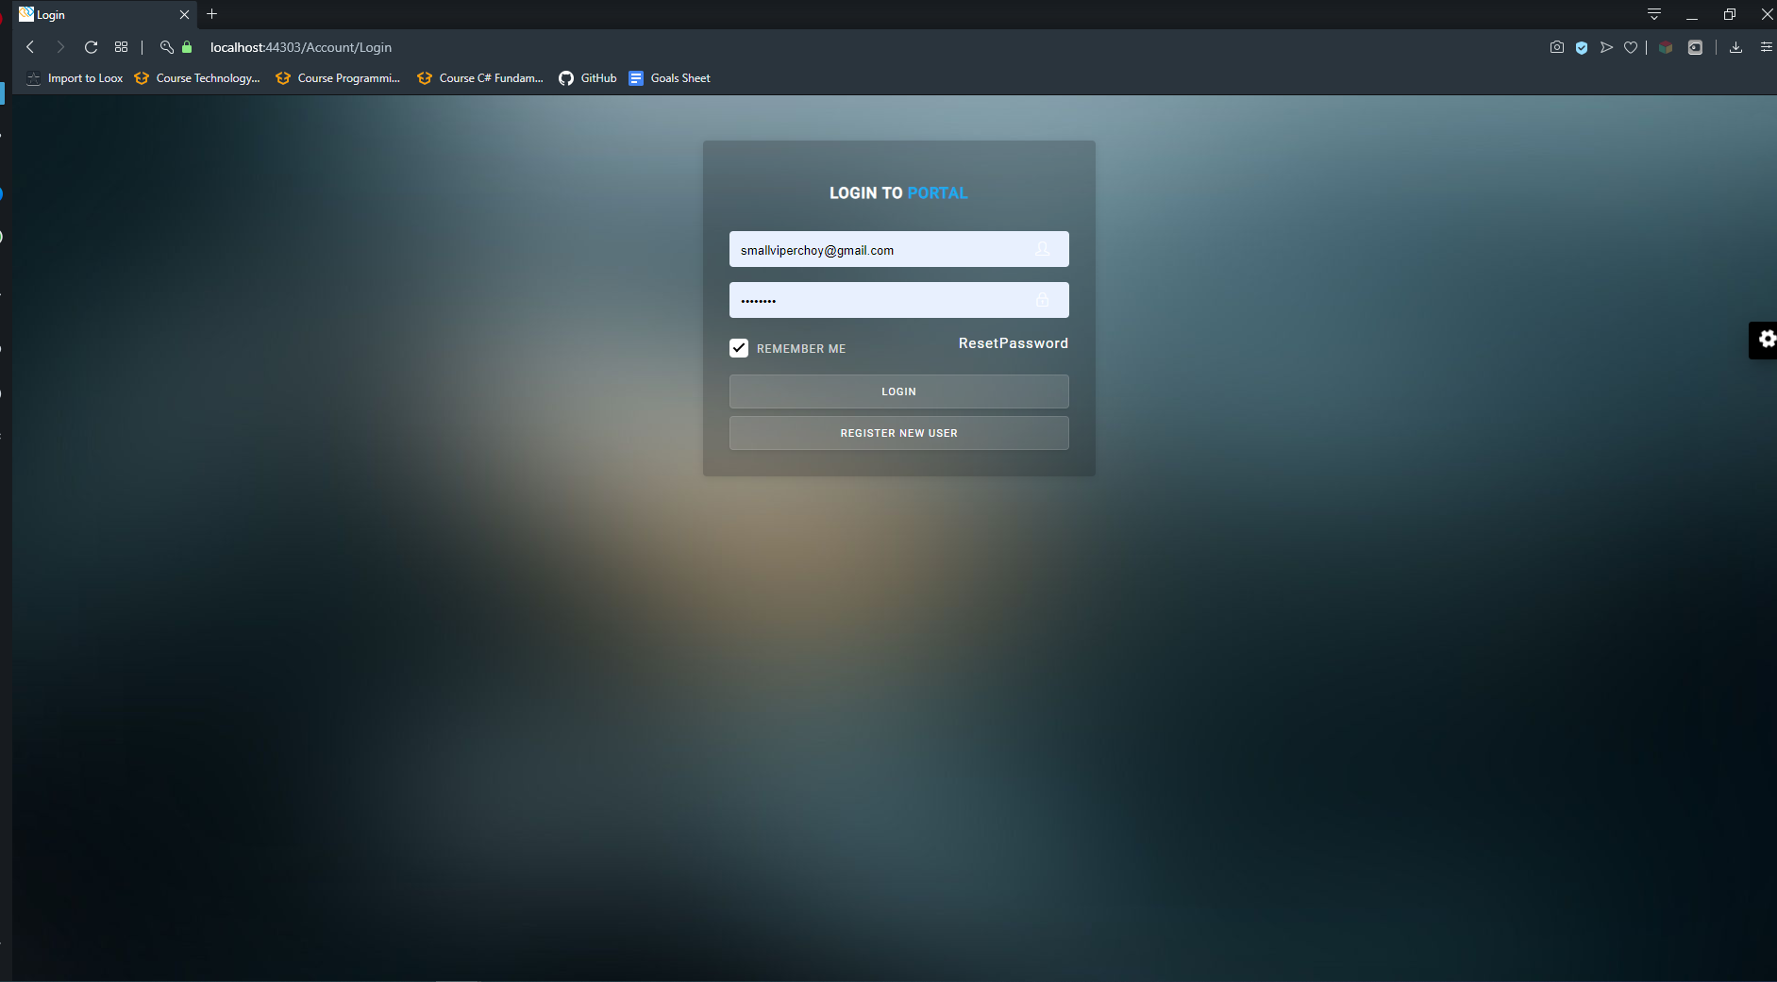

Overview of the functions(CRUD)

as per requirement.

you can delete the existing ones create delete edit..

Here is a screenshot of the student list

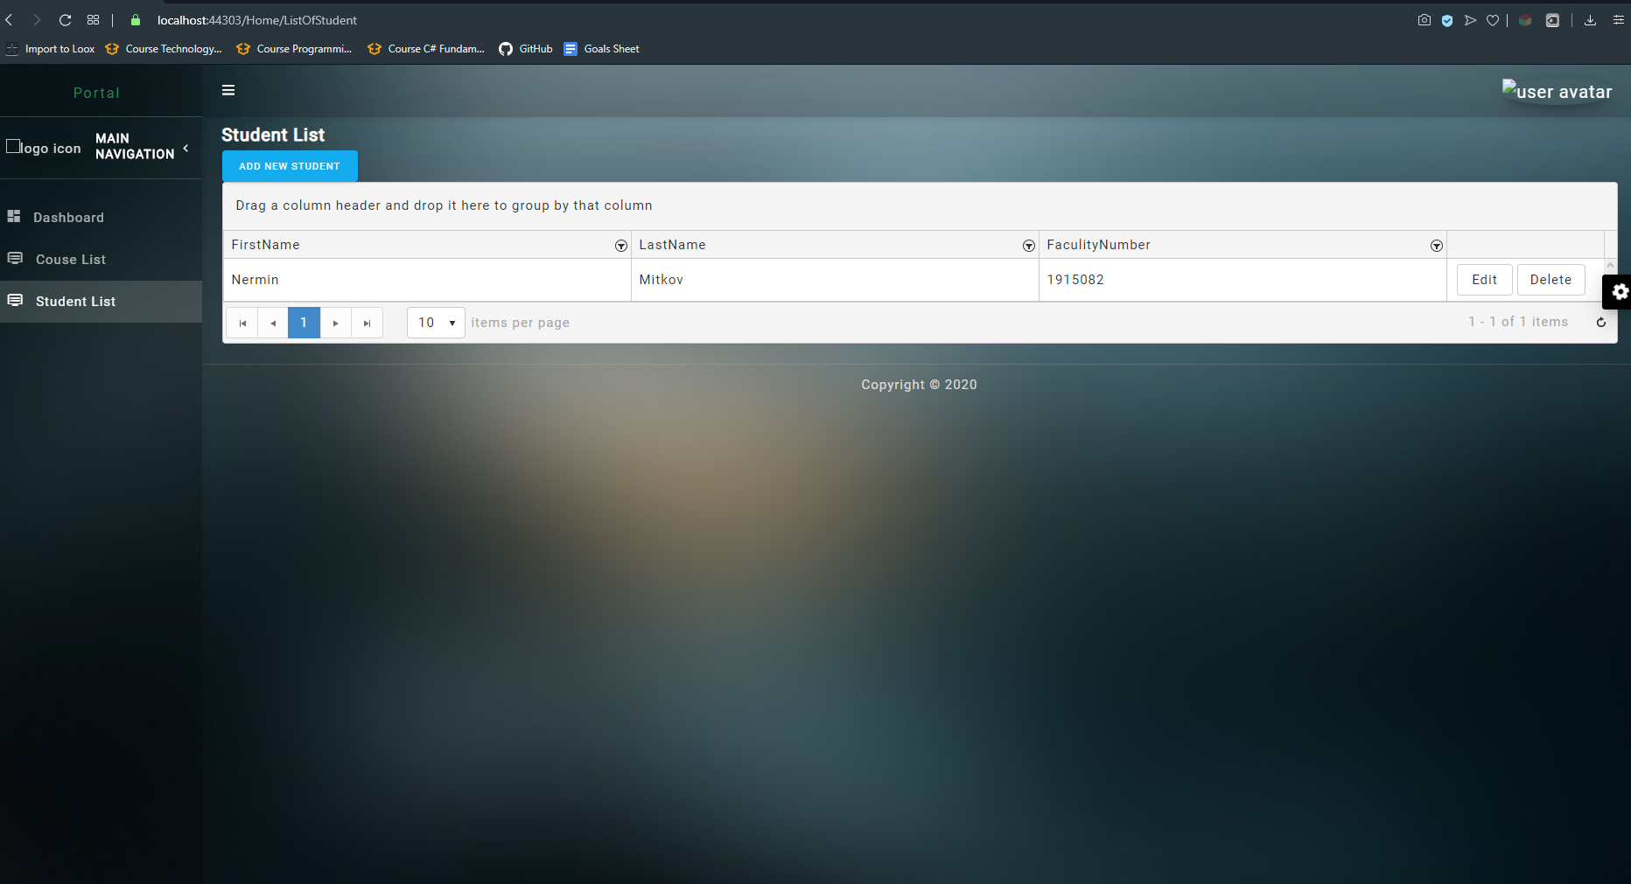

The view when you click add new student to the list:

You can do the search with the following options

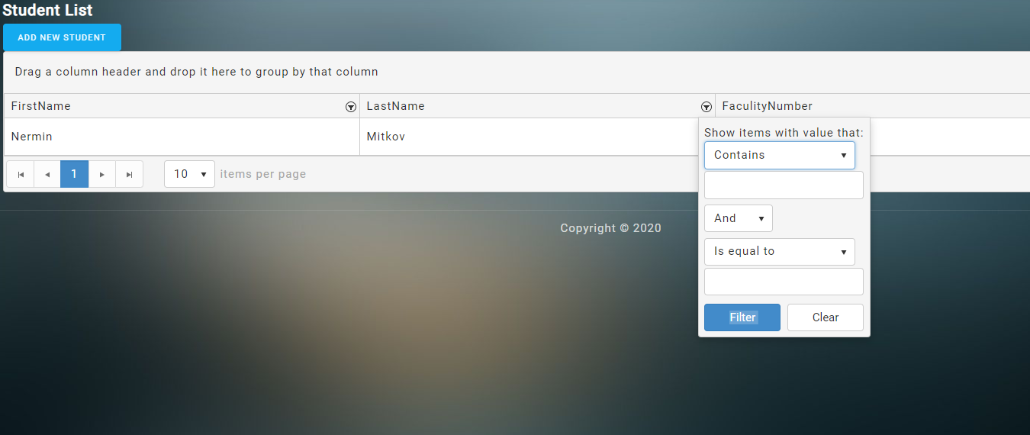

/

Also, please note that when you are changing the database name there could be an error due to the version of MS SQL as I personally had a lot of issues where the assembly files didn’t connect properly due to some mistakes so I had to re write.

Note that the MIT design is taken from github its free to use tamplate.