<Bilet Purchasing System>

Object Design

<1.0>

<10.01.2022>

<Uğur Kaya Küçükkaptan>

<Bekir Malik Özkuran>

<Mehmet Keremhan Yılmaz>

<Büşra Nur Tekin>

Prepared for

SE301 Software Engineering



Table of Contents

1. Introduction 1

1.1. Object Design Trade-offs 1

1.2. Interface Documentation Guidelines 1

1.3. Definitions, Acronyms, and Abbreviations 1

1.4. References 1

2. Packages 1

3. Class Interfaces 1

OBJECT DESIGN DOCUMENT

# Introduction

## Object Design Trade-offs

The name of the project is Biletbiz, and it is a ticket purchasing website. Main purpose of the website is to purchase tickets for various entertainment events. All of the implementation of user interfaces, database implementations and functions are our own original work. We used PHP as main coding language, HTML and CSS for interfaces and MySQL for database.

We decided that during the ticket purchasing phase, instead of generating the amounts of

Tickets that is the number equal to capacity, we changed the system into making it so that whenever a user purchases a ticket a new ticket is generated. It required a complete change of how system works but this way it improves the system speed and workload.

We had to decide between delivery time and functionality and we decided to give delivery time more priority. Since we had a certain delivery date, we decided to add as much functionality to the system as we can and deliver it on time.

## Interface Documentation Guidelines

In this system, object-design principle had applied. We used MVC type of architectural structure on Biletbiz. There are three groups of users in this project. First interface is for user side and company side. User panel also has three groups; Visitor, Registered User and Administrated User. These two designs are similar to each other.

On the user side, we made sure there are some of criterias that must be fulfilled. For instance; user may understand the site easily and do his/her actions easily on the site, user can perform the functions such as buy ticket or view information about ticket that she or he bought. The site should be easily understandable.

The Admin panel, is a little more complex according to user-side. However, it is also simplified and easy to use for an administrator. Admins have updated menu from User menu which possesses new options such as ban user, remove user and approve company.

The Company panel is another different user type. Company can perform functions such as reading the messages from registered users and send them messages.

## Definitions, Acronyms, and Abbreviations

* **Event:** An entertainment planning that is for the purpose of entertainment that happens or takes place.
* **Buy:** Function to purchase tickets.
* **Publish:** Admins making events publicly available for the user on the website.
* **Consumer:** An individual that is using the system.
* **Admin:** User type that arranges events and communicate with the operators.
* **Visitor:** A user who is not logged in to system
* **Registered User:** A user who io logged in to the system.
* **Search**: Different criteria functions to find an event
* **MVC**: Model-View-Controller Structure

## References

<https://www.w3schools.com/>

<https://www.biletix.com/anasayfa/TURKIYE/tr>

<https://www.bubilet.com.tr/>

https://www.stubhub.com/

Bruegge B. & Dutoit A.H.. (2010). Object-Oriented Software Engineering Using UML, Patterns, and Java, Prentice Hall, 3rd ed.

# Packages

* **User Management Package :** This package contains functions that a registered user can perform in Biletbiz.
* **CompanyManagement Package :** This package contains functions that a company type user can perform in Biletbiz.
* **Event Management Package :** This package contains functions that involve a creation of events.
* **Admin Management Package :** This package contains functions that a administrator can perform in Biletbiz.

# Class Interfaces

**User Package**

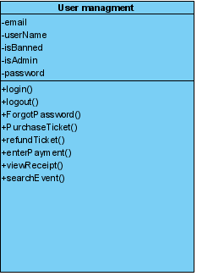

**Attributes:**

* **email - String:** User email that is registered in the Biletbiz system.
* **userName-String:** User username that is registered in the Biletbiz system.
* **isBanned-Boolean:** A boolean value that checks if the user is banned or not.
* **isAdmin-Boolean:** A boolean value that checks if the user is a administrator or not.
* **password-String:** User password that is used in order to login into the system.

**Operations:**

* **Login():** A public function that is responsible of authentication function that registered users must complete in order to enter into the website as a registered user.
* **Logout():** Function that registered users must in order to finalize their section in the Biletbiz website.
* **ForgotPassword():** A public function that is used for adjusting new password when user forget his/her account password.
* **PurchaseTicket():** A function that is used for purchasing a ticket for a specific event.
* **RefundTicket():** A function that is used for requesting a refund of a already purchased ticket for a specific event.
* **EnterPayment():** A function that is used for taking the users credit card information in order to use for purchasing tickets.
* **ViewReceipt():** A function that is used for viewing the receipt of a purchased ticket.
* **SearchEvent():** A function that is used for typing and searching events on searchbar for users using keywords.

**Company Package**

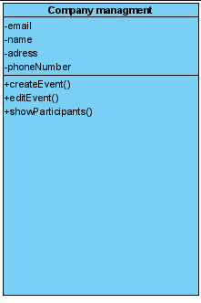

**Attributes:**

* **email-String:** Company email registered into the Biletbiz system.
* **name-String:** Company name that is registered into the Biletbiz system.
* **address-String:** Company address that is registered into the Biletbiz system.
* **phoneNumber-String:** Company phone number that is registered into the Biletbiz system.

**Operations:**

* **createEvent():** A function that is used by companies in order to create and design events that the users can purchase tickets and attend to.
* **editEvent():** A function that is used by companies in order to edit the existing events to adjust its settings.
* **showParticipants():** A function that is used by companies to view the participants that are attending to the given, already existing event.

**Event Package**

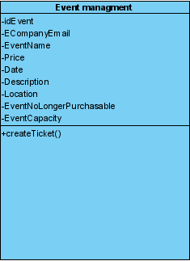

**Attributes:**

* **idEvent-Integer:** An attribute of events that is generated by system to differentiate every event.
* **ECompanyEmail-String:** An attribute to show the email of the events organizator companies email.
* **EventName-String:** Name of the organized event.
* **Price-Double:** An attribute to show and hold the price for tickets that is available for purchase.
* **Date-Date:** Attribute that shows the date the event is going to happen.
* **Description-String:** Attribute that describes and informs the user for the events contents that is going to take place.
* **Location-String:** Attribute which shows the place and address of the event that is going to take place.
* **EventNoLongerPurchasable-Boolean:** A boolean attribute to determine if the given event tickets can be still purchasable or not.
* **EventCapacity-Integer:** An attribute the hold the number of attendees which the given event has the capacity for.

**Operations:**

* **createTicket():** A function to create tickets for users that can purchase in order to attend the events they want to go.

**Admin Package**

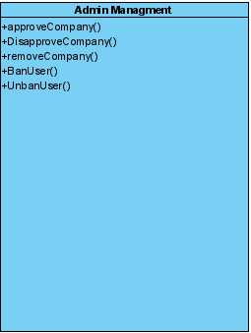

**Operations:**

* **approveCompany():** A function that approves a company request so that the company can complete its registration process into the Biletbiz.
* **disapproveCompany():** A function that disapproves a company request so that the company can not complete its registration process into the Biletbiz.
* **removeCompany():** A function that is used by admins in order to remove, ban a company from the website.
* **BanUser():** A function that is used by admins which is used for blocking any user in order to remove them from accessing the website.
* **UnbanUser():** A function that is used by admins which is used for removing a block from any user in order to grant them access to the website once again.