cell Segmentation of Glioblastoma-astrocytoma U373

Berk Arslan¹

¹Department of Electrical and Electronics Engineering, Izmir University of Economics, Izmir, Turkey

Abstract
Automated cell segmentation is basic process of computer aided diagnosis systems. In the article, Glioblastoma-astrocytoma U373 cells on a polyacrylamide substrate data used for training and test stages from Cell Tracking Challenge under IEEE International Symposium on Biomedical Imaging (ISBI) 2019 Conference. Input image set has 19 images for test stage and 30 images for training stage (15 original images and 15 ground truth segmentation images) which each have 696x520 pixel size and 8-bit depth.

A couple of methods is used in parallel or cascade instead of divide them into algorithm because the main architecture is not decided yet. However parallel operations would be separated to different algorithms and they would compared with each other according to results of dice method. These methods are meanshift filtering, gaussian blurring, k-means classification, Otsu's thresholding method, Hough circle transform, blob detection, Canny and Laplacian edge detection and morphological operations as opening, closing, dilation or erosion.

Morphological operations are not successful enough with not perfect preprocessed images and objects which have high complex edge as seen on Fig.1. Also basic thresholding methods are not accomplished. However meanshift filtering and edge detection algorithms work quite fine together. Therefore this study aims that to automate cell segmentation with results which is accurate as expert's ground truth segmentation result and output image of defined edge from different algorithms could be segmented with thresholding and morphological operations in the future.

1. Introduction

In recent decades, cell imaging and lens technology of microscopy have a great influence and development. Therefore cell segmentation has major importance with this technology. Before popularity of cell imaging with high quality images, experts define cells and describe them with microscope. On the other hand, computer has a crucial role on cell segmentation and analysis thanks to development on transistor technology. Cell segmentation can be used from biologists, doctors or laboratory technicians. It is a crucial preliminary work of disease diagnosis and abnormal cell detection on medicine, analysis on pharmaceutical industry or evolutionary biology research. Support of artificial intelligence like CNN or MLP can create more complex cell analysis, so computer aided diagnosis research could progress rapidly.

2. Method

First of all, input image is read and meanshift filtering algoritm (Fig1.a) is applied with 54 for maximum level of pyramid for the segmentation and 10 for termination criteria when to stop meanshift iterartions. It removes the background cells and dissect from cells with a single color appearance also it reduces small size salt and pepper grains in the cells. Secondly, grayscale output of meanshift filtered image is blurred with gaussian kernel (Fig1.b) to reduce high frequencies details of cell contour. The next step is definition of cell contour and Canny Edge Detector (Fig1.e) is used to edge detection of cell with threshold values as 20 and 100, however it does not work properly because some part of cell edge is unclear. Then, to reduce the distorted edge from Canny algorithm, morphological operations are tried to fill gaps and to segment the cell however it just worked partially. Furthermore Laplacian filter (Fig1.c) applied and it shows that there is high contrast of contour areas which belongs to cells when after the meanshift filtering in double float (CV_64F) image.

Also, K-means (Fig1.d) are tried to implemented after gaussian filter in parallel. Therefore, Hough circle transform (Fig1.g) is used to define cells nevertheless Canny edge detection output is not enough to define cells as circle. Moreover Blob Detector (Fig1.f) is attached after the gaussian filter in parallel however it detects couple of cell parts.

Morphological operations (Fig1.h) are assigned on the Canny edges but they are not satisfies the final segmentation result because of unclear edges from Canny edge detector. They would be tried on other methods on the final report.

Finally, static cells would be eliminated from segmented output with location differences of each cell from image sequence because of non-marked static cells from manually segmented training data.
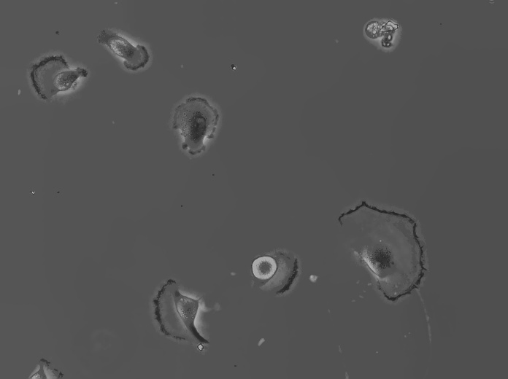
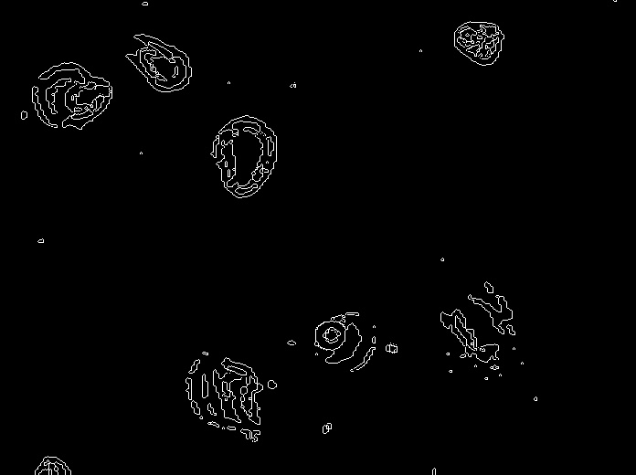
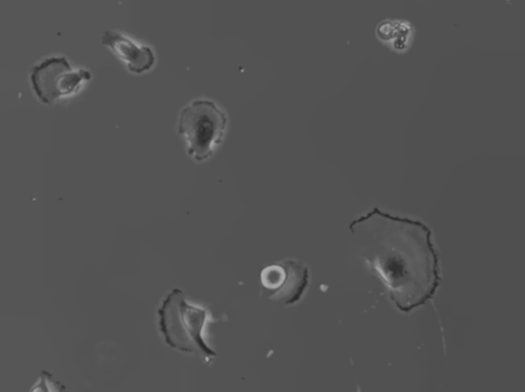

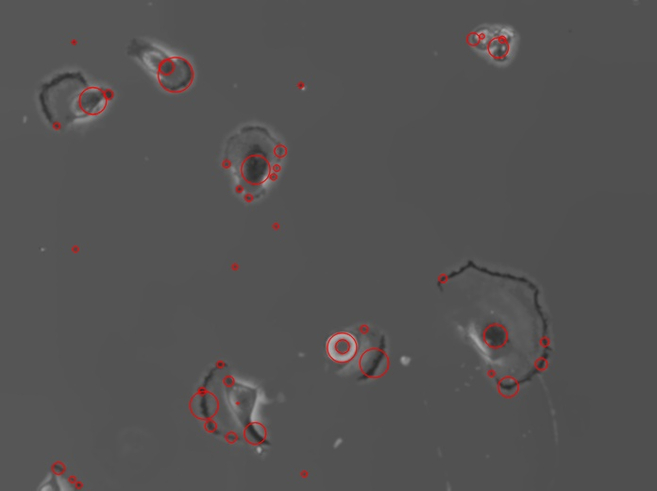
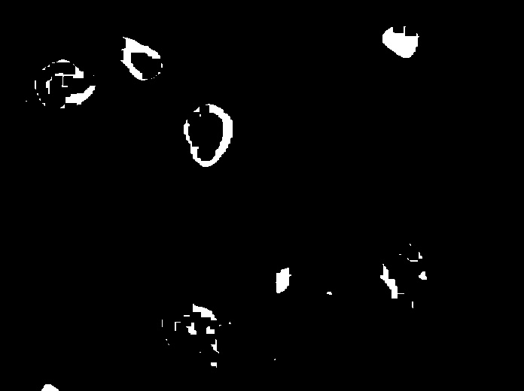
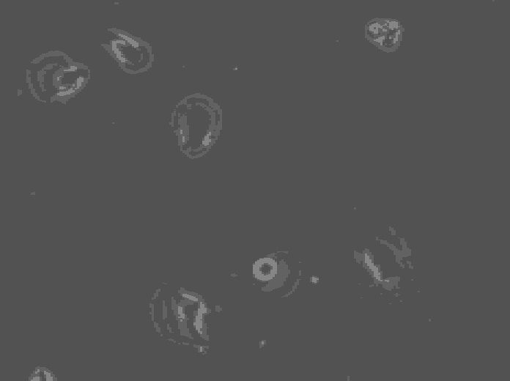
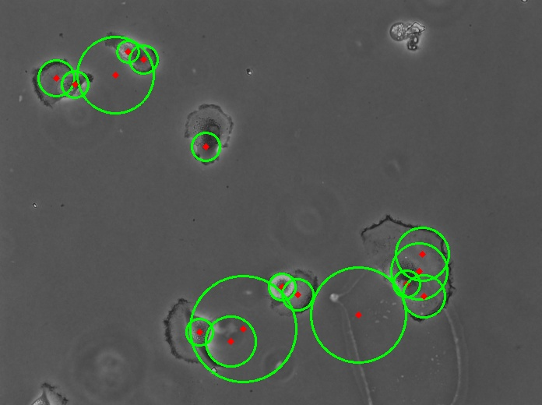
Fig. 1. (left to right, up to down) a. Meanshift Filtered, b. Gaussian Filtered, c. Laplacian Filtered, d. K-Means Classification, e. Canny Edge Detection, f. Blob Detection, g. Hough Circle Transform, h. Morphological Operations (in order of closing, opening, dilation, closing and erosion)

3. SOFTWARE

Python 3.7 and OpenCV 4.1.0 is base environment of the application. They are chosen because of fast and easy scripting, open-source code and well-documented.

Basically, algorithms and image manipulation operations are separated functions totally and they are pretty modular. Also all parameters of them controllable from GUI to resolve parameter errors interactively.

Furthermore main cell segmentation function calls the algorithm functions as initialization, preprocess for data paths and main process tree of algorithm. Also dice algorithm automatically is implemented at the end of image processing and prints the result, so it could be compared with other algorithms.

4. Results

Visual outputs of algorithm is added on Fig.1. Meanshift filter and gaussian filter parameters effects on edge detection of cells which is basis of segmentation.

However k-means gave unsatisfying results because of gradient gray shade of background and color-based classification in cell area. Also Hough circle transform and blob detection have not a good result with Canny edge detection output, but maybe it would give better position and radius result with a better binary mask or input from enhanced Laplacian/Sobel edge detection algorithms' output on the future.

Finally, morphological operated Canny edge detection results (Fig.1.g) do not satisfy when compared with ground truth segmented images. On the other hand, thresholding and morphological operations is needed to segmentation of cells. Therefore these operations would be tried on other algorithm results on the final report. To measure the similarity of binary segmented result with manually segmented result, dice method would be used and each algorithm result would be compared with others and the best one would be selected to reach the aim of report which is to automate the segmentation with the nearest output to ground truth segmentation.

5.Conclusions

Computer aided diagnosis system is a fatal feature for medicine today and automated cell segmentation is fundamental of it. Artificial intelligence or computer vision algorithms could be used to segment cell.

In this report, more than one computer vision algorithm tries are presented and they could be supported with artificial intelligence algorithms on the feature works.

Segmentation is not effortless with basic operations on used data set however a couple of cascaded complex algorithms or parallel check of complex algorithms could separate cells. The algorithms are not finalized totally and the final report would be written on these algorithms with more concrete results. Also, new algorithms would be tried like region growth algorithm or watershed algorithm with differently parameterized old methods.

