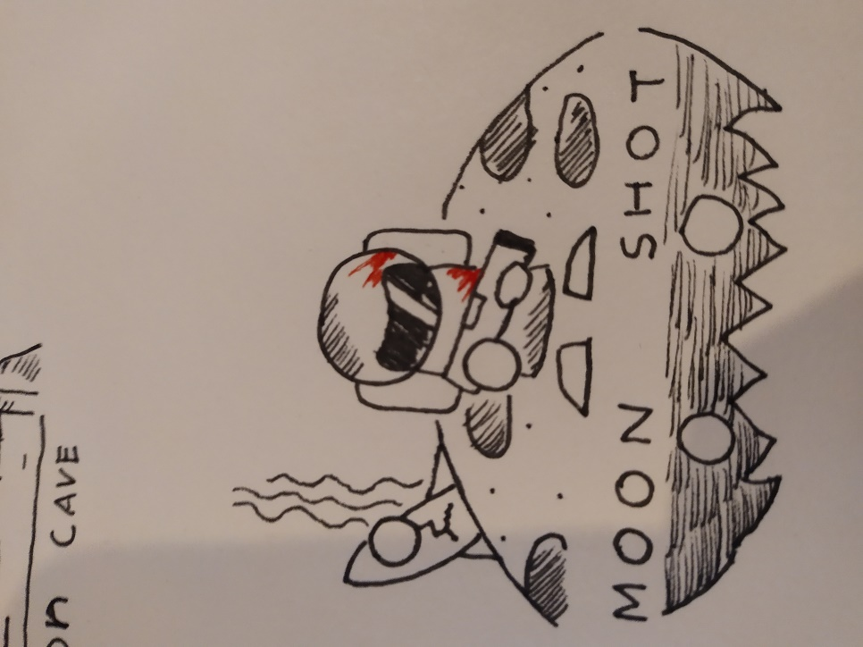

**Type or Genre:**

* endless top down wave survival shooter.

**Intended Audience**

* 16+ due to some horror elements

**General Premise of Game**

* An exploration team that got stranded on the moon. Armed with ancient alien weapons, you must embark from floor to floor descending deeper into the moon’s levels which is for some reason, the only way out but also the worse way.
* 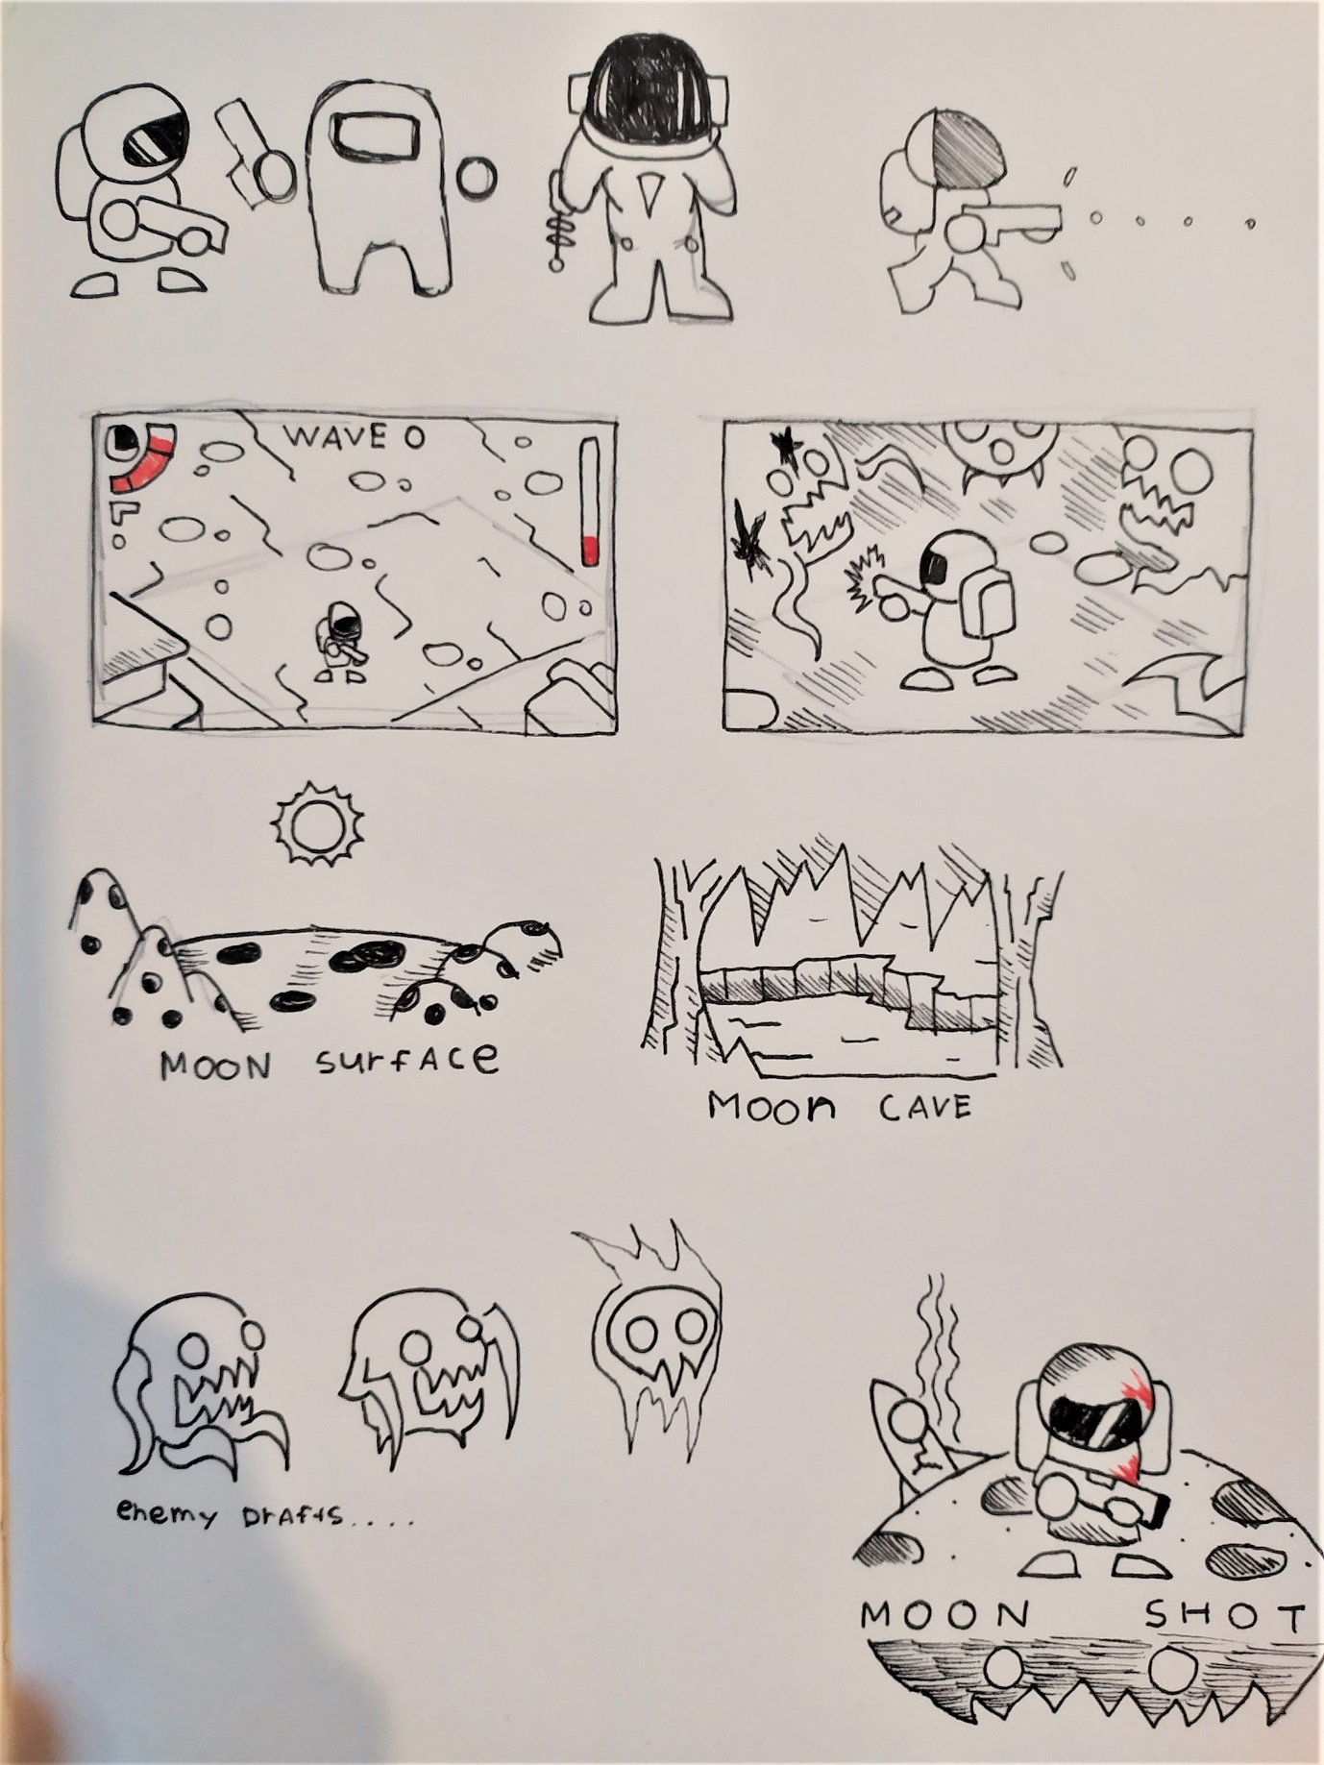A highscore base system will be the determiner to unlock the next floors, but the main premise of the game is to survive for as long as you can.

**Game Elements**

* **Character:** a character that is able to move from a top down standpoint, one weapon, with limited amount that can be collected in the game. Can only shoot in the direction its facing.
* **Scaling Waves:** the game progression is determined by the player surviving each wave via score. Once a certain score is achieved new floors can be unlocked with more challenges, such as the addition of harder enemies or overall increase in enemies per wave.
* **Currently planned levels are about three, an example like moon surface lv one**
* **Moon cave, Moon relic.**

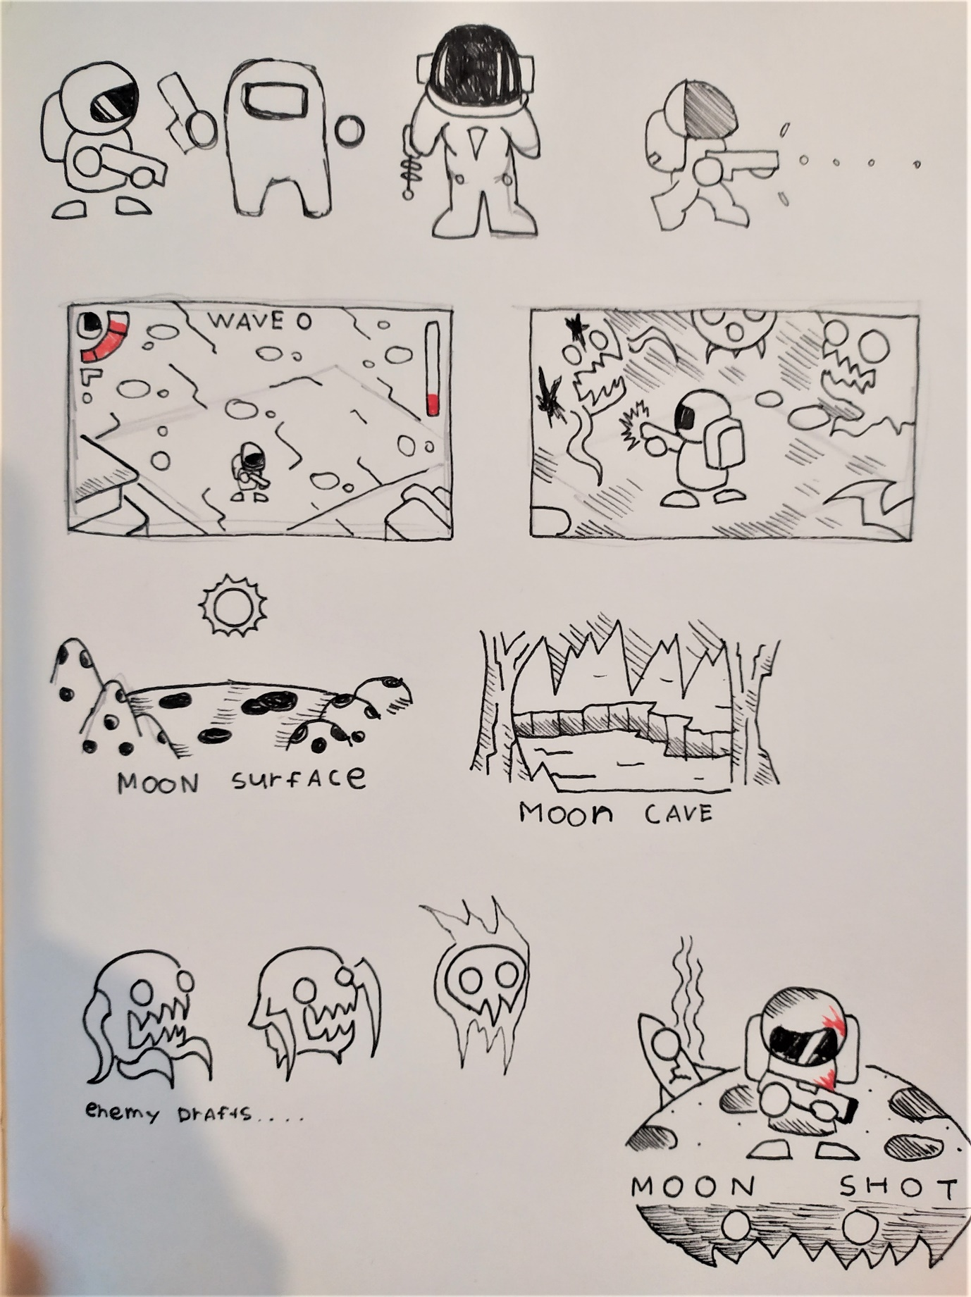

**Game Mechanics and Systems**

* **Game system and Rules:** The player has a health bar, once the health bar reaches zero, which is directly caused if the enemies damaged said player, will cause the game to end. The score is then banked, and once the player reaches a milestone for each wave, a new level is unlocked. Ideally the main goal is to kill as much as you can to survive each wave.
* **Powerups/Aid:** limited ammo, and the player must collect random orbs in the map to gain ammo. Some other powerups such as re-life powerup that enables you to respawn once your health reaches zero.
* 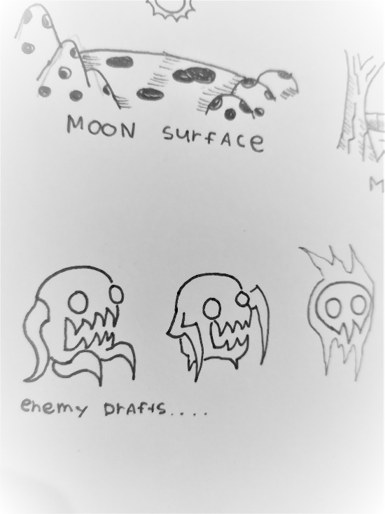**Enemies:** have one common goal and that is to kill the player, as the game progresses plans for unique enemies can also be added to add more dynamic and difficulty for each level.



**An outline of progression/Game progression (How your gameplays)**

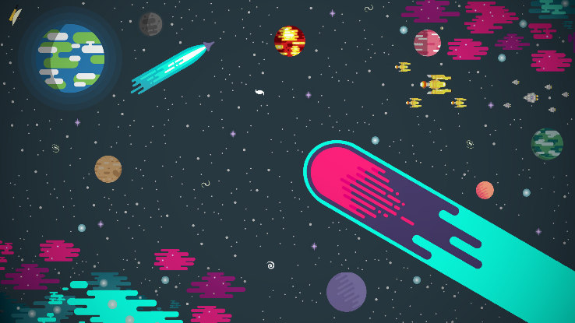**General Look/Theme**



**Scope moonshot***– noun*

* an extremely ambitious and innovative project
* the act of launching a spacecraft to the moon
* a hit or thrown ball that travels a great distance with a high trajectory

**moonshot** ***thinking*** – *noun*

* a type of thinking that aims to achieve something that is generally believed to be impossible.

Use “[moonshot thinking](https://www.youtube.com/watch?v=fAnyAwCe_5k)” and interpret the theme however you like. Let it be the inspiration for your creation. If you need some ideas think about:

* A roguelite, lunar lander style game where you literally get one*shot* at landing on the *moon*
* A platform game, where the hero jumps across the surface of the *moon* firing *shots* at the enemy
* A game about traveling back in time to make an impactful change
* A game about solving a huge/world problem with some ridiculous technology

SURVIVAL GAME: BOXHEAD STYLE