Release Notes

nGraph is provided as source code, APIs, build scripts, and some binary formats for various Compiler stack configurations and use cases.

For downloads formatted as .zip and tar.gz, see https://github.com/NervanaSystems/ngraph/releases.
This page includes additional documentation updates.
We are pleased to announce the release of version 0.28.

Core updates for 0.28

Latest documentation updates
- Better debugging documentation
- Dynamic Shapes and APIs
- Provenance
- Add linkages and overview for quantization APIs
- New ngraph.ai themed illustrations
Important
Pre-releases (-rc-0.*) have newer features, and are less stable.

Changelog on Previous Releases
0.27.1
- Fixes broken serializer for Sum and Product
- New ops
- Provenance improvements from 0.25.1
- More dynamic shape ops
- More informative errors
- Additional details on quantization
- Index updates
- API updates
- All ops support Output<Node> arguments
- Additional ops
- ONNX handling unknown domains
- Provenance works with builders and fused ops
- RPATH for finding openmpi
- Negative indices/axes fixes
- Migrate some get_argument removals
- Negative indices/axes fixes
- Better support for MKL-DNN 1.0 (DNNL)
- Additional constant element types
- Add new Sphinx-friendly theme (can be built natively for an alternative to ngraph.ai docs).
- Update PaddlePaddle documentation to reflect demo directories instead of example directory.
- Update doc regarding the validation of Sum op.

0.26.1
- Performance increase for ConstantFolding pass

0.25.1
- Allow DLLs that link nGraph statically to load backends
- Add rank id to trace file name
- Allow provenance merging to be disabled
- Remove some white-listed compiler warnings
- Provenance, builders, ops that make ops, and fused op expansions
- Note the only support for nGPU is now through PlaidML; nGraph support for nGPU (via cuDNN) has been deprecated.
- iGPU works only with nGraph version 0.24.

0.25.0
- Better PlaidML support
- Double-buffering support
- Constant folding
- Support for static linking
- Additional ops
- Preliminary static linking support
- Known issue: No PlaidML training support
- Doc: Add instructions how to build NGRAPH_PLAIDML backend
- Published interim version of doc navigation for updates at ngraph.ai
- GPU validations: added 5 functional TensorFlow workloads and 4 functional ONNX workloads

0.24
- Fixes reshape sink/swim issue
- More ONNX ops
- Elementwise divide defaults to Python semantics
- GenerateMask seed optional
- Graph visualization improvements
- Preserve control dependencies in more places
- GetOutputElement has single input

0.23
- More ONNX ops
- Elementwise divide defaults to Python semantics
- GenerateMask seed optional
- Document new debug tool
- Graph visualization improvements
- Note deprecation of MXNet's ngraph-mxnet PyPI
- Note default change to svg files for graphs and visualization
- Add more prominent tips for contributors who find the doc-contributor-README
- Better GSG / Install Guide structure.
- Added group edits and new illustrations from PR 2994 to introduction.rst.
- Ensure ngraph-bridge link in README goes to right place.
- Make project extras their own subdirectory with index to help organize them.
- Known Issues
  - When using TensorFlow* v1.14.0 with `ngraph-bridge v0.16.0rc0 and CPU backend, we saw notable to severe decreases in throughput in many models.

0.22
- More ONNX ops
- Optimizations
- Don't reseed RNG on each use
- Initial doc and API for IntelGPU backend
- DynamicBackend API

0.21
- The offset argument in tensor reads and writes has been removed
- Save/load API
- More ONNX ops
- Better tensor creation
- More shape support
- Provenance improvements
- offset arg for tensor creation is deprecated
- static linking support
- Initial test of 0.21-doc
- Updated doc-contributor-README for new community-based contributions.
- Added instructions on how to test or display the installed nGraph version.
- Added instructions on building nGraph bridge (ngraph-bridge).
- Updated Backend Developer Guides and ToC structure.
- Tested documentation build on Clear Linux OS; it works.
- Fixed a few links and redirs affected by filename changes.
- Some coding adjustments for options to render math symbols, so they can be documented more clearly and without excessive JS (see replacements.txt).
- Consistent filenaming on all BE indexes.
- Removed deprecated TensorAPI.

0.20
- Save/load API
- More ONNX ops
- Better tensor creation
- More shape support
- Provenance improvements

pre-0.20
- More dynamic shape preparation
- Distributed interface factored out
- fp16 and bfloat16 types
- codegen execution parameterized by context
- NodeMap, NodeVector, ParameterVector, ResultVector now vectors
  - node_vector.hpp replaced by node.hpp
  - op/parameter_vector.hpp replaced by op/parameter.hpp
  - op/result_vector.hpp replaced by op/result.hpp
- Additional ONNX ops
- Add graph visualization tools to doc
- Update doxygen to be friendlier to frontends
- Python formatting issue
- mkl-dnn work-around
- Event tracing improvements
- Gaussian error function
- Begin tracking framework node names
- ONNX quantization
- More fusions
- Allow negative padding in more places
- Add code generation for some quantized ops
- Preliminary dynamic shape support
- initial distributed ops
- Pad op takes CoordinateDiff instead of Shape pad values to allow for negative padding.
- NodeInput and NodeOutput classes prepare for simplifications of Node
- Test improvements
- Additional quantization ops
- Performance improvements
- Fix memory leak
- Concat optimization
- Doc updates

Introduction
Future developments in Artificial Intelligence (AI) will increasingly rely on better methods to accelerate the performance of deep learning workloads. As Deep Learning (DL) models become more complex, and as the volume of data those models are expected to handle increases rapidly, the deployment of scalable AI solutions becomes a greater challenge.
Today, two standard approaches to accelerate deep learning performance are:
- Design hardware solutions dedicated to deep learning computation -- Many companies, ranging from startups to established manufacturers such as Intel, are actively developing Application Specific Integrated Circuits (ASICs) to accelerate the performance of deep learning for both training and inference.
- Optimize software to accelerate performance -- nGraph Compiler, an open-source deep learning compiler, is Intel's solution to deliver performance via software optimization. nGraph provides developers with a way to accelerate workloads via software and to provide a significant increase in performance for standard hardware targets such as CPUs and GPUs. For deploying scalable AI solutions, nGraph uses kernel libraries, a popular and effective method to improve deep learning performance. Where kernel libraries are available and perform well, we use them.

Motivations
The current State-of-the-Art (SoTA) software solution for deep learning computation is to integrate kernel libraries such as Intel® Math Kernel Library for Deep Neural Networks (Intel® MKL DNN) and Nvidia's CuDNN into deep learning frameworks. These kernel libraries offer a performance boost during runtime on specific hardware targets through highly-optimized kernels and other operator-level optimizations.
However, kernel libraries have three main problems:
- Kernel libraries do not support graph-level optimizations.
- Framework integration of kernel libraries does not scale.
- The number of required kernels keeps growing.
nGraph Compiler addresses the first two problems, and nGraph Compiler combined with PlaidML addresses the third problem. nGraph applies graph-level optimizations by taking the computational graph from a deep learning framework such as TensorFlow and reconstructing it with nGraph's :abbr: IR (Intermediate Representation). nGraph IR centralizes computational graphs from various frameworks and provides a unified way to connect backends for targeted hardware. To address the third problem, nGraph is integrated with PlaidML, a tensor compiler, which generates code in LLVM, OpenCL, OpenGL, and Metal. Low-level optimizations are automatically applied to the generated code, resulting in a more efficient execution that does not require manual kernel integration for most hardware targets.
The following three sections explore the main problems of kernel libraries in more detail and describe how nGraph addresses them.

Problem 1: Kernel libraries do not support graph-level optimizations
The example diagrams below show how a deep learning framework, when integrated with a kernel library, can optimally run each operation in a computational graph, but the choice of operations in the graph may not be optimal.
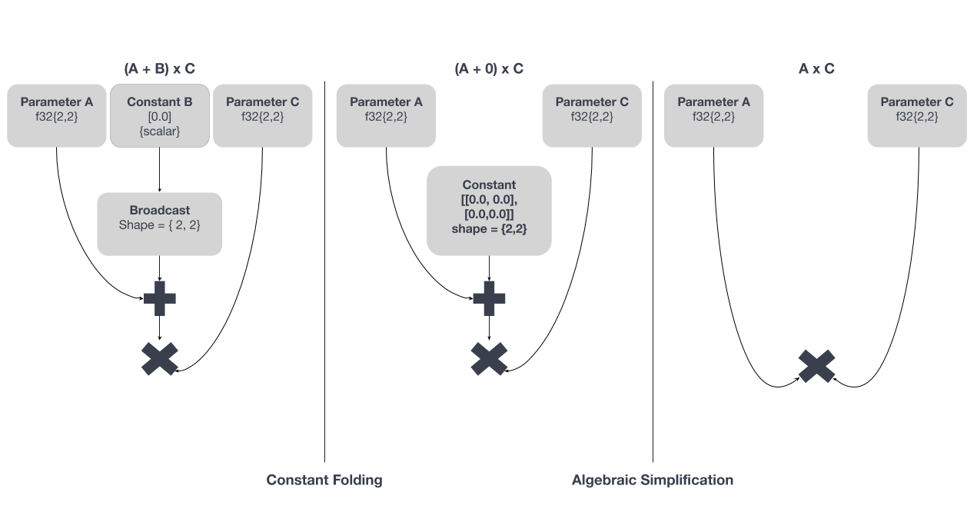
Figure A: The mathematical operations in a Deep Learning stack can be simplified significantly with a graph compiler
The computation is constructed to execute (A+B)*C. With nGraph, we can further optimize the graph to be represented as A*C. From the first graph shown on the left, the operation on the constant B can be computed at compile time (an optimization known as constant folding). The graph can be further simplified to the one on the right because the constant has a value of zero (known as algebraic simplification). Without such graph-level optimizations, a deep learning framework with a kernel library will compute all operations, resulting in suboptimal execution.

Problem 2: Framework integration of kernel libraries does not scale
Due to the growing number of new deep learning accelerators, integrating kernel libraries with frameworks has become increasingly more difficult. For each new deep learning accelerator, a custom kernel library integration must be implemented by a team of experts. This labor-intensive work is further complicated by the number of frameworks, as illustrated in the following diagram.
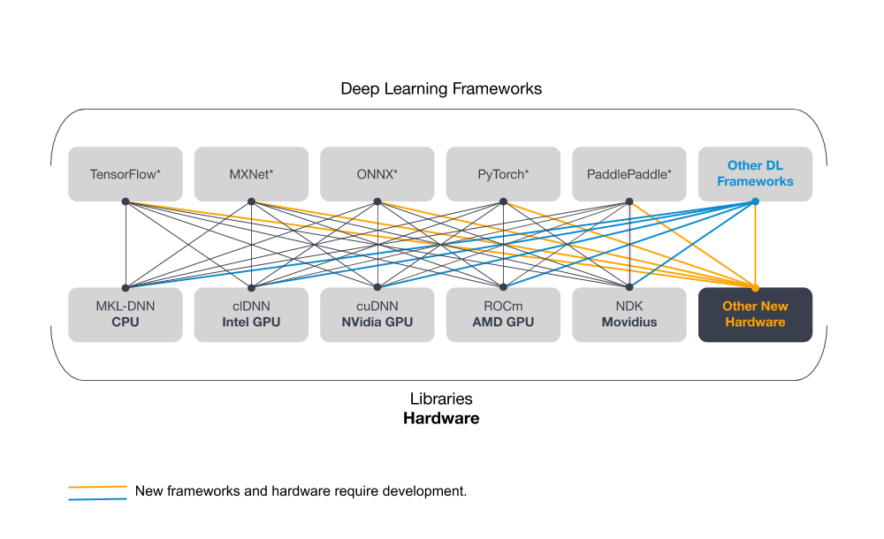
Figure B: A many-to-many problem
Each framework must be manually integrated with each hardware-specific kernel library. Additionally, each integration is unique to the framework and its set of deep learning operators, view on memory layout, feature set, etc. Each connection that needs to be made increases the amount of work, resulting in a fragile setup that is costly to maintain.
nGraph solves this problem with bridges. A bridge takes a computational graph or similar structure and reconstructs it in the nGraph IR along with a few primitive nGraph operations. With a unified computational graph, kernel libraries no longer need to be separately integrated into each deep learning framework. Instead, the libraries only need to support nGraph primitive operations, and this approach streamlines the integration process for the backend.

Problem 3: The number of required kernels keeps growing
Integrating kernel libraries with multiple deep learning frameworks is a difficult task that becomes more complex with the growing number of kernels needed to achieve optimal performance. Past deep learning research has been built on a small set of standard computational primitives (convolution, GEMM, etc.). But as AI research advances and industrial deep learning applications continue to develop, the number of required kernels continues to increase exponentially. The number of required kernels is based on the number of chip designs, data types, operations, and the cardinality of each parameter per operation. Each connection in the following diagram represents significant work for what will ultimately be a fragile setup that is costly to maintain.
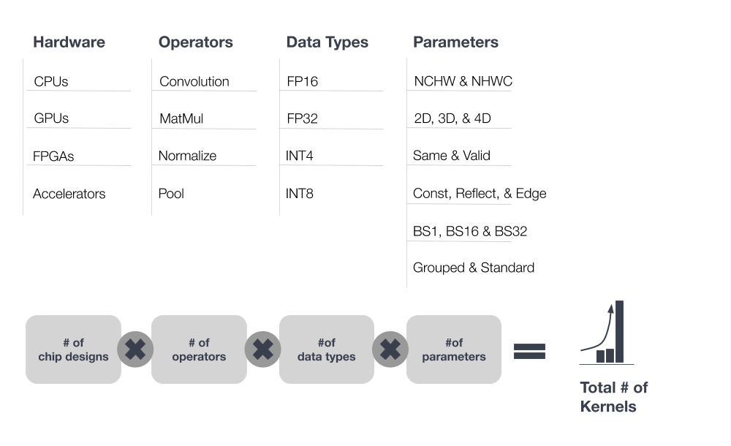
Figure C: Inevitable scaling problem
Integrating PlaidML with nGraph provides flexibility to support the latest deep learning models in the absence of hand-optimized kernels for new operations. PlaidML works together with nGraph to address the exponential growth of kernels.
PlaidML takes two inputs: the operation defined by the user and the machine description of the hardware target. It then automatically generates kernels that are iteratively optimized through an IR known as Stripe. Integration of PlaidML with nGraph allows users to choose the hardware and framework that suits their needs, resulting in freedom from kernel libraries.

Solution: nGraph and PlaidML
We developed nGraph and integrated it with PlaidML to allow developers to accelerate deep learning performance and address the problem of scalable kernel libraries. To address the problem of scaling backends, nGraph applies graph-level optimizations to deep learning computations and unifies computational graphs from deep learning frameworks with nGraph IR.
In conjunction with nGraph's graph-level optimizations, PlaidML automatically applies low-level optimizations to improve deep learning performance. Additionally, PlaidML offers extensive support for various hardware targets due to its ability to generate code in LLVM, OpenCL, OpenGL, and Metal.
Given a backend with existing kernel libraries, nGraph can readily support the target hardware because the backend only needs to support a few primitive operations. If the hardware supports one of the coding languages supported by PlaidML, developers must specify the machine description to support the hardware. Together, nGraph and PlaidML provide the best of both worlds.
- Framework owners looking to support new hardware and custom chips.
- Data scientists and ML developers wishing to accelerate deep learning performance.
- New DL accelerator developers creating an end-to-end software stack from a deep learning framework to their silicon.

Build and Test
There are a few common paths to take when manually building the from source code. Today nGraph supports various developers working on all parts of the Deep Learning (DL) stack, and the way you decide to build or install components ought to depend on the capabilities of your hardware, and how you intend to use it.
A "from scratch" source-code build of the nGraph Library enables the CPU, Interpreter, and unit tests by default. See default_ngflags for more detail.
A "from scratch" source-code build that defaults to the PlaidML backend contains rich algorithm libraries akin to those that were previously available only to developers willing to spend extensive time writing, testing, and customizing kernels. An NGRAPH_PLAIDML dist can function like a framework that lets developers compose, train, and even deploy DL (Deep Learning) models in their preferred language on neural networks of any size. This is a good option if, for example, you are working on a laptop with a high-end GPU that you want to use for compute. See ngraph_plaidml_backend for instructions on how to build.
In either case, there are some prerequisites that your system will need to build from sources.

Prerequisites
Operating System | Compiler | Build System | Status | Additional Packages
CentOS 7.4 64-bit | GCC 4.8 | CMake 3.9.0 | supported | wget zlib-devel ncurses-libs ncurses-devel patch diffutils gcc-c++ make git perl-Data-Dumper
Ubuntu 16.04 or 18.04 (LTS) 64-bit | Clang 6 | CMake 3.5.1 + GNU Make | supported | build-essential cmake clang-format-6.0 clang-tidy-6.0 clang-6.0 git curl zlib1g zlib1g-dev libtinfo-dev unzip autoconf automake libtool
Clear Linux* OS for Intel® Architecture version 28880+ | Clang 8.0 | CMake 3.14.2 | experimental | bundles machine-learning-basic c-basic python-basic python-basic-dev dev-utils

Building nGraph from source
Important
The default cmake procedure (no build flags) will install ngraph_dist to an OS-level location like /usr/bin/ngraph_dist or /usr/lib/ngraph_dist. Here we specify how to build locally to the location of ~/ngraph_dist with the cmake target -DCMAKE_INSTALL_PREFIX=~/ngraph_dist.
All of the nGraph Library documentation presumes that ngraph_dist gets installed locally. The system location can be used just as easily by customizing paths on that system. See the ngraph/CMakeLists.txt file to change or customize the default CMake procedure.
- ubuntu
- centos

Ubuntu LTS build steps
The process documented here will work on Ubuntu* 16.04 (LTS) or on Ubuntu 18.04 (LTS).
- Ensure you have installed the prerequisites for Ubuntu*.
- Clone the NervanaSystems ngraph repo:
$ git clone https://github.com/NervanaSystems/ngraph.git
$ cd ngraph
- Create a build directory outside of the ngraph/src directory tree; somewhere like ngraph/build, for example:
$ mkdir build && cd build
- Generate the GNU Makefiles in the customary manner (from within the build directory). This command enables ONNX support in the library and sets the target build location at ~/ngraph_dist, where it can be found easily.
$ cmake .. -DNGRAPH_ONNX_IMPORT_ENABLE=ON -DCMAKE_INSTALL_PREFIX=~/ngraph_dist
Other optional build flags -- If running gcc-5.4.0 or clang-3.9, remember that you can also append cmake with the prebuilt LLVM option to speed-up the build. Another option if your deployment system has Intel® Advanced Vector Extensions (Intel® AVX) is to target the accelerations available directly by compiling the build as follows during the cmake step: -DNGRAPH_TARGET_ARCH=skylake-avx512.
$ cmake .. [-DNGRAPH_TARGET_ARCH=skylake-avx512]
- Run $ make and make install to install libngraph.so and the header files to ~/ngraph_dist:
$ make # note: make -j <N> may work, but sometimes results in out-of-memory errors if too many compilation processes are used
$ make install
- (Optional, requires doxygen, Sphinx, and breathe). Run make html inside the doc/sphinx directory of the cloned source to build a copy of the website docs locally. The low-level API docs with inheritance and collaboration diagrams can be found inside the /docs/doxygen/ directory. See the project/doc-contributor-README for more details about how to build documentation for nGraph.

CentOS 7.4 build steps
The process documented here will work on CentOS 7.4.
- Ensure you have installed the prerequisites for CentOS*, and update the system with yum.
$ sudo yum update
- Install Cmake 3.4:
$ wget https://cmake.org/files/v3.4/cmake-3.5.0.tar.gz
$ tar -xzvf cmake-3.5.0.tar.gz
$ cd cmake-3.5.0
$ ./bootstrap --system-curl --prefix=~/cmake
$ make && make install
- Clone the NervanaSystems ngraph repo via HTTPS and use Cmake 3.5.0 to build nGraph Libraries to ~/ngraph_dist. This command enables ONNX support in the library (optional).
$ cd /opt/libraries
$ git clone https://github.com/NervanaSystems/ngraph.git
$ cd ngraph && mkdir build && cd build
$ ~/cmake/bin/cmake .. -DCMAKE_INSTALL_PREFIX=~/ngraph_dist -DNGRAPH_ONNX_IMPORT_ENABLE=ON
$ make && sudo make install

Building nGraph-PlaidML from source
The following instructions will create the ~/ngraph_plaidml_dist locally:
- Ensure you have installed the prerequisites for your OS.
- Install the prerequisites for the backend. Our hybrid NGRAPH_PLAIDML backend works best with Python3 versions. We recommend that you use a virtual environment, due to some of the difficulties that users have seen when trying to install outside of a venv.
$ sudo apt install python3-pip
$ pip install plaidml
$ plaidml-setup
- Clone the source code, create and enter your build directory:
$ git clone https://github.com/NervanaSystems/ngraph.git
$ cd ngraph && mkdir build && cd build
- Prepare the CMake files as follows:
$ cmake .. -DCMAKE_INSTALL_PREFIX=~/ngraph_plaidml_dist -DNGRAPH_CPU_ENABLE=OFF -DNGRAPH_PLAIDML_ENABLE=ON
- Run make and make install. Note that if you are building outside a local or user path, you may need to run make install as the root user.
$ make
$ make install
This should create the shared library libplaidml_backend.so and nbench. Note that if you built in a virtual environment and run make check from it, the Google Test may report failures. Full tests can be run when PlaidML devices are available at the machine level.
For more about working with the PlaidML backend from nGraph, see our API documentation backends/plaidml-ng-api/index.

macOS* development
Note
Although we do not currently offer full support for the macOS platform, some configurations and features may work.
The repository includes two scripts (maint/check-code-format.sh and maint/apply-code-format.sh) that are used respectively to check adherence to libngraph code formatting conventions, and to automatically reformat code according to those conventions. These scripts require the command clang-format-3.9 to be in your PATH. Run the following commands (you will need to adjust them if you are not using bash):
$ brew install llvm@3.9 automake
$ mkdir -p $HOME/bin
$ ln -s /usr/local/opt/llvm@3.9/bin/clang-format $HOME/bin/clang-format-3.9
$ echo 'export PATH=$HOME/bin:$PATH' >> $HOME/.bash_profile

Testing the build
We use the googletest framework from Google for unit tests. The cmake command automatically downloaded a copy of the needed gtest files when it configured the build directory.
To perform unit tests on the install:
- Create and configure the build directory as described in our buildlb guide.
- Enter the build directory and run make check:
$ cd build/
$ make check

Framework Support

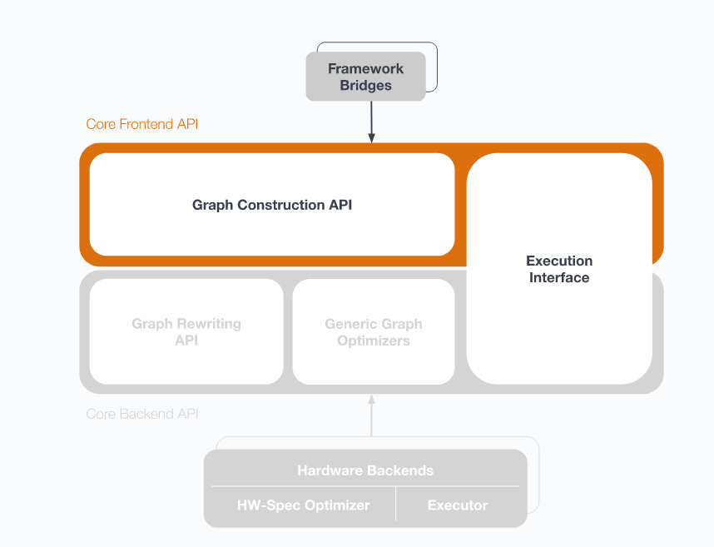
A framework bridge connects to the nGraph graph construction API

Basic concepts
To understand how a data science framework (TensorFlow <tensorflow_connect>, PyTorch, paddle_integ, and others) can unlock acceleration available in the nGraph Compiler, it helps to familiarize yourself with some basic concepts.
We use the term bridge to describe code that connects to any nGraph device backend(s) while maintaining the framework's programmatic or user interface. We have a bridge for the TensorFlow framework. We also have a paddle_integ bridge. Intel previously contributed work to an MXNet bridge <../project/extras/testing_latency>; however, support for the MXNet bridge is no longer active.
ONNX on its own is not a framework; it can be used with nGraph's ../python_api/index to import and execute ONNX models.
Because it is framework agnostic (providing opportunities to optimize at the graph level), nGraph can do the heavy lifting required by many popular workloads <validated/list> without any additional effort of the framework user. Optimizations that were previously available only after careful integration of a kernel or hardware-specific library are exposed via the Core graph construction API <../core/constructing-graphs/index>
The illustration above shows how this works.
While a Deep Learning (DL) framework is ultimately meant for end-use by data scientists, or for deployment in cloud container environments, nGraph's Core ops <../core/overview> are designed for framework builders themselves. We invite anyone working on new and novel frameworks or neural network designs to explore our highly-modularized stack of components.
Please read the other/index section for other framework-agnostic configurations available to users of the nGraph Compiler stack.
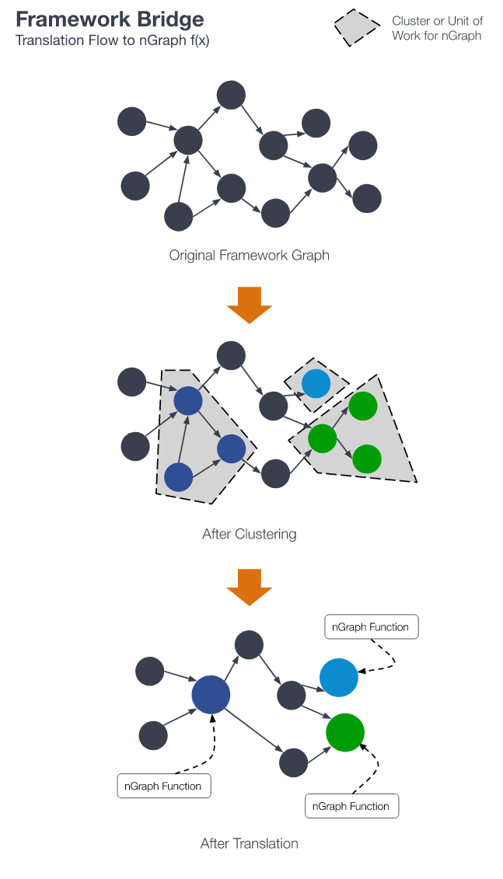

TensorFlow*
See the README on the ngraph_bridge repo for the many ways to connect Tensorflow to nGraph, enabling a DSO backend that can speed up your TensorFlow training and inference workloads.

ONNX
nGraph is able to import and execute ONNX models. Models are converted to nGraph's Intermediate Representation (IR) and converted to Function objects, which can be compiled and executed with nGraph backends.
You can use nGraph's Python API to run an ONNX model and nGraph can be used as a backend to ONNX with the add-on package nGraph ONNX.
Note
In order to support ONNX, nGraph must be built with the NGRAPH_ONNX_IMPORT_ENABLE flag. See Building nGraph-ONNX for more information. All nGraph packages published on PyPI are built with ONNX support.

Importing an ONNX model
You can download models from the ONNX Model Zoo. For example, ResNet-50:
$ wget https://s3.amazonaws.com/download.onnx/models/opset_9/resnet50.tar.gz
$ tar -xzvf resnet50.tar.gz
Use the following Python commands to convert the downloaded model to an nGraph Function:
# Import ONNX and load an ONNX file from disk
>>> import onnx
>>> onnx_protobuf = onnx.load('resnet50/model.onnx')

# Convert ONNX model to an ngraph model
>>> from ngraph.impl.onnx_import import import_onnx_model
>>> ng_function = import_onnx_model(onnx_protobuf.SerializeToString())

# The importer returns a list of ngraph models for every ONNX graph output:
>>> print(ng_function)
<Function: 'resnet50' ([1, 1000])>
This creates an nGraph Function object, which can be used to execute a computation on a chosen backend.

Running a computation
You can now create an nGraph Runtime backend and use it to compile your Function to a backend-specific Computation object. Finally, you can execute your model by calling the created Computation object with input data:
# Using an nGraph runtime (CPU backend) create a callable computation object
>>> import ngraph as ng
>>> runtime = ng.runtime(backend_name='CPU')
>>> resnet_on_cpu = runtime.computation(ng_function)
>>> print(resnet_on_cpu)
<Computation: resnet50(Parameter_269)>

# Load an image (or create a mock as in this example)
>>> import numpy as np
>>> picture = np.ones([1, 3, 224, 224], dtype=np.float32)

# Run computation on the picture:
>>> resnet_on_cpu(picture)
[array([[2.16105007e-04, 5.58412226e-04, 9.70510227e-05, 5.76671446e-05,
7.45318757e-05, 4.80892748e-04, 5.67404088e-04, 9.48728994e-05,
...
Find more information about nGraph and ONNX in the nGraph ONNX GitHub repository.

PaddlePaddle*
PaddlePaddle is an open source deep learning framework developed by Baidu. It aims to enable performant large-scale distributed computation for deep learning. The nGraph Compiler stack's integration to PaddlePaddle respects PaddlePaddle’s design philosophy to minimize switching cost for users. To access nGraph from PaddlePaddle, we've added three modules to PaddlePaddle:
- nGraph engine operator (op),
- nGraph engine, and
- nGraph bridge.
The nGraph engine op inherits the PaddlePaddle operator class to allow nGraph engine op to be called using methods consistent with other PaddlePaddle operators. When the nGraph engine is called by the aforementioned op, the nGraph bridge converts PaddlePaddle operators into nGraph operators. nGraph will then build a computational graph based on the converted ops according to the input topology.

Integration design
Key design criteria for nGraph-PaddlePaddle integration includes:
- Minimal intermediate links between nGraph and PaddlePaddle, to reduce latency and improve performance.
- Close to no switching cost for end users of PaddlePaddle framework.
- Ease of maintenance.
To satisfy the first design criteria, nGraph designed its operator to match PaddlePaddle's implementation. nGraph is triggered by the PaddlePaddle executor by one line of code.
After nGraph engine is called, it and the nGraph C++ backend manage all the heavy lifting for performance optimization. The Python frontend on PaddlePaddle remains the same, and end users need no changes in the code they write to be able to benefit from the increased performance. This design fulfills the second criteria.
Lastly, the code contributed by nGraph to PaddlePaddle repository mainly resides in the fluid/operator/ngraph directory, and having most of the nGraph code in one place allows for easy maintenance.
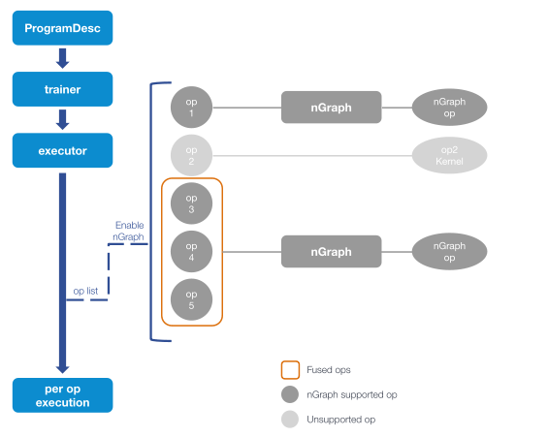
Figure A
Figure A above depicts nGraph access from PaddlePaddle. The PaddlePaddle executor generates an executable operator according to the program description (ProgramDesc). nGraph scans the operator sequence before execution, and replaces the supported operators (or subgraphs) with nGraph operators. PaddlePaddle can then execute the nGraph operators and the unreplaced PaddlePaddle operators with a uniform interface. The unreplaced operators are executed by PaddlePaddle native implementation.
nGraph's current integration reflected on PaddlePaddle's github repository is organized in the following file structure:
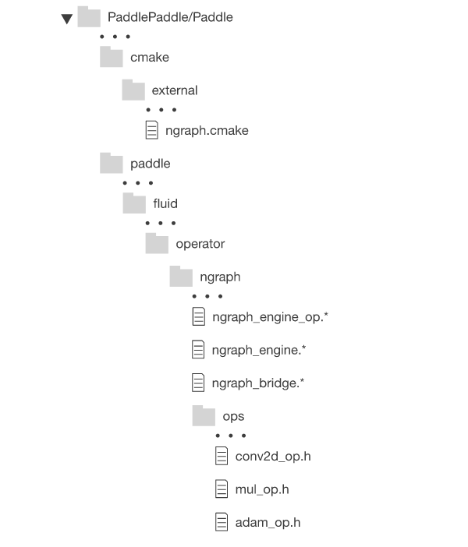
Compilation of nGraph is handled by the ngraph.cmake file in the cmake/external directory. Other newly-introduced files are located primarily in the paddle/fluid/operator/ngraph directory. The nGraph operators replacing PaddlePaddle operators as described in the previous section can be found in the ngraph/ops directory.

Integration details
More details on implementation of nGraph engine op, nGraph engine, and nGraph bridges are provided below:
- nGraph engine op: Triggers subgraphs to be executed by nGraph.
  - Input: Input variable set
  - Output: Output variable set
  - Attribute :
    - Graph: Serialized subgraph. The protobuffer described by PaddlePaddle is serialized and passed to nGraph as a string.
    - Interval: The interval of ops in operator list that will be executed by nGraph.
  - Related code :
    - Paddle/fluid/operators/ngraph/ngraph_engine_op.h link to ngraph_engine_op header code
    - Paddle/fluid/operators/ngraph/ngraph_engine_op.cc link to ngraph_engine_op cpp code
- nGraph engine: calls the nGraph Library to perform calculations.
The nGraph engine class includes the input and output required to build a nGraph function graph from the nGraph engine kernel, the execution function, and the data exchange between nGraph and PaddlePaddle. The primary methods are:
  - BuildNgIO: gets input and output variables.
  - GetNgFunction: obtains the nGraph function used in the calculation. It matches entire pattern of the input to the output and saves functions that need to be called repeatedly.
  - BuildNgFunction: builds nGraph functions.
  - Run: calls backend execution and exchange data with the paddle.
  - Related code :
    - Paddle/fluid/operators/ngraph/ngraph_engine.h link to ngraph_engine header code
    - Paddle/fluid/operators/ngraph/ngraph_engine.cc link to ngraph_engine cpp code
- nGraph bridge: converts PaddlePaddle operators to nGraph operators.
The nGraph bridge converts supported PaddlePaddle operators to nGraph operators, which results in a reconstruction of the subgraph with nGraph's intermediate representation. The convertable operators are located in the ngraph ops directory, and each operator has its own files for easy management. For the conversion of operators. There is a common unified interface to facilitate code development and operator transformation. The relevant interfaces are:
  - GetInputNode: obtains input node for the conversion operator. The nodes are managed through a map.
  - SetOutputNode: sets the constructed node to the map.
  - Related code :
    - Paddle/fluid/operators/ngraph/ngraph_bridge.h link to ngraph_bridge header code
    - Paddle/fluid/operators/ngraph/ngraph_bridge.cc link to ngraph_bridge cpp code

nGraph compilation control and trigger method
- Compile Control -- The compilation of nGraph is controlled with the WITH_NGRAPH option. If compiled using WITH_NGRAPH=ON, the nGraph Library will be downloaded and compiled. This option has a corresponding PADDLE_WITH_NGRAPH flag. If compiled WITH_NGRAPH=OFF, the relevant code will not be compiled.
- Trigger Control -- FLAGS_use_ngraph triggers nGraph. If this option is set to true, nGraph will be triggered by the PaddlePaddle executor to convert and execute the supported subgraph. Demos are provided under paddle/benchmark/fluid/train/demo (link train_demo) and paddle/benchmark/fluid/train/imdb_demo (link imdb_demo)

Contribution Guide

License
All contributed code must be compatible with the Apache 2 license, preferably by being contributed under the Apache 2 license. Code contributed with another license will need the license reviewed by Intel before it can be accepted.

Code formatting
All C/C++ source code in the repository, including the test code, must adhere to the source-code formatting and style guidelines described here. The coding style described here applies to the nGraph repository. Related repositories may make adjustments to better match the coding styles of libraries they are using.

Adding ops to nGraph Core
Our design philosophy is that the graph is not a script for running optimized kernels; rather, the graph is a specification for a computation composed of basic building blocks which we call ops. Compilation should match groups of ops to appropriate optimal semantically equivalent groups of kernels for the backend(s) in use. Thus, we expect that adding of new Core ops should be infrequent and that most functionality instead gets added with new functions that build sub-graphs from existing core ops.

Coding style
We have a coding standard to help us to get development done. If part of the standard is impeding progress, we either adjust that part or remove it. To this end, we employ coding standards that facilitate understanding of what nGraph components are doing. Programs are easiest to understand when they can be understood locally; if most local changes have local impact, you do not need to dig through multiple files to understand what something does and if it is safe to modify.

Names
Names should briefly describe the thing being named and follow these casing standards:
- Define C++ class or type names with CamelCase.
- Assign template parameters with UPPER_SNAKE_CASE.
- Case variable and function names with lower_snake_case.
Method names for basic accessors are prefixed by get_, is_, or set_ and should have simple implementations:
- A get_ method should be externally idempotent. It may perform some simple initialization and cache the result for later use. Trivial get_ methods can be defined in a header file. If a method is non-trivial, that is often a sign that it is not a basic accessor.
- An is_ may be used instead of get_ for boolean accessors.
- A set_ method should change the value returned by the corresponding get_ method.
  - Use set_is_ if using is_ to get a value.
  - Trivial set_ methods may be defined in a header file.
- Names of variables should indicate the use of the variable.
  - Member variables should be prefixed with m_.
  - Static member variables should be rare and be prefixed with s_.
- Do not use using to define a type alias at top-level in header file. If the abstraction is useful, give it a class.
  - C++ does not enforce the abstraction. For example if X and Y are aliases for the same type, you can pass an X to something expecting a Y.
  - If one of the aliases were later changed, or turned into a real type, many callers could require changes.

Namespaces
- ngraph is for the public API, although this is not currently enforced.
  - Use a nested namespace for implementation classes.
  - Use an unnamed namespace or static for file-local names. This helps prevent unintended name collisions during linking and when using shared and dynamically-loaded libraries.
  - Never use using at top-level in a header file.
    - Doing so leaks the alias into users of the header, including headers that follow.
    - It is okay to use using with local scope, such as inside a class definiton.
  - Be careful of C++'s implicit namespace inclusions. For example, if a parameter's type is from another namespace, that namespace can be visible in the body.
  - Only use using std and/or using ngraph in .cpp files. using a nested namespace has can result in unexpected behavior.

File Names
- Do not use the same file name in multiple directories. At least one IDE/debugger ignores the directory name when setting breakpoints.
- Use .hpp for headers and .cpp for implementation.
- Reflect the namespace nesting in the directory hierarchy.
- Unit test files are in the tests directory.
  - Transformer-dependent tests are tests running on the default transformer or specifying a transformer. For these, use the form
TEST(file_name, test_name)
  - Transformer-independent tests:
    - File name is file_name.in.cpp
    - Add #include "test_control.hpp" to the file's includes
    - Add the line static std::string s_manifest = "${MANIFEST}"; to the top of the file.
    - Use
NGRAPH_TEST(${BACKEND_NAME}, test_name)
for each test. Files are generated for each transformer and the ${BACKEND_NAME} is replaced with the transformer name.
Individual unit tests may be disabled by adding the name of the test to the unit_test.manifest file found in the transformer's source file directory.

Formatting
Things that look different should look different because they are different. We use clang format to enforce certain formatting. Although not always ideal, it is automatically enforced and reduces merge conflicts.
- The .clang-format file located in the root of the project specifies our format. Simply run:
$ make style-check
$ make style-apply
- Formatting with #include files:
  - Put headers in groups separated by a blank line. Logically order the groups downward from system-level to 3rd-party to ngraph.
  - Formatting will keep the files in each group in alphabetic order.
  - Use this syntax for files that do not change during nGraph development; they will not be checked for changes during builds. Normally this will be everything but the ngraph files:
#include <file>
  - Use this syntax for files that are changing during nGraph development; they will be checked for changes during builds. Normally this will be ngraph headers:
#include "file"
  - Use this syntax for system C headers with C++ wrappers:
#include <c...>
- To guard against multiple inclusion, use:
#pragma once
  - The syntax is a compiler extension that has been adopted by all supported compilers.
- The initialization
Foo x{4, 5};
is preferred over
Foo x(4, 5);
- Indentation should be accompanied by braces; this includes single-line bodies for conditionals and loops.
- Exception checking:
  - Throw an exception to report a problem.
  - Nothing that calls abort, exit or terminate should be used. Remember that ngraph is a guest of the framework.
  - Do not use exclamation points in messages!
  - Be as specific as practical. Keep in mind that the person who sees the error is likely to be on the other side of the framework and the message might be the only information they see about the problem.
- If you use auto, know what you are doing. auto uses the same type-stripping rules as template parameters. If something returns a reference, auto will strip the reference unless you use auto&:
  - Don't do things like
auto s = Shape{2,3};
Instead, use
Shape s{2, 3};
  - Indicate the type in the variable name.
- One variable declaration/definition per line
  - Don't use the C-style
int x, y, *z;
Instead, use:
int x;
int y;
int* z;

To contribute documentation for your code, please see the next section.

Contributing to documentation
Note: Tips for contributors who are new to the highly-dynamic environment of documentation in AI software:
- A good place to start is "document something you figured out how to get working". Content changes and additions should be targeted at something more specific than "developers". If you don't understand how varied and wide the audience is, you'll inadvertently break or block things.
- There are experts who work on all parts of the stack; try asking how documentation changes ought to be made in their respective sections.
- Start with something small. It is okay to add a "patch" to fix a typo or suggest a word change; larger changes to files or structure require research and testing first, as well as some logic for why you think something needs changed.
- Most documentation should wrap at about 80. We do our best to help authors source-link and maintain their own code and contributions; overwriting something already documented doesn't always improve it.
- Be careful editing files with links already present in them; deleting links to papers, citations, or sources is discouraged.
- Please do not submit Jupyter* notebook code to the nGraph Library or core repos; best practice is to maintain any project-specific examples, tests, or walk-throughs in a separate repository and to link back to the stable op or Ops that you use in your project.
For updates within the nGraph Library /doc repo, please submit a PR with any changes or ideas you'd like integrated. This helps us maintain trackability with respect to changes made, additions, deletions, and feature requests.
If you prefer to use a containerized application, like Jupyter* notebooks, Google Docs*, the GitHub* GUI, or MS Word* to explain, write, or share documentation contributions, you can convert the doc/sphinx/source/*.rst files to another format with a tool like pypandoc and share a link to your efforts on our wiki.
Another option is to fork the ngraph repo, essentially snapshotting it at that point in time, and to build a Jupyter* notebook or other set of docs around it for a specific use case. Add a note on our wiki to show us what you did; new and novel applications may have their projects highlighted on an upcoming ngraph.ai release.
Note
Please do not submit Jupyter* notebook code to the nGraph Library or core repos; best practice is to maintain any project-specific examples, tests, or walk-throughs in a separate repository.

Documenting source code examples
When verbosely documenting functionality of specific sections of code -- whether they are entire code blocks within a file, or code strings that are outside the nGraph Library's documentation repo, here is an example of best practice:
Say a file has some interesting functionality that could benefit from more explanation about one or more of the pieces in context. To keep the "in context" navigable, write something like the following in your .rst documentation source file:
.. literalinclude:: ../../../examples/abc/abc.cpp
:language: cpp
:lines: 20-31
And the raw code will render as follows
../../../examples/abc/abc.cpp
You can now verbosely explain the code block without worrying about breaking the code. The trick here is to add the file you want to reference relative to the folder where the Makefile is that generates the documentation you're writing.
See the note at the bottom of this page for more detail about how this works in the current version of nGraph Library documentation.

Adding captions to code blocks
One more trick to helping users understand exactly what you mean with a section of code is to add a caption with content that describes your parsing logic. To build on the previous example, let's take a bigger chunk of code, add some line numbers, and add a caption:
.. literalinclude:: ../../../examples/abc/abc.cpp
:language: cpp
:lines: 48-56
:caption: "caption for a block of code that initializes tensors"
and the generated output will show readers of your helpful documentation
../../../examples/abc/abc.cpp
Our documentation practices are designed around "write once, reuse" that we can use to prevent code bloat. See the contribution-guide for our code style guide.

How to build the documentation

Note: Stuck on how to generate the html? Run these commands; they assume you start at a command line running within a clone (or a cloned fork) of the ngraph repo. You do not need to run a virtual environment to create documentation if you don't want; running $ make clean in the doc/sphinx folder removes any generated files.

Right now the minimal version of Sphinx needed to build the documentation is Sphinx v. 1.7.5. This can be installed with pip3, either to a virtual environment, or to your base system if you plan to contribute much core code or documentation. For C++ API docs that contain inheritance diagrams and collaboration diagrams which are helpful for framework integratons, building bridge code, or creating a backend UI for your own custom framework, be sure you have a system capable of running doxygen.
To build documentation locally, run:
$ sudo apt-get install python3-sphinx
$ pip3 install Sphinx==1.7.5
$ pip3 install breathe numpy
$ cd doc/sphinx/
$ make html
$ cd build/html
$ python3 -m http.server 8000
Then point your browser at localhost:8000.
To build documentation in a python3 virtualenv, try:
$ python3 -m venv py3doc
$ . py3doc/bin/activate
(py3doc)$ pip install Sphinx breathe numpy
(py3doc)$ cd doc/sphinx
(py3doc)$ make html
(py3doc)$ cd build/html
(py3doc)$ python -m http.server 8000
Then point your browser at localhost:8000.
Note
For docs built in a virtual env, Sphinx latest changes may break documentation; try building with a specific version of Sphinx.

For tips on writing reStructuredText-formatted documentation, see the sphinx stable reST documentation.

Glossary
backend
A component that can execute computations.
bridge
A component of nGraph that acts as a backend for a framework, allowing the framework to define and execute computations.
builder
A builder is a function that creates a sub-graph and returns a root node to the bridge. Fused ops are preferred over builders See also: provenance/overview.
data-flow graph
Data-flow graphs are used to implement deep learning models. In a data-flow graph, nodes represent operations on data and edges represent data flowing between those operations.
framework
Frameworks provide expressive user-facing APIs for constructing, training, validating, and deploying DL/ML models: TensorFlow*, PaddlePaddle*, MXNet*, PyTorch*, and Caffe* are all examples of well-known frameworks.
function graph
The nGraph Library uses a function graph to represent an op's parameters and results.
fusion
Fusion is the fusing, combining, merging, collapsing, or refactoring of a graph's functional operations (ops) into one or more of nGraph's core ops.
ISA
An acronym for "Instruction Set Architecture," an ISA is machine code that is compatible with the underlying silicon architecture. A realization of an ISA is called an implementation. An ISA permits multiple implementations that may vary in performance, physical size, memory use or reuse, and monetary cost among other things. An ISA defines everything a machine-language programmer needs to know in order to program a particular backend device. What an ISA defines will differ among ISAs; in general, it defines things like:
- supported data types;
- physical states available, such as the main memory and registers;
- semantics, such as the memory consistency and addressing modes;
- low-level machine instructions that comprise a machine language;
- and the input/output model.
Be careful to not confuse ISAs with microarchitectures.
op
An op represents an operation. Ops are stateless and have zero or more inputs and zero or more outputs. Some ops have additional constant attributes. Every output of an op corresponds to a tensor and has an element type and a shape. The element types and shapes of the outputs of an op are determined by the inputs and attributes of the op.
parameter
In the context of a function graph, a "parameter" refers to what "stands in" for an argument in an op definition.
provenance
The term provenance refers to the matching of device code to framework sub-graphs; it is analogous to source code locators in conventional compilers, which associate regions of object code with source files and line numbers.
quantization
Quantization refers to the conversion of numerical data into a lower-precision representation. Quantization is often used in deep learning to reduce the time and energy needed to perform computations by reducing the size of data transfers and the number of steps needed to perform a computation. This improvement in speed and energy usage comes at a cost in terms of numerical accuracy, but deep learning models are often able to function well in spite of this reduced accuracy.
result
In the context of a function graph, the term "result" refers to what stands in for the returned value.
dynamic tensor
A tensor whose shape can change from one "iteration" to the next. When created, a framework bridge might supply only partial shape information: it might be all the tensor dimensions, some of the tensor dimensions, or none of the tensor dimensions; furthermore, the rank of the tensor may be left unspecified.
shape
The shape of a tensor is a tuple of non-negative integers that represents an exclusive upper bound for coordinate values.
shape propagation
The static process by which assignment of every tensor (or, equivalently, every node output) in the graph is assigned complete shape information.
shared pointer
The C++ standard template library has the template std::shared_ptr<X>. A shared pointer is used like an X* pointer, but maintains a reference count to the underlying object. Each new shared pointer to the object increases the count. When a shared pointer goes out of scope, the reference count is decremented, and, when the count reaches 0, the underlying object is deleted. The function template std::make_shared<X>(...) can be used similarly to new X(...), except it returns a std::shared_ptr<X> instead of an X*.
If there is a chain of shared pointers from an object back to itself, every object in the chain is referenced, so the reference counts will never reach 0 and the objects will never be deleted.
If a referenced b and b wanted to track all references to itself and shared pointers were used both directions, there would be a chain of pointers form a to itself. We avoid this by using shared pointers in only one direction, and raw pointers for the inverse direction. std::enabled_shared_from_this is a class template that defines a method shared_from_this that provides a shared pointer from a raw pointer.
nGraph makes use of shared pointers for objects whose lifetime is hard to determine when they are allocated.
step
An abstract "action" that produces zero or more tensor outputs from zero or more tensor inputs. Steps correspond to ops that connect nodes.
tensors
Tensors are maps from coordinates to scalar values, all of the same type, called the element type of the tensor.
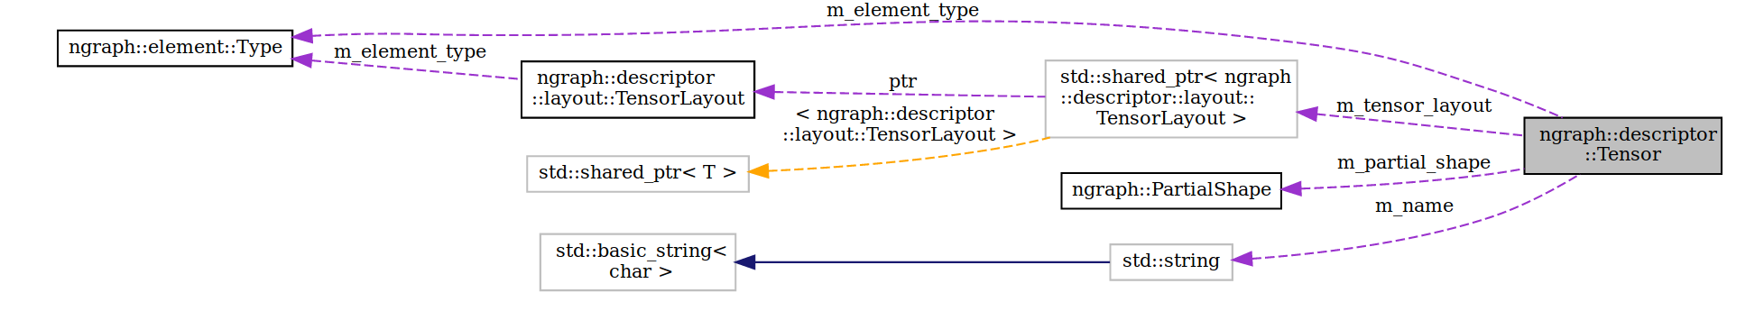
Tensorview
The interface backends implement for tensor use. When there are no more references to the tensor view, it will be freed when convenient for the backend.
model description
A description of a program's fundamental operations that are used by a framework to generate inputs for computation.
export
The serialized version of a trained model that can be passed to one of the nGraph backends for computation.
NN
NN (Neural Network) is an acronym for "Neural Network". NN models are used to simulate possible combinations of binary logic processing and multi-layer (multi-dimensional) paths through which a data-flow graph may be mapped or computed. A NN does not have centralized storage; rather, a NN manifests as information stored as patterns throughout the network structure. NNs may be Recurrent (feedback loop) or Nonrecurrent (feed-forward) with regard to the network vector.
ANN
Artificial Neural Network (ANN), often abbreviated as NN.
RANN
Recurrent Artificial Neural Network (RANN), often abbreviated as RNN.
RNN
A Recurrent Neural Network (RNN) is a variety of NN where output nodes from a layer on a data-flow graph have loopback to nodes that comprise an earlier layer. Since the RNN has no "centralized" storage, this loopback is the means by which the ANN can "learn" or be trained. There are several sub-categories of RNNs. The traditional RNN looks like:

where is the input data, is the memory, and output is . ops/tanh, ops/dot, and ops/softmax are all nGraph core Ops <ops/index>.
LSTM
LSTM (Long Short-Term Memory) is an acronym for "Long Short-Term Memory". LSTMs extend on the traditional RNN by providing a number of ways to "forget" the memory of the previous time step via a set of learnable gates. These gates help avoid the problem of exploding or vanishing gradients that occur in the traditional RNN.
SGD
Stochastic Gradient Descent (SGD), also known as incremental gradient descent, is an iterative method for optimizing a differentiable objective function.
validated
To provide optimizations with nGraph, we first confirm that a given workload is "validated" as being functional; that is, we can successfully load its serialized graph as an nGraph function graph

