

**White Paper**

**Table of Contents**

Abstract 4

1. Background 5

2. Why do we develop Nerve 6

3. What is Nerve 8

4. Technical Design of Nerve 9

(1) The bottom layer of blockchain 9

(2) Consensus algorithm 10

(3) Price feeding mechanism 12

(4) Cross-chain interaction 13

5. NerveDEX 17

(1) Function description of NerveDEX 17

(2) Technical structure of NerveDEX 19

(3) Account system 20

(4) Transaction matching logic 21

(5) Transaction confirmation time 21

(6) Supported assets 21

6. Economic model of Nerve 22

(1) Initial distribution (1.1 billion) 22

(2) node consensus output (1 billion) 23

7. Team 29

8. Development plan of Nerve 30

Phase 1: October 2019 - March 2020 30

Phase 2: April 2020 - December 2020 31

Phase 3: 2021 - 2023 31

9. Open-source community of Nerve 31

# Abstract

**Nerve is a decentralized digital asset service network** and a blockchain cross-chain interaction protocol based on NULS microservice framework and developed with NULS ChainBox. It aims to break the Isolated value island of the blockchain, establish a cross-chain asset interaction network, and provide all the necessary underlying support for the Defi application ecosystem. Let every digital asset holder enjoys truly secure, free and transparent Defi application services.

# 1. Background

Bitcoin has grown to trillions of market value, surpassing the market value of many countries' sovereign currencies. In the inevitable process of the development history of blockchain, various public chains are also emerging one after another. There are more and more public chains, but each blockchain is an independent closed loop, of which the application can only be used with the chain assets. Assets on the chain have become isolated value islands, and some breakthrough Defi scenarios can't give full play to their value due to the limitation of the local token on the chain, thus the blockchain, an emerging industry, can't gather strength to make further breakthroughs.

People's pursuit of freedom has never stopped and the DeFi applications allow humans for the first time to fully enjoy the asset services that everyone should have. Nerve aims to realize this vision, creating a value world of multi-asset interaction and discussing the universal cross-chain protocol for value exchange with various communities to provide better support for the birth of large-scale Defi applications, and gathering industry strength to make continuous breakthroughs on DeFi to achieve the goal of serving all mankind.

# 2. Why do we develop Nerve

**Developing a general cross-chain interaction protocol.** Through the standard protocol conversion layer of Nerve, we can match the general interface standard for development, access more mainstream digital assets, and form a general cross-chain interaction protocol. By following the general interface standard to develop a module and through the verification and upgrading of virtual bank and consensus node, you can load the cross-chain interaction protocol of Nerve.

**Providing a new intelligent lightning network for mainstream digital assets such as BTC.** Bitcoin has a long confirmation time and a high transfer fee. Through Nerve, you can initiate a fast transaction with low handling fee , and it can realize second level confirmation on Nerve. Most mainstream digital assets such as BTC do not have smart contracts, thus decentralized mortgage lending, decentralized exchange and other Defi applications cannot be directly implemented in their chains. While more application scenarios or ecosystem can be easily realized through Nerve.

**Opening the blockchain closed-loop of mainstream digital assets and enabling quick transfer to each blockchain of the NULS ecosystem.** Any blockchain is like a local area network (LAN). The assets on the chain can only circulate in the closed-loop. NULS is an infrastructure for building the blockchain and the blockchain built through NULS modules can realize asset circulation, with the only need to configure cross-chain modules. The goal of Nerve is to connect LANs of other network with different structure types, such as BTC/ETH, etc.

**The multi-asset, open and transparent value interaction platform provides the underlying support for the Defi application ecosystem.** We store digital assets such as BTC into centralized platforms, such as exchanges, centralized financial wallets, etc., and then they can arbitrarily misappropriate your assets. These platforms are black boxes that cannot ensure the safety of your assets. While in Nerve, you can build an asset trading platform, where all data is open and transparent. Your assets are controlled by multiple signatures through cross-chain virtual banks to ensure the security of assets.

# 3. What is Nerve

**Nerve is a decentralized network of digital asset services and a blockchain cross-chain interaction protocol based on NULS microservice framework and developed with NULS ChainBox.**It aims to break the isolated value island of the blockchain, establish a cross-chain asset interaction network, and provide all the necessary underlying support for the Defi application ecology. Let every digital asset holder enjoys the real security, freedom, and transparency of the Defi application services.

Through the Nerve cross-chain interaction protocol, only a small amount of development is needed through the standard interface, and then the blockchain with different structures can be transformed into a set of common asset types that can be identified by the cross-chain modules in the NULS ecosystem. In this way, we can achieve the asset interaction inside and outside of the NULS ecosystem, and provide rich Defi scenarios for mainstream digital assets such as BTC.

# 4. Technical Design of Nerve

## (1) The bottom layer of blockchain

Nerve is built based on the NULS ChainBox development framework, . ChainBox is a tool to build a blockchain quickly. It encapsulates six underlying modules of ledger, account, transaction, block, consensus, and network and shields complex blockchain technologies such as distributed data storage, peer-to-peer transmission, consensus mechanism, and encryption algorithm. Developers can use it to build a basic chain in minutes, or develop business modules according to the standard communication protocol and then form a new application chain driven by ChainBox.



Based on ChainBox, Nerve has made the following optimization and expansion:

1. Adding the cross-chain module;

2. Replacing the consensus module POC in ChainBox with the consensus module POCBFT;

3. Adding a protocol conversion module for communication with other blockchains.

NULS modular architecture based on microservice can lower the development threshold of blockchain and reduce the development and time cost of building the blockchain. Through the NULS cross-chain protocol, all the NULS ecological assets can be docked. In addition, Nerve supports communication with other heterogeneous blockchains, thereby achieving extension of NULS ecosystem and self-value.

4. Adding the DEX module to support the decentralized matchmaking transaction at the bottom, and providing rich asset management and functional application for the assets in the Nerve ecosystem and the cross-chain ecological assets of NULS.

## (2) Consensus algorithm

Nerve's consensus algorithm is implemented based on the POC (proof of credit) algorithm of NULS. POC is a safe, reasonable and fair consensus mechanism, which has the advantages of DPOS and POS and achieves a good balance in decentralization and efficiency. Nerve is a decentralized digital asset service network, which needs to provide the underlying support for massive applications and services in the future. There are very high requirements for performance and stability. Therefore, based on the POC consensus algorithm, Nerve has designed an efficient and stable consensus algorithm POCBFT. POCBFT adds PBFT mechanism based on POC to realize the final confirmation of blocks and reduce the block time interval to the second level, which can enhances the user experience. Block confirmation is transaction confirmation, so the transaction will not be rolled back.

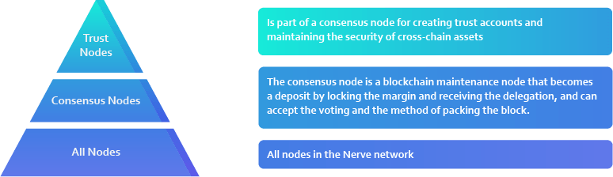

Nerve's network consists of three layers:

1. Virtual bank: the virtual bank is responsible for the maintenance of cross-chain assets, including creating and managing multiple accounts or smart contracts in parallel chains, creating and broadcasting asset transferred out transactions, etc. The virtual bank is selected from the consensus nodes, and the 15 consensus nodes with the largest amount of deposit will be selected by default. The reward weight of a virtual bank is twice that of a common consensus nodes.

2. Consensus node: the consensus node is responsible for the maintenance of the blockchain. Consensus node can be created with deposit, which can’ be less than 200,000 NVT and is not capped. The number of consensus nodes is fixed to 35, and the top 35 nodes by deposit are selected to maintain the entire Nerve network.

3. Common node: other nodes are responsible for transaction collection, block and transaction verification and providing services for applications, etc.

## (3) Price feeding mechanism

Each consensus node must provide accurate price feeding procedures for the average price of multiple exchanges, Oracles or quotation agencies, similar to the index. The data provided to the system by the price feeding procedures provided by the distributed consensus node to judge the weight is called the price feeding index.

The feeding index changes every day, and the change result is written into the block.

1. Eliminating 2 lowest and 2 highest feeding prices;

2. The average price of all remaining consensus nodes is submitted to the system as the weight basis.

Pledge and mortgage mining tokens according to accessed tokens , and distribute the weight according to the corresponding market value.

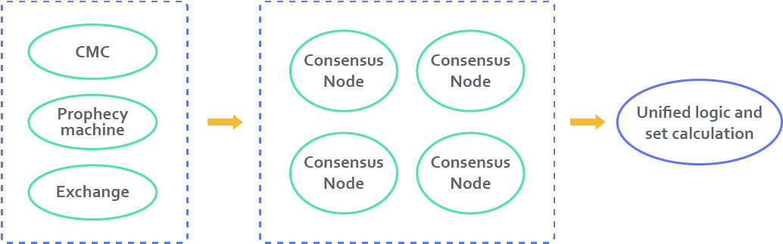

## Cross-chain interaction

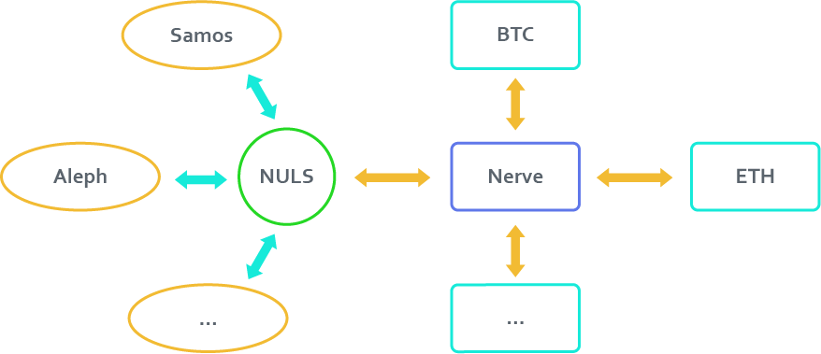

**Nerve's cross-chain interaction is divided into two parts**

* NULS cross-chain ecological docking: realize the interaction of all blockchains in the NULS ecosystem based on the general NULS cross-chain protocol.
* For independent public chains such as Bitcoin, Ethereum and Binance chain, Nerve defines a set of interface protocols, which can facilitate the interaction of different blockchains. The cross-chain interface protocol includes the following aspects:
* address mapping
* creating multi-signature addresses/creating smart contracts
* transaction verification
* transaction assembly
* transaction broadcast
* signature verification
* additional signature

The architecture of cross-chain interaction protocol is designed as follows:

Every time a blockchain is docked, it needs to implement a set of interface protocol components for data interaction between the two chains.

A certain number of virtual banks are selected from the consensus nodes to create and manage multi-signature addresses (smart contracts). Virtual banks are responsible for the verification of assets transfer in and execution of asset transfer out.

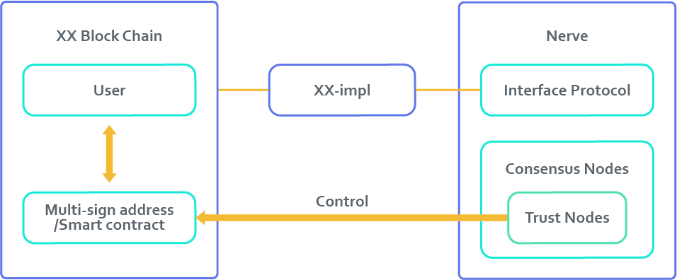

Taking BTC as an example, the cross-chain interaction process is as follows:

Transfer in cross-chain assets (deposit):

The user transfers BTC to the multi-signature account of the Bitcoin chain managed by the virtual bank, and fill in the remarks with his/her Nerve address of Nerve-ADDR. The virtual bank of Nerve monitors the transaction of the Bitcoin network, verifies the confirmation number, prevents the fork rollback attack, assembles a coin-creating transaction to the user's mapping address of Nerve-ADDR, and signs the transaction. Then it will broadcast the transaction, collect 66% signatures from the virtual bank, pack the transaction into the block, and then update the ledger. After that, the user has BTC assets in the Nerve ecosystem. The actual BTC assets on Bitcoin network are guaranteed not to be used by the virtual bank.

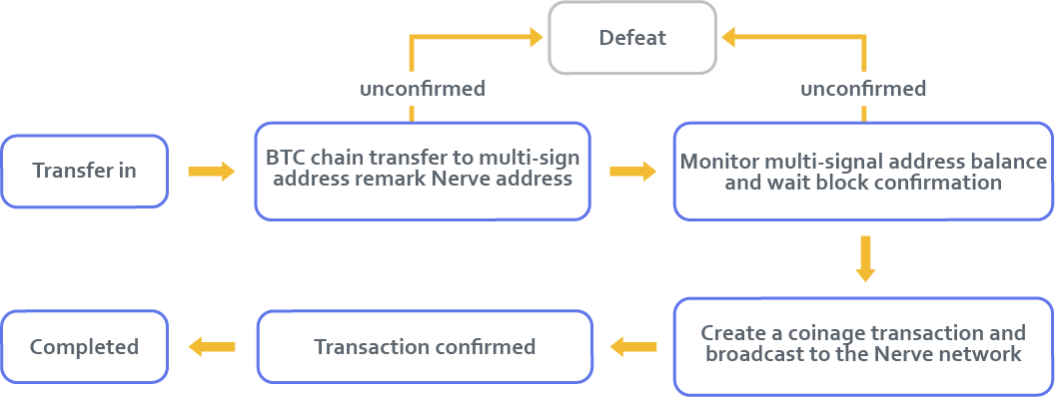

Transfer out cross-chain assets (withdrawal):

The user assembles the transfer-out transaction, with the target address of Bitcoin address of BTC-ADDR, signs and broadcasts the transaction. Once the consensus node receives the transaction, it will validate the transaction signature and pack the transaction into the block after approving. After the block is confirmed, each node assembles the multi-signature transaction, and broadcasts it to the Nerve network. When the number of signatures is sufficient, the transaction will be broadcast to the Bitcoin main network, and BTC will be transferred to the BTC-ADDR from the Bitcoin multi-signature account. After that, the transaction is completed.

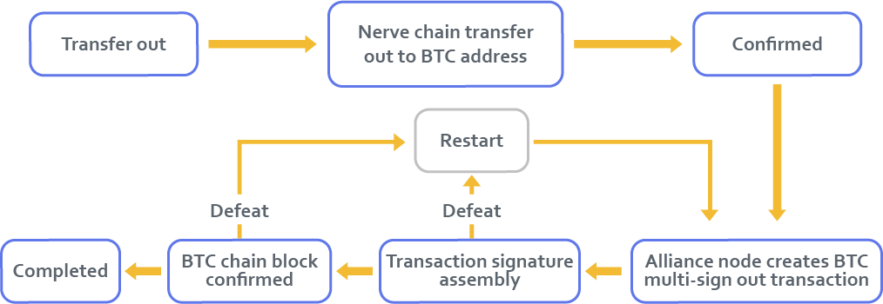

# 5. NerveDEX

In a complete Defi application ecosystem, asset exchange will be an essential infrastructure. Compared with the centralized exchange, DEX will have a better future as a more fair and transparent solution.

Based on the Nerve network, NerveDEX is designed as an open exchange that anyone can participate in. NerveDEX adopts the way of matching on the chain, where all consensus nodes participate in the transaction matching to ensure the fairness of the exchange.

## (1) Function description of NerveDEX

• **Asset issuance**

Anyone in NerveDEX can issue assets by destroying a certain amount of NVT. The assets issued on NerveDEX can directly create trading pairs and start trading.

**• Trading pair creation**

On NerveDEX, there is no review permission and approval for creating trading pair. Anyone can create a trading pair and start asset trading after destroying a certain number of NVT.

**• Transaction fees**

The NerveDEX transaction will charge a certain handling fee (initially set at 0.02%), and all handling fees will be collected into an open account. The Nerve foundation will repurchase NVT with all the assets in the account and destroy them at a fixed time.

**• Order open & cancellation**

NerveDEX order open and cancellation operations need to be carried out through transactions, which will be sent by the user. Subsequent matching or cancellation operations will take effect only after the transaction is successfully packed into the block.

Assets are locked in the process of buying and selling orders. For the open order that has not been filled, the assets in the open order can be unlocked through the cancellation of the order, to restore the normal use of the assets.

The basic fee is required for the transactions of order open and cancellation to pay the miner.

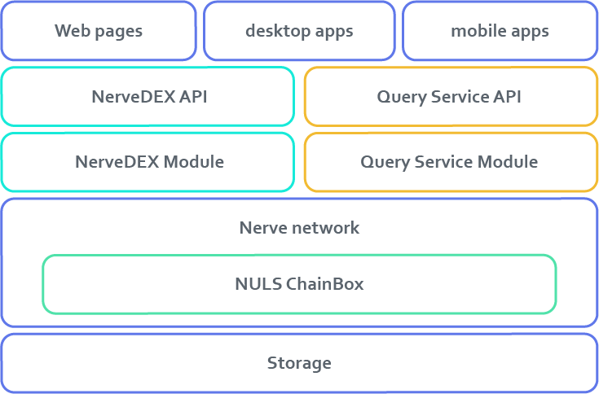

## (2) Technical structure of NerveDEX

**• User layer**

NerveDEX will provide a web-based operation interface, mobile phone operation interface and multi-system desktop operation interface so that users can easily conduct asset transactions.

**• Interface layer**

All users operations need to rely on two API services. In the future, each node can deploy its API services, or use the public API services provided by the team. API services do not involve account operations, and the use of public APIs does not affect the security of user accounts.

**• Service layer**

All APIs are provided by two bottom modules. The NerveDEX module is an essential module at the bottom, which is used to manage and match transactions. The QueryService module is a optional module that provides data statistics, query and other functions required by the NerveDEX client.

**• Blockchain layer**

The above two modules need to be embedded in Nerve.network to work together with other business modules and ChainBox modules in the way of expanding modules at the bottom layer.

**• Storage layer**

Including persistent storage and cache.

## (3) Account system

NerveDEX account system is compatible with the Nerve network's account system. It can be directly imported into NerveDEX for use, and there is no deposit or withdrawal operation. The trading assets are always in their accounts, and the order open is only involved in locking operation, not for transfer of asset ownership, and the asset exchange operation can be carried out only after the transaction is completed.

## (4) Transaction matching logic

The NerveDEX module always maintains the current inventory port. When the new block is confirmed, the operation is carried out according to the transaction (order open/cancellation) sequence in the block.

## (5) Transaction confirmation time

The block time interval of the Nerve network will reach the second level. The confirmation time of the NerveDEX is consistent with that of the underlying layer to avoid false deals and ensure the timeliness of the transaction.

## (6) Supported assets

**•** Nerve;

**•** The assets generated through the asset issuance function in NerveDEX;

**•** NULS: NULS will be transferred into Nerve in the way of cross-chain.

**•** NRC20: all NRC20 assets that support cross-chain;

**•** BTC: Nerve will realize heterogeneous cross-chain transactions, and the initial target including BTC;

**•** ETH: Nerve will realize heterogeneous cross-chain transactions, and the initial target including ETH;

**•** ERC20: while realizing ETH cross-chain, Nerve will support ERC20 asset cross-chain;

**•** Other: more assets will be accessed in the future;

# **6. Economic model of Nerve**

Nerve is a built-in original asset in the network, with the cap of 2.1 billion NVT. The initial supply of NVT is 1.1 billion, where 1 billion are generated through node consensus.

1. **Initial distribution (1.1 billion)**

**Early development: 200 million (airdrop: 10 million, 0.48%) 9.5%**

It is used for community construction and promotion in the early stage, as well as the recruitment of virtual banks. 10 million of them are airdropped to the corresponding address according to the proportion of NULS held.

**Cornerstone Investment: 300 million, 14.3%**

It is used for the participation of institutions and partners, bringing more resources and institutional partners to the Nerve and NULS ecosystem, and promoting the development of the Nerve project.

**Nerve Foundation: 600 million, 28.6%**

It is used for the team development and phase I and phase II R&D for Nerve, as well as the long-term development fund support of the project to ensure the sustainable development of the Nerve project.

200 million of them are permanently staked in virtual bank nodes to ensure the safe operation of assets on the network and chain.

And 400 million are gradually unlocked monthly one year later after the launch of the MainNet and unlocked finishing in 20 months.

## node consensus output (1 billion)

**• Staking consensus:**

Any asset in the Nerve chain can participate in the Staking, including the assets transferred from other chains. In the future, all valuable digital assets, such as BTC and ETH, can participate in the Staking after they are transferred to the Nerve chain, and get consensus rewards.

**• Create nodes:**

To create a consensus node, you need to lock the deposit, which has the same effect as the other assets' Staking. The way of Staking is to lock the asset in a Staking pool. The user has only the ownership of the asset and no operation right and the operation right can only be restored after cancelling the Staking. When an asset is being staked, you can choose flexible or time-fixed staking, flexible staking means you can cancel the staking at any time and unlock related assets.

**• Weight coefficient:**

Nerve has designed an incentive system with different weights for different assets and different ways of Staking.

**• Consensus reward:**

- Initial daily total reward: 86400

- Block reward decrements time: 100 days

- Block decay coefficient: 0.822%

- Cap: when the total amount reaches 2.1 billion, it will no longer produce new tokens, which is expected to take about 100 years.

A weight can be calculated for each staking of each account, with which the number of rewards for that staking can be calculated. The weight is calculated according to the amount of Staking and the weight coefficient.

**• Weight calculation**

The weight coefficient *weightcoefficient* is equal to 1 by default and increases in the following cases:

1. In the calculation of NULS and Nerve, the weight coefficient is multiplied by 2;

2. In the calculation of the deposit of virtual bank, the weight coefficient is multiplied by 2;

3. In the calculation of consensus nodes of the non-virtual bank, the weight coefficient is multiplied by 1.5;

4. For the time-fixed staking, weight coefficient varies from the time, as shown in the following table:

|  |  |
| --- | --- |
| Duration | weight coefficient |
| Three months | 1.2 |
| Half a year | 1.5 |
| One year | 2 |
| Two years | 2.5 |
| Three years | 3 |
| Five years | 4 |
| Ten years | 5 |

5. When any two of the above three conditions are satisfied at the same time, it can be superposed;

6. Calculation formula:



7. Example of weight calculation:

a) When an account creates a consensus node and pays a deposit of 200000 NVT, the weight of this account is , equal to 346000;

b) After account becomes a virtual bank, the weight of this account is , equal to 400000;

c) if an account is transferred into 5 BTC, and one BTC is equal to 3500 NVT according to the exchange ratio of the current day's feeding system. The account stakes the 5 BTC with the locking time of 5 years, then the weight of this account is , equal to 350000;

d) if an account is transferred into 1000 NULS, one NULS is equal to 12 NVT according to the exchange ratio of the current day's feeding system. The account stakes the 1000 NULS with the locking time of half a year, then the weight of the account is , equal to 20760;

**• Reward calculation**

Description of parameters used in the reward calculation formula:

|  |  |  |
| --- | --- | --- |
| Field | Type | Remark |
| Weight | Long | Weight of a certain staking |
| Total Weight | Long | Sum of weight of all accounts |
| Height | Long | Current block height |
| Credit | Double | Credit value of the node |

Description of constants used in the reward calculation formula:

|  |  |
| --- | --- |
| Key figure | Description |
| 86400 | Number of blocks per day |
| 8640000 | Number of blocks in a reward decay period (100 days) |
| 0.00822 | Decreasing proportion |

• Calculation formula of the Staking reward (daily reward)



• Calculation formula of node reward (reward for producing a block)



• **Virtual bank:**

The top 15 with the largest deposit will become virtual banks, which have twice the rewards of blocking. Moreover, these 15 virtual banks will protect cross-chain asset security through multiple signatures. Virtual banks are also the core of the entire Nerve project and the entire value interaction platform. It is necessary to increase PAX, USDT and other stable assets as a deposit to become a virtual bank at a proper time.

• **Usage of Nerve:**

1. Paying for cross-chain settlement;

2. Voting rights of Nerve project and of the on-chain governance tool;

3. Handling fees for on-chain transactions;

4. Deposit for creating a node;

5. Participating in the staking to get rewards;

6. Repurchase and destroy the transaction fees of the decentralized exchange;

7. Destroy the fees for creating transactions pairs in the decentralized exchange;

8. Destroy the fees for creating assets in the decentralized exchange;

9. Other application scenarios of the Nerve ecosystem.

# **Team**

**Founder**

Berzeck,one of NTC members;System engineering bachelor graduated from Engineering Military School,La Paz -Bolivia; General Manager at ARXEN SRL(Official distributor of Pulzar ERP );Former National Director for Information System Division in PROESA(A national commercial );Nearly 20 years of experience in system development and team management ,He has extensive experience in using modular methods and microservices. He has led and completed the design and development of modular refactoring and microservice architecture for the underlying core of NULS 2.0.

**Core Team**

NTC（NULS Technical Community) is the core technical community. NTC members have an in-depth understanding of the NULS architecture and products, and they enjoy the flexibility and creativity of self-government and community support. The Nerve project was founded by the member of the NTC and received full support from the community. Nerve was developed and provided incubation support by NTC. It would build a multi-chain interworking blockchain network for the NULS and Nerve ecosystems.

# **Development plan of Nerve**

## **Phase 1: October 2019 - March 2020**

Product technology: realizing cross-chain interaction of BTC, ETH and ERC20.

The first on-chain financial application NerveDEX will be released along with the Nerve, which can better help the circulation and transaction between different tokens combined with the financing and issuance protocol for new projects POCM in the NULS ecosystem. NerveDEX will support transactions between all NCR20 assets, and the cross-chain assets of Nerve and NULS.

## **Phase 2: April 2020 - December 2020**

Product technology: realizing cross-chain interaction of mainstream digital assets such as BCH without smart contract function.

NerveDEX provides free circulation and trading for more mainstream digital assets.

## **Phase 3: 2021 - 2023**

Product technology: realizing the top 10 among types of digital assets

Access to the OTC function and more stable assets such as PAX, DAI, etc.

# **Open-source community of Nerve**

Nerve is a global open-source software project driven by the community. The community ecosystem is the vitality of open-source projects. Nerve is an open-source community project initiated by the Nerve foundation and the Nerve foundation is committed to supporting the development and construction of the open-source project Nerve and promoting the safety, harmony, and development of the open-source ecosystem.