Оглавление

Git 2

Байт код 12

# Git

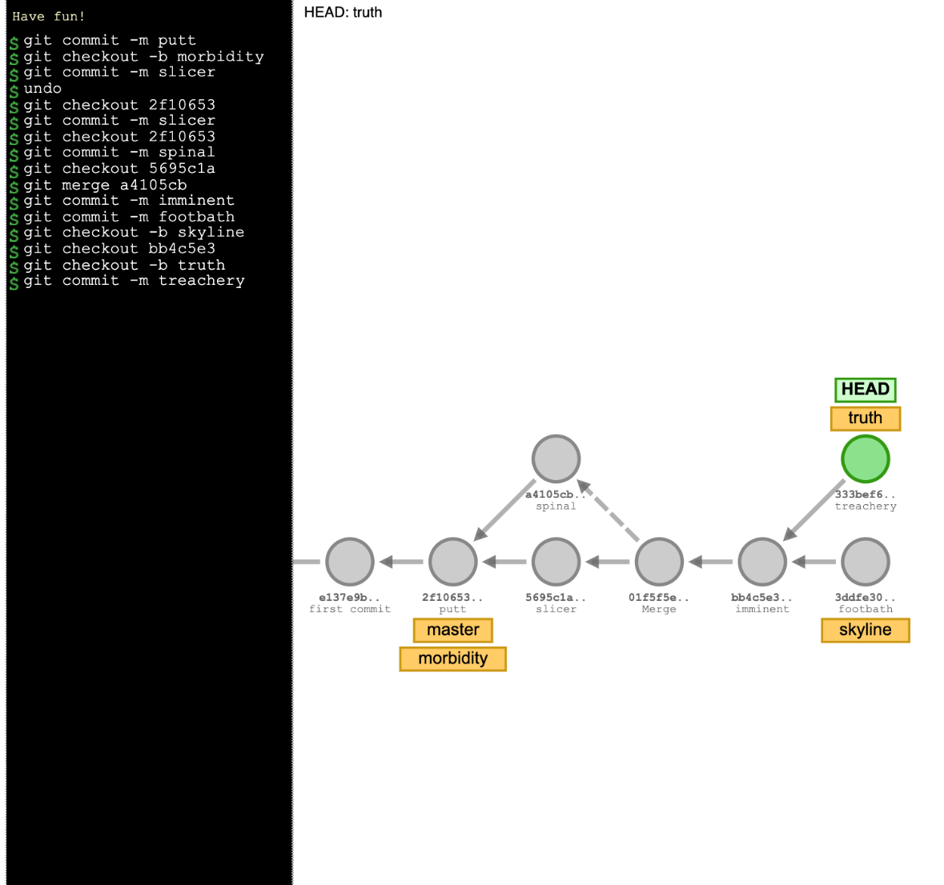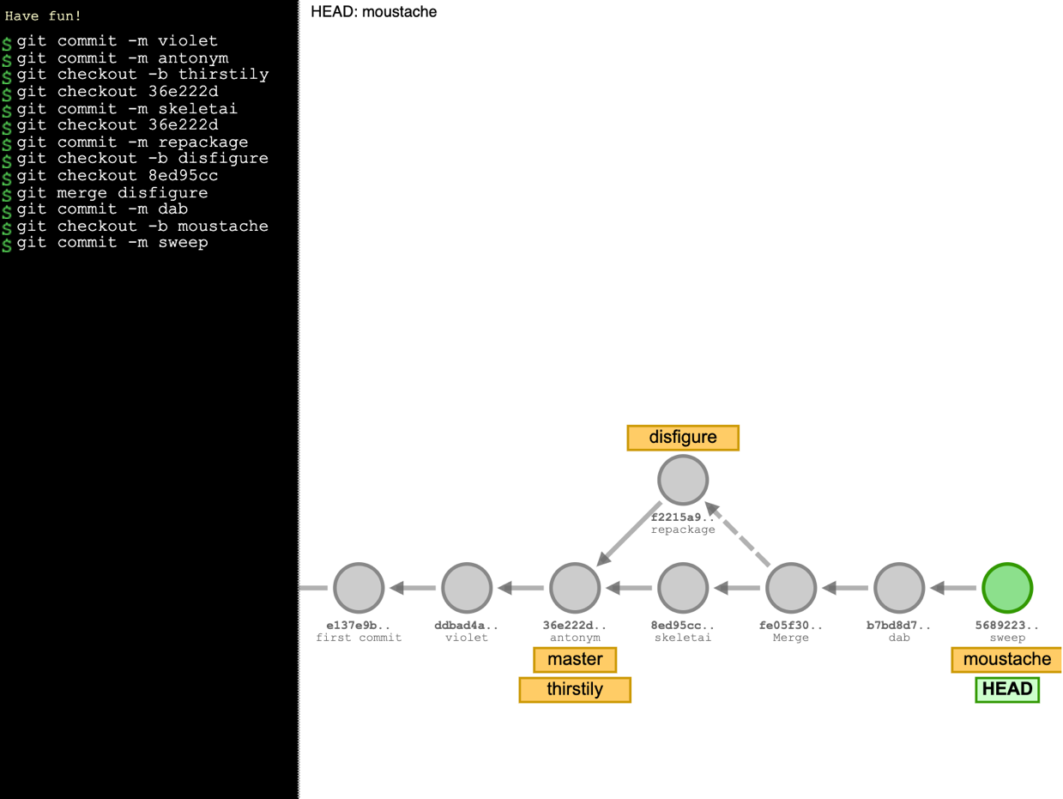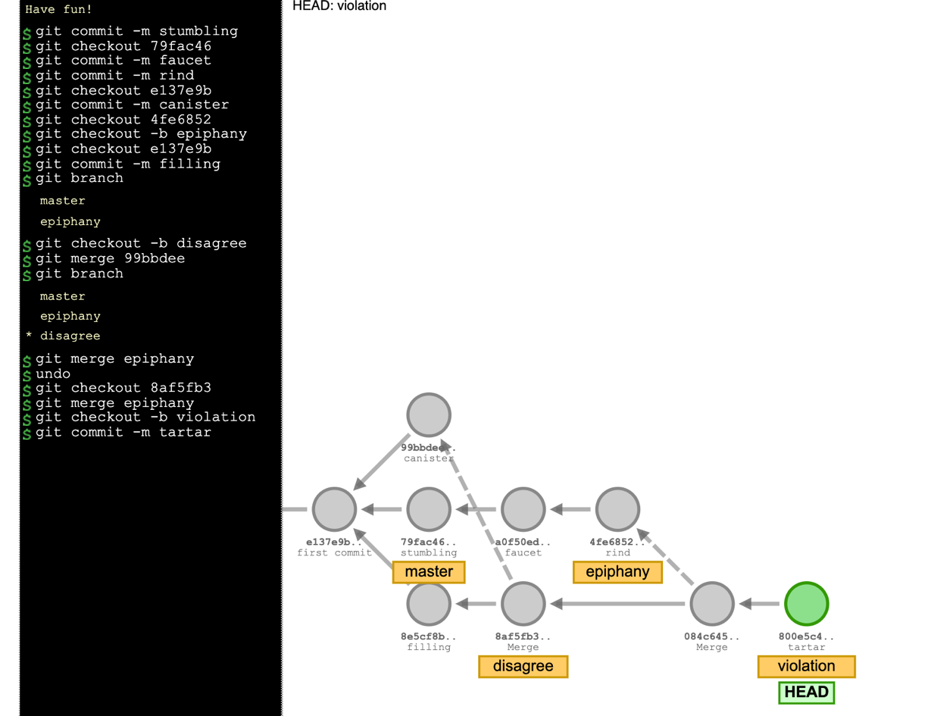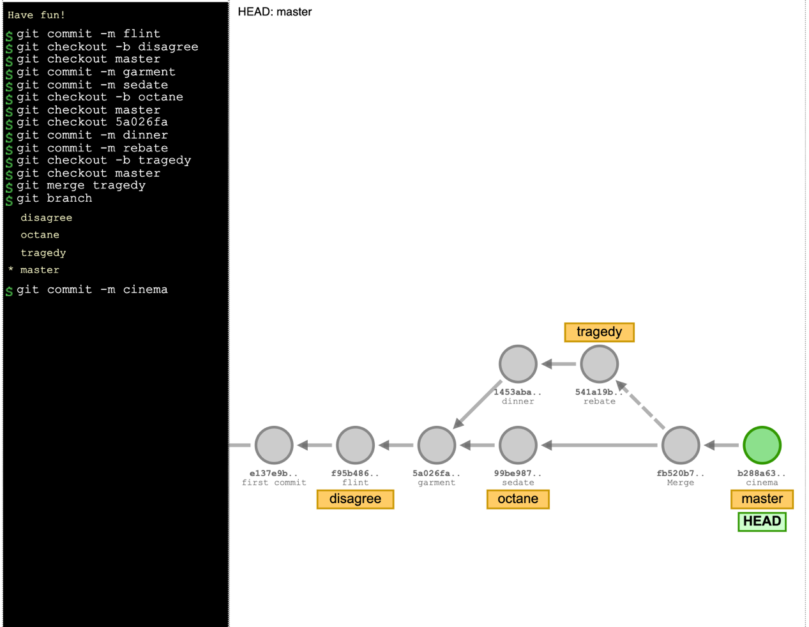

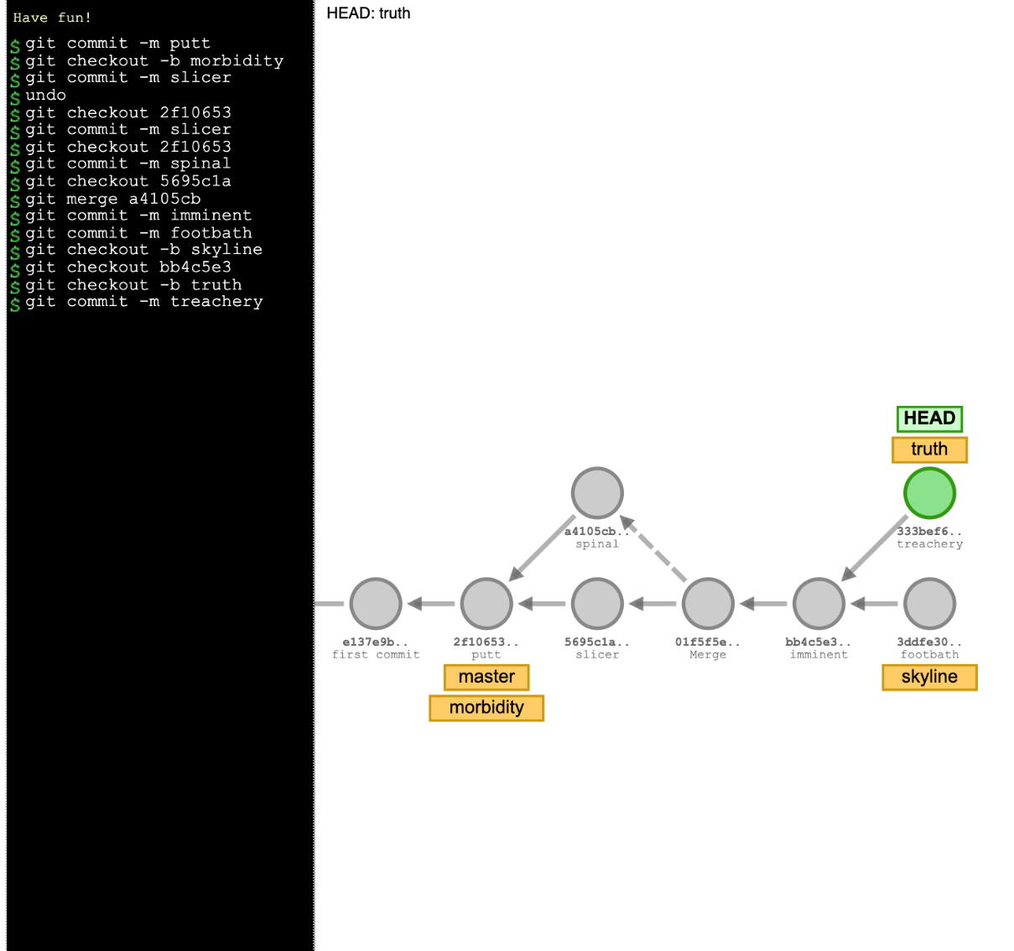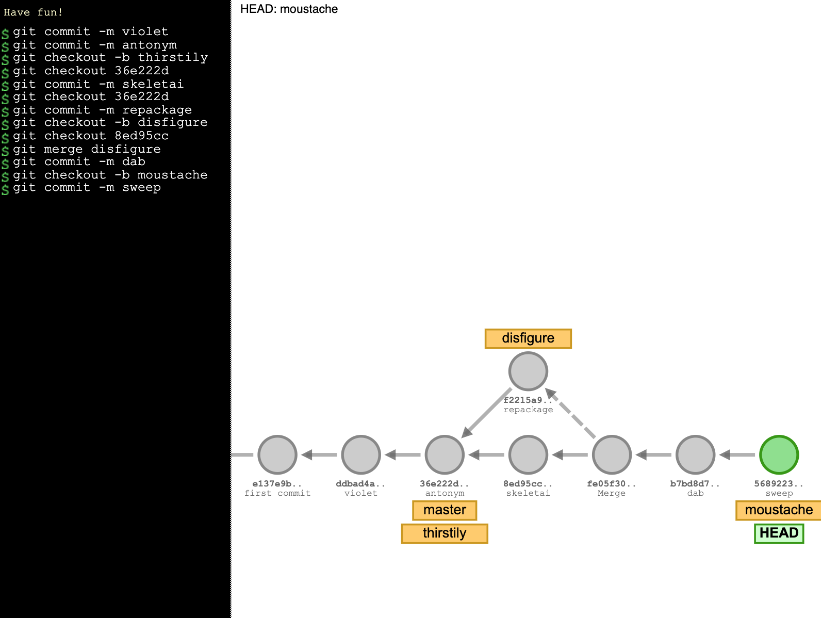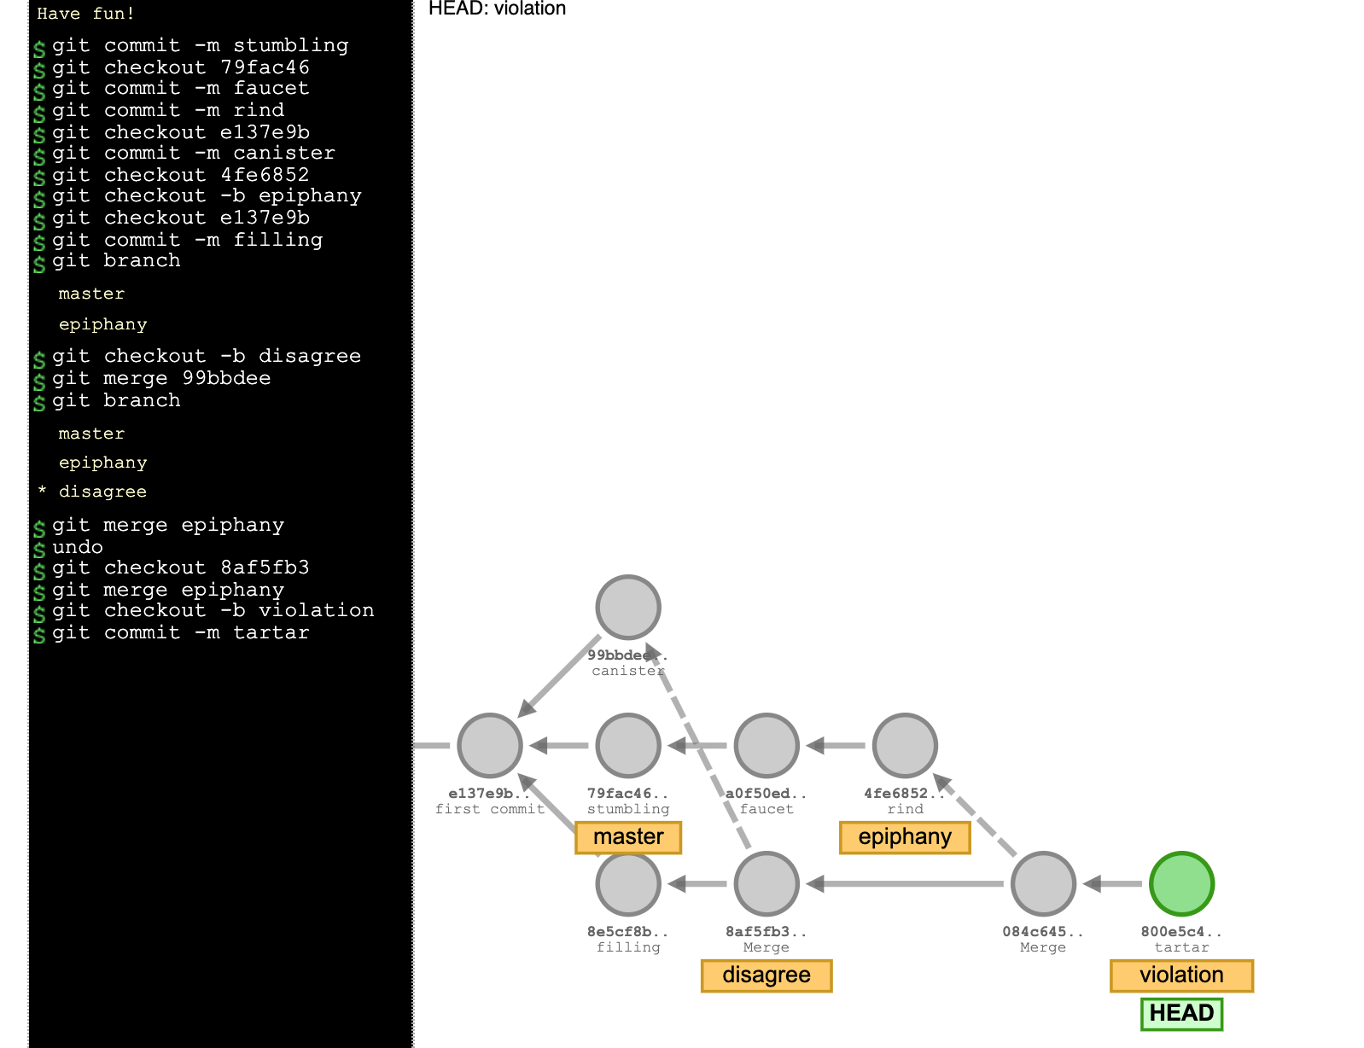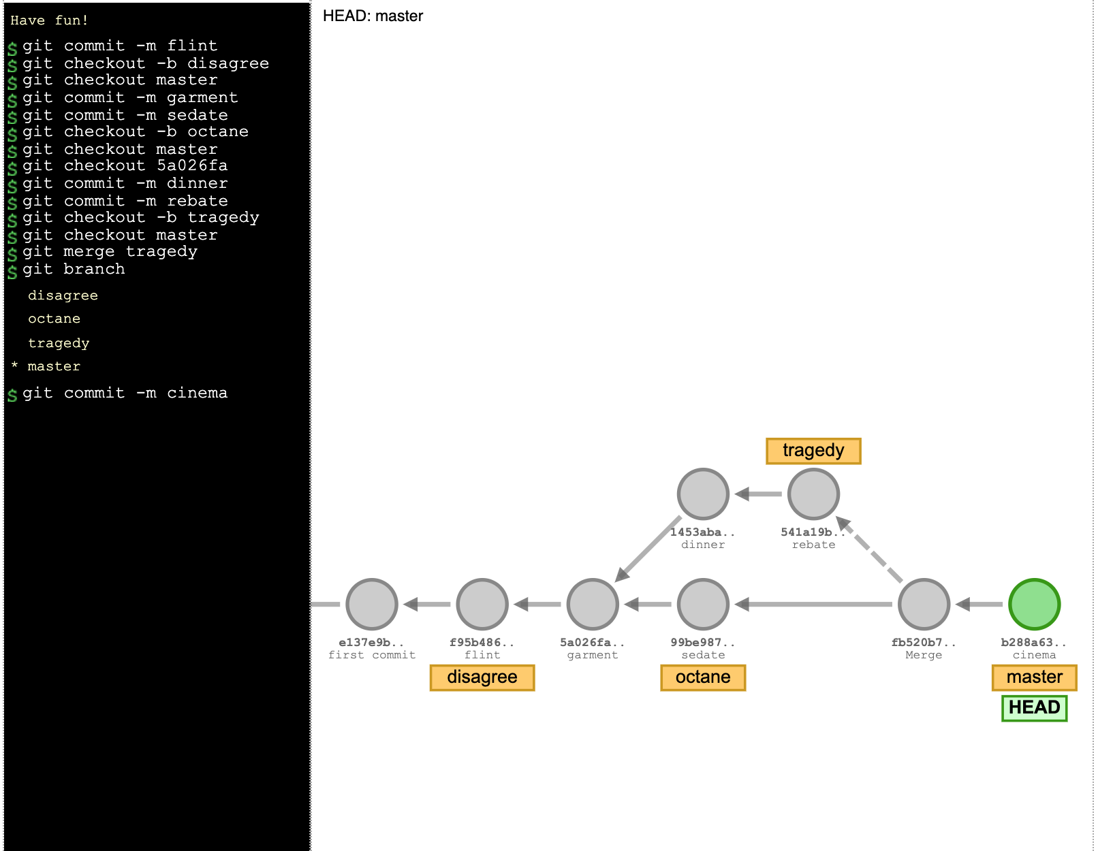

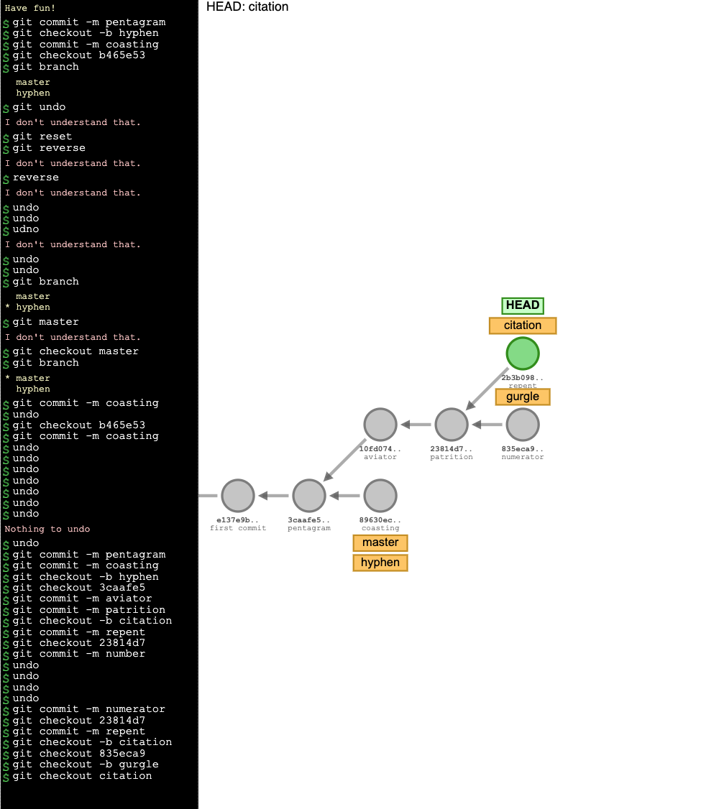

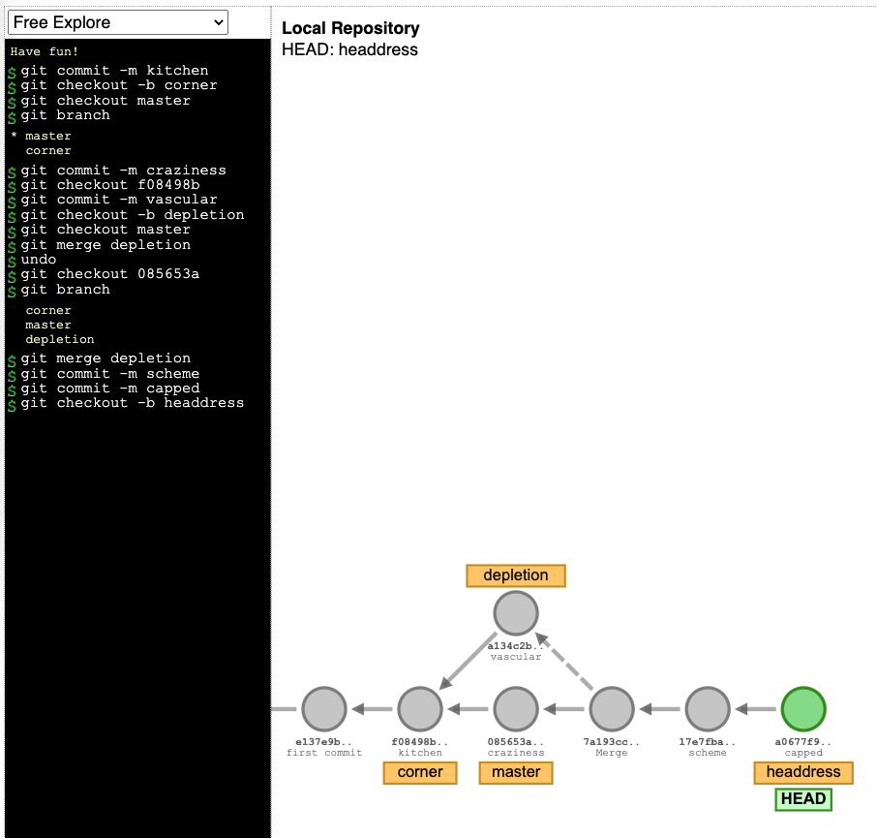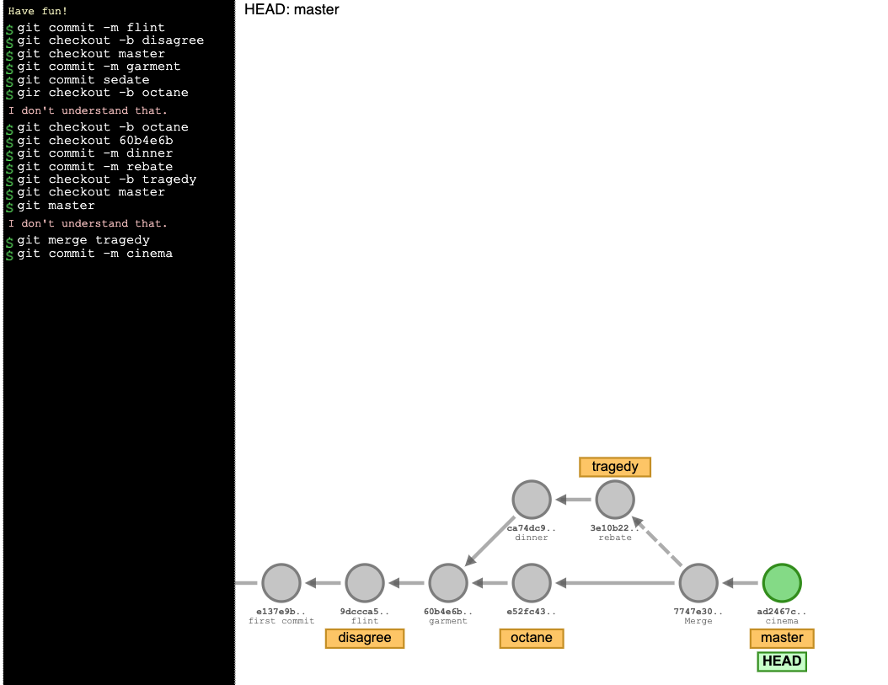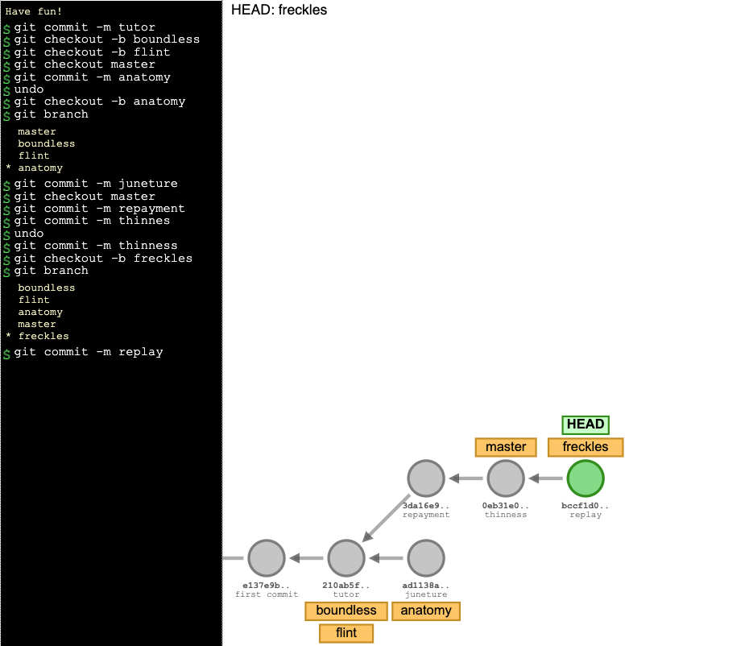

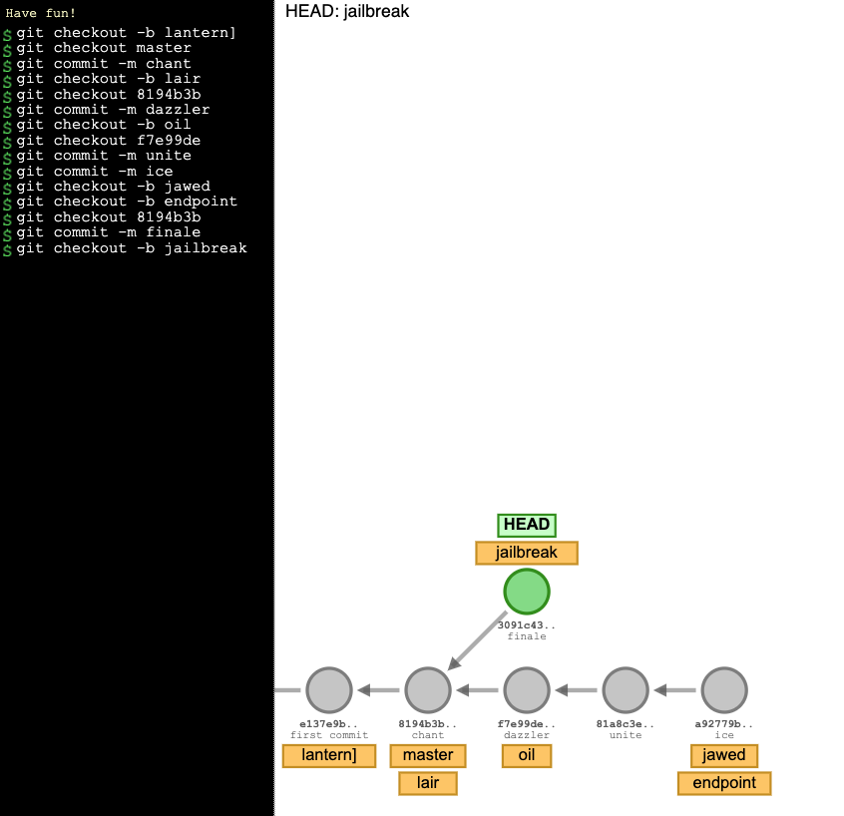

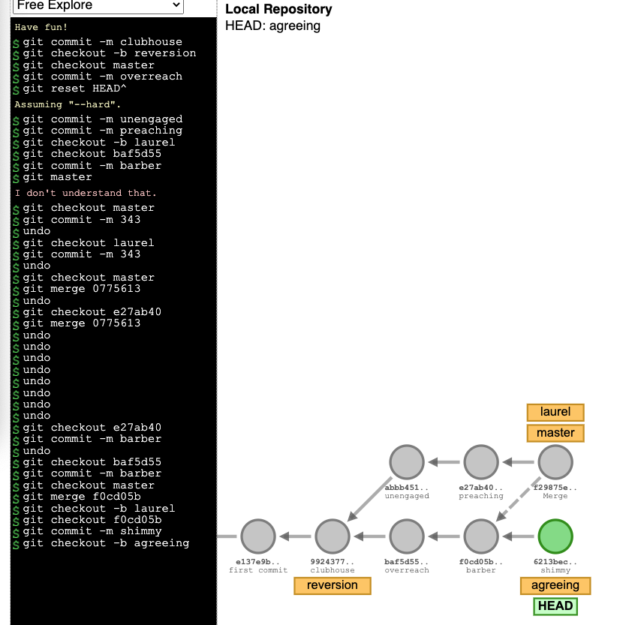

# Байт код

1 0 LOAD_GLOBAL 0 (h)  
 2 LOAD_GLOBAL 1 (f)  
 4 BINARY_SUBTRACT  
 6 LOAD_FAST 1 (b)  
 8 LOAD_FAST 0 (c)  
 10 LOAD_CONST 1 (342)  
 12 LOAD_GLOBAL 2 (a)  
 14 BINARY_SUBTRACT  
 16 BINARY_MULTIPLY  
 18 BINARY_OR  
 20 LOAD_FAST 1 (b)  
 22 BINARY_XOR  
 24 BINARY_ADD  
 26 LOAD_FAST 2 (d)  
 28 BINARY_XOR  
 30 RETURN_VALUE

Решение:

(((h-f)+((b | (c*(342-a)))^b))^d)

-------

import dis

h,f,a = 1, 1, 1

def func(b,c,d):

return (((h-f)+((b | (c*(342-a)))^b))^d)

print(dis.dis(func))

1 0 LOAD_FAST 1 (e)  
 2 LOAD_GLOBAL 0 (c)  
 4 LOAD_GLOBAL 1 (h)  
 6 LOAD_GLOBAL 2 (f)  
 8 BINARY_MULTIPLY  
 10 LOAD_GLOBAL 1 (h)  
 12 BINARY_SUBTRACT  
 14 BINARY_AND  
 16 LOAD_CONST 1 (34)  
 18 BINARY_MULTIPLY  
 20 BINARY_XOR  
 22 RETURN_VALUE

Решение:

(e ^ ((c & ((h*f) - h)) * 1))

-------

import dis

h,f,c = 1, 1, 1

def func(e):

return (e ^ ((c & ((h*f) - h)) * 1))

print(dis.dis(func))

1 0 LOAD_CONST 1 (877)  
 2 LOAD_GLOBAL 0 (c)  
 4 BINARY_XOR  
 6 LOAD_FAST 0 (b)  
 8 BINARY_AND  
 10 LOAD_GLOBAL 1 (a)  
 12 LOAD_GLOBAL 2 (h)  
 14 LOAD_FAST 0 (b)  
 16 BINARY_SUBTRACT  
 18 BINARY_OR  
 20 LOAD_GLOBAL 0 (c)  
 22 LOAD_FAST 0 (b)  
 24 BINARY_OR  
 26 BINARY_ADD  
 28 BINARY_TRUE_DIVIDE  
 30 RETURN_VALUE

Решение:

(((877^c)&b)/((a|(h-b))+(c|b)))

-------

import dis

h,a,c = 1, 1, 1

def func(b):

return (((877^c)&b)/((a|(h-b))+(c|b)))

print(dis.dis(func))

1 0 LOAD_GLOBAL 0 (f)  
 2 LOAD_GLOBAL 0 (f)  
 4 LOAD_GLOBAL 1 (b)  
 6 BINARY_XOR  
 8 LOAD_FAST 0 (c)  
 10 BINARY_SUBTRACT  
 12 LOAD_CONST 1 (233)  
 14 LOAD_FAST 1 (h)  
 16 BINARY_MULTIPLY  
 18 BINARY_OR  
 20 BINARY_TRUE_DIVIDE  
 22 LOAD_GLOBAL 1 (b)  
 24 LOAD_CONST 2 (5)  
 26 BINARY_MULTIPLY  
 28 BINARY_SUBTRACT  
 30 RETURN_VALUE

Решение:

((f / ((( f ˆ b ) – c ) | (233 * h))) - (b *5))

-------

import dis

f, f, b = 1, 1, 1

def func(c,h):

return ( ( f / ( ( ( f ^ b ) - c ) | ( 233 * h ) ) ) - ( b * 5 ) )

print(dis.dis(func))

1 0 LOAD_GLOBAL 0 (h)  
 2 LOAD_FAST 1 (e)  
 4 LOAD_GLOBAL 1 (c)  
 6 LOAD_FAST 0 (a)  
 8 BINARY_XOR  
 10 LOAD_CONST 1 (553)  
 12 LOAD_FAST 0 (a)  
 14 BINARY_AND  
 16 LOAD_GLOBAL 0 (h)  
 18 BINARY_XOR  
 20 BINARY_ADD  
 22 BINARY_TRUE_DIVIDE  
 24 BINARY_TRUE_DIVIDE  
 26 RETURN_VALUE

Решение:

(h / (e / ((c ˆ a) + ((533 & a) ^ h))))

--------

import dis

h, c = 1, 1

def func(e,a):

return (h / (e / ((c ^ a) + ((533 & a) ^ h))))

print(dis.dis(func))

1 0 LOAD_GLOBAL 0 (g)  
 2 LOAD_CONST 1 (966)  
 4 BINARY_SUBTRACT  
 6 LOAD_GLOBAL 1 (b)  
 8 LOAD_CONST 2 (173)  
 10 BINARY_TRUE_DIVIDE  
 12 LOAD_FAST 0 (c)  
 14 BINARY_OR  
 16 BINARY_XOR  
 18 LOAD_GLOBAL 2 (f)  
 20 BINARY_AND  
 22 RETURN_VALUE

Решение:

((g – 966) ˆ ((b / 173) | c )) & f

--------

import dis

g, b, f = 1, 1, 1

def func(c):

return ((g - 966) ^ ((b / 173) | c )) & f

print(dis.dis(func))

1 0 LOAD_FAST 0 (g)  
 2 LOAD_FAST 2 (c)  
 4 BINARY_TRUE_DIVIDE  
 6 LOAD_GLOBAL 0 (e)  
 8 BINARY_AND  
 10 LOAD_FAST 1 (d)  
 12 BINARY_AND  
 14 LOAD_CONST 1 (904)  
 16 LOAD_FAST 0 (g)  
 18 BINARY_TRUE_DIVIDE  
 20 BINARY_MULTIPLY  
 22 RETURN_VALUE

Решение:

((g / c) & e) & d) * (904/g)

--------

import dis

e = 1р

def func(g,c,d):

return (((g / c) & e) & d) * (904/g)

print(dis.dis(func))

1 0 LOAD_CONST 1 (182)  
 2 LOAD_GLOBAL 0 (h)  
 4 BINARY_AND  
 6 LOAD_GLOBAL 1 (c)  
 8 BINARY_ADD  
 10 LOAD_GLOBAL 2 (d)  
 12 LOAD_FAST 0 (b)  
 14 LOAD_CONST 2 (809)  
 16 BINARY_AND  
 18 BINARY_MULTIPLY  
 20 BINARY_ADD  
 22 RETURN_VALUE

Решение:

((182&h)&c)+(d*(b&809))

-------

import dis

h, c, d = 1,1,1

def func(b):

return ((182&h)&c)+(d*(b&809))

print(dis.dis(func))

1 0 LOAD_GLOBAL 0 (g)  
 2 LOAD_CONST 1 (16)  
 4 LOAD_GLOBAL 1 (f)  
 6 BINARY_SUBTRACT  
 8 LOAD_GLOBAL 2 (h)  
 10 LOAD_FAST 2 (c)  
 12 BINARY_TRUE_DIVIDE  
 14 BINARY_SUBTRACT  
 16 BINARY_MULTIPLY  
 18 RETURN_VALUE

Решение:

g*((16-f)-(h/c))

------

import dis

g, f, h = 1, 1, 1

def func(c):

return g*((16-f)-(h/c))

print(dis.dis(func))

1 0 LOAD_GLOBAL 0 (c)  
 2 LOAD_GLOBAL 1 (h)  
 4 LOAD_GLOBAL 0 (c)  
 6 LOAD_GLOBAL 2 (d)  
 8 BINARY_ADD  
 10 LOAD_GLOBAL 2 (d)  
 12 BINARY_SUBTRACT  
 14 BINARY_TRUE_DIVIDE  
 16 LOAD_GLOBAL 3 (e)  
 18 LOAD_GLOBAL 2 (d)  
 20 BINARY_ADD  
 22 BINARY_TRUE_DIVIDE  
 24 BINARY_MULTIPLY  
 26 RETURN_VALUE

Решение:

c*((h/((c+d)-d))/(e+d))

------

import dis

c, h, d, e = 1, 1, 1, 1

def func():

return c*((h/((c+d)-d))/(e+d))

print(dis.dis(func))

1 0 LOAD_FAST 0 (h)  
 2 LOAD_GLOBAL 0 (c)  
 4 BINARY_MULTIPLY  
 6 LOAD_GLOBAL 1 (b)  
 8 BINARY_SUBTRACT  
 10 LOAD_GLOBAL 1 (b)  
 12 LOAD_CONST 1 (666)  
 14 BINARY_AND  
 16 LOAD_CONST 2 (606)  
 18 LOAD_GLOBAL 0 (c)  
 20 BINARY_XOR  
 22 BINARY_AND  
 24 BINARY_TRUE_DIVIDE  
 26 RETURN_VALUE

Решение:

((h*c)- b)/((b&666)&(606ˆc))

1 0 LOAD_FAST 1 (c)  
 2 LOAD_GLOBAL 0 (e)  
 4 LOAD_GLOBAL 1 (g)  
 6 BINARY_OR  
 8 LOAD_CONST 1 (127)  
 10 LOAD_FAST 1 (c)  
 12 BINARY_TRUE_DIVIDE  
 14 LOAD_GLOBAL 2 (h)  
 16 BINARY_TRUE_DIVIDE  
 18 BINARY_SUBTRACT  
 20 BINARY_ADD  
 22 RETURN_VALUE

Решение:

c + ((e|g) - ((127/c)/h))

import dis

e, g, h = 1, 1, 1

def func(c):

return c + ((e|g) - ((127/c)/h))

print(dis.dis(func))