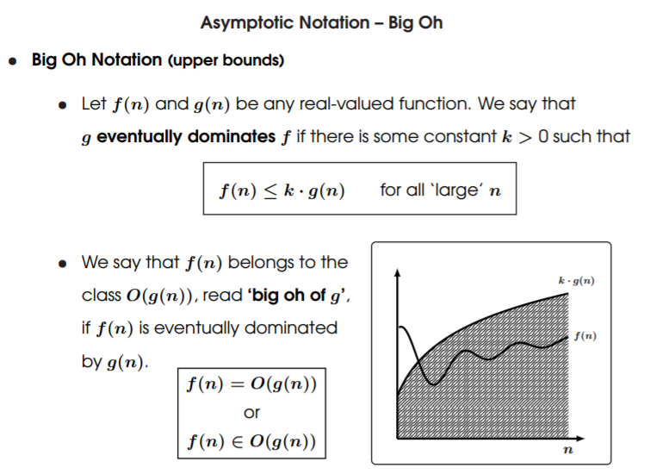

Complexity Classes P and NP

EVERYTHING THAT IS EXPONENTIAL CAN NOT BE SOLVED IN POLYNOMIAL TIME

* ***Polynomial Time Problems***
  + A decision problem **X** is said to be *decidable/solvable* in **polynomial time** if there is a **deterministic Turing Machine** *M* such that:
    - ***M***accepts ***X***
    - ***T(n)***∈ **O(n ^ k)** is dominated by a **polynomial function**, where

**T(n)** = number of steps required to terminate on input of length **n**

* + The **complexity class P** is the class of all problems that are decidable in polynomial time
    - **P** -all problems decidable in polynomial time
    - ***NP*** – all problems decidable in non-deterministic polynomial time.
* **Non-deterministic Polynomial Time Problems**
  + The class of **non-deterministic polynomial time** problems is defined similarly but replacing ***M*** with a non-deterministic *TM*, for which

***T(n)*** - number of steps required to terminate on input of length **n** for some possible computation

* + - **P** -all problems decidable in polynomial time.
    - ***NP*** – all problems decidable in non-deterministic polynomial time.
  + Problems that belong to **NP** are those for which we can **verify** solution in polynomial time – you only need to show a single computation that accepts the input. However, to find the solution may require an **exhaustive search** of all possible computations

Complexity Class PSpace

* **Polynomial Space Problems**
  + A decision problem **X** is said to be ***decidable/solvable*** *in* **polynomial space** if there is a **deterministic Turing machine *M*** such that:
    - **M** *accepts* **X**
    - ***S(n)*** ∈ ***O(n ^ k)*** is dominated by a **polynomial function** where

***S(n) =*** amount of tape used for an input of length ***n***

* The **complexity class P** is the class of all problems that are decidable in polynomial time
  + ***PSpace*** *= all problems decidable in polynomial space*

Complexity hierarchy

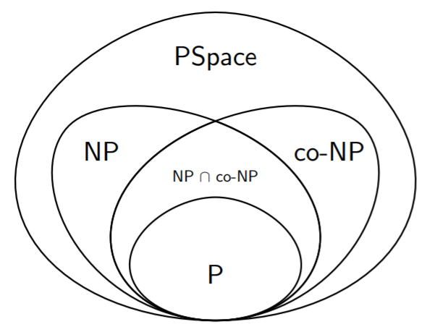

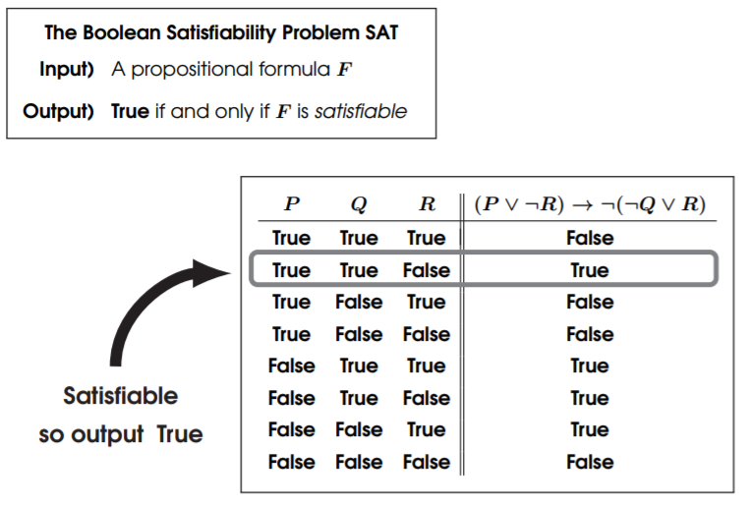The Boolean Satisfiability Problem

This problem can be solved using power of parallel computation on non-deterministic Turing Machine,

**Theorem:**

* *The Boolean Satisfiability Problem* ***SAT*** *belongs to the class* ***NP***

***( there is a non-deterministic algorithm for SAT that runs in polynomial time)***

**Proof:**

* **Step 1)** Given a propositional formula **F,** we can decide whether **F** is **satisfiable** by computing the **truth table.**
  + *However, the truth table content contains 2 ^ n rows –* ***NOT polynomial!***
* **Step 2)** However a non-deterministic algorithm can evaluate each row in a separate **parallel processor,** each of which takes at most **polynomial time.**

***Q.E.D***

The Clique Problem

**Checking** if all ***K*** nodes are connected together

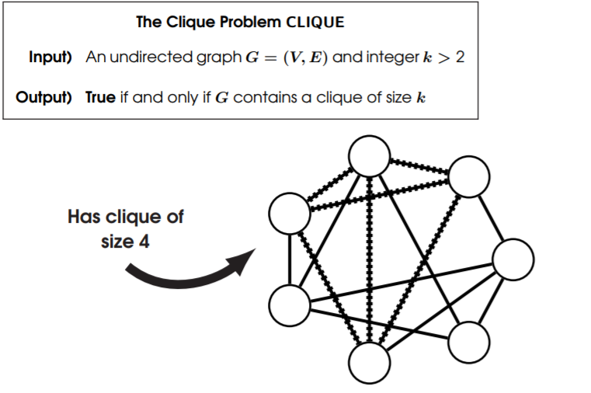

**Theorem:**

* The Clique Problem **CLIQUE** belongs to the class **NP.**

***( there is a non-deterministic algorithm for CLIQUE that runs in polynomial time)***

**Proof:**

* **Step 1 )** Given an *undirected graph*  **G = (V, E)** and integer **k > 2,** we can decide whether **G** contains a clique of size **k**  by checking every subset of vertices of size **k**. (BASICALLY BRUTE-FORCING the answer)
  + *However, there are* ***n ^ n*** *possible subsets –* ***NOT*** *polynomial!*
* **Step 2)** However, a non-deterministic algorithm can check every possible subset of vertices in **parallel,** each of which takes at most **polynomial time**.

Polynomial Reduction

* **Polynomial Reduction**
  + A **polynomial reduction** from a problem ***A*** to a problem ***B*** is a function

**Computable in polynomial time**, that maps instances of ***A*** to instances of ***B*** such that



* + We say that ***A*** is reducible to ***B*** and write ***A*** <= ***B***

***Nota Bene:***

* For **mapping reduction,** we did not care about the time taken to compute the function ***f*** since we were not concerned about **efficiency,** since we were only interested in whether a problem was **decidable.**

Polynomial Reduction

* 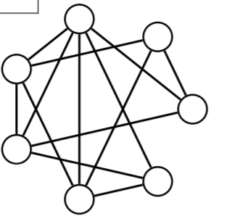**The Graph Colouring Problem COLOURING**
* **Input)** An *undirected gra*ph***G = (V, E)*** and set of colours **C**
* **Output) True** if and only if **V** can be coloured so that adjacent vertices are different colours

|  |
| --- |
| ***G = { Blue B, Green G, Red R }*** |

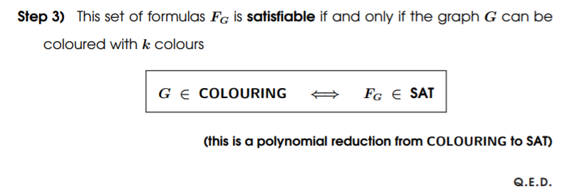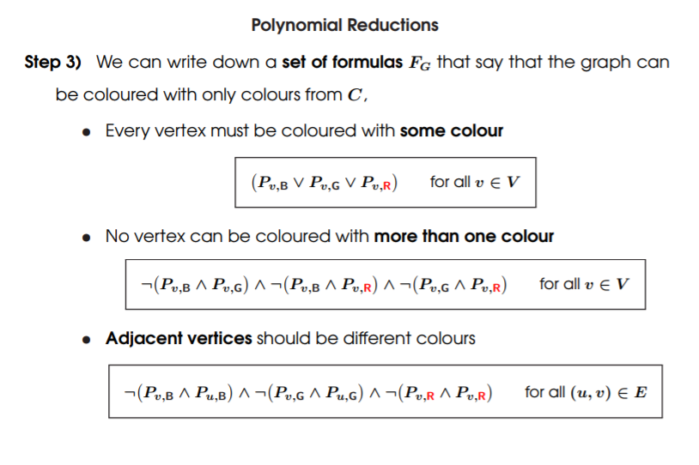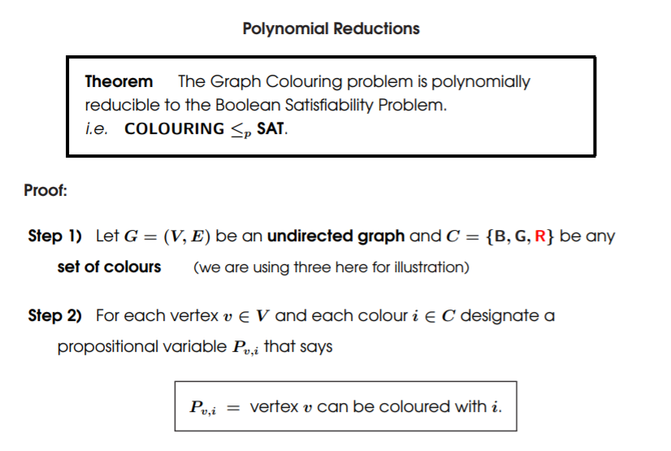

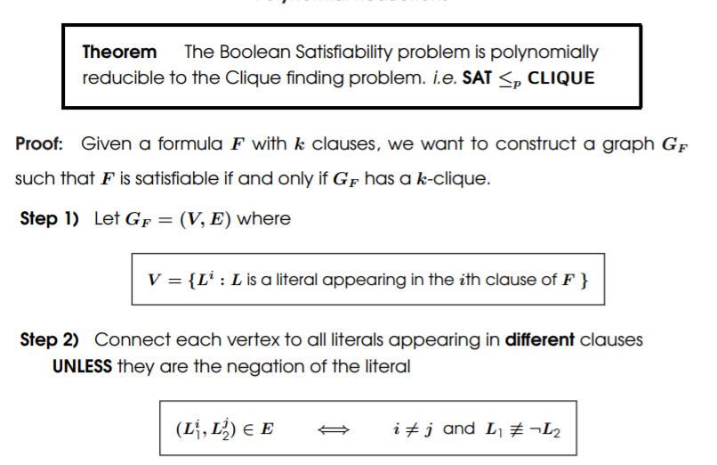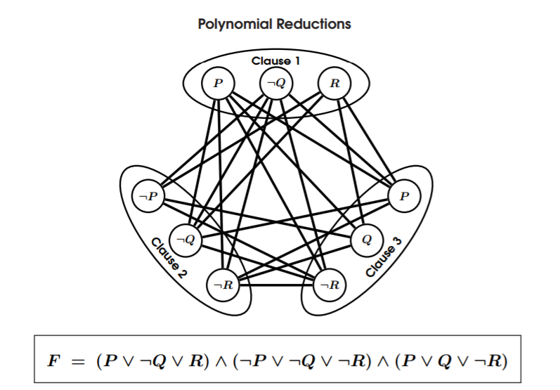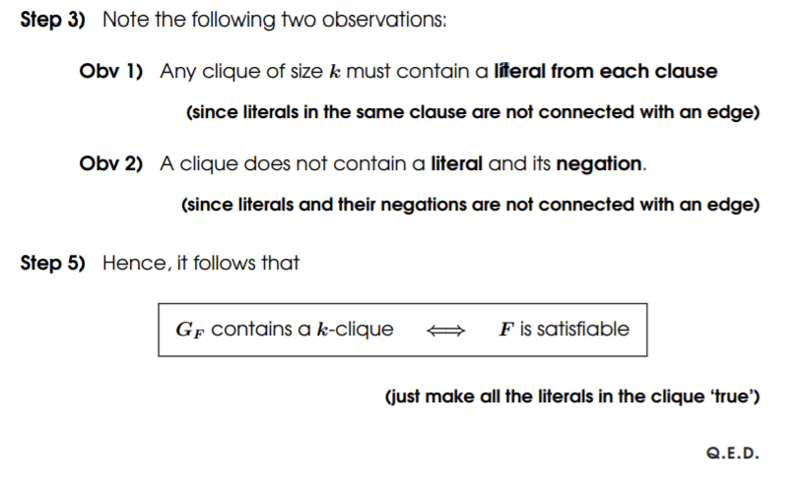Polynomial Reductions

NP-Completeness

+b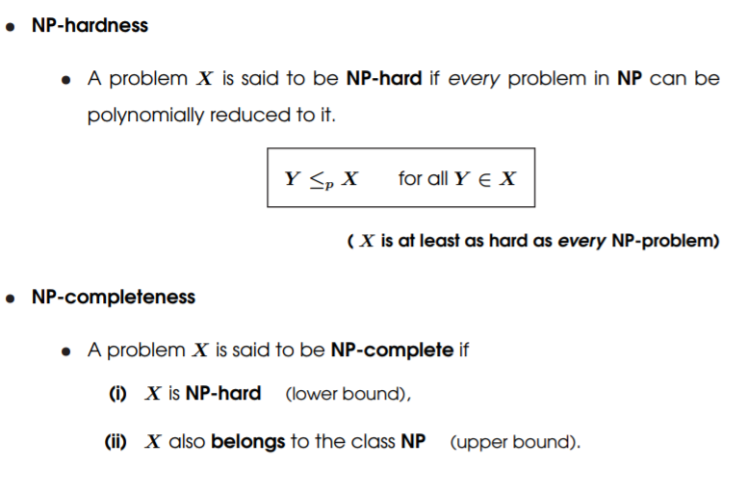 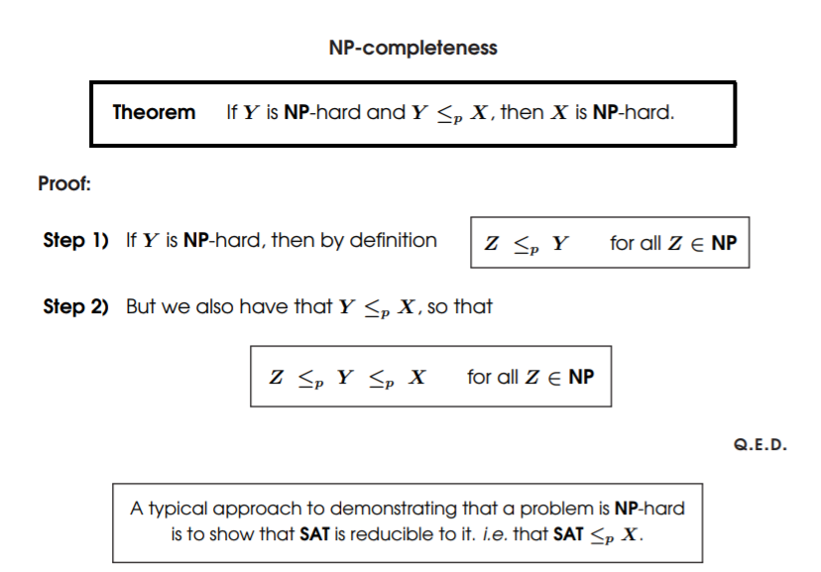

List of NP-complete Problems

* (Incomplete) List of NP-complete Problems
  + The Boolean Satisfiability Problem SAT
  + The Graph Colouring Problem COLOURING
  + The Clique Problem CLIQUE
  + The Hamilton Cycle Problem HAMILTON CYCLE
  + The Travelling Salesman Problem TSP
  + The Knapsack Problem KNAPSACK

**NP-Complete**

*NP-Complete is a complexity class which represents the set of all problems X in NP for which it is possible to reduce any other NP problem Y to X in polynomial time.*

Intuitively this means that we can solve Y quickly if we know how to solve X quickly. Precisely, Y is reducible to X, if there is a polynomial time algorithm f to transform instances y of Y to instances x = f(y) of X in polynomial time, with the property that the answer to y is yes, if and only if the answer to f(y) is yes.

**Example**

3-SAT. This is the problem wherein we are given a conjunction (ANDs) of 3-clause disjunctions (ORs), statements of the form

(x_v11 OR x_v21 OR x_v31) AND

(x_v12 OR x_v22 OR x_v32) AND

... AND

(x_v1n OR x_v2n OR x_v3n)

where each x_vij is a Boolean variable or the negation of a variable from a finite predefined list (x_1, x_2, ... x_n).

It can be shown that *every NP problem can be reduced to 3-SAT*. The proof of this is technical and requires use of the technical definition of NP (*based on non-deterministic Turing machines*). This is known as *Cook's theorem*.

What makes NP-complete problems important is that if a deterministic polynomial time algorithm can be found to solve one of them, every NP problem is solvable in polynomial time (one problem to rule them all).

# NP-hard

Intuitively, these are the problems that are at least as hard as the NP-complete problems. Note that NP-hard problems do not have to be in NP, and they do not have to be decision problems.

The precise definition here is that a problem *X* is NP-hard, if there is an NP-complete problem *Y*, such that *Y* is reducible to *X* in polynomial time.

But since any NP-complete problem can be reduced to any other NP-complete problem in polynomial time, all NP-complete problems can be reduced to any NP-hard problem in polynomial time. Then, if there is a solution to one NP-hard problem in polynomial time, there is a solution to all NP problems in polynomial time.

**Example**

The halting problem is an NP-hard problem. This is the problem that given a program P and input I, will it halt? This is a decision problem, but it is not in NP. It is clear that any NP-complete problem can be reduced to this one. As another example, any NP-complete problem is NP-hard.

To show a problem is NP complete, you need to:

## Show it is in NP

In other words, given some information C, you can create a polynomial time algorithm V that will verify for every possible input X whether X is in your domain or not.

### Example

Prove that the problem of vertex covers (that is, for some graph G, does it have a vertex cover set of size *k* such that every edge in *G* has at least one vertex in the cover set?) is in NP:

* our input X is some graph G and some number k (this is from the problem definition)
* Take our information C to be "any possible subset of vertices in graph G of size k"
* Then we can write an algorithm V that, given G, k and C, will return whether that set of vertices is a vertex cover for G or not, in **polynomial time**.

Then for every graph G, if there exists some "possible subset of vertices in G of size k" which is a vertex cover, then G is in NP.

**Note** that we do **not** need to find C in polynomial time. If we could, the problem would be in `P.

**Note** that algorithm V should work for **every** G, for some C. For every input there should **exist** information that could help us verify whether the input is in the problem domain or not. That is, there should not be an input where the information doesn't exist.

## Prove it is NP Hard

This involves getting a known NP-complete problem like [SAT](https://en.wikipedia.org/wiki/Boolean_satisfiability_problem), the set of boolean expressions in the form:

(A or B or C) and (D or E or F) and ...

where the expression is satisfiable, that is there exists some setting for these booleans, which makes the expression true.

Then **reduce the NP-complete problem to your problem in polynomial time**.

That is, given some input X for SAT (or whatever NP-complete problem you are using), create some input Y for your problem, such that X is in SAT if and only if Y is in your problem. The function f : X -> Y must run in **polynomial time**.

In the example above, the input Y would be the graph G and the size of the vertex cover k.

For a full proof, you'd have to prove both:

* that X is in SAT => Y in your problem
* and Y in your problem => X in SAT.

**marcog's** answer has a link with several other NP-complete problems you could reduce to your problem.

Footnote: In step 2 (**Prove it is NP-hard**), reducing another NP-hard (not necessarily NP-complete) problem to the current problem will do, since NP-complete problems are a subset of NP-hard problems (that are also in NP).