Explainable Concrete Mix Optimization Using Machine Learning
Miduna R (23CSR131), Nesha R K (23CSR147), Rohith O R (23CSR180)
Department of Computer Science and Engineering
Academic Year: 2023–2027
Abstract—Concrete compressive strength (CCS) is the paramount mechanical criterion governing structural integrity and safety. Conventional laboratory determination requires standardized destructive compressive testing after 28 days of curing, imposing substantial delays, material waste, and financial expenditure. While data-driven machine learning (ML) models have demonstrated strong predictive capabilities, most existing architectures operate as opaque "black-box" systems and restrict their scope to strength estimation without addressing production cost or environmental sustainability. This study develops an explainable, multi-objective concrete mix optimization framework. Six machine learning algorithms—Linear Regression, Decision Tree, Random Forest, CatBoost, LightGBM, and Extreme Gradient Boosting (XGBoost)—were trained and evaluated on 1,005 verified experimental concrete mixes derived from the UCI repository after duplicate removal. Grid search with 5-fold cross-validation optimized the XGBoost regressor, achieving superior performance with an R² of 0.9385, an RMSE of 4.2821 MPa, and an MAE of 3.0207 MPa on the independent test split. Model interpretability was established through Tree-based SHapley Additive exPlanations (SHAP), which revealed curing age (mean |SHAP| = 8.0068 MPa), cement content (6.3848 MPa), and water dosage (4.0258 MPa) as the dominant drivers of compressive strength. Finally, a multi-criteria decision framework simultaneously integrating compressive strength (50% weighting), material production cost (25%), and embodied carbon emissions (25%) identified concrete mix proportions that balance mechanical capacity with economic and ecological viability. The optimal formulation achieved 81.75 MPa compressive strength at a cost of ₹5,904.75/m³ and 314.52 kg CO₂/m³ embodied carbon, providing an actionable tool for sustainable structural engineering.
Keywords—Concrete compressive strength, explainable artificial intelligence, machine learning, multi-objective optimization, SHAP, XGBoost.
I. INTRODUCTION
Concrete represents the most consumed manufactured material on earth, serving as the foundational medium for civil infrastructure worldwide [1]. Among its performance attributes, concrete compressive strength (CCS) remains the definitive metric used by structural engineers to verify load-bearing capacity, serviceability, and durability compliance [2]. In conventional engineering workflows, CCS is quantified through standardized destructive crushing tests of cylindrical or cubic specimens following predetermined water-curing periods (typically 7, 14, and 28 days) [3]. Although empirically robust, this procedure presents pronounced practical drawbacks: it introduces rigid 28-day scheduling bottlenecks into construction schedules, requires extensive manual labor and specialized equipment, and generates substantial material waste [4].
To alleviate reliance on prolonged physical trials, empirical mix-design charts and classical regression formulas (e.g., Abrams' water-cement ratio law) have historically been employed [2]. Nonetheless, concrete behaves as a highly heterogeneous, non-linear composite material. Its ultimate mechanical strength emerges from complex chemical hydration kinetics and physical packing interactions involving ordinary Portland cement, water, chemical admixtures (superplasticizers), coarse aggregates, fine aggregates, and supplementary cementitious materials (SCMs) such as fly ash and ground granulated blast furnace slag [5]. Consequently, classical linear or parametric formulations exhibit limited generalization across variable mix designs [6].
Data-driven Artificial Intelligence (AI) and Machine Learning (ML) techniques have emerged as powerful alternatives capable of modeling complex nonlinear phenomena without imposing restrictive mathematical assumptions [7]. Various algorithms, including Artificial Neural Networks (ANN), Support Vector Machines (SVM), and ensemble decision trees, have been investigated for CCS forecasting [8]. Ensemble boosting architectures—most notably Extreme Gradient Boosting (XGBoost), Light Gradient Boosting Machine (LightGBM), and Categorical Boosting (CatBoost)—consistently demonstrate superior predictive accuracy by sequentially mitigating residual errors through gradient descent in function space [1], [5].
Despite these advances, two critical research gaps persist in the literature: (1) The Explainability Deficit: High-performing gradient boosting models operate fundamentally as black-box estimators. In safety-critical civil engineering projects, the inability of practitioners to audit the physical rationale behind an algorithm's output severely impedes field deployment and regulatory acceptance [3], [8]. (2) Isolation of Prediction from Multi-Objective Optimization: Most published studies focus exclusively on predictive fidelity (minimizing RMSE or maximizing R²). However, modern construction design operates under stringent multi-criteria constraints: mixes must not only satisfy structural strength targets, but also minimize production cost and mitigate embodied carbon dioxide (CO₂) emissions, particularly given that Portland cement manufacturing contributes approximately 7–8% of anthropogenic global carbon emissions [1], [4].
To address these dual challenges, this paper presents an explainable, multi-objective concrete mix optimization framework. The specific contributions of this work are threefold: (i) A comparative benchmarking of six machine learning paradigms (Linear Regression, Decision Tree, Random Forest, CatBoost, LightGBM, and XGBoost) on a rigorously curated dataset, followed by systematic 5-fold cross-validated hyperparameter optimization. (ii) The application of game-theoretic SHapley Additive exPlanations (SHAP) to unpack the internal mechanics of the optimal model, quantifying both global feature attributions and local feature dependencies from a material science perspective. (iii) The formulation of an integrated multi-objective optimization index that balances predicted mechanical strength, unit material economics, and embodied carbon footprints, validated through candidate ranking and backend deployment.
The remainder of this paper is structured as follows: Section II surveys related literature. Section III describes the dataset, preprocessing steps, machine learning models, explainability pipeline, and multi-objective optimization equations. Section IV presents empirical results, model rankings, SHAP interpretability findings, and optimized mix selections. Section V concludes the paper with practical implications and future research directions.
II. RELATED WORK
The application of machine learning to concrete materials science has progressed through three distinct phases: classical parametric models, complex non-parametric predictive ensembles, and interpretable learning frameworks.
Early computational efforts focused on empirical formulations and single-layer artificial neural networks. Yeh [9] pioneered the use of neural networks to model the compressive strength of high-performance concrete using eight mix parameters, demonstrating that data-driven techniques could surpass conventional empirical regression equations. Pawar et al. [2] proposed a Modified Dimensional Analysis (MDA) approach to overcome dimensional inconsistency in empirical models, establishing that rational dimensional grouping could produce competitive predictions while utilizing 60% less training data than unstructured empirical models.
With the proliferation of ensemble algorithms, researchers demonstrated that tree-based ensembles reliably outperform individual learners. Bandaru et al. [6] examined decision trees, Random Forest, and boosting techniques for mixes incorporating industrial fly ash, concluding that ensemble methods effectively capture the nonlinear impact of mineral admixtures. Similarly, Yaqub and Serrano [5] evaluated seven regression algorithms—including Linear Regression, Random Forest, XGBoost, LightGBM, and CatBoost—for concrete containing fly ash, slag, and superplasticizer. Their findings established CatBoost and XGBoost as the top-performing algorithms, achieving R² scores of 0.8948 and 0.8900, respectively. Shaaban et al. [4] investigated machine learning approaches for forecasting high-strength concrete (HSC) performance, verifying that tuned XGBoost models (R² ≈ 0.94) mitigated prediction error compared to conventional laboratory testing regimes.
More recently, research attention has shifted toward model interpretability through Explainable Artificial Intelligence (XAI). Miao et al. [8] developed an interpretable XGBoost architecture coupled with Bayesian optimization for recycled-aggregate self-compacting concrete, utilizing SHAP values to confirm that cement dosage and curing age exert the strongest positive influence on strength development. Sapkota et al. [3] applied metaheuristic optimization algorithms (including Leopard Seal and Cuckoo Search) to tune XGBoost models for high-strength concrete, integrating SHAP to identify optimal material dosage intervals (e.g., 600–900 kg/m³ for cement and 8–10 kg/m³ for superplasticizers). Abioye et al. [7] conducted an extensive benchmarking of eight algorithms on high-performance concrete, utilizing SHAP summary and dependence plots to elucidate parameter interactions. Furthermore, Alsaadawi et al. [1] categorized concrete strength classes using Bayesian-optimized LightGBM models coupled with SHAP, deploying their findings into an interactive graphical interface.
A critical limitation in existing literature is that explainability and strength prediction are rarely synthesized with actionable mix optimization that factors in economic and environmental sustainability. While existing studies demonstrate that gradient boosting achieves high statistical accuracy, they predominantly treat concrete design as a single-objective regression problem. This paper bridges this gap by directly coupling an optimized XGBoost predictor with SHAP explanations and a multi-attribute utility function encompassing material cost and embodied CO₂ emissions.
III. MATERIALS AND METHODOLOGY
The systematic research methodology executed in this study is illustrated in the project workflow in Fig. 1, spanning data curation, comparative model training, hyperparameter optimization, SHAP explainability, and multi-objective mix ranking.
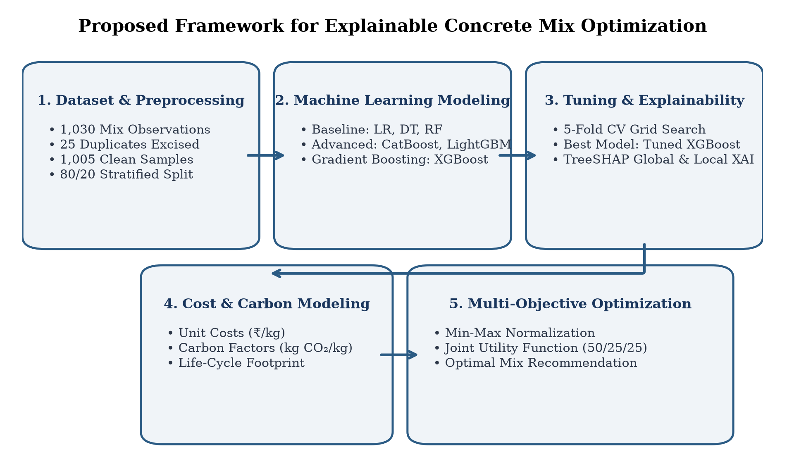
Fig. 1. Proposed framework for explainable concrete mix optimization.
A. Dataset Description
The empirical foundation of this study is the benchmark Concrete Compressive Strength dataset [9], comprising 1,030 experimental concrete mix observations. The dataset encapsulates eight physical input parameters and one continuous output target: (1) Cement (X₁): Quantity of Portland cement (kg/m³); (2) Blast Furnace Slag (X₂): Supplementary cementitious byproduct (kg/m³); (3) Fly Ash (X₃): Pozzolanic coal combustion byproduct (kg/m³); (4) Water (X₄): Water content (kg/m³); (5) Superplasticizer (X₅): High-range water-reducing admixture (kg/m³); (6) Coarse Aggregate (X₆): Crushed stone or gravel (kg/m³); (7) Fine Aggregate (X₇): Natural sand (kg/m³); (8) Age (X₈): Curing duration prior to testing (days, ranging from 1 to 365 days); and (9) Compressive Strength (Y): Uniaxial compressive strength (MPa). All features are continuous floating-point variables with the exception of Age (integer). Statistical profiling revealed an initial mean compressive strength of 35.82 MPa (range: 2.33–82.60 MPa) and a mean curing age of 45.66 days.
B. Data Preprocessing
Data integrity verification confirmed that the dataset contained zero missing or null attributes. A deduplication scan identified 25 exact duplicate mix formulations, which were excised to prevent artificial inflation of cross-validation accuracy, yielding a cleaned dataset of 1,005 unique samples. The cleaned dataset was partitioned into an 80% training set (N = 804) and a 20% testing set (N = 201) using pseudo-random stratification (random_state = 42). For parametric baseline algorithms, standard z-score normalization was executed: z = (x - μ) / σ, where μ and σ denote the sample mean and standard deviation of the training split. For tree-based ensemble architectures, raw engineering units were retained to preserve the direct physical interpretability of split thresholds.
C. Feature Engineering
In strict accordance with the experimental codebase, no synthetic features, polynomial expansions, or dimensionality-reduction projections were introduced. The eight raw mix quantities were preserved in their native physical dimensions (kg/m³ and days) to ensure uncorrupted engineering interpretability.
D. Machine Learning Models
Six supervised regression models were implemented and comparatively evaluated: (1) Linear Regression (LR): Serves as the parametric baseline, fitting a hyperplane via ordinary least squares: ŷ = β₀ + Σ βᵢ Xᵢ. (2) Decision Tree Regressor (DT): A non-parametric partitioner recursively splitting feature space based on mean squared error reduction: MSE = (1/N) Σ (yᵢ - ŷᵢ)². (3) Random Forest Regressor (RF): An ensemble bagging architecture constructing B decorrelated regression trees over bootstrap samples, aggregating predictions via ensemble averaging: ŷ_RF = (1/B) Σ T_b(x). (4) CatBoost Regressor: A gradient boosted decision tree implementation utilizing symmetric (oblivious) trees and ordered boosting to counter target leakage. (5) LightGBM Regressor: A leaf-wise (best-first) gradient boosting framework employing Gradient-Based One-Side Sampling (GOSS) and Exclusive Feature Bundling (EFB). (6) Extreme Gradient Boosting (XGBoost): An optimized distributed gradient boosting system minimizing a regularized objective function at step t: L^(t) = Σ l(yᵢ, ŷᵢ^(t-1) + f_t(xᵢ)) + Ω(f_t), where Ω(f) = γ T + 0.5 λ Σ wⱼ² penalizes tree complexity (T leaves and leaf weights w).
E. Hyperparameter Optimization
Based on initial screening, XGBoost emerged as the superior architecture and was subjected to systematic hyperparameter optimization via GridSearchCV utilizing 5-fold cross-validation on the 804-sample training set. The search space encompassed 72 distinct parameter configurations (360 total fit operations) across discrete bounds: n_estimators ∈ {100, 200}, max_depth ∈ {4, 6, 8}, learning_rate ∈ {0.01, 0.05, 0.1}, subsample ∈ {0.8, 1.0}, and colsample_bytree ∈ {0.8, 1.0}. The optimal hyperparameter tuple converged at: {colsample_bytree: 0.8, learning_rate: 0.1, max_depth: 4, n_estimators: 200, subsample: 0.8}.
F. Explainable AI via SHAP
To resolve the black-box opacity of the optimized XGBoost model, game-theoretic SHapley Additive exPlanations (SHAP) were implemented via shap.TreeExplainer on the 201 test instances. Grounded in cooperative game theory, SHAP assigns an additive attribution value φᵢ to each feature i for a given prediction f(x): f(x) = φ₀ + Σ φᵢ(x), where φ₀ = E[f(x)] denotes the baseline expectation across the training distribution. TreeSHAP computes exact Shapley values in polynomial time by leveraging the tree ensemble structure of XGBoost. Global feature importance was quantified through the mean absolute SHAP value: Iᵢ = (1/N_test) Σ |φᵢ^(j)|. Furthermore, local feature contributions were extracted using waterfall plots for individual sample explanations, while non-linear feature interactions and threshold behaviors were examined using SHAP dependence plots.
G. Multi-Objective Concrete Mix Optimization
To advance beyond single-property prediction, an empirical multi-attribute utility framework was established to balance mechanical performance, economic cost, and environmental sustainability.
1) Economic Cost Model: The unit production cost per cubic meter (C_cost, in INR/m³) is computed by taking the inner product of component masses wᵢ and verified market unit costs derived from project reference data: C_cost = Σ wᵢ · cᵢ, where unit costs (cᵢ, INR/kg) are: Cement = 8.50, Slag = 3.00, Fly Ash = 2.00, Water = 0.05, Superplasticizer = 120.00, Coarse Aggregate = 1.20, and Fine Aggregate = 1.00.
2) Embodied Carbon Model: The embodied carbon emission per cubic meter (E_carbon, in kg CO₂/m³) is determined using life-cycle inventory emission factors (eᵢ, kg CO₂/kg): E_carbon = Σ wᵢ · eᵢ, where emission factors are: Cement = 0.9000, Slag = 0.0520, Fly Ash = 0.0270, Water = 0.0003, Superplasticizer = 1.8800, Coarse Aggregate = 0.0080, and Fine Aggregate = 0.0050.
3) Multi-Criteria Utility Formulation: Each objective is normalized across the 1,005-sample empirical domain via Min-Max scaling: S_norm = (S - S_min) / (S_max - S_min); C_norm = (C_cost - C_min) / (C_max - C_min), C_score = 1 - C_norm; E_norm = (E_carbon - E_min) / (E_max - E_min), E_score = 1 - E_norm. The final composite Optimization Score is defined by weighting structural strength at 50%, material cost at 25%, and embodied carbon at 25%:
Optimization Score = 0.50 · S_norm + 0.25 · C_score + 0.25 · E_score (1)
All candidate mixes in the repository were systematically evaluated and ranked according to this composite index.
IV. EXPERIMENTAL RESULTS AND DISCUSSION
A. Model Performance Comparison
The predictive performance of the six machine learning algorithms evaluated on the 201-sample testing split is summarized in Table I. Metrics include Mean Absolute Error (MAE), Mean Squared Error (MSE), Root Mean Squared Error (RMSE), and the Coefficient of Determination (R²).
TABLE I
PERFORMANCE COMPARISON OF MACHINE LEARNING MODELS ON TEST DATA (N = 201)
Model Category | Model Architecture | MAE (MPa) | MSE (MPa²) | RMSE (MPa) | R² Score
Baseline | Linear Regression | 8.8953 | 125.2456 | 11.1913 | 0.5802
Baseline | Decision Tree | 3.7755 | 35.0908 | 5.9237 | 0.8824
Baseline | Random Forest | 3.4979 | 27.6173 | 5.2552 | 0.9074
Advanced | CatBoost | 3.7037 | 29.3250 | 5.4153 | 0.9017
Advanced | LightGBM | 3.1179 | 22.4489 | 4.7380 | 0.9248
Advanced | Default XGBoost | 2.9719 | 20.8070 | 4.5615 | 0.9303
Optimized | Tuned XGBoost | 3.0207 | 18.3364 | 4.2821 | 0.9385
Linear Regression demonstrated inadequate performance (R² = 0.5802, RMSE = 11.1913 MPa), highlighting the fundamentally nonlinear behavior of multi-component concrete hydration. Decision Tree partitioning substantially reduced error (R² = 0.8824), while Random Forest bagging further improved predictive capability (R² = 0.9074, RMSE = 5.2552 MPa). Among the advanced boosting algorithms, Default XGBoost achieved superior baseline accuracy (R² = 0.9303, RMSE = 4.5615 MPa), outperforming LightGBM (R² = 0.9248) and CatBoost (R² = 0.9017).
B. Best Model Selection and Optimization
Hyperparameter tuning via 5-fold cross-validated grid search further refined the XGBoost model. As documented in Table I, Tuned XGBoost reduced MSE from 20.8070 to 18.3364 MPa² and RMSE from 4.5615 to 4.2821 MPa, elevating the test R² score to 0.9385. Constraining maximum tree depth to 4 and subsampling both rows and columns to 0.8 effectively curbed structural overfitting while improving generalization across unseen mix proportions. Fig. 2 illustrates the experimental versus predicted compressive strength for the optimized XGBoost model across the independent test set (N = 201), demonstrating tight clustering along the ideal 1:1 equality line with an R² of 0.9385 and an RMSE of 4.2821 MPa.
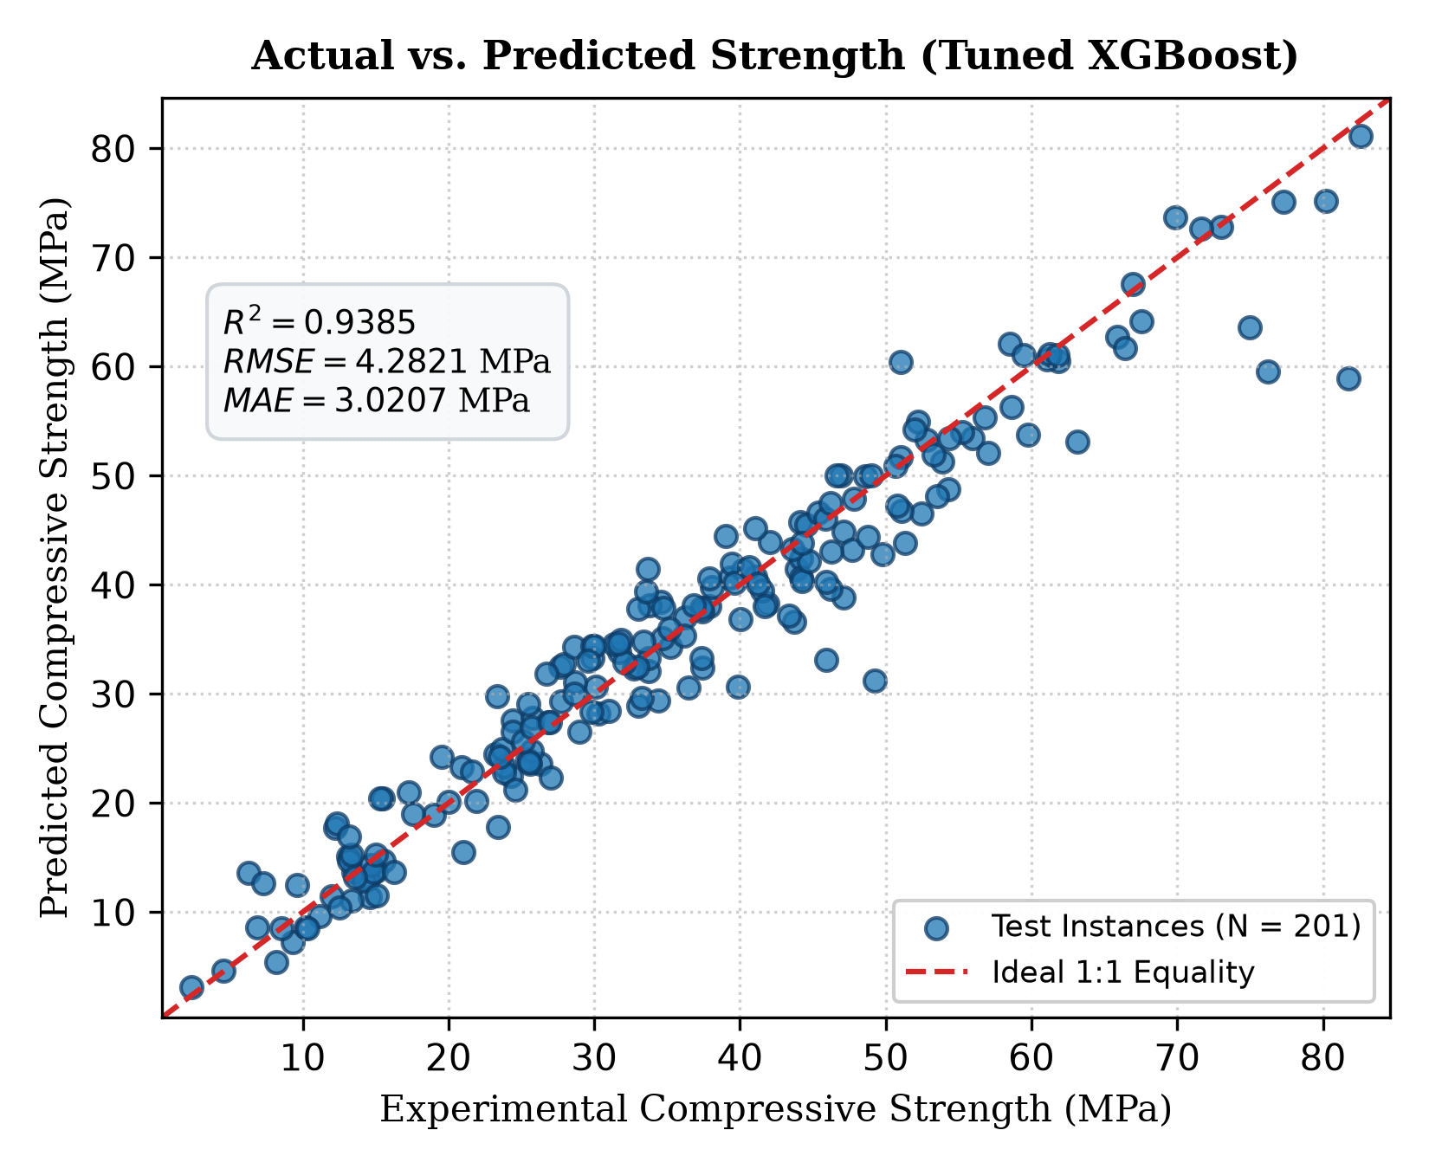
Fig. 2. Actual versus predicted compressive strength for the optimized XGBoost model on the test dataset (N = 201).
C. Explainability Results
TreeSHAP attribution analysis over the 201 test samples provides granular insight into the model's decision logic. The waterfall plot for individual instance explanation verifies that the model establishes a base expected value (E[f(x)] ≈ 35.07 MPa) and adjusts predictions via additive positive and negative pushes corresponding to local constituent concentrations. Fig. 3 illustrates the global feature attributions and impact distributions obtained using the SHAP summary beeswarm plot for the 201 test instances.
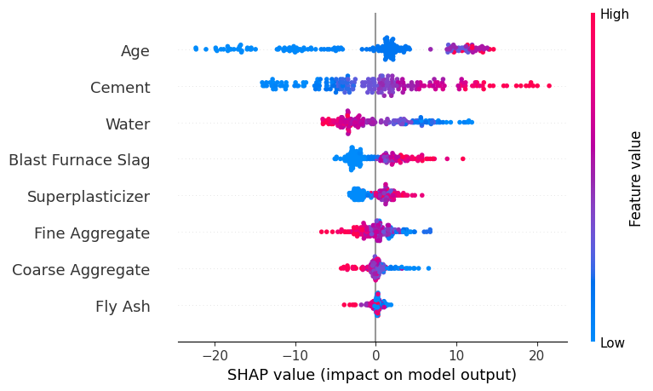
Fig. 3. SHAP summary plot illustrating feature attributions and impact distributions for the optimized XGBoost model.
SHAP dependence plots demonstrate non-linear threshold effects consistent with cement chemistry: (1) Cement Dependence: Compressive strength exhibits a strong monotonic increase as cement content increases from 150 to 450 kg/m³, after which gains plateau unless accompanied by adequate superplasticizer additions. (2) Water Dependence: SHAP values transition sharply from positive to negative as water content surpasses ~175–180 kg/m³, reflecting the classic porosity-inducing effect of excess capillary water during hydration. (3) Age Dependence: Strength attributions rise rapidly between 1 and 28 days of curing, followed by logarithmic asymptotic gains up to 365 days, accurately mirroring the kinetics of tricalcium silicate (C₃S) and dicalcium silicate (C₂S) hydration.
D. Feature Importance Ranking
Global feature importance was quantified by calculating the mean absolute SHAP value for each parameter across the testing set. The empirical ranking and corresponding attribution magnitudes are reported in Table II.
TABLE II
SHAP GLOBAL FEATURE IMPORTANCE RANKING
Rank | Constituent / Feature | Mean Absolute SHAP Value (MPa)
1 | Curing Age | 8.0068
2 | Cement | 6.3848
3 | Water | 4.0258
4 | Blast Furnace Slag | 2.7816
5 | Superplasticizer | 1.7529
6 | Fine Aggregate | 1.6580
7 | Coarse Aggregate | 0.9205
8 | Fly Ash | 0.4825
Curing Age (8.0068 MPa) and Cement Content (6.3848 MPa) exert the dominant control over compressive strength development, followed by Water (4.0258 MPa) and Blast Furnace Slag (2.7816 MPa). Superplasticizer and aggregates play secondary structural roles, while Fly Ash exhibits a modest mean SHAP attribution (0.4825 MPa) due to its latent pozzolanic reactivity, which primarily manifests at advanced curing ages.
E. Multi-Objective Optimization Results
Evaluating all 1,005 concrete formulations under the multi-criteria utility function identified mixes that achieve high compressive strength without incurring excessive financial costs or carbon footprints. Fig. 4 depicts the distribution of compressive strength versus embodied carbon emissions across all 1,005 mixes in the empirical dataset, highlighting the superior trade-off positions achieved by the top-ranked optimized mixes. The top three overall mix recommendations are detailed in Table III.
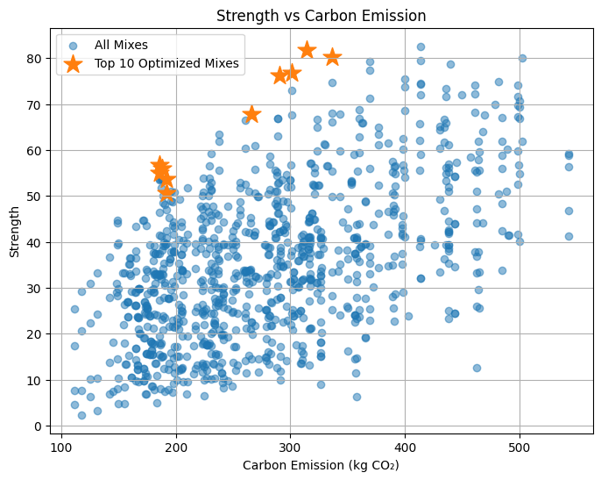
Fig. 4. Multi-objective optimization trade-off between compressive strength and embodied carbon emissions, highlighting the top-ranked concrete mixes.
TABLE III
TOP-RANKED CONCRETE MIX PROPORTIONS FROM MULTI-OBJECTIVE OPTIMIZATION
Parameter / Metric | Top Mix 1 (Rank 1) | Top Mix 2 (Rank 2) | Top Mix 3 (Rank 3)
Cement (kg/m³) | 315.0 | 275.0 | 190.0
Blast Furnace Slag (kg/m³) | 137.0 | 180.0 | 190.0
Fly Ash (kg/m³) | 0.0 | 120.0 | 0.0
Water (kg/m³) | 145.0 | 162.0 | 228.0
Superplasticizer (kg/m³) | 5.9 | 10.4 | 0.0
Coarse Aggregate (kg/m³) | 1130.0 | 830.0 | 932.0
Fine Aggregate (kg/m³) | 745.0 | 765.0 | 670.0
Curing Age (days) | 28 | 28 | 365
Compressive Strength (MPa) | 81.75 | 76.24 | 53.69
Material Cost (INR/m³) | ₹5,904.75 | ₹6,134.60 | ₹3,984.80
Embodied Carbon (kg CO₂/m³) | 314.52 | 290.17 | 191.75
Strength Benefit Score (S_norm) | 0.9894 | 0.9208 | 0.6398
Cost Score (1 - C_norm) | 0.6192 | 0.5851 | 0.9045
Carbon Score (1 - E_norm) | 0.5291 | 0.5856 | 0.8140
Composite Optimization Score | 0.7818 | 0.7531 | 0.7495
Top Mix 1 achieves an outstanding compressive strength of 81.75 MPa at 28 days through synergistic slag replacement (137 kg/m³) and low water content (145 kg/m³) enabled by superplasticizer (5.9 kg/m³), maintaining an embodied carbon level of 314.52 kg CO₂/m³. Top Mix 2 introduces ternary blending (275 kg/m³ cement, 180 kg/m³ slag, 120 kg/m³ fly ash), reducing carbon emissions to 290.17 kg CO₂/m³ while delivering 76.24 MPa. Top Mix 3 represents an ultra-low-carbon economic formulation (191.75 kg CO₂/m³, ₹3,984.80/m³) achieving 53.69 MPa at 365 days of curing without chemical admixtures.
F. Engineering Discussion
The experimental findings validate core principles of concrete material science. While conventional high-strength mixes often exceed 500 kg/m³ of cement (yielding embodied carbon footprints exceeding 480–520 kg CO₂/m³), the multi-objective optimization reveals that utilizing supplementary cementitious materials alongside high-range water reducers achieves equivalent or superior strength (76–82 MPa) with cement contents restricted to 275–315 kg/m³. The SHAP attributions confirm why this optimization succeeds: keeping water dosage low (< 165 kg/m³) yields positive SHAP attributions that offset lower cement quantities, while slag and fly ash provide secondary silicate hydration products that densify the interfacial transition zone. Integrating these model explanations with multi-objective optimization provides civil engineers with transparent, verifiable heuristics rather than uninterpretable numerical outputs.
V. CONCLUSION
This paper presented an explainable, multi-objective concrete mix optimization framework combining gradient boosting prediction, game-theoretic SHAP interpretability, and multi-criteria sustainability assessment. Key conclusions from this work include: (1) Predictive Superiority: Tuned XGBoost outperformed five alternative machine learning architectures, achieving an R² of 0.9385, an RMSE of 4.2821 MPa, and an MAE of 3.0207 MPa on unseen testing data. (2) Transparent Interpretability: TreeSHAP resolved the black-box dilemma of ensemble boosting, establishing an objective global importance hierarchy: Age (8.0068 MPa), Cement (6.3848 MPa), Water (4.0258 MPa), and Slag (2.7816 MPa). Dependence plots confirmed the presence of physically realistic non-linear thresholds and optimal dosage intervals. (3) Actionable Multi-Objective Optimization: Formulating a joint utility function incorporating strength, unit material cost, and embodied carbon emissions identified optimized mixes achieving 81.75 MPa strength at ₹5,904.75/m³ and 314.52 kg CO₂/m³, demonstrating substantial carbon reductions compared to traditional cement-intensive designs.
Limitations and Future Work: The present framework is trained on laboratory-tested mixes and does not account for curing temperatures, aggregate moisture variability, or long-term durability metrics (such as chloride penetration and carbonation depth). Future work will incorporate dynamic Pareto frontier metaheuristics (e.g., NSGA-II) and validate optimized mix recommendations through in-situ field testing.

REFERENCES
[1] M. M. Alsaadawi, M. K. Elshaarawy, and A. K. Hamed, "Concrete compressive strength classification using hybrid machine learning models and interactive GUI," Innovative Infrastructure Solutions, vol. 10, no. 198, pp. 1–29, 2025, doi: 10.1007/s41062-025-01983-2.
[2] N. M. Pawar, S. Gujar, H. B. Dhonde, and D. Valles, "Early Prediction of Characteristic Compressive Strength of Concrete Based on Mix Proportions Using Modified Dimensional Analysis," in 2024 IEEE 14th Annual Computing and Communication Workshop and Conference (CCWC), Las Vegas, NV, USA, 2024, pp. 1–10, doi: 10.1109/CCWC60891.2024.10427830.
[3] S. C. Sapkota, C. Panagiotakopoulou, D. Dahal, A. N. Beskopylny, S. Dahal, and P. G. Asteris, "Optimizing high-strength concrete compressive strength with explainable machine learning," Multiscale and Multidisciplinary Modeling, Experiments and Design, vol. 8, no. 160, pp. 1–26, 2025, doi: 10.1007/s41939-025-00737-y.
[4] M. Shaaban, M. Amin, S. Selim, and I. M. Riad, "Machine learning approaches for forecasting compressive strength of high-strength concrete," Scientific Reports, vol. 15, no. 1, p. 10342, 2025, doi: 10.1038/s41598-025-10342-1.
[5] M. F. Yaqub and B. L. A. Serrano, "Predicting Compressive Strength of Concrete Incorporating Fly Ash, Blast Furnace Slag, and Superplasticizer Using Machine Learning Techniques," in 2024 REYES Proceedings, vol. 1, pp. 1–10, 2024. [Online]. Available: https://digitalcommons.odu.edu/reyes-2024/1
[6] M. D. Bandaru, S. Kyle, T. I. Priyadarshini, D. V. P. Bokka, and U. G. Sai, "Predicting the Compressive Strength of Concrete by using Machine Learning Techniques," Journal of Physics: Conference Series, vol. 2779, no. 1, p. 012016, 2024, doi: 10.1088/1742-6596/2779/1/012016.
[7] S. O. Abioye, Y. O. Babatunde, O. A. Abikoye, A. N. Shaibu, and B. J. Bankole, "Optimized machine learning algorithms with SHAP analysis for predicting compressive strength in high-performance concrete," AI in Civil Engineering, vol. 4, no. 16, pp. 1–32, 2025, doi: 10.1007/s43503-025-00061-x.
[8] Q. Miao, Z. Gao, K. Zhu, Z. Guo, Q. Sun, and L. Zhou, "Interpretable machine learning model for compressive strength prediction of self-compacting concrete with recycled concrete aggregates and SCMs," Journal of Building Engineering, vol. 108, p. 112965, 2025, doi: 10.1016/j.jobe.2025.112965.
[9] I.-C. Yeh, "Modeling of strength of high-performance concrete using artificial neural networks," Cement and Concrete Research, vol. 28, no. 12, pp. 1797–1808, 1998, doi: 10.1016/S0008-8846(98)00165-3.

