The Result of Program
Entering a word :

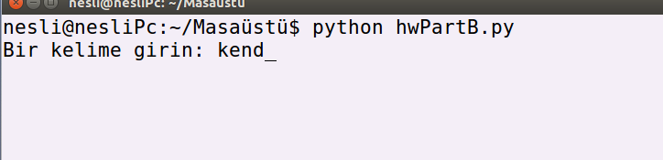

Selecting all words in the database which length is between 3 and 5 and the first two letter k and e:
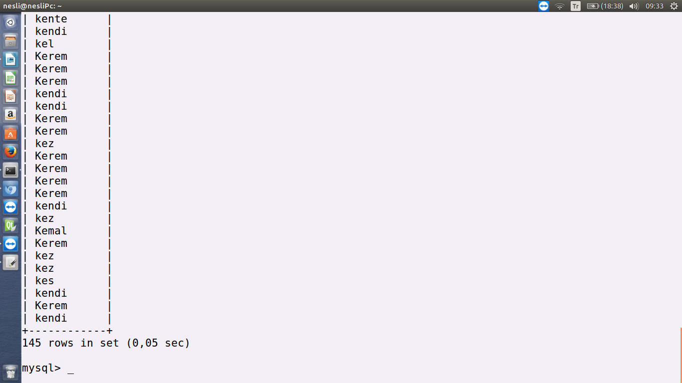

The result of the program:

