**PawCare:**

**Pet Care Monitoring and Tracking System**

**(NESRIN K S-IMCA 244)**

**DIAGRAMS**

**USE CASE DIAGRAM**

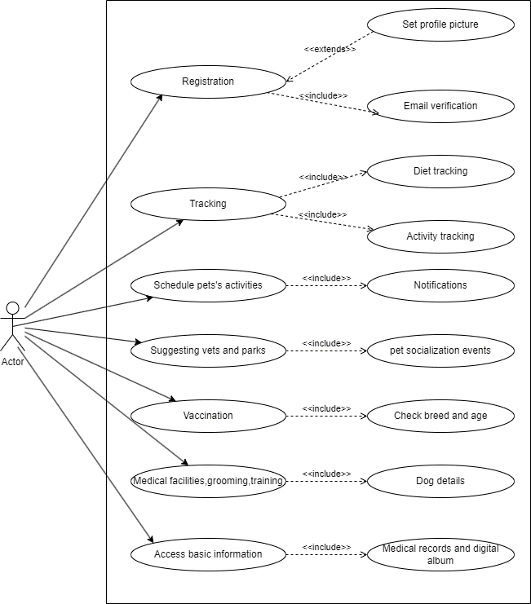

**CLASS DIAGRAM**

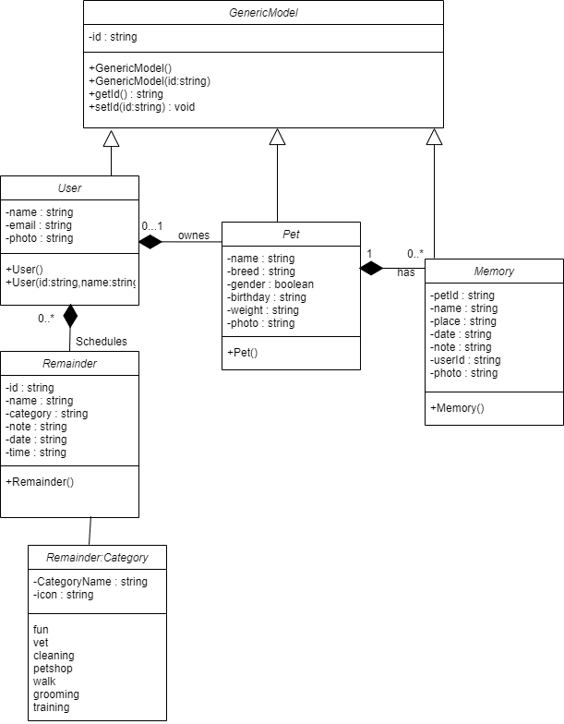

**ACTIVITY DIAGRAM**

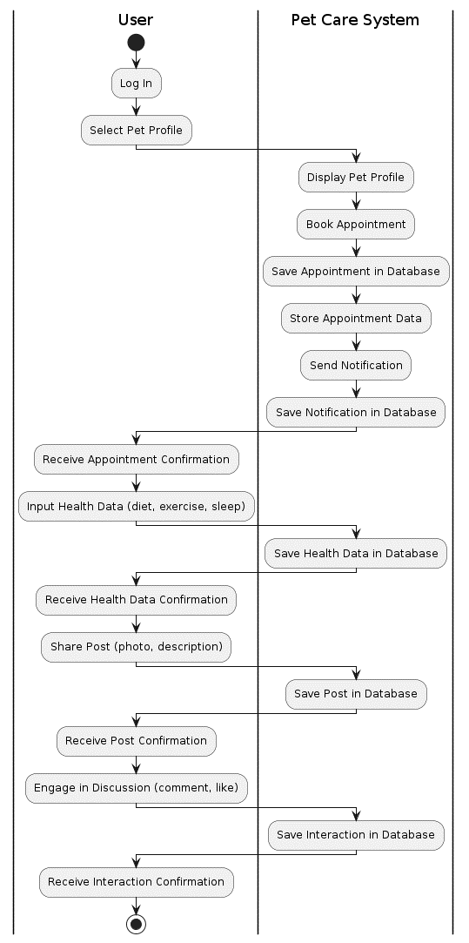

**SEQUENCE DIAGRAM**

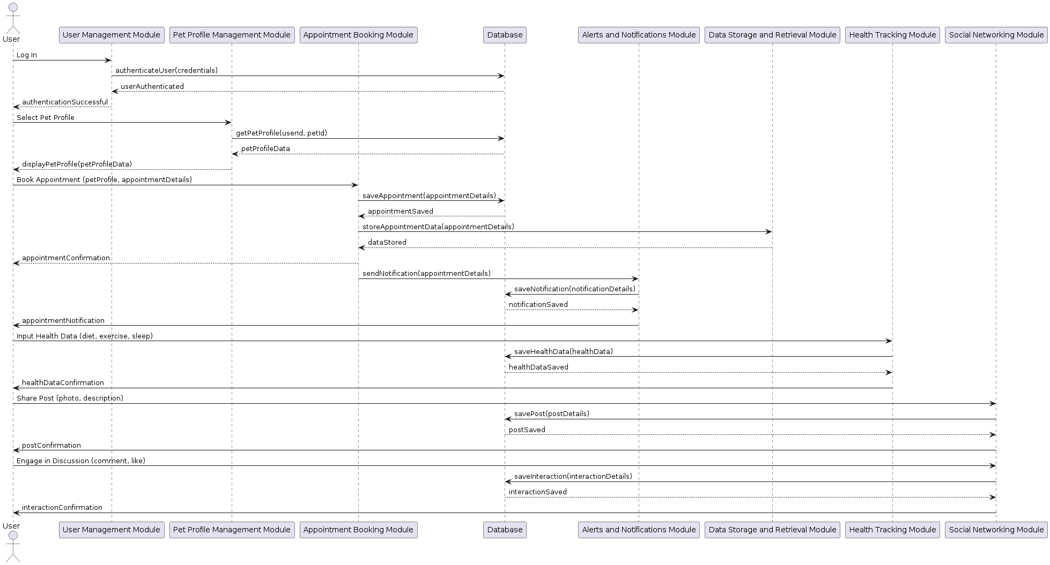

**TABLES**

**TABLE 1:LOGIN**

|  |  |  |
| --- | --- | --- |
| **NAME** | **DATATYPE** | **CONSTRAINTS** |
| login_id | int | NOT NULL,PRIMARY KEY |
| username | varchar(20) | NOT NULL |
| password | varchar(20) | NOT NULL |
| user_type | varchar(10) | NOT NULL |

**TABLE 2:USER**

|  |  |  |
| --- | --- | --- |
| **NAME** | **DATATYPE** | **CONSTRAINTS** |
| user_id | int | NOT NULL,PRIMARY KEY |
| login_id | int | NOT NULL |
| first_name | varchar(15) | NOT NULL |
| last_name | varchar(15) | NOT NULL |
| place | varchar(10) | NOT NULL |
| email | varchar(15) | NOT NULL |
| phone | varchar(10) | NOT NULL |
| pincode | varchar(6) | NOT NULL |
| address | varchar(15) | NOT NULL |
| username | varchar(10) | NOT NULL |
| password | varchar(15) | NOT NULL |

**TABLE 3:PETS**

|  |  |  |
| --- | --- | --- |
| **NAME** | **DATATYPE** | **CONSTRAINTS** |
| pet_id | int | NOT NULL,PRIMARY KEY |
| category_id | int | NOT NLL |
| pet_for_id | int | NOT NULL |
| pet_name | varchar(10) | NOT NLL |
| breed | varchar(10) | NOT NULL |
| age | varchar(2) | NOT NLL |
| color | varchar(10) | NOT NULL |
| gender | varchar(10) | NOT NULL |

**TABLE 4:IMAGE**

|  |  |  |
| --- | --- | --- |
| **NAME** | **DATATYPE** | **CONSTRAINTS** |
| pet_image_id | int | NOT NULL,PRIMARY KEY |
| pet_image | varchar(15) | NOT NULL |
| pet_id | int | NOT NULL |
| file | varchar(15) | NOT NULL |

**TABLE 5:STAFF**

|  |  |  |
| --- | --- | --- |
| **NAME** | **DATATYPE** | **CONSTRAINTS** |
| staff_id | int | NOT NULL,PRIMARY KEY |
| login_id | int | NOT NULL |
| fname | varchar(15) | NOT NULL |
| lname | varchar(15) | NOT NULL |
| place | varchar(10) | NOT NULL |
| phone | varchar(10) | NOT NULL |
| email | varchar(15) | NOT NULL |
| specialization | varchar(15) | NOT NULL |

**TABLE 6:CHAT**

|  |  |  |
| --- | --- | --- |
| **NAME** | **DATATYPE** | **CONSTRAINTS** |
| chat_id | int | NOT NULL,PRIMARY KEY |
| senter_id | int | NOT NULL |
| receiver_id | int | NOT NULL |
| chat | varchar(20) | NOT NULL |
| date | varchar(10) | NOT NULL |

**TABLE 7:APPOINTMENT**

|  |  |  |
| --- | --- | --- |
| **NAME** | **DATATYPE** | **CONSTRAINTS** |
| appointment_id | int | NOT NULL,PRIMARY KEY |
| category_id | int | NOT NULL |
| pet_id | int | NOT NULL |
| user_id | int | NOT NULL |
| status | varchar(10) | NOT NULL |
| date | varchar(10) | NOT NULL |

**TABLE 8:PAYMENT**

|  |  |  |
| --- | --- | --- |
| **NAME** | **DATATYPE** | **CONSTRAINTS** |
| payment_id | int | NOT NULL,PRIMARY KEY |
| appointment_id | int | NOT NULL |
| payment_type | varchar(10) | NOT NULL |
| amount | varchar(5) | NOT NULL |
| date | varchar(10) | NOT NULL |